Quantum Computing and Encryption: A Literature Review
Tyler Vander Mooren
CS/CYB — Literature Review Assignment
October 21, 2025
Quantum computing poses both a disruption risk and an innovation pathway for modern cryptography. On the disruption side, Shor’s algorithm threatens public‑key systems that depend on the hardness of integer factorization and discrete logarithms, including RSA and elliptic‑curve cryptography (ECC). On the innovation side, quantum algorithms such as Grover’s search reduce the effective security of symmetric primitives only quadratically, which can often be mitigated by increasing key sizes. In response to the asymmetric threat, the National Institute of Standards and Technology (NIST) finalized its first three post‑quantum cryptography (PQC) standards in 2024 and is guiding organizations on migration through transition roadmaps and implementation guidance. Meanwhile, quantum key distribution (QKD) continues to evolve with architectures like measurement‑device‑independent QKD to mitigate implementation attacks, prompting a recurring policy and engineering question: when should we prefer PQC over QKD (or a hybrid)? This review synthesizes five representative sources across theory, standards, transition policy, and quantum communications. Together, they outline (1) why conventional public‑key cryptosystems are at risk, (2) how PQC standards like ML‑KEM and quantum‑safe signature schemes address that risk, (3) what migration requires beyond algorithm swaps, and (4) where QKD fits within a broader cryptographic portfolio focused on security, deployability, and cost.
Shor, P. W. “Polynomial-Time Algorithms for Prime Factorization and Discrete Logarithms on a Quantum Computer.” SIAM Journal on Computing, 26(5), 1997.
Shor’s result is the foundational driver of post‑quantum cryptography. The paper shows that a sufficiently large, fault‑tolerant quantum computer can factor large integers and compute discrete logarithms in polynomial time. Because the computational intractability of these two problems underpins RSA, Diffie–Hellman, and ECC, Shor demonstrates that public‑key systems based on these assumptions would be broken at scale once practical quantum computers exist. Technically, the algorithm casts factoring and discrete logs as instances of period‑finding and leverages the quantum Fourier transform to extract the period efficiently. The contribution is twofold: (1) a provable asymptotic speedup relative to the best known classical methods, and (2) a clear cryptographic implication—asymmetric primitives grounded in these hard problems are not future‑proof. For practitioners, the key takeaway is not that encryption is doomed, but that we must shift to hardness assumptions believed to resist quantum algorithms (e.g., module‑lattice problems). Shor’s paper also catalyzed three decades of research into error correction, fault‑tolerant architectures, and resource estimation, which continue to refine timelines for real‑world risk. As a result, organizations should treat ‘harvest‑now, decrypt‑later’ as a near‑term threat for long‑lived data and plan migrations accordingly.
Grover, L. K. “A Fast Quantum Mechanical Algorithm for Database Search.” Proceedings of STOC ’96; arXiv:quant-ph/9605043.
Grover’s algorithm provides a quadratic speedup for unstructured search, reducing the query complexity from O(N) to O(√N). In cryptography, its most direct implication is on the brute‑force search of symmetric‑key spaces and hash preimages. While devastating asymptotically, Grover’s speedup is ‘only’ quadratic, so the community can often restore security margins with larger parameters (e.g., AES‑256 instead of AES‑128 and SHA‑2/3 with longer digests for preimage resistance). The paper’s method uses amplitude amplification: repeated oracle queries and reflections about the mean increase the amplitude of the target state, making it measurable with high probability after O(√N) iterations. For defenders, two practical insights follow. First, symmetric cryptography remains viable in a post‑quantum world, provided parameters are adjusted. Second, system designers should review protocol components that rely on hash preimages, MAC key sizes, and KDF output lengths to ensure adequate post‑quantum margins. Grover also frames why post‑quantum key‑establishment (e.g., ML‑KEM) is more urgent than symmetric replacement: current symmetric primitives already have cost‑effective quantum‑safe paths via parameter increases.
NIST FIPS 203. “Module‑Lattice‑Based Key‑Encapsulation Mechanism (ML‑KEM).” 2024.
FIPS 203 standardizes ML‑KEM (derived from CRYSTALS‑Kyber) as a quantum‑resistant key‑encapsulation mechanism. Its security is related to the Module Learning‑with‑Errors (MLWE) problem, for which no efficient classical or quantum attacks are known. The standard specifies parameter sets ML‑KEM‑512, ‑768, and ‑1024 to trade performance for security strength, with broad guidance that ML‑KEM‑768 is a balanced default for many applications. Importantly, KEMs enable drop‑in replacement of key exchange in protocols like TLS 1.3 without changing data‑at‑rest encryption or application semantics. Implementation guidance emphasizes resistance to side‑channels (constant‑time coding, masked decapsulation) and proper randomness. For engineering teams, ML‑KEM clarifies a migration path: hybrid key exchange (X25519+ML‑KEM‑768) during transition, followed by pure ML‑KEM once ecosystems mature. Operational benefits include compact keys/ciphertexts relative to alternatives and strong performance on general‑purpose CPUs, which eases deployment. Standardization at the FIPS level signals vendor and regulator alignment, accelerating availability across libraries, HSMs, and certifications.
NIST IR 8547 (Initial Public Draft). “Transition to Post‑Quantum Cryptography.” 2024.
This NIST Interagency Report provides migration guidance that goes beyond algorithm selection. It recommends organizations conduct cryptographic inventories, prioritize systems by risk (sensitivity and data longevity), and adopt hybrid mechanisms during phased rollouts. The document maps quantum‑vulnerable standards to quantum‑resistant replacements and underscores the ‘harvest‑now, decrypt‑later’ risk, pressing agencies and industry to begin preparations immediately—even before final profiles exist for every use case. Operationally, it stresses governance (assigning ownership), testing and validation (interoperability, performance), and supply‑chain coordination (vendors, cloud services, PKI providers). The report also addresses documentation and change management: updating security policies, crypto‑agility hooks, and incident playbooks. For practitioners, IR 8547 functions as a checklist-oriented playbook to reduce migration surprises, surface dependencies (e.g., certificate profiles, OCSP, keys in HSMs), and ensure that teams can revert safely if early integrations encounter performance or compatibility issues. Its key contribution is reframing PQC as an enterprise program rather than an isolated code change.
Alshowkan, M., et al. “Quantum Key Distribution: A Survey on Current Vulnerability Landscape and Robust Countermeasures.” Optica Optics Continuum, 2024.
This survey examines the real‑world security of QKD systems, focusing on implementation‑level vulnerabilities rather than idealized proofs. Attacks include detector blinding, time‑shift exploits, Trojan‑horse probing, and side channels in state preparation; the paper catalogs countermeasures such as measurement‑device‑independent (MDI) architectures, decoy‑state methods, and passive encoding schemes. The authors emphasize that while the physics guarantees are appealing, deployed systems are only as secure as their components and calibration. The survey argues that QKD is complementary to, not a replacement for, PQC: QKD can secure links with information‑theoretic guarantees, but practical deployments still require authenticated channels and integration into key management and routing. For enterprises, the most relevant contributions are (1) a taxonomy of attacks and mitigations that informs procurement and certification criteria, and (2) guidance on when QKD is operationally justified—e.g., high‑value, fixed fiber routes where link budgets and cost permit. Combined with evolving MDI‑QKD proposals, the survey clarifies the near‑ to mid‑term role of quantum communications in a quantum‑ready security architecture.
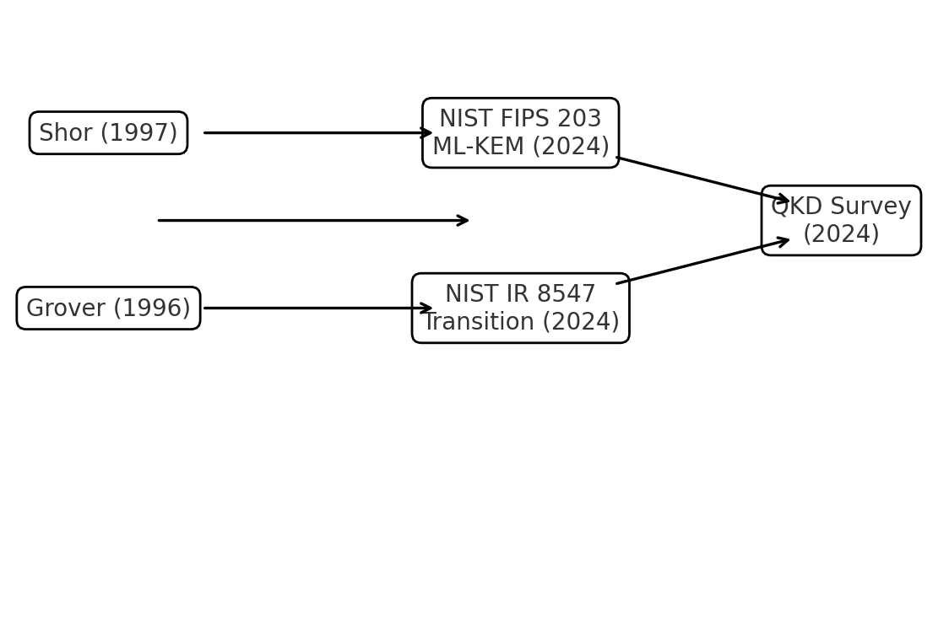
Figure 1. Relationships among core sources: theory (Shor, Grover), standards (FIPS 203), transition guidance (NIST IR 8547), and communications (QKD survey).

References (IEEE)
[1] P. W. Shor, “Polynomial-Time Algorithms for Prime Factorization and Discrete Logarithms on a Quantum Computer,” SIAM J. Comput., vol. 26, no. 5, pp. 1484–1509, 1997. doi:10.1137/S0097539795293172
[2] L. K. Grover, “A fast quantum mechanical algorithm for database search,” in Proc. 28th ACM Symp. Theory of Computing (STOC), 1996, pp. 212–219; also arXiv:quant-ph/9605043.
[3] National Institute of Standards and Technology (NIST), “Module‑Lattice‑Based Key‑Encapsulation Mechanism (ML‑KEM),” FIPS 203, Aug. 13, 2024. Available: https://csrc.nist.gov/pubs/fips/203/final
[4] NIST, “Transition to Post‑Quantum Cryptography,” NIST IR 8547, Initial Public Draft, Nov. 12, 2024. Available: https://nvlpubs.nist.gov/nistpubs/ir/2024/NIST.IR.8547.ipd.pdf
[5] M. Alshowkan et al., “Quantum key distribution: a survey on current vulnerability landscape and robust countermeasures,” Opt. Continuum, vol. 3, no. 8, pp. 1438–1465, Aug. 2024. doi:10.1364/OPTCON.3.001438

