Module Eleven:

Port Scanner & SSH Worm

Grading Criteria
Total Points: 45 points
[5 points] Your submission is labeled as “cyb404_module11_lab00_[nau_id]_[lastname]_[firstname].zip.” For example, if I were to submit a file, it would be labeled as cyb404_module11_lab00_mv668_vigil-hayes_morgan.zip. FAILURE TO COMPLY WITH THIS STEP CAN LEAD TO A ZERO GRADE.
[5 points] Your submission files contained in the ZIP are in the correct formats as specified.
- [1 points] The port scanner is all contained in a file port_scanner.py
- [1.5 points] There is a comment for every functional unit of code that details the purpose of the port scanner code.
- [1 points] SSH worm is all contained in a file ssh_worm_brute.py
- [1.5 points] There is a comment for every functional unit of code that details the purpose of the SSH worm code.
[15 points] Code correctly scans a list of ports and hostnames and uses threading to do so more efficiently
- [2.5 points] File runs using command: python3 port_scanner.py -H <target host> -p <target port>
- [2.5 points] There are no runtime errors
- [5 points] Screenshot of some of the banner TCP packets prompted by your scanner
- [5 points] Screenshot of terminal output of your scanner
[20 points] Code correctly starts an SSH session with pxssh and tries to brute force the password.
- [2.5 points] File runs using command: python3 ssh_worm_brute.py
- [2.5 points] There are no runtime errors
- [5 points] Screenshot of the script taking control of the remote host with the telnet command
- [5 points] Screenshot of the terminal output of python3 ssh_worm_brute.py
- [5 points] Screenshot of the packets generated when running python3 ssh_worm_brute.py

Part 1:
Take a screenshot of your terminal output that results from your port scan over a list of targets that includes at least 5 hostnames and 10 ports for each. You can reuse the port numbers for each target hostname.
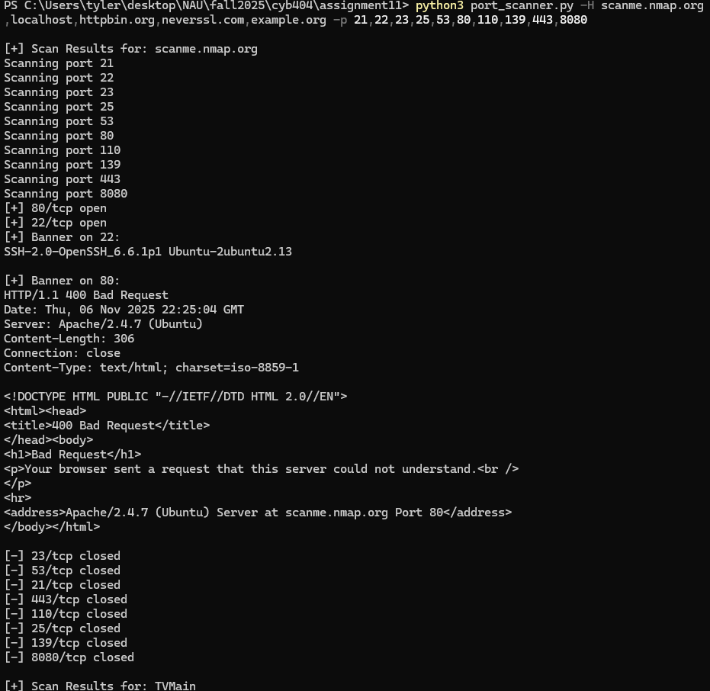

While your port scanner is running, run Wireshark to capture the packets that are being sent back and forth. Take a screenshot that shows a deep dive into a packet that contains the banner information from one of the services you have scanned.
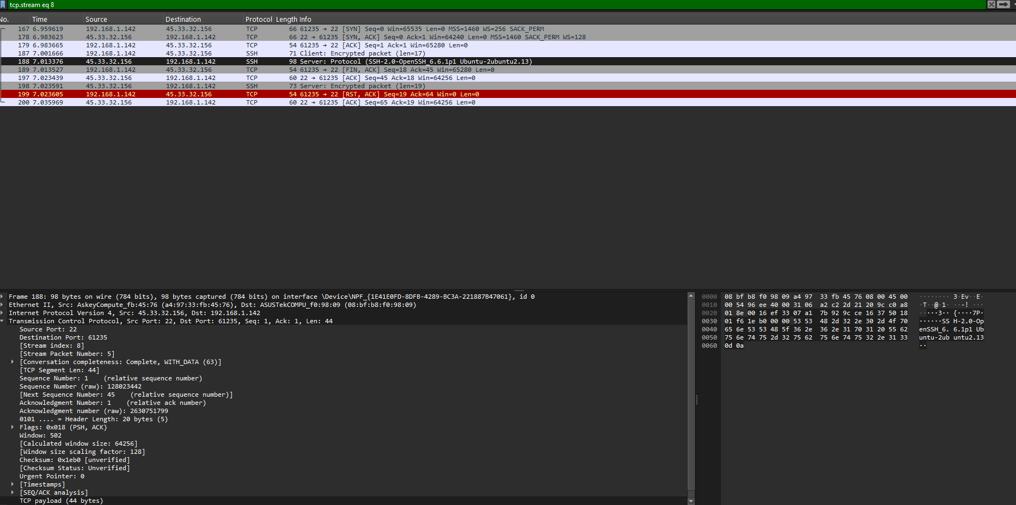

Part 2: Taking control of an SSH session
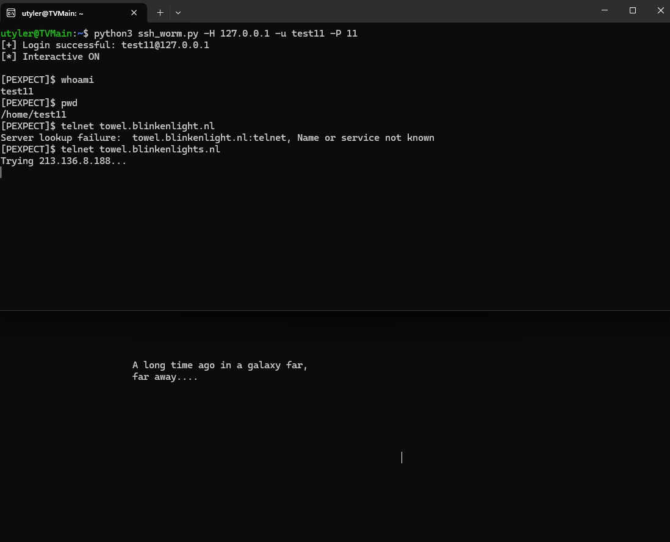
Take a screenshot of your script being run from the commandline and the result of running the telnet command.

Part 3: Brute forcing the password
When you have successfully written your script to launch the brute force login, take a screenshot of the terminal output when you run the script (this will require you insert some print() statements detailing the progress of your script). Turn on Wireshark and capture packets that are involved in your connection to the SSH server. Include screenshots of the terminal output and captured packets here:
