Module Five:

SMTP with Python

Grading Criteria
Total Points: 20 points
In this lab, you will be writing a simple dictionary-based password cracker. Hopefully, this helps illustrate how scary easy it can be to use a dictionary to crack simple passwords.
[2.5 points] Your submission is labeled as “cyb404_module05_lab00_[nau_id]_[lastname]_[firstname].zip.” For example, if I were to submit a file, it would be labeled as cs460_module14_lab00_mv668_vigil-hayes_morgan.zip. FAILURE TO COMPLY WITH THIS STEP CAN LEAD TO A ZERO GRADE.
[2.5 points] Your submission files are in the correct formats as specified.
- [1 points] Password cracker code is all contained in a file called smtp_spammer.py
- [1.5 points] There is a comment for every functional unit of code that details the purpose of the code.
[15 points] Code correctly takes in a Google username, password, and target email address and sends an email to that address.
- [2.5 points] File runs using command: python3 smtp_spammer.py -t [target email] -l [Gmail login] -p [Gmail password]
- [2.5 points] There are no runtime errors
- [5 points] Screenshot of all SMTP packets generated by your SMTP SPAM mailer.
- [5 points] Screenshot of an email sent by your SMTP SPAM mailer to your NAU or personal inbox.

Part 1: Create an automatic SPAM emailer
When you have your SMTP SPAM mailer working, turn on Wireshark and capture packets being sent from your mailer. Add a screenshot of the captured SMTP packets below:
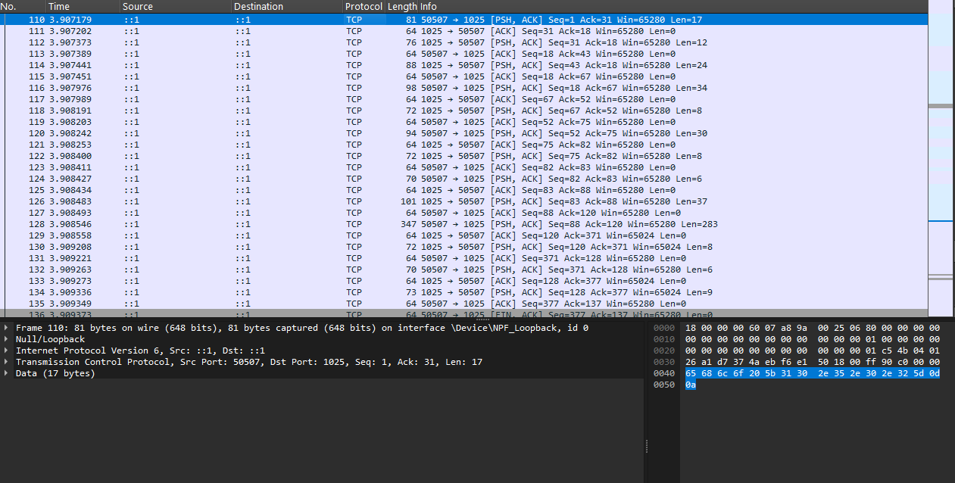

Try sending an email to your NAU account or your personal email. Take a screenshot of the email sent by the SMTP SPAM mailer as it appears in your inbox:
