Module 2: Lab00

Implementing a

Basic Web Server

Grading Criteria
Total Points: 70 + 30 extra credit points available
You may only use your own original Python libraries and the thread and socket Python libraries.
[2.5 points] Your submission is labeled as “cs460_module02_lab00_[nau_id]_[lastname]_[firstname].zip.” For example, if I were to submit a file, it would be labeled as cs460_module02_lab00_mv668_vigil-hayes_morgan.zip. FAILURE TO COMPLY WITH THIS STEP CAN LEAD TO A ZERO GRADE.
[7.5 points] Your submission files are in the correct format. FAILURE TO COMPLY WILL RESULT IN A ZERO GRADE.
- [2.5 points] All files must be submitted as a single ZIP file
- [2.5 points] Server code is all contained in a file called [nau_id]_web_server.py
- [2.5 points] This lab manual is contained in a file called [nau_id]_lab_manual.pdf
[20 points] Code runs without errors in Unix environment and is highly readable. I will be testing code on Mac OS X and Ubuntu environments.
- [5 points] XX_web_server.py starts without error and is able to start up a main server thread that handles incoming client requests.
- [5 points] XX_web_server.py runs using the following command at the terminal:
python3 XX_web_server.py [socket]
- [5 points] Code is well organized into subroutines (helper functions) that
- [5 points] I am able to use a simple telnet client to test the server
[20 points] Your server correctly complies with RFC 2616
- [5 points] When the server receives a correctly formatted GET request for the file at the root directory, the server is able to provide a correctly formatted response that results in sending a small bit of HTML with an original message embedded (e.g., “Computer Networks are the best!”)
- [5 points] When the server receives correctly formatted HTTP requests that are NOT GET requests, the server follows RFC 2616 and sends the proper response indicating a lack of server implementation support.
- [5 points] When the server receives correctly formatted HTTP requests that is a GET request for a file that does not exist in the server’s directory, the server needs to send the proper response according to RFC 2616.
- [5 points] When the server receives an incorrectly formatted HTTP request, it needs to respond according to RFC 2616.

[20 points] Part 1 of the Lab Manual (i.e., this document) has been completed correctly and completely
- [2.5 points] Identify where in RFC 2616 you found the rules for correctly responding to a correctly formatted GET request for the root directory
- [2.5 points] Show a screenshot of a Wireshark capture of the GET request packet sent to your server and the server response
- [2.5 points] Identify where in RFC 2616 you found the rules for correctly responding to a correctly formatted GET request for a nonexistent file
- [2.5 points] Show a screenshot of a Wireshark capture of the GET request for nonexistent file packet sent to your server and the server response
- [2.5 points] Identify where in RFC 2616 you found the rules for correctly responding to correctly formatted non-GET requests (e.g., POST) for a nonexistent file
- [2.5 points] Show a screenshot of a Wireshark capture of the correctly formatted non-GET request packet sent to your server and the server response
- [2.5 points] Identify where in RFC 2616 you found the rules for correctly responding to incorrectly formatted requests
- [2.5 points] Show a screenshot of a Wireshark capture of the incorrectly formatted request packet sent to your server and the server response

Part 1: Simple Web Server
[2.5 points] Identify where in RFC 2616 you found the rules for correctly responding to a correctly formatted GET request for the root directory
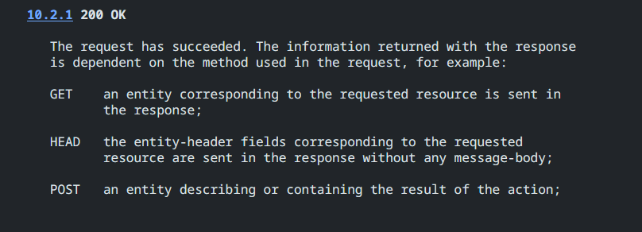
[2.5 points] Show a screenshot of a Wireshark capture of the GET request packet sent to your server and the server response
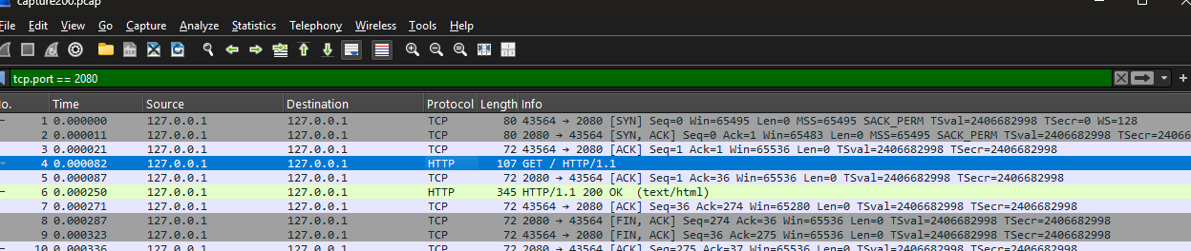
[2.5 points] Identify where in RFC 2616 you found the rules for correctly responding to a correctly formatted GET request for a nonexistent file
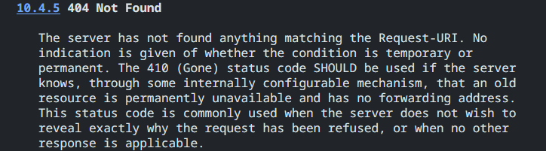
[2.5 points] Show a screenshot of a Wireshark capture of the GET request for nonexistent file packet sent to your server and the server response
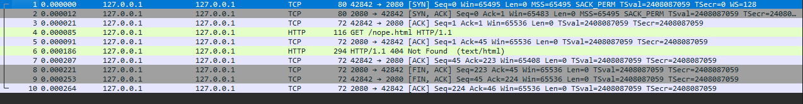
[2.5 points] Identify where in RFC 2616 you found the rules for correctly responding to correctly formatted non-GET requests (e.g., POST) for a nonexistent file
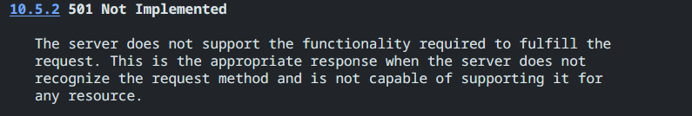
[2.5 points] Show a screenshot of a Wireshark capture of the correctly formatted non-GET request packet sent to your server and the server response
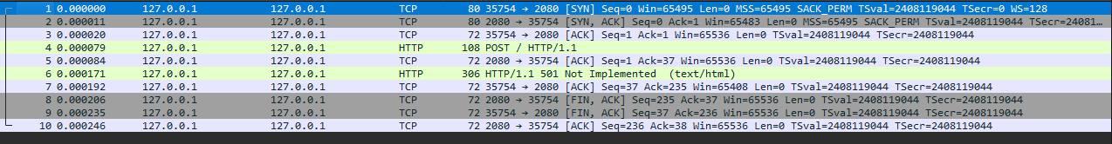
[2.5 points] Identify where in RFC 2616 you found the rules for correctly responding to incorrectly formatted requests
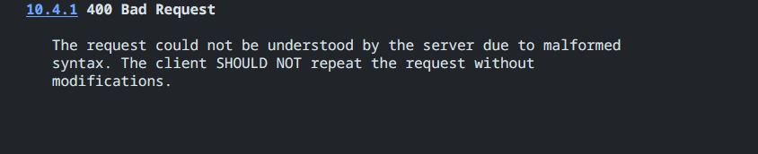
[2.5 points] Show a screenshot of a Wireshark capture of the incorrectly formatted request packet sent to your server and the server response
