Activity 1
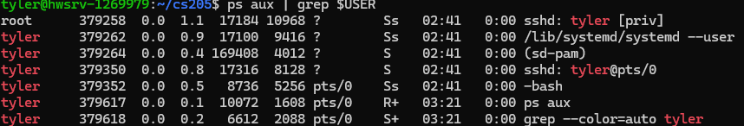
This filters the results by your username.
Activity 2
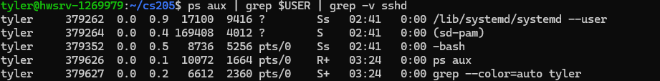
This excludes any process that includes sshd
Activity 3
CTRL-Z
This temporarily suspends htop and brings the terminal back.
Activity 4
This will generate a large number and output it to a file.
Activity 5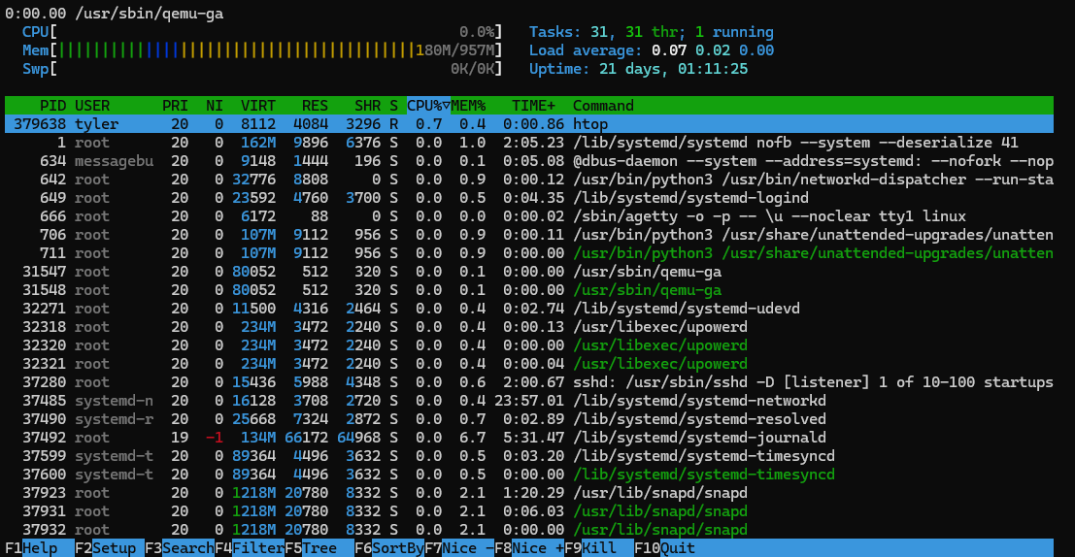

Activity 6
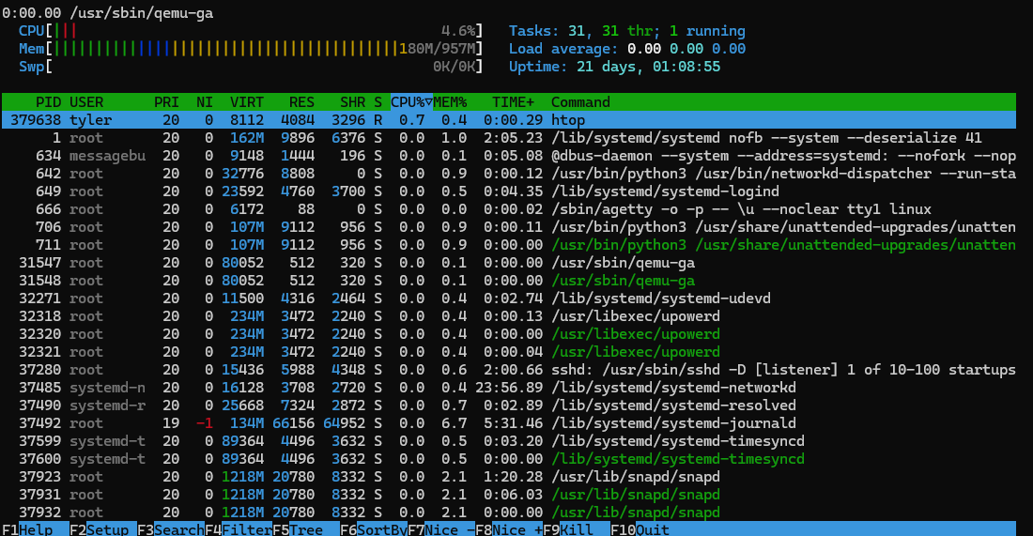Press F9 to kill a process
Activity 7
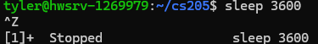
Use CTRL-Z to suspend process

Activity 8
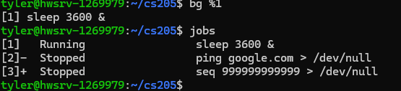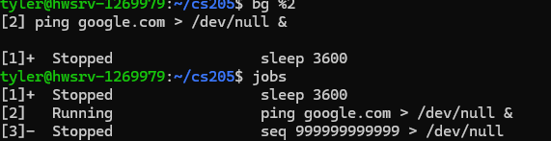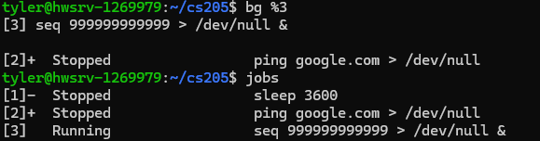
Activity 9

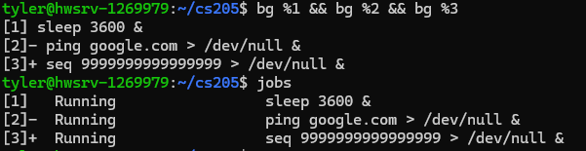This will resume all three processes in the background at once.
Activity 10
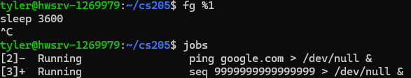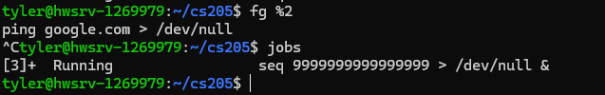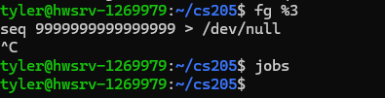
Bring each process to the foreground using fg. Then used CTRL-C to terminate each process. Used jobs to verify they have been terminated.
Activity 11
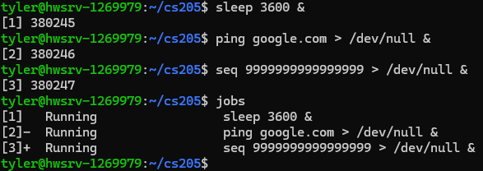
This will start each process in the background immediately.
Activity 12
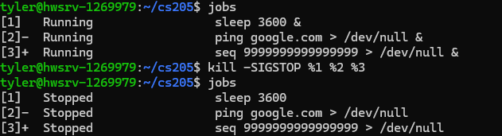
This will suspend all three processes using the kill command and -SIGSTOP
Activity 13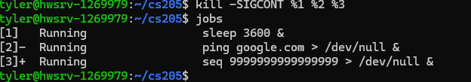
This will resume all three processes using the kill command and -SIGCONT
Activity 14
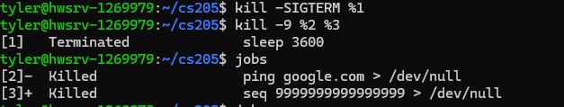
Used sigterm to not “overkill” sleep. And kill -9 to terminate process 2 and 3.

