Picture 1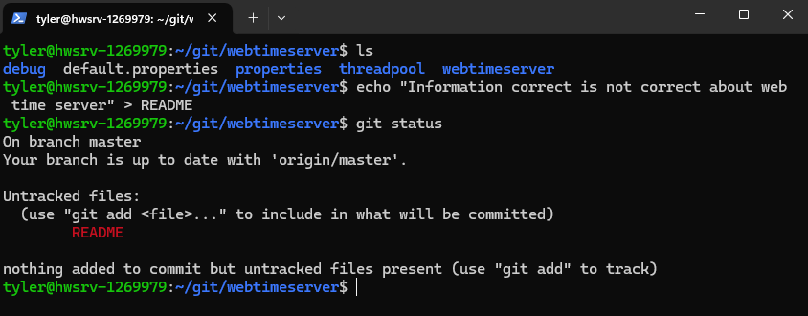
After running git status before staging, it will show README as an untracked file.
Picture 2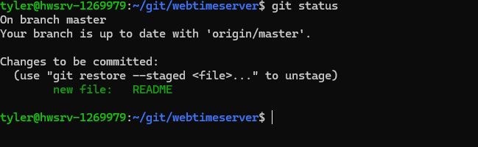
After running git status after staging, it will show README as a file to be committed.
Picture 3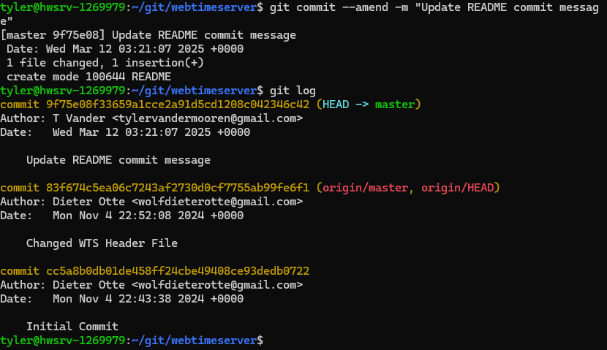
After committing with git commit -m "Add README with time server info", the git log will show the commit details with the message provided.
Picture 4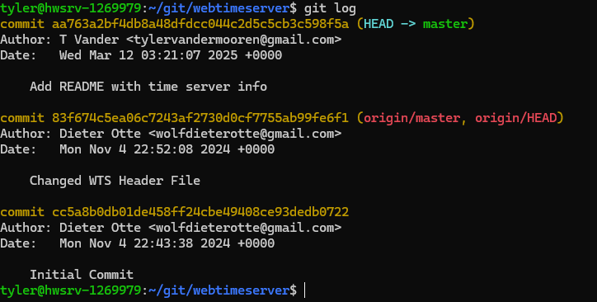
After amending the commit with git commit --amend -m "Update README commit message", the git log will show the updated commit message.
Picture 5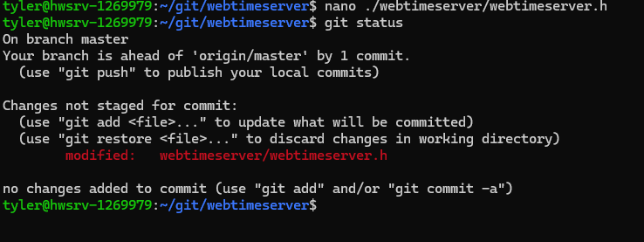
After modifying webtimeserver/webtimeserver.h by removing the comment /* Function prototypes */, git status shows that the file is modified but not staged for commit.
Picture 6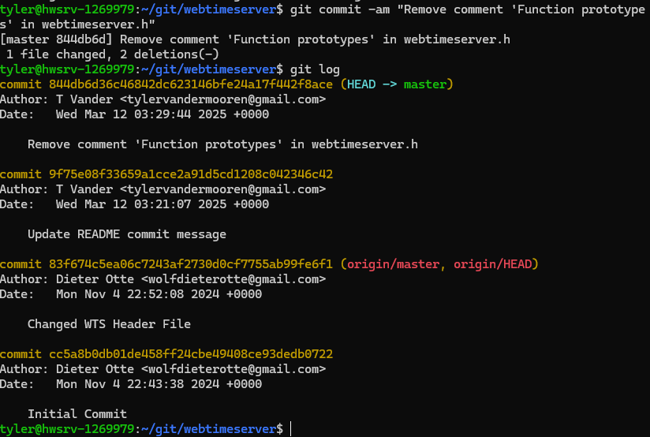 After staging and committing the changes in one step using git commit -am "Remove comment 'Function prototypes' in webtimeserver.h", git log will display the commit just made.
Picture 7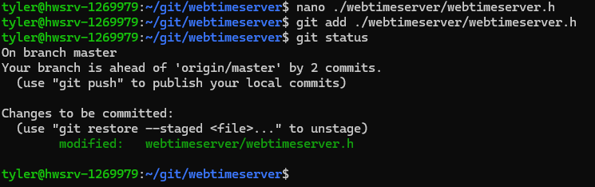
After making the second change by removing /* Preprocessor directives */ and staging the file, git status shows that the file is staged for the next commit.
Picture 8
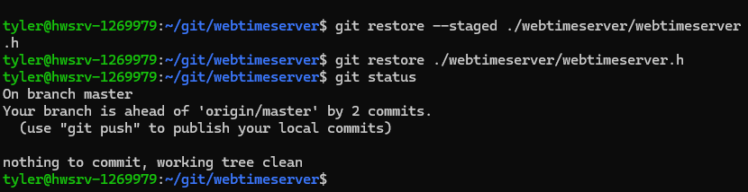
After running git restore --staged and git restore on webtimeserver/webtimeserver.h, git status shows "nothing to commit, working tree clean."
Picture 9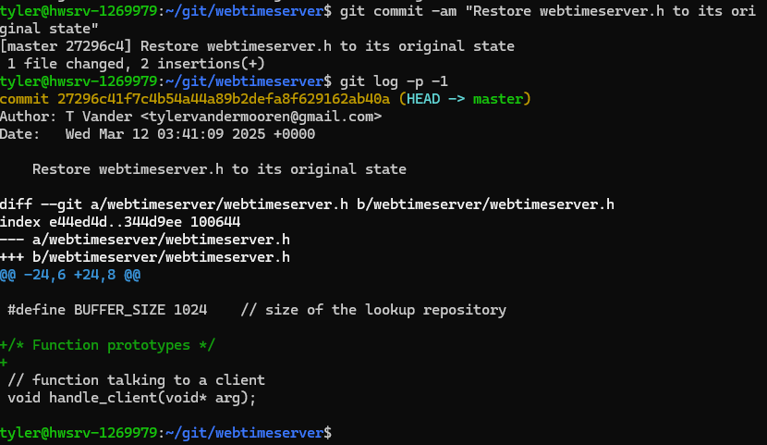
After running git log -p -1 to see the diff of the restoration commit, commit details and the diff indicating that webtimeserver.h was restored to its original state.
Picture 10

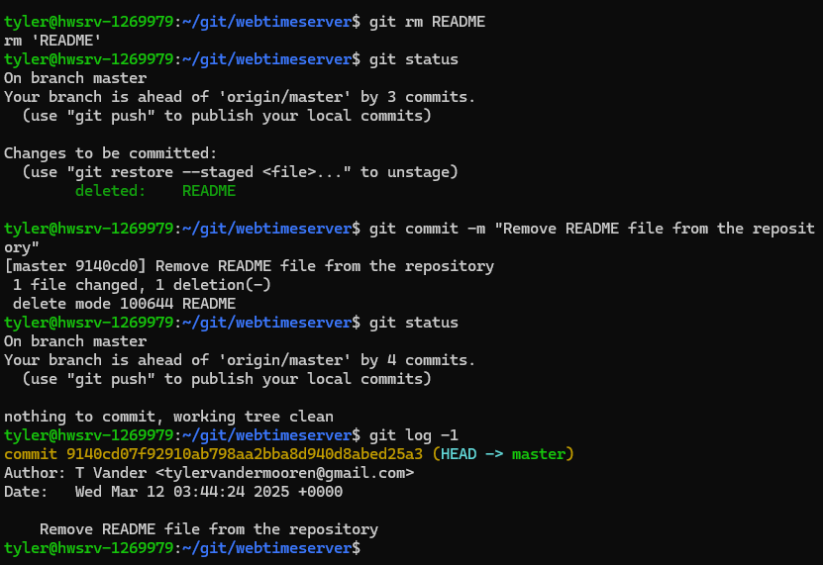After git rm README: The file will be marked as deleted and staged for commit.
After git status: Git will show that the README file is staged for deletion.
After git commit -m "Remove README file from the repository": The file will be committed as removed, and git status shows "nothing to commit."
Picture 11
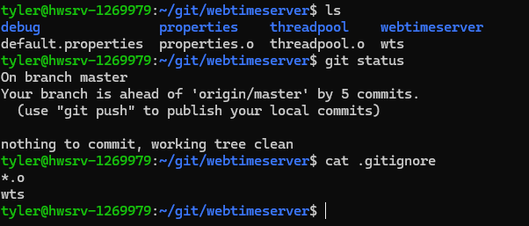
ls -l *.o wts: Shows a list of .o object files and the wts executable.
git status: Shows that the .o files and wts are ignored, with nothing to commit.
cat .gitignore: Displays the content of the .gitignore file, with the lines *.o and wts.

