Tyler Vander Mooren
CYB 310: Malware Analysis
Professor Troy Adams
January 29, 2026
Lab1 – Malware Classification and Infection Vector Analysis: Emotet
Malware classification is commonly used to categorize and describe threats but in practice it provides limited analytical value. The problem is that modern malware campaigns are rarely single purpose or static. Many change behavior over time, deliver additional payloads or function primarily as access enables rather than end stage tools. So, using rigid labels such as trojan and ransomware can obscure how an attack actually unfolds. For analysis, infection vectors and attack chains offer more meaningful insight. Understanding how the malware is introduced, what dependencies it relies on and how it progresses through a system are tools that analysts can use to assess risk, identify control failures and anticipate further activity. This approach shifts the focus from what malware is classified as, to what it actually does and how it enables broader adversary objectives. Emotet is an example of this, which is a widely observed malware family and demonstrates the limitations of rigid classification. It is often described as a banking trojan, however this label no longer accurately reflects its operational role. While initially its early variants focused on credential theft, its later variants function primarily as a modular loader and initial access platform (CISA, 2020).
Primary infection vector
The primary infection vector for Emotet is phishing emails containing malicious Microsoft Word documents. These emails are designed to appear routine and credible, often imitating invoices, shipping confirmations and emails from coworkers (CISA, 2020). The technical complexity in the initial stage is low and the attack primarily relies on user interaction rather than exploitation of software vulnerabilities. Once the document is opened, the user is then prompted to enable macros and once they enable these macros the embedded code executes PowerShell commands that retrieve the Emotet payload from an external server. This is when the malware establishes persistence and initiates command and control communication (CISA, 2020). This infection vector is very significant because it bypasses traditional security controls. The malware is delivered in a way using a trusted file format and that requires no privilege escalation or exploit chain. So, it's driven by social engineering and user decision making, which makes it rather difficult to fully mitigate through technical controls alone.
Secondary payloads and Attack Progression
After the initial execution, Emotet then transitions into a staging role. Rather than immediately delivering a high impact payload, it will maintain access and evaluate the infected environment it is in. Based on the attacker’s objective, Emotet then deploys secondary malware such as credential stealers, exploitation frameworks or ransomware (CISA, 2020). Once it's in this phase the attack shifts from endpoint compromise to network-level risk. The original malware classification becomes increasingly irrelevant as the operational impact is driven by the secondary payloads rather than Emotet itself. This progression of Emotet illustrates why focusing just on malware labels can be ill-advised. While Emotet may initially be identified as a trojan delivered via a document, its real analytical value lies in enabling further payloads that lead to data theft, lateral movement or operational disruption.
Intended impact and Risk Assessment
The intended impact extends well beyond the initially compromised host. Emotet is designed with the intent to establish reliable access to an organization’s environment, creating a foothold from which the attack can expand access, escalate privileges and prepare the network for further exploitation (CISA, 2020). Rather than delivering immediate damage to the host, Emotet chooses to maintain a sustained presence allowing it to be a critical enabler in multi-stage attack campaigns. In many cases the Emotet infection acts as precursors to ransomware deployment, often leading to widespread operational disruption and financial loss. Even when the ransomware isn't immediately deployed, the presence of persistent access and stolen credentials means long term risk. For example, compromised credentials may be reused for lateral movement, leveraged in future intrusions or sold to other threat actors. When using risk assessment as shown in figure 1, the most significant failure occurs at the initial infection vector. A single malicious document delivered through phishing can result in enterprise-wide infection, demonstrating how low complexity entry points can enable high-impact outcomes. This imbalance highlights why infection vectors and attack chains provide more actionable insight rather than malware categories alone.
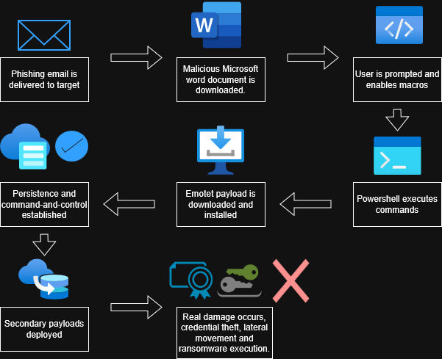
Figure 1. Infection chain for Emotet Malware.
Note. This diagram shows the initial progression from phishing based delivery through the end phase secondary malware deployment. The critical failure point occurs when the user enables macros within the document, permitting it to run Powershell commands.
Emotet showcases the actual analytical limitations of rigid malware classification, while it may be labeled as a trojan or downloader these designations fail to explain its actual operational role within modern attack campaigns. By focusing on how the malware enters a system and what it enables afterward instead of just the classification, it gives analysts a better understanding of where defenses will fail and how initial compromise can escalate into significant organizational impact. For modern malware analysis, infection vectors and attack chains should be treated as primary analytical tools rather than just secondary descriptors.
References
Cybersecurity and Infrastructure Security Agency. (2020). Emotet malware. https://www.cisa.gov/news-events/cybersecurity-advisories/aa20-280a

