Tyler Vander Mooren
Professor Bryan Knueppel
ITC 413
18 January 2026
Assignment 1: HealthTrack Database Proposal
With the new requirements that are arising with HealthTracks’s next phase of platform growth it will need to be able to support a rapidly expanding user base, increased data ingestion from devices and more complex social and analytical features. HealthTrack’s current approach of a single-database will not work for this environment; the platform will need to support multiple types of data and access patterns, which include consistent transactional operations, high-frequency time-series data and relationship driven social interactions. This will produce performance bottlenecks and limit future scalability by staying on a single relational database. To address these challenges, it is recommended to adopt a polyglot persistence architecture that combines relational and NoSQL databases, each being aligned with specific functional requirements. This approach will improve system performance, support horizontal scalability and provide a flexible environment capable of accommodating any future growth of HealthTrack.
Technical Challenge
The current database architecture faces several technical challenges that will limit its ability to scale in the future and support expanding the platform. These challenges come from rapid user growth, increasing data diversity and conflicting access patterns all being handled by a single database system. The first challenge to address is scale and performance. HealthTrack is expected to grow from 50,000 users to 1 million users within 18 months, while at the same time ingesting high-frequency data streams from wearable devices. These workloads are going to generate sustained data loads that will degrade performance, especially when combined with transactional queries and analytics, which will lead to contention for shared resources and reduced system responsiveness. The second challenge to overcome is data diversity. Currently HealthTrack manages a combination of structured, semi-structured and unstructured data. This data ranges from user accounts, device-generated health metrics and social content. Enforcing a rigid schema across all data types increases the development overhead and will limit the system’s ability to adapt to new devices, features and content formats when introduced.
Also, the platform must support diverse access patterns. Core user management functions will require strong consistent transactional operations, while the health data ingestion will prioritize write throughput and availability. Social features will introduce relationship-based queries and feed oriented read patterns that will differ significantly from traditional relational workloads. Attempting to optimize a single database to handle all these patterns will result in an architectural compromise and will negatively affect performance and scalability. Together these challenges demonstrate the limitations of a single database approach and bring up the need for an architecture that can align specific data workloads with the technologies designed to handle them effectively.
Proposal Overview
The proposed architecture adopts a polyglot persistence model where multiple databases support distinct function components of the HealthTrack platform. Application services will interact with data stored through a unified service layer, allowing each workload to be processed by a database that is optimized for its data model and access patterns. Doing the design this way will reduce contention between the competing workloads while enabling independent scaling and adaptability (Sullivan, 2015).
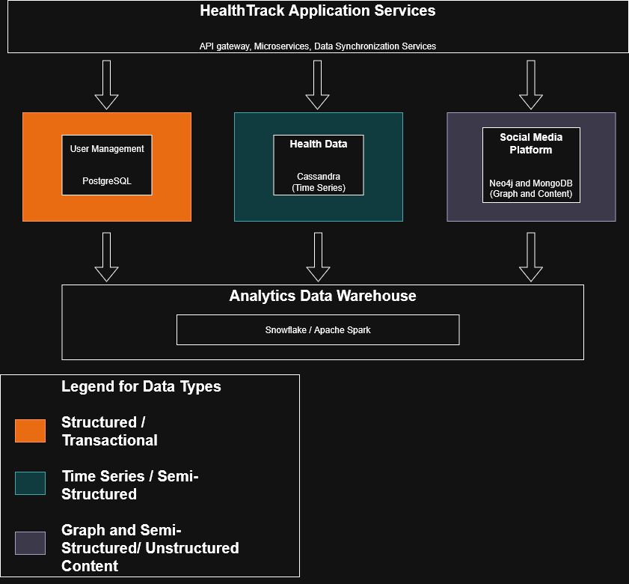
Figure 1
The proposed architecture and the relationship between application services, functional data domains and the analytics layer.
User Management
User management data including authentication credentials, role-based access control and subscription information should still be managed by PostgreSQL. These workloads demand full ACID transactional guarantees to ensure correctness for security and billing related operations. PostgreSQL provides strong consistency, structured schema support and integrity, making it well suited for this function (Sullivan, 2015). By isolating user management from the high-volume and unstructured workloads, the system will ensure transactional reliability while reducing contention and performance degradation.
Health Data Repository
Apache Cassandra is recommended for the Health Data Repository because it is designed for write intensive and time-series workloads. This is ideal for wearable device data which typically vary in structure across device manufacturers, generated frequently and is usually append-only. Its distributed architecture supports horizontal scalability through partitioning and replication, allowing the platform to ingest large volumes of data with high availability. Also, its BASE consistency model and eventual consistency are appropriate for health metrics, where short synchronization delays do not compromise system functionality or user experience (Ploetz et al., 2018).
Social Media Platform
The social media platform would benefit from a multiple NoSQL model due to its diverse access patterns. Social relationships should be managed using Neo4j, as social interactions are inherently relationship-centric utilizing a graph database will efficiently support queries. Graph databases are efficient in supporting queries such as identifying connections, communities and users with similar interests, which is ideal for social relationships handling. Social content, education resources and personalized recommendations should be stored in MongoDB. Since these data types are going to be semi-structured/unstructured, metadata heavy and subject to frequent schema evolution the flexibility of MongoDB will address these challenges, while enabling rapid feature development and efficient read performance for content feeds. Together these databases form a cohesive polyglot persistence solution that aligns database capabilities with individual function requirements, which will enable HealthTrack to scale efficiently while maintaining performance, flexibility and data integrity.
Adopting a polyglot persistence architecture provides HealthTrack with a scalable and flexible data foundation capable of supporting continued growth and increasing data complexity. This is achieved by aligning specific databases with distinct function requirements, the proposed solution improves performance, reduces resource contention and preserves data integrity where it is critical. The relational database for transactional user management will remain PostgreSQL while introducing NoSQL databases for high-volume health data and social interactions. Doing this enables horizontal scalability without sacrificing reliability. This architecture positions HealthTrack to be able to accommodate future users, devices and features while maintaining a resilient and adaptable data infrastructure.
References
Ploetz, A., Devram Kandhare, Sudarshan Kadambi, & Xun (Brian) Wu. (2018). Seven NoSQL databases in a week : get up and running with the fundamentals and functionalities of seven of the most popular NoSQL databases. Packt Publishing.
Sullivan, D. (2015). NoSQL for mere mortals. Addison-Wesley.

‌

