Tyler Vander Mooren
ITC 413: NoSQL Databases
Professor Bryan Knueppel
February 2, 2026
Assignment 4
Part 1: Add a New Collection
Picture 1
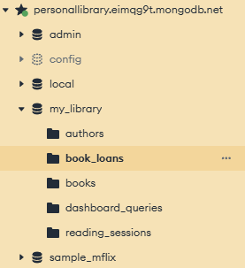
Picture one shows the newly created book_loans collection within the my_library database in MongoDB Compass.
Picture 2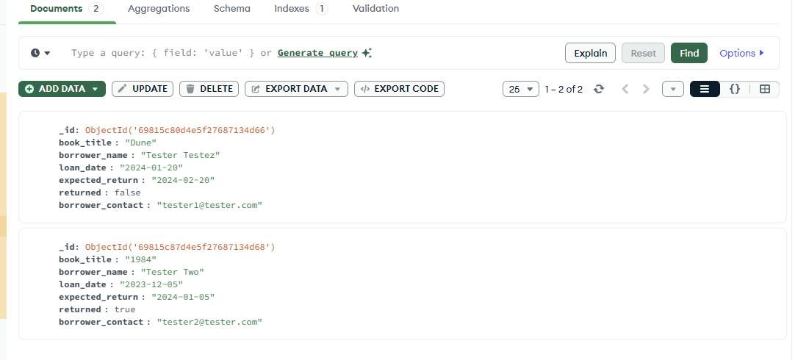
Picture two displays two populated loan records in the book_loans collection. Each document contains the required fields including book title, borrower information, loan date, expected return date and return status.
Part 2: Enhance Existing Data
Picture 3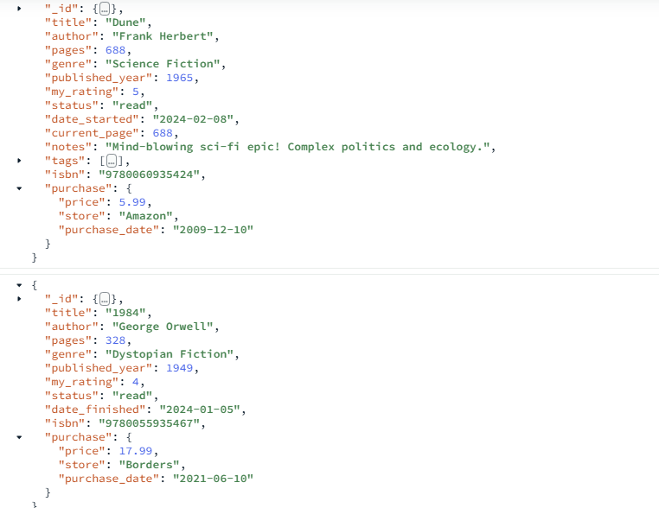
Picture 4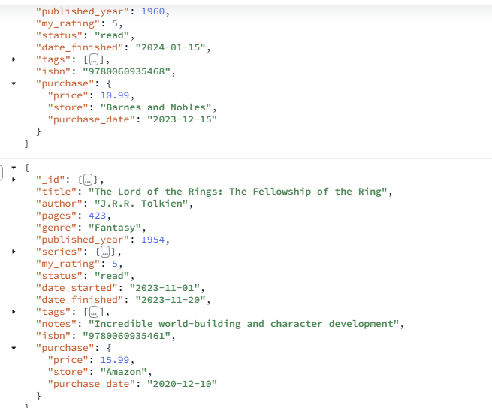

Picture three and four shows the updated book document with the newly added ISBN and purchase information fields. These enhancements include a unique ISBN number and the embedded purchase which includes details such as price, store and purchase date.
Part 3: Create an Advanced Query
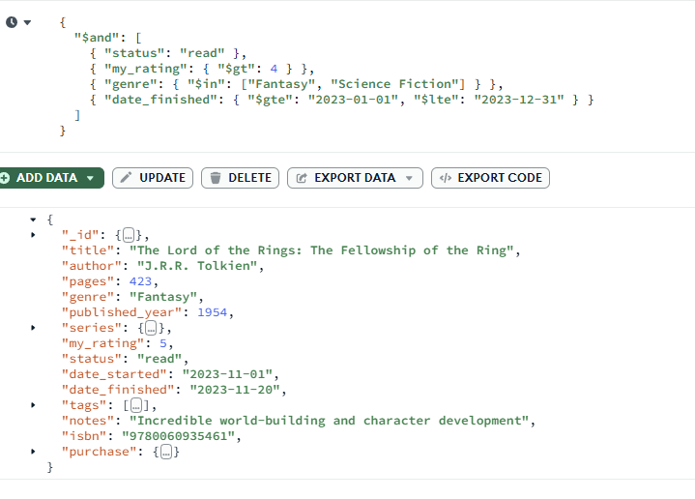
This query returns books marked as read that were completed in 2023 and filters the results to include only specific genres, Fantasy and Science Fiction. By combining multiple conditions, the query provides insight into which genres contained the highest-rated books completed during that year and helps identify top recommendations from the library.

