SYST 664: HW Assignment 1

Jake Whalen

January 29, 2018

1. In both part a & b the sensitivity and specificity are 0.8 and 0.85 respectively.
   * **Part A**  
     In part a the organization knows that 1 individual in 1000 commits a security violation. The objective is to determine the posterior probability that an individual has commited a security violation given their polygraph indicates a concern. The posterior probability can be calculated given the prior probability, sensitivity and specificity. The equation below shows how to calculate the posterior probability. $Con$ means a concern was raised by the polygraph. $Com$ means an individual commited the violation. $NotCom$ means an individual did not commit the violation.
 $$P(Com|Con)=P(Con|Com)P(Com)/P(Con|Com)P(Com)+P(Con|NotCom)P(Com)$$  * After plugging in the values you end up with a posterior probability of 0.00531 that an individual commited the violation given their polygraph had a concern. Using this for routine screening of individuals who require clearances would not be a good idea. The problem is that there is only a 0.00531 probability the individual **did** commit the violation when a concern is raised by the polygraph. On the other hand there is a 0.99469 probability the individual **did not** commit the violation when a concern is raised by the polygraph. Thus, the security group at this organization would have to deal with a large amount of false positives if they simply trusted the results of the polygraph.
   * **Part B**  
     In part b we change the prior probability to 1 individual in 4 (0.25) commits a theft (new crime). The change is due to an investigator looking into the theft and bringing new knowledge to the table. This drastically increases the posterior probability. The new posterior probability is equal to 0.64. Now we can say that the probability that the individual stole the item is 0.64 when the polygraph raises a concern. We can also say there is a 0.36 probability the individual did not steal the item when the polygraph raises a concern. Unlike in problem *a* we are much more confident in the polygraph results. In the case presented in *b*, the organization can put more weight on the results of the polygraph because the false positives have gone way down and true positives have gone up.
2. The situation in problem 2 involves an individual commiting a crime or security violation. We were able to obtain evidence that the sensitivity and specificity were 0.8 and 0.85 respectively. The goal is to find the policy that minimizes expected loss. To do this I first created a table that lays out the different States of the world, Probabilities of each State, Actions to take when in that State and the resulting Loss in that Action.

|  |  |  |  |
| --- | --- | --- | --- |
| State | Probability | Action | Loss |
| Commit, Positive | .8*P(Commit) | Sanction | 1 |
| Commit, Negative | .2*P(Commit) | No Sanction | 100 |
| No Commit, Positive | .15*(1-P(Commit)) | Sanction | 10 |
| No Commit, Negative | .85*(1-P(Commit)) | No Sanction | 0 |

The next step is to form the Loss equations for the three different options Following the Test, Always Sanction, and Never Sanction. First to find the equation for always following the test I add all the expected losses together.

$$1*0.8*P(Commit)+100*0.2*P(Commit)+10*0.15*(1-P(Commit))+0*0.85*(1-P(Commit))$$

$$=19.3*P(Commit)+1.5$$

Next the expected Loss for always applying a Sanction is calculated. To do this you simply sum the product of each state where a sanction is applied and the probability of the individual commiting the crime (rows 1 & 3 in table).

$$1*P(Commit)+10*(1-P(Commit))=10-9*P(Commit)$$

Last the expected Loss for never applying a Sanction is calculated (rows 2 & 4 in table).

$$100*P(Commit)+0*(1-P(Commit))=100*P(Commit)$$

Now the value of $P(Commit)$ is varied between 0 and 1 and the expected loss of the three different scenarios is calculated. The graph below shows the three scenarios and the values of $P(Commit)$ at which they intersect (black points).

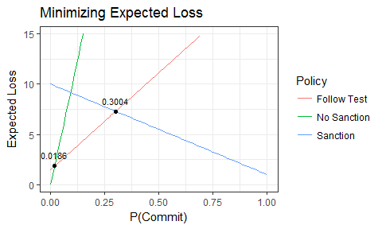

The intersection points indicate changes in what action should be taken based on the prior probability $P(Commit)$. When $P(Commit)<0.0186$ No Sanction should be administered always, no matter the polygraph test results. When $0.0186<P(Commit)<0.3004$ the organization should always follow the results of the polygraph test. If a concern is raised then a sanction should be administered. If no concern is raised then no sanction should be administered. When $P(Commit)>0.3004$ a sanction should always be placed on the individual. Using these ranges for the prior probability to determine the actions will ensure the lowest expected loss.

1. Experimenters performed a study in which a polygraph was administered to subjects in a simulated theft scenario. Before being polygraphed, subjects waited in a room where $50 was left on a table in open view. Some subjects were instructed to take the money, while others were asked to leave it there. Both groups were asked to tell the polygrapher that they did not take the money, and were given a monetary reward if the polygrapher believed them. Assume the polygraph sensitivity Q has 20 equally spaced possible values ranging from 0.025 to 0.975. Assume that polygraph results for people who took the $50 are independent and identically distributed, with probability Q of the polygraph showing a concern. Assume that all 20 values of Q are equally likely a priori. Suppose the polygrapher found a concern for 12 of the 15 subjects who took the $50. Make a bar plot of the posterior distribution for Q given the results of the study.

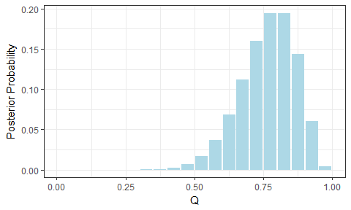

The resulting graph of the posterior probability is what I expected. The distribution looks to center around 0.75 to 0.85. Given that the polygrapher found a concern for 12 of 15 (0.8) individuals who took the money, I expected the posterior distribution to have a negative skew. The graph above has a negative skew and also shows a mean close to 0.8 as expected.