SYST 664: HW Assignment 2

Jake Whalen

February 5, 2018

# Problem 1

There are two parts to problem 1. Each deals with a choice between two options for a gamble. In each section the expected utility functions will be calculated and graphed. Using these graphs I will be able to determine which options are preffered based on maximizing the expected utility.

## Gamble 1

Gamble one has two options A and B. Option A has three possible outcomes. Option A is to win $2500 with a 0.33 probability, win $2400 with a 0.66 probability or win nothing ($0) with a 0.01 probability. Option B offered a guaranteed (1.0 probability) $2400.

The winnings of both options had the same utilites. Winning $0 had a utility of 0. Winning $2500 had a utility of 1. The utility of winning $2400 was set to x. In order to find the utility of each option we must sum up the probabilities multiplied by the utilities of each winning.

* Utility Option A
$$0.33*U(2500)+0.66*x+0.01*U(0)=0.33+0.66*x$$

* Utility Option B

$$1.0*x$$

The graph below helps determine for what values of x a person would choose option A or option B given they are an expected utility maximizer.

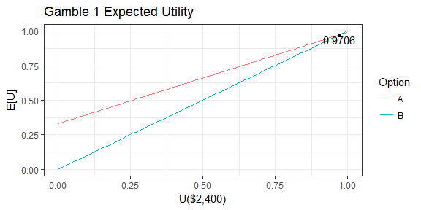

Based on the plot above an expected utility maximizer would choose Option A when x < 0.9706. Option B would be chosen when x > 0.9706.

## Gamble 2

In Gamble 2 the gambler is again presented with two options this time labelled C and D. Option C has two possible outcomes. They are win $2500 with a 0.33 probability or win $0 with a 0.67 probability. Option B has two possible outcomes. They are win $2400 with a 0.34 probability or win $0 with a 0.66 probability. Again I need to calculate the expected utility functions for each option.

* Utility Option C
$$0.33*U(2500)+0.66*U(0)=0.33$$

* Utility Option D

$$0.34*x+0.66*U(0)=0.34x$$

The graph below helps determine for what values of x a person would choose option C or option D given they are an expected utility maximizer.

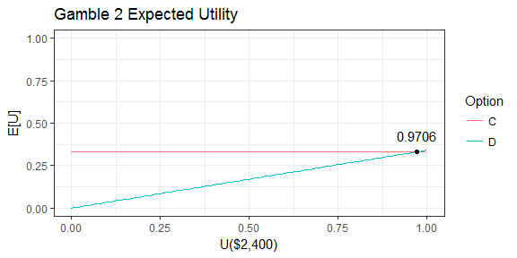

Based on the plot above an expected utility maximizer would choose Option C when x < 0.9706. Option D would be chosen when x > 0.9706.

#### Explain why no expected utility maximizer would prefer both B in Gamble 1 and C in Gamble 2? Discuss these results.

This question is stating that there is a single expected utility maximizer. Given this statement we can safely assume that between Gambles the maximizers utilities do not change. Thus in both Gamble 1 and 2 the utility of winning $2400 (x) remains the same. Looking at the graphs below we see that in both Gambles the two options (A & B in Gamble 1, C & D in Gamble 2) intersect when x equals 0.9706.

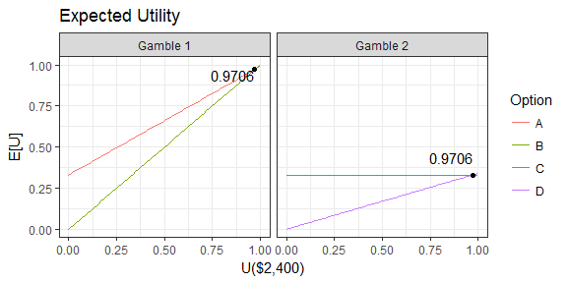

Option B in Gamble 1 (left) **is not** preffered by the maximizer for values of x below 0.9706. Option C in Gamble 2 (right) **is** preffered by the maximizer for values of x below 0.9706. If the expected utility maximizer sets x to 0.5 then they would prefer option A in Gamble 1 and option C in Gamble 2. Likewise if they set x to 0.99 then they would prefer option B in Gamble 1 and option D in Gamble 2.

#### Why do you think many people prefer B in Gamble 1 and C in Gamble 2?

I think people prefer option B in Gamble 1 because it is a sure thing with absolutely no risk. Most people will think in terms of losses rather then only gains when assessing the situation. Part of the findings from Kahneman and Tversky was that people are very risk averse. This is because the idea of a loss feels more painful then the joy of a gain. Therefore anytime a person is given a sure thing, with no chance of a loss, they will usually take it.

People prefer option C in Gamble 2 even though the probability of winning nothing is 1% (0.01) higher then in option D. The difference here is that people often perceive this difference as much smaller then the difference in the first gamble. Even in Gamble 1 you only had a 1% greater probability of losing by going with option A. The difference there however was that 0% chance of winning nothing in option B. The human mind looks at the probabilities of winning nothing 0.67 and 0.66 in Gamble 2 and does not see as drastic a difference as from 0.01 to 0 in Gamble 1.

Site used to understand more about Kahneman and Tversky: <https://www.wired.com/2010/10/the-allais-paradox/>

#### Do you think this is reasonable even if it does not conform to expected utility theory?

Yes because humans are not always rational. I would choose option B in gamble 1 myself. Even after reading about this I would prefer knowing that I will receive something rather then a small chance of getting nothing. Similarly in Gamble 2 the difference from 0.66 to .67 probability of getting nothing seems negligible therefore I would chose the option with the larger prize (C).

# Problem 2

First I set up an array for theta and the prior probability in R.

p2.df <- NULL  
p2.df$theta <- seq(0.025, 0.975, length.out=20)  
p2.df$prior <- 1/20

## A

In part A there are 2 out of 13 rats found with tumors. The code below shows how the posterior probability was calculated.

a.rats <- 13  
a.tumor.rats <- 2  
  
p.A <- p2.df$prior*p2.df$theta^a.tumor.rats*(1-p2.df$theta)^(a.rats-a.tumor.rats)  
p2.df$postA <- p.A/sum(p.A)

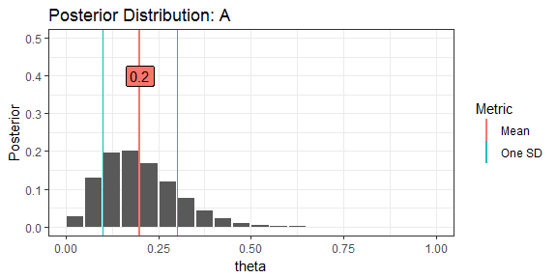

* Posterior Mean = 0.1998465
* Posterior StDev = 0.1001691

## B

In part B 1 out of 18 rats were found with tumors. In B we use the posterior found in A as the prior and not the equally distributed prior used in A.

b.rats <- 18  
b.tumor.rats <- 1  
  
p.B <- p2.df$postA*p2.df$theta^b.tumor.rats*(1-p2.df$theta)^(b.rats-b.tumor.rats)  
p2.df$postB <- p.B/sum(p.B)

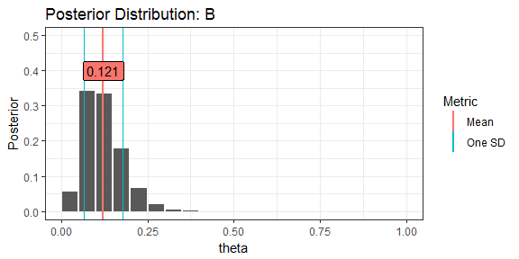

* Posterior Mean = 0.1214895
* Posterior StDev = 0.0559829

## C

In C, 3 out of 31 rats have a tumor, and the original equally distributed prior is used.

c.rats <- 31  
c.tumor.rats <- 3  
  
p.C <- p2.df$prior*p2.df$theta^c.tumor.rats*(1-p2.df$theta)^(c.rats-c.tumor.rats)  
p2.df$postC <- p.C/sum(p.C)

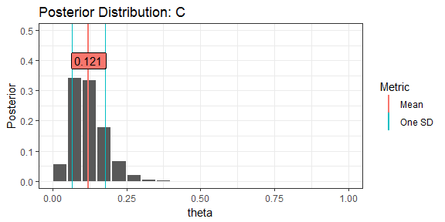

* Posterior Mean = 0.1214895
* Posterior StDev = 0.0559829

Both parts B and C result in the same posterior distribution. Below is a table showing the posterior probabilities for each part.

## theta postA postB postC  
## 1 0.025 2.581609e-02 5.551632e-02 5.551632e-02  
## 2 0.075 1.302091e-01 3.432604e-01 3.432604e-01  
## 3 0.125 1.962765e-01 3.352949e-01 3.352949e-01  
## 4 0.175 2.013859e-01 1.771316e-01 1.771316e-01  
## 5 0.225 1.673568e-01 6.538326e-02 6.538326e-02  
## 6 0.275 1.200447e-01 1.844733e-02 1.844733e-02  
## 7 0.325 7.639551e-02 4.117438e-03 4.117438e-03  
## 8 0.375 4.362168e-02 7.331716e-04 7.331716e-04  
## 9 0.425 2.239153e-02 1.033565e-04 1.033565e-04  
## 10 0.475 1.028251e-02 1.129829e-05 1.129829e-05  
## 11 0.525 4.177418e-03 9.254870e-07 9.254870e-07  
## 12 0.575 1.474258e-03 5.399642e-08 5.399642e-08  
## 13 0.625 4.396060e-04 2.084428e-09 2.084428e-09  
## 14 0.675 1.062390e-04 4.776577e-11 4.776577e-11  
## 15 0.725 1.951171e-05 5.505551e-13 5.505551e-13  
## 16 0.775 2.452284e-06 2.440546e-15 2.440546e-15  
## 17 0.825 1.751000e-07 2.587609e-18 2.587609e-18  
## 18 0.875 4.863914e-09 2.500207e-22 2.500207e-22  
## 19 0.925 1.972046e-11 1.813894e-28 1.813894e-28  
## 20 0.975 1.236827e-16 9.285503e-42 9.285503e-42