Dichrom mart 2017 (KELDYSH/pro5Tibo/dEE=2)
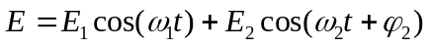, collinear polarization.
Eg0=2.56 eV. 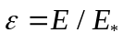, 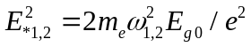 (field amplitudes are normalized on their own E_*). Hydrogen like atom.
monochromatic
For monochrome the code keen3.for is used with K0=2000, Nt0=1000, Nn0=40, dEE=0.0025. Files Tibo2017/dEE=2/keen3/
DLG1030mono.dat, DLG800mono.dat, DLG400mono.dat.
Column 1 – 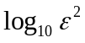,
Column 2 – 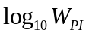 according to text,
Column 3 – 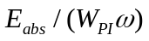 – index of multiphoton ionization,
Column 4 – 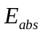 as in the text in 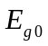 units
Column 5 – 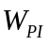,
Column 6 – 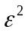.

Accuracy of this
For 1030 nm the above parameters gives huge accuracy.
For 800 nm K0=500 difference in 4-th number, Nn0=30 difference in 5-th number, Nt0=500 – in 5-th number.
For 400 nm , K0=500 difference in 5-th number, Nn0=30 difference in 6-th number, Nt0=500 – 6-th number.

Dichromatic, collinear
ra.for
800x1030 nm
rational, 1- multiple (kratnoe) Furie

K0=101, Nt0=2400, Nn0=3500, dEE=0.05, ISNT-Ifi=Ikz=1. First wave (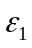) 800 nm, second (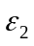) 1030 nm.
Tibo2017/dEE=2/
DLG800raEE2(1030)=0.dat, Dependence on 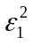, 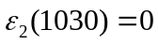;
DLG800raEE(1030)=0_2fi=0.dat 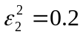, 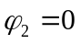;
DLG800raEE(1030)=1fi=0.dat 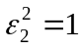, ;
DLG800raEE(1030)=2fi=0.dat 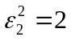, ;
DLG800raEE(1030)=2fi=Pina2.dat , 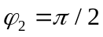;
In this files
Column 1 – ,
Column 2 – ,
Column 3 – in units,
Column 4 – ,
Column 5 –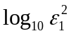.

Error <3%.
The conclusion. The result practically is independent on phase and coincidence with irrational case.
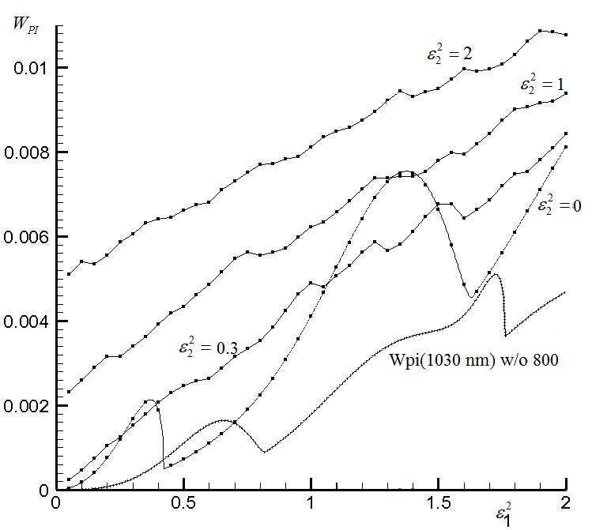
Fig. The dependence of Wpi on (800 nm) for different 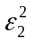. The dependence 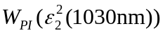 for 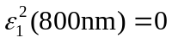 in monochromatic cases is also shown.

It is interesting that the code with irrational which can calculates absorption energy for different waves gives one wave absorbs the energy and another lost.

The case 400 & 800 nm

Tibo2017/dEE=2/400x800
ra.for, rational, K0=201, N0=35, Nt0=800 – huge accuracy.
DLGEE(800)=2fi=0.dat - 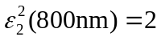, ;
DLGEE(800)=2fi=pina3.dat - , 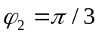;
DLGEE(800)=2fi=pina4.dat - , 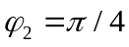;
DLGEE(800)=2fi=pina4.dat - , ;
DLGEE(800)=0_2fi=pina4.dat - , ;
In this files
Column 1 – ,
Column 2 – ,
Column 3 – in units,
Column 4 – ,
Column 5 –.
Note, that in this case dependence on phase 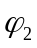 is symmetrical in respect to and has a period 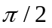.
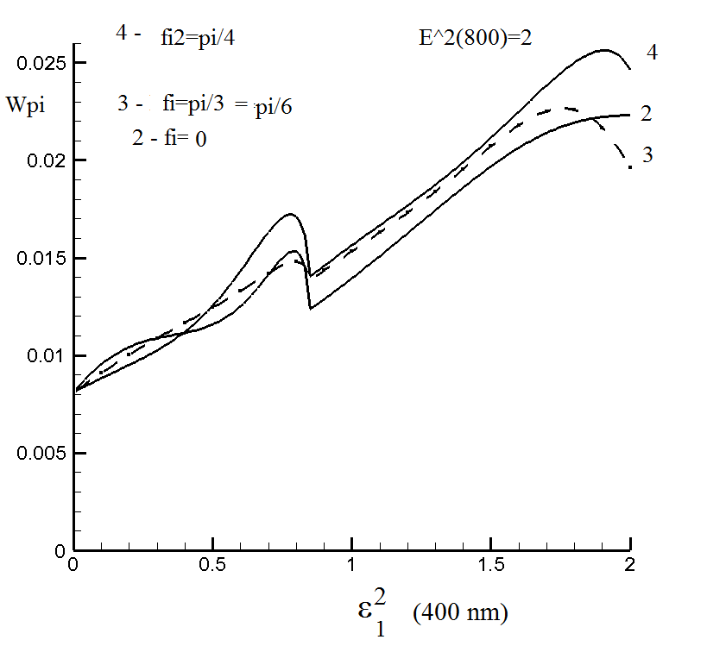
Fig. Dependence Wpi (arbitrary units) on (400 nm) and (800 nm) for different phases .

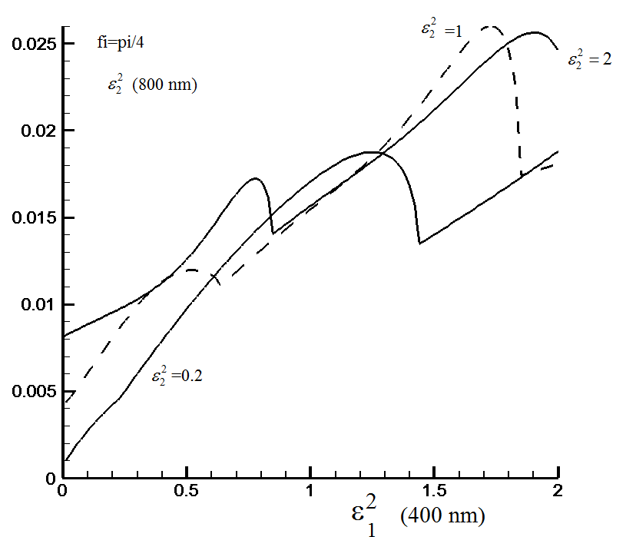
Fig. Dependence Wpi (arbitrary units) on (400 nm) for phase and different (800 nm).

File W400x800fi=pina4.dat – table for 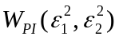, Etot400x800fi=pina4.dat – table for total absorbed energy for .
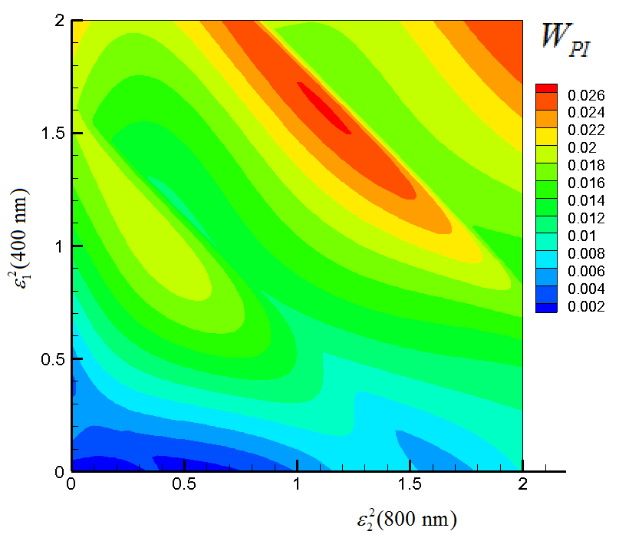
Fig. for 400 & 800nm, .
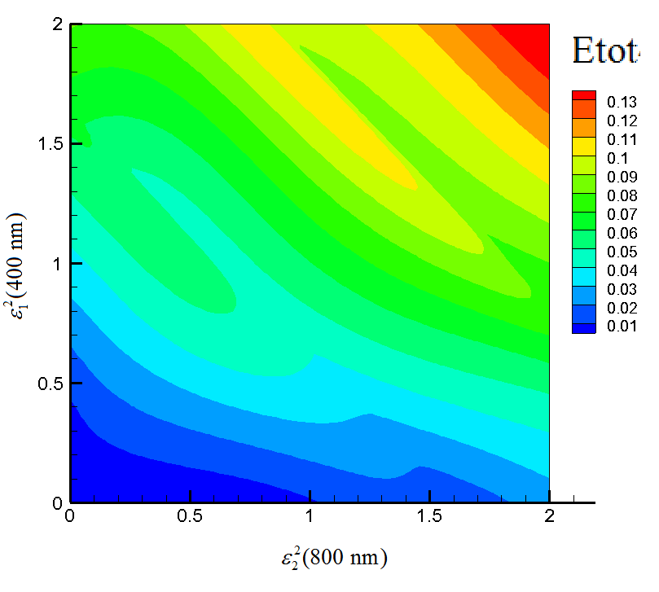
Fig. 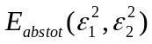 for 400 & 800nm, .

File W400x800fi=0.dat – table for , Etot400x800fi=0.dat – table for total absorbed energy for .

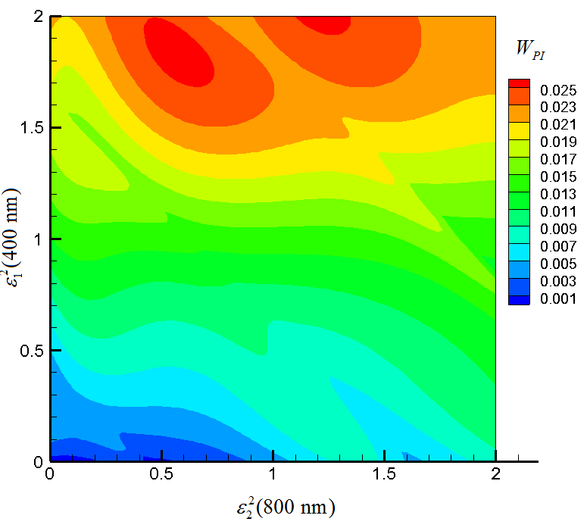
Fig. for 400 & 800nm, .

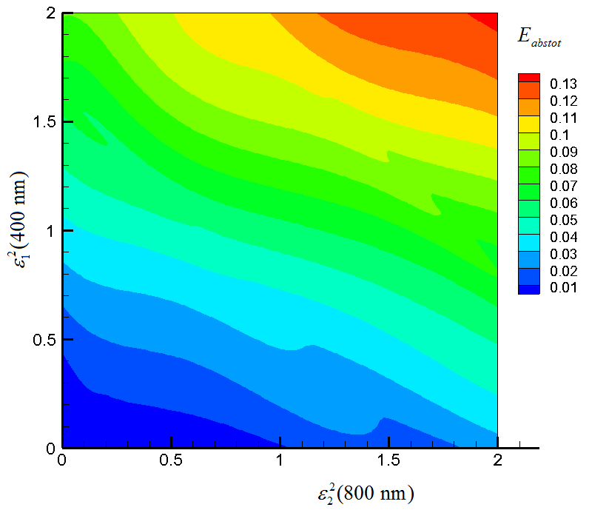
Fig. for 400 & 800nm, .

Conclusion.
- In the case 800x1030 nm (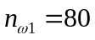, 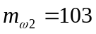) there is not dependence on phase . This corresponds to general theory (numbers 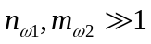). There is not difference which code is used rational or irrational. The calculations in this case take large time because of many m,n-photon processes must be taken into account. In this case the absorbed energy of each wave calculated formally by irrational code can be negative for the wave 800 nm (amplification) and positive (attenuation) for 1030 nm. This is for sufficiently large amplitude of 1030 nm wave (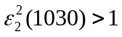).
- In the case 400x800 nm (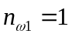, 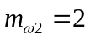) there is dependence on phase. The amplification effect has not place. But this isn’t investigated carefully.
- In the case of fused silica (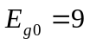 eV) typically was . In presented case of 2.56 eV it is not so.

