Homework 1

Name: Jiyang Tang

Netid: jt304

Written Part

Problem 1: Sort I

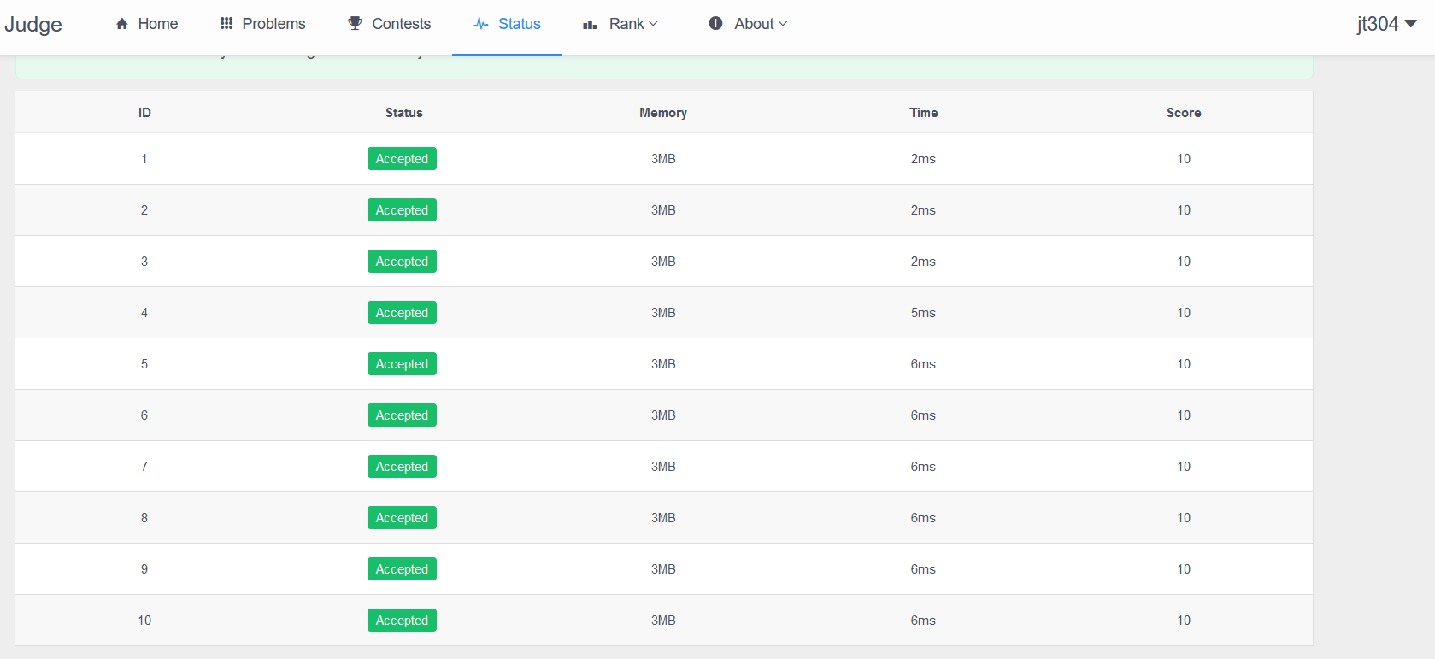

Problem 2: Sort II

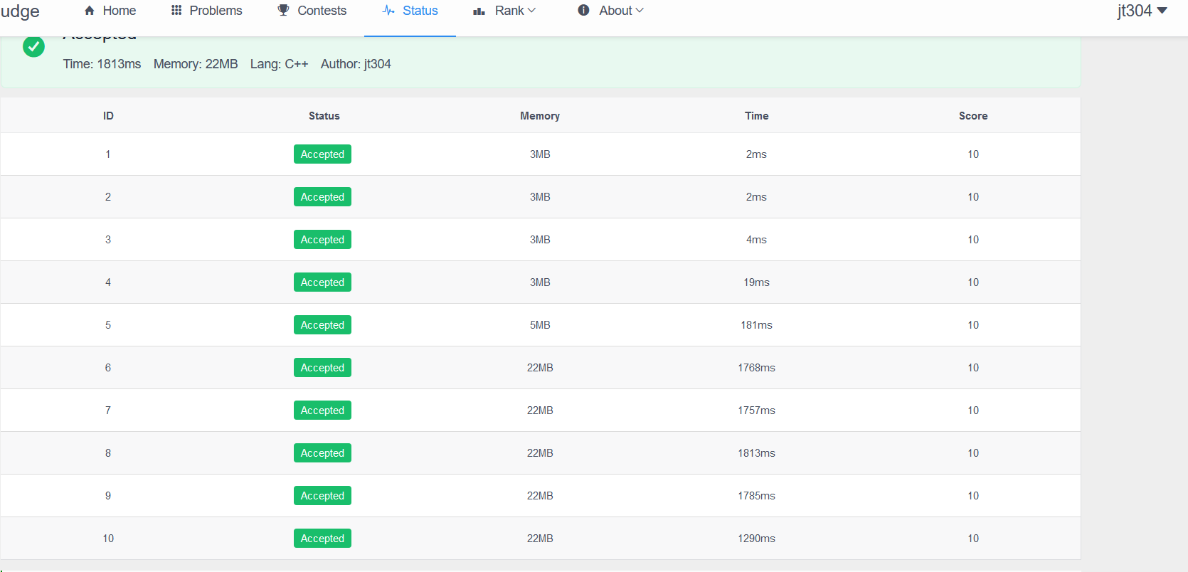

Problem 3: Sort III

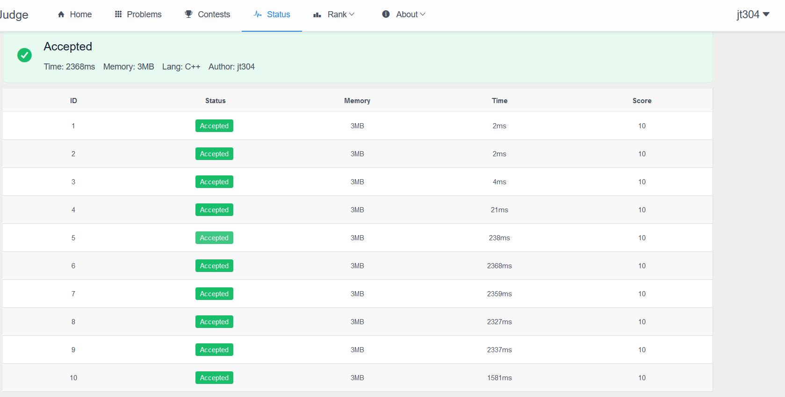

Problem 4: Light Board

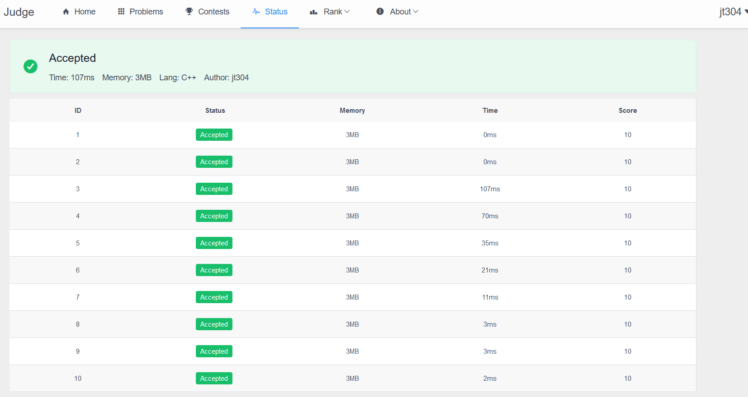

Problem 5: Genius Voting

