Homework 2

Name: Jiyang Tang

Netid: jt304

# Written Part

­

## Pseudocode of quicksort:

I used Hoare partition scheme here.

**function** quicksort(A, lo, hi)

**if** lo < hi

p = partition(A, lo, hi)

quicksort(A, lo, p)

quicksort(A, p + 1, hi)

**function** partition(A, lo, hi)

pivot := A[**floor**((hi + lo) / 2)]

i = lo - 1

j = hi + 1

**while true**

**do**

i = i + 1

**while** A[i] < pivot

**do**

j = j - 1

**while** A[j] > pivot

**if** i >= j

**return** j

swap A[i] with A[j]

The worst case occurs when one of the sublists returned by all partitioning routines are of size 2 less than the previous list (minus pivot and one element).

For example, [1, 3, 2, 4, 5] will be partitioned to [] and [3, 2, 4, 5], [3, 2, 4, 5] will be partitioned to [2] and [4, 5], and [4, 5] will be partitioned to [] and [5].

Then the time complexity of the worst case is $O(n^{2})$. Since we need to make $\frac{n-1}{2}$ partition calls to get a list of size 1, and each partition call has $O(n)$ complexity because it iterates through all elements in the list. So the overall time complexity is $O\left(n\frac{n-1}{2}\right)=O(n^{2})$.

The best case occurs when all sublists returned by all partitioning routines are of size $\frac{n-1}{2}$, where $n$ is the size of the previous list. That means the number of calls to the partition routine is slightly less than $\log_{2}{n}$. Similarly, the partition routine has $O(n)$ complexity, and the overall time complexity is $O(n\log_{2}{n})$.

## Problem 7-3 in Intro to Alg

1. Since we assume that all permutations of the input numbers are equally likely, then the probability of an element being chose as the pivot is $\frac{1}{n}$. Then $X_{i}$ follows uniform distribution, which means $E\left[X_{i}\right]=\frac{1}{n}$.
2. Let $T_{q}\left(n\right)$ be the running time of a recursive call in which the $q$-th smallest element is chose as the pivot, then $$E\left[T_{q}\left(n\right)\right]=E[X_{q}(T\left(q-1\right)+T\left(n-q\right)+Θ\left(n\right))]$$

Where $T(q-1)$ is the time of the shorter sublist, and $T(n-q)$ for the other one, while $Θ(n)$ is the time of the partition procedure.

$$E\left[T\left(n\right)\right]=\sum_{q=1}^{n}{E(T_{q})}$$

$$=\sum_{q=1}^{n}{E\left[X_{q}\left(T\left(q-1\right)+T\left(n-q\right)+O\left(n\right)\right)\right]}$$

$$=E\left[\sum_{q=1}^{n}{X_{q}\left(T\left(q-1\right)+T\left(n-q\right)+O\left(n\right)\right)}\right]$$

$$E\left[\sum_{q=1}^{n}{X_{q}\left(T\left(q-1\right)+T\left(n-q\right)+O\left(n\right)\right)}\right]$$

$$=\sum_{q=1}^{n}{E\left[X_{q}\left(T\left(q-1\right)+T\left(n-q\right)+O\left(n\right)\right)\right]}$$

$$=\sum_{q=1}^{n}{\frac{\left(T\left(q-1\right)+T\left(n-q\right)+O\left(n\right)\right)}{n}}$$

$$=\frac{1}{n}\sum_{q=1}^{n}{T\left(q-1\right)}+\frac{1}{n}\sum_{q=1}^{n}{T\left(n-q\right)}+\frac{1}{n}\sum_{q=1}^{n}{O\left(n\right)}$$

$$=\frac{1}{n}\sum_{q=1}^{n}{T\left(q-1\right)}+\frac{1}{n}\sum_{u=0}^{n-1}{T\left(u\right)}+O\left(n\right)$$

$$=\frac{2}{n}\sum_{q=0}^{n-1}{T\left(q\right)}+O\left(n\right)$$

$$=\frac{2}{n}\sum_{q=0}^{n-1}{T\left(q\right)}+\frac{2E[T(0)]}{n}+\frac{2E[T(1)]}{n}+O(n)$$

$$=\frac{2}{n}\sum_{q=2}^{n-1}{T\left(q\right)}+O\left(n\right)$$

$$\sum_{k=2}^{n-1}{k\lg{k}}=\sum_{k=2}^{\frac{n}{2}}{k\lg{k}}+\sum_{k=\frac{n}{2}+1}^{n-1}{k\lg{k}}$$

$$≤\sum_{k=1}^{\frac{n}{2}}{k\lg{k}}+\sum_{k=\frac{n}{2}+1}^{n}{k\lg{k}}$$

$$≤\sum_{k=1}^{\frac{n}{2}}{k\lg{\frac{n}{2}}}+\sum_{k=\frac{n}{2}+1}^{n}{k\lg{n}}$$

$$=\lg{\frac{n}{2}}\sum_{k=2}^{\frac{n}{2}}{k}+\lg{n}\sum_{k=\frac{n}{2}+1}^{n}{k}$$

$$=\left(\lg{n}-\lg{2}\right)\frac{\frac{n}{2}\left(\frac{n}{2}+1\right)}{2} +\left(\lg{n}\right)\left(\frac{n\left(n+1\right)}{2}-\frac{\frac{n}{2}\left(\frac{n}{2}+1\right)}{2}\right)$$

$$=\frac{n\left(n+1\right)}{2}\lg{n}-\frac{\frac{n}{2}\left(\frac{n}{2}+1\right)}{2}$$

$$=\frac{n^{2}}{2}\lg{n}+\frac{n}{2}\lg{n}-\frac{n^{2}}{8}-\frac{n}{4}$$

$$≤\frac{n^{2}}{2}\lg{n}-\frac{n^{2}}{8}$$

$$E\left[T\left(n\right)\right]=\frac{2}{n}\sum_{q=2}^{n-1}{T\left(q\right)}+O\left(n\right)$$

$$≤\frac{2}{n}\sum_{q=2}^{n-1}{an\lg{n}}+O\left(n\right)$$

$$≤\frac{2a}{n}\left(\frac{n^{2}}{2}\lg{n}-\frac{n^{2}}{8}\right)+O\left(n\right)$$

$$=an\lg{n}-\frac{a}{4}n+O\left(n\right)$$

$$≤an\lg{n}+O(n)$$

So

$$E\left(T\left(n\right)\right)=O(n\lg{n})$$

# DKUOJ

NOTE that the submission code is generated using gen_single_file_cpp.sh source_file generated_file

Problem 7: Ten Integers

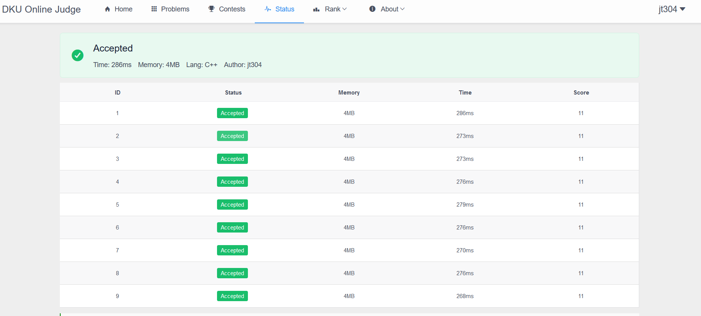

Problem 24: Sum of Three

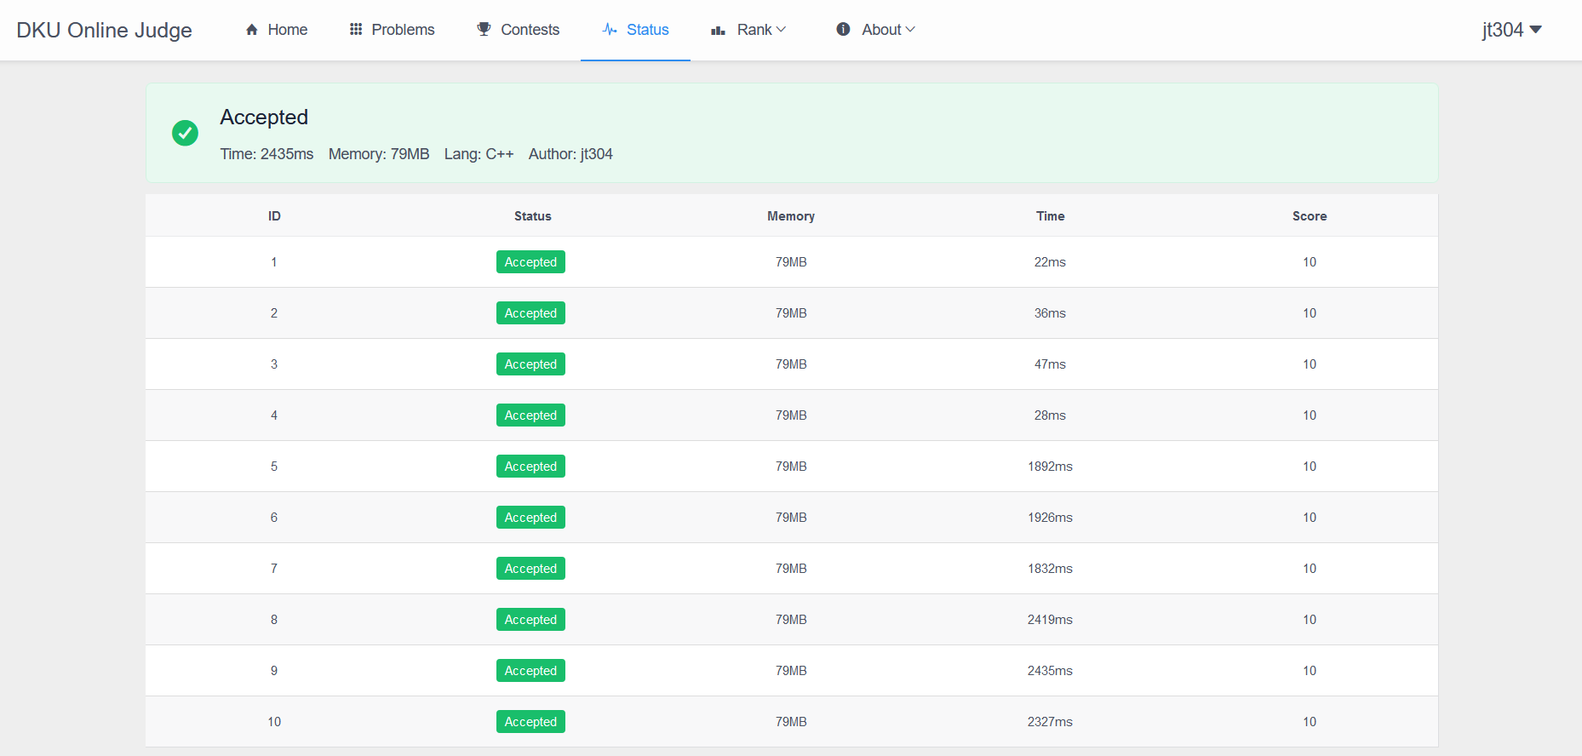

Problem 25: Ten Integers

