Homework 3

Name: Jiyang Tang

NetID: jt304

# Written Part

## 12.3-3

Worst case: $O(n^{2})$, when the tree-insert operations created a linear chain of nodes

Best case: $O(n\lg{n})$, when the tree-insert operations created a binary tree of height $\lg{n}$.

## 12-1

1. Each insertion will add the element to the right of the rightmost leaf according to the code. Thus, the running time is
$$\sum_{i=1}^{n}{i}=O(n^{2})$$

2. This strategy will result in each of the two children subtrees having a difference in size at most one. This means that the height of the tree will be $O(\lg{n})$. So, the total runtime will be
$$\sum_{i=1}^{n}{\lg{n}}=O(n\lg{n})$$

3. This will only take linear time. Because the tree itself will be height $0$, and a single insertion into a list can be done in constant time.
4. Worse case: every random choice is to the right (or all to the left) this will result in the same behavior as in (a)

$$O(n^{2})$$

Expected running time: roughly speaking, we will pick left roughly half the time, so the tree will be almost balanced. Therefore, we have that the depth is roughly $O(\lg{n})$. Then the running time is

$$O(n\lg{n})$$

# DKUOJ

Problem 5

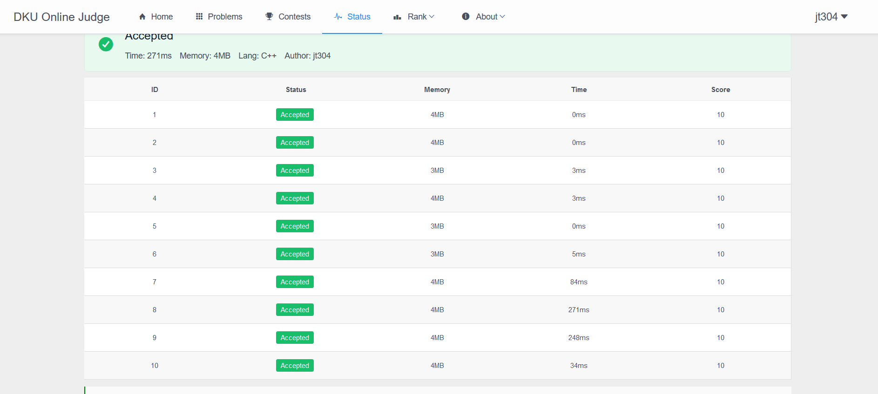

Problem 6

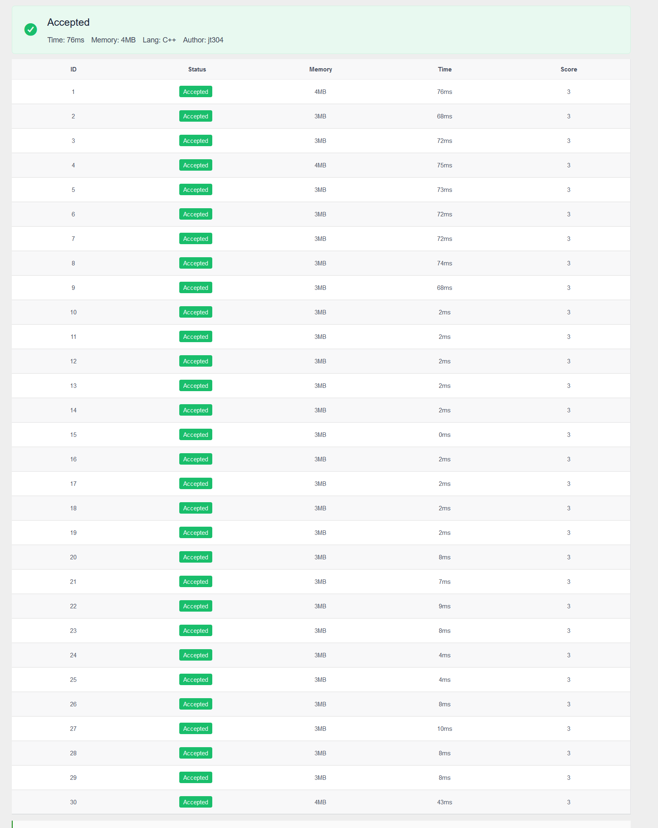

Problem 15

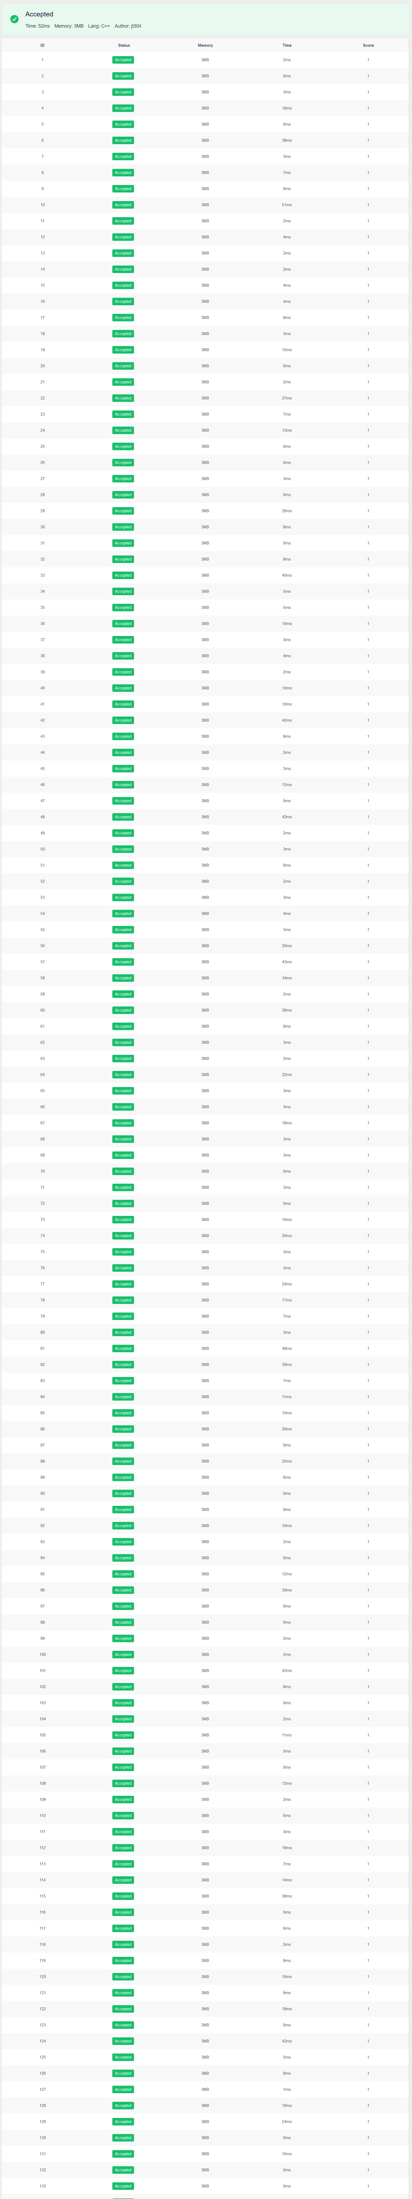

Problem 21

