1. Problem
Compute coefficients for IIR Biquadratic Fractional Delay Filter to obtain desired fractional latency.

2. Math
1. According to [1] general closed form formula for IIR FDF filter with H(z) transfer function
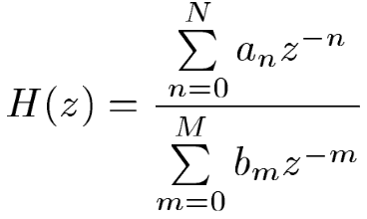
that can be used to find coefficients is
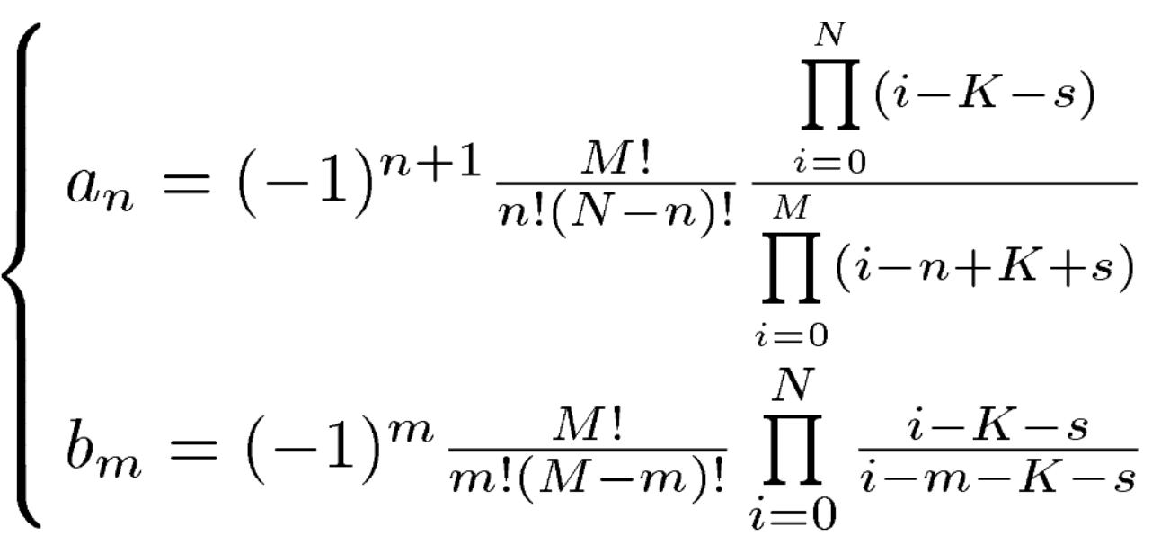
where M, N are IIR polynomial orders, K is desired integer delay, -0.5 >= s >= 0.5 is desired fractional delay.
2. According to [1] the filter is stable if
K + s > N – 1
3. According to [1] for maxflat FDF filters a_{n} = b_{N-n}

3. Implementation
1. General implementation for any-order IIR: calculate_fdf_coeff.m
2. Optimized implementation for biquad filter (N=M=2): calculate_biquad_fdf_coeff.m
3. Optimized implementation for bilinear(?) filter (N=M=1): calculate_bilinear_fdf_coeff

4. Example
With sampling time T = 1ms and selected fractional delay 1.5ms (K = 1, s = 0.5)
>> fdf

numerator =
-0.028571 0.400000 1.000000

denominator =
1.000000 0.400000 -0.028571

Transfer function 'sys' from input 'u1' to output ...

-0.02857 z^2 + 0.4 z + 1
y1: ------------------------
z^2 + 0.4 z - 0.02857

Sampling time: 0.001 s
Discrete-time model.

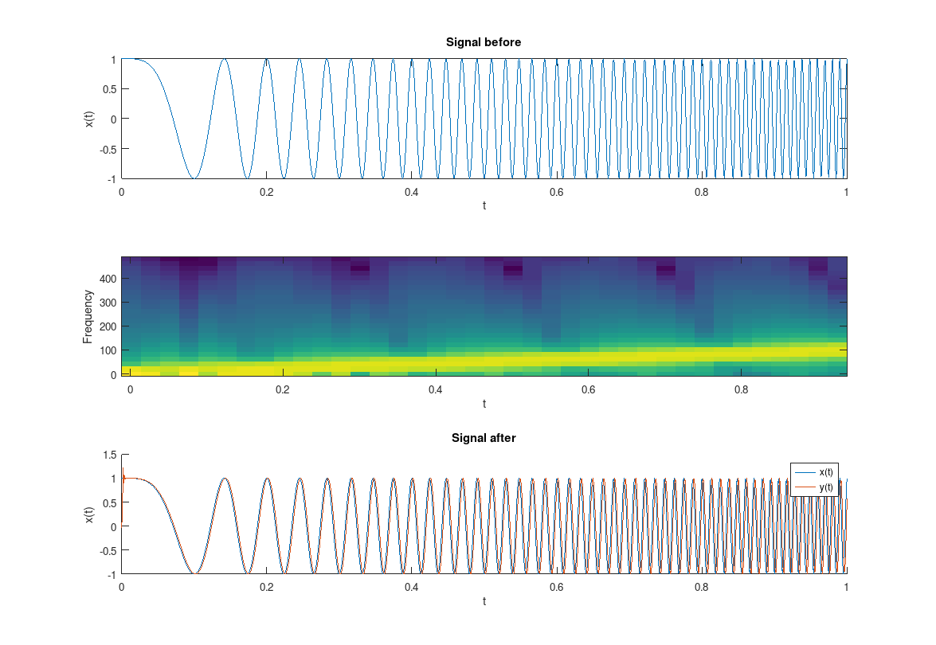
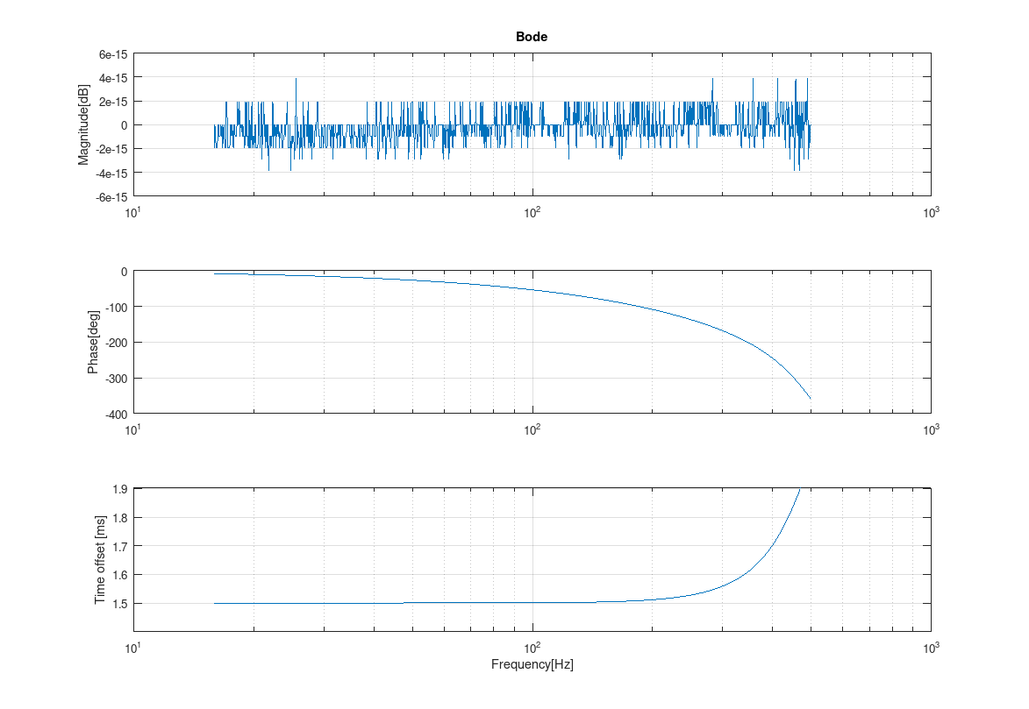

5. Findings
1. It was empirically verified that in order for biquad (N=M=2) FDF filter to be stable, it must introduce at least one sample delay (K >= 1), which is in accordance with above stability condition K + s > N – 1
2. In order to go below 1 sample delay (K = 0), while preserving the above stability condition, N=M=1 can be used, so the filter becomes bilinear, instead of biquadratic. Possible higher output distortion to consider.
3. For biquad FDF filter only 2 coefficients are required instead of 5-6, as a_{n} = b_{N-n}

5. Sources
[1] Closed-Form Design of Maxflat Fractional Delay IIR Filters, Xi Zhang, 2009

