Practical-2

AIM: Perform Router on Stick. Use four computers (assign each VLAN two computers), a switch between router and computer systems, and a router. Then divide the router interface virtually (e.g., Gig 0/0/0.1 or Gig 0/0.1) in order to accept traffic from VLANs 10

Step 1: Open Cisco Packet Tracer.
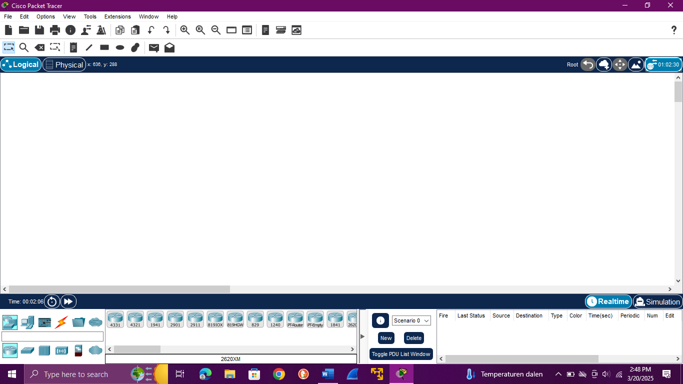

Analysis: This step initializes the simulation environment where devices and network topologies can be virtually created and configured.

.

Step 2: Add one router, one switch, and two PCs to the workspace.
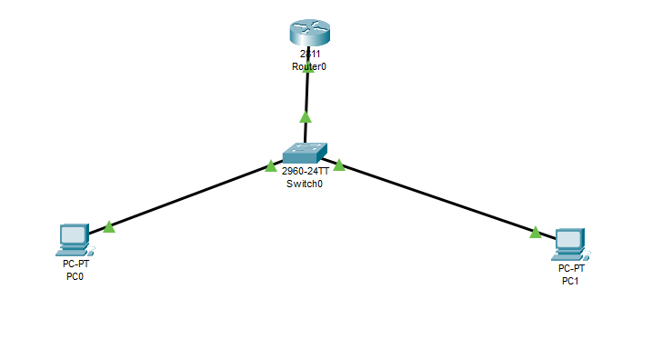
Analysis: These are the essential components needed to simulate VLAN setup and routing. The router performs inter-VLAN routing, the switch manages VLAN segmentation, and PCs act as host devices.

Step 3: Use copper straight-through cables to connect:
PC0 → Switch (Fa0/2)
PC1 → Switch (Fa0/3)
Switch (Fa0/1) → Router (Fa0/0)

Analysis: Appropriate cabling ensures devices are physically connected. The router is connected to the switch via a trunk port for VLAN tagging and routing.
Step 4: Open the switch CLI, enter privileged EXEC mode using enable, then enter global configuration mode using configure terminal.

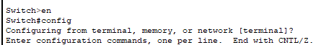

Analysis: Privileged EXEC mode allows administrative-level commands; configuration mode enables setup of VLANs, interfaces, and other networking features.
Step 5: Create two VLANs using:
vlan 10
name Finance
exit
vlan 20
name Test2
exit
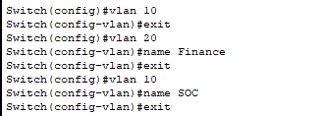
Analysis: VLANs logically segment the network. Naming them improves identification, especially in larger networks.

Step 6: Assign switch ports to VLANs:
interface fa0/1
switchport access vlan 10
exit
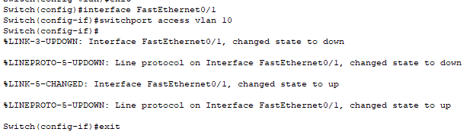
interface fa0/2
switchport access vlan 20
exit
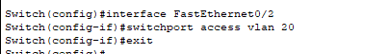
Analysis: Assigning access ports to specific VLANs ensures each PC belongs to its designated VLAN. VLAN 10 → PC0, VLAN 20 → PC1.

Step 7: Configure the switch’s trunk port (Fa0/1):
interface fa0/1
switchport mode trunk
exit
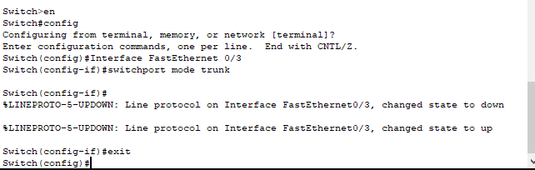
Analysis: The trunk port allows traffic from multiple VLANs to pass through the switch-router link. This is essential for Router-on-a-Stick setup.

Step 8: Open the router CLI and enable the interface using:
interface fa0/0
no shutdown
exit
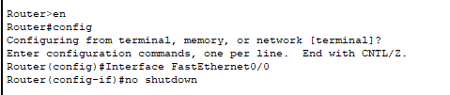
Analysis: The physical router interface must be up to allow subinterfaces (virtual interfaces for VLANs) to function.

Step 9: Configure router subinterfaces:
interface fa0/0.10
encapsulation dot1Q 10
ip address 192.168.10.1 255.255.255.0
exit
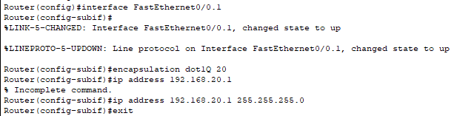
interface fa0/0.20
encapsulation dot1Q 20
ip address 192.168.20.1 255.255.255.0
exit
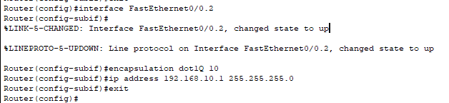
Analysis: Subinterfaces route traffic between VLANs. The dot1Q command tags the VLAN ID. IP addresses act as gateways for each VLAN.

Step 10: Assign IP addresses to PCs:
PC0 (VLAN 10):
IP: 192.168.10.3
Subnet: 255.255.255.0
Gateway: 192.168.10.1
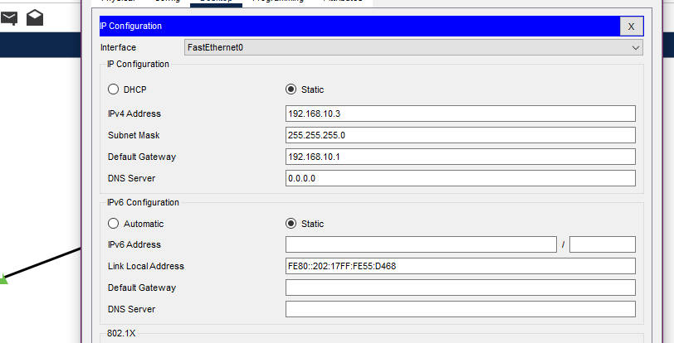
PC1 (VLAN 20):
IP: 192.168.20.3
Subnet: 255.255.255.0
Gateway: 192.168.20.1
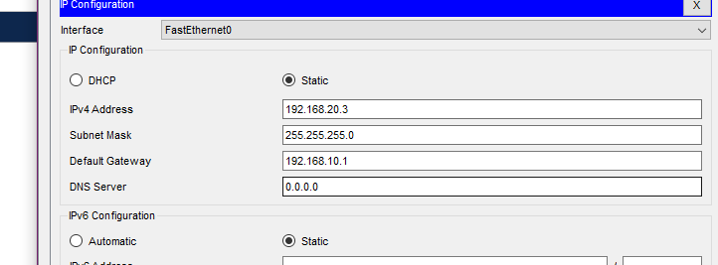
Analysis: Static IP assignment ensures the PCs are on the correct network. The gateway allows communication outside their VLAN through the router.

Step 11: Test connectivity using ping between PC0 and PC1.
Analysis: Successful pings confirm that routing between VLANs is functioning properly through the configured subinterfaces.
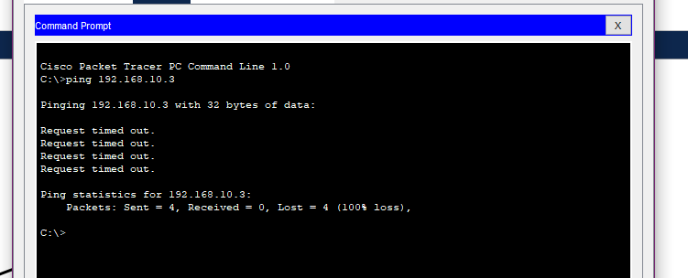

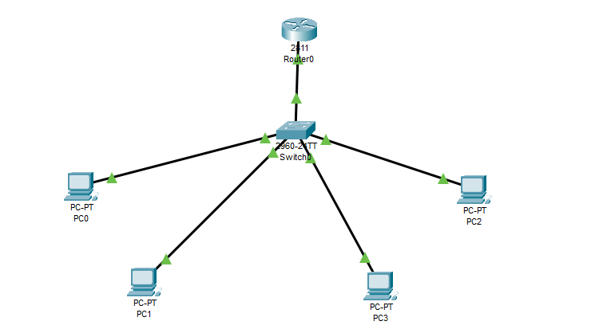

Conclusion: The Router-on-a-Stick configuration was successfully implemented using a single router interface with subinterfaces for VLAN 10 and VLAN 20. Through correct trunking and VLAN configuration, inter-VLAN communication was achieved. This setup demonstrates efficient use of router resources and proper network segmentation using VLANs in a simulated environment.

