
VENDOR-READY ARCHITECTURE REFERENCE

Digital Learning Portal
Target Architecture
A multi-tenant, edition-aware, mobile-ready and AI-governed platform for Bhagavad Gita learning across organisations, schools and public programmes.
Architecture intent One trusted request context controls tenant, programme, scripture edition, language, age policy, role and entitlement across every channel and service.
VERSION 1.0 | 1 September 2026 | External development brief
Companion editable file: Living_Bliss_Portal_Architecture_Editable.pptx
CONFIDENTIAL — FOR AUTHORISED EVALUATION AND DELIVERY PARTNERS

DOCUMENT GUIDE

Purpose and use
This document translates the portal architecture into an implementation reference that a delivery organisation can estimate, design, build and operate.
Editable source The companion PowerPoint is the diagram master. Every box, label and connector is editable in Microsoft PowerPoint and remains editable after import into Google Slides or Canva.

Document status
Attribute | Value
Status | Target architecture for vendor discovery, solution design and phased implementation
Product scope | Responsive web/PWA, iOS and Android, role workspaces, content operations, learning, assessment, reporting and approved AI assistance
Primary launch | Living Bliss Bhagavad Gita learning pathway, expandable to all 18 chapters and future programmes
Expansion model | White-label tenants for spiritual organisations, schools, public bodies and international partners
Companion documents | Product Design Blueprint and UI Wireframes Technical Design; align all detailed delivery artefacts with their approved requirements

Contents
- 1. Executive architecture statement and key decisions
- 2. Design principles and system context
- 3. Target layered architecture
- 4. Platform domains, data and integrations
- 5. AI architecture and governance
- 6. Security, privacy, safeguarding and operations
- 7. Non-functional requirements and delivery roadmap
- 8. Vendor deliverables, decisions and glossary

1. Executive architecture statement
Living Bliss should be built as a configurable learning platform, not as a single-organisation content website.
The platform will preserve the current Living Bliss experience while introducing a clear separation between shared product capability and tenant-controlled doctrine, branding, programmes, translations, commentaries, media, policies and reporting. A request is not valid until its tenant and learning context are resolved. This prevents content leakage, protects publication rights and makes the same codebase usable by organisations such as ISKCON, Chinmaya Mission, BAPS, schools and government programmes.

1.1 Target outcome
- A responsive laptop and desktop experience, a mobile-first PWA, and native iOS/Android applications using the same versioned platform APIs.
- A complete learning journey from prerequisite knowledge and orientation through all 18 chapters, assessments, reflection, progress tracking and credentials.
- White-label tenant editions with organisation-owned translations, guru commentaries, branding, age policies, language packs and approved AI knowledge boundaries.
- School-ready cohort, teacher, guardian/consent, roster, assignment, reporting and accessibility capabilities.
- An AI-ready foundation in which assistance is tenant-scoped, source-grounded, rights-aware, cited, evaluated and reversible.

1.2 Architecture decisions
Decision | Position
Product model | Multi-tenant software platform with configurable editions and programmes
Initial backend | Modular monolith with explicit domain boundaries and asynchronous events
Channels | Responsive web/PWA first; native mobile clients reuse the same API contracts
Content authority | Curated, versioned and approved source material; AI never becomes the canonical scripture repository
AI pattern | Provider-neutral AI gateway plus tenant-scoped retrieval, safety, rights filtering, citations and audit
Integration posture | Standards-oriented identity, school, assessment and analytics interfaces behind adapters

2. Architecture principles
One trusted context Tenant, programme, edition, language, role, age policy and entitlement are resolved at the edge and propagated as verified claims.
Configuration before custom code Differences between organisations are represented as policies, content packages, workflows and theme tokens wherever practical.
Doctrine remains authoritative Scripture, translation and commentary are curated scholarly assets with provenance, rights, review and publication status.
API-first and channel-neutral Web and mobile clients consume versioned contracts; business rules do not live only in a user interface.
Offline-aware learning Course structure, authorised media and progress events can be cached and synchronised using explicit conflict rules.
Privacy and safeguarding by design Child data, consent, private reflections, retention and support escalation are separate design concerns, not post-launch additions.
AI is assistive and replaceable AI providers sit behind an internal gateway, cannot bypass rights and policy checks, and can be disabled without interrupting core learning.
Observable and recoverable Every critical workflow emits auditable events, defined service indicators and recoverable state transitions.

3. System context and boundaries

3.1 Actors and channels
- Learner: discovers a programme, completes readiness content, studies chapters and verses, reflects, completes assessments and tracks progress.
- Teacher or facilitator: manages cohorts, assignments, discussions, interventions, assessment review and classroom reporting.
- Content scholar/editor: imports source texts, establishes canonical verse mappings, prepares translations and commentaries, reviews media and publishes editions.
- Tenant administrator: manages brand, domains, languages, policies, SSO, roles, licences, integrations and organisation-level reporting.
- Platform operations: manages tenant provisioning, availability, security, support, feature flags, releases, data recovery and AI provider controls.
- Guardian or school administrator: manages consent, roster and learner access where age and local policy require it.

3.2 Inside the product boundary
- Identity, consent and role scopes; tenant and programme configuration; catalogue and discovery.
- Canonical scripture structure, edition content, publishing workflow, rights and provenance.
- Learning pathways, progress, bookmarks, notes, reflection, offline sync, assessment and credentials.
- Notifications, reporting, analytics events, integration adapters and governed AI assistance.

3.3 External dependencies
- Identity providers and school SSO; email and push delivery; media transcoding/CDN; payment or entitlement services if commercial access is introduced.
- School information and learning platforms through approved roster, launch, assessment and result interfaces.
- Approved AI and safety providers through internal adapters; no client application connects directly to a public model endpoint.

ARCHITECTURE VIEW

4. Target layered architecture
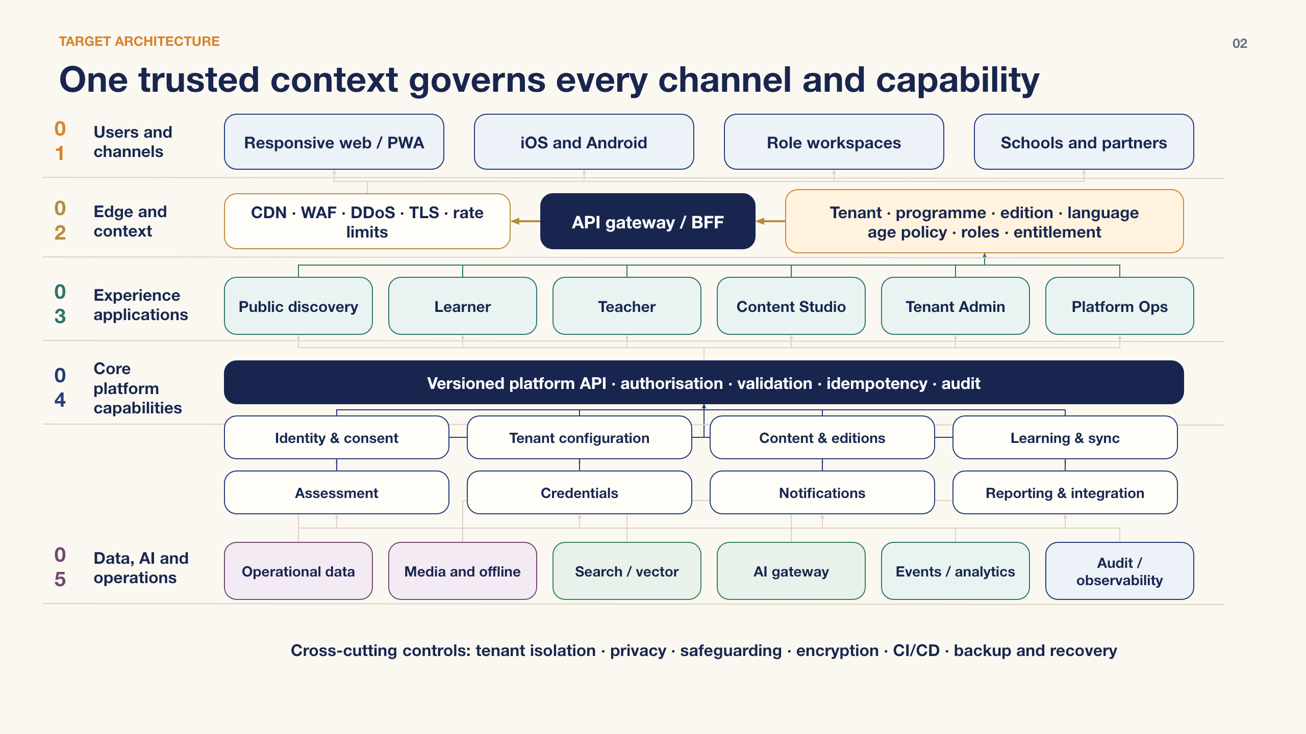
Figure 1 — One trusted tenant and learning context governs every user channel, experience application and platform capability.

4.1 Users and channels
Laptop and desktop screens should use the available horizontal space for persistent course navigation, parallel scripture/translation/commentary reading and contextual notes. Tablet and phone layouts progressively collapse into focused study steps. The PWA provides rapid reach and offline support; native applications add deeper device integration and store distribution where justified.
Laptop design requirement Use a 12-column responsive grid, persistent left course navigation, a central reading/learning canvas and an optional right context panel. Preserve a distraction-free reading mode and keyboard navigation.

4.2 Edge and trusted context
- CDN, web application firewall, DDoS protection, TLS enforcement and rate limits protect public entry points.
- The backend-for-frontend resolves host/domain, tenant, programme, edition, language, age policy, authentication state, role and entitlement before invoking domain services.
- Context claims are signed or server-held, short-lived and validated on every privileged operation; the client cannot nominate an unrestricted tenant or edition identifier.

4.3 Experience applications
Application | Primary responsibility
Public discovery | Tenant-branded catalogue, programme information, scripture browsing, preview, search and enrolment entry
Learner | Onboarding, readiness pathway, chapter learning, verse study, media, reflection, assessment, progress and credentials
Teacher | Cohorts, assignments, facilitation, interventions, review, attendance and class reporting
Content Studio | Structured import, canonical mapping, rights, scholarly review, localisation, release and rollback
Tenant Admin | Brand, domains, policies, users, roles, entitlements, integrations, retention and reporting
Platform Ops | Provisioning, support, security operations, releases, feature flags, observability and recovery

4.4 Core capability layer
All write operations pass through a versioned platform API that performs authorisation, validation, idempotency, audit and tenant isolation. Domain modules own their rules and storage access; clients and integration adapters do not write directly to operational databases.

4.5 Data, AI and operations
- Relational operational data remains the source of truth for users, configuration, enrolment, content metadata, learning state and assessment results.
- Encrypted object storage holds approved media and content packages; tenant-aware CDN rules protect licensed assets.
- Search and vector indexes are derived stores and must retain tenant, edition, rights, language and publication filters.
- Events support analytics, notifications, integration and asynchronous jobs; audit evidence is append-oriented and access-controlled.

4.6 Cross-cutting control implementation
- Tenant isolation, privacy, safeguarding and encryption are enforced in shared libraries and verified by automated negative tests.
- Feature flags are scoped by environment and tenant, include an owner and expiry, and never replace durable authorisation checks.
- CI/CD produces signed, traceable releases with database migration checks, security gates and automatic rollback criteria.
- Backup and recovery controls cover operational data, content, configuration, search rebuilds and the evidence needed to restore a tenant safely.
- Architecture decisions and policy versions are retained so operational behaviour can be reconstructed for support, audit and incident review.

ARCHITECTURE VIEW

5. Platform domains, data and integration
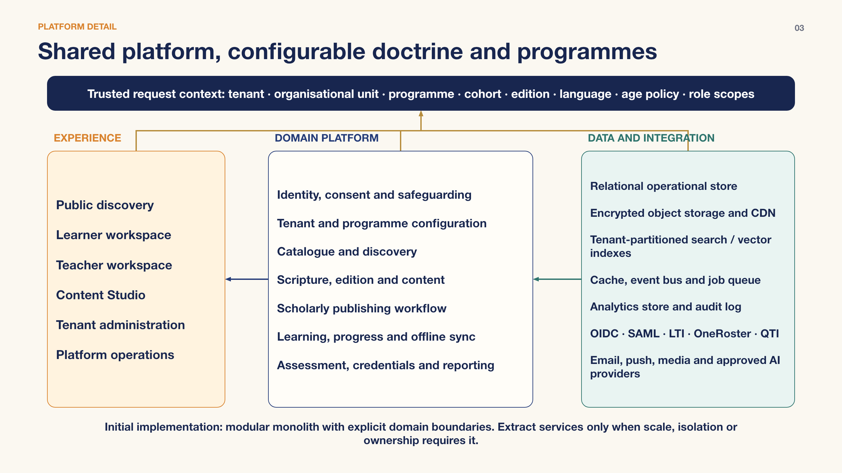
Figure 2 — Shared platform capability remains central while organisation-specific doctrine, editions and programmes remain configurable.

5.1 Domain responsibilities

Identity, consent and safeguarding
Accounts, authentication links, SSO, guardian relationships, consent evidence, age policy, session assurance, role scopes and safeguarding escalation.

Tenant and programme configuration
Brand, domains, organisational units, locale, feature policy, programme structure, cohort rules, entitlement and integration settings.

Catalogue and discovery
Public metadata, search facets, recommendations based on approved catalogue data, preview and enrolment eligibility.

Scripture, edition and content
Canonical chapter/verse identifiers, source texts, translation variants, commentary, glossary, media, provenance, licences and publication releases.

Scholarly publishing
Draft, review, doctrinal approval, rights approval, localisation, scheduling, publication, withdrawal and immutable release history.

Learning, progress and sync
Pathways, prerequisites, enrolment, completion rules, bookmarks, notes, reflection, device checkpoints and conflict-safe progress events.

Assessment and credentials
Item banks, quizzes, assignments, rubrics, attempts, moderation, results, certificates and revocation.

Notifications and reporting
Preference-aware messages, operational alerts, learner/teacher dashboards, institutional exports and privacy-controlled analytics.

5.2 Initial modular structure
Recommended starting point Deploy a modular monolith with explicit domain packages, separate schemas or ownership boundaries, contract tests and an internal event bus. Extract services only when measured scale, isolation, deployment cadence or team ownership creates a clear benefit.
- This approach reduces distributed-system complexity during product discovery while preserving future extraction paths.
- No module may query another module's tables directly; it uses an application interface, published read model or versioned event.
- Long-running work such as media processing, bulk imports, search indexing and notification delivery runs in resilient job workers.

6. Data architecture

6.1 Core information model
Entity group | Representative records and design rule
Organisation | Tenant, organisational unit, brand, domain, policy set, integration and subscription/entitlement
Programme | Programme, pathway, module, chapter, lesson, prerequisite, cohort, assignment and completion rule
Scripture | Canonical work, chapter, verse, segment and stable source identifier independent of a translation
Edition | Edition, source text, translation, transliteration, commentary, scholar, language, licence, provenance and publication release
Learning | Learner, enrolment, activity attempt, progress event, bookmark, private note, reflection, sync checkpoint and credential
Assessment | Item, rubric, assessment version, attempt, response, score, moderation decision and result release
Governance | Consent, access decision, audit event, AI request evidence, policy version, retention hold and deletion action

6.2 Canonical content and editions
- A stable canonical chapter/verse model links every translation and commentary without treating one organisation's edition as the universal default.
- Published content is immutable by release; corrections create a new version with an effective date, reason and approver trail.
- Rights metadata controls countries, tenants, channels, offline availability, AI retrieval eligibility, quotation limits and expiry.
- Search documents and AI chunks inherit source identifiers, edition, language, rights, publication status and citation anchors.

6.3 Learning state and offline synchronisation
- Clients write append-style progress events with device, timestamp, content version and idempotency key; the server derives current completion state.
- Deterministic merge rules resolve repeated completion, playback position and bookmarks. Free-text conflicts are preserved as separate revisions rather than silently overwritten.
- Offline packages are signed, expiry-aware and restricted by tenant rights. Logout, entitlement withdrawal or policy change invalidates protected cached material when the device reconnects.

6.4 Analytics and retention
- Operational records, product analytics, institutional reports and security audit evidence use separate access paths and retention policies.
- Analytics events use pseudonymous identifiers where full identity is unnecessary; sensitive free text is excluded by default.
- Deletion and export workflows are tenant-aware, legally reviewable and observable; backups follow the same retention and access model.

7. API and integration architecture

7.1 API conventions
- Resource-oriented HTTPS APIs for interactive operations, explicit API versions, documented error contracts and correlation identifiers.
- Idempotency keys for enrolment, submission, payment/entitlement and offline sync writes; optimistic concurrency for editable resources.
- Cursor pagination for large collections, content hashes/ETags for caching, and time-bounded signed URLs for protected media.
- Machine-readable contracts, generated client types, automated backward-compatibility tests and deprecation windows.

7.2 Events and asynchronous work
Domain events communicate durable facts such as LearnerEnrolled, ContentReleasePublished, AssessmentSubmitted and CredentialIssued. Consumers must be idempotent, retries use back-off and dead-letter handling, and external delivery uses an outbox or equivalent atomic publication pattern.

7.3 External interfaces
Interface family | Use and boundary
OIDC / SAML | Organisation and school single sign-on through tenant-configured identity adapters
LTI | Launch and deep-link learning activities from approved learning platforms
OneRoster | Roster, class, user and enrolment synchronisation for participating schools
QTI / results | Portable assessment content or result exchange where a programme requires it
Webhooks / exports | Signed, retryable partner notifications and scheduled privacy-filtered extracts
Email / push | Template, locale, consent and preference-aware delivery behind provider adapters

Implementation note The delivery partner should confirm the precise profile, version and certification expectations for each education standard with launch partners before committing detailed contracts.

ARCHITECTURE VIEW

8. AI architecture and governance
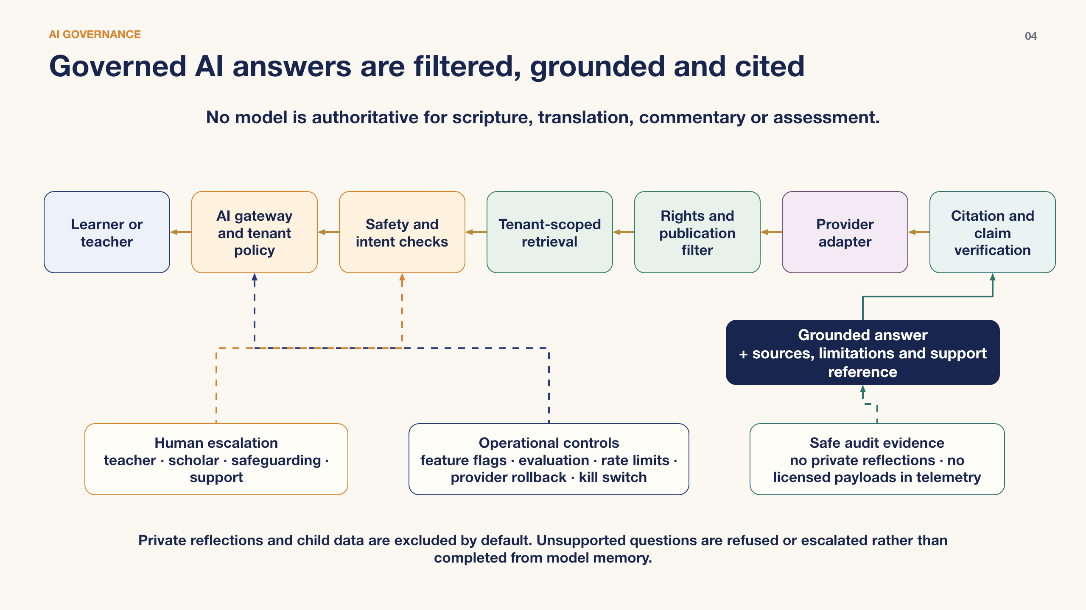
Figure 3 — AI remains assistive because each answer is policy-filtered, source-grounded, rights-checked, cited and auditable.

8.1 Permitted initial use cases
- Explain a verse or concept using only the learner's selected, approved edition and cited supporting material.
- Generate study questions, summaries or practice prompts for teacher review within a tenant-approved programme scope.
- Support semantic search, glossary discovery and navigation across approved content.
- Assist authorised editors with metadata, translation workflow and quality checks without publishing automatically.
- Surface learner support options when the request falls outside educational scope or triggers safeguarding policy.

8.2 Required request pipeline
- Resolve identity, tenant, programme, edition, language, role, age policy, feature flag and consent state.
- Classify intent and apply prompt-injection, misuse, privacy and safeguarding checks.
- Retrieve only published, tenant-permitted content from edition-partitioned search/vector indexes.
- Apply rights and publication filters before any source excerpt is sent to a model provider.
- Invoke an approved provider through a versioned internal adapter with explicit data-handling settings.
- Verify that material claims are supported by returned source anchors; attach citations and limitations.
- Return the response, refuse it or escalate to a teacher, scholar, safeguarding lead or support queue.
- Record policy, model, prompt-template, source and evaluation metadata without logging excluded private content.

8.3 Non-negotiable AI controls
- No model output changes scripture, translation, commentary, assessment score or credential without an authorised human workflow.
- No cross-tenant retrieval. Index namespaces alone are insufficient; tenant and rights predicates are enforced at retrieval and source-fetch layers.
- Private reflections, child data and licensed full-text payloads are excluded from provider requests and telemetry by default.
- Provider, model and prompt-template changes are versioned, evaluated, feature-flagged and reversible through a kill switch.
- Unsupported or weakly grounded answers are refused or escalated rather than completed from model memory.

8.4 Evaluation and evidence
- Maintain tenant-approved evaluation sets covering doctrinal fidelity, citation correctness, refusal, privacy, age appropriateness and multilingual quality.
- Release gates compare the proposed model/configuration against the current baseline and block material regressions.
- Audit records retain policy decisions, model/version, source identifiers, latency, token/cost metrics and outcome; raw sensitive payloads require a separate approved diagnostic process.

9. Security, privacy and safeguarding

9.1 Identity and access
- Use standards-based authentication, short-lived sessions/tokens, phishing-resistant multi-factor authentication for privileged roles and step-up checks for high-risk actions.
- Authorisation combines role, tenant, organisational unit, programme, resource ownership, age policy and entitlement. Administrative delegation is scoped and time-bound where possible.
- Service identities are workload-specific; secrets reside in a managed secret store and are never embedded in mobile applications or source code.

9.2 Tenant isolation
- Every tenant-owned record carries an immutable tenant key; server-side repositories automatically apply tenant predicates.
- Object paths, cache keys, search/vector filters, job payloads, analytics partitions and audit views preserve the same boundary.
- Automated negative tests attempt cross-tenant access across every API and background workflow. High-assurance tenants may be moved to dedicated storage or deployment cells without changing domain contracts.

9.3 Child and school data
- Age/grade policy is configurable by tenant and jurisdiction; guardian or school authority evidence is recorded where required.
- Minimise profile fields, separate private reflection from teacher-visible coursework and provide clear visibility labels before submission.
- Safeguarding signals follow a documented escalation workflow with restricted access, human review and incident evidence controls.

9.4 Secure delivery controls
- Threat modelling, secure coding standards, dependency and container scanning, secret detection, code review and environment-specific release approval.
- Encryption in transit and at rest, managed keys, least-privilege network access, protected administrative endpoints and central security monitoring.
- Independent penetration testing before institutional launch and after material changes to authentication, tenancy, payments or AI data flow.

10. Deployment and operations

10.1 Recommended topology
- Global CDN and edge security in front of separately deployable web/PWA assets and API entry points.
- Containerised application and worker workloads deployed across at least two failure zones in the production region.
- Managed relational database with point-in-time recovery, encrypted object storage, managed cache/queue, search/vector service and isolated analytics store.
- Separate development, test, staging and production environments with distinct identities, keys, data and approval paths.
- Infrastructure as code, repeatable environment creation, immutable releases and progressive deployment with automatic rollback criteria.

10.2 Observability
- Structured logs, metrics and traces share correlation identifiers and tenant-safe metadata; private learning text is not a default log field.
- Service-level indicators cover availability, latency, error rate, job delay, sync success, content delivery, notification delivery and AI grounding/refusal quality.
- Dashboards separate global platform health from tenant-specific operational views and restrict cost/usage detail appropriately.

10.3 Backup, recovery and continuity
- Encrypted automated backups and point-in-time recovery are tested through scheduled restoration exercises.
- Runbooks define response to tenant misconfiguration, content withdrawal, data corruption, provider outage, credential compromise and AI safety regression.
- Core learning and published content remain usable when the AI provider is disabled; queued progress synchronises after transient outages.

11. Non-functional requirements
The following are proposed procurement baselines. Final commitments should be agreed against launch scale, jurisdiction and commercial service levels.
Quality attribute | Proposed baseline
Availability | 99.9% monthly for core learner and teacher APIs; planned maintenance and third-party exclusions explicitly defined
Performance | p95 authenticated API response under 500 ms for standard reads; initial content view interactive under 3 seconds on representative mobile networks
Scale | Horizontal application/worker scaling, load-tested tenant isolation and no single-tenant noisy-neighbour failure at agreed peak concurrency
Recovery | Proposed RPO ≤15 minutes and RTO ≤4 hours for core operational data, validated by restore exercises
Accessibility | WCAG 2.2 AA target for web and mobile journeys, including keyboard, screen reader, contrast, zoom and captions/transcripts
Internationalisation | Unicode, localised UI/content, locale-aware dates/numbers, RTL readiness and font validation for supported scripts
Offline | Authorised course packages and progress capture supported; deterministic conflict handling and transparent sync status
Security | Documented threat model, critical vulnerability release gate, annual independent test and incident response exercises
Privacy | Data inventory, purpose/retention policy, access/export/delete workflows and privacy impact assessment for child/AI processing
Operability | Automated deployments, rollback, tenant-safe telemetry, on-call alerts, runbooks and tested backup restoration

12. Delivery roadmap

Phase 0 — Discovery and foundations
Confirm tenant model, canonical scripture identifiers, content/rights inventory, school/child policies, target integrations, threat model, cloud landing zone and measurable acceptance criteria.

Phase 1 — Living Bliss production MVP
Responsive web/PWA, identity, readiness path, all-chapter structure, approved Living Bliss edition, learning/progress, Content Studio minimum, administration, analytics, accessibility and production operations.

Phase 2 — Institution-ready platform
Tenant provisioning, white-label branding, multiple editions/languages, role workspaces, cohorts, consent, school integrations, assessment moderation, credentials and tenant reporting.

Phase 3 — Governed AI assistance
Tenant-scoped search/vector foundation, AI gateway, permitted learner/teacher use cases, citations, evaluation, human escalation, cost controls and kill switch.

Phase 4 — Scale and ecosystem
Native mobile optimisation, broader partner integrations, regional deployment cells, advanced analytics, marketplace/content licensing capabilities and selective service extraction.

12.1 Stage gates
- A phase is complete only when functional, accessibility, security, privacy, performance, migration, operational and documentation acceptance criteria pass.
- No tenant edition launches without approved rights, content provenance, policy configuration, support ownership and rollback plan.
- No AI feature launches without an approved use case, data-flow review, evaluation baseline, monitoring, human escalation route and kill switch test.

13. Vendor delivery expectations
The selected organisation should deliver an operable product and reusable platform capability—not only application screens.

13.1 Required architecture artefacts
- Solution architecture and environment diagrams; domain model; API and event catalogue; data classification, lineage and retention model.
- Tenant isolation design and test evidence; identity/authorisation model; threat model; privacy and safeguarding data-flow assessment.
- Content canonicalisation and publishing design; offline/sync design; integration specifications and error/reconciliation handling.
- AI use-case register, provider abstraction, retrieval and rights model, evaluation plan, audit model and rollback controls.
- Deployment pipeline, infrastructure code, observability dashboards, runbooks, disaster recovery plan and cost model.

13.2 Engineering and quality expectations
- Source code, build pipelines, infrastructure definitions, tests and documentation are transferred to Living Bliss-controlled repositories and accounts.
- Automated unit, contract, integration, end-to-end, accessibility, security, performance, offline and cross-tenant negative tests run in delivery pipelines.
- Architecture decisions are recorded with options, consequences and exit criteria; significant deviations require written approval.
- Operational readiness includes support training, incident exercises, restore evidence, monitoring thresholds, licence inventory and handover.

13.3 Proposal response requested
- Describe the proposed team, delivery model, governance, assumptions, dependencies and phased cost/timeline range.
- Map the proposed solution to every domain and control in this document, explicitly identifying reused products and custom build.
- Explain tenancy, content rights, school/child data, offline, accessibility and AI governance approaches with evidence from comparable work.
- Identify design decisions requiring Living Bliss, scholar, partner, legal/privacy or school stakeholder input.
- Provide a transition plan that avoids vendor lock-in for source code, infrastructure, identity, content, analytics and AI providers.

14. Decisions to confirm during discovery
Decision area | Required confirmation
Launch tenancy | Whether initial Living Bliss deployment is the first tenant within the shared platform from day one
Authoritative edition | Source, translation, commentary, licensing, scholar approval and correction process for launch
Learner policy | Minimum age, consent evidence, reflection visibility, community features and teacher access
School launch | Priority jurisdictions, identity/roster/LMS platforms, reporting obligations and data residency
Commercial model | Free, sponsored, licensed or subscription entitlements and whether payment is in initial scope
Mobile delivery | PWA-first versus parallel native build based on offline, device and distribution requirements
AI launch | Approved first use cases, prohibited content/data, providers, languages, reviewers and evaluation thresholds
Operations | Hosting owner, support hours, incident responsibilities, RPO/RTO, regions and procurement constraints

15. Glossary
Term | Meaning in this architecture
Tenant | An organisation or governed programme boundary with its own branding, users, policies, editions, data and integrations
Edition | A versioned collection of scripture text, translation, commentary, metadata, media, provenance and rights
Canonical scripture model | Stable work/chapter/verse identifiers that allow multiple editions to align without losing their distinct authority
BFF | Backend for frontend; an API entry layer shaped for web/mobile experiences that resolves trusted request context
Modular monolith | One deployable application containing strongly separated domain modules and contracts
RAG | Retrieval-augmented generation; a model response grounded in retrieved approved sources
PWA | Progressive web application with installable and offline-capable web features
RPO / RTO | Maximum acceptable data-loss window / target time to restore service after a disruption

Appendix A — Architecture acceptance checklist
- Tenant, programme, edition, language, age policy, role and entitlement context is server-validated end to end.
- No client, integration, worker, search query, media URL or AI request can bypass tenant and rights controls.
- Web, laptop, tablet and mobile experiences meet approved responsive and accessibility criteria.
- All 18 chapters can be structured into versioned pathways with prerequisites, learning activities, assessment and progress rules.
- Content publication provides provenance, rights, review, scheduled release, withdrawal and rollback.
- School and child-data workflows separate consent, private reflection, teacher visibility and safeguarding escalation.
- Offline packages and progress synchronisation behave deterministically under interruption and multi-device use.
- Critical APIs, integrations and background jobs are observable, idempotent where needed and recoverable.
- AI can be disabled without breaking core learning; answers are grounded, cited, evaluated and auditable.
- Living Bliss receives code, infrastructure, configuration, data export, documentation, runbooks and knowledge transfer.
Document ownership Maintain this architecture with the approved product blueprint, UI specification, security model, data catalogue and architecture decision records. The editable PowerPoint remains the controlled diagram source.

