
TECHNICAL DESIGN SPECIFICATION
Bhagavad Gita Learning Platform
Complete User Interface Wireframes
Web · iOS · Android · Teacher · Content · Tenant Administration · Platform Operations
DESIGN INTENT: Preserve the calm, scripture-first Living Bliss experience while extending it into a coherent multi-organisation, school-ready and operational product.

Document | Version | Status
UI wireframes and technical design | 1.0 | Vendor implementation baseline
Prepared for Living Bliss and the selected product-development organisation

Document purpose and use
This specification converts the product blueprint into a complete interface inventory, low-fidelity wireframe set and implementation contract. It is designed for product discovery, UX design, solution architecture, delivery estimation and acceptance planning.
SCOPE: 75 distinct screens across nine interface families, including responsive and mobile-specific states. The wireframes define information, hierarchy and interaction; final visual design must use the approved Living Bliss design system and tenant themes.

How to read the wireframes
Marker | Meaning
1 | Global identity, tenant context and workspace navigation.
2 | Page title, source/edition context or learner orientation.
3 | Primary task surface, search, editor or learning content.
4 | Supporting state, progress, metadata or secondary action.
5 | Primary completion, publish, submit or create action.

Design authority
- Current prototype baseline: library.livingbliss.org home, Bhagavad Gita course, lesson, assessment, dashboard, onboarding, account and certificate interfaces.
- Product blueprint: multi-tenant editions, schools, teacher tools, content governance, rights, mobile/offline and platform operations.
- Final product must not blend scripture, translation, commentary and learning explanation into an unlabeled content stream.

Contents
- 1. Design baseline and interface principles
- 2. Workspace and navigation architecture
- 3. Responsive shell and shared components
- 4. Complete screen inventory
- 5. Wireframe boards 01–25
- 6. Interaction and state model
- 7. Technical interface contracts
- 8. Accessibility, localisation and analytics
- 9. Delivery and acceptance requirements

Key product decision
ONE DESIGN SYSTEM, MANY TRUSTED EDITIONS: Tenant branding changes tokens, identity, approved content, policies and programme configuration. It must not create divergent navigation models or unsupported code forks.

1. Design baseline and interface principles

Brand-aligned token baseline
Token | Value | Primary use
Ivory | #FBF8F1 | Application canvas and calm reading surface
Paper | #FFFDF8 | Cards, forms and scripture panels
Indigo | #18264F | Navigation, primary actions and headings
Saffron | #D9832E | Active state, focus accent and spiritual warmth
Gold | #B68C3B | Source details, ornament and secondary emphasis
Teal | #2E746D | Progress, links and structured learning state
Green | #34805B | Success, approval and verified status
Line | #DDD3C1 | Quiet borders and separators

Non-negotiable interface principles
- Source before interpretation: every content layer is labeled and traceable.
- Learning, not scrolling: each screen has an explicit orientation, task and next action.
- Progress without pressure: no public ranking, streak anxiety or spiritual gamification.
- Private by default: reflections and private notes remain outside teacher/admin analytics.
- Configuration over forks: shells and components are shared; tenants change governed tokens and data.
- Accessible and multilingual by architecture: scripts, captions, dynamic type and keyboard use are core states.

2. Workspace and navigation architecture
Workspace | Primary roles | Navigation model | Boundary
Public / identity | Visitor, learner, guardian | Top navigation; tenant and edition context | No privileged controls
Learner | Learner | Top navigation + contextual chapter rail; mobile bottom navigation | Own learning and private data
Teacher | Teacher, facilitator | Workspace rail + cohort context | Assigned cohorts only
Content Studio | Author, translator, reviewer, publisher | Workspace rail + edition/release context | Named editions and review tasks
Tenant admin | Organisation administrator | Workspace rail + tenant context | One tenant and delegated units
Platform ops | Platform operator, support, security | Ops rail + region/tenant selector | Controlled and audited elevation

Context resolution order
- Tenant/domain → identity/role → programme → authorised edition → language → age/guardian policy → accessibility preferences → entitlement.
- Every deep link must preserve the resolved context or explain why the requested resource is unavailable.
- Switching edition may change translation, commentary and assessment; the UI must explain whether progress equivalence exists.

Responsive shell
Breakpoint intent | Shell behaviour
Compact phone | Bottom navigation; contextual sheets; one primary action; single-column learning.
Large phone | Same information hierarchy with richer media controls and split transcript where space permits.
Tablet | Collapsible rail; two-column teacher and content detail; presentation mode.
Laptop / desktop | Persistent workspace or chapter rail; dense lists and side-by-side review where valuable.
Wide desktop | Constrain reading measure; use extra width for comparison, preview and evidence—not longer lines.

3. Shared components and states
Component family | Required variants
Global shell | Public, learner, teacher, studio, tenant admin, platform ops; tenant and workspace switcher.
Content identity | Scripture reference, edition label, translator/guru, language, version, approval and rights.
Learning status | Not started, available, in progress, revision due, passed, locked, expired and superseded.
Action controls | Primary, secondary, destructive, disabled, loading, offline queued and permission denied.
Data views | Empty, filtered empty, loading, partial, stale, sync conflict, integration failure and export in progress.
Feedback | Inline validation, formative response, summative result, review comment, approval and incident alert.
Media | Video, audio, slides, transcript, captions, download, speed, quality and accessible alternative.

State ownership rules
- The server remains authoritative for entitlements, published content, certificate status, roles and policy versions.
- The device may optimistically queue progress, bookmarks, notes and low-risk learning events; conflict resolution must be visible.
- Draft content and assessment changes require explicit save, validation and version state; publishing is never implicit.

4. Complete screen inventory

Public
ID | Screen | Route | Purpose
PUB-01 | Tenant-aware home | / | Orient the visitor, resolve organisation and offer the clearest next step.
PUB-02 | Edition directory | /editions | Choose an authorised organisation, guru/translator, language and access model.
PUB-03 | Course catalogue | /courses | Browse approved programmes by audience, edition, age band, format and duration.
PUB-04 | Scripture search | /scripture | Find chapters, verses, topics and approved layers without confusing commentary with source.
PUB-05 | Course detail | /course/:courseId | Explain outcomes, prerequisites, effort, assessment, edition and certificate before enrolment.
PUB-06 | Edition detail | /edition/:editionId | Make tradition, translator/guru, rights, version and approval status transparent.

Identity
ID | Screen | Route | Purpose
ID-01 | Sign in | /sign-in | Authenticate through passwordless email, password, Google, Microsoft or tenant SSO.
ID-02 | Registration | /register | Create the minimum viable account and retain eligible guest progress.
ID-03 | Learning onboarding | /onboarding | Capture goal, experience, language, accessibility and notification preferences.

Guardian
ID | Screen | Route | Purpose
GUA-01 | Age and consent routing | /consent | Apply jurisdiction and programme rules before creating a minor account.
GUA-02 | Guardian invitation | /guardian/invite | Invite and verify a guardian without exposing private learning reflections.
GUA-03 | Guardian overview | /guardian | Manage consent, linked learners and permitted progress visibility.

Learner
ID | Screen | Route | Purpose
LRN-01 | Learner dashboard | /dashboard | Resume the most meaningful next action and understand mastery across programmes.
LRN-02 | Prerequisite pathway | /learn/foundations | Build common background knowledge while allowing experienced learners to move quickly.
LRN-03 | Readiness diagnostic | /diagnostic | Route the learner to bridge modules or Chapter 1 with an explainable result.
LRN-04 | Course pathway | /course/:courseId/path | Show all 18 chapters, state, mastery evidence, time and next action.
LRN-05 | Chapter overview | /chapter/:chapterId | Orient the learner to outcomes, key verses, activities and assessment.
LRN-06 | Lesson player | /lesson/:lessonId | Deliver multimodal learning with a persistent chapter rail and calm completion logic.
LRN-07 | Verse study | /verse/:verseId | Keep Sanskrit, transliteration, word meaning, translation and commentary visibly distinct.
LRN-08 | Media transcript | /lesson/:id/transcript | Provide synchronised transcript, captions, speed, search and accessible alternatives.
LRN-09 | Glossary and concepts | /glossary | Explain Sanskrit and philosophical terms in edition- and age-aware language.
LRN-10 | Private reflection | /reflection/:activityId | Support private meaning-making with autosave and explicit optional sharing.
LRN-11 | Practice activity | /practice/:activityId | Apply concepts through scenario, sorting, matching or short response.
LRN-12 | Assessment question | /assessment/:assessmentId | Present one accessible item at a time with progress, save/resume and attempt policy.
LRN-13 | Assessment result | /assessment/:id/result | Explain mastered outcomes, misconceptions, pass decision and next action.
LRN-14 | Targeted remediation | /revision/plan | Create a short evidence-based revision plan linked to missed outcomes and verses.
LRN-15 | Revision queue | /revision | Support spaced review across verses, concepts and prior assessments.
LRN-16 | Bookmarks | /bookmarks | Return to saved verses, lessons and media while preserving edition context.
LRN-17 | Private notes | /notes | Manage searchable notes separately from teacher-visible submissions.
LRN-18 | Downloads and offline | /downloads | Control offline packs, size, rights expiry, update and sync status.
LRN-19 | Certificate | /certificate/:id | Display a verifiable, revocable completion credential with issuer and edition.
LRN-20 | Preferences and privacy | /account/preferences | Control language, accessibility, notifications, sessions and data rights.
LRN-21 | Help and report issue | /support | Reach approved support and report content, access, safety or technical issues.

Mobile
ID | Screen | Route | Purpose
MOB-01 | Mobile home | app://home | Resolve tenant and offer one high-confidence next action.
MOB-02 | Mobile course map | app://course/:id | Navigate 18 chapters with states, schedule and offline availability.
MOB-03 | Mobile lesson | app://lesson/:id | Support interruption-safe video/audio/text learning with bottom next action.
MOB-04 | Mobile verse study | app://verse/:id | Read source-aware verse layers comfortably on a narrow screen.
MOB-05 | Mobile assessment | app://assessment/:id | Complete accessible one-question screens with autosave and resume.
MOB-06 | Mobile result | app://assessment/:id/result | Explain mastery and route directly to revision or continuation.
MOB-07 | Offline library | app://downloads | Download, update and remove authorised content with transparent storage.
MOB-08 | Sync conflict | app://sync | Resolve conflicting completion, note and assessment events without data loss.
MOB-09 | Mobile certificate | app://certificate/:id | Present a wallet-ready certificate and verification QR.

Teacher
ID | Screen | Route | Purpose
TCH-01 | Teacher dashboard | /teacher | Show classes, upcoming work, support flags and recent submissions.
TCH-02 | Cohort list | /teacher/cohorts | Manage permitted cohorts with programme, edition, schedule and roster state.
TCH-03 | Cohort overview | /teacher/cohort/:id | Understand participation, mastery, pace and accessibility support.
TCH-04 | Teaching schedule | /teacher/schedule | Plan chapter sequence, live sessions, due dates and exceptions.
TCH-05 | Create assignment | /teacher/assignment/new | Assign only approved activities with rubric, due date and accommodation rules.
TCH-06 | Learner detail | /teacher/learner/:id | Support learning from permitted evidence without exposing private reflections.
TCH-07 | Submissions and rubric | /teacher/submissions | Review work, apply an approved rubric and provide accessible feedback.
TCH-08 | Class outcome report | /teacher/reports/outcomes | Identify concept-level needs without public ranking or sensitive inference.
TCH-09 | Class presentation mode | /teacher/present/:lessonId | Project verses, diagrams and activities with large text and minimal controls.

Content
ID | Screen | Route | Purpose
CNT-01 | Content work queue | /studio | Prioritise draft, review, rights and accessibility work by edition and release.
CNT-02 | Course structure editor | /studio/course/:id | Assemble reusable modules, outcomes, chapters, lessons and assessments.
CNT-03 | Lesson editor | /studio/lesson/:id | Author structured layers and activities without mixing source and explanation.
CNT-04 | Verse picker | /studio/verse-picker | Select canonical references and approved edition layers with provenance.
CNT-05 | Translation compare | /studio/compare | Compare authorised versions side by side without silently merging them.
CNT-06 | Assessment bank | /studio/items | Create and govern items by outcome, edition, age band and exposure state.
CNT-07 | Review and sign-off | /studio/review/:id | Capture scholarly, pedagogical, language, accessibility and rights approvals.
CNT-08 | Release manager | /studio/releases | Publish immutable versions to named tenants, languages and audiences.
CNT-09 | Rights ledger | /studio/rights | Enforce media and text rights by territory, channel, audience, language and time.

Tenant admin
ID | Screen | Route | Purpose
ADM-01 | Tenant overview | /admin | See organisation health, programmes, editions, users, integrations and alerts.
ADM-02 | Brand and domain | /admin/brand | Configure approved logo, colours, domain, app skin and communication templates.
ADM-03 | Users and roles | /admin/users | Invite, import and govern staff and learners with scoped roles.
ADM-04 | Programme and cohorts | /admin/programmes | Configure edition, course, age band, schedule, pass rules and certificate.
ADM-05 | SSO, LTI and SIS | /admin/integrations | Configure identity and school integrations with test and health evidence.
ADM-06 | Policies and retention | /admin/policies | Version consent, privacy, retention, notification and safeguarding rules.
ADM-07 | Certificate configuration | /admin/certificates | Configure issuer, wording, signatures, verification and revocation rights.
ADM-08 | Tenant analytics | /admin/analytics | Measure reach, activation, mastery, inclusion and service health within scope.
ADM-09 | Audit and support | /admin/audit | Investigate privileged actions, data exports, content releases and incidents.

Platform ops
ID | Screen | Route | Purpose
OPS-01 | Tenant registry | /ops/tenants | Operate tenant lifecycle, regions, tiers, ownership and data boundaries.
OPS-02 | Feature flags and releases | /ops/releases | Stage capabilities by tenant, cohort, app version and region with rollback.
OPS-03 | System health and incidents | /ops/health | Monitor service objectives, jobs, sync, media, integrations and active incidents.
OPS-04 | Content distribution | /ops/distribution | Trace edition packages, tenant entitlement, CDN state and retractions.
OPS-05 | Support elevation | /ops/support | Troubleshoot with time-bound, approved, audited access and privacy masks.
OPS-06 | Security and audit | /ops/security | Review privileged activity, threats, vulnerabilities, backups and tenant-isolation evidence.

5. Wireframe boards
Each board is a functional composition baseline. During discovery, the vendor must turn every screen into a clickable prototype, test critical journeys with representative users and return an annotated component and state specification.
FIDELITY: These are deliberately low-fidelity: structure, controls, context and workflow are authoritative; exact typography, imagery, spacing and motion are refined in the design-system phase.

Board 01 — Public discovery
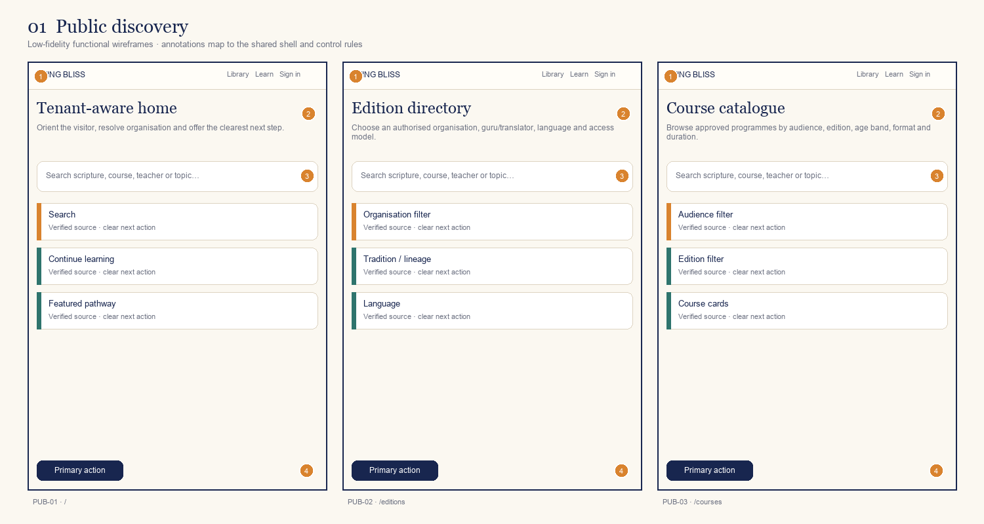
ID | Screen / route | Primary decision or outcome
PUB-01 | Tenant-aware home  / | Orient the visitor, resolve organisation and offer the clearest next step.
PUB-02 | Edition directory  /editions | Choose an authorised organisation, guru/translator, language and access model.
PUB-03 | Course catalogue  /courses | Browse approved programmes by audience, edition, age band, format and duration.
Annotation contract: 1 shell/identity · 2 orientation/context · 3 primary task · 4 supporting state · 5 next action.

Board 02 — Search and product detail
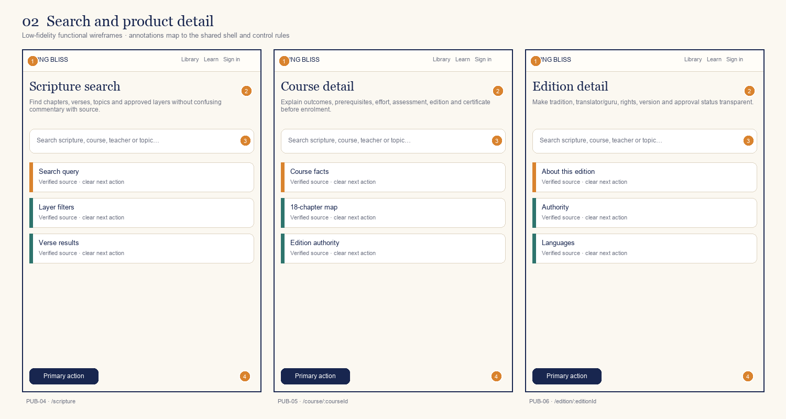
ID | Screen / route | Primary decision or outcome
PUB-04 | Scripture search  /scripture | Find chapters, verses, topics and approved layers without confusing commentary with source.
PUB-05 | Course detail  /course/:courseId | Explain outcomes, prerequisites, effort, assessment, edition and certificate before enrolment.
PUB-06 | Edition detail  /edition/:editionId | Make tradition, translator/guru, rights, version and approval status transparent.
Annotation contract: 1 shell/identity · 2 orientation/context · 3 primary task · 4 supporting state · 5 next action.

Board 03 — Identity and onboarding
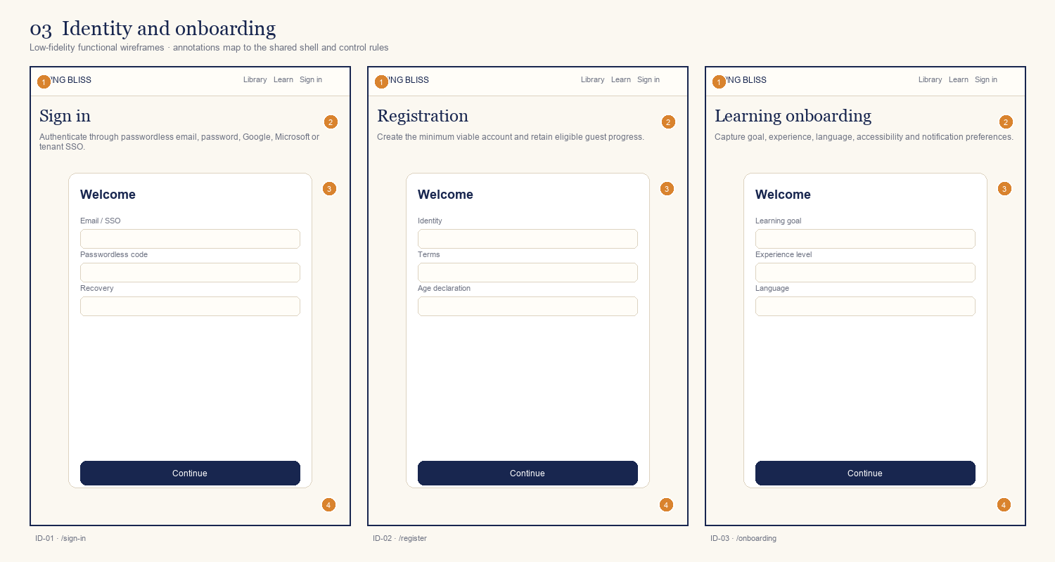
ID | Screen / route | Primary decision or outcome
ID-01 | Sign in  /sign-in | Authenticate through passwordless email, password, Google, Microsoft or tenant SSO.
ID-02 | Registration  /register | Create the minimum viable account and retain eligible guest progress.
ID-03 | Learning onboarding  /onboarding | Capture goal, experience, language, accessibility and notification preferences.
Annotation contract: 1 shell/identity · 2 orientation/context · 3 primary task · 4 supporting state · 5 next action.

Board 04 — Guardian and consent
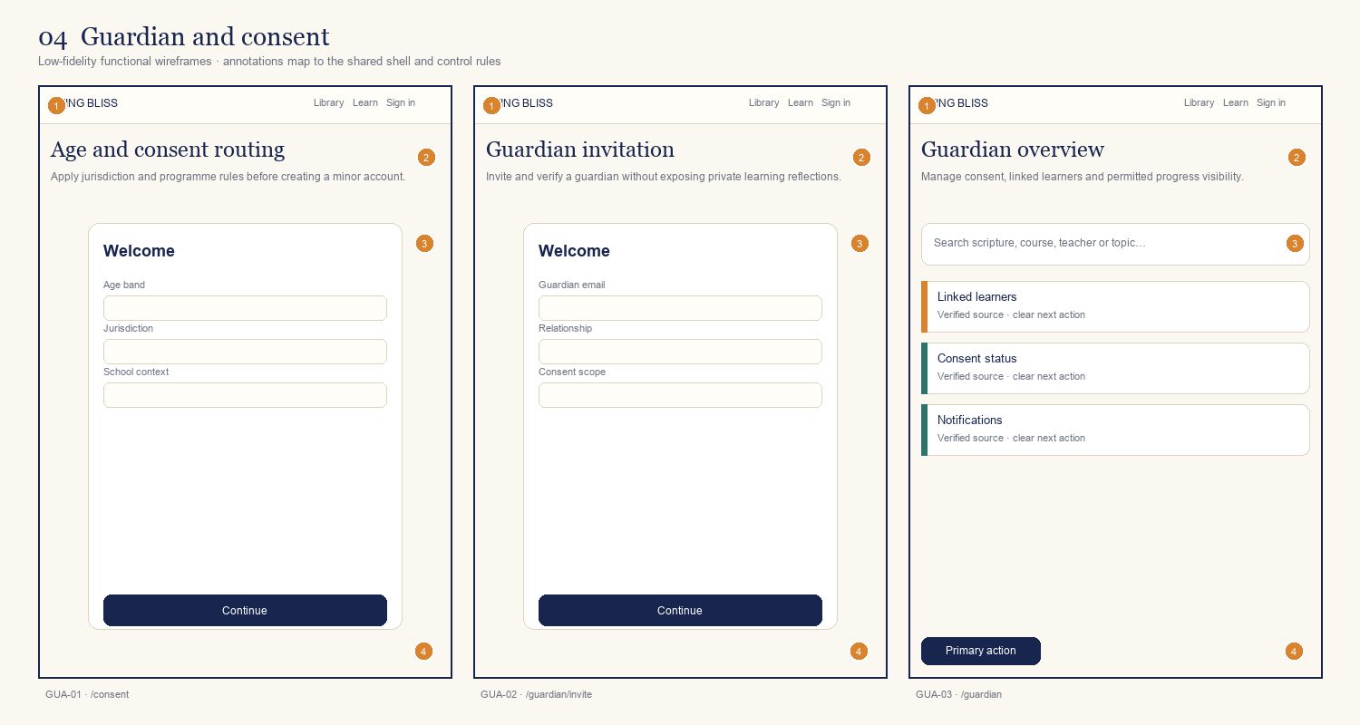
ID | Screen / route | Primary decision or outcome
GUA-01 | Age and consent routing  /consent | Apply jurisdiction and programme rules before creating a minor account.
GUA-02 | Guardian invitation  /guardian/invite | Invite and verify a guardian without exposing private learning reflections.
GUA-03 | Guardian overview  /guardian | Manage consent, linked learners and permitted progress visibility.
Annotation contract: 1 shell/identity · 2 orientation/context · 3 primary task · 4 supporting state · 5 next action.

Board 05 — Learner start
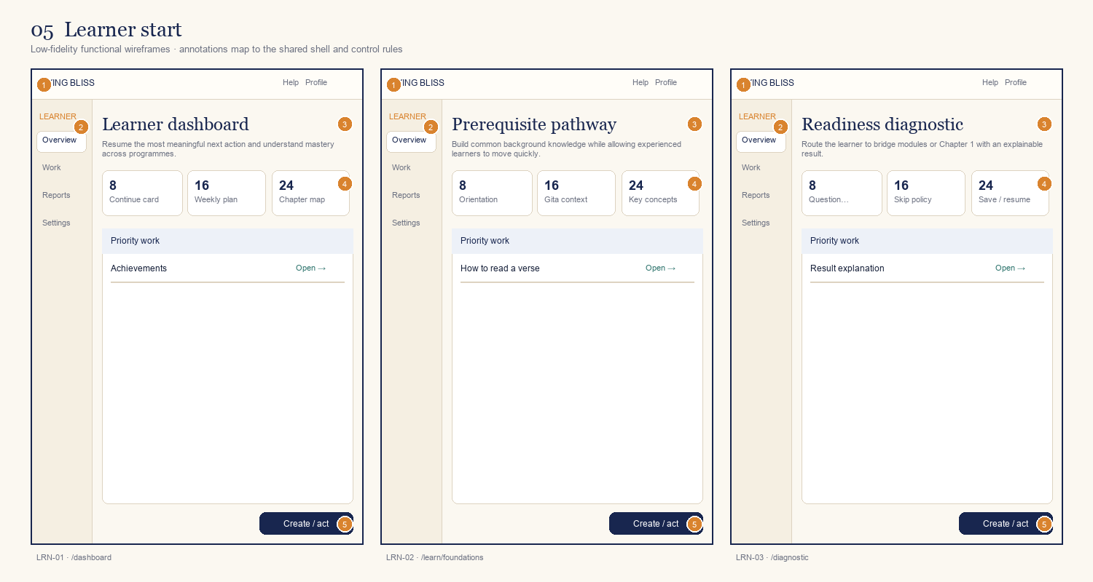
ID | Screen / route | Primary decision or outcome
LRN-01 | Learner dashboard  /dashboard | Resume the most meaningful next action and understand mastery across programmes.
LRN-02 | Prerequisite pathway  /learn/foundations | Build common background knowledge while allowing experienced learners to move quickly.
LRN-03 | Readiness diagnostic  /diagnostic | Route the learner to bridge modules or Chapter 1 with an explainable result.
Annotation contract: 1 shell/identity · 2 orientation/context · 3 primary task · 4 supporting state · 5 next action.

Board 06 — Course and chapter
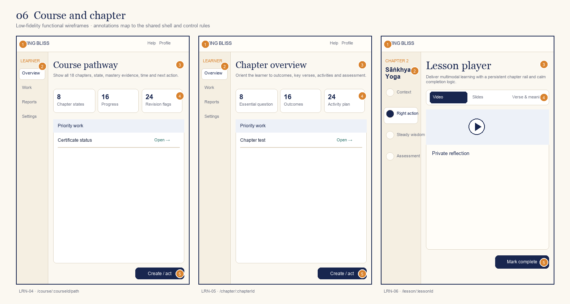
ID | Screen / route | Primary decision or outcome
LRN-04 | Course pathway  /course/:courseId/path | Show all 18 chapters, state, mastery evidence, time and next action.
LRN-05 | Chapter overview  /chapter/:chapterId | Orient the learner to outcomes, key verses, activities and assessment.
LRN-06 | Lesson player  /lesson/:lessonId | Deliver multimodal learning with a persistent chapter rail and calm completion logic.
Annotation contract: 1 shell/identity · 2 orientation/context · 3 primary task · 4 supporting state · 5 next action.

Board 07 — Verse and learning content
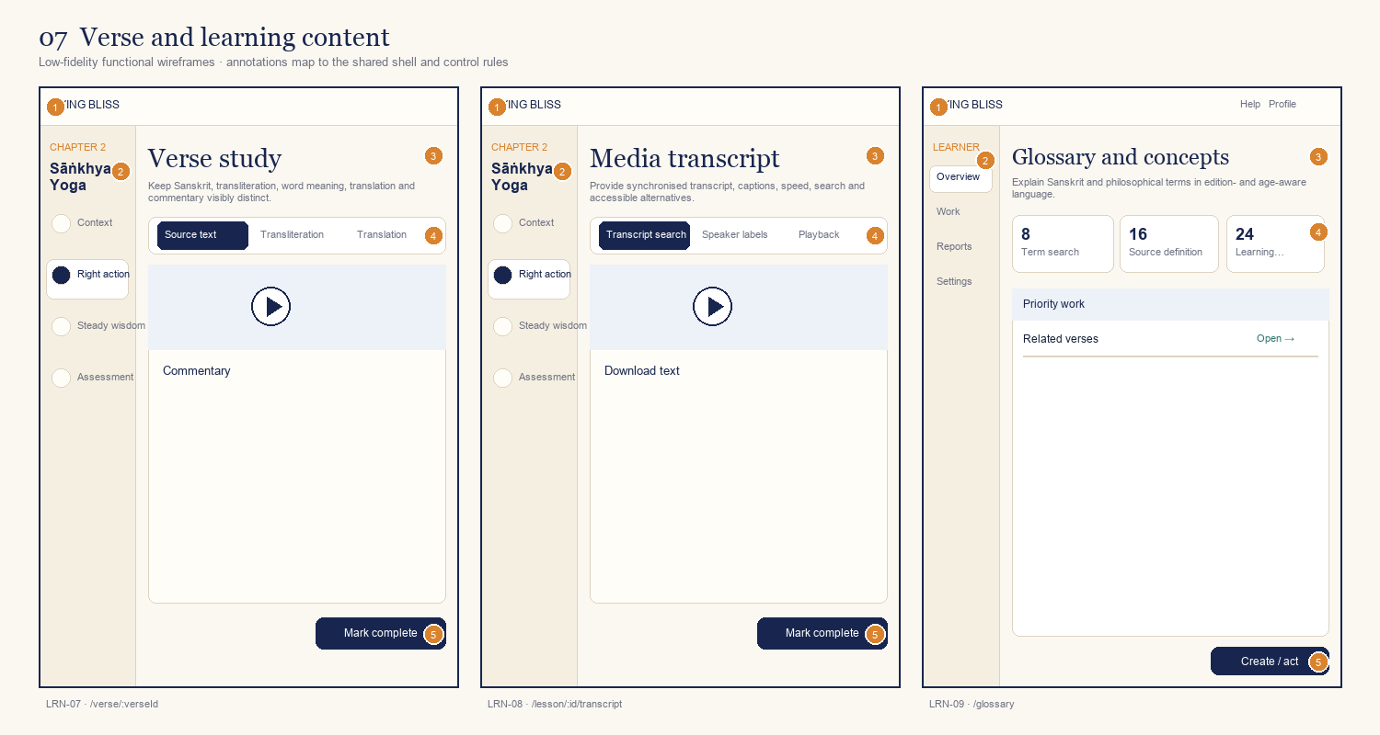
ID | Screen / route | Primary decision or outcome
LRN-07 | Verse study  /verse/:verseId | Keep Sanskrit, transliteration, word meaning, translation and commentary visibly distinct.
LRN-08 | Media transcript  /lesson/:id/transcript | Provide synchronised transcript, captions, speed, search and accessible alternatives.
LRN-09 | Glossary and concepts  /glossary | Explain Sanskrit and philosophical terms in edition- and age-aware language.
Annotation contract: 1 shell/identity · 2 orientation/context · 3 primary task · 4 supporting state · 5 next action.

Board 08 — Practice and assessment
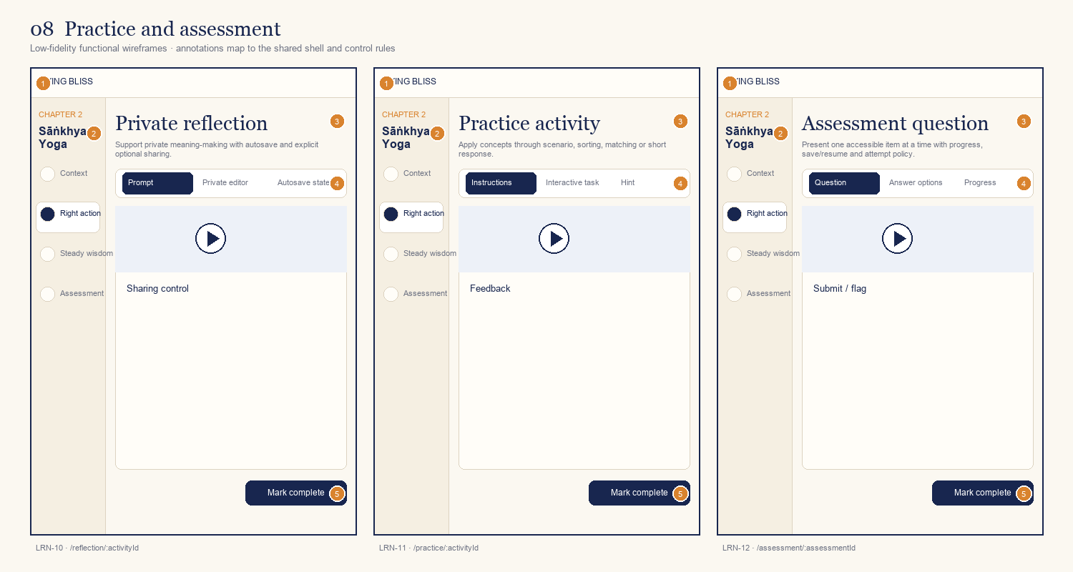
ID | Screen / route | Primary decision or outcome
LRN-10 | Private reflection  /reflection/:activityId | Support private meaning-making with autosave and explicit optional sharing.
LRN-11 | Practice activity  /practice/:activityId | Apply concepts through scenario, sorting, matching or short response.
LRN-12 | Assessment question  /assessment/:assessmentId | Present one accessible item at a time with progress, save/resume and attempt policy.
Annotation contract: 1 shell/identity · 2 orientation/context · 3 primary task · 4 supporting state · 5 next action.

Board 09 — Results and revision
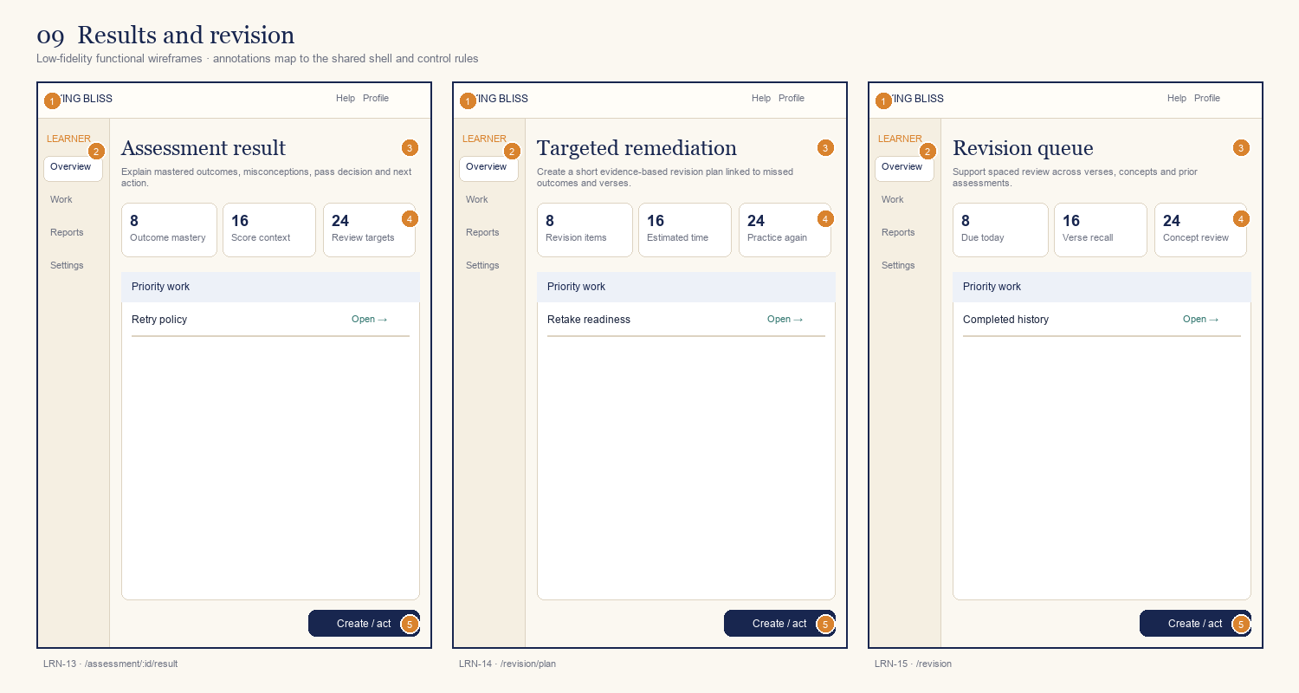
ID | Screen / route | Primary decision or outcome
LRN-13 | Assessment result  /assessment/:id/result | Explain mastered outcomes, misconceptions, pass decision and next action.
LRN-14 | Targeted remediation  /revision/plan | Create a short evidence-based revision plan linked to missed outcomes and verses.
LRN-15 | Revision queue  /revision | Support spaced review across verses, concepts and prior assessments.
Annotation contract: 1 shell/identity · 2 orientation/context · 3 primary task · 4 supporting state · 5 next action.

Board 10 — Personal library
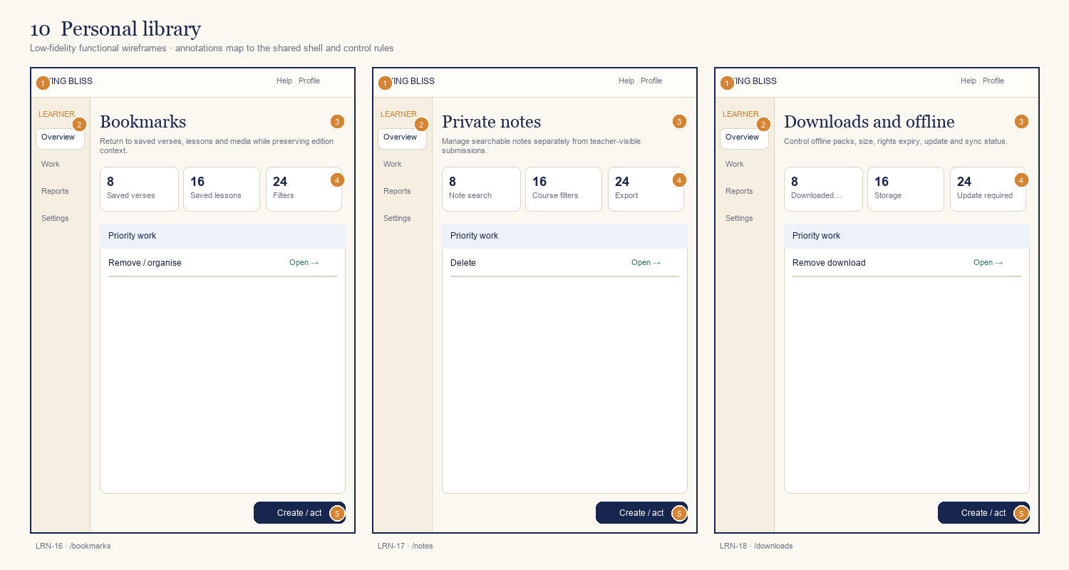
ID | Screen / route | Primary decision or outcome
LRN-16 | Bookmarks  /bookmarks | Return to saved verses, lessons and media while preserving edition context.
LRN-17 | Private notes  /notes | Manage searchable notes separately from teacher-visible submissions.
LRN-18 | Downloads and offline  /downloads | Control offline packs, size, rights expiry, update and sync status.
Annotation contract: 1 shell/identity · 2 orientation/context · 3 primary task · 4 supporting state · 5 next action.

Board 11 — Recognition and support
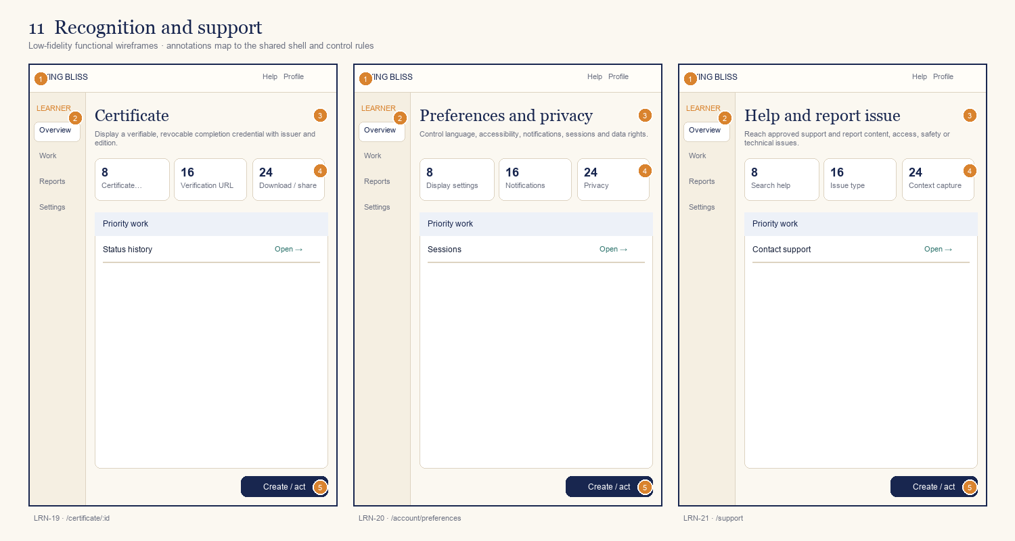
ID | Screen / route | Primary decision or outcome
LRN-19 | Certificate  /certificate/:id | Display a verifiable, revocable completion credential with issuer and edition.
LRN-20 | Preferences and privacy  /account/preferences | Control language, accessibility, notifications, sessions and data rights.
LRN-21 | Help and report issue  /support | Reach approved support and report content, access, safety or technical issues.
Annotation contract: 1 shell/identity · 2 orientation/context · 3 primary task · 4 supporting state · 5 next action.

Board 12 — Mobile core learning
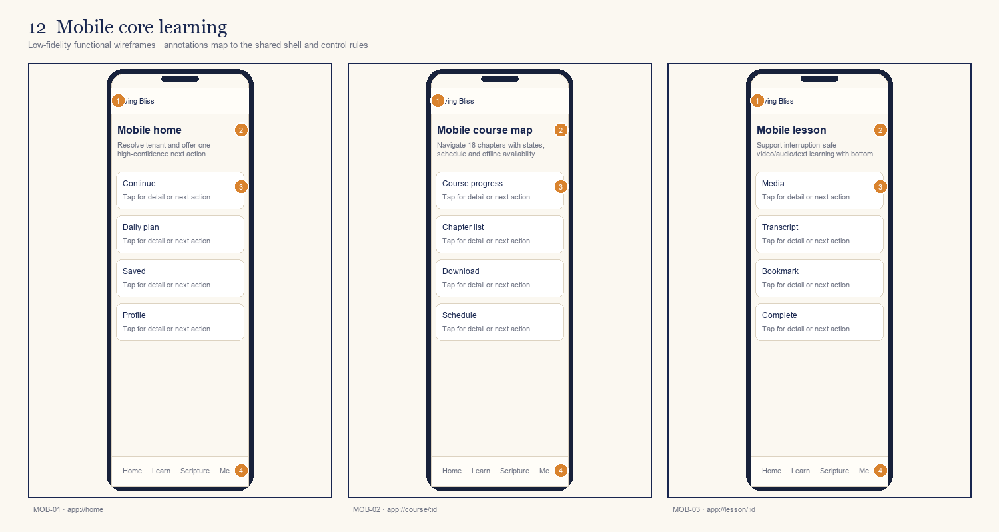
ID | Screen / route | Primary decision or outcome
MOB-01 | Mobile home  app://home | Resolve tenant and offer one high-confidence next action.
MOB-02 | Mobile course map  app://course/:id | Navigate 18 chapters with states, schedule and offline availability.
MOB-03 | Mobile lesson  app://lesson/:id | Support interruption-safe video/audio/text learning with bottom next action.
Annotation contract: 1 shell/identity · 2 orientation/context · 3 primary task · 4 supporting state · 5 next action.

Board 13 — Mobile scripture and assessment
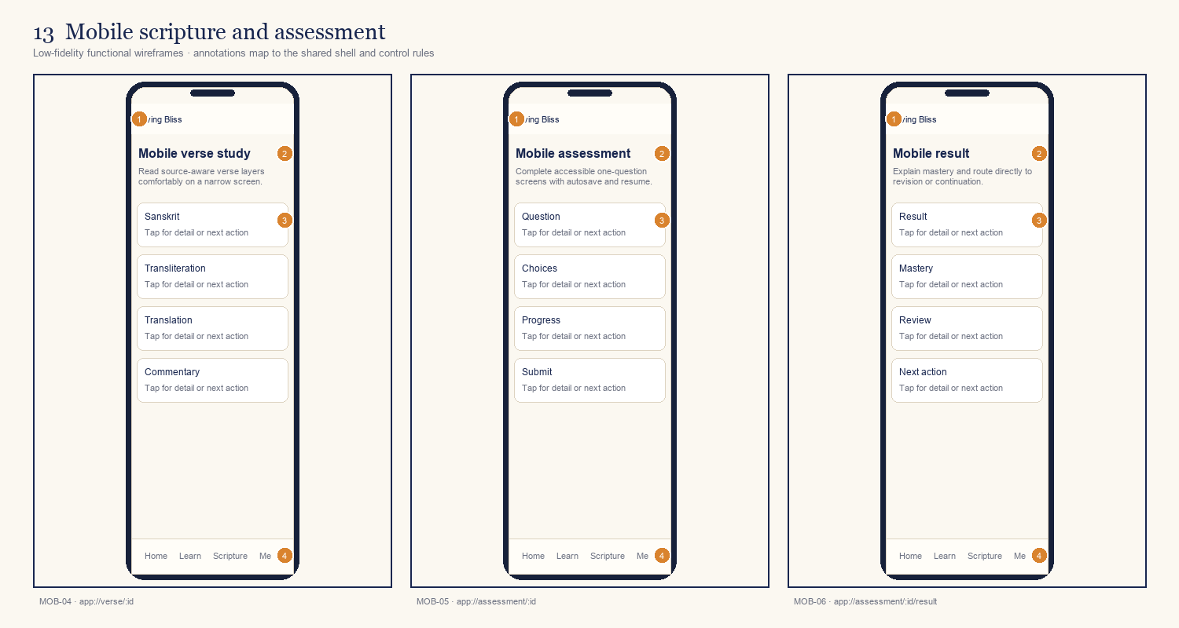
ID | Screen / route | Primary decision or outcome
MOB-04 | Mobile verse study  app://verse/:id | Read source-aware verse layers comfortably on a narrow screen.
MOB-05 | Mobile assessment  app://assessment/:id | Complete accessible one-question screens with autosave and resume.
MOB-06 | Mobile result  app://assessment/:id/result | Explain mastery and route directly to revision or continuation.
Annotation contract: 1 shell/identity · 2 orientation/context · 3 primary task · 4 supporting state · 5 next action.

Board 14 — Mobile offline and credentials
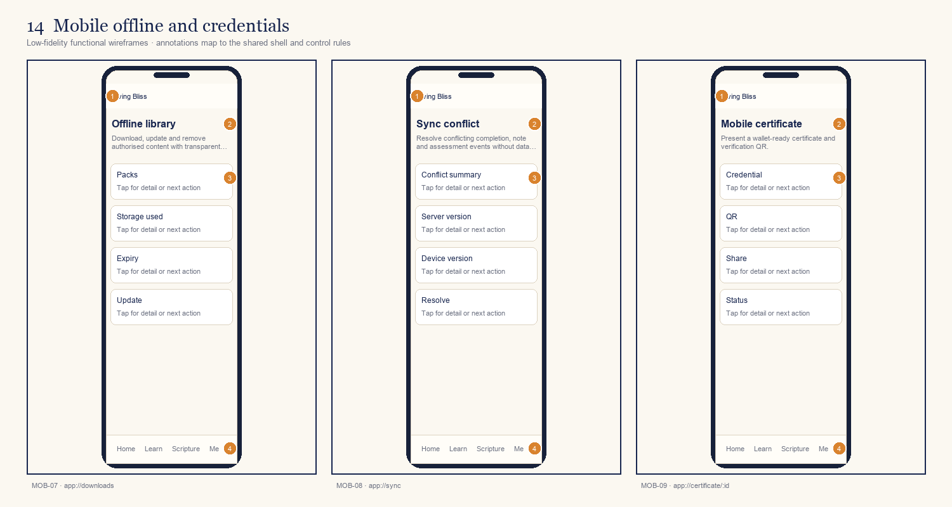
ID | Screen / route | Primary decision or outcome
MOB-07 | Offline library  app://downloads | Download, update and remove authorised content with transparent storage.
MOB-08 | Sync conflict  app://sync | Resolve conflicting completion, note and assessment events without data loss.
MOB-09 | Mobile certificate  app://certificate/:id | Present a wallet-ready certificate and verification QR.
Annotation contract: 1 shell/identity · 2 orientation/context · 3 primary task · 4 supporting state · 5 next action.

Board 15 — Teacher planning
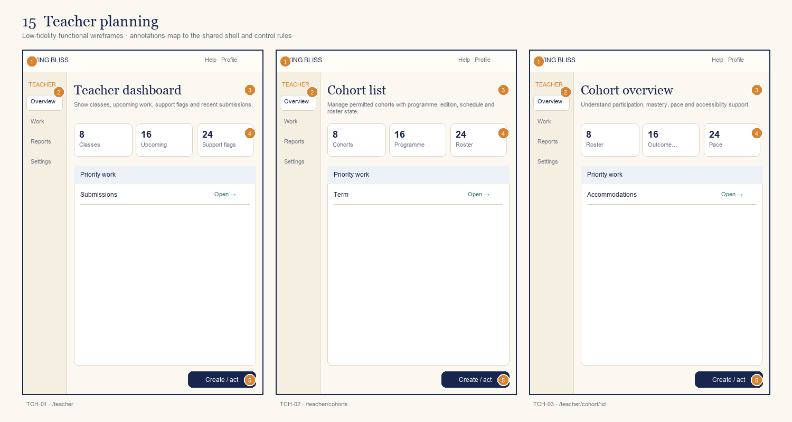
ID | Screen / route | Primary decision or outcome
TCH-01 | Teacher dashboard  /teacher | Show classes, upcoming work, support flags and recent submissions.
TCH-02 | Cohort list  /teacher/cohorts | Manage permitted cohorts with programme, edition, schedule and roster state.
TCH-03 | Cohort overview  /teacher/cohort/:id | Understand participation, mastery, pace and accessibility support.
Annotation contract: 1 shell/identity · 2 orientation/context · 3 primary task · 4 supporting state · 5 next action.

Board 16 — Teacher delivery and evidence
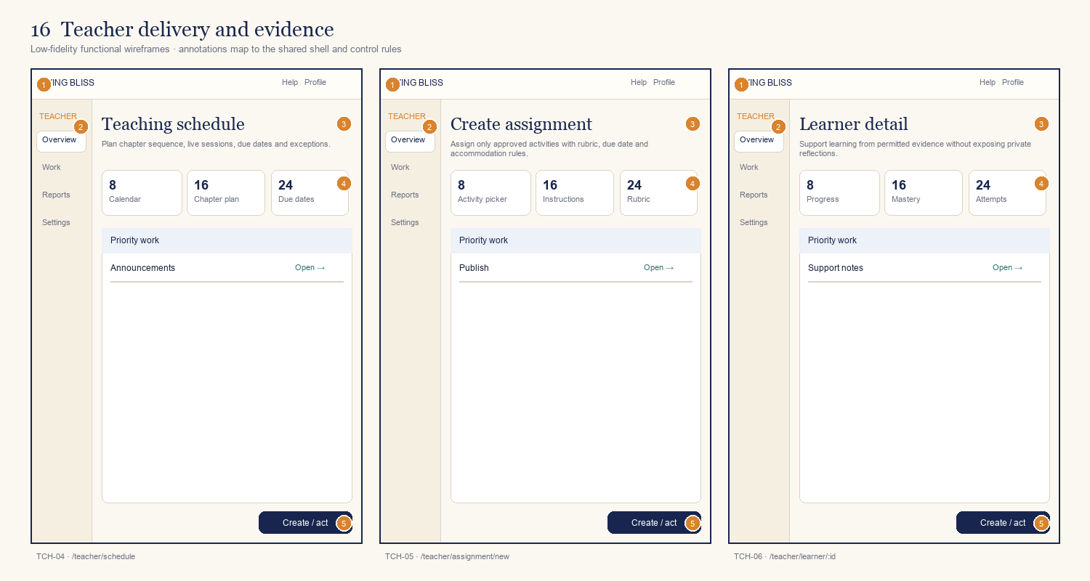
ID | Screen / route | Primary decision or outcome
TCH-04 | Teaching schedule  /teacher/schedule | Plan chapter sequence, live sessions, due dates and exceptions.
TCH-05 | Create assignment  /teacher/assignment/new | Assign only approved activities with rubric, due date and accommodation rules.
TCH-06 | Learner detail  /teacher/learner/:id | Support learning from permitted evidence without exposing private reflections.
Annotation contract: 1 shell/identity · 2 orientation/context · 3 primary task · 4 supporting state · 5 next action.

Board 17 — Teacher assessment and reports
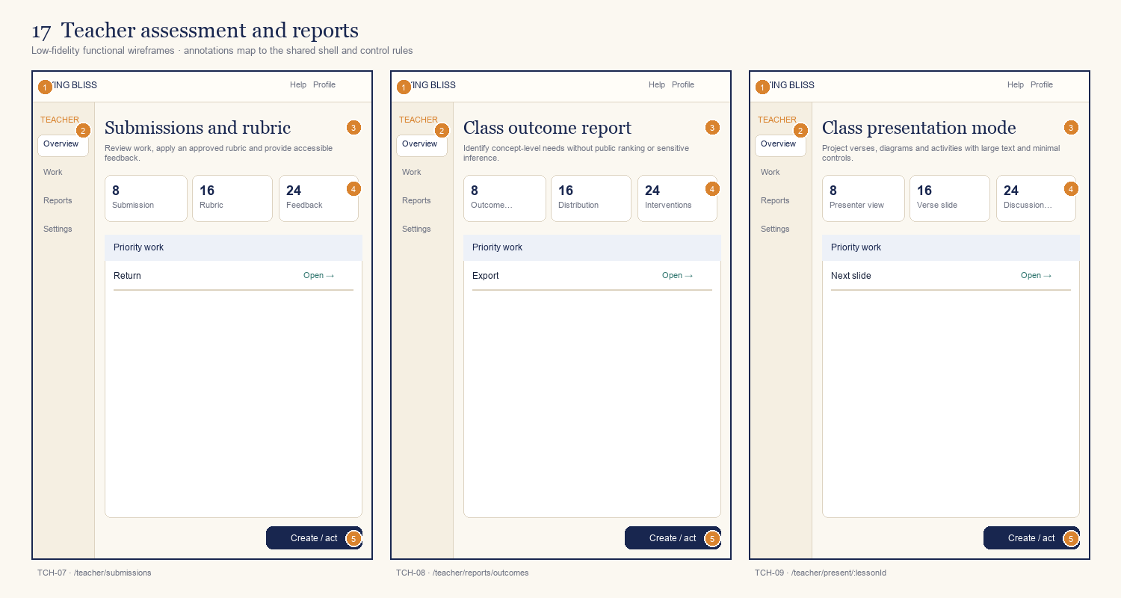
ID | Screen / route | Primary decision or outcome
TCH-07 | Submissions and rubric  /teacher/submissions | Review work, apply an approved rubric and provide accessible feedback.
TCH-08 | Class outcome report  /teacher/reports/outcomes | Identify concept-level needs without public ranking or sensitive inference.
TCH-09 | Class presentation mode  /teacher/present/:lessonId | Project verses, diagrams and activities with large text and minimal controls.
Annotation contract: 1 shell/identity · 2 orientation/context · 3 primary task · 4 supporting state · 5 next action.

Board 18 — Content authoring
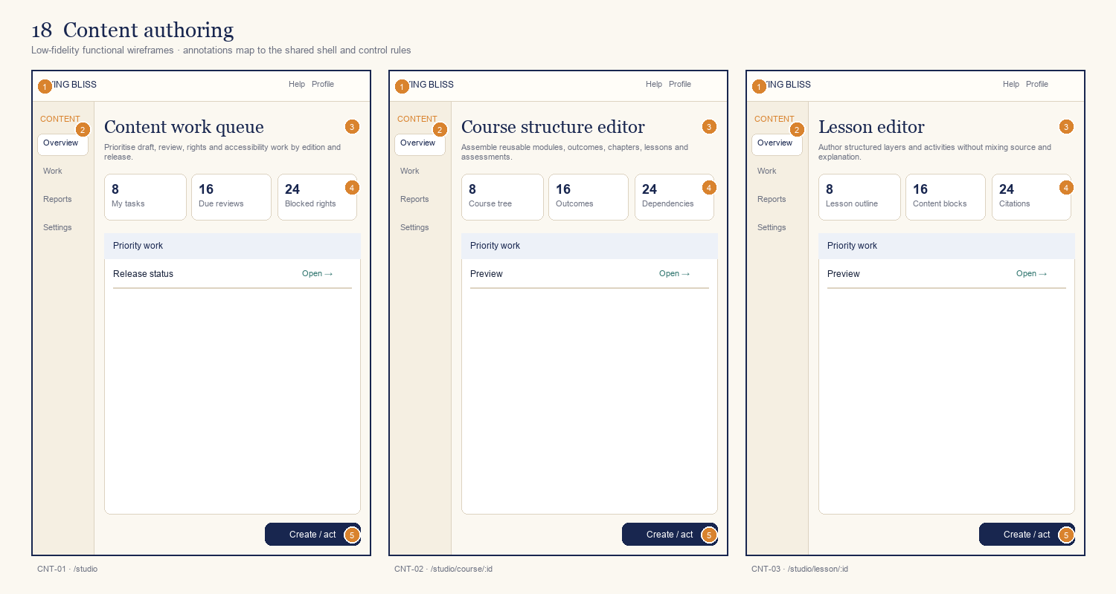
ID | Screen / route | Primary decision or outcome
CNT-01 | Content work queue  /studio | Prioritise draft, review, rights and accessibility work by edition and release.
CNT-02 | Course structure editor  /studio/course/:id | Assemble reusable modules, outcomes, chapters, lessons and assessments.
CNT-03 | Lesson editor  /studio/lesson/:id | Author structured layers and activities without mixing source and explanation.
Annotation contract: 1 shell/identity · 2 orientation/context · 3 primary task · 4 supporting state · 5 next action.

Board 19 — Scholarly content tools
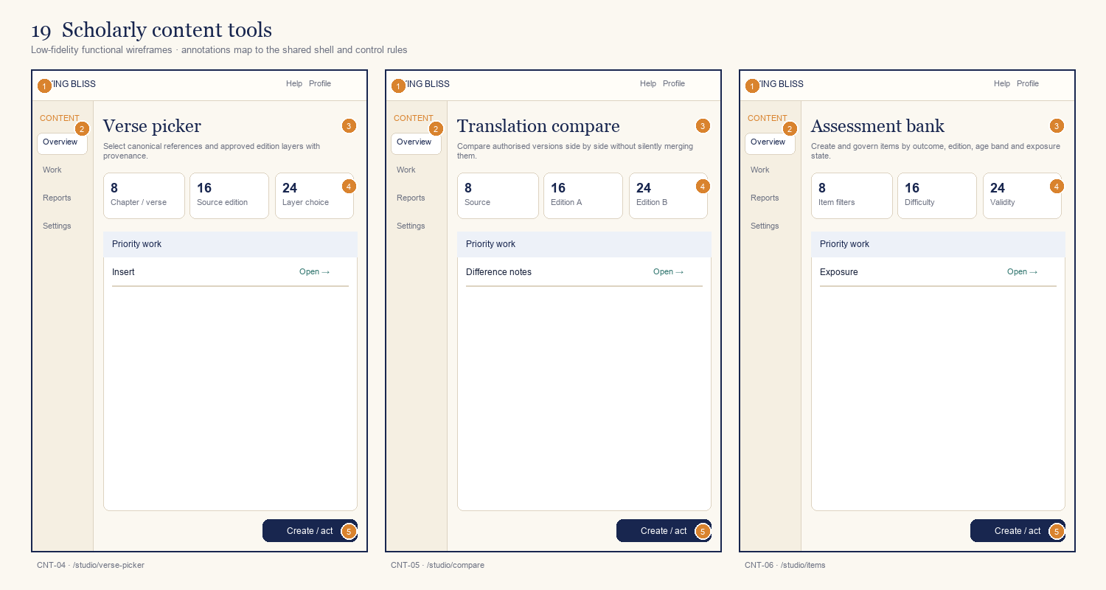
ID | Screen / route | Primary decision or outcome
CNT-04 | Verse picker  /studio/verse-picker | Select canonical references and approved edition layers with provenance.
CNT-05 | Translation compare  /studio/compare | Compare authorised versions side by side without silently merging them.
CNT-06 | Assessment bank  /studio/items | Create and govern items by outcome, edition, age band and exposure state.
Annotation contract: 1 shell/identity · 2 orientation/context · 3 primary task · 4 supporting state · 5 next action.

Board 20 — Content review, release and rights
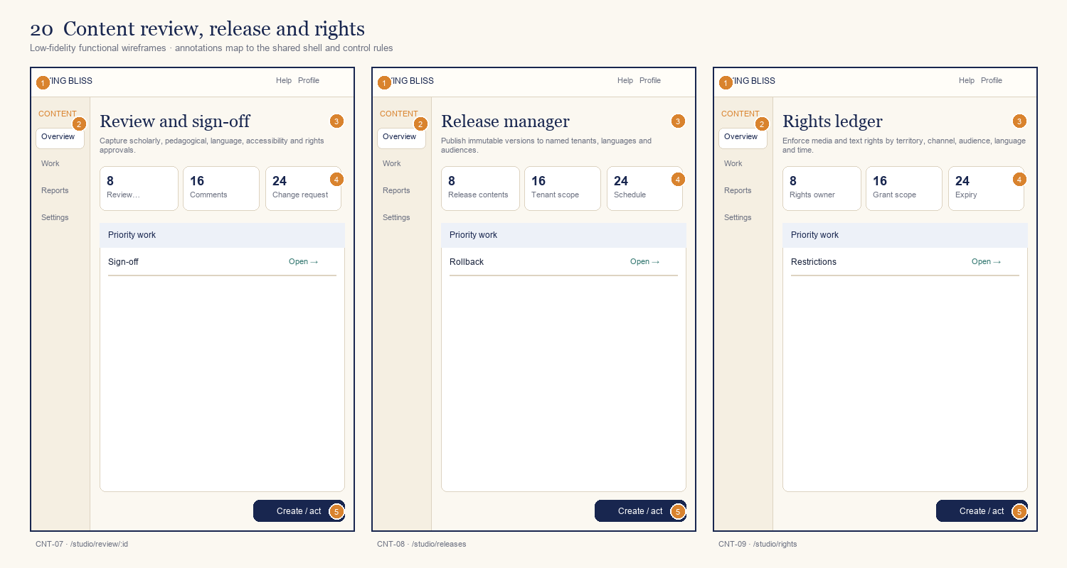
ID | Screen / route | Primary decision or outcome
CNT-07 | Review and sign-off  /studio/review/:id | Capture scholarly, pedagogical, language, accessibility and rights approvals.
CNT-08 | Release manager  /studio/releases | Publish immutable versions to named tenants, languages and audiences.
CNT-09 | Rights ledger  /studio/rights | Enforce media and text rights by territory, channel, audience, language and time.
Annotation contract: 1 shell/identity · 2 orientation/context · 3 primary task · 4 supporting state · 5 next action.

Board 21 — Tenant administration
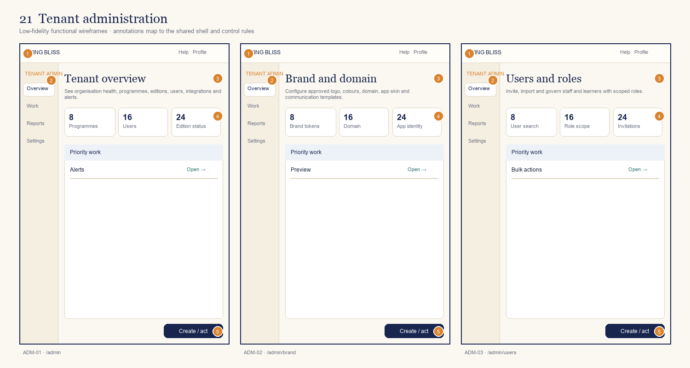
ID | Screen / route | Primary decision or outcome
ADM-01 | Tenant overview  /admin | See organisation health, programmes, editions, users, integrations and alerts.
ADM-02 | Brand and domain  /admin/brand | Configure approved logo, colours, domain, app skin and communication templates.
ADM-03 | Users and roles  /admin/users | Invite, import and govern staff and learners with scoped roles.
Annotation contract: 1 shell/identity · 2 orientation/context · 3 primary task · 4 supporting state · 5 next action.

Board 22 — Programmes and integrations
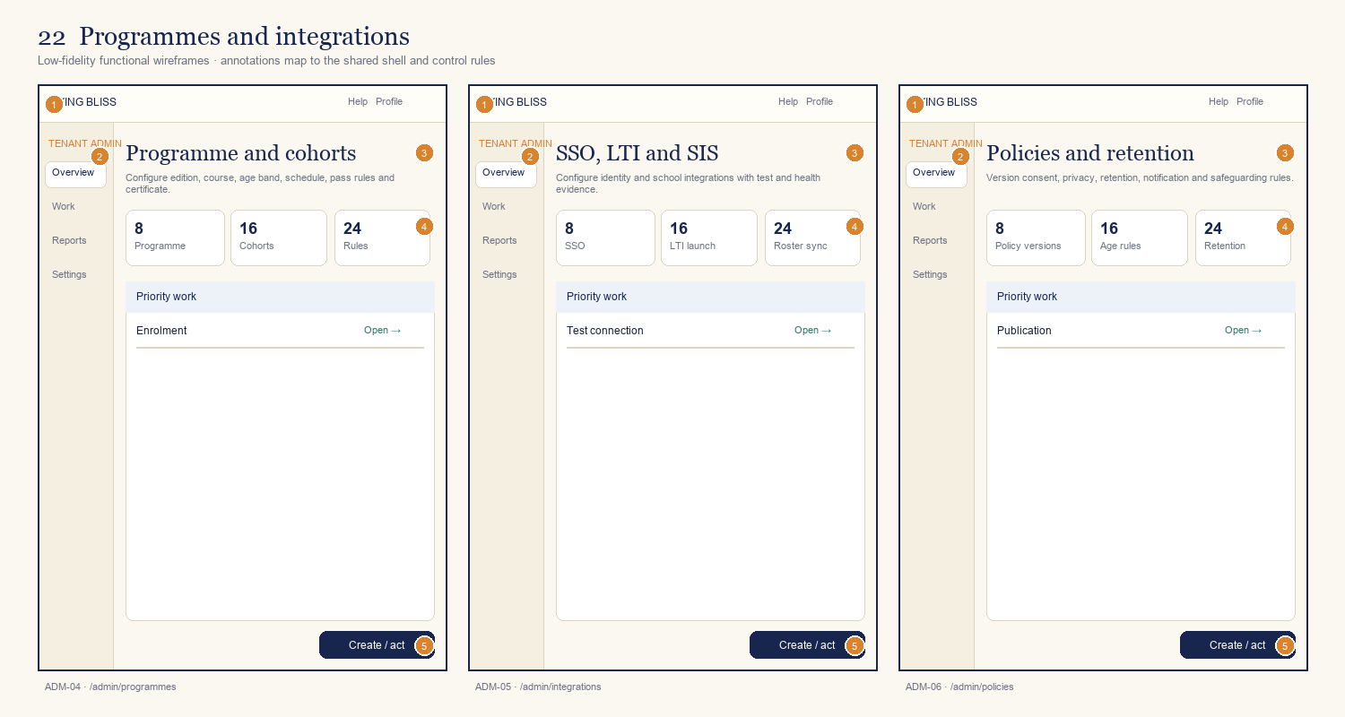
ID | Screen / route | Primary decision or outcome
ADM-04 | Programme and cohorts  /admin/programmes | Configure edition, course, age band, schedule, pass rules and certificate.
ADM-05 | SSO, LTI and SIS  /admin/integrations | Configure identity and school integrations with test and health evidence.
ADM-06 | Policies and retention  /admin/policies | Version consent, privacy, retention, notification and safeguarding rules.
Annotation contract: 1 shell/identity · 2 orientation/context · 3 primary task · 4 supporting state · 5 next action.

Board 23 — Certificates, analytics and audit
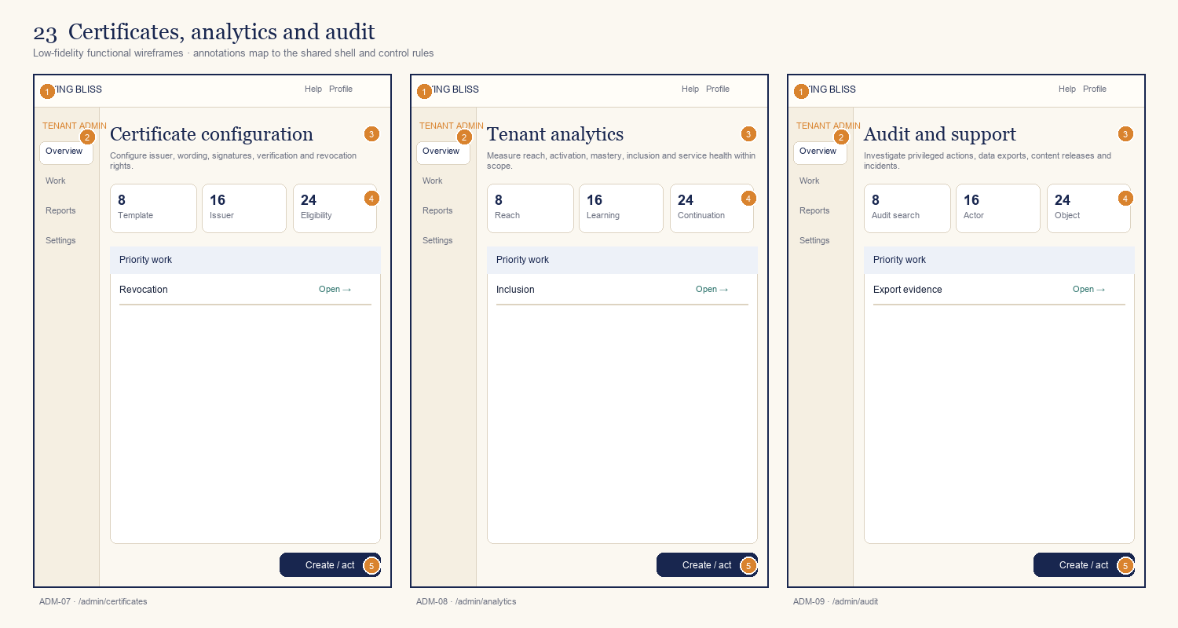
ID | Screen / route | Primary decision or outcome
ADM-07 | Certificate configuration  /admin/certificates | Configure issuer, wording, signatures, verification and revocation rights.
ADM-08 | Tenant analytics  /admin/analytics | Measure reach, activation, mastery, inclusion and service health within scope.
ADM-09 | Audit and support  /admin/audit | Investigate privileged actions, data exports, content releases and incidents.
Annotation contract: 1 shell/identity · 2 orientation/context · 3 primary task · 4 supporting state · 5 next action.

Board 24 — Platform operations
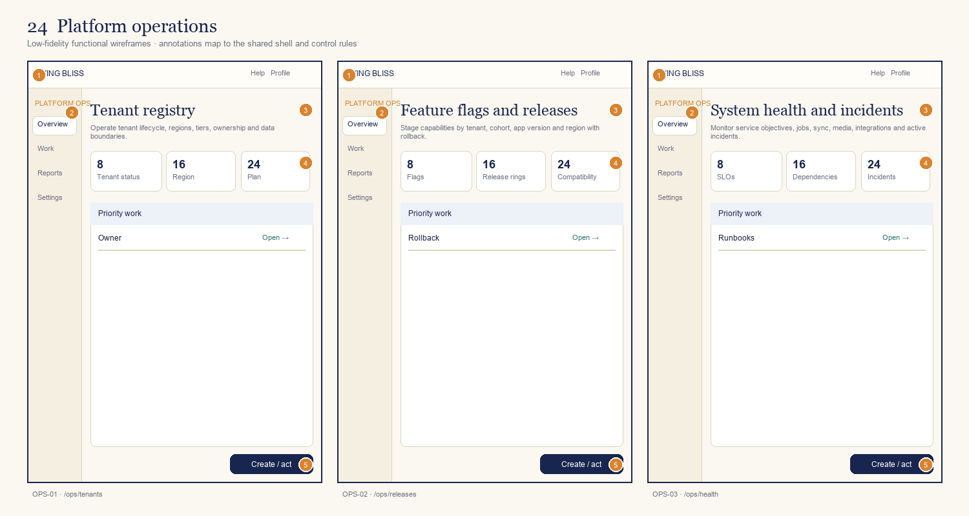
ID | Screen / route | Primary decision or outcome
OPS-01 | Tenant registry  /ops/tenants | Operate tenant lifecycle, regions, tiers, ownership and data boundaries.
OPS-02 | Feature flags and releases  /ops/releases | Stage capabilities by tenant, cohort, app version and region with rollback.
OPS-03 | System health and incidents  /ops/health | Monitor service objectives, jobs, sync, media, integrations and active incidents.
Annotation contract: 1 shell/identity · 2 orientation/context · 3 primary task · 4 supporting state · 5 next action.

Board 25 — Platform trust and support
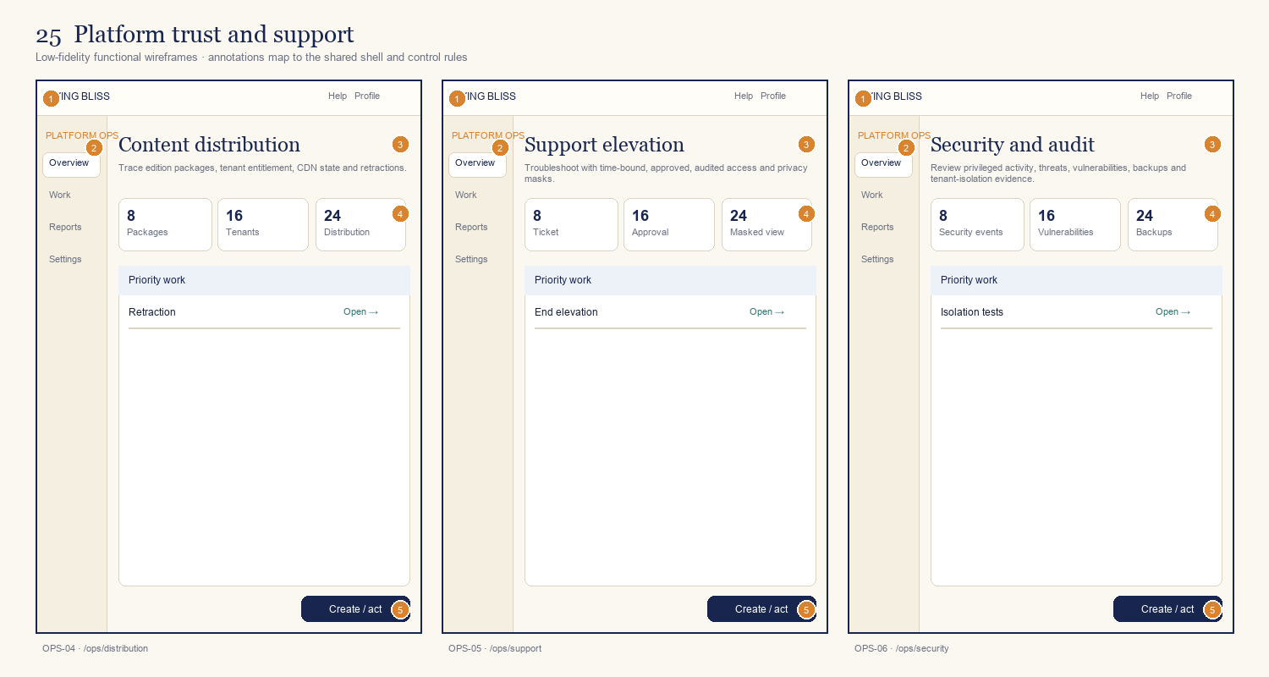
ID | Screen / route | Primary decision or outcome
OPS-04 | Content distribution  /ops/distribution | Trace edition packages, tenant entitlement, CDN state and retractions.
OPS-05 | Support elevation  /ops/support | Troubleshoot with time-bound, approved, audited access and privacy masks.
OPS-06 | Security and audit  /ops/security | Review privileged activity, threats, vulnerabilities, backups and tenant-isolation evidence.
Annotation contract: 1 shell/identity · 2 orientation/context · 3 primary task · 4 supporting state · 5 next action.

6. Interaction and state model

Critical end-to-end journeys
Journey | Screen sequence | Completion evidence
Independent learner | PUB-01 → PUB-02 → PUB-05 → ID-02/03 → LRN-02/03 → LRN-04–15 → LRN-19 | Readiness resolved; 18 chapters; capstone; verifiable certificate.
School learner | LMS launch → GUA-01/02 if required → LRN-01 → LRN-04–15 | Roster and consent applied; results returned only as authorised.
Teacher delivery | TCH-01 → TCH-02/03 → TCH-04/05 → TCH-07/08 | Approved plan assigned; feedback and outcome report produced.
Organisation onboarding | ADM-01–09 + CNT-04/05/07–09 | Brand, domain, identity, policies, rights and edition approved before launch.
Content release | CNT-01 → CNT-02/03/04 → CNT-07 → CNT-08 → OPS-04 | Immutable authorised version published to named tenants and audiences.
Support incident | LRN-21/TCH-01 → OPS-05 → OPS-03/06 | Approved elevation, masked diagnostics, audit evidence and closure.

Destructive and high-trust actions
- Delete account/data, retract content, revoke certificate, remove tenant and end support elevation require confirmation, scope summary and audit evidence.
- Publish, approve, release, export and role assignment show the exact tenant, edition, audience and version affected before commitment.
- A user must never infer success from navigation alone; save, submit, sync, publish and certificate actions require explicit status feedback.

7. Technical interface contracts

Front-end application boundaries
Client | Responsibilities | Must not own
Responsive web | Public discovery, learner, teacher, studio, admin and ops shells; SSR/PWA where valuable. | Authoritative entitlement, policy or certificate decisions.
iOS / Android | Native-quality playback, downloads, notifications, secure storage and offline sync. | A separate curriculum or tenant administration model.
Design system | Tokens, components, interaction states, content patterns and accessibility semantics. | Tenant-specific components that cannot be upgraded centrally.
BFF / API gateway | Resolve context, aggregate view models, enforce scopes and mobile compatibility. | Silent cross-tenant joins or UI-derived authorisation.

Required view-model fields
- context: tenantId, programmeId, editionId, language, agePolicy, roleScopes and entitlement.
- resource: stable ID, version, publication status, effective date, source/edition lineage and rights state.
- learning: activity state, mastery evidence, attempt policy, sync state, next action and revision reason.
- UI: accessible name, status text, permitted actions, empty/error/offline variants and support reference.

Navigation and API guarantees
- All routes use stable identifiers; human-readable slugs are aliases, not database keys.
- Mutations are idempotent where retried by mobile/offline clients and return the resulting version and sync token.
- Every privileged mutation includes tenant scope, actor, reason where required, correlation ID and audit event.

8. Accessibility, localisation and analytics

Accessibility acceptance
- Target WCAG 2.2 Level AA for web and relevant mobile guidance, including keyboard, switch, screen reader, text reflow, reduced motion and accessible authentication.
- Test scripture scripts, diacritics, transliteration, dynamic type, audio controls, assessments and error states with target assistive technologies.
- Do not rely on colour, shape or position alone for edition, status, correctness, approval or risk.

Localisation contract
Layer | Requirement
Interface | Externalised strings, pluralisation, directionality, locale formats and translated validation.
Scripture | Independent script, source text, transliteration, translation and commentary layers.
Media | Per-language audio, captions, transcripts, description and rights.
Programme | Local schedule, age band, policy, curriculum terms and certificate wording.
Operations | Per-language release state, reviewers, support coverage and fallbacks.

Analytics event principles
- Events are purpose-bound and exclude private reflections, free-text notes and sensitive religious inferences.
- Recommended core events: context_resolved, course_started, activity_completed, outcome_demonstrated, revision_started, assessment_submitted, certificate_issued, offline_sync_completed and content_issue_reported.
- Every event carries tenant, programme, edition, language, resource version and consent classification as permitted.

9. Delivery and acceptance requirements

Design deliverables expected from the development organisation
- Validated information architecture and route map for all 75 screens.
- Clickable desktop, tablet and mobile prototypes for all critical journeys and high-risk states.
- Living Bliss multi-brand design system with tokens, components, content patterns and accessibility annotations.
- Screen-by-screen specification including data, actions, permissions, events, empty/error/offline states and acceptance criteria.
- Usability findings from learners, teachers, content reviewers, administrators and disabled participants.
- Traceability from this screen inventory to backlog stories, APIs, tests and release evidence.

UI definition of done
Gate | Evidence required
Functional | All permitted actions, validation, persistence, status and recovery paths work.
Responsive | Approved breakpoints and supported devices pass visual regression.
Accessibility | Automated and manual tests pass; critical journeys tested with assistive technology.
Tenant integrity | Brand and content change by configuration; no cross-tenant data or unapproved edition leakage.
Content integrity | Source layers, version, authority, rights and approval remain visible and traceable.
Offline | Downloads, queued events, conflicts, expiry and retraction behave as specified.
Operational | Analytics, audit, support references, feature flags and rollback are present.
RECOMMENDED NEXT STEP: Commission a six-week paid discovery and UX validation phase. Require the vendor to return clickable prototypes for these wireframes, a production design system, API/view-model contracts, a prioritised backlog and a fixed-assumption delivery plan.

