
TECHNICAL DESIGN SPECIFICATION
Bhagavad Gita Learning Platform
Complete User Interface Wireframes
Web · iOS · Android · Teacher · Content · Tenant Administration · Platform Operations
DESIGN INTENT: Preserve the calm, scripture-first Living Bliss experience while extending it into one configurable, multi-organisation learning platform. Structure, source integrity and acceptance obligations in this document are implementation requirements; the wireframes remain intentionally low fidelity.
Document | Version | Status
UI wireframes and technical design | 2.0 Professional | Vendor discovery and implementation baseline
Prepared for Living Bliss and the selected product-development organisation · 31 August 2026

Document purpose and use
This specification converts the product blueprint into a complete interface inventory, 25-board wireframe set and testable implementation contract for an external development organisation. It supports discovery, UX design, solution architecture, estimation, backlog creation, build, verification and release acceptance.
CONTROLLED SCOPE: Exactly 75 screens are defined across nine interface families and consolidated into six authenticated role-based workspaces. Public discovery and identity are entry surfaces; learner web and learner mobile are separate interface families for one learner workspace.

Authority and interpretation
Classification | Meaning
Requirement | Must be implemented or formally varied through agreed change control.
Wireframe intent | Information hierarchy, context, actions and states are authoritative; pixel treatment is refined in the design-system phase.
Example | Illustrative organisation, route or API name; the vendor validates the production form without weakening the requirement.
Decision in discovery | A bounded open point that must be resolved, recorded and traceable before solution design is accepted.

How to read the wireframes
Marker | Meaning
1 | Global identity, tenant context and workspace navigation.
2 | Page title, source/edition context or learner orientation.
3 | Primary task surface, search, editor or learning content.
4 | Supporting state, progress, metadata or secondary action.
5 | Primary completion, publish, submit or create action.

Design authority
- Visual authority is the current library.livingbliss.org experience; scope authority is the product blueprint covering multi-tenant editions, schools, teacher tools, content governance, rights, mobile/offline and platform operations.
- Scripture, translation, commentary and learning explanation must stay visibly distinct. ISKCON, Chinmaya Mission, BAPS, schools, governments and other organisations are configuration examples—not claims of affiliation or approval—and must not be hard-coded.

Contents
- 1. Design baseline and interface principles
- 2. Information architecture and role workspaces
- 3. Learning journey and 18-chapter curriculum spine
- 4. Responsive shell, shared components and key states
- 5. Complete screen inventory (75 screens)
- 6. Wireframe boards 01–25
- 7. Screen-level implementation register
- 8. End-to-end workflows and state transitions
- 9. Technical, API and data contracts
- 10. Accessibility, localisation and responsible analytics
- 11. Vendor delivery, evidence and acceptance criteria
- Appendix A. Traceability, decisions and glossary

Key product decision
ONE DESIGN SYSTEM, MANY TRUSTED EDITIONS: Tenant branding changes tokens, identity, approved content, policies and programme configuration. It must not create divergent navigation models or unsupported code forks.

Vendor response rule
The vendor must preserve the 75 screen identifiers in its backlog and prototype. Proposed consolidation is permitted only with a traceability matrix showing that every named route, role, state, action and acceptance obligation remains testable.

1. Design baseline and interface principles

Brand-aligned token baseline
Token | Value | Primary use
Ivory | #FBF8F1 | Application canvas and calm reading surface
Paper | #FFFDF8 | Cards, forms and scripture panels
Indigo | #18264F | Navigation, primary actions and headings
Saffron | #D9832E | Active state, focus accent and spiritual warmth
Gold | #B68C3B | Source details, ornament and secondary emphasis
Teal | #2E746D | Progress, links and structured learning state
Green | #34805B | Success, approval and verified status
Line | #DDD3C1 | Quiet borders and separators

Non-negotiable interface principles
- Source before interpretation: every content layer is labeled and traceable.
- Learning, not scrolling: each screen has an explicit orientation, task and next action.
- Progress without pressure: no public ranking, streak anxiety or spiritual gamification.
- Private by default: reflections and private notes remain outside teacher/admin analytics.
- Configuration over forks: shells and components are shared; tenants change governed tokens and data.
- Accessible and multilingual by architecture: scripts, captions, dynamic type and keyboard use are core states.

2. Information architecture and role workspaces

Nine interface families
Family | Screen range | Surface | Relationship to workspace
Public discovery | PUB-01–06 | Responsive web | Unauthenticated entry; resolves tenant, edition and programme.
Identity | ID-01–03 | Responsive web / native hand-off | Entry surface shared by all authenticated roles.
Guardian | GUA-01–03 | Responsive web | Guardian workspace plus consent routing.
Learner web | LRN-01–21 | Responsive web / PWA | Learner workspace on browser-capable devices.
Learner mobile | MOB-01–09 | iOS and Android | Native expression of the same learner domain and curriculum.
Teacher | TCH-01–09 | Responsive web / tablet | Teacher workspace.
Content Studio | CNT-01–09 | Desktop-first responsive web | Content Studio workspace.
Tenant administration | ADM-01–09 | Desktop-first responsive web | Tenant Administration workspace.
Platform operations | OPS-01–06 | Desktop-first responsive web | Platform Operations workspace.
COUNT RECONCILIATION: Nine interface families are not nine role workspaces. Public discovery and identity are entry surfaces; learner web and learner mobile share the Learner role. The six authenticated role-based workspaces are Learner, Guardian, Teacher, Content Studio, Tenant Administration and Platform Operations.

Six authenticated role-based workspaces
Workspace | Primary roles | Navigation model | Authorisation boundary
Learner | Learner | Top navigation + chapter rail; native bottom navigation | Own learning, permitted programme and private data.
Guardian | Verified guardian | Simple top navigation | Linked minors and explicitly permitted consent/progress fields only.
Teacher | Teacher, facilitator | Workspace rail + cohort context | Assigned cohorts, approved programmes and allowed accommodations.
Content Studio | Author, translator, reviewer, publisher | Workspace rail + edition/release context | Named editions, languages, rights grants and review tasks.
Tenant Administration | Organisation administrator | Workspace rail + tenant context | One tenant and delegated organisational units.
Platform Operations | Operator, support, security | Ops rail + region/tenant selector | Controlled, time-bound and audited elevation.

Context resolution order
- Domain or invitation → tenant → identity → role and scope → programme/cohort → authorised edition → language → age/guardian policy → accessibility preferences → entitlement.
- Every deep link must preserve resolved context or return a human-readable denial with recovery. A missing or conflicting tenant is never guessed from a resource identifier.
- The active tenant, programme, edition, language and role are visible wherever their absence could lead to a consequential action.
- Workspace switching preserves the user identity but re-resolves permission, policy, edition and data scope before any cached view is shown.

Navigation invariants
- One canonical route registry supplies web navigation, native deep links, breadcrumbs, analytics screen names and authorisation checks.
- Back, refresh, sign-in return and app relaunch must restore a valid state without repeating a committed assessment or mutation.
- Unavailable items remain explainable: locked by prerequisite, outside entitlement, unpublished, retracted, expired, region-limited or permission denied.

Multi-tenant and edition context
Configuration level | Examples | Inheritance / override rule
Platform | Core navigation, security baseline, shared design tokens | Mandatory baseline; tenants cannot weaken security or accessibility.
Tenant / organisation | Domain, logo, palette, support, policies, data region | Configuration only; no tenant-specific application fork.
Programme | Audience, edition, learning path, pass rules, certificate | Versioned and effective-dated; approved before learner assignment.
Cohort / unit | Schedule, teacher, local due dates, roster | May narrow programme rules but not silently replace edition content.
User | Language, accessibility, notifications, lawful consent state | Portable preferences constrained by tenant policy and role.
Edition release | Tradition, authority, translation/commentary, language, rights | Immutable published release; correction creates a new version.

Edition descriptor shown in the interface
Every scripture-bearing and edition-sensitive screen must be able to disclose: edition name and ID; tradition or lineage; translator and/or guru/commentator; approving authority; canonical reference; interface/content language; release version and effective date; publication state; territory/channel/audience rights; source provenance; and any approved progress-equivalence map.

Edition switching rules
- A switch preview explains which translation, commentary, lessons, assessments, progress and certificates will change before commitment.
- Progress carries across editions only through an explicit, versioned equivalence map approved at outcome and assessment level. Otherwise the UI retains history and marks the new path as not yet demonstrated.
- Content from different traditions or organisations—such as configurable editions for ISKCON, Chinmaya Mission or BAPS—must never be silently merged. Labels and provenance stay adjacent to the content they qualify.
- Rights expiry or retraction invalidates future access and offline packages without deleting lawful learning evidence; the user receives a clear reason and support path.

3. Learning journey and 18-chapter curriculum spine

Prerequisite-to-completion journey
Stage | Primary screens | Entry / exit contract
1. Resolve context | PUB-01–06 | Exit with valid tenant, programme, edition, language and entitlement choice.
2. Establish identity | ID-01–03; GUA-01–03 | Exit with authenticated role, preferences and required consent evidence.
3. Build foundations | LRN-02 | Complete orientation, Gita context, key concepts and how to study a verse.
4. Determine readiness | LRN-03 | Produce explainable placement: bridge activity, recommended start or approved bypass.
5. Navigate the course | LRN-01; LRN-04–05 | Show all 18 chapters, gating reason, evidence state, effort and next action.
6. Repeat chapter loop | LRN-06–15 | Learn → verse study → reflect/practise → assess → result → remediate/revise.
7. Complete programme | LRN-13; LRN-19 | Apply versioned completion rules and issue a verifiable, revocable certificate.
8. Continue learning | LRN-15–18; LRN-20–21 | Support revision, saved content, privacy choices and help.
NO HIDDEN GATES: Every lock has a visible reason, the evidence needed to unlock it, and an accessible next action. Experienced learners may bypass only where the programme policy explicitly allows it.

Recommended 18-chapter spine — chapters 1–9
Chapter titles are reference labels; the active edition controls the approved Sanskrit title, transliteration, translation, ordering labels and learning interpretation.
Ch. | Reference label | Learning emphasis
1 | Arjuna Viṣāda Yoga | Context, moral conflict and the learner’s central question.
2 | Sāṅkhya Yoga | Self, right understanding, disciplined action and steady wisdom.
3 | Karma Yoga | Selfless action, responsibility and freedom from attachment to results.
4 | Jñāna Karma Sannyāsa Yoga | Knowledge, action, teaching lineage and transformative understanding.
5 | Karma Sannyāsa Yoga | Renunciation, service and the relationship between knowledge and action.
6 | Dhyāna Yoga | Meditation, self-mastery, balance and compassionate practice.
7 | Jñāna Vijñāna Yoga | Knowledge and realised understanding of the divine.
8 | Akṣara Brahma Yoga | The imperishable, remembrance and the direction of a life.
9 | Rāja Vidyā Rāja Guhya Yoga | The most confidential knowledge, devotion and divine presence.

Chapter delivery contract
- Each chapter is a configurable module with orientation, outcomes, essential verses, multimodal lessons, glossary concepts, private reflection, practice, assessment, remediation and completion evidence.
- The shell must support the same loop across all chapters while allowing edition- and audience-specific content, activity mix, time estimate, pass rule and teaching support.

Recommended 18-chapter spine — chapters 10–18
Ch. | Reference label | Learning emphasis
10 | Vibhūti Yoga | Recognising divine manifestations and cultivating attentive perception.
11 | Viśvarūpa Darśana Yoga | The universal form, awe, duty and transformed understanding.
12 | Bhakti Yoga | Devotion, relationship and qualities of a devoted practitioner.
13 | Kṣetra Kṣetrajña Vibhāga Yoga | The field, the knower and discriminating knowledge.
14 | Guṇatraya Vibhāga Yoga | The three guṇas, observable patterns and transcendence.
15 | Puruṣottama Yoga | The cosmic tree, the self and the Supreme Person.
16 | Daivāsura Sampad Vibhāga Yoga | Constructive and destructive qualities; ethical self-reflection.
17 | Śraddhātraya Vibhāga Yoga | Threefold faith, intention and the qualities shaping practice.
18 | Mokṣa Sannyāsa Yoga | Synthesis, discernment, surrender, liberation and committed action.

Progress and assessment rules
- Progress is evidence-based and append-only: started, activity completed, outcome demonstrated, revision due, passed, superseded or revoked. Percentages are derived, never the sole source of truth.
- Assessment attempts, item version, pass rule and accommodations are captured with the evidence. Retakes never overwrite prior attempts.
- Private reflections are excluded from teacher/admin analytics unless the learner makes a deliberate, scoped submission; disclosure defaults to off.

4. Responsive shell, shared components and key states

Responsive behaviour and verification widths
Class | Verification widths | Required shell behaviour
Compact phone | 320, 360, 390 CSS px | Single column; bottom navigation; sticky next action that does not obscure focus; sheets for context; no horizontal page scroll.
Large phone | 414, 430 CSS px | Same task order; richer media controls; long Sanskrit and translation reflow; safe-area and dynamic-type support.
Tablet | 768, 820, 1024 CSS px | Collapsible rail; optional two-pane teacher/content detail; touch targets remain primary; portrait and landscape tested.
Laptop / desktop | 1280, 1366 CSS px | Persistent contextual rail where useful; comparison and preview panes; keyboard-complete workflows.
Wide desktop | 1440, 1920 CSS px | Constrain scripture/reading measure; extra width supports evidence, preview and comparison—not longer lines.
Breakpoints are content-driven. The widths above are regression fixtures, not a licence to optimise only for those devices.

Family-specific adaptations
Pattern | Compact behaviour | Expanded behaviour
Public / identity | One decision per viewport; filters in modal sheet; clear sign-in return. | Inline filters, comparison cards and trust/provenance detail.
Learning / verse | Chapter rail becomes sheet; tabs become accessible disclosure when needed. | Rail plus bounded reading column; optional transcript/commentary companion.
Teacher / admin data | Cards or priority columns; secondary fields disclosed on demand. | Sortable table with visible filters, column controls and detail pane.
Content Studio | Editing is limited to supported tablet tasks; preview stacks below. | Structure/editor/preview panes with keyboard-resizable boundaries.
Native mobile | Offline-first queue, downloads, notifications and secure storage. | Tablet layouts may use two panes but share the same domain/API contracts.

Shared component contract
Component family | Required variants and semantics
Global shell | Public, learner, guardian, teacher, studio, tenant admin and platform ops; tenant/workspace switcher; skip link; landmarks; deep-link recovery.
Context bar | Tenant, programme, edition, language, role and rights state; compact summary and full disclosure.
Content identity | Canonical reference, source, edition, translator/guru, language, version, approval and rights.
Learning status | Not started, available, in progress, revision due, passed, locked, expired, superseded and revoked.
Action controls | Primary, secondary, destructive, disabled with reason, loading, offline queued, permission denied and completed.
Data views | First use, populated, empty, filtered empty, loading, partial, stale, conflict, integration failure and export in progress.
Feedback | Inline validation, formative response, summative result, review comment, approval, warning and incident alert.
Media | Video, audio, slides, transcript, captions, description, download, speed, quality and accessible alternative.

State ownership rules
- The server is authoritative for tenant scope, entitlements, published content, policy versions, roles, assessment decisions, rights and certificate status.
- The device may optimistically queue progress, bookmarks, private notes and other low-risk learning events. A durable local event ID prevents duplicate commits.
- Draft content and assessment changes require explicit save, validation and version state. Publishing, retraction, role assignment and certificate revocation are never optimistic.

Key-state matrix
State | Required presentation | Recovery / acceptance evidence
Loading / slow | Skeleton or progress with stable layout; announce prolonged waits without repeated screen-reader noise. | No blocked input without status; retry is idempotent.
Empty / filtered empty | Explain whether no data exists or filters exclude it. | Offer one relevant create, clear-filter or help action.
Permission denied | Name the unavailable action and safe reason; never disclose hidden object detail. | Return to authorised context or request access through policy.
Locked / prerequisite | Show required evidence, progress and next eligible step. | Completing prerequisite re-evaluates the gate without sign-out.
Offline / queued | Persistent offline banner, local timestamp and queued action count. | Reconnect sync is resumable, idempotent and observable.
Stale / superseded | Show current and requested version with effective date. | Refresh or retain lawful history; never silently replace submitted work.
Sync conflict | Summarise differences and identify authoritative fields. | Automatic merge only for commutative events; otherwise explicit resolution.
Rights expired / retracted | Remove protected payload, preserve metadata permitted by policy and explain why. | Offer update/removal/support; offline copy becomes unusable.
Partial integration failure | Keep unaffected functions available and label data freshness. | Retry, support reference and reconciliation evidence are available.
Destructive confirmation | State tenant, object, version, consequence and reversibility. | Re-auth or dual approval where policy requires; audit event created.

Native mobile and offline rules
- Downloads are encrypted at rest, tied to tenant/user/edition entitlement, checksummed, versioned, remotely retractable and accompanied by size, expiry and last-verified status.
- Assessment submission requires an explicit offline policy. If offline submission is allowed, the UI shows queued/not-yet-graded state and prevents duplicate attempts across devices.
- Dynamic type, screen-reader order, captions, background audio policy, safe areas, interruption recovery and OS-level reduced motion are acceptance requirements on both iOS and Android.

5. Complete screen inventory

Public
ID | Screen | Route | Purpose
PUB-01 | Tenant-aware home | / | Orient the visitor, resolve organisation and offer the clearest next step.
PUB-02 | Edition directory | /editions | Choose an authorised organisation, guru/translator, language and access model.
PUB-03 | Course catalogue | /courses | Browse approved programmes by audience, edition, age band, format and duration.
PUB-04 | Scripture search | /scripture | Find chapters, verses, topics and approved layers without confusing commentary with source.
PUB-05 | Course detail | /course/:courseId | Explain outcomes, prerequisites, effort, assessment, edition and certificate before enrolment.
PUB-06 | Edition detail | /edition/:editionId | Make tradition, translator/guru, rights, version and approval status transparent.

Identity
ID | Screen | Route | Purpose
ID-01 | Sign in | /sign-in | Authenticate through passwordless email, password, Google, Microsoft or tenant SSO.
ID-02 | Registration | /register | Create the minimum viable account and retain eligible guest progress.
ID-03 | Learning onboarding | /onboarding | Capture goal, experience, language, accessibility and notification preferences.

Guardian
ID | Screen | Route | Purpose
GUA-01 | Age and consent routing | /consent | Apply jurisdiction and programme rules before creating a minor account.
GUA-02 | Guardian invitation | /guardian/invite | Invite and verify a guardian without exposing private learning reflections.
GUA-03 | Guardian overview | /guardian | Manage consent, linked learners and permitted progress visibility.

Learner
ID | Screen | Route | Purpose
LRN-01 | Learner dashboard | /dashboard | Resume the most meaningful next action and understand mastery across programmes.
LRN-02 | Prerequisite pathway | /learn/foundations | Build common background knowledge while allowing experienced learners to move quickly.
LRN-03 | Readiness diagnostic | /diagnostic | Route the learner to bridge modules or Chapter 1 with an explainable result.
LRN-04 | Course pathway | /course/:courseId/path | Show all 18 chapters, state, mastery evidence, time and next action.
LRN-05 | Chapter overview | /chapter/:chapterId | Orient the learner to outcomes, key verses, activities and assessment.
LRN-06 | Lesson player | /lesson/:lessonId | Deliver multimodal learning with a persistent chapter rail and calm completion logic.
LRN-07 | Verse study | /verse/:verseId | Keep Sanskrit, transliteration, word meaning, translation and commentary visibly distinct.
LRN-08 | Media transcript | /lesson/:id/transcript | Provide synchronised transcript, captions, speed, search and accessible alternatives.
LRN-09 | Glossary and concepts | /glossary | Explain Sanskrit and philosophical terms in edition- and age-aware language.
LRN-10 | Private reflection | /reflection/:activityId | Support private meaning-making with autosave and explicit optional sharing.
LRN-11 | Practice activity | /practice/:activityId | Apply concepts through scenario, sorting, matching or short response.
LRN-12 | Assessment question | /assessment/:assessmentId | Present one accessible item at a time with progress, save/resume and attempt policy.
LRN-13 | Assessment result | /assessment/:id/result | Explain mastered outcomes, misconceptions, pass decision and next action.
LRN-14 | Targeted remediation | /revision/plan | Create a short evidence-based revision plan linked to missed outcomes and verses.
LRN-15 | Revision queue | /revision | Support spaced review across verses, concepts and prior assessments.
LRN-16 | Bookmarks | /bookmarks | Return to saved verses, lessons and media while preserving edition context.
LRN-17 | Private notes | /notes | Manage searchable notes separately from teacher-visible submissions.
LRN-18 | Downloads and offline | /downloads | Control offline packs, size, rights expiry, update and sync status.
LRN-19 | Certificate | /certificate/:id | Display a verifiable, revocable completion credential with issuer and edition.
LRN-20 | Preferences and privacy | /account/preferences | Control language, accessibility, notifications, sessions and data rights.
LRN-21 | Help and report issue | /support | Reach approved support and report content, access, safety or technical issues.

Mobile
ID | Screen | Route | Purpose
MOB-01 | Mobile home | app://home | Resolve tenant and offer one high-confidence next action.
MOB-02 | Mobile course map | app://course/:id | Navigate 18 chapters with states, schedule and offline availability.
MOB-03 | Mobile lesson | app://lesson/:id | Support interruption-safe video/audio/text learning with bottom next action.
MOB-04 | Mobile verse study | app://verse/:id | Read source-aware verse layers comfortably on a narrow screen.
MOB-05 | Mobile assessment | app://assessment/:id | Complete accessible one-question screens with autosave and resume.
MOB-06 | Mobile result | app://assessment/:id/result | Explain mastery and route directly to revision or continuation.
MOB-07 | Offline library | app://downloads | Download, update and remove authorised content with transparent storage.
MOB-08 | Sync conflict | app://sync | Resolve conflicting completion, note and assessment events without data loss.
MOB-09 | Mobile certificate | app://certificate/:id | Present a wallet-ready certificate and verification QR.

Teacher
ID | Screen | Route | Purpose
TCH-01 | Teacher dashboard | /teacher | Show classes, upcoming work, support flags and recent submissions.
TCH-02 | Cohort list | /teacher/cohorts | Manage permitted cohorts with programme, edition, schedule and roster state.
TCH-03 | Cohort overview | /teacher/cohort/:id | Understand participation, mastery, pace and accessibility support.
TCH-04 | Teaching schedule | /teacher/schedule | Plan chapter sequence, live sessions, due dates and exceptions.
TCH-05 | Create assignment | /teacher/assignment/new | Assign only approved activities with rubric, due date and accommodation rules.
TCH-06 | Learner detail | /teacher/learner/:id | Support learning from permitted evidence without exposing private reflections.
TCH-07 | Submissions and rubric | /teacher/submissions | Review work, apply an approved rubric and provide accessible feedback.
TCH-08 | Class outcome report | /teacher/reports/outcomes | Identify concept-level needs without public ranking or sensitive inference.
TCH-09 | Class presentation mode | /teacher/present/:lessonId | Project verses, diagrams and activities with large text and minimal controls.

Content
ID | Screen | Route | Purpose
CNT-01 | Content work queue | /studio | Prioritise draft, review, rights and accessibility work by edition and release.
CNT-02 | Course structure editor | /studio/course/:id | Assemble reusable modules, outcomes, chapters, lessons and assessments.
CNT-03 | Lesson editor | /studio/lesson/:id | Author structured layers and activities without mixing source and explanation.
CNT-04 | Verse picker | /studio/verse-picker | Select canonical references and approved edition layers with provenance.
CNT-05 | Translation compare | /studio/compare | Compare authorised versions side by side without silently merging them.
CNT-06 | Assessment bank | /studio/items | Create and govern items by outcome, edition, age band and exposure state.
CNT-07 | Review and sign-off | /studio/review/:id | Capture scholarly, pedagogical, language, accessibility and rights approvals.
CNT-08 | Release manager | /studio/releases | Publish immutable versions to named tenants, languages and audiences.
CNT-09 | Rights ledger | /studio/rights | Enforce media and text rights by territory, channel, audience, language and time.

Tenant admin
ID | Screen | Route | Purpose
ADM-01 | Tenant overview | /admin | See organisation health, programmes, editions, users, integrations and alerts.
ADM-02 | Brand and domain | /admin/brand | Configure approved logo, colours, domain, app skin and communication templates.
ADM-03 | Users and roles | /admin/users | Invite, import and govern staff and learners with scoped roles.
ADM-04 | Programme and cohorts | /admin/programmes | Configure edition, course, age band, schedule, pass rules and certificate.
ADM-05 | SSO, LTI and SIS | /admin/integrations | Configure identity and school integrations with test and health evidence.
ADM-06 | Policies and retention | /admin/policies | Version consent, privacy, retention, notification and safeguarding rules.
ADM-07 | Certificate configuration | /admin/certificates | Configure issuer, wording, signatures, verification and revocation rights.
ADM-08 | Tenant analytics | /admin/analytics | Measure reach, activation, mastery, inclusion and service health within scope.
ADM-09 | Audit and support | /admin/audit | Investigate privileged actions, data exports, content releases and incidents.

Platform ops
ID | Screen | Route | Purpose
OPS-01 | Tenant registry | /ops/tenants | Operate tenant lifecycle, regions, tiers, ownership and data boundaries.
OPS-02 | Feature flags and releases | /ops/releases | Stage capabilities by tenant, cohort, app version and region with rollback.
OPS-03 | System health and incidents | /ops/health | Monitor service objectives, jobs, sync, media, integrations and active incidents.
OPS-04 | Content distribution | /ops/distribution | Trace edition packages, tenant entitlement, CDN state and retractions.
OPS-05 | Support elevation | /ops/support | Troubleshoot with time-bound, approved, audited access and privacy masks.
OPS-06 | Security and audit | /ops/security | Review privileged activity, threats, vulnerabilities, backups and tenant-isolation evidence.

6. Wireframe boards
Each board is a functional composition baseline. During discovery, the vendor must turn every screen into a clickable prototype, test critical journeys with representative users and return an annotated component and state specification.
FIDELITY: These are deliberately low-fidelity: structure, controls, context and workflow are authoritative; exact typography, imagery, spacing and motion are refined in the design-system phase.

Board 01 — Public discovery
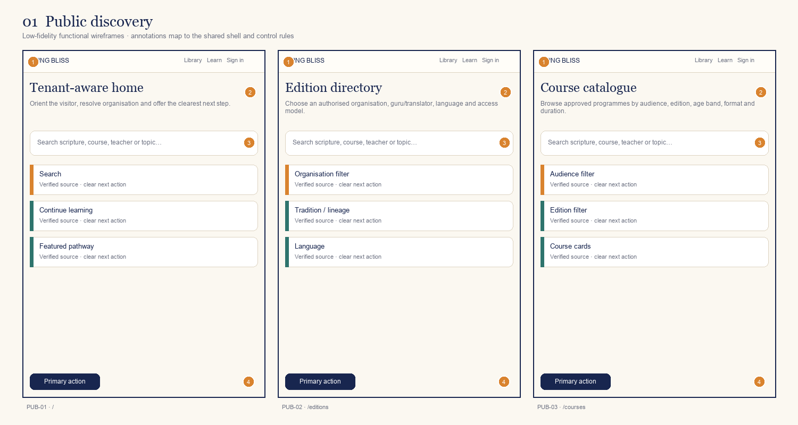
ID | Screen / route | Primary decision or outcome
PUB-01 | Tenant-aware home  / | Orient the visitor, resolve organisation and offer the clearest next step.
PUB-02 | Edition directory  /editions | Choose an authorised organisation, guru/translator, language and access model.
PUB-03 | Course catalogue  /courses | Browse approved programmes by audience, edition, age band, format and duration.
Annotation contract: 1 shell/identity · 2 orientation/context · 3 primary task · 4 supporting state · 5 next action.

Board 02 — Search and product detail
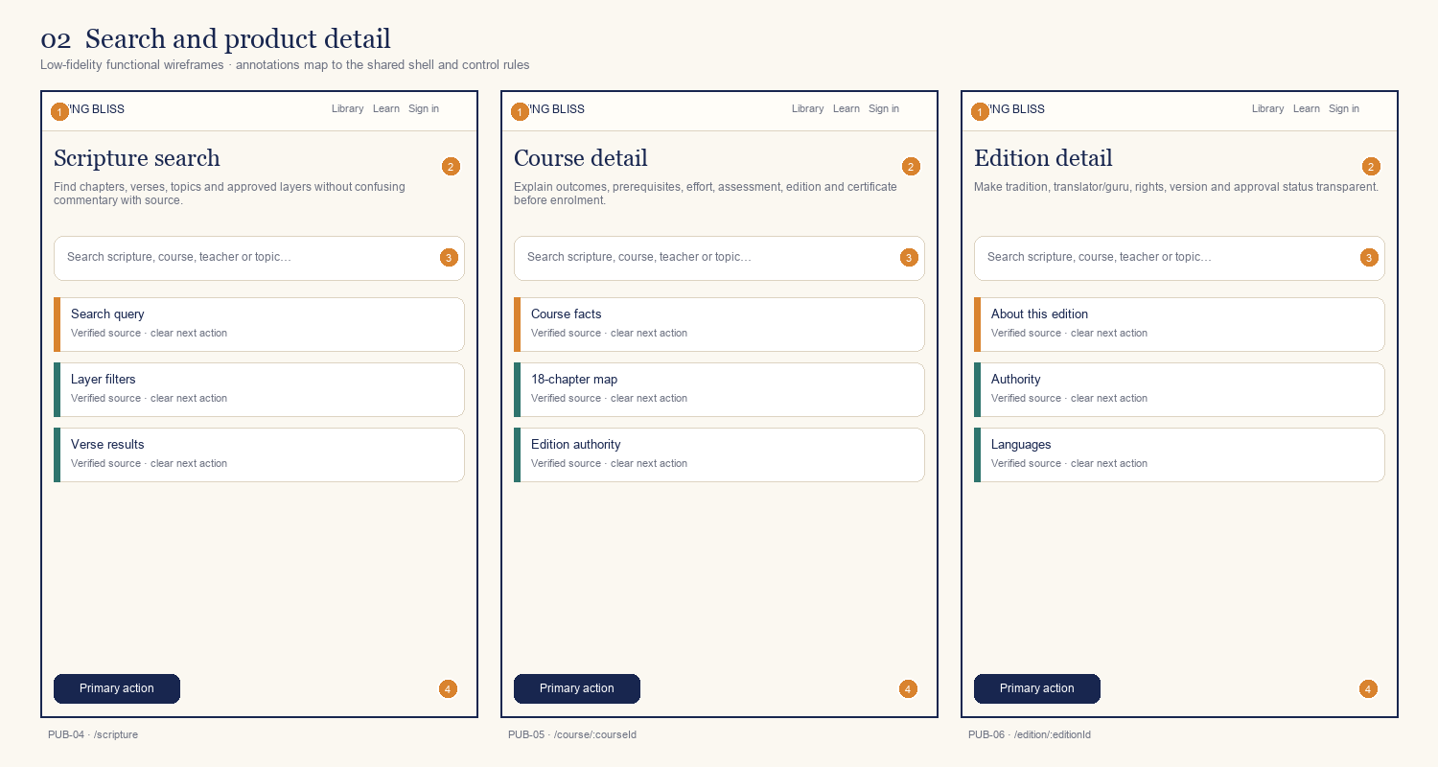
ID | Screen / route | Primary decision or outcome
PUB-04 | Scripture search  /scripture | Find chapters, verses, topics and approved layers without confusing commentary with source.
PUB-05 | Course detail  /course/:courseId | Explain outcomes, prerequisites, effort, assessment, edition and certificate before enrolment.
PUB-06 | Edition detail  /edition/:editionId | Make tradition, translator/guru, rights, version and approval status transparent.
Annotation contract: 1 shell/identity · 2 orientation/context · 3 primary task · 4 supporting state · 5 next action.

Board 03 — Identity and onboarding
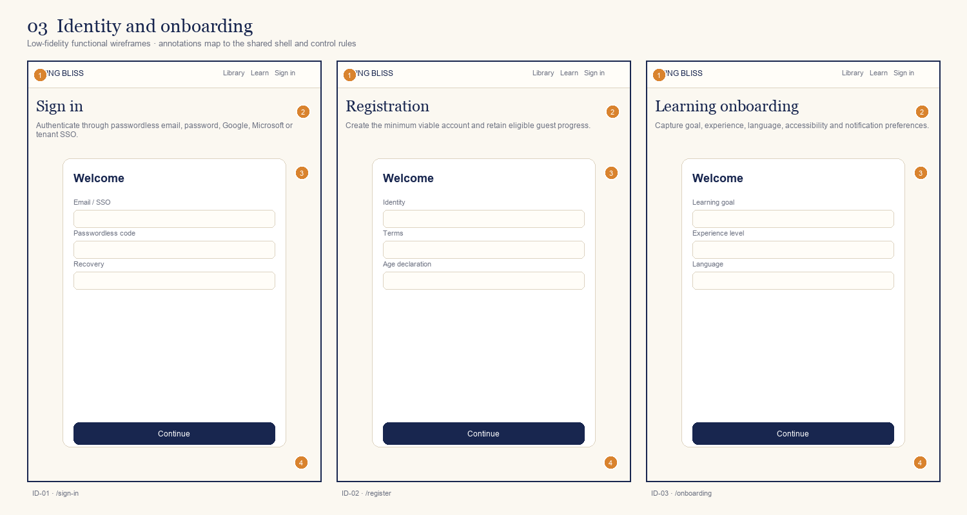
ID | Screen / route | Primary decision or outcome
ID-01 | Sign in  /sign-in | Authenticate through passwordless email, password, Google, Microsoft or tenant SSO.
ID-02 | Registration  /register | Create the minimum viable account and retain eligible guest progress.
ID-03 | Learning onboarding  /onboarding | Capture goal, experience, language, accessibility and notification preferences.
Annotation contract: 1 shell/identity · 2 orientation/context · 3 primary task · 4 supporting state · 5 next action.

Board 04 — Guardian and consent
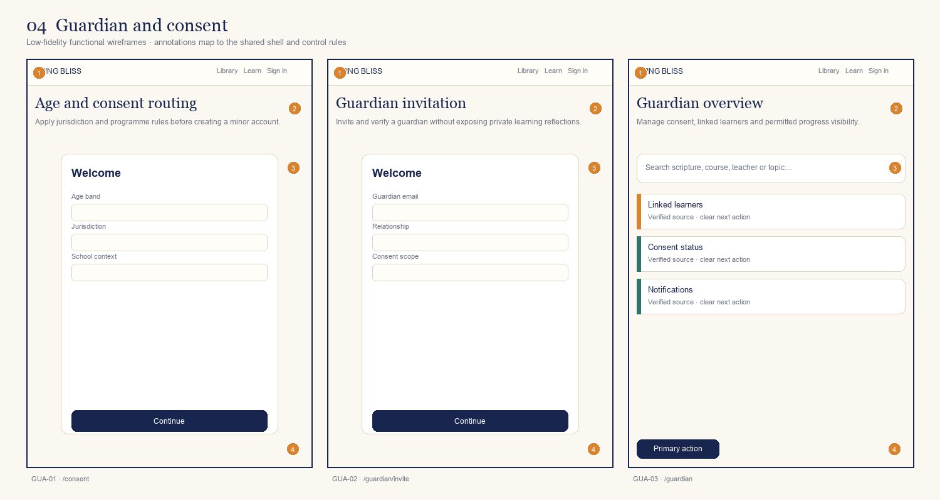
ID | Screen / route | Primary decision or outcome
GUA-01 | Age and consent routing  /consent | Apply jurisdiction and programme rules before creating a minor account.
GUA-02 | Guardian invitation  /guardian/invite | Invite and verify a guardian without exposing private learning reflections.
GUA-03 | Guardian overview  /guardian | Manage consent, linked learners and permitted progress visibility.
Annotation contract: 1 shell/identity · 2 orientation/context · 3 primary task · 4 supporting state · 5 next action.

Board 05 — Learner start
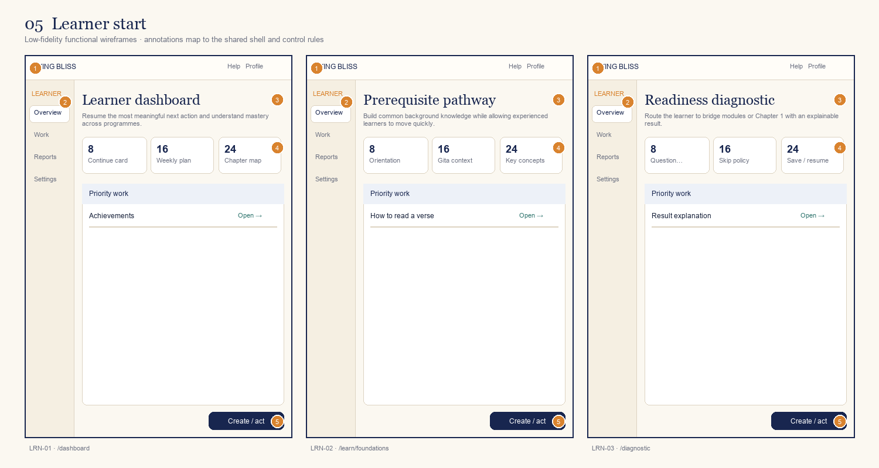
ID | Screen / route | Primary decision or outcome
LRN-01 | Learner dashboard  /dashboard | Resume the most meaningful next action and understand mastery across programmes.
LRN-02 | Prerequisite pathway  /learn/foundations | Build common background knowledge while allowing experienced learners to move quickly.
LRN-03 | Readiness diagnostic  /diagnostic | Route the learner to bridge modules or Chapter 1 with an explainable result.
Annotation contract: 1 shell/identity · 2 orientation/context · 3 primary task · 4 supporting state · 5 next action.

Board 06 — Course and chapter
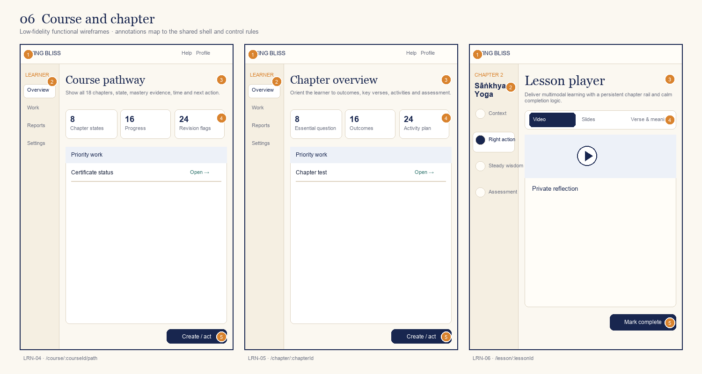
ID | Screen / route | Primary decision or outcome
LRN-04 | Course pathway  /course/:courseId/path | Show all 18 chapters, state, mastery evidence, time and next action.
LRN-05 | Chapter overview  /chapter/:chapterId | Orient the learner to outcomes, key verses, activities and assessment.
LRN-06 | Lesson player  /lesson/:lessonId | Deliver multimodal learning with a persistent chapter rail and calm completion logic.
Annotation contract: 1 shell/identity · 2 orientation/context · 3 primary task · 4 supporting state · 5 next action.

Board 07 — Verse and learning content
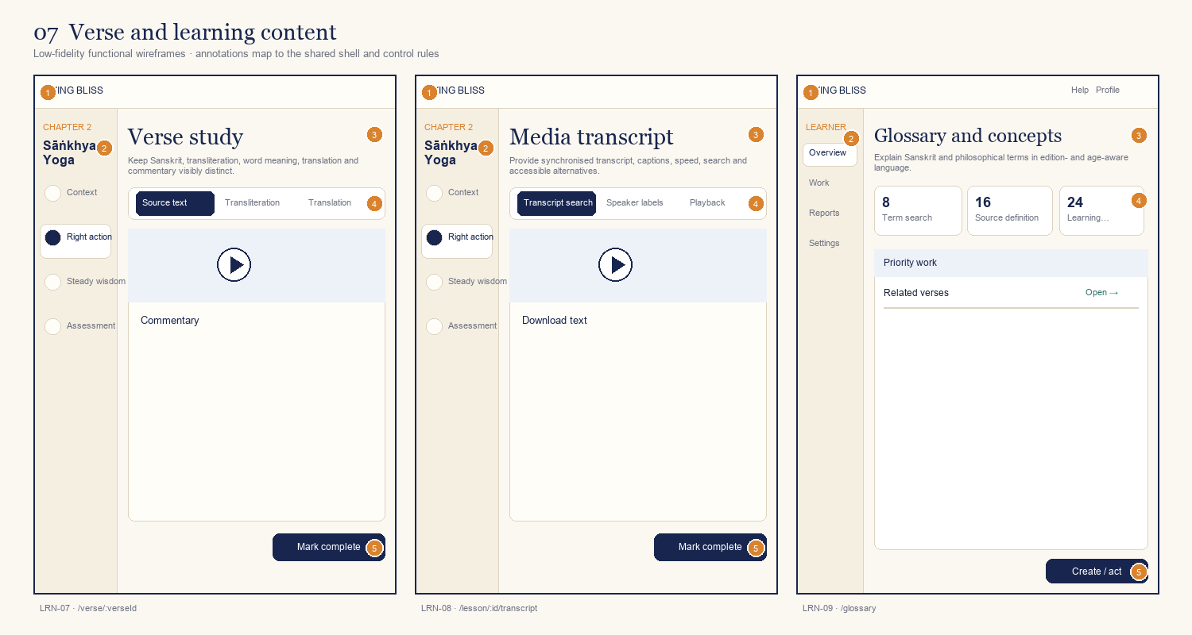
ID | Screen / route | Primary decision or outcome
LRN-07 | Verse study  /verse/:verseId | Keep Sanskrit, transliteration, word meaning, translation and commentary visibly distinct.
LRN-08 | Media transcript  /lesson/:id/transcript | Provide synchronised transcript, captions, speed, search and accessible alternatives.
LRN-09 | Glossary and concepts  /glossary | Explain Sanskrit and philosophical terms in edition- and age-aware language.
Annotation contract: 1 shell/identity · 2 orientation/context · 3 primary task · 4 supporting state · 5 next action.

Board 08 — Practice and assessment
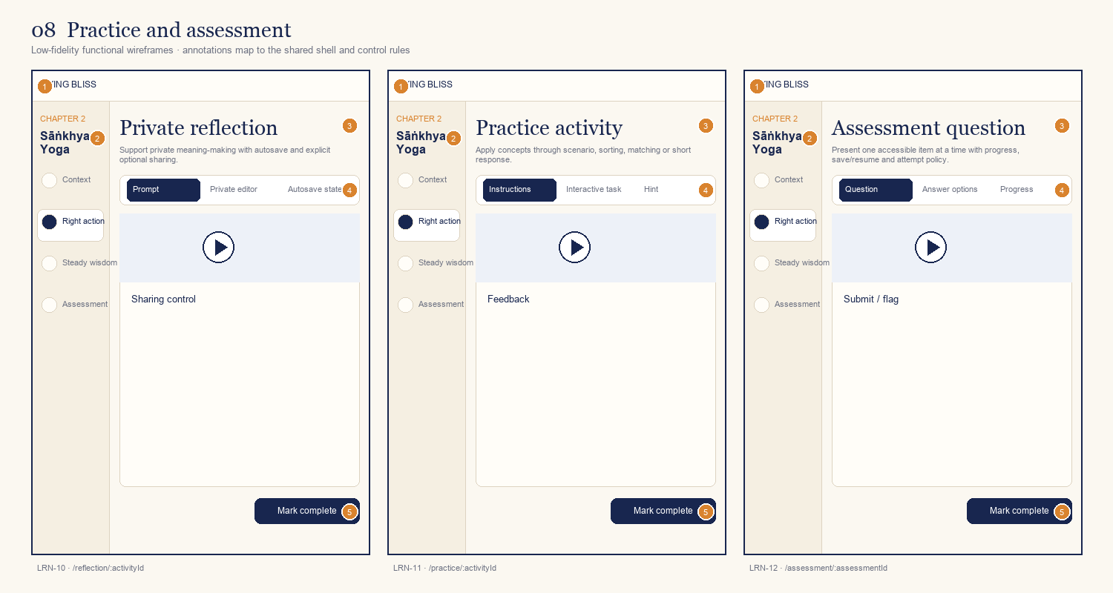
ID | Screen / route | Primary decision or outcome
LRN-10 | Private reflection  /reflection/:activityId | Support private meaning-making with autosave and explicit optional sharing.
LRN-11 | Practice activity  /practice/:activityId | Apply concepts through scenario, sorting, matching or short response.
LRN-12 | Assessment question  /assessment/:assessmentId | Present one accessible item at a time with progress, save/resume and attempt policy.
Annotation contract: 1 shell/identity · 2 orientation/context · 3 primary task · 4 supporting state · 5 next action.

Board 09 — Results and revision
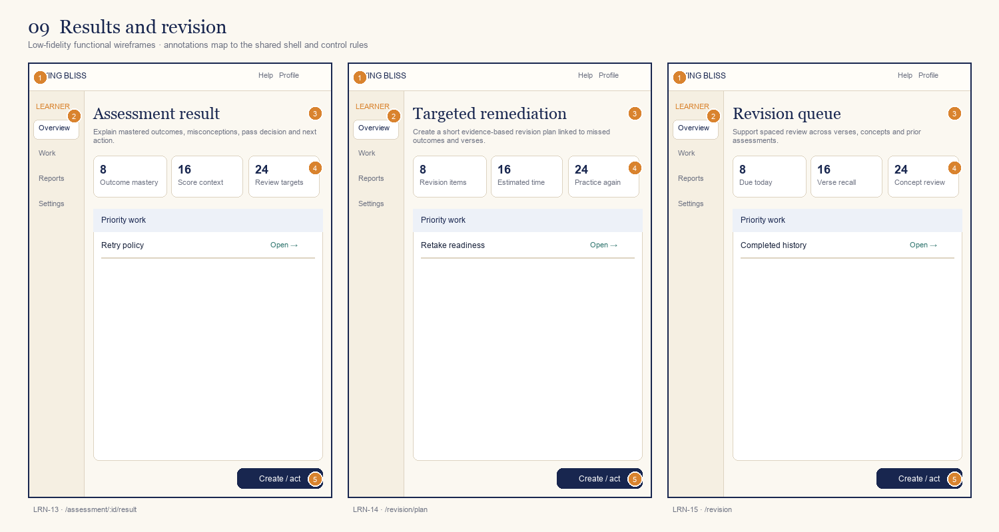
ID | Screen / route | Primary decision or outcome
LRN-13 | Assessment result  /assessment/:id/result | Explain mastered outcomes, misconceptions, pass decision and next action.
LRN-14 | Targeted remediation  /revision/plan | Create a short evidence-based revision plan linked to missed outcomes and verses.
LRN-15 | Revision queue  /revision | Support spaced review across verses, concepts and prior assessments.
Annotation contract: 1 shell/identity · 2 orientation/context · 3 primary task · 4 supporting state · 5 next action.

Board 10 — Personal library
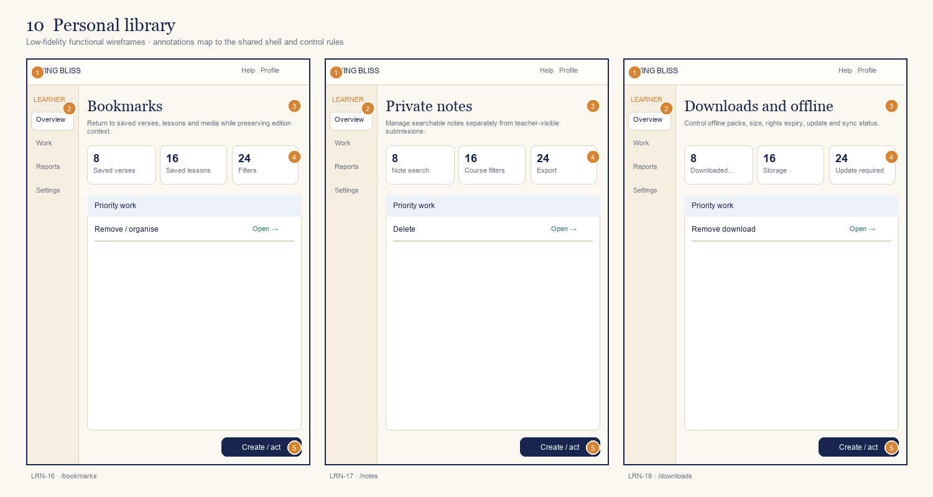
ID | Screen / route | Primary decision or outcome
LRN-16 | Bookmarks  /bookmarks | Return to saved verses, lessons and media while preserving edition context.
LRN-17 | Private notes  /notes | Manage searchable notes separately from teacher-visible submissions.
LRN-18 | Downloads and offline  /downloads | Control offline packs, size, rights expiry, update and sync status.
Annotation contract: 1 shell/identity · 2 orientation/context · 3 primary task · 4 supporting state · 5 next action.

Board 11 — Recognition and support
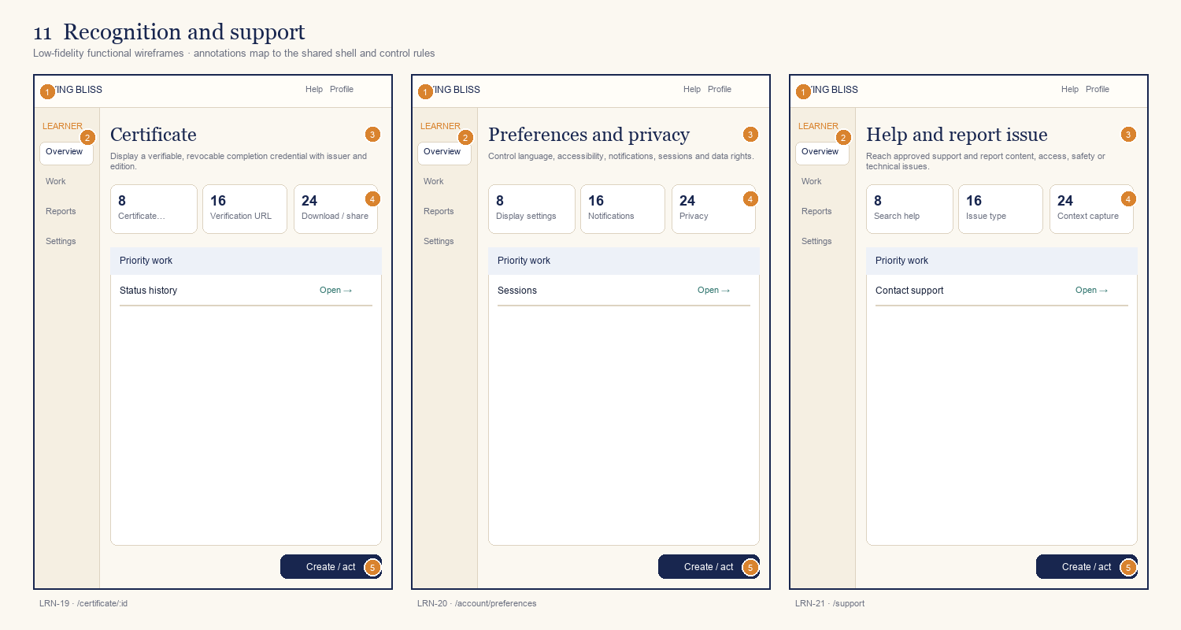
ID | Screen / route | Primary decision or outcome
LRN-19 | Certificate  /certificate/:id | Display a verifiable, revocable completion credential with issuer and edition.
LRN-20 | Preferences and privacy  /account/preferences | Control language, accessibility, notifications, sessions and data rights.
LRN-21 | Help and report issue  /support | Reach approved support and report content, access, safety or technical issues.
Annotation contract: 1 shell/identity · 2 orientation/context · 3 primary task · 4 supporting state · 5 next action.

Board 12 — Mobile core learning
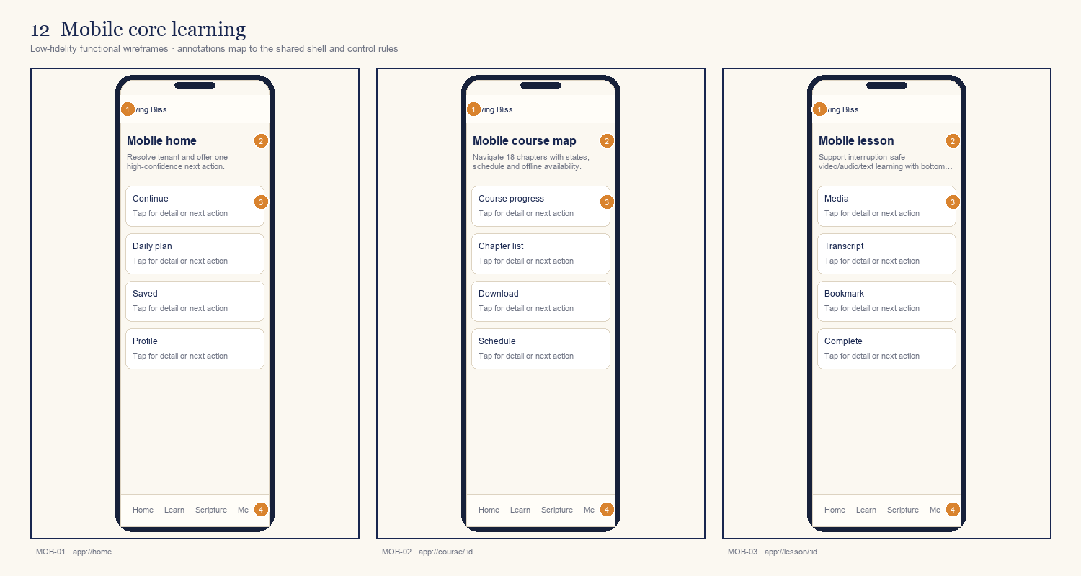
ID | Screen / route | Primary decision or outcome
MOB-01 | Mobile home  app://home | Resolve tenant and offer one high-confidence next action.
MOB-02 | Mobile course map  app://course/:id | Navigate 18 chapters with states, schedule and offline availability.
MOB-03 | Mobile lesson  app://lesson/:id | Support interruption-safe video/audio/text learning with bottom next action.
Annotation contract: 1 shell/identity · 2 orientation/context · 3 primary task · 4 supporting state · 5 next action.

Board 13 — Mobile scripture and assessment
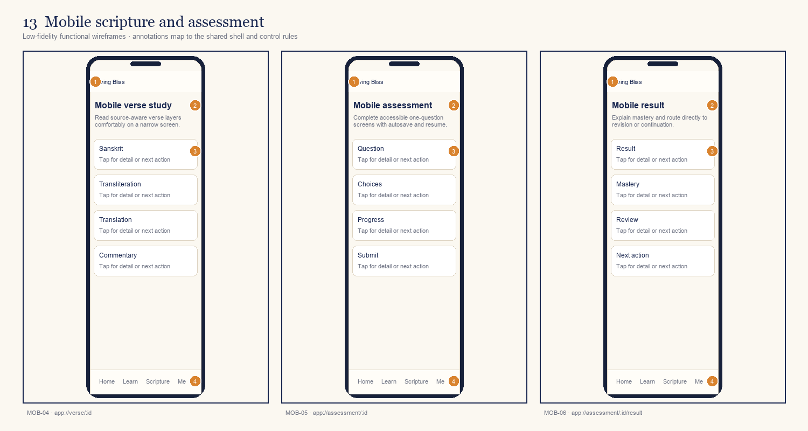
ID | Screen / route | Primary decision or outcome
MOB-04 | Mobile verse study  app://verse/:id | Read source-aware verse layers comfortably on a narrow screen.
MOB-05 | Mobile assessment  app://assessment/:id | Complete accessible one-question screens with autosave and resume.
MOB-06 | Mobile result  app://assessment/:id/result | Explain mastery and route directly to revision or continuation.
Annotation contract: 1 shell/identity · 2 orientation/context · 3 primary task · 4 supporting state · 5 next action.

Board 14 — Mobile offline and credentials
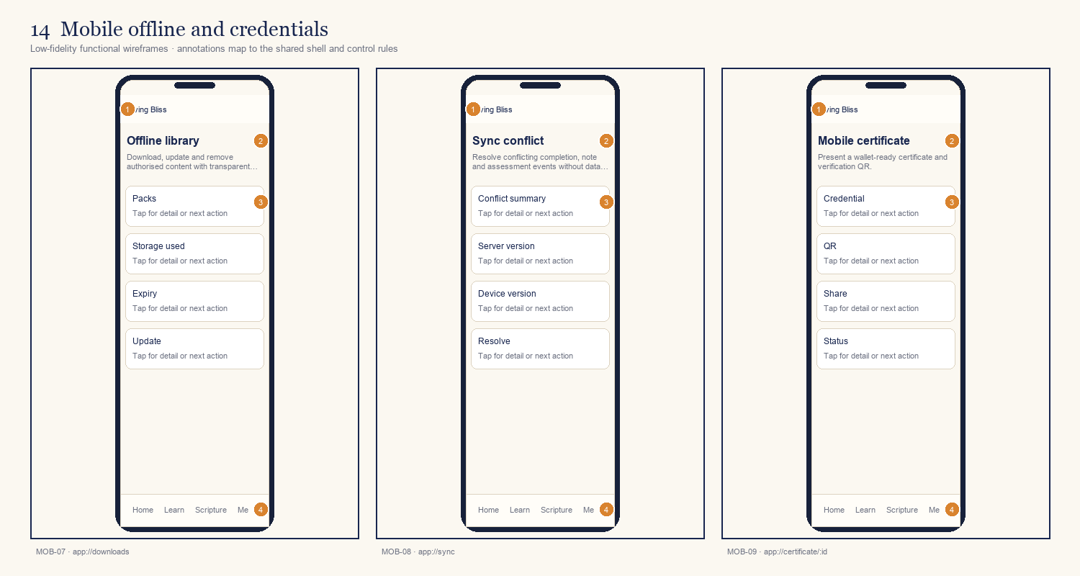
ID | Screen / route | Primary decision or outcome
MOB-07 | Offline library  app://downloads | Download, update and remove authorised content with transparent storage.
MOB-08 | Sync conflict  app://sync | Resolve conflicting completion, note and assessment events without data loss.
MOB-09 | Mobile certificate  app://certificate/:id | Present a wallet-ready certificate and verification QR.
Annotation contract: 1 shell/identity · 2 orientation/context · 3 primary task · 4 supporting state · 5 next action.

Board 15 — Teacher planning
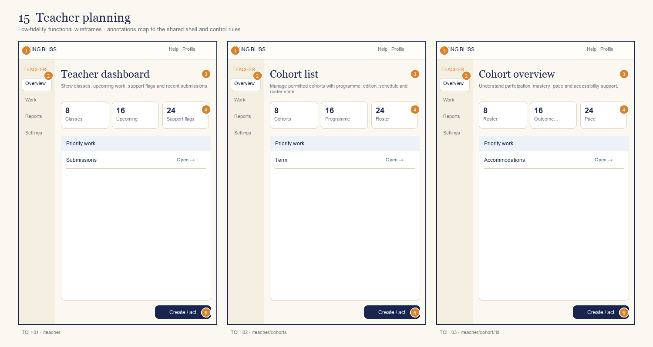
ID | Screen / route | Primary decision or outcome
TCH-01 | Teacher dashboard  /teacher | Show classes, upcoming work, support flags and recent submissions.
TCH-02 | Cohort list  /teacher/cohorts | Manage permitted cohorts with programme, edition, schedule and roster state.
TCH-03 | Cohort overview  /teacher/cohort/:id | Understand participation, mastery, pace and accessibility support.
Annotation contract: 1 shell/identity · 2 orientation/context · 3 primary task · 4 supporting state · 5 next action.

Board 16 — Teacher delivery and evidence
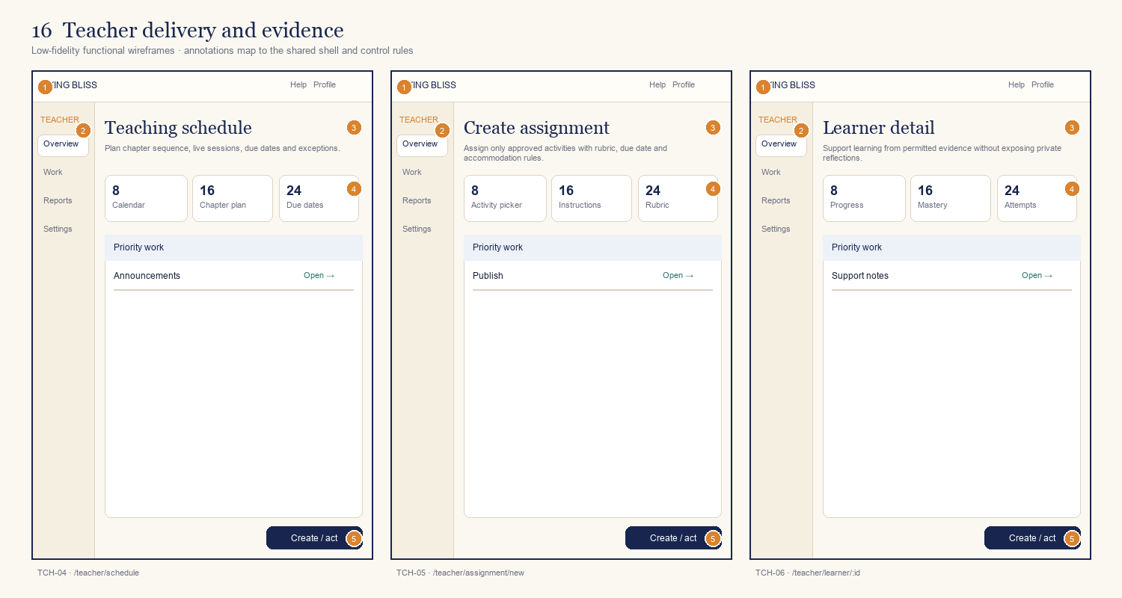
ID | Screen / route | Primary decision or outcome
TCH-04 | Teaching schedule  /teacher/schedule | Plan chapter sequence, live sessions, due dates and exceptions.
TCH-05 | Create assignment  /teacher/assignment/new | Assign only approved activities with rubric, due date and accommodation rules.
TCH-06 | Learner detail  /teacher/learner/:id | Support learning from permitted evidence without exposing private reflections.
Annotation contract: 1 shell/identity · 2 orientation/context · 3 primary task · 4 supporting state · 5 next action.

Board 17 — Teacher assessment and reports
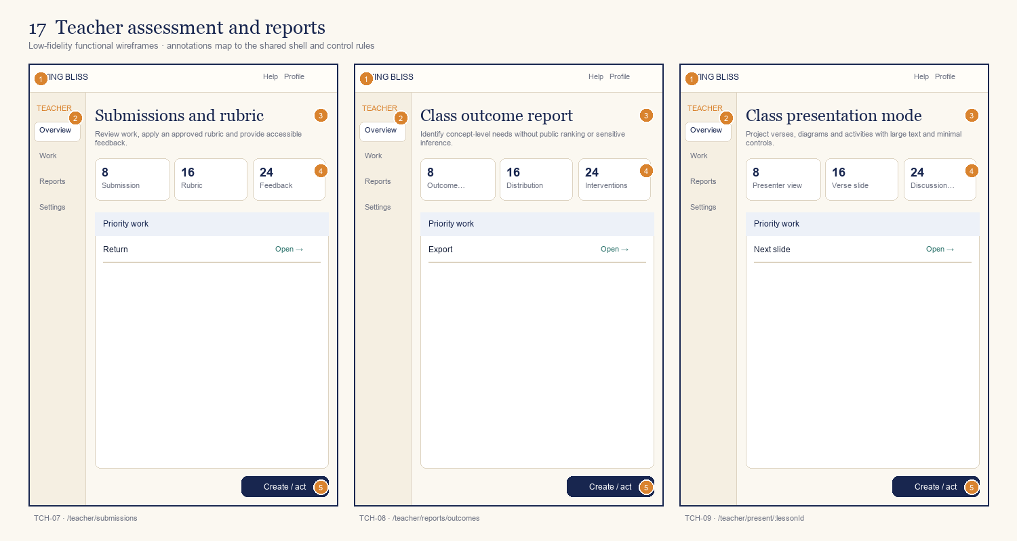
ID | Screen / route | Primary decision or outcome
TCH-07 | Submissions and rubric  /teacher/submissions | Review work, apply an approved rubric and provide accessible feedback.
TCH-08 | Class outcome report  /teacher/reports/outcomes | Identify concept-level needs without public ranking or sensitive inference.
TCH-09 | Class presentation mode  /teacher/present/:lessonId | Project verses, diagrams and activities with large text and minimal controls.
Annotation contract: 1 shell/identity · 2 orientation/context · 3 primary task · 4 supporting state · 5 next action.

Board 18 — Content authoring
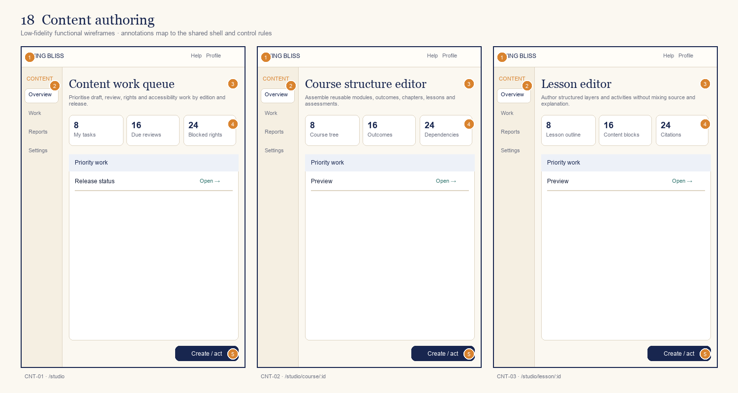
ID | Screen / route | Primary decision or outcome
CNT-01 | Content work queue  /studio | Prioritise draft, review, rights and accessibility work by edition and release.
CNT-02 | Course structure editor  /studio/course/:id | Assemble reusable modules, outcomes, chapters, lessons and assessments.
CNT-03 | Lesson editor  /studio/lesson/:id | Author structured layers and activities without mixing source and explanation.
Annotation contract: 1 shell/identity · 2 orientation/context · 3 primary task · 4 supporting state · 5 next action.

Board 19 — Scholarly content tools
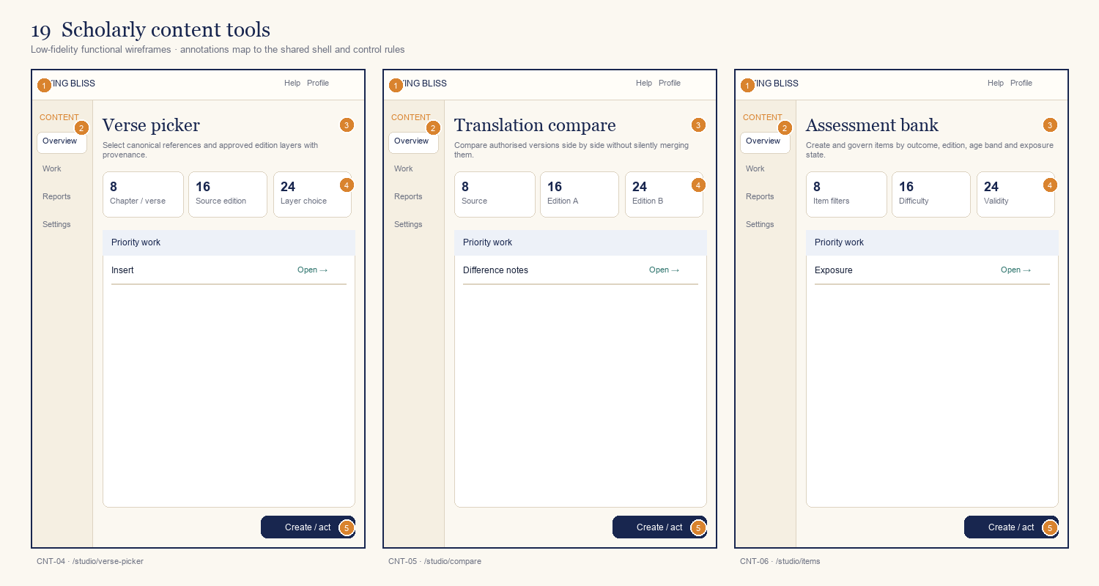
ID | Screen / route | Primary decision or outcome
CNT-04 | Verse picker  /studio/verse-picker | Select canonical references and approved edition layers with provenance.
CNT-05 | Translation compare  /studio/compare | Compare authorised versions side by side without silently merging them.
CNT-06 | Assessment bank  /studio/items | Create and govern items by outcome, edition, age band and exposure state.
Annotation contract: 1 shell/identity · 2 orientation/context · 3 primary task · 4 supporting state · 5 next action.

Board 20 — Content review, release and rights
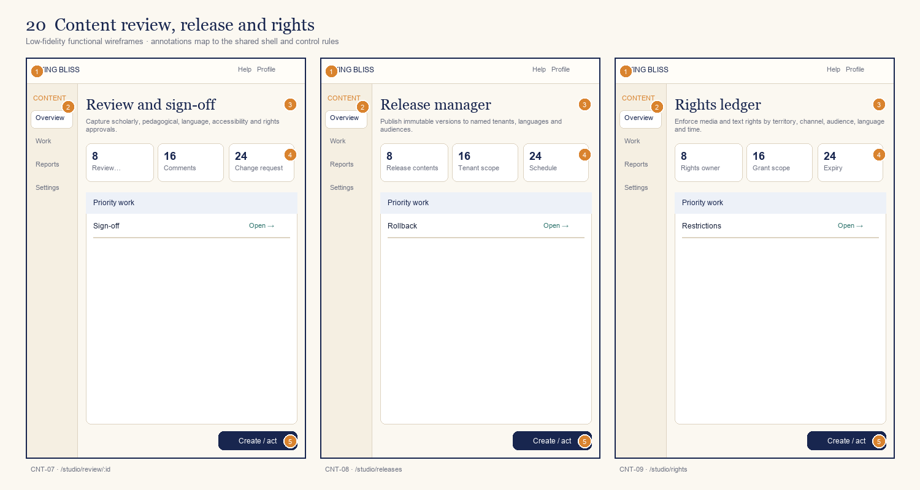
ID | Screen / route | Primary decision or outcome
CNT-07 | Review and sign-off  /studio/review/:id | Capture scholarly, pedagogical, language, accessibility and rights approvals.
CNT-08 | Release manager  /studio/releases | Publish immutable versions to named tenants, languages and audiences.
CNT-09 | Rights ledger  /studio/rights | Enforce media and text rights by territory, channel, audience, language and time.
Annotation contract: 1 shell/identity · 2 orientation/context · 3 primary task · 4 supporting state · 5 next action.

Board 21 — Tenant administration
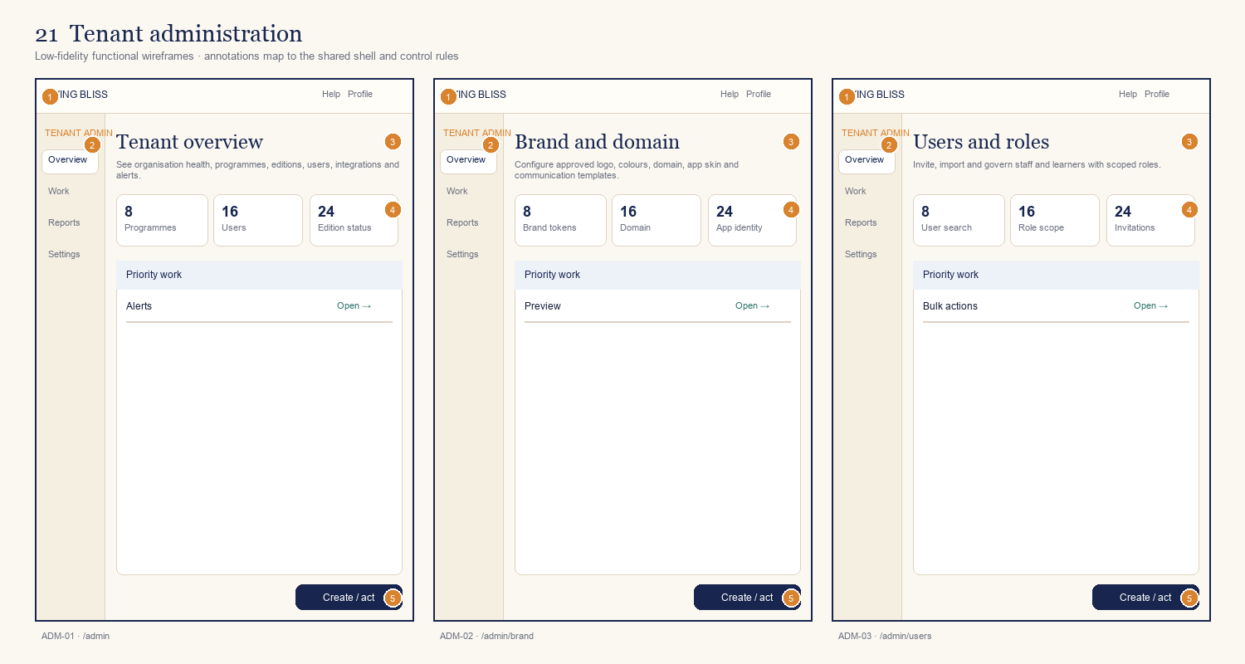
ID | Screen / route | Primary decision or outcome
ADM-01 | Tenant overview  /admin | See organisation health, programmes, editions, users, integrations and alerts.
ADM-02 | Brand and domain  /admin/brand | Configure approved logo, colours, domain, app skin and communication templates.
ADM-03 | Users and roles  /admin/users | Invite, import and govern staff and learners with scoped roles.
Annotation contract: 1 shell/identity · 2 orientation/context · 3 primary task · 4 supporting state · 5 next action.

Board 22 — Programmes and integrations
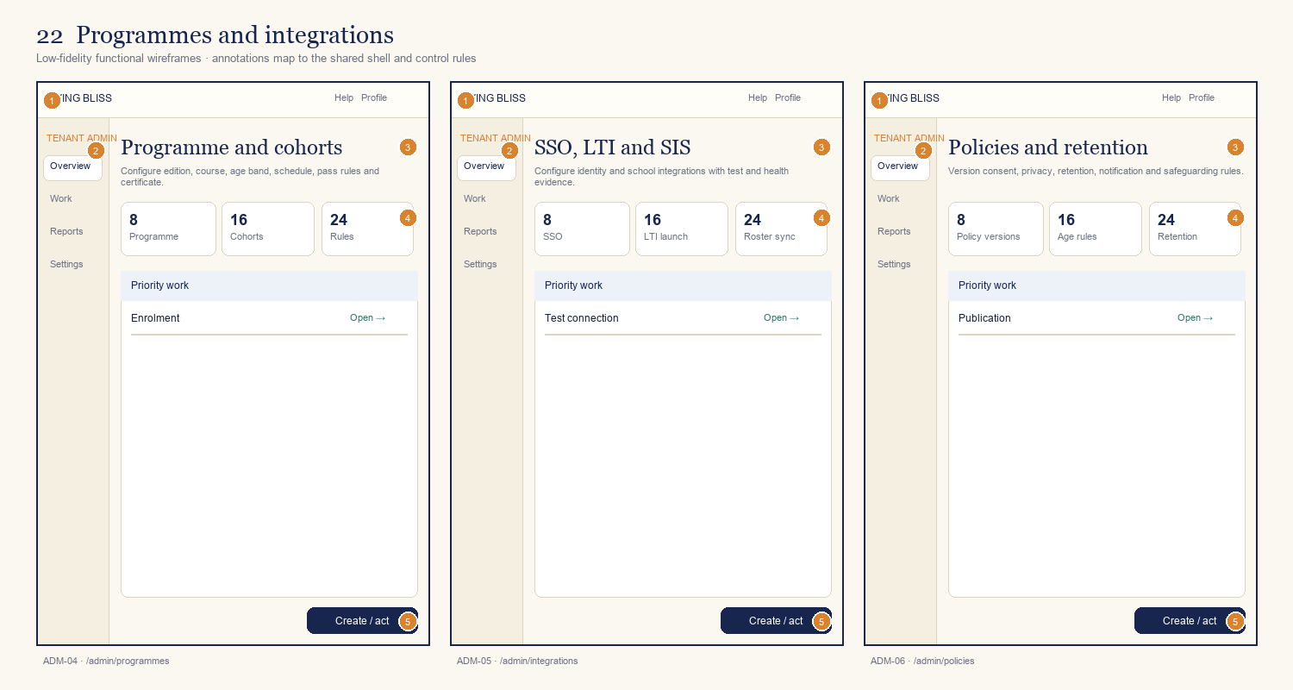
ID | Screen / route | Primary decision or outcome
ADM-04 | Programme and cohorts  /admin/programmes | Configure edition, course, age band, schedule, pass rules and certificate.
ADM-05 | SSO, LTI and SIS  /admin/integrations | Configure identity and school integrations with test and health evidence.
ADM-06 | Policies and retention  /admin/policies | Version consent, privacy, retention, notification and safeguarding rules.
Annotation contract: 1 shell/identity · 2 orientation/context · 3 primary task · 4 supporting state · 5 next action.

Board 23 — Certificates, analytics and audit
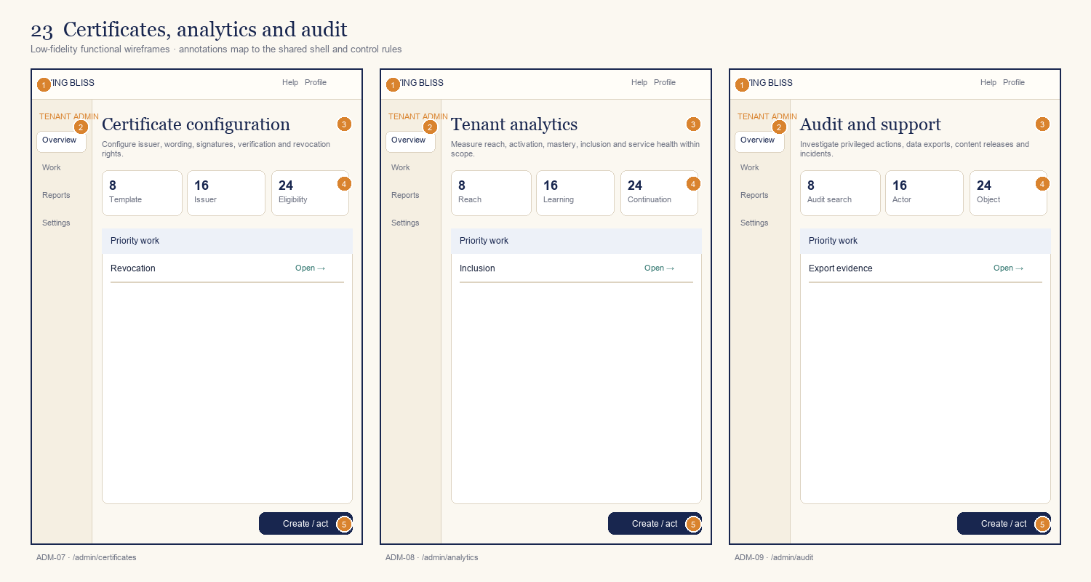
ID | Screen / route | Primary decision or outcome
ADM-07 | Certificate configuration  /admin/certificates | Configure issuer, wording, signatures, verification and revocation rights.
ADM-08 | Tenant analytics  /admin/analytics | Measure reach, activation, mastery, inclusion and service health within scope.
ADM-09 | Audit and support  /admin/audit | Investigate privileged actions, data exports, content releases and incidents.
Annotation contract: 1 shell/identity · 2 orientation/context · 3 primary task · 4 supporting state · 5 next action.

Board 24 — Platform operations
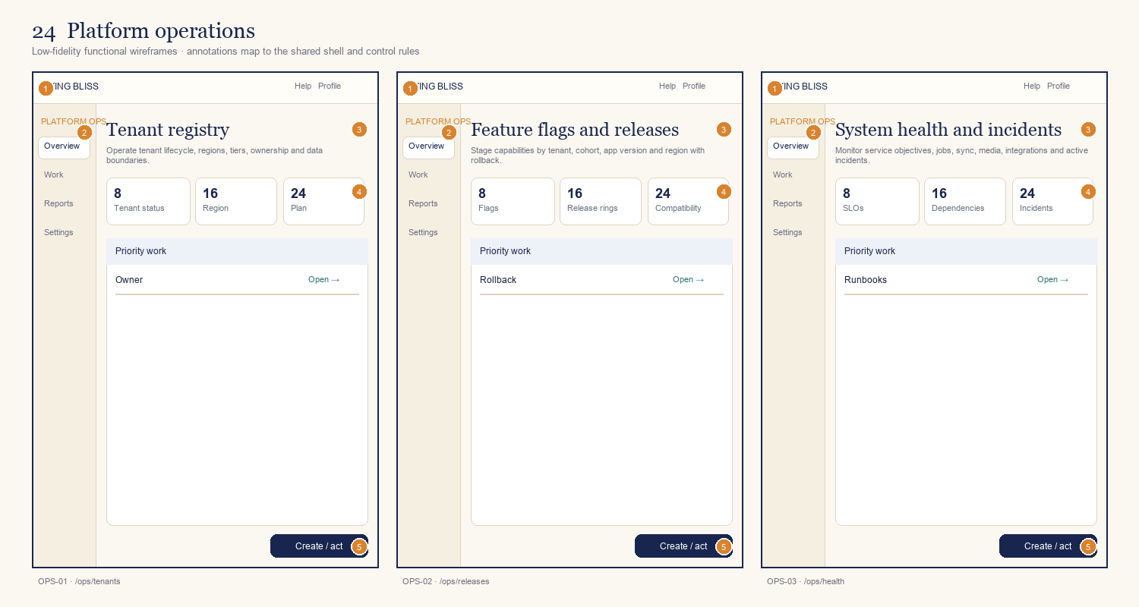
ID | Screen / route | Primary decision or outcome
OPS-01 | Tenant registry  /ops/tenants | Operate tenant lifecycle, regions, tiers, ownership and data boundaries.
OPS-02 | Feature flags and releases  /ops/releases | Stage capabilities by tenant, cohort, app version and region with rollback.
OPS-03 | System health and incidents  /ops/health | Monitor service objectives, jobs, sync, media, integrations and active incidents.
Annotation contract: 1 shell/identity · 2 orientation/context · 3 primary task · 4 supporting state · 5 next action.

Board 25 — Platform trust and support
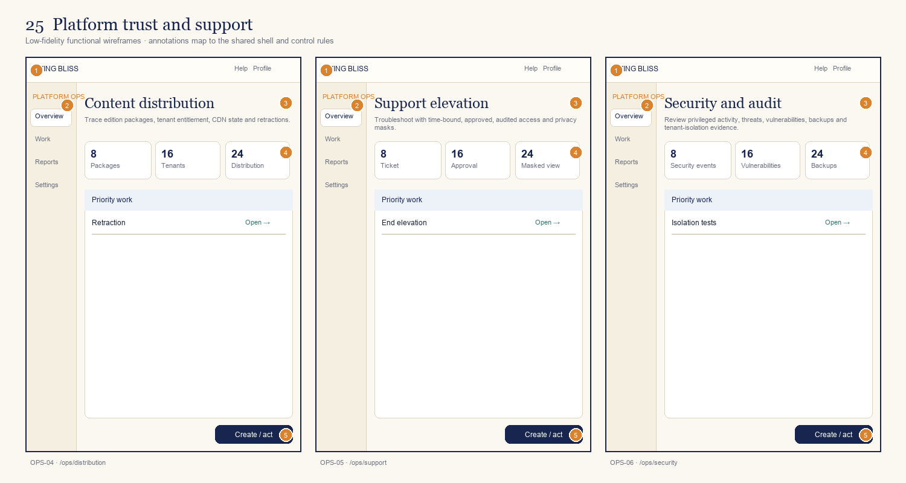
ID | Screen / route | Primary decision or outcome
OPS-04 | Content distribution  /ops/distribution | Trace edition packages, tenant entitlement, CDN state and retractions.
OPS-05 | Support elevation  /ops/support | Troubleshoot with time-bound, approved, audited access and privacy masks.
OPS-06 | Security and audit  /ops/security | Review privileged activity, threats, vulnerabilities, backups and tenant-isolation evidence.
Annotation contract: 1 shell/identity · 2 orientation/context · 3 primary task · 4 supporting state · 5 next action.

7. Screen-level implementation register
This register is the minimum screen contract for estimation and backlog traceability. The vendor must elaborate each row into component, content, validation, permission, event, API and acceptance annotations without changing the screen ID.
TRACEABILITY KEY: Every backlog story, design frame, API contract and test case must reference at least one screen ID. Every screen ID must trace to a tested route or deep link, including denied, empty, offline and recovery states.

7.01 — Public discovery
Screen / route | Access and resolved context | View model and actions | Required states and test evidence
PUB-01  Tenant-aware home  / | Anonymous or authenticated; published tenant catalogue only.  Context: tenantId, programmeId?, editionId?, language, publicationStatus | View model exposes Search, Continue learning, Featured pathway, Trust strip.  Primary action: Trust strip; server returns permittedActions, resourceVersion and status text. | loading; tenant unresolved; filtered empty; unpublished/rights unavailable; sign-in return.  Acceptance: resolved context is visible; action commits or navigates once, failure retains user input, and event pub_01_primary_action contains no private free text.
PUB-02  Edition directory  /editions | Anonymous or authenticated; published tenant catalogue only.  Context: tenantId, programmeId?, editionId?, language, publicationStatus | View model exposes Organisation filter, Tradition / lineage, Language, Edition provenance.  Primary action: Edition provenance; server returns permittedActions, resourceVersion and status text. | loading; tenant unresolved; filtered empty; unpublished/rights unavailable; sign-in return.  Acceptance: resolved context is visible; action commits or navigates once, failure retains user input, and event pub_02_primary_action contains no private free text.
PUB-03  Course catalogue  /courses | Anonymous or authenticated; published tenant catalogue only.  Context: tenantId, programmeId?, editionId?, language, publicationStatus | View model exposes Audience filter, Edition filter, Course cards, Compare pathways.  Primary action: Compare pathways; server returns permittedActions, resourceVersion and status text. | loading; tenant unresolved; filtered empty; unpublished/rights unavailable; sign-in return.  Acceptance: resolved context is visible; action commits or navigates once, failure retains user input, and event pub_03_primary_action contains no private free text.
Implementation note: accessible names, validation text, status messages, edition labels and destructive confirmations are content-managed or localised strings—not image text.

7.02 — Search and product detail
Screen / route | Access and resolved context | View model and actions | Required states and test evidence
PUB-04  Scripture search  /scripture | Anonymous or authenticated; published tenant catalogue only.  Context: tenantId, programmeId?, editionId?, language, publicationStatus | View model exposes Search query, Layer filters, Verse results, Source labels.  Primary action: Source labels; server returns permittedActions, resourceVersion and status text. | loading; tenant unresolved; filtered empty; unpublished/rights unavailable; sign-in return.  Acceptance: resolved context is visible; action commits or navigates once, failure retains user input, and event pub_04_primary_action contains no private free text.
PUB-05  Course detail  /course/:courseId | Anonymous or authenticated; published tenant catalogue only.  Context: tenantId, programmeId?, editionId?, language, publicationStatus | View model exposes Course facts, 18-chapter map, Edition authority, Start / enrol.  Primary action: Start / enrol; server returns permittedActions, resourceVersion and status text. | loading; tenant unresolved; filtered empty; unpublished/rights unavailable; sign-in return.  Acceptance: resolved context is visible; action commits or navigates once, failure retains user input, and event pub_05_primary_action contains no private free text.
PUB-06  Edition detail  /edition/:editionId | Anonymous or authenticated; published tenant catalogue only.  Context: tenantId, programmeId?, editionId?, language, publicationStatus | View model exposes About this edition, Authority, Languages, Version history.  Primary action: Version history; server returns permittedActions, resourceVersion and status text. | loading; tenant unresolved; filtered empty; unpublished/rights unavailable; sign-in return.  Acceptance: resolved context is visible; action commits or navigates once, failure retains user input, and event pub_06_primary_action contains no private free text.
Implementation note: accessible names, validation text, status messages, edition labels and destructive confirmations are content-managed or localised strings—not image text.

7.03 — Identity and onboarding
Screen / route | Access and resolved context | View model and actions | Required states and test evidence
ID-01  Sign in  /sign-in | Anonymous/challenged identity; tenant authentication and age policy.  Context: tenantId, authPolicyVersion, inviteId?, agePolicy, returnRoute | View model exposes Email / SSO, Passwordless code, Recovery, Privacy notice.  Primary action: Privacy notice; server returns permittedActions, resourceVersion and status text. | validation; challenged; expired code/link; SSO failure; rate limited; recovery complete.  Acceptance: resolved context is visible; action commits or navigates once, failure retains user input, and event id_01_primary_action contains no private free text.
ID-02  Registration  /register | Anonymous/challenged identity; tenant authentication and age policy.  Context: tenantId, authPolicyVersion, inviteId?, agePolicy, returnRoute | View model exposes Identity, Terms, Age declaration, Create account.  Primary action: Create account; server returns permittedActions, resourceVersion and status text. | validation; challenged; expired code/link; SSO failure; rate limited; recovery complete.  Acceptance: resolved context is visible; action commits or navigates once, failure retains user input, and event id_02_primary_action contains no private free text.
ID-03  Learning onboarding  /onboarding | Anonymous/challenged identity; tenant authentication and age policy.  Context: tenantId, authPolicyVersion, inviteId?, agePolicy, returnRoute | View model exposes Learning goal, Experience level, Language, Accessibility.  Primary action: Accessibility; server returns permittedActions, resourceVersion and status text. | validation; challenged; expired code/link; SSO failure; rate limited; recovery complete.  Acceptance: resolved context is visible; action commits or navigates once, failure retains user input, and event id_03_primary_action contains no private free text.
Implementation note: accessible names, validation text, status messages, edition labels and destructive confirmations are content-managed or localised strings—not image text.

7.04 — Guardian and consent
Screen / route | Access and resolved context | View model and actions | Required states and test evidence
GUA-01  Age and consent routing  /consent | Verified guardian; linked learner and consent scope only.  Context: tenantId, guardianId, learnerLinkId, consentPolicyVersion, jurisdiction | View model exposes Age band, Jurisdiction, School context, Required consent.  Primary action: Required consent; server returns permittedActions, resourceVersion and status text. | invitation pending/expired; consent required/granted/revoked; link removed; access denied.  Acceptance: resolved context is visible; action commits or navigates once, failure retains user input, and event gua_01_primary_action contains no private free text.
GUA-02  Guardian invitation  /guardian/invite | Verified guardian; linked learner and consent scope only.  Context: tenantId, guardianId, learnerLinkId, consentPolicyVersion, jurisdiction | View model exposes Guardian email, Relationship, Consent scope, Expiry.  Primary action: Expiry; server returns permittedActions, resourceVersion and status text. | invitation pending/expired; consent required/granted/revoked; link removed; access denied.  Acceptance: resolved context is visible; action commits or navigates once, failure retains user input, and event gua_02_primary_action contains no private free text.
GUA-03  Guardian overview  /guardian | Verified guardian; linked learner and consent scope only.  Context: tenantId, guardianId, learnerLinkId, consentPolicyVersion, jurisdiction | View model exposes Linked learners, Consent status, Notifications, Data rights.  Primary action: Data rights; server returns permittedActions, resourceVersion and status text. | invitation pending/expired; consent required/granted/revoked; link removed; access denied.  Acceptance: resolved context is visible; action commits or navigates once, failure retains user input, and event gua_03_primary_action contains no private free text.
Implementation note: accessible names, validation text, status messages, edition labels and destructive confirmations are content-managed or localised strings—not image text.

7.05 — Learner start
Screen / route | Access and resolved context | View model and actions | Required states and test evidence
LRN-01  Learner dashboard  /dashboard | Authenticated learner; own enrolment, entitlement and private data.  Context: tenantId, learnerId, enrolmentId, programmeId, editionId, language | View model exposes Continue card, Weekly plan, Chapter map, Achievements.  Primary action: Achievements; server returns permittedActions, resourceVersion and status text. | first use; loading; locked; in progress; completed; offline; stale; sync conflict; entitlement expired.  Acceptance: resolved context is visible; action commits or navigates once, failure retains user input, and event lrn_01_primary_action contains no private free text.
LRN-02  Prerequisite pathway  /learn/foundations | Authenticated learner; own enrolment, entitlement and private data.  Context: tenantId, learnerId, enrolmentId, programmeId, editionId, language | View model exposes Orientation, Gita context, Key concepts, How to read a verse.  Primary action: How to read a verse; server returns permittedActions, resourceVersion and status text. | first use; loading; locked; in progress; completed; offline; stale; sync conflict; entitlement expired.  Acceptance: resolved context is visible; action commits or navigates once, failure retains user input, and event lrn_02_primary_action contains no private free text.
LRN-03  Readiness diagnostic  /diagnostic | Authenticated learner; own enrolment, entitlement and private data.  Context: tenantId, learnerId, enrolmentId, programmeId, editionId, language | View model exposes Question progress, Skip policy, Save / resume, Result explanation.  Primary action: Result explanation; server returns permittedActions, resourceVersion and status text. | first use; loading; locked; in progress; completed; offline; stale; sync conflict; entitlement expired.  Acceptance: resolved context is visible; action commits or navigates once, failure retains user input, and event lrn_03_primary_action contains no private free text.
Implementation note: accessible names, validation text, status messages, edition labels and destructive confirmations are content-managed or localised strings—not image text.

7.06 — Course and chapter
Screen / route | Access and resolved context | View model and actions | Required states and test evidence
LRN-04  Course pathway  /course/:courseId/path | Authenticated learner; own enrolment, entitlement and private data.  Context: tenantId, learnerId, enrolmentId, programmeId, editionId, language | View model exposes Chapter states, Progress, Revision flags, Certificate status.  Primary action: Certificate status; server returns permittedActions, resourceVersion and status text. | first use; loading; locked; in progress; completed; offline; stale; sync conflict; entitlement expired.  Acceptance: resolved context is visible; action commits or navigates once, failure retains user input, and event lrn_04_primary_action contains no private free text.
LRN-05  Chapter overview  /chapter/:chapterId | Authenticated learner; own enrolment, entitlement and private data.  Context: tenantId, learnerId, enrolmentId, programmeId, editionId, language | View model exposes Essential question, Outcomes, Activity plan, Chapter test.  Primary action: Chapter test; server returns permittedActions, resourceVersion and status text. | first use; loading; locked; in progress; completed; offline; stale; sync conflict; entitlement expired.  Acceptance: resolved context is visible; action commits or navigates once, failure retains user input, and event lrn_05_primary_action contains no private free text.
LRN-06  Lesson player  /lesson/:lessonId | Authenticated learner; own enrolment, entitlement and private data.  Context: tenantId, learnerId, enrolmentId, programmeId, editionId, language | View model exposes Video, Slides, Verse & meaning, Private reflection.  Primary action: Private reflection; server returns permittedActions, resourceVersion and status text. | first use; loading; locked; in progress; completed; offline; stale; sync conflict; entitlement expired.  Acceptance: resolved context is visible; action commits or navigates once, failure retains user input, and event lrn_06_primary_action contains no private free text.
Implementation note: accessible names, validation text, status messages, edition labels and destructive confirmations are content-managed or localised strings—not image text.

7.07 — Verse and learning content
Screen / route | Access and resolved context | View model and actions | Required states and test evidence
LRN-07  Verse study  /verse/:verseId | Authenticated learner; own enrolment, entitlement and private data.  Context: tenantId, learnerId, enrolmentId, programmeId, editionId, language | View model exposes Source text, Transliteration, Translation, Commentary.  Primary action: Commentary; server returns permittedActions, resourceVersion and status text. | first use; loading; locked; in progress; completed; offline; stale; sync conflict; entitlement expired.  Acceptance: resolved context is visible; action commits or navigates once, failure retains user input, and event lrn_07_primary_action contains no private free text.
LRN-08  Media transcript  /lesson/:id/transcript | Authenticated learner; own enrolment, entitlement and private data.  Context: tenantId, learnerId, enrolmentId, programmeId, editionId, language | View model exposes Transcript search, Speaker labels, Playback, Download text.  Primary action: Download text; server returns permittedActions, resourceVersion and status text. | first use; loading; locked; in progress; completed; offline; stale; sync conflict; entitlement expired.  Acceptance: resolved context is visible; action commits or navigates once, failure retains user input, and event lrn_08_primary_action contains no private free text.
LRN-09  Glossary and concepts  /glossary | Authenticated learner; own enrolment, entitlement and private data.  Context: tenantId, learnerId, enrolmentId, programmeId, editionId, language | View model exposes Term search, Source definition, Learning explanation, Related verses.  Primary action: Related verses; server returns permittedActions, resourceVersion and status text. | first use; loading; locked; in progress; completed; offline; stale; sync conflict; entitlement expired.  Acceptance: resolved context is visible; action commits or navigates once, failure retains user input, and event lrn_09_primary_action contains no private free text.
Implementation note: accessible names, validation text, status messages, edition labels and destructive confirmations are content-managed or localised strings—not image text.

7.08 — Practice and assessment
Screen / route | Access and resolved context | View model and actions | Required states and test evidence
LRN-10  Private reflection  /reflection/:activityId | Authenticated learner; own enrolment, entitlement and private data.  Context: tenantId, learnerId, enrolmentId, programmeId, editionId, language | View model exposes Prompt, Private editor, Autosave state, Sharing control.  Primary action: Sharing control; server returns permittedActions, resourceVersion and status text. | first use; loading; locked; in progress; completed; offline; stale; sync conflict; entitlement expired.  Acceptance: resolved context is visible; action commits or navigates once, failure retains user input, and event lrn_10_primary_action contains no private free text.
LRN-11  Practice activity  /practice/:activityId | Authenticated learner; own enrolment, entitlement and private data.  Context: tenantId, learnerId, enrolmentId, programmeId, editionId, language | View model exposes Instructions, Interactive task, Hint, Feedback.  Primary action: Feedback; server returns permittedActions, resourceVersion and status text. | first use; loading; locked; in progress; completed; offline; stale; sync conflict; entitlement expired.  Acceptance: resolved context is visible; action commits or navigates once, failure retains user input, and event lrn_11_primary_action contains no private free text.
LRN-12  Assessment question  /assessment/:assessmentId | Authenticated learner; own enrolment, entitlement and private data.  Context: tenantId, learnerId, enrolmentId, programmeId, editionId, language | View model exposes Question, Answer options, Progress, Submit / flag.  Primary action: Submit / flag; server returns permittedActions, resourceVersion and status text. | first use; loading; locked; in progress; completed; offline; stale; sync conflict; entitlement expired.  Acceptance: resolved context is visible; action commits or navigates once, failure retains user input, and event lrn_12_primary_action contains no private free text.
Implementation note: accessible names, validation text, status messages, edition labels and destructive confirmations are content-managed or localised strings—not image text.

7.09 — Results and revision
Screen / route | Access and resolved context | View model and actions | Required states and test evidence
LRN-13  Assessment result  /assessment/:id/result | Authenticated learner; own enrolment, entitlement and private data.  Context: tenantId, learnerId, enrolmentId, programmeId, editionId, language | View model exposes Outcome mastery, Score context, Review targets, Retry policy.  Primary action: Retry policy; server returns permittedActions, resourceVersion and status text. | first use; loading; locked; in progress; completed; offline; stale; sync conflict; entitlement expired.  Acceptance: resolved context is visible; action commits or navigates once, failure retains user input, and event lrn_13_primary_action contains no private free text.
LRN-14  Targeted remediation  /revision/plan | Authenticated learner; own enrolment, entitlement and private data.  Context: tenantId, learnerId, enrolmentId, programmeId, editionId, language | View model exposes Revision items, Estimated time, Practice again, Retake readiness.  Primary action: Retake readiness; server returns permittedActions, resourceVersion and status text. | first use; loading; locked; in progress; completed; offline; stale; sync conflict; entitlement expired.  Acceptance: resolved context is visible; action commits or navigates once, failure retains user input, and event lrn_14_primary_action contains no private free text.
LRN-15  Revision queue  /revision | Authenticated learner; own enrolment, entitlement and private data.  Context: tenantId, learnerId, enrolmentId, programmeId, editionId, language | View model exposes Due today, Verse recall, Concept review, Completed history.  Primary action: Completed history; server returns permittedActions, resourceVersion and status text. | first use; loading; locked; in progress; completed; offline; stale; sync conflict; entitlement expired.  Acceptance: resolved context is visible; action commits or navigates once, failure retains user input, and event lrn_15_primary_action contains no private free text.
Implementation note: accessible names, validation text, status messages, edition labels and destructive confirmations are content-managed or localised strings—not image text.

7.10 — Personal library
Screen / route | Access and resolved context | View model and actions | Required states and test evidence
LRN-16  Bookmarks  /bookmarks | Authenticated learner; own enrolment, entitlement and private data.  Context: tenantId, learnerId, enrolmentId, programmeId, editionId, language | View model exposes Saved verses, Saved lessons, Filters, Remove / organise.  Primary action: Remove / organise; server returns permittedActions, resourceVersion and status text. | first use; loading; locked; in progress; completed; offline; stale; sync conflict; entitlement expired.  Acceptance: resolved context is visible; action commits or navigates once, failure retains user input, and event lrn_16_primary_action contains no private free text.
LRN-17  Private notes  /notes | Authenticated learner; own enrolment, entitlement and private data.  Context: tenantId, learnerId, enrolmentId, programmeId, editionId, language | View model exposes Note search, Course filters, Export, Delete.  Primary action: Delete; server returns permittedActions, resourceVersion and status text. | first use; loading; locked; in progress; completed; offline; stale; sync conflict; entitlement expired.  Acceptance: resolved context is visible; action commits or navigates once, failure retains user input, and event lrn_17_primary_action contains no private free text.
LRN-18  Downloads and offline  /downloads | Authenticated learner; own enrolment, entitlement and private data.  Context: tenantId, learnerId, enrolmentId, programmeId, editionId, language | View model exposes Downloaded packs, Storage, Update required, Remove download.  Primary action: Remove download; server returns permittedActions, resourceVersion and status text. | first use; loading; locked; in progress; completed; offline; stale; sync conflict; entitlement expired.  Acceptance: resolved context is visible; action commits or navigates once, failure retains user input, and event lrn_18_primary_action contains no private free text.
Implementation note: accessible names, validation text, status messages, edition labels and destructive confirmations are content-managed or localised strings—not image text.

7.11 — Recognition and support
Screen / route | Access and resolved context | View model and actions | Required states and test evidence
LRN-19  Certificate  /certificate/:id | Authenticated learner; own enrolment, entitlement and private data.  Context: tenantId, learnerId, enrolmentId, programmeId, editionId, language | View model exposes Certificate preview, Verification URL, Download / share, Status history.  Primary action: Status history; server returns permittedActions, resourceVersion and status text. | first use; loading; locked; in progress; completed; offline; stale; sync conflict; entitlement expired.  Acceptance: resolved context is visible; action commits or navigates once, failure retains user input, and event lrn_19_primary_action contains no private free text.
LRN-20  Preferences and privacy  /account/preferences | Authenticated learner; own enrolment, entitlement and private data.  Context: tenantId, learnerId, enrolmentId, programmeId, editionId, language | View model exposes Display settings, Notifications, Privacy, Sessions.  Primary action: Sessions; server returns permittedActions, resourceVersion and status text. | first use; loading; locked; in progress; completed; offline; stale; sync conflict; entitlement expired.  Acceptance: resolved context is visible; action commits or navigates once, failure retains user input, and event lrn_20_primary_action contains no private free text.
LRN-21  Help and report issue  /support | Authenticated learner; own enrolment, entitlement and private data.  Context: tenantId, learnerId, enrolmentId, programmeId, editionId, language | View model exposes Search help, Issue type, Context capture, Contact support.  Primary action: Contact support; server returns permittedActions, resourceVersion and status text. | first use; loading; locked; in progress; completed; offline; stale; sync conflict; entitlement expired.  Acceptance: resolved context is visible; action commits or navigates once, failure retains user input, and event lrn_21_primary_action contains no private free text.
Implementation note: accessible names, validation text, status messages, edition labels and destructive confirmations are content-managed or localised strings—not image text.

7.12 — Mobile core learning
Screen / route | Access and resolved context | View model and actions | Required states and test evidence
MOB-01  Mobile home  app://home | Authenticated learner on registered app instance; same learner scope as web.  Context: tenantId, learnerId, enrolmentId, editionId, deviceId, syncCursor | View model exposes Continue, Daily plan, Saved, Profile.  Primary action: Profile; server returns permittedActions, resourceVersion and status text. | offline; queued; syncing; conflict; storage low; download expired/retracted; app update required.  Acceptance: resolved context is visible; action commits or navigates once, failure retains user input, and event mob_01_primary_action contains no private free text.
MOB-02  Mobile course map  app://course/:id | Authenticated learner on registered app instance; same learner scope as web.  Context: tenantId, learnerId, enrolmentId, editionId, deviceId, syncCursor | View model exposes Course progress, Chapter list, Download, Schedule.  Primary action: Schedule; server returns permittedActions, resourceVersion and status text. | offline; queued; syncing; conflict; storage low; download expired/retracted; app update required.  Acceptance: resolved context is visible; action commits or navigates once, failure retains user input, and event mob_02_primary_action contains no private free text.
MOB-03  Mobile lesson  app://lesson/:id | Authenticated learner on registered app instance; same learner scope as web.  Context: tenantId, learnerId, enrolmentId, editionId, deviceId, syncCursor | View model exposes Media, Transcript, Bookmark, Complete.  Primary action: Complete; server returns permittedActions, resourceVersion and status text. | offline; queued; syncing; conflict; storage low; download expired/retracted; app update required.  Acceptance: resolved context is visible; action commits or navigates once, failure retains user input, and event mob_03_primary_action contains no private free text.
Implementation note: accessible names, validation text, status messages, edition labels and destructive confirmations are content-managed or localised strings—not image text.

7.13 — Mobile scripture and assessment
Screen / route | Access and resolved context | View model and actions | Required states and test evidence
MOB-04  Mobile verse study  app://verse/:id | Authenticated learner on registered app instance; same learner scope as web.  Context: tenantId, learnerId, enrolmentId, editionId, deviceId, syncCursor | View model exposes Sanskrit, Transliteration, Translation, Commentary.  Primary action: Commentary; server returns permittedActions, resourceVersion and status text. | offline; queued; syncing; conflict; storage low; download expired/retracted; app update required.  Acceptance: resolved context is visible; action commits or navigates once, failure retains user input, and event mob_04_primary_action contains no private free text.
MOB-05  Mobile assessment  app://assessment/:id | Authenticated learner on registered app instance; same learner scope as web.  Context: tenantId, learnerId, enrolmentId, editionId, deviceId, syncCursor | View model exposes Question, Choices, Progress, Submit.  Primary action: Submit; server returns permittedActions, resourceVersion and status text. | offline; queued; syncing; conflict; storage low; download expired/retracted; app update required.  Acceptance: resolved context is visible; action commits or navigates once, failure retains user input, and event mob_05_primary_action contains no private free text.
MOB-06  Mobile result  app://assessment/:id/result | Authenticated learner on registered app instance; same learner scope as web.  Context: tenantId, learnerId, enrolmentId, editionId, deviceId, syncCursor | View model exposes Result, Mastery, Review, Next action.  Primary action: Next action; server returns permittedActions, resourceVersion and status text. | offline; queued; syncing; conflict; storage low; download expired/retracted; app update required.  Acceptance: resolved context is visible; action commits or navigates once, failure retains user input, and event mob_06_primary_action contains no private free text.
Implementation note: accessible names, validation text, status messages, edition labels and destructive confirmations are content-managed or localised strings—not image text.

7.14 — Mobile offline and credentials
Screen / route | Access and resolved context | View model and actions | Required states and test evidence
MOB-07  Offline library  app://downloads | Authenticated learner on registered app instance; same learner scope as web.  Context: tenantId, learnerId, enrolmentId, editionId, deviceId, syncCursor | View model exposes Packs, Storage used, Expiry, Update.  Primary action: Update; server returns permittedActions, resourceVersion and status text. | offline; queued; syncing; conflict; storage low; download expired/retracted; app update required.  Acceptance: resolved context is visible; action commits or navigates once, failure retains user input, and event mob_07_primary_action contains no private free text.
MOB-08  Sync conflict  app://sync | Authenticated learner on registered app instance; same learner scope as web.  Context: tenantId, learnerId, enrolmentId, editionId, deviceId, syncCursor | View model exposes Conflict summary, Server version, Device version, Resolve.  Primary action: Resolve; server returns permittedActions, resourceVersion and status text. | offline; queued; syncing; conflict; storage low; download expired/retracted; app update required.  Acceptance: resolved context is visible; action commits or navigates once, failure retains user input, and event mob_08_primary_action contains no private free text.
MOB-09  Mobile certificate  app://certificate/:id | Authenticated learner on registered app instance; same learner scope as web.  Context: tenantId, learnerId, enrolmentId, editionId, deviceId, syncCursor | View model exposes Credential, QR, Share, Status.  Primary action: Status; server returns permittedActions, resourceVersion and status text. | offline; queued; syncing; conflict; storage low; download expired/retracted; app update required.  Acceptance: resolved context is visible; action commits or navigates once, failure retains user input, and event mob_09_primary_action contains no private free text.
Implementation note: accessible names, validation text, status messages, edition labels and destructive confirmations are content-managed or localised strings—not image text.

7.15 — Teacher planning
Screen / route | Access and resolved context | View model and actions | Required states and test evidence
TCH-01  Teacher dashboard  /teacher | Teacher/facilitator; assigned tenant, programme and cohort only.  Context: tenantId, actorId, roleScopes, programmeId, cohortId? | View model exposes Classes, Upcoming, Support flags, Submissions.  Primary action: Submissions; server returns permittedActions, resourceVersion and status text. | empty cohort; roster syncing; partial data; permission denied; submission locked; export pending.  Acceptance: resolved context is visible; action commits or navigates once, failure retains user input, and event tch_01_primary_action contains no private free text.
TCH-02  Cohort list  /teacher/cohorts | Teacher/facilitator; assigned tenant, programme and cohort only.  Context: tenantId, actorId, roleScopes, programmeId, cohortId? | View model exposes Cohorts, Programme, Roster, Term.  Primary action: Term; server returns permittedActions, resourceVersion and status text. | empty cohort; roster syncing; partial data; permission denied; submission locked; export pending.  Acceptance: resolved context is visible; action commits or navigates once, failure retains user input, and event tch_02_primary_action contains no private free text.
TCH-03  Cohort overview  /teacher/cohort/:id | Teacher/facilitator; assigned tenant, programme and cohort only.  Context: tenantId, actorId, roleScopes, programmeId, cohortId? | View model exposes Roster, Outcome mastery, Pace, Accommodations.  Primary action: Accommodations; server returns permittedActions, resourceVersion and status text. | empty cohort; roster syncing; partial data; permission denied; submission locked; export pending.  Acceptance: resolved context is visible; action commits or navigates once, failure retains user input, and event tch_03_primary_action contains no private free text.
Implementation note: accessible names, validation text, status messages, edition labels and destructive confirmations are content-managed or localised strings—not image text.

7.16 — Teacher delivery and evidence
Screen / route | Access and resolved context | View model and actions | Required states and test evidence
TCH-04  Teaching schedule  /teacher/schedule | Teacher/facilitator; assigned tenant, programme and cohort only.  Context: tenantId, actorId, roleScopes, programmeId, cohortId? | View model exposes Calendar, Chapter plan, Due dates, Announcements.  Primary action: Announcements; server returns permittedActions, resourceVersion and status text. | empty cohort; roster syncing; partial data; permission denied; submission locked; export pending.  Acceptance: resolved context is visible; action commits or navigates once, failure retains user input, and event tch_04_primary_action contains no private free text.
TCH-05  Create assignment  /teacher/assignment/new | Teacher/facilitator; assigned tenant, programme and cohort only.  Context: tenantId, actorId, roleScopes, programmeId, cohortId? | View model exposes Activity picker, Instructions, Rubric, Publish.  Primary action: Publish; server returns permittedActions, resourceVersion and status text. | empty cohort; roster syncing; partial data; permission denied; submission locked; export pending.  Acceptance: resolved context is visible; action commits or navigates once, failure retains user input, and event tch_05_primary_action contains no private free text.
TCH-06  Learner detail  /teacher/learner/:id | Teacher/facilitator; assigned tenant, programme and cohort only.  Context: tenantId, actorId, roleScopes, programmeId, cohortId? | View model exposes Progress, Mastery, Attempts, Support notes.  Primary action: Support notes; server returns permittedActions, resourceVersion and status text. | empty cohort; roster syncing; partial data; permission denied; submission locked; export pending.  Acceptance: resolved context is visible; action commits or navigates once, failure retains user input, and event tch_06_primary_action contains no private free text.
Implementation note: accessible names, validation text, status messages, edition labels and destructive confirmations are content-managed or localised strings—not image text.

7.17 — Teacher assessment and reports
Screen / route | Access and resolved context | View model and actions | Required states and test evidence
TCH-07  Submissions and rubric  /teacher/submissions | Teacher/facilitator; assigned tenant, programme and cohort only.  Context: tenantId, actorId, roleScopes, programmeId, cohortId? | View model exposes Submission, Rubric, Feedback, Return.  Primary action: Return; server returns permittedActions, resourceVersion and status text. | empty cohort; roster syncing; partial data; permission denied; submission locked; export pending.  Acceptance: resolved context is visible; action commits or navigates once, failure retains user input, and event tch_07_primary_action contains no private free text.
TCH-08  Class outcome report  /teacher/reports/outcomes | Teacher/facilitator; assigned tenant, programme and cohort only.  Context: tenantId, actorId, roleScopes, programmeId, cohortId? | View model exposes Outcome heatmap, Distribution, Interventions, Export.  Primary action: Export; server returns permittedActions, resourceVersion and status text. | empty cohort; roster syncing; partial data; permission denied; submission locked; export pending.  Acceptance: resolved context is visible; action commits or navigates once, failure retains user input, and event tch_08_primary_action contains no private free text.
TCH-09  Class presentation mode  /teacher/present/:lessonId | Teacher/facilitator; assigned tenant, programme and cohort only.  Context: tenantId, actorId, roleScopes, programmeId, cohortId? | View model exposes Presenter view, Verse slide, Discussion prompt, Next slide.  Primary action: Next slide; server returns permittedActions, resourceVersion and status text. | empty cohort; roster syncing; partial data; permission denied; submission locked; export pending.  Acceptance: resolved context is visible; action commits or navigates once, failure retains user input, and event tch_09_primary_action contains no private free text.
Implementation note: accessible names, validation text, status messages, edition labels and destructive confirmations are content-managed or localised strings—not image text.

7.18 — Content authoring
Screen / route | Access and resolved context | View model and actions | Required states and test evidence
CNT-01  Content work queue  /studio | Named author/reviewer/publisher scopes; edition, language and release task.  Context: tenantId, actorId, editionId, language, contentVersion, reviewTaskId? | View model exposes My tasks, Due reviews, Blocked rights, Release status.  Primary action: Release status; server returns permittedActions, resourceVersion and status text. | draft; validation failed; in review; changes requested; approved; rights blocked; published/superseded.  Acceptance: resolved context is visible; action commits or navigates once, failure retains user input, and event cnt_01_primary_action contains no private free text.
CNT-02  Course structure editor  /studio/course/:id | Named author/reviewer/publisher scopes; edition, language and release task.  Context: tenantId, actorId, editionId, language, contentVersion, reviewTaskId? | View model exposes Course tree, Outcomes, Dependencies, Preview.  Primary action: Preview; server returns permittedActions, resourceVersion and status text. | draft; validation failed; in review; changes requested; approved; rights blocked; published/superseded.  Acceptance: resolved context is visible; action commits or navigates once, failure retains user input, and event cnt_02_primary_action contains no private free text.
CNT-03  Lesson editor  /studio/lesson/:id | Named author/reviewer/publisher scopes; edition, language and release task.  Context: tenantId, actorId, editionId, language, contentVersion, reviewTaskId? | View model exposes Lesson outline, Content blocks, Citations, Preview.  Primary action: Preview; server returns permittedActions, resourceVersion and status text. | draft; validation failed; in review; changes requested; approved; rights blocked; published/superseded.  Acceptance: resolved context is visible; action commits or navigates once, failure retains user input, and event cnt_03_primary_action contains no private free text.
Implementation note: accessible names, validation text, status messages, edition labels and destructive confirmations are content-managed or localised strings—not image text.

7.19 — Scholarly content tools
Screen / route | Access and resolved context | View model and actions | Required states and test evidence
CNT-04  Verse picker  /studio/verse-picker | Named author/reviewer/publisher scopes; edition, language and release task.  Context: tenantId, actorId, editionId, language, contentVersion, reviewTaskId? | View model exposes Chapter / verse, Source edition, Layer choice, Insert.  Primary action: Insert; server returns permittedActions, resourceVersion and status text. | draft; validation failed; in review; changes requested; approved; rights blocked; published/superseded.  Acceptance: resolved context is visible; action commits or navigates once, failure retains user input, and event cnt_04_primary_action contains no private free text.
CNT-05  Translation compare  /studio/compare | Named author/reviewer/publisher scopes; edition, language and release task.  Context: tenantId, actorId, editionId, language, contentVersion, reviewTaskId? | View model exposes Source, Edition A, Edition B, Difference notes.  Primary action: Difference notes; server returns permittedActions, resourceVersion and status text. | draft; validation failed; in review; changes requested; approved; rights blocked; published/superseded.  Acceptance: resolved context is visible; action commits or navigates once, failure retains user input, and event cnt_05_primary_action contains no private free text.
CNT-06  Assessment bank  /studio/items | Named author/reviewer/publisher scopes; edition, language and release task.  Context: tenantId, actorId, editionId, language, contentVersion, reviewTaskId? | View model exposes Item filters, Difficulty, Validity, Exposure.  Primary action: Exposure; server returns permittedActions, resourceVersion and status text. | draft; validation failed; in review; changes requested; approved; rights blocked; published/superseded.  Acceptance: resolved context is visible; action commits or navigates once, failure retains user input, and event cnt_06_primary_action contains no private free text.
Implementation note: accessible names, validation text, status messages, edition labels and destructive confirmations are content-managed or localised strings—not image text.

7.20 — Content review, release and rights
Screen / route | Access and resolved context | View model and actions | Required states and test evidence
CNT-07  Review and sign-off  /studio/review/:id | Named author/reviewer/publisher scopes; edition, language and release task.  Context: tenantId, actorId, editionId, language, contentVersion, reviewTaskId? | View model exposes Review dimensions, Comments, Change request, Sign-off.  Primary action: Sign-off; server returns permittedActions, resourceVersion and status text. | draft; validation failed; in review; changes requested; approved; rights blocked; published/superseded.  Acceptance: resolved context is visible; action commits or navigates once, failure retains user input, and event cnt_07_primary_action contains no private free text.
CNT-08  Release manager  /studio/releases | Named author/reviewer/publisher scopes; edition, language and release task.  Context: tenantId, actorId, editionId, language, contentVersion, reviewTaskId? | View model exposes Release contents, Tenant scope, Schedule, Rollback.  Primary action: Rollback; server returns permittedActions, resourceVersion and status text. | draft; validation failed; in review; changes requested; approved; rights blocked; published/superseded.  Acceptance: resolved context is visible; action commits or navigates once, failure retains user input, and event cnt_08_primary_action contains no private free text.
CNT-09  Rights ledger  /studio/rights | Named author/reviewer/publisher scopes; edition, language and release task.  Context: tenantId, actorId, editionId, language, contentVersion, reviewTaskId? | View model exposes Rights owner, Grant scope, Expiry, Restrictions.  Primary action: Restrictions; server returns permittedActions, resourceVersion and status text. | draft; validation failed; in review; changes requested; approved; rights blocked; published/superseded.  Acceptance: resolved context is visible; action commits or navigates once, failure retains user input, and event cnt_09_primary_action contains no private free text.
Implementation note: accessible names, validation text, status messages, edition labels and destructive confirmations are content-managed or localised strings—not image text.

7.21 — Tenant administration
Screen / route | Access and resolved context | View model and actions | Required states and test evidence
ADM-01  Tenant overview  /admin | Delegated tenant administrator; one tenant or permitted organisational unit.  Context: tenantId, actorId, delegatedUnitId?, policyVersion, roleScopes | View model exposes Programmes, Users, Edition status, Alerts.  Primary action: Alerts; server returns permittedActions, resourceVersion and status text. | first use; import pending; partial integration; policy unpublished; destructive confirmation; audit ready.  Acceptance: resolved context is visible; action commits or navigates once, failure retains user input, and event adm_01_primary_action contains no private free text.
ADM-02  Brand and domain  /admin/brand | Delegated tenant administrator; one tenant or permitted organisational unit.  Context: tenantId, actorId, delegatedUnitId?, policyVersion, roleScopes | View model exposes Brand tokens, Domain, App identity, Preview.  Primary action: Preview; server returns permittedActions, resourceVersion and status text. | first use; import pending; partial integration; policy unpublished; destructive confirmation; audit ready.  Acceptance: resolved context is visible; action commits or navigates once, failure retains user input, and event adm_02_primary_action contains no private free text.
ADM-03  Users and roles  /admin/users | Delegated tenant administrator; one tenant or permitted organisational unit.  Context: tenantId, actorId, delegatedUnitId?, policyVersion, roleScopes | View model exposes User search, Role scope, Invitations, Bulk actions.  Primary action: Bulk actions; server returns permittedActions, resourceVersion and status text. | first use; import pending; partial integration; policy unpublished; destructive confirmation; audit ready.  Acceptance: resolved context is visible; action commits or navigates once, failure retains user input, and event adm_03_primary_action contains no private free text.
Implementation note: accessible names, validation text, status messages, edition labels and destructive confirmations are content-managed or localised strings—not image text.

7.22 — Programmes and integrations
Screen / route | Access and resolved context | View model and actions | Required states and test evidence
ADM-04  Programme and cohorts  /admin/programmes | Delegated tenant administrator; one tenant or permitted organisational unit.  Context: tenantId, actorId, delegatedUnitId?, policyVersion, roleScopes | View model exposes Programme, Cohorts, Rules, Enrolment.  Primary action: Enrolment; server returns permittedActions, resourceVersion and status text. | first use; import pending; partial integration; policy unpublished; destructive confirmation; audit ready.  Acceptance: resolved context is visible; action commits or navigates once, failure retains user input, and event adm_04_primary_action contains no private free text.
ADM-05  SSO, LTI and SIS  /admin/integrations | Delegated tenant administrator; one tenant or permitted organisational unit.  Context: tenantId, actorId, delegatedUnitId?, policyVersion, roleScopes | View model exposes SSO, LTI launch, Roster sync, Test connection.  Primary action: Test connection; server returns permittedActions, resourceVersion and status text. | first use; import pending; partial integration; policy unpublished; destructive confirmation; audit ready.  Acceptance: resolved context is visible; action commits or navigates once, failure retains user input, and event adm_05_primary_action contains no private free text.
ADM-06  Policies and retention  /admin/policies | Delegated tenant administrator; one tenant or permitted organisational unit.  Context: tenantId, actorId, delegatedUnitId?, policyVersion, roleScopes | View model exposes Policy versions, Age rules, Retention, Publication.  Primary action: Publication; server returns permittedActions, resourceVersion and status text. | first use; import pending; partial integration; policy unpublished; destructive confirmation; audit ready.  Acceptance: resolved context is visible; action commits or navigates once, failure retains user input, and event adm_06_primary_action contains no private free text.
Implementation note: accessible names, validation text, status messages, edition labels and destructive confirmations are content-managed or localised strings—not image text.

7.23 — Certificates, analytics and audit
Screen / route | Access and resolved context | View model and actions | Required states and test evidence
ADM-07  Certificate configuration  /admin/certificates | Delegated tenant administrator; one tenant or permitted organisational unit.  Context: tenantId, actorId, delegatedUnitId?, policyVersion, roleScopes | View model exposes Template, Issuer, Eligibility, Revocation.  Primary action: Revocation; server returns permittedActions, resourceVersion and status text. | first use; import pending; partial integration; policy unpublished; destructive confirmation; audit ready.  Acceptance: resolved context is visible; action commits or navigates once, failure retains user input, and event adm_07_primary_action contains no private free text.
ADM-08  Tenant analytics  /admin/analytics | Delegated tenant administrator; one tenant or permitted organisational unit.  Context: tenantId, actorId, delegatedUnitId?, policyVersion, roleScopes | View model exposes Reach, Learning, Continuation, Inclusion.  Primary action: Inclusion; server returns permittedActions, resourceVersion and status text. | first use; import pending; partial integration; policy unpublished; destructive confirmation; audit ready.  Acceptance: resolved context is visible; action commits or navigates once, failure retains user input, and event adm_08_primary_action contains no private free text.
ADM-09  Audit and support  /admin/audit | Delegated tenant administrator; one tenant or permitted organisational unit.  Context: tenantId, actorId, delegatedUnitId?, policyVersion, roleScopes | View model exposes Audit search, Actor, Object, Export evidence.  Primary action: Export evidence; server returns permittedActions, resourceVersion and status text. | first use; import pending; partial integration; policy unpublished; destructive confirmation; audit ready.  Acceptance: resolved context is visible; action commits or navigates once, failure retains user input, and event adm_09_primary_action contains no private free text.
Implementation note: accessible names, validation text, status messages, edition labels and destructive confirmations are content-managed or localised strings—not image text.

7.24 — Platform operations
Screen / route | Access and resolved context | View model and actions | Required states and test evidence
OPS-01  Tenant registry  /ops/tenants | Privileged operator; least privilege, reason, approval and time-bound elevation.  Context: actorId, region, tenantId?, elevationId?, correlationId | View model exposes Tenant status, Region, Plan, Owner.  Primary action: Owner; server returns permittedActions, resourceVersion and status text. | healthy/degraded; incident open; approval pending; elevated; rollback running; retracted; audit sealed.  Acceptance: resolved context is visible; action commits or navigates once, failure retains user input, and event ops_01_primary_action contains no private free text.
OPS-02  Feature flags and releases  /ops/releases | Privileged operator; least privilege, reason, approval and time-bound elevation.  Context: actorId, region, tenantId?, elevationId?, correlationId | View model exposes Flags, Release rings, Compatibility, Rollback.  Primary action: Rollback; server returns permittedActions, resourceVersion and status text. | healthy/degraded; incident open; approval pending; elevated; rollback running; retracted; audit sealed.  Acceptance: resolved context is visible; action commits or navigates once, failure retains user input, and event ops_02_primary_action contains no private free text.
OPS-03  System health and incidents  /ops/health | Privileged operator; least privilege, reason, approval and time-bound elevation.  Context: actorId, region, tenantId?, elevationId?, correlationId | View model exposes SLOs, Dependencies, Incidents, Runbooks.  Primary action: Runbooks; server returns permittedActions, resourceVersion and status text. | healthy/degraded; incident open; approval pending; elevated; rollback running; retracted; audit sealed.  Acceptance: resolved context is visible; action commits or navigates once, failure retains user input, and event ops_03_primary_action contains no private free text.
Implementation note: accessible names, validation text, status messages, edition labels and destructive confirmations are content-managed or localised strings—not image text.

7.25 — Platform trust and support
Screen / route | Access and resolved context | View model and actions | Required states and test evidence
OPS-04  Content distribution  /ops/distribution | Privileged operator; least privilege, reason, approval and time-bound elevation.  Context: actorId, region, tenantId?, elevationId?, correlationId | View model exposes Packages, Tenants, Distribution, Retraction.  Primary action: Retraction; server returns permittedActions, resourceVersion and status text. | healthy/degraded; incident open; approval pending; elevated; rollback running; retracted; audit sealed.  Acceptance: resolved context is visible; action commits or navigates once, failure retains user input, and event ops_04_primary_action contains no private free text.
OPS-05  Support elevation  /ops/support | Privileged operator; least privilege, reason, approval and time-bound elevation.  Context: actorId, region, tenantId?, elevationId?, correlationId | View model exposes Ticket, Approval, Masked view, End elevation.  Primary action: End elevation; server returns permittedActions, resourceVersion and status text. | healthy/degraded; incident open; approval pending; elevated; rollback running; retracted; audit sealed.  Acceptance: resolved context is visible; action commits or navigates once, failure retains user input, and event ops_05_primary_action contains no private free text.
OPS-06  Security and audit  /ops/security | Privileged operator; least privilege, reason, approval and time-bound elevation.  Context: actorId, region, tenantId?, elevationId?, correlationId | View model exposes Security events, Vulnerabilities, Backups, Isolation tests.  Primary action: Isolation tests; server returns permittedActions, resourceVersion and status text. | healthy/degraded; incident open; approval pending; elevated; rollback running; retracted; audit sealed.  Acceptance: resolved context is visible; action commits or navigates once, failure retains user input, and event ops_06_primary_action contains no private free text.
Implementation note: accessible names, validation text, status messages, edition labels and destructive confirmations are content-managed or localised strings—not image text.

8. End-to-end workflows and state transitions

Critical end-to-end journeys
Journey | Screen sequence | Completion evidence
Independent learner | PUB-01 → PUB-02 → PUB-05 → ID-02/03 → LRN-02/03 → LRN-04 → [LRN-05–15 × 18] → LRN-19 | Readiness resolved; 18 chapter loops; completion rule; verifiable certificate.
School learner | LMS launch → GUA-01/02 if required → LRN-01 → LRN-04–15 | Roster and consent applied; results returned only as authorised.
Teacher delivery | TCH-01 → TCH-02/03 → TCH-04/05 → TCH-07/08 | Approved plan assigned; feedback and outcome report produced.
Organisation onboarding | ADM-01–09 + CNT-04/05/07–09 | Brand, domain, identity, policies, rights and edition approved before launch.
Content release | CNT-01 → CNT-02/03/04 → CNT-07 → CNT-08 → OPS-04 | Immutable authorised version published to named tenants and audiences.
Support incident | LRN-21/TCH-01 → OPS-05 → OPS-03/06 | Approved elevation, masked diagnostics, audit evidence and closure.

8.1 Learner chapter loop
Transition | Trigger | Server decision | User-visible result
Available → in progress | First eligible activity opened | Validate enrolment, edition release and prerequisite state. | Chapter status, first activity and resumable position.
Activity pending → complete | Required evidence accepted | Append evidence event; derive activity state; return resource version. | Explicit saved/completed status and next eligible action.
Assessment open → submitted | Learner confirms submission | Lock attempt version; score under approved policy; record accommodations. | Submitted once; result now or pending-review state.
Result → remediation | Outcome threshold not met | Generate plan from missed outcomes and authorised resources. | Explain misconception, next activities and retake condition.
Chapter passed → next available | All chapter rules satisfied | Append chapter evidence; unlock only policy-approved successor. | Celebration without ranking; clear next chapter or revision action.
Chapter 18 passed → programme review | Programme completion candidate | Evaluate all 18 chapters, capstone rule, version and entitlement. | Certificate eligibility or explicit remaining evidence.

Resume and interruption guarantees
- Media position, activity state and unsent low-risk events resume across browser refresh, app relaunch and device change. The interface distinguishes “saved on this device” from “synced”.
- An assessment never auto-submits because of navigation, timeout or connection loss unless the approved attempt policy explicitly requires it and the user was warned before starting.
- Server rejection preserves the learner’s local response where lawful, gives a support reference and never advances the gate optimistically.

8.2 Edition switch and content release workflows
Step | Edition switch | Content release
1. Select | Learner/admin chooses an entitled target edition. | Publisher selects immutable candidate version and target scope.
2. Compare | System resolves content, outcome and assessment equivalence. | System validates source, rights, language, accessibility and approvals.
3. Explain | UI lists affected learning, progress, assessment and certificate states. | UI lists tenant, audience, region, version and scheduled effective date.
4. Confirm | User confirms; no default if equivalence is incomplete. | Authorised publisher confirms; dual control where policy requires.
5. Commit | Context version changes; safe mappings are applied; history retained. | Release becomes immutable and distribution job receives idempotency key.
6. Verify | Deep links, downloads and next action resolve under new edition. | OPS-04 shows entitlement/CDN status; rollback or retraction is available.

Workflow invariants
- A published edition is never edited in place. Correction, localisation and rights change create a new effective-dated release linked to the prior version.
- Content inheritance retains source lineage. A tenant override must show what it replaces, its approving authority and its release scope.
- Retraction propagates to web caches, search, mobile packages and learning routes; lawful historical evidence remains distinguishable from currently accessible content.

8.3 Privileged action lifecycle
Phase | Required control | Minimum audit evidence
Request | Actor scope, target tenant/object/version, intended action and stated reason. | Actor, source, timestamp, correlation ID and request payload hash.
Authorise | Step-up authentication; approval or dual control for policy-defined actions. | Decision, approver, policy version and expiry.
Preview | Human-readable impact, affected audience, reversibility and alternative. | Preview version tied to the later commit.
Commit | Idempotency key, optimistic concurrency and server-side scope enforcement. | Before/after version, result, service identity and affected objects.
Observe | Status, progress, retry and partial failure are visible. | Job state, retries, errors and reconciliation result.
Close / reverse | Completion evidence; rollback, revoke or end elevation where supported. | Final state, closure reason, retained evidence and reviewer.

Destructive and high-trust actions
- Delete account/data, retract content, revoke certificate, remove tenant and end support elevation require confirmation, scope summary and audit evidence.
- Publish, approve, release, export and role assignment show the exact tenant, edition, audience and version affected before commitment.
- A user must never infer success from navigation alone; save, submit, sync, publish and certificate actions require explicit status feedback.

9. Technical, API and data contracts

Front-end application boundaries
Client | Responsibilities | Must not own
Responsive web | Public discovery, learner, teacher, studio, admin and ops shells; SSR/PWA where valuable. | Authoritative entitlement, policy or certificate decisions.
iOS / Android | Native-quality playback, downloads, notifications, secure storage and offline sync. | A separate curriculum or tenant administration model.
Design system | Tokens, components, interaction states, content patterns and accessibility semantics. | Tenant-specific components that cannot be upgraded centrally.
BFF / API gateway | Resolve context, aggregate view models, enforce scopes and mobile compatibility. | Silent cross-tenant joins or UI-derived authorisation.

Required view-model fields
- context: tenantId, programmeId, editionId, language, agePolicy, roleScopes and entitlement.
- resource: stable ID, version, publication status, effective date, source/edition lineage and rights state.
- learning: activity state, mastery evidence, attempt policy, sync state, next action and revision reason.
- UI: accessible name, status text, permitted actions, empty/error/offline variants and support reference.

Navigation and API guarantees
- All routes use stable identifiers; human-readable slugs are aliases, not database keys.
- Mutations are idempotent where retried by mobile/offline clients and return the resulting version and sync token.
- Every privileged mutation includes tenant scope, actor, reason where required, correlation ID and audit event.

9.1 Logical API surface
Endpoint names are logical and must be confirmed in solution design. The behavioural contracts, scoping and evidence are requirements.
Capability | Logical operations | Contract requirements
Context and catalogue | resolve context; list tenants/programmes/editions; fetch publication | Cacheable reads vary by tenant, language, entitlement and release; no hidden cross-tenant fallback.
Learning delivery | get path/chapter/lesson/verse; append evidence; get derived progress | Published immutable resources; append-only evidence; version returned with next eligible action.
Assessment | start attempt; save response; submit; retrieve result/remediation | Attempt and item versions fixed at start; idempotent submit; accommodation and policy captured.
Personal library | bookmarks; private notes; downloads; preferences; data rights | Private-by-default scopes, encryption, retention classification and user-visible sync state.
Teacher | cohorts; assignments; submissions; feedback; outcome reports | Cohort assignment enforced server-side; private reflections excluded; exports audited.
Content and editions | draft; compare; review; approve; publish; retract; rights | Immutable release, provenance graph, dual control where configured and distribution status.
Tenant administration | users/roles; programmes; policies; integrations; certificates | Delegated tenant scope; preview before high-trust mutation; job and audit status.
Platform operations | tenants; flags; health; distribution; elevation; security events | Privileged scopes, reason/approval, time limit, privacy masking and tamper-evident audit.
Sync | push client events; pull changes; acknowledge; resolve conflict | Monotonic cursor, durable event ID, per-item result and rights/retraction priority.

9.2 Core data contracts
Contract | Required fields / rules
ContextEnvelope | tenantId; programmeId?; cohortId?; editionId; language; roleScopes; entitlement; age/consent policy; contextVersion; permittedWorkspaces.
EditionDescriptor | editionId; organisation/tradition; translatorCommentator; authority; language; version; effectiveAt; status; provenance; rightsSummary; equivalenceMapId?.
ResourceEnvelope | resourceId; resourceType; canonicalReference?; version; editionId; publicationStatus; effectiveAt; rightsState; contentHash; permittedActions.
LearningState | learnerId; enrolmentId; activity/chapter/programme state; evidenceRefs; attemptPolicy; revisionReason; nextAction; derivedAt; resourceVersion.
ActionDescriptor | actionId; accessibleLabel; method/target; enabled; disabledReasonCode?; confirmation; idempotencyRequired; requiredScope.
SyncEnvelope | deviceId; clientEventId; baseVersion; occurredAt; syncCursor; operation; payload; consentClass; per-item result and authoritativeVersion.
ErrorEnvelope | stable code; localisable message key/parameters; field errors; retryable; supportReference; correlationId; safe context; no stack or sensitive object data.
AuditEvent | actor/service; tenant; elevation?; action; object/version; before/after hash; reason; approver?; result; timestamp; correlationId; retention class.

Domain modelling rules
- Use immutable IDs and effective-dated versions for scripture layers, editions, rights, policies, assessments, rubrics, equivalence maps and certificates.
- Separate canonical scripture reference from translation, commentary, transliteration, glossary and learning explanation. Each layer has its own authority, language, rights and version.
- Model organisation, tenant, organisational unit, programme and cohort separately; do not overload one identifier to mean all five.
- Separate operational learning evidence, derived progress, analytics events and private learner content so retention and access policies can differ.

9.3 Mutation, concurrency and error contract
Concern | Minimum contract | UI obligation
Idempotency | Client supplies durable key for retryable mutations; server returns same logical result. | Retry must not duplicate enrolment, evidence, submission, publication or invitation.
Optimistic concurrency | Mutation includes base version/ETag; conflict returns current version and safe diff metadata. | Preserve input; explain conflict; refresh or merge explicitly.
Validation | Stable field/path errors and rule codes; localisable parameters. | Focus summary then first invalid field; retain values; no colour-only error.
Long-running work | 202/job resource with status, progress, retry and cancellation policy. | Persistent job state for imports, exports, releases and distribution.
Partial success | Per-item status for bulk and sync operations; transaction boundary declared. | Show succeeded, failed and unprocessed items; allow safe retry.
Rate / service failure | Retryable flag, Retry-After where applicable and support reference. | Backoff without data loss; communicate degraded scope and freshness.
Authorisation | Server resolves tenant/object/action scope every time. | Disabled affordance may guide; hidden data is never inferred from error detail.

Security and tenant-isolation acceptance
- Tenant context is enforced in authentication, authorisation, database queries, cache keys, object storage, search indexes, queues, exports, background jobs, media URLs and analytics destinations.
- Automated negative tests attempt cross-tenant ID substitution for every resource class and privileged mutation. Passing UI tests without service-level isolation evidence is insufficient.
- Tokens and logs contain the minimum scope; secrets, scripture licensing payloads, learner free text and sensitive inference are excluded from telemetry by default.

9.4 Offline sync precedence
Data class | Offline action | Conflict rule
Published content | Read downloaded immutable package. | Server retraction/rights expiry wins; package is disabled and securely removed.
Progress evidence | Append completion/practice events. | De-duplicate by clientEventId; retain both lawful non-conflicting events.
Bookmark | Add/remove with timestamped operation. | Latest valid user intent wins; history need not be exposed.
Private note | Create/edit encrypted local draft. | Never discard silently; retain both versions or require explicit merge.
Assessment response | Save locally only when policy allows. | Attempt policy and server submission state win; duplicate submit returns original result.
Preferences | Change device-capable settings. | Field-level merge where safe; policy-controlled values remain server authoritative.
Admin/content mutation | Read-only reference cache at most. | No offline publish, role, rights, policy, retraction or elevation mutation.

Compatibility and observability
- Web and native clients declare supported API contract versions. The server may require update before a rights-, assessment- or policy-sensitive action that an old client cannot represent safely.
- Each user-visible failure carries a support reference mapped to correlation ID, service health and safe diagnostics. Support tools must not expose private notes/reflections.
- Service objectives, error budgets, backups, recovery targets, data residency and penetration-testing scope are discovery decisions recorded in the decision log before production acceptance.

10. Accessibility, localisation and responsible analytics

Accessibility acceptance
- Target WCAG 2.2 Level AA for web and relevant mobile guidance, including keyboard, switch, screen reader, text reflow, reduced motion and accessible authentication.
- Test scripture scripts, diacritics, transliteration, dynamic type, audio controls, assessments and error states with target assistive technologies.
- Do not rely on colour, shape or position alone for edition, status, correctness, approval or risk.
Experience | Manual acceptance evidence
Structure and navigation | Landmarks/headings are logical; skip mechanism works; page title and focus update on route change; deep links announce resolved context.
Keyboard and switch | Every action, disclosure, editor and media control is reachable, visibly focused, operable and dismissible without pointer or trap.
Reflow and text | Core journeys work at 400% browser zoom / 320 CSS px reflow and at supported native dynamic-type sizes without lost content or action.
Screen reader | Named controls, state, validation, progress, edition/source labels, tables and live status are understandable in tested browser/AT pairs, VoiceOver and TalkBack.
Media | Captions, transcript, keyboard controls, playback status and audio-description/alternative policy are complete for every required language.
Scripture | Devanagari/other scripts and diacritics render correctly; reading order keeps source, transliteration, translation and commentary distinct.
Assessment / auth | Timing, focus, instructions, error prevention, accessible authentication and retry do not disadvantage assistive-technology users.
Motion / contrast | Reduced motion is respected; focus, text, icons, charts and status meet approved contrast; no information relies on colour alone.

10.1 Localisation contract
Layer | Requirement
Interface | Externalised strings, pluralisation, grammatical variables, directionality, locale formats, sorting, search normalisation and translated validation.
Scripture | Independent script, source text, transliteration, word meaning, translation and commentary layers; edition controls terminology and fallback.
Typography | Script-aware font stack with Devanagari coverage and diacritics; line height tested; no text embedded in images.
Media | Per-language audio, captions, transcripts, description, thumbnails and rights; fallback is explicit, never silent.
Programme | Local schedule, age band, policy, curriculum terms, assessment language and certificate wording.
Operations | Per-language release completeness, reviewers, support coverage, fallback and rights status.

Localisation verification
- Pseudo-localisation covers at least 35% text expansion, long unbreakable tokens, bidirectional readiness, non-Latin digits where applicable and mirrored directional icons.
- Search supports approved equivalence among Devanagari, transliteration and common spellings without altering canonical source text or losing edition filters.
- A language can be released only when interface, content, captions/transcripts, validation, policies, support and rights meet the programme completeness gate. Missing layers are disclosed before enrolment.

10.2 Responsible analytics
- Events are purpose-bound and exclude private reflections, free-text notes and sensitive religious inferences.
- Recommended core events: context_resolved, course_started, activity_completed, outcome_demonstrated, revision_started, assessment_submitted, certificate_issued, offline_sync_completed and content_issue_reported.
- Every event carries tenant, programme, edition, language, resource version and consent classification as permitted.
Rule | Acceptance evidence
Minimisation | Reviewed schema shows no scripture search terms, reflection text, note text, assessment free text or inferred belief in general analytics.
Consent and purpose | Event registry records purpose, lawful basis/consent class, owner, retention, destinations and deletion behaviour.
Tenant control | Tenant analytics, exports and configured destinations are scoped; suppression and residency rules are testable.
Quality | Event IDs, versions and validation prevent silent schema drift; derived metrics link to documented definitions.
Learner dignity | No public ranking, manipulative streak pressure or spiritual-value score; teachers receive actionable learning evidence only.

11. Vendor delivery, evidence and acceptance criteria

Required delivery package
Deliverable | Minimum contents | Acceptance evidence
Information architecture | Route/deep-link registry for all 75 IDs; six workspaces; context and navigation rules. | Traceability matrix has no orphan screen, route, role or state.
Experience design | Clickable critical journeys for web, iOS and Android; high-risk, empty, error, offline and recovery states. | Research report, issue log and Living Bliss approval of resolved findings.
Design system | Living Bliss tokens, tenant-safe theming, components, content patterns, accessibility semantics and versioning. | Coded catalogue/Storybook equivalent with visual and interaction tests.
Screen specifications | Data, content, actions, validation, permissions, events, state transitions and responsive annotations. | Each screen ID has backlog and acceptance links.
Architecture and APIs | Context/edition model, service boundaries, OpenAPI or equivalent schemas, error/sync contracts and ADRs. | Contract tests and threat-model review; breaking-change policy agreed.
Content and edition model | Structured scripture layers, workflow, rights ledger, releases, equivalence and retraction. | Representative edition imported, reviewed, published, switched and retracted end to end.
Quality and security | Test strategy, automation, accessibility, performance, device/browser matrix, security/privacy/safeguarding. | Dashboards and release evidence show agreed gates passed.
Operations and handover | Environments, IaC, CI/CD, monitoring, runbooks, backup/recovery, support, training and source access. | Recovery/rollback rehearsal, support drill and Living Bliss handover sign-off.

11.1 Stage gates
Gate | Exit criteria | Approval
Discovery baseline | Assumptions/decisions logged; user/tenant research complete; 75-screen traceability, MVP boundary, risks, estimates and delivery plan agreed. | Living Bliss product owner; architecture/security leads.
Experience and architecture | Critical prototypes validated; design-system direction, domain model, API/sync/error contracts and threat model approved. | Product, design, scholarly/content and technical authorities.
Alpha | Vertical slices prove context isolation, one edition, foundations + chapter loop, assessment, offline sync and admin/content release. | Product owner and quality/security leads.
Pilot / beta | Representative tenant themes, languages, roles, integrations and devices pass; migration, support and analytics operate. | Pilot tenants and Living Bliss acceptance group.
Production readiness | All definition-of-done evidence, rollback/recovery, accessibility, penetration remediation, support and ownership complete. | Named release authority.

Change control
- A proposed screen merge, role change, edition rule, offline limitation or acceptance waiver includes impact on screen IDs, journeys, APIs, content, privacy, accessibility, cost, schedule and tests.
- No assumption becomes product behaviour solely because it appears in an estimate. The decision log records owner, due date, options, recommendation and approval.
- Acceptance is evidence-based. Demonstration alone does not replace repeatable tests, artefacts, source access or operational proof.

11.2 Release definition of done
Gate | Evidence required
Functional | Permitted actions, validation, persistence, status, navigation and recovery pass against screen-level acceptance criteria.
Responsive | Approved widths, orientations, browser/device matrix, dynamic type and virtual keyboard pass automated and manual regression.
Accessibility | Automated checks plus manual keyboard, screen-reader, reflow, contrast, media and cognitive review pass; critical journeys tested by representative disabled participants.
Tenant integrity | Automated cross-tenant negative tests pass across UI, API, storage, search, cache, jobs, exports and analytics.
Content integrity | Source layers, canonical reference, edition, authority, version, rights, approval and retraction remain visible and traceable.
Localisation | Target locale package is complete; scripts/diacritics, expansion, fallback, search, captions, policies and certificate wording pass.
Offline | Download, encryption, queue, idempotency, conflict, expiry, retraction, storage pressure and client-upgrade paths pass.
Security/privacy | Threat model, scans, privacy/safeguarding review, penetration fixes, retention/deletion and audit controls pass.
Performance/reliability | Agreed budgets and service objectives pass under representative tenant/content/roster scale; recovery and rollback rehearsed.
Operational | Monitoring, alerts, audit, feature flags, runbooks, support references, migration, training, licences and source handover are complete.

11.3 Minimum acceptance scenarios
ID | Scenario | Pass condition
AC-01 | Resolve two tenants on the same build with different branding, policies and editions. | No code fork; context is visible; cache/search/data remain isolated.
AC-02 | Deep-link into a learner lesson after sign-in and entitlement resolution. | Returns to intended resource/version or explains denial and safe recovery.
AC-03 | Complete foundations, diagnostic and one full chapter loop. | Every gate is explainable; evidence is append-only; resume works across devices.
AC-04 | Switch to a non-equivalent edition mid-course. | Impact preview appears; no silent carry-over; prior history remains traceable.
AC-05 | Submit the same assessment twice after a network timeout. | One attempt is committed; retry returns the original result.
AC-06 | Create an offline note conflict and a queued progress event. | No note text is lost; progress de-duplicates; status is understandable.
AC-07 | Retract an edition item while it exists in a mobile download. | Web/search/cache/package access closes; user receives explanation; lawful evidence remains.
AC-08 | Teacher requests another cohort by substituted identifier. | Service denies without disclosing roster; event is auditable.
AC-09 | Publisher releases content with missing rights or approval. | Release is blocked with field/rule evidence and no distribution begins.
AC-10 | Support opens and closes approved elevation. | Masking, time limit, visible status and immutable audit evidence work.
AC-11 | Run a critical journey at 320 CSS px, keyboard-only and with target screen readers. | No lost action/content; logical focus, names, errors and status pass.
AC-12 | Release a second language with long strings and Devanagari/diacritics. | Typography, layout, search, media/policy completeness and fallback pass.

11.4 Required vendor proposal response
- Understanding of the product vision, explicit assumptions, risks and recommended scope changes.
- Six-week discovery approach, research participants, artefacts, decisions and acceptance plan.
- Solution architecture, build/buy choices, data model, tenancy, edition/content, integration and offline strategy.
- Experience and design-system approach for responsive web, iOS, Android, accessibility and localisation.
- Delivery plan, milestones, team by role, dependencies, client responsibilities and named decision points.
- Quality, security, privacy, child safeguarding, DevOps, service management, support and warranty model.
- Itemised commercial proposal for discovery, build, content/media assumptions, licences, hosting, support and change rates.
- IP ownership, repository/source access, portability, subcontractors, exit/transition assistance and data export.
- Comparable multi-tenant learning/mobile work, references and a demonstration mapped to the acceptance scenarios.

Commercial estimation rules
- Estimate assumptions state supported languages, tenants, users, roster size, media/storage, integrations, offline scope, content migration and service levels; uncertain items are ranges with validation tasks.
- The estimate separates reusable platform capability from tenant configuration and content production. Named-organisation custom forks are not an acceptable scaling strategy.
RECOMMENDED PROCUREMENT STEP: Commission a six-week paid discovery and UX validation phase. Require the vendor to return validated prototypes, a production design-system foundation, architecture/API contracts, a prioritised traceable backlog, risk register and fixed-assumption implementation plan.

Appendix A. Traceability, decisions and glossary

Traceability model
Artefact | Required identifiers
Design frame | Screen ID; state; viewport/device; role; tenant/programme/edition context; design-system version.
Backlog item | Screen/workflow IDs; requirement; acceptance scenario; API/data dependency; owner; release.
API/schema | Capability; consuming screen IDs; tenant/role scope; version; errors; contract tests.
Test | Screen/workflow/acceptance ID; fixture context; precondition; expected state; evidence location.
Release evidence | Build/release; tenant/edition/language scope; gates; waivers; approvals; rollback.

Discovery decision register — minimum topics
Decision | Required outcome
MVP boundary | Which of 75 screens ship in each release, with no loss of final-state traceability.
Edition governance | Named authorities, review dimensions, equivalence approval and retraction process.
Content platform | Authoring/CMS approach, import formats, media pipeline, preview and migration.
Identity / minors | Authentication methods, tenant SSO, age bands, consent and safeguarding by jurisdiction.
Mobile / offline | Native technology, package size, assessment policy, expiry checks and app distribution.
Non-functional targets | Scale, performance budgets, availability, RTO/RPO, data residency, support and audit retention.
Launch languages | Completeness gate, font/script support, content/media/support ownership and fallback.

Glossary
Term | Meaning in this specification
Tenant | A securely isolated organisational configuration and data boundary; not necessarily the same as a legal organisation.
Organisation / unit | The institution and optional delegated structure represented within a tenant.
Programme | A versioned learning offer: audience, course/path, edition, policy, assessment and certificate rules.
Edition | An authorised, versioned collection of scripture/translation/commentary and learning layers with provenance and rights.
Release | An immutable, effective-dated publication of content/configuration to a defined tenant, audience, language and channel scope.
Evidence | Append-only record that an eligible learning or assessment action occurred under a named resource and policy version.
Derived progress | Current status calculated from valid evidence and active programme rules; it can be recomputed and explained.
Equivalence map | Approved, versioned mapping of outcomes/assessments between editions or programme versions.
Retraction | Withdrawal of a release or asset from future access while retaining lawful audit and learning history.
Elevation | Time-bound, approved and audited privileged support access with privacy masking and stated reason.

Vendor acknowledgement
In its response, the development organisation should identify accepted requirements, proposed variations, discovery decisions, dependencies and exclusions. Silence is not treated as an approved variation.

