Jimmy Lau, Todd Kahler

CSS 475

Project

**Part 1 Diagrams:**

**ER Diagram:**

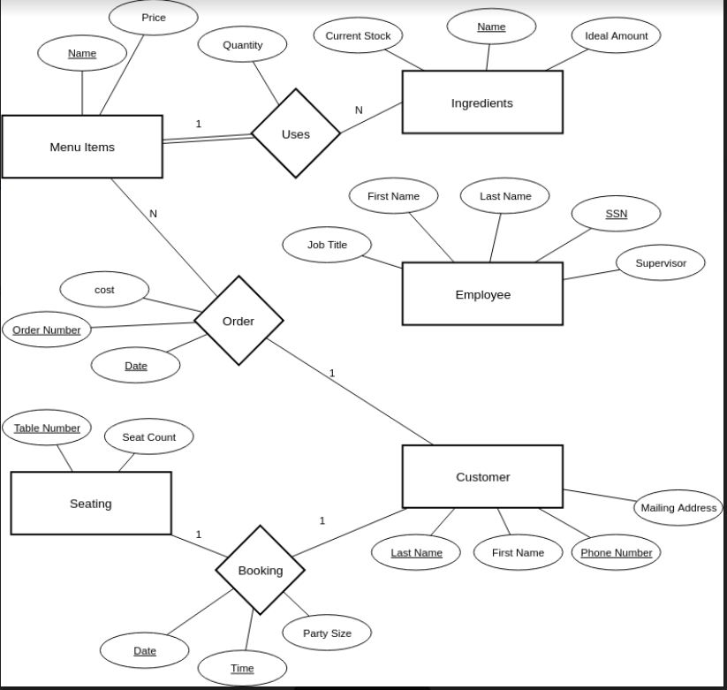

**Relational Data Model**

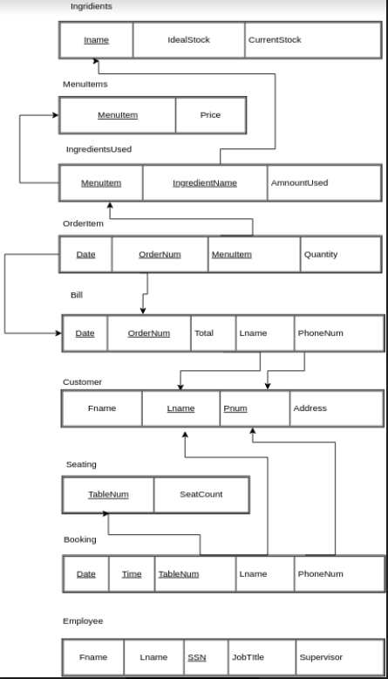

**Part 2 SQL Scripts:**

**File Name:** Resturant.db

**Table Names:** Bill, Booking, Customer, Employee, Ingredient, IngredientUsed, MenuItem, OrderItem, Seating

**Making and populating Database scripts:**

BEGIN TRANSACTION;

CREATE TABLE Ingredient(

Name varchar(20) NOT NULL,

CurStock int NOT NULL,

IdealStock int NOT NULL,

primary Key (Name),

check (CurStock >= 0),

check (IdealStock > 0));

INSERT INTO Ingredient VALUES('Lettuce',50,30);

INSERT INTO Ingredient VALUES('Tomato',50,25);

INSERT INTO Ingredient VALUES('Egg',200,50);

INSERT INTO Ingredient VALUES('Chicken Stock',50,15);

INSERT INTO Ingredient VALUES('Potato',150,40);

INSERT INTO Ingredient VALUES('Chicken Breast',75,30);

INSERT INTO Ingredient VALUES('Strip Steak',80,15);

INSERT INTO Ingredient VALUES('Slice of Bread',150,30);

INSERT INTO Ingredient VALUES('Bacon',30,50);

CREATE TABLE Employee(

SSN int NOT NULL,

Fname varchar(20) NOT NULL,

Lname varchar(20) NOT NULL,

JobTitle varchar(20) NOT NULL,

SuperSSN int,

primary key(SSN));

INSERT INTO Employee VALUES(123456789,'Meis','Ashef','Head Chef',NULL);

INSERT INTO Employee VALUES(987654321,'Wann','Abeshef','Sous Chef',123456789);

INSERT INTO Employee VALUES(321654987,'Zee','Bozz','Manger',NULL);

INSERT INTO Employee VALUES(111111111,'Buzz','Boi','Waiter',321654987);

INSERT INTO Employee VALUES(765432198,'Keen','Tabuus','Waiter',321654987);

CREATE TABLE Customer(

Lname varchar(20) NOT NULL,

Fname varchar(20) NOT NULL,

PhoneNum varchar(10) NOT NULL,

MailAddress varchar(50),

primary key (Lname, PhoneNum));

INSERT INTO Customer VALUES('Doe','John','1234567890','This is an Address place');

INSERT INTO Customer VALUES('Doe','Jane','0123456789','This is also an Address');

INSERT INTO Customer VALUES('Hobbs','Billy','7410852963',NULL);

INSERT INTO Customer VALUES('Smith','Mary','9638520741','Look its another random Address');

CREATE TABLE Seating(

TableNum int NOT NULL,

SeatCount int NOT NULL,

primary key(TableNum));

INSERT INTO Seating VALUES(1,2);

INSERT INTO Seating VALUES(2,2);

INSERT INTO Seating VALUES(3,4);

INSERT INTO Seating VALUES(4,4);

INSERT INTO Seating VALUES(5,8);

CREATE TABLE MenuItem(

Name varchar(20) NOT NULL,

Price decimal(6,2) NOT NULL,

primary key(Name));

INSERT INTO MenuItem VALUES('Chicken Scramble',7.9900000000000002131);

INSERT INTO MenuItem VALUES('Stir-Fried Tomato and Eggs',5.9900000000000002131);

INSERT INTO MenuItem VALUES('Steak',12.990000000000000212);

INSERT INTO MenuItem VALUES('BELT Sandwich',6.4900000000000002131);

CREATE TABLE IngredientUsed(

MenuName varchar(20) NOT NULL,

IngredientName varchar(20) NOT NULL,

Amount int NOT NULL,

primary key (MenuName, IngredientName),

foreign key(MenuName) references MenuItem(Name),

foreign key(IngredientName) references Ingredient(Name));

INSERT INTO IngredientUsed VALUES('Chicken Scramble','Chicken Breast',1);

INSERT INTO IngredientUsed VALUES('Chicken Scramble','Egg',3);

INSERT INTO IngredientUsed VALUES('Stir-Fried Tomato and Eggs','tomato',3);

INSERT INTO IngredientUsed VALUES('Stir-Fried Tomato and Eggs','egg',6);

INSERT INTO IngredientUsed VALUES('Steak','Strip Steak',1);

INSERT INTO IngredientUsed VALUES('BELT Sandwich','Bacon',3);

INSERT INTO IngredientUsed VALUES('BELT Sandwich','Egg',1);

INSERT INTO IngredientUsed VALUES('BELT Sandwich','Lettuce',1);

INSERT INTO IngredientUsed VALUES('BELT Sandwich','Tomato',1);

INSERT INTO IngredientUsed VALUES('BELT Sandwich','Slice of Bread',2);

CREATE TABLE Booking(

Date date NOT NULL,

Time time NOT NULL,

TableNum int NOT NULL,

Lname varchar(20) NOT NULL,

PhoneNum varchar(10) NOT NULL,

primary key(Date, Time, TableNum),

foreign key(TableNum) references Seating(TableNum),

foreign key(Lname, PhoneNum) references Customer(Lname, PhoneNum));

INSERT INTO Booking VALUES('06-15-2018','19:30:00',1,'Doe','0123456789');

INSERT INTO Booking VALUES('06-25-2018','20:00:00',2,'Hobbs','7410852963');

CREATE TABLE Bill(

Date date NOT NULL,

OrderNum INT NOT NULL,

Total decimal(6,2) NOT NULL,

Lname varchar(20) NOT NULL,

PhoneNum varchar(10) NOT NULL,

primary key(Date, OrderNum),

foreign key(Lname, PhoneNum) references Customer(Lname, PhoneNum));

INSERT INTO Bill VALUES('05-30-2018',1,20.839999999999999857,'Doe','1234567890');

INSERT INTO Bill VALUES('05-30-2018',2,7.1100000000000003197,'Hobbs','7410852963');

CREATE TABLE OrderItem(

Date date NOT NULL,

OrderNum int NOT NULL,

ItemName varchar(20) NOT NULL,

Quantity int NOT NULL,

primary key(Date, OrderNum, ItemName),

foreign key(Date, OrderNum) references Bill(Date, OrderNum),

foreign key(ItemName) references MenuItem(Name));

INSERT INTO OrderItem VALUES('05-30-2018',1,'Stir-Fried Tomato',1);

INSERT INTO OrderItem VALUES('05-30-2018',1,'Steak',1);

INSERT INTO OrderItem VALUES('05-30-2018',2,'BELT Sandwich',1);

COMMIT;

**Query Statements**

|  |  |
| --- | --- |
| SQL Statement | Purpose |
| select curStock,IdealStock  from Ingredient  where Name = "tomato"; | Manager wants to know how many tomatoes he needs to order. |
| select price  from MenuItem  where name = ""; | See how much a certain item on the menu costs. |
| update Seating  set SeatCount = 6  where TableNum = 1 | The restaurant replaced a 4 person table with a 6 person table. |
| update IngredientUsed  set Amount = 3  where MenuName = "" and Ingredient = "" | The manager changes the ingredients used for a menu item to reflect a change in the menu. |
| select Date, Time, TableNum  from Booking  where Lname = "Mosely" and PhoneNum = 5558886666; | Mr.Mosely called because he forgot when he set his reservation for. |
| select Date, OrderNum, Total  from Bill  where Lname = "Richardson" and PhoneNum = 7774443333; | Richardson thinks his card was overcharged and wants to know what his order total was. |
| Select Fname, Lname, MailAddress  from Customers; | Manager wants the mailing list of their customers. |
| Select Fname, Lname, JobTitle  from Employee; | Manager wants a complete list of employees |
| Select Lname, PhoneNum, Time, TableNum  from Booking  where Date = date('now'); | Manager wants to print off all of the days current reservations. |
| select Name, CurStock, IdealStock  from Ingredient  where CurStock < IdealStock; | Manager is going to order a shipment of ingredients and needs to know which ingredients and how much of each to order. |
| select COUNT(ItemName)  from OrderItem  where ItemName = "ceasar salad" and Date > "2018-05-01" and Date < "2018-05-31”; | Manager wants to know how popular the caesar salad is by seeing how often is was ordered in may. |
| select Count(distinct OrderNum)  from OrderItem  where Date = date(“now”); | Manager wants to know how many orders were serviced that day. |
| update Ingredient  SET CurStock = CurStock - 5  Where Name = "Hamburger Patty 1/2lb"; | 5 patties were dropped/ruined/wasted throughout the day, so manager updates current stock. |
| Select * ingredientName, amount from Ingredient used where menuname = “” | Generate all ingredients that will be used and the amount used for a specific menu item |
| Update ingredient  Set curStock = (select curstock from ingrident where name = “”) - amt where name = “” | Decrement stock of an ingredient by a given amount (amt) |
|  |  |