Software Requirements Specification (SRS) Document
Faculty Hiring web application
Note: This is a “living document”, meaning its content will change with the implementation of the project. Use it to capture key project requirements and make sure that your product features match the requirements exactly – if you wish to add any features, they must be added first to the requirements. Changes in the document must be approved by the customer (mentor) and the instructor/TA in-charge.

Brief problem statement
Developing a faculty hiring web application for college. The aim is reduce manual and redundant steps and automate tasks at as many places as possible. This will reduce the manual emails sent between the candidate and the college and system generated emails can be used to proceed with the task. This will make the whole process more transparent and easy to follow, both for college and the applicant.

System requirements
The portal will be built using MVT(MVC) framework, preferably in 'Django'(where the front end is not coupled with the back end).
Additionally, the design of style sheet definitions will be compiled using CSS extensions like SASS (Syntactically Awesome Style Sheets).
For controlling HTML/XML, jquery ajax , javascript and similar technologies will be used.

Users profile
The profiles of the users who will be interacting with the interface can be broadly divided in five categories:
→ Administrator
→ Faculty/Research center heads
→ Members in the hiring committee
→ Staff members
→ Applicants

→ The Administrator will have access to the entire database and the source code of the portal. They will have access to change privileges of the members in the database, and change/update/modify the source code if need be.
→ Faculty/Research center head will be able to view the profiles forwarded by the faculty hiring committee and request additional references, publications, papers from the candidate if need be. They will also have an option to express an opinion whether to call the candidate for an interview. Additionally, they can forward the profile to any other faculty member to view, if they wish to.

→ Members in the faculty hiring committee will be able to view the profiles forwarded by the staff committee. They can request additional publications, information, references from the candidate if need be. After reviewing the profiles, they can forward the profiles of the choice to the heads of research center and to other faculties. The members in this committee can change their roles to faculty/research center head as well.

→ The staff committee members will have access to profiles of all the applicants who applied through the college portal. They can forward the suitable applications to the faculty hiring committee.
→ The applicant will be able to input additional information such as research area interests, publications etc. The applicant will get regular notifications like- request for a reference, call for an interview etc. Additionally, they can also view at what stage the application is at, in the application tracker. They can request a slot for interview, confirm slot and receive call letters.
Login process will be common for all kinds of users.
Staff, faculty, administrator will have their college login ids authenticated by CAS(Central Authentication Service) which will be used here to login.
All participants of the system are expected to be quite proficient and comfortable in using the system because of prior experience in interacting with such portals in the past, and general high proficiency in using computer systems.

Feature requirements (described using use cases)

No. | User Case Name | Description | Release
 | Login for candidate | The candidate logs in the portal using the registered email id and password | R2
 | Register for candidate | The candidate who wishes to register, fills out specified columns and verifies their email id to register as an applicant. | R2
 | Login | The user logs in from the account. The email id is identified with the assigned profile and respectively, the account opens. | R2
 | Areas of interest | The candidate enters the areas of research that he/she is interested in. This is taken into consideration while reviewing the application. | R2
 | Upload Documents | The candidate uploads his resume AND three published papers. | R2
 | Request Reference | From the given referencer email id, reference is requested. | 3rd Iteration
 | Forward/Reject application | An application is forwarded or rejected by the staff committee or the hiring committee. | R2
 | Search Profiles | Profiles are viewed and sorted based on filters. | R2
 | Forward Profile | Research Lab head can choose to forward the profile to a faculty. | R2
 | Express Opinion | Reviewers of the application can express opinion over calling the candidate or not. | 3rd Iteration
 | Selection for Interview | If the application is recommended by the faculty then the Hiring Committee is able to assign a faculty for the interview. | 3rd Iteration
 | Choosing preferred slots | The candidate is able to choose his/her preferred dates for the interview. | 3rd Iteration
 | Faculty fixing a date for interview | Based on the faculty's free time slots the candidate is called for an interview. | 3rd Iteration
 | Change Roles | The faculty members can change roles and become a part of hiring committee if they are allowed to. | 3rd Iteration

Use case diagram

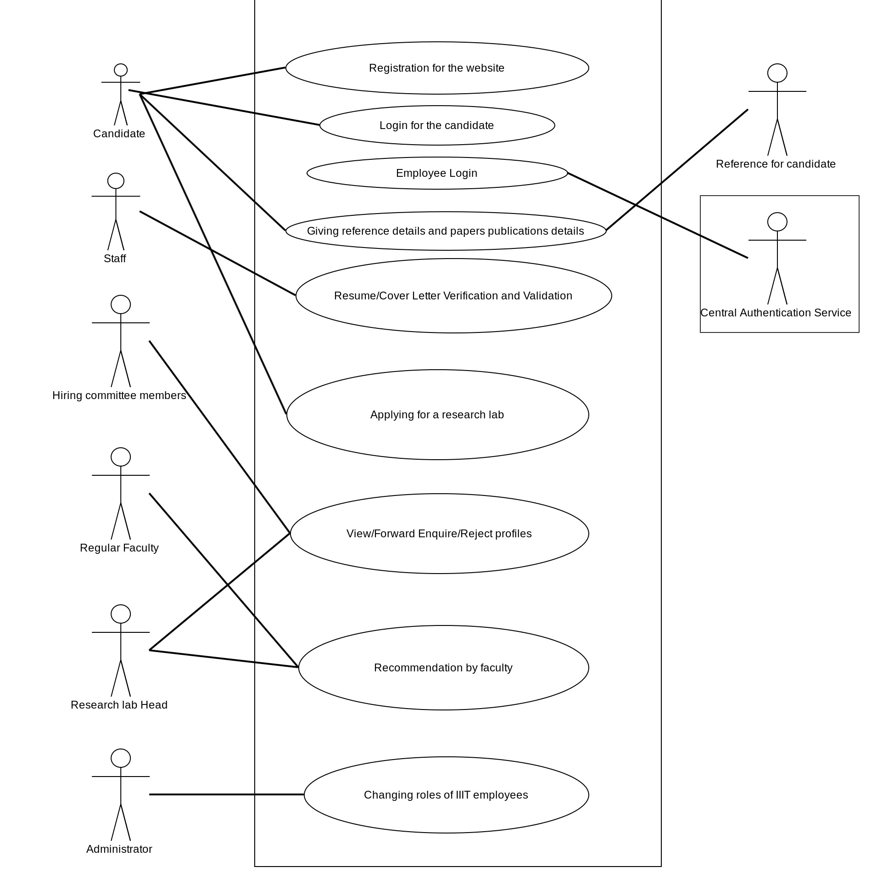

Use case description

Use Case Number: | UC-01
Use Case Name: | Login for the candidate.
Overview: | The candidate logs in the portal using the previously registered emailid and password.
Actors: | Applicant
Pre condition: | The applicant must have registered on the portal before.
Flow: | Main (success) Flow:  1) The applicant enters the email id and roll number.  2) If the account is verified/registered, then applicant logs in the portal.
Alternate Flows:
1)The applicant enters a wrong email/password.
2)They are informed of a wrong login.
3)They are given a choice of clicking on “forgot password” by which they can recover the password.
4)The applicant may unsuccessfully log-in three times, after which no further chance is given and can be accessed only from the registered email.
1)User may not be registered and prompted with an option to register.
Post Condition: | The candidate logs in to the portal.

Use Case Number: | UC-02
Use Case Name: | Registering candidate
Overview: | The candidate who wishes to register, fills out specified columns and verifies their email id to register as an applicant.
Actors: | Applicant
Pre condition: | Must have a functional email-id.
Flow: | Main (success) Flow:  1) Candidate enters the column fields.  2) Candidate enters the security captcha.  3)Candidate clicks on register and is redirected to a page where he is informed that the account will be active once the email is verified.
Alternate Flows:
1)Candidate enters the captcha wrong.
2) Given three chances,after which the page redirects to the home page.
Post Condition: | If the email is verified, the candidate is able to register in the portal.

Use Case Number: | UC-03
Use Case Name: | Login
Overview: | The user logs in from the account. The email id is identified with the assigned profile and respectively, the account opens.
Actors: | Staff, administrator, faculty, research head, faculty hiring committee, CAS
Pre condition: | User must have an authorized role in the process.
Flow: | Main (success) Flow:  1) The user enters the email id and password.  2) If the account is verified/registered, then user logs in the portal.
Alternate Flows:
1)The applicant enters a wrong email/password.
2)They are informed of a wrong login.
3)They are given a choice of clicking on “forgot password” by which they can recover the password.
4)The applicant may unsuccessfully log-in three times, after which no further chance is given and can be accessed only from the registered email.
Post Condition: | The specified user can login the portal.

Use Case Number: | UC-04
Use Case Name: | Enter areas of interest.
Overview: | The candidate enters the areas of research that he/she is interested in. This is taken into consideration while reviewing the application.
Actors: | Applicant
Pre condition: | The applicant must have registered on the portal before.
Flow: | Main (success) Flow:  1) The applicant selects the domain/ technology they are interested in.  2) The options are “ticked”/selected and submitted by clicking the “SUBMIT” button.
Alternate Flows:
1) The applicant is not interested in the listed domain/technology centers.
2) Applicant selects the “other” option and specifies their interest in text.
3)Clicks the “submit” button to submit.
Post Condition: | The applicant has expressed his area of research interest.

Use Case Number: | UC-05
Use Case Name: | Upload Required documents.
Overview: | The candidate uploads his resume AND three published papers.
Actors: | Applicant
Pre condition: | The applicant must have registered on the portal before.
Flow: | Main (success) Flow:  1) Beside the “RESUME” button, the candidate uploads the resume(pref. a .pdf)  2) Beside the “PAPER-1” button, the candidate uploads the first paper.  3) Beside the “PAPER-2” button, the candidate uploads the second paper.  4) Beside the “PAPER-3” button, the candidate uploads the third paper.
Alternate Flows:
1)The applicant may decide against uploading the document/some of the documents.
Post Condition: | Applicant would have successfully uploaded the documents.

Use Case Number: | UC-06
Use Case Name: | Request a Reference
Overview: | A reference from say, an advisor can be requested from the candidate.
Actors: | Referencer, Faculty hiring committee, Applicant,Faculty, Research lab head
Pre condition: | The applicant must have sought consent of the referencer for giving a reference for him.
Flow: | Main (success) Flow:  1)The user enters the email id of the referencer, in the home page of the profile.  2)The faculty/hiring committee, clicks on “REQUEST REFERENCE” button.  3)An email is sent to the referencer with the details of the applicant and a link to submit reference in.  4)Within 2-3 weeks the referencer is expected to open the link, and fill in the reference of the applicant.  5)The reference is received and is open to view by the hiring committee/faculty/research head.
Alternative flows:
1)The applicant may not have entered the email id of the referencer initially.
2)The hiring committee/faculty requests for a reference.
3)The applicant is notified in the notifications that a reference is requested.
4)The applicant enters the email id of the referencer, in the home page of the profile.

1)The referencer fails to submit reference for the applicant.
2)The request lapses and no further request is made.
Post Condition: | The reference of the candidate is received.

Use Case Number: | UC-07
Use Case Name: | Forward/Reject the application profile.
Overview: | The application of the candidate can be forwarded/rejected.
Actors: | Staff committee, Faculty hiring committee, Research Lab head, Faculty
Pre condition: | The applicant must have registered on the portal before.
Flow: | Main (success) Flow:  1)The staff committee/faculty hiring committee short lists the applications on certain criteria and forward them to the faculty hiring committee/Research lab head by clicking the “FORWARD” button or reject them by selecting the “REJECT” button.
Post Condition: | The application is forwarded or rejected.

Use Case Number: | UC-08
Use Case Name: | Search Profiles.
Overview: | The profiles of the candidates can be sorted and searched based on different requirements.
Actors: | Staff Committee, Faculty Hiring committee, Research lab head, Faculty
Pre condition: | The profiles of the candidates should be available to view.
Flow: | Main (success) Flow:  1)In the drop down box, forwarded option is selected.  2)in the “sort-by” drop down box, date is selected.  3)All the forwarded applications sorted by date are visible
Alternate Flows:
1.1.1-)Rejected is selected
1.2.1-)All is selected
2.1.1-)Name is selected
2.2.1-)Date of birth is selected

Post Condition: | The profile is searched based on the filter.

Use Case Number: | UC-09
Use Case Name: | Forward the profile
Overview: | If the research lab head wants, he can forward the application to another faculty for a review.
Actors: | Research lab head, faculty.
Pre condition: | The profile must be available for review with the lab head.
Flow: | Main flow:  1)The lab head views the profile.  2)He selects the option “FORWARD”.  3)In a drop down all the faculty names are displayed.  4)Selects the faculty.  5)Clicks “SUBMIT”
Alternate Flows:
1)Default option in drop down- NONE
Post Condition: | The profile gets forwarded to the faculty.

Use Case Number: | UC-10
Use Case Name: | Express Opinion
Overview: | Express opinion over inviting or not inviting the candidate for interview
Actors: | Research lab head, Faculty
Pre condition: | The profile must have be available for review
Flow: | Main (success) Flow:  1)View the Profile.  2)Click on the “CALL” button if desired.
Post Condition: | The vote is registered with the faculty hiring committee.

Use Case Number: | UC-11
Use Case Name: | Assign faculty for interview
Overview: | Assigning a faculty for interview.
Actors: | Research lab head, Faculty, Hiring Committee
Pre condition: | The application must be successfully recommended by the faculty.
Flow: | Main (success) Flow:  1) The Hiring Committee assigns a faculty for taking the candidates interview.  2) The faculty receives this application in his list of “To be interviewed”.
Alternate Flow: | No recommended application reaches the Hiring Committee.
Post Condition: | Roles are successfully switched.

Use Case Number: | UC-12
Use Case Name: | Interview slots.
Overview: | Choose preferred Time slots for the interview.
Actors: | Candidate
Pre condition: | The candidate is selected for an interview.
Flow: | Main (success) Flow:  1) The candidate can choose his preferred dates for the interview.  2) This is now visible to the assigned faculty.
Alternate Flow: | The candidate sends an email in case of failure.
Post Condition: | Dates are successfully chosen by the candidate.

Use Case Number: | UC-13
Use Case Name: | Interview time slots.
Overview: | Schedule an interview.
Actors: | Candidate, Faculty
Pre condition: | The candidate is selected for an interview and fills in his preferred time slots.
Flow: | Main (success) Flow:  1) The faculty schedules an interview at some time slot on candidate chosen dates.  2) This is now visible to the candidate.
Alternate Flow: | The candidate sends an e-mail.
Post Condition: | The interview is successfully scheduled.

Use Case Number: | UC-14
Use Case Name: | Change roles
Overview: | Switching between roles of faculty and hiring committee member.
Actors: | Research lab head, Faculty, Hiring Committee
Pre condition: | The faculty must be a part of Hiring committee also, then only he can switch.
Flow: | Main (success) Flow:  1) His role is changed to Hiring Committee member.  2) Hiring Committee member can again switch back to faculty.
Alternate Flow: | There is no option for the user to Change Role.
Post Condition: | Roles are successfully switched.

