Product Design
Team | SSAD Team-4  ABHISHEK VINJAMOORI, SAI SAHITH NAMA,  KAMLESH TENGADU, P.V. CHAITANYA, SHANTANU PRABHAT
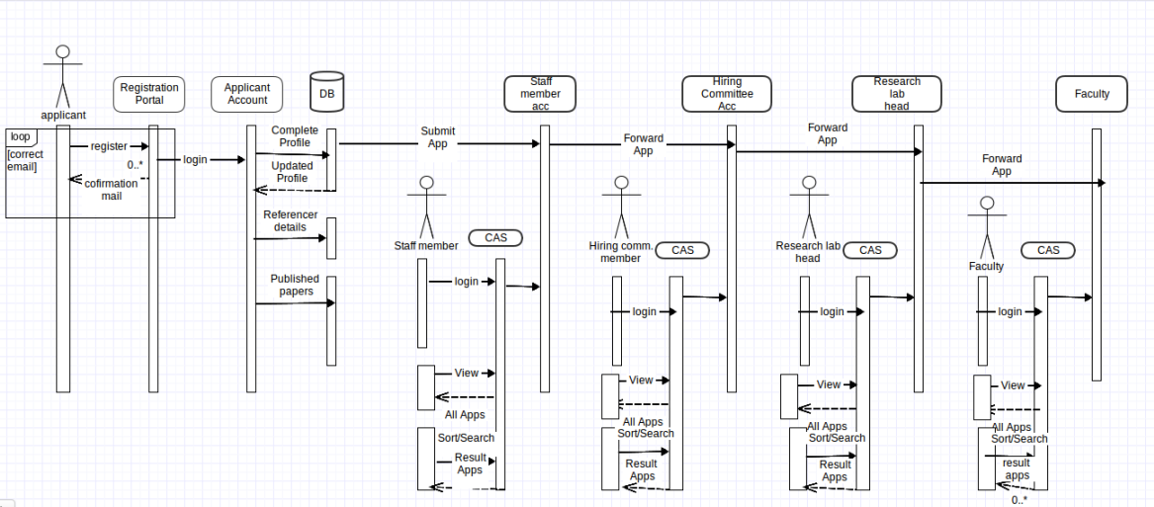
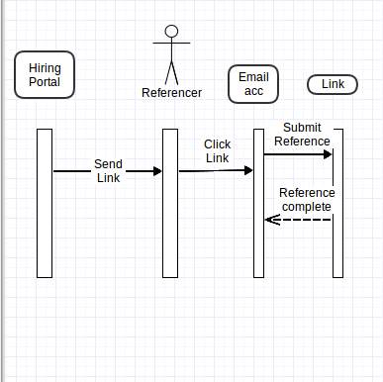
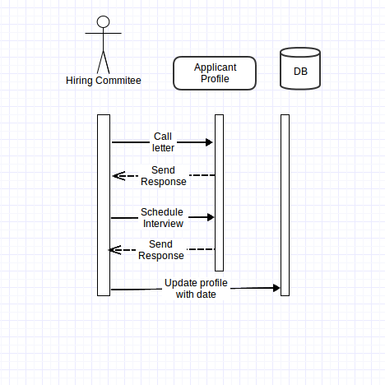

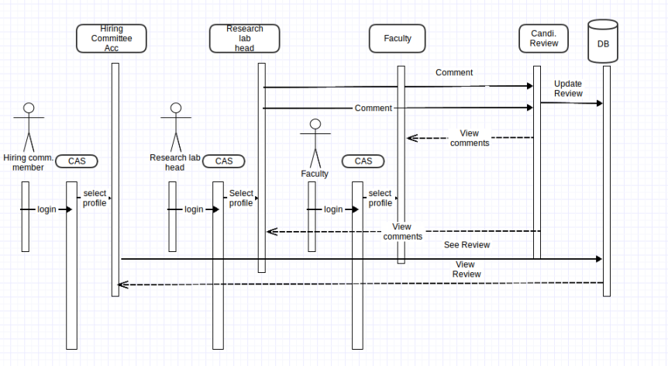
B)UML CLASS DIAGRAM
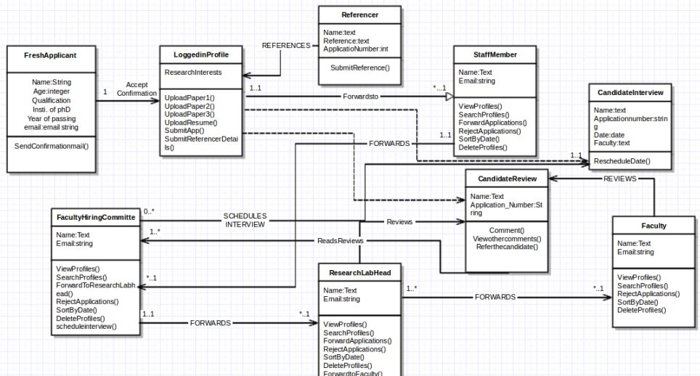

Fresh Applicant | Class State: Personal Infomation, resume,coverletter,research papers.  Class Behaviour: Edit profile, upload resume,coverletter.
Staff Member | Class State: Name,IIIT-mail address.  Class Behaviour: View Profile,Search profile,Forward Application,Reject Application,Sortbydate,DeleteProfile.
Faculty Hiring Committe | Class State: Name,IIIT-mail address.  Class Behaviour: ViewProfile,SearchProile,Forward to ResearchLabHead,RejectApplication,SotbyDate,DeleteProfile,ScheduleInterview.
Faculty | Class State: Name,IIIT-mail address.  Class Behaviour: ViewProfile,SearchProfile,RejectApplication,SortbyDate,DeleteProfile.
Research Lab Head | Class State: Name,IIIT-mail address.  Class Behaviour: ViewProfile,SearchProfile,ForrwardApplication,RejectApplication,SortbyDate,ForwardtoFaculty,DeleteProfile.

DESIGN RATIONALE

The design is motivated by the need to decrease as much as manual steps and increase automated tasks. There is a specified role for every user account with minimal interferences and clashes. The work flow of the whole process is linear and very rarely goes cyclic. The motive of the whole process is to reduce work flow for every user profile.
The steps are designed to be as minimal as possible and that the user is forced to think on as less things as possible. Design rationale therefore is guided by “Don't make me think”.
The registrations have been made as simple as possible so that the applicant is not forced to fill many columns. The regular college profiles have been granted access through the CAS , as it lets them skip the registering process.
Usually when an applicant submits his application for some job profile,he is unable to track the process of his application. Thus an application tracker has been designed which updates the status of the applicant through the various stages. This is motivated by the need for transparency in the application process.
A simple search and view bar is present for each of the faculty and the committee hiring members which enables to modify their searches and view the forwarded and rejected application. It makes it easy to make sense of the enormous applications that the committee receives.
When the referencer is prompted to fill in the reference of the applicant, they are directed to a simple link where they are prompted to fill the reference. Doing this the college is putting faith on the authenticity of the referencer and thus skips the part on registering and directly goes to submitting the reference. It makes it easier for the referencer who must be receiving multiple mails to submit references.
A one page summary is generated for every application that is received. Thus when the application is reviewed by the staff committee, the hiring committee or the faculty, there is lesser incentive to go through the entire resume and cover letter for every applicant and focus on only those applicants which pass the filter of the summary. The summary could be based on distinguishing factors such as the institute of PhD, the advisor for PhD which helps get a background and repute of the research work undertaken. This simplifies the process of selection.
The interview is scheduled such that both the parties can agree on a common date and the candidate's preference is taken in to account as the institute prefers physical presence over skype or VOIP interviews.

