Analysis software for the OSCOR-project

1.Introduction
Our ability to detect very small differences in sound localisation in the azimuthal plane (thus via temporal cues) contrasts sharply with our inability to follow fast temporal changes in interaural cues, referred to as “binaural sluggishness”. In the OSCOR-project this “sluggishness” is investigated via a special noise stimulus, namely noise tokens with interaural oscillating correlation. The noise tokens with oscillating correlation are generated by taking two uncorrelated noise tokens, designated as A and B, and modulating the first token with a sinusoidal tone at a given frequency, the second with a cosinus at the same frequency. After modulating, the two tones are added up. This final noise token is designated ABx, where x is the frequency at which was modulated.

The responses to these noise stimuli where recorded at the neurophysiology departement of the university of Wisconsin and where stored in an archaic data format. This data format was created and stored on a DIGITAL® VAX-station. To make these datafiles accessible, they should be moved to C:\USR\”UserName” \MadisonData\ and MADISONDATA.XLS should be updated and converted to a MATLAB-accessible format (See addendum).

The requirements and directory organisation are the same as for the stereausis project (see appropriate documentation). Also, the property/value system to change default parameters for a program is analogous.

2.Loading datasets (dat2ds)
Datasets, which contain the responses of a cell or fiber to a given stimulus, can be loaded via the program dat2ds (for SGSR-terminology see appropriate documentation). This program actually has the same function as dataset in the SGSR, except that it loads datafiles recorded at the university of Wisconsin. All OSCOR-data is in this format, so dat2ds should always be used in this project instead of dataset.

>> help dat2ds

DAT2DS convert Wisconsin Data to a dataset object
ds = DAT2DS(FileName, dsID or CellNr, DataType) returns dataset-object loaded from datafile recorded at the University of Wisconsin. The name of the datafile is given in FileName, the extension is .DAT by default. The ID can be given to specify the dataset to be loaded. This identifier must be a character string giving the cellnumber separated by the testnummer by a dash. The type of dataset must be specified by DataType. This string can be NSPL, OSCR, OSCRCTL or OSCRTD. NSPL designates an itensity function for noise stimuli(mostly OSCOR-noise stimulus at a given modulation frequency), OSCOR denotes the interaural adminstration of oscillating correlation(OSCOR) stimuli for different modulation frequency. OSCRCTL is the control stimulus and OSCRTD is the delay-function for OSCOR-noise at a given modulation frequency.
If there is only one dataset for the supplied stimulus type, then a dataset can be identified only by its cell number.

Dataset objects with responses to oscillating correlation(OSCOR) noise are timewarped to correct a stimulus artefact that was introduced while recording.

Attention! These results are cached in C:\usr\"UserName"\madisondata\cache\.

See also DATASET
The conversion of some datasets could not be automated. These datasets were converted manually and stored in the MAT-file manualds.mat, located in the OSCOR project directory. Via the script manualds.m, these dataset objects can be exported to the cache. Afterwards, loading of these datasets can be done via dat2ds in the normal way. So, if a new user needs to analyse OSCOR data, first of all these manually converted datasets should be exported. It is important to leave the cache as it is after this export has been done. The aforementioned datasets are: for R95057.DAT: 9-20-OSCR, 20-4-OSCR, 20-17-OSCR, for R95060.DAT: 4-6-OSCR, 28-5-OSCR, for I95101.DAT: 1-18-OSCR; R95106.DAT: 7-14-OSCR, 10-6-OSCR, for R95110.DAT: 4-4-OSCR, 5-4-OSCR and for R96078.DAT: 7-6-OSCR.

Each dataset in a datafile is represented by a character string. This string contains the cell number, the test number and the stimulus type separated by a dash. The stimulus type can be OSCR, OSCRCTL, OSCRTD, NITD or NSPL. NSPL designates an intensity function for noise stimuli (mostly OSCOR-noise stimulus at a given modulation frequency at one ear, and one of the original noise tokens at the other), OSCR denotes the interaural administration of oscillating correlation stimuli for different modulation frequency. OSCRCTL is the control stimulus, where the same OSCOR-noise is given at both ears, and OSCRTD is the delay-function for OSCOR-noise at a given modulation frequency (same as with NSPL, but interaural time difference is changed instead of intensity). It is important to mention that the original dsID is not used, but this can always be retrieved via the field ds.ID.OrigSeqID or shorter ds.OrigSeqID, where ds is the variable name of a dataset object. Sometimes one dataset object is a merging of several original dsIDs (for OSCR-datasets), then the original dsIDs are given as a cell-array of strings located in the same field.

3.Evaluating datasets

3.1 Evaluating binaural data (CalcData, PlotData)
After loading datasets, they are accessible as a variable in the MATLAB workspace (in computer memory). CalcData is a program that calculates all relevant data for an NSPL, OSCR, OSCRCTL or OSCRTD-dataset. It is located in the directory C:\USR\ “UserName” \mfiles\OSCOR\ and while evaluating datasets, this directory should be the current working directory.
CalcData has one mandatory input argument, namely a dataset object, and returns a scalar structure with all the calculated curves and extracted parameters.

D = CalcData(DS, …)

Optional properties and their values can be given as a comma-separated list. To view list a of all possible properties and their default values, use 'list' as only extra argument.
All the possible properties are (default values are given in braces):
- nbin: the number of bins used in the computation of cyclehistograms {64}
- anwin: the analsyis window for the spiketimes in ms. Its value should be a two element vector with the analysis onset as first element and the offset as the second. –1 designates the duration of the stimulus. Used in the computation of cyclehistograms and rate curves. {[0 -1]}
- binfreq: the binning frequency for the cyclehistograms. Negative values denote a multiplication of the modulation frequency. {-1}
- rcutoffthr: the level in dB over which the modulation transfer function has to drop, to get a measure for the cutoff frequency of the low pass filter. {3}
- zcutoffthr: the value of the statistical variable Z = n * R² (where n is the number of elements or spikes in the distribution, and R is the vector strength for this circular distribution. Z is actually the Rayleigh criterion.) above which datapoints are treated as significant.{6.91}
- unwrpalg {'iter'}, delayacc {0.005ms} and mxwrapstp {0.4cyc} are parameters for the unwrapping algorithm. (See section 5.2)
- retmode: By default ‘all’ the data for the curves and the derived parameters are returned in a scalar structure. If the value for this property is ‘reduced’, a reduced scalar structure, with only the derived data, is returned as ouput.

The fields in the scalar structure D depend on the type of dataset that is given as input and on the value of the proprerty retmode. Here, only the fields of the scalar structure in reduced form will be discussed.
For dataset objects with stimulus type OSCR or OSCRCTL the fields are:
- CF: the characteristic frequency in Hz derived from the threshold curve.
- Thr: the threshold in dB for this characteristic frequency.
- SA: the spontaneous activity in spk/sec.
- BW: the bandwidth of the cell derived from the threshold curve, this is the width of the threshold curve 10dB above CF. Unit is Hz.
- Q10: the Q10, i.e. the CF divided by the bandwidth BW.
- Loc: the location of the cell, this is 'IC' for the inferior colliculus and ‘AN’ for the auditory nerve.
- SPL: the intensity level in dB at which the stimulus was administered.
- MaxR: the maximum magnitude of the vector strength.
- BMF: the best modulation frequency in Hz, i.e. the modulation frequency that corresponds with MaxR.
- COMF: the cutoff frequency of the low pass filter given by the transfer function in curve VS magnitude versus modulation frequency, i.e. the modulation frequency at which the vector strength drops with rcutoffthr dB.
- HSMF: the highest significant modulation frequency derived from the curve Z versus modulation frequency, i.e. the modulation frequency at which Z goes below zcutoffthr and thus becomes insignificant (Hz).
- Delay: the delay taken from the phase-frequency curve in seconds.

E.g.:

>> ds = dat2ds('R95060', '28-5', 'OSCR')
ds =
Dataset R95060 <28-5-OSCR>, WISCDATA Seq=251 252 253 254 255 256 257 258 259 260 261 262 263 267 268, 2003-Apr-11 11:52:6.187, Leuven\sikio
stimtype OSCR, 15/15 x 5 x 6000 ms
varied: Modulation frequency = [1...1000] Hz
Burst = 5000 ms
>> D = CalcData(ds, 'retmode', 'r')
D =
CF: 1851
Thr: 21
SA: 0
Q10: 3.35
BW: 552
Loc: 'IC'
SPL: 80
MaxR: 0.65883
BMF: 2
COMF: 367.7
HSMF: 610.36
Delay: 0.0079889

Dataset objects with stimulus type NSPL have the following fields:
- CF, Thr, SA, BW, Q10 and Loc are the same as for OSCR-datasets.
- ModFreq: the modulation frequency of the OSCR-noise token that was administered.
- MaxR: the maximum magnitude of the vector strength.
- BSPL: the intensity level with the best response, i.e. the level that corresponds with MaxR.

E.g.:

>> ds = dat2ds('R97047', '1-9', 'NSPL')
ds =
Dataset R97047 <1-9-NSPL>, WISCDATA Seq=12, 2003-Apr-22 11:28:33.677, Leuven\sikio
stimtype NSPL, 10/10 x 5 x 6000 ms
varied: Intensity = [30...120] dB SPL
Burst = 5000 ms Mod @ 1 Hz
>> D = calcdata(ds, 'retmode', 'r')
D =
CF: 476
Thr: 25
SA: 0.5
Q10: 1.66
BW: 286
Loc: 'IC'
ModFreq: 1
MaxR: 0.59507
BSPL: 80

Dataset objects with stimulus type OSCRTD have the following fields:
- CF, Thr, SA, BW, Q10 and Loc are the same as for OSCR-datasets.
- ModFreq: the modulation frequency of the OSCR-noise token that was administered.
- SPL: the intensity level in dB at which the stimulus was given.

E.g.:

>> ds = dat2ds('I95101', '1-32', 'OSCRTD')
ds =
Dataset I95101 <1-32-OSCRTD>, WISCDATA Seq=40, 2003-Apr-22 11:13:49.614, Leuven\sikio
stimtype OSCRTD, 21/21 x 3 x 6000 ms
varied: Interaural time = [-1000...1000] \mus
Burst = 5000 ms Mod @ 1 Hz
>> D = calcdata(ds, 'retmode', 'r')
D =
CF: 951
Thr: 36
SA: 0
Q10: 1.24
BW: 769
Loc: 'IC'
SPL: NaN
ModFreq: 1

To view the actual curves, the MATLAB command plot can be used with the structures returned from CalcData. It is much more convenient to use the program PlotData, which actually uses CalcData to compute the curves.
PlotData has the same syntax as CalcData. The subset of properties that can be changed for PlotData, were all discussed for CalcData and are: nbin, anwin, binfreq, rcutoffthr, zcutoffthr, unwrpalg, delayacc and mxwrapstp.

According to the type of dataset, a different plot is produced. For NSPL, OSCR and OSCRCTL-datasets the cyclehistograms for all modulation frequencies are given (up to 15 histograms can be plotted). The frequency at which a histogram is calculated is designated as BF, the binning frequency. From these histogram several parameters are retrieved, the most important ones are the vector strength R and the phase Φ. R is a measure for phase locking of cell on the OSCOR-stimulus. Via the Rayleigh-test we decide if the circular distribution given by the cyclehistogram differs significantly from the uniform distribution. Ry is the propability that the null hypothesis is true, i.e. that the given distribution doesn’t differ from a random one (NS denotes ‘Not Significant’). The total number of spikes is designated as #Spk. For NSPL-datasets an additional parameter is indicated on the histograms, namely the intensity level in dB of the noise token that was administered (SPL).
In addition, the vector strength magnitude, the statistical variable Z (cfr Rayleigh test), the rate and the vector strength phase are plotted in function of modulation frequency or SPL, for OSCOR/OSCRCTL or NSPL-datasets respectively. The different parameters which are extracted from these curves are plotted (for an explanation of these parameters, see CalcData). On these plots significant datapoints are given as circles, insignificant datapoints are given as solid blue dots.
The textbox in the lower right corner gives additional information, such as cell parameters retrieved from the threshold curve, calculation and plot parameters, …

For datasets with OSCRTD as stimulus only two curves are plotted: the vector strength magnitude and phase versus interaural time difference(ITD). These curves should be self-explanatory.

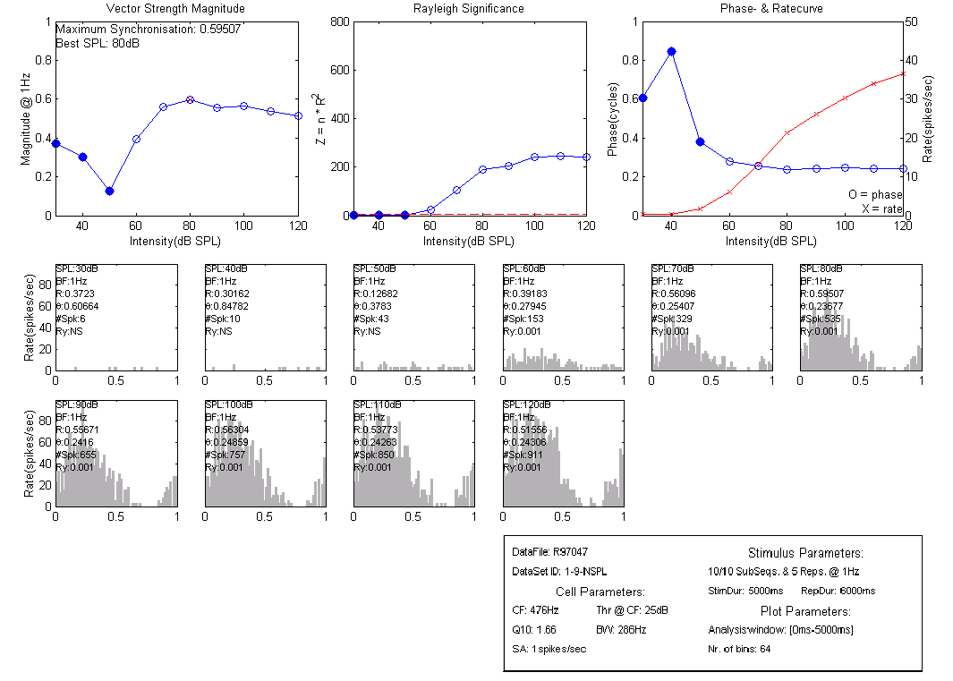
Figure 1 Plot of R97047 <1-9-NSPL>

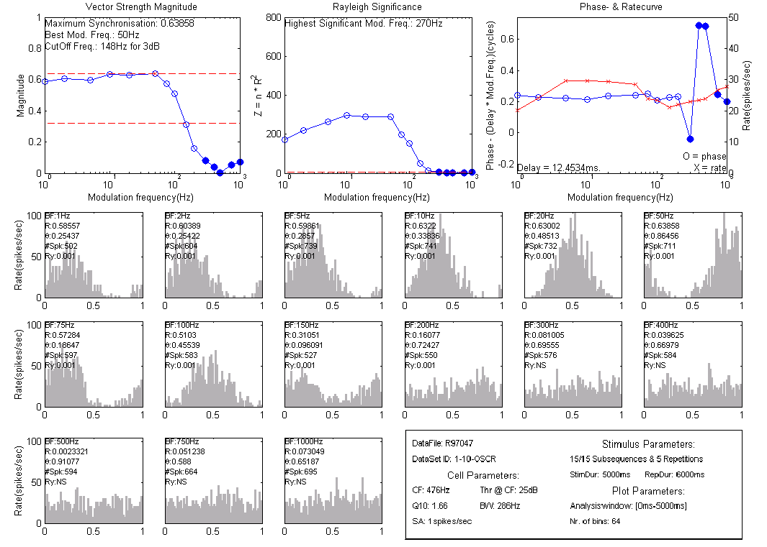
Figure 2 Plot of R97047 <1-10-OSCR>

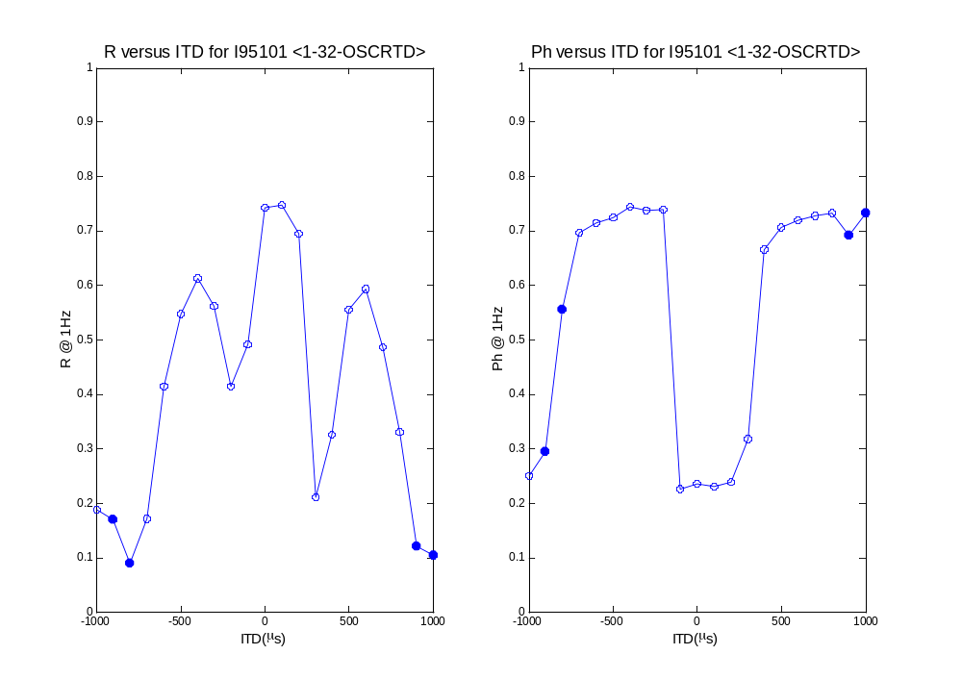
Figure 3 Plot of I95101 <1-32-OSCRTD>

3.2 Evaluating monaural data (CrBin)
Responses collected from the auditiry nerve (AN) need to be used as input for a modelled binaural crosscorrelator before they can be analysed by CalcData and PlotData. This can be done via the program CrBin (For a discussion of the actual model see section 5.1).

>> help crbin

CRBIN Create Binaural Data
ds = CRBIN(ds, {CoWindow, AnWin}) creates binaural dataset object from auditory nerve(AN) responses to oscillating correlation(OSCOR) noise at different modulation frequency via a coincidence model for the IC. The analysis window is given by the two element vector AnWin, where the first element is the onset in ms and the second the offset. The latter can be minus one, siginfying the stimulus duration. The coincidence window in ms for the model can be changed with CoWindow. The default is 0.050ms.

See also DAT2DS, TIMEWARP

After this conversion, these datasets can be used as if they were recorded from the binaural cell (IC) itself.

4.Making scatterplots via a script
Because of the small amount of datasets in the OSCOR study, a script-approach was used to organise calculated data. The script is actually popscript.m, located in the OSCOR project directory, and calls the function CalcData for all the specified datasets. The calculated data is stored in an array of structures. Depending on the stimulustype, this structure-array is DNSPL, DOSCR, DOSCRCTL, DOSCRTD or DNERVE.
After running the script these structures are present and accessible in the MATLAB workspace. They are also saved in a MAT-file popscript.mat. So, after running the script once, these variables can be loaded into the workspace with the simple command

>> load popscript.mat

instead of having to rerun the script.
An array of structures is not a convenient datastructure for the creation of scatterplots, therefore the function struct2ct is supplied to convert these structures to a column organised table (CT):

>> help struct2ct
STRUCT2CT convert structure-array to column-organised table
T = STRUCT2CT(S) converts structure-array S to scalar structure T with fields FName and Data.
FName is a cell-array of strings containing the expanded fieldnames of S, so each field from the form <SuperField>.<SuperField>. ...<Field>. Data is a cell-array conatining the actual data, it has the same number of rows as their are elements in the structure array. The number of columns is equal to the total number of leaves in the structure-field.

struct2ct converts the structure-array, given as only input argument, to a column organised table. This table is actually a cell-array where each column corresponds to a field in the original structure-array. The only exception with an ordinary cell-array is that columns can be retrieved by the name of the field. This can be done via the function getctcol.

>> help getctcol

GETCTCOL get column from column-organised table
D = GETCTCOL(T, ColName) gets column with name ColName from column-organised table T.

Getctcol returns a column-vector if the requested field contains numeric data, otherwise a cell-array is returned. These vectors can then be used to plot scatterplots via the MATLAB command plot.
Fieldnames of column-organised table are case sensitive. For an overview of all the calculated parameters and their corresponding fieldnames, see the discussion on CalcData.

E.g.:

>> TB = struct2ct(DOSCR);
>> TM = struct2ct(DNERVE)
>> DelayB = getctcol(TB, 'Delay');
>> DelayM = getctcol(TM, 'Delay');
>> CFB = getctcol(TB, 'CF');
>> CFM = getctcol(TM, 'CF');
>> plot(CFM, DelayM, 'r.', CFB, DelayB, 'b.');

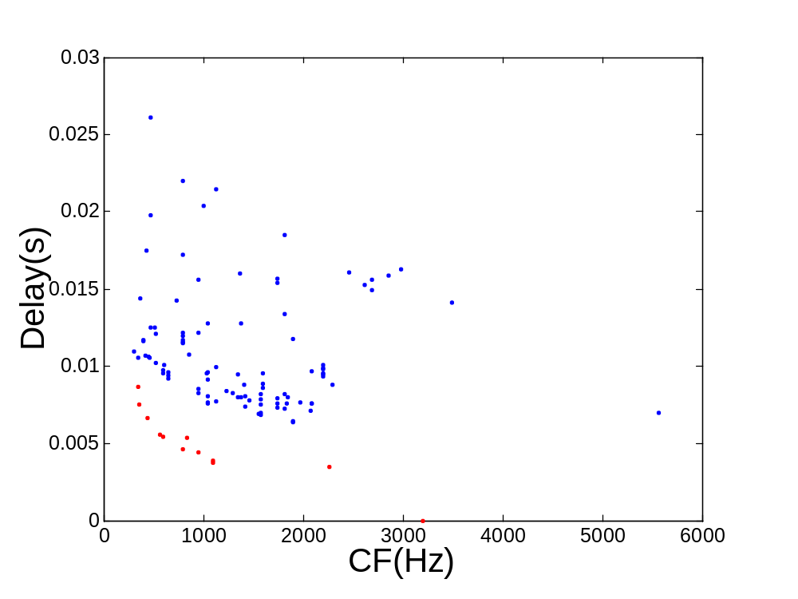
Figure 4 Example of a scatterplot
In this example the structure-arrays DOSCR and DNERVE are converted to the column-organised tables TB and TM. From these tables the fields Delay and CF are extracted and stored in the vectors DelayB and CFB for the OSCOR-data (B denotes binaural), DelayM and CFM for DNERVE (M denotes monaural). The actual scatterplot is generated with the MATLAB-command plot.

5.Computational techniques

5.1 Correcting for stimulus artefact in oscillating correlation (OSCOR) noise
As previously mentioned, the noise tokens with oscillating correlation are generated by taken two uncorrelated noise tokens, designated A and B, and modulating the first token with a sinusoidal at a given frequency, the second with a cosinus at the same frequency. After modulating, the two tones are added up. This final noise token is designated ABx, where x is the frequency at which was modulated.
An artefact was introduced while modulating these noise tokens. As it turned out, the modulation tones had a phase shift after a given duration (probably due to an approximation error). This introduced a notch in the modulation transfer function.
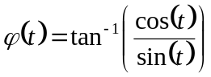Because the original sampled tones, both sinus and cosinus, were still accessible, this artefact could be undone. The phase in function of the stimulus duration can be extracted by using the arctangens. This function shows a change in slope, which underlines the fact that there was a phase shift in the stimulus.
By using this function, each spiketime is shifted in time, i.e. each spiketime is warped in time, hence the name time warping for this technique.
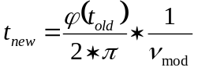Where:
- ν_{mod} is the modulation frequency for the given spiketrain
- t_{old} and t_{new} are the times of the spikes in seconds, before and after warping respectively

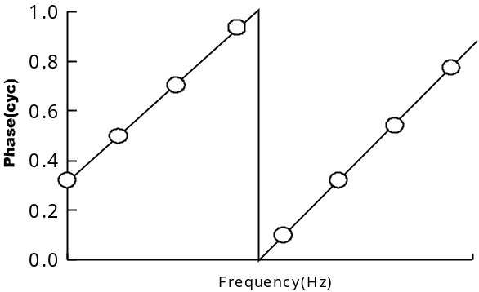
5.2 Unwrapping phase-frequency curves
To unwrap a phase-frequency curve, where the phases are exctracted from cyclehistograms, a special iterative algorithm is used.
The slope of the first period in the sawtooth wave is calculated. To distinguish this first period, the discrete derivative is used: the first sawtooth is constituted by the consecutive phase points for which the derivative doesn’t exceeds 0.4 cycles (This value can be changed via the property mxwrpstep). The slope that is derived by this method is a measure for the delay.
For each given frequency the delay is converted to the number of cycles that correspond to the delay. Because we need to unwrap, the fractional part of this value is subtracted from the phases.
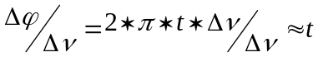This computational sequence is then repeated, and at each repetition of the algorithm the delay gets more accurate, until the change in the delay isn’t more than the value given by the property delayacc. By default this is set 0.005s.
It is important to note that only the first consecutive significant points (via the Raleigh test) are taken into account. Sometimes this algorithm doesn’t work well, mostly this is because the first phase point differs more from the second than 0.4 cycles. In these cases, another algorithm, which doesn’t use an iterative approach, can be used. The delay is derived from the first five significant data points (up until a modulation frequency of 20Hz). For this stimulus this always falls within the first sawtooth. Via the property unwrpalg the user can decide which one to use: ‘iter’ for the iterative algorithm and ‘nl’ for the non-iterative approach.

5.3 Model for a coincidence detector
For recordings from the auditory nerve a reconstruction of the binaural response can be created. From each AN-fiber not only the responses to modulated noise tokens (e.g. AB1, AB2, … AB1000) need to be recorded, but also the responses to one of the original noise tokens (e.g. A or B).
For each modulation frequency, the response to noise token A is compared with the response to the modulated tone. The intervals between spikes is computed. To regenerate a spiketrain, only the last spike from the intervals that fall within a window, the coincidence window, is retained. This coincidence window is 0.050ms by default. This is somewhat reflecting a physiological coincidence detector, which only fires as a second spike arrives within a given time limit from another. Of course these two spikes need to arrive from different input fibers for a real binaural cell, but in our modulation this is not the case.
This is repeated for all permutations of repetitions to both stimuli. The modulated binaural response has therefore N_{rep}*N_{rep} repetitions, where N_{rep} is the original number of repetitions of the stimulus A and ABx.

6.Addendum: Making Madison VAX-format accessible
At the neurophysiology departement of the university of Wisconsin, an archaic data format is used to stored spiketimes. The data stored in this format can be used with this software, but some additional action is required. First of all the datafiles should be moved to \USR\ ”UserName” \MadisonData\. Then the datasets that need to be accessed in MATLAB should be entered in MADISONDATA.XLS.

 |  |  |  |  | Cell Parameters |  |  |  |  | DataSet ID's |  |  | Comments
DataFile | Cell Nr. | Localisation | CF | Thr @ CF | SA | Q10 | BW | NSPL | NITD | OSCR | OSCRCTL | OSCRTD
R95057 | 9 | IC | NaN | NaN | NaN | NaN | NaN | 9-4-1hz | 9-3-nitd,9-19-nitd | 9-4-1hz(SEQ),9-20-1hz(MAN) | 9-11-ab1(SEQ), 9-28-ab1(SEQ) | N/A | oscrctl: 9-28-ab1 kan niet ingeladen worden
R95057 | 10 | IC | NaN | NaN | NaN | NaN | NaN | 10-5-1hz | 10-2-nitd,10-4-nitd | 10-5-1hz(SEQ) | N/A | N/A | N/A

Each line in this spreadsheet uniquely represents a recorded cell (except for the mandatory header). The recording site of this cell should be given for each cell and can be ‘IC’ (Inferior Colliculus) or ‘AN’ (Auditory Nerve). Information acquired from the threshold curve should also be added for each cell (CF is the characteristic frequency, Thr@CF is the threshold in dB at the CF, SA is the spontaneous activity, BW is the bandwidth for that cell). If no threshold curve is present, these fields should be filled in as NaN.
For each cell lists of dataset IDs need to be given, and these lists must be divided according to stimulus type. The different stimulus types that can be entered are NSPL, NITD, OSCR, OSCRCTL and OSCRTD. The last three types are datasets containing responses to a special stimulus, conceived for sluggishness analysis. Datasets with a stimulus type different than these mentioned cannot be loaded and analysed from within MATLAB. Comments for that cell can be given in the last column.

Empty fields should be filled in as N/A.

After editing this spreadsheet it should be saved as the TAB-delimited text file MADISONDATA.TXT. Back in MATLAB, the program maketables, located in the same directory as the datafiles, should be run. This program converts the spreadsheet to MATLAB-accessible format. Now, madison datasets can be used interchangeably with SGSR-datasets via the command dat2ds.
Dat2ds has three mandatory input arguments:

ds = dat2ds(DF, dsID, StimType)

Where DF is the name of the Madison-datafile to be used, dsID stands for the dataset identifier and StimType is the name of the stimulus type for that dataset. StimType can only be one of the previously mentioned types. E.g. to load the dataset ‘10-4’ from the datafile R00001, containing responses to a NITD stimulus, the following command should be entered:

>> ds = dat2ds('R00001', '10-4', 'NITD')
ds =
Dataset R00001 <10-4-NITD>, WISCDATA Seq=49, 2003-Apr-3 12:51:50.823, Leuven\sikio
stimtype NITD, 41/41 x 5 x 1500 ms
varied: Interaural time = [-1500...1500] \mus
Burst = 1000 ms

