

Functional Safety Concept Lane Assistance

**Document Version: [Version]**

**Template Version 1.0, Released on 2017-06-21**



# Document history

|  |  |  |  |
| --- | --- | --- | --- |
| Date | Version | Editor | Description |
| Jan 04 2018 | 1.0 | Tarun Kandala | First draft/submission |
| Jan 6th 2018 | 1.1 | Tarun Kandala | Revised based on feedback |
|  |  |  |  |
|  |  |  |  |
|  |  |  |  |

# Table of Contents

[Document history](#_1t3h5sf)

[Table of Contents](#_ktt3lgighckp)

[Purpose of the Functional Safety Concept](#_fulgh8sf1ocg)

[Inputs to the Functional Safety Analysis](#_757cx6xm46zb)

[Safety goals from the Hazard Analysis and Risk Assessment](#_pi1c1upmo8jt)

[Preliminary Architecture](#_s0p6ihti6jgk)

[Description of architecture elements](#_cqb49updinx4)

[Functional Safety Concept](#_mx8us8onanqo)

[Functional Safety Analysis](#_mtn6qbhgsr36)

[Functional Safety Requirements](#_frlc9y84ede8)

[Refinement of the System Architecture](#_74udkdvf7nod)

[Allocation of Functional Safety Requirements to Architecture Elements](#_g2lqf7kmbspk)

[Warning and Degradation Concept](#_4w6r8buy4lrp)

# Purpose of the Functional Safety Concept

Purpose of the Functional Safety Concept is to identify new requirements and allocate these requirements to system diagrams at a general functionality level.

# Inputs to the Functional Safety Concept

## Safety goals from the Hazard Analysis and Risk Assessment

|  |  |
| --- | --- |
| **ID** | **Safety Goal** |
| Safety\_Goal\_01 | 1. The oscillating steering torque from the lane departure warning function shall be limited |
| Safety\_Goal\_02 | 1. The lane keeping assistance function shall be time limited, and the additional steering torque shall end after a given time interval so that the driver cannot misuse the system for autonomous driving. |

## Preliminary Architecture

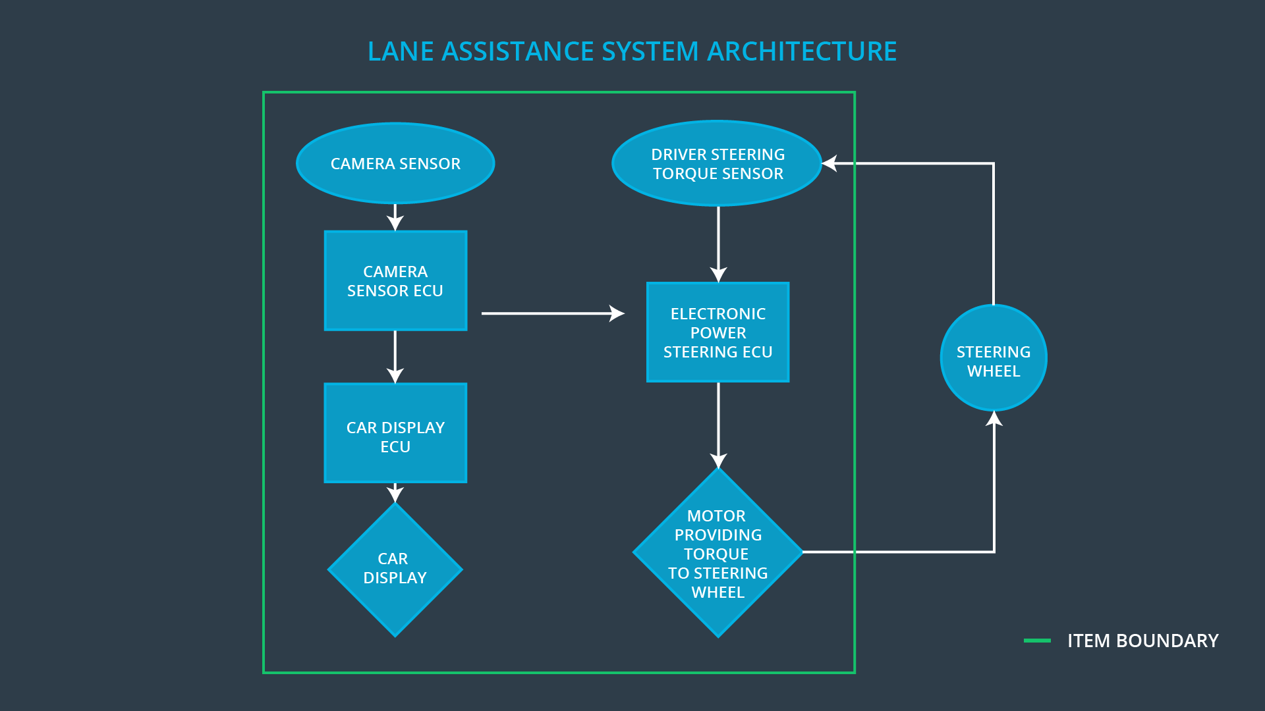

### Description of architecture elements

|  |  |
| --- | --- |
| **Element** | **Description** |
| Camera Sensor | Responsible for detecting lanes |
| Camera Sensor ECU | Responsible for determining when the vehicle leaves the lane by mistake |
| Car Display | Display lane departure warning |
| Car Display ECU | Manage the display warnings |
| Driver Steering Torque Sensor | Sense the torque applied by the driver |
| Electronic Power Steering ECU | Combine the sensor readings from the Driver Steering Torque sensor and Camera Sensor to decide how much resultant torque to apply to steering |
| Motor | Apply the resultant torque to the steering wheel |

# Functional Safety Concept

The functional safety concept consists of:

* Functional safety analysis
* Functional safety requirements
* Functional safety architecture
* Warning and degradation concept

## Functional Safety Analysis

|  |  |  |  |
| --- | --- | --- | --- |
| **Malfunction ID** | **Main Function of the Item Related to Safety Goal Violations** | **Guidewords (NO, WRONG, EARLY, LATE, MORE, LESS)** | **Resulting Malfunction** |
| Malfunction\_01 | Lane Departure Warning (LDW) function shall apply an oscillating steering torque to provide the driver a haptic feedback | MORE | The oscillating amplitude is too high |
| Malfunction\_02 | Lane Departure Warning (LDW) function shall apply an oscillating steering torque to provide the driver a haptic feedback | MORE | The oscillating frequency is too high |
| Malfunction\_03 | Lane Keeping Assistance (LKA) function shall apply the steering torque when active in order to stay in ego lane | NO | The lane keeping assistance function is not limited in time duration which leads to misuse as an autonomous driving function. |

## Functional Safety Requirements

Lane Departure Warning (LDW) Requirements:

|  |  |  |  |  |
| --- | --- | --- | --- | --- |
| **ID** | **Functional Safety Requirement** | **ASIL** | **Fault Tolerant Time Interval** | **Safe State** |
| Functional  Safety  Requirement  01-01 | The lane keeping item shall ensure that the lane departure oscillating torque amplitude is below Max\_Torque\_Amplitude | C | 50ms | LDW Torque Request Amplitude shall be set to zero |
| Functional  Safety  Requirement  01-02 | The lane keeping item shall ensure that the lane departure oscillating torque frequency is below Max\_Torque\_Frequency | C | 50ms | LDW Torque Request Frequency shall be set to zero |

Lane Departure Warning (LDW) Verification and Validation Acceptance Criteria:

|  |  |  |
| --- | --- | --- |
| **ID** | **Validation Acceptance**  **Criteria and Method** | **Verification Acceptance**  **Criteria and Method** |
| Functional  Safety  Requirement  01-01 | test how drivers react to different torque amplitudes to prove that we chose an appropriate value | Perform software test inserting a fault into the system and verify when the torque amplitude crosses the limit, the lane assistance output is set to zero within the 50 ms fault tolerant time interval |
| Functional  Safety  Requirement  01-02 | test how drivers react to different torque frequencies to prove that we chose an appropriate value | Perform software test inserting a fault into the system and verify when the torque Frequency crosses the limit, the lane assistance output is set to zero within the 50 ms fault tolerant time interval |

Lane Keeping Assistance (LKA) Requirements:

|  |  |  |  |  |
| --- | --- | --- | --- | --- |
| **ID** | **Functional Safety Requirement** | **ASIL** | **Fault Tolerant Time Interval** | **Safe State** |
| Functional  Safety  Requirement  02-01 | The electronic power steering ECU shall ensure that the lane keeping assistance torque is applied for only Max\_Duration | B | 500ms | LKA Torque Request shall be set to zero |

Lane Keeping Assistance (LKA) Verification and Validation Acceptance Criteria:

|  |  |  |
| --- | --- | --- |
| **ID** | **Validation Acceptance**  **Criteria and Method** | **Verification Acceptance**  **Criteria and Method** |
| Functional  Safety  Requirement  02-01 | Test and validate that the max\_duration chosen really did dissuade drivers from taking their hands off the wheel | Verify that the system really does turn off if the lane keeping assistance every exceeded max\_duration |

## Refinement of the System Architecture

## ../Architecture_Diagrams/graphic_asset_3.png

## Allocation of Functional Safety Requirements to Architecture Elements

|  |  |  |  |  |
| --- | --- | --- | --- | --- |
| **ID** | **Functional Safety Requirement** | **Electronic Power Steering ECU** | **Camera ECU** | **Car Display ECU** |
| Functional  Safety  Requirement  01-01 | The lane keeping item shall ensure that the lane departure oscillating torque amplitude is below Max\_Torque\_Amplitude | **X** |  |  |
| Functional  Safety  Requirement  01-02 | The lane keeping item shall ensure that the lane departure oscillating torque frequency is below Max\_Torque\_Frequency | **X** |  |  |
| Functional  Safety  Requirement  02-01 | The electronic power steering ECU shall ensure that the lane keeping assistance torque is applied for only Max\_Duration | **X** |  |  |

## Warning and Degradation Concept

|  |  |  |  |  |
| --- | --- | --- | --- | --- |
| **ID** | **Degradation Mode** | **Trigger for Degradation Mode** | **Safe State invoked?** | **Driver Warning** |
| WDC-01 | Turn off Lane Departure warning function | When the oscillating torque amplitude and frequency go beyond limit | Yes | The driver will see a warning light on the dashboard when the system malfunctions |
| WDC-02 | Turn off Lane Keeping assistance function | When the lane keeping assistance goes beyond the set time limit | Yes | The driver will see a warning light on the dashboard when the system malfunctions |