**DVT PROJECTS**

**BY :**

**K.TEJESH**

|  |  |
| --- | --- |
| **Table contents**Creation of multiple charts and tables for representing useful insights/findings. The charts used should be inline with the objective that you wish to convey to the Senior Management. [Mandatory 8 types of charts/tables from any of the following: text table, bar chart(multiple/stacked/side by side), bubble chart, treemap, Pareto chart, scatterplot, Wordcloud, line plot, histogram, boxplot, circle views, heatmap, highlighted tables. No restrictions on the upper limit of the number of charts/tables to be used] . **Please note the charts should represent useful insights** |  |
| Creating a calculated field. The calculated field should add some meaningful value and should be inline with your storyboard which you will create in this project. ** Please make sure that you specify wherever calculated field has been used** . The calculated field should add some meaningful value and should be inline with your storyboard which you will create in this project. ** Please make sure that you specify wherever calculated field has been used** |  |
| Use filters, parameter, actions, etc in the charts so that it helps in understanding the data |  |
| Minimal clutter and consistency in use of colors across charts. Avoid cluttering & make consistency in colors throughout |  |
| Multiple Dashboards creation Create at least 5 Dashboards which deliver some useful insights from business perspective. |  |
| Correct interpretations, insights are expected from each type of chart created. The interpretations should be inline with the storyboard which is to be created in this project. These interpretations can be in the captions of the storyboard or in the plots as well. **Please make sure the insights shared should be from business perspective & should deliver useful information & are quantifiable |  |
| Interactivity among the charts on each Dashboard. Each dashboard should be highly interactive |  |
| 1 Storyboard Creation Storyboard is an important part of the project., make sure it shows a sequence of visualizations that work together to convey information. |  |
| Logical flow to the story represented in the storyboard. Sequence is very important, perhaps it is important to have a logical view (step by step) of the storyboard |  |
| New dashboard which will cover the summary and the recommendations from the insights to be added to the end of the storyboard This dashboard will be an extra dashboard apart from the mandatory 5 dashboards mentioned in the 5th part of the rubric. At least 5 summary/recommendation points should be mentioned in this dashboard(at least 1 recommendation & summary point from each dashboard you have created). 1 conclusion point of the story. This dashboard has to be a part of the storyboard created and not to be submitted separately. Note: This will not be evaluated if submitted as a separate dashboard/storyboard. Please do not add any plots/visualizations to this dashboard. |  |
|  |  |

1. Creation of multiple charts and table for representing useful insights/finginds. The charts used should be inline with the objective that you wish to convey to the Senior managements

The above pic show the car type by average car age and average claim amount by the different types of cars. Using the table scale. Panel truck has highest avg from all than the van in the data shows .

The above pic show the different types of education by total data count in it and colour shows the Education types .here high school has more members like 2383 member and phd are 523 members will be using the in this data.and it’s a bubble chart

The above pic shows the Gender difference by count of data and color use by Gender Female has more distribution than the male. Using the pie graph in the pic shows.

The above pic show the types of cars that claim the sum of amount in the different types of SUV was the highest receiving claim amount than other van was the least amount receiving than other. And the color was by the car types .Graphical user interface, application

The above pic shows the Marital status using the total data more are married in the data .

The above pic shows the occupation in detail using the total data count with the color different in this by using occupation in the color. Blue collar was highest data count members in it .least was doctors the above data shows.

The above pic shows the purpose of car use data broken by the Gender In it. In private female are higher than the male in commercial male are higher than the women. For the car use

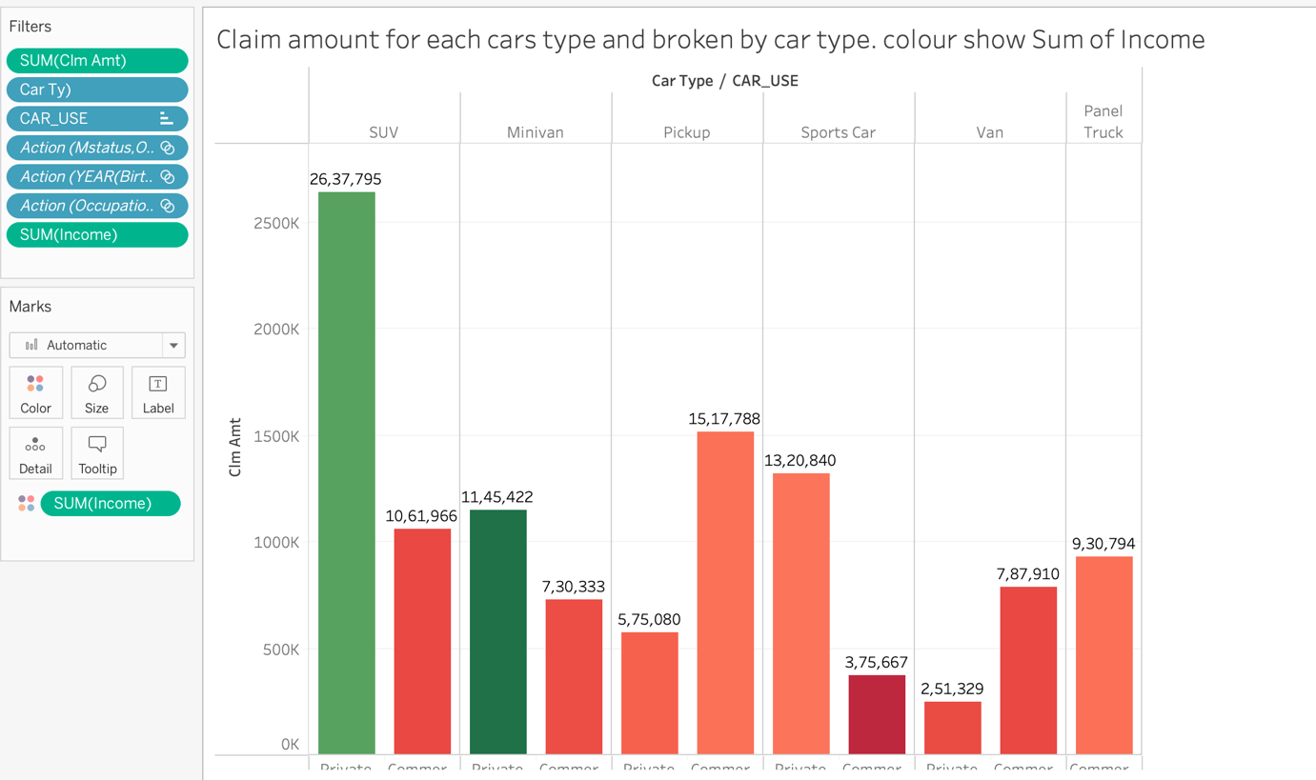

The above pic shows the claim amount for the each cars type and broken by car use of customers. And color by the Sum of income in the above pic. SUV are the highest.

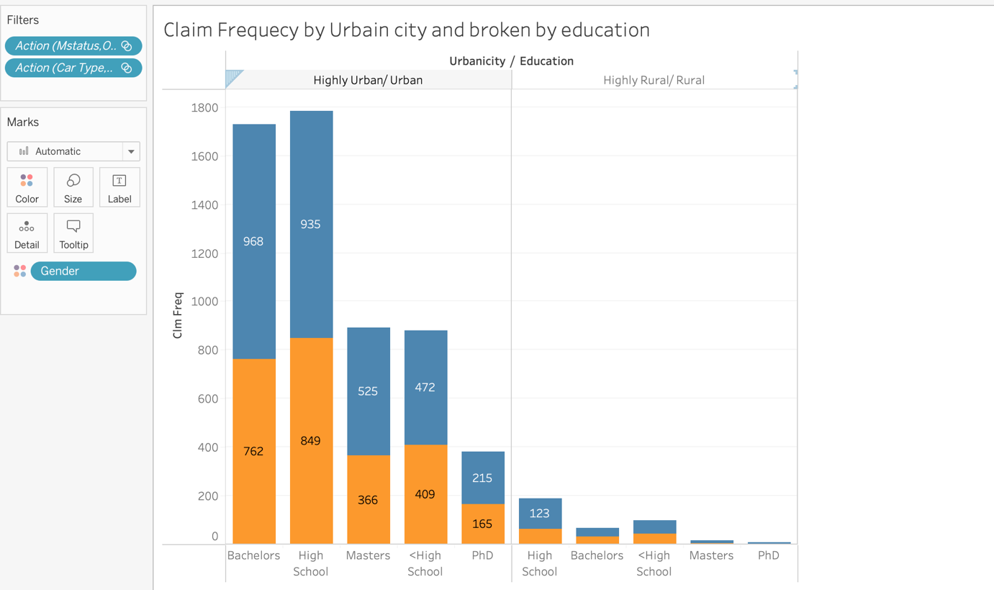

The above pic shows the Claim frequency by urban city and rural are in education high school in urban city are highest than rural and color by gender mainly female customer are more than the male.

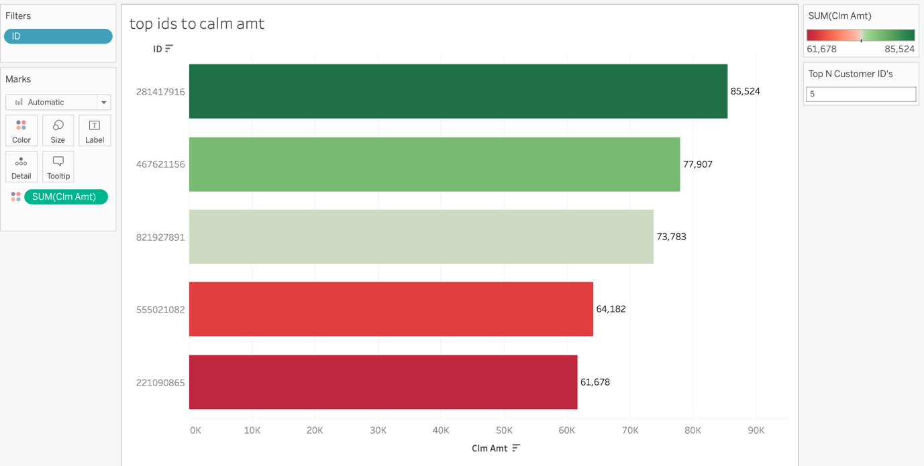

The top ids to claim the amount using the parameters are used and color by the sum of claim amount

The id 281417916 are the top in claim amount in the above parameter used.

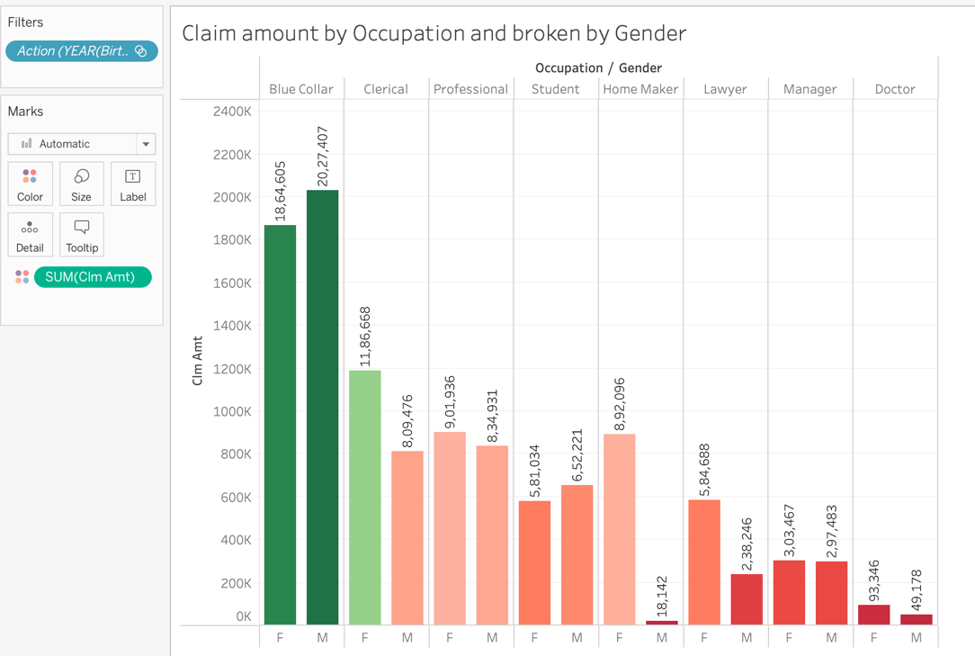

The above pic shows the claim amount by the occupation and broken by the Gender. Blue collar was highest for both male and female than others, professional was third highest than other in the data shows.

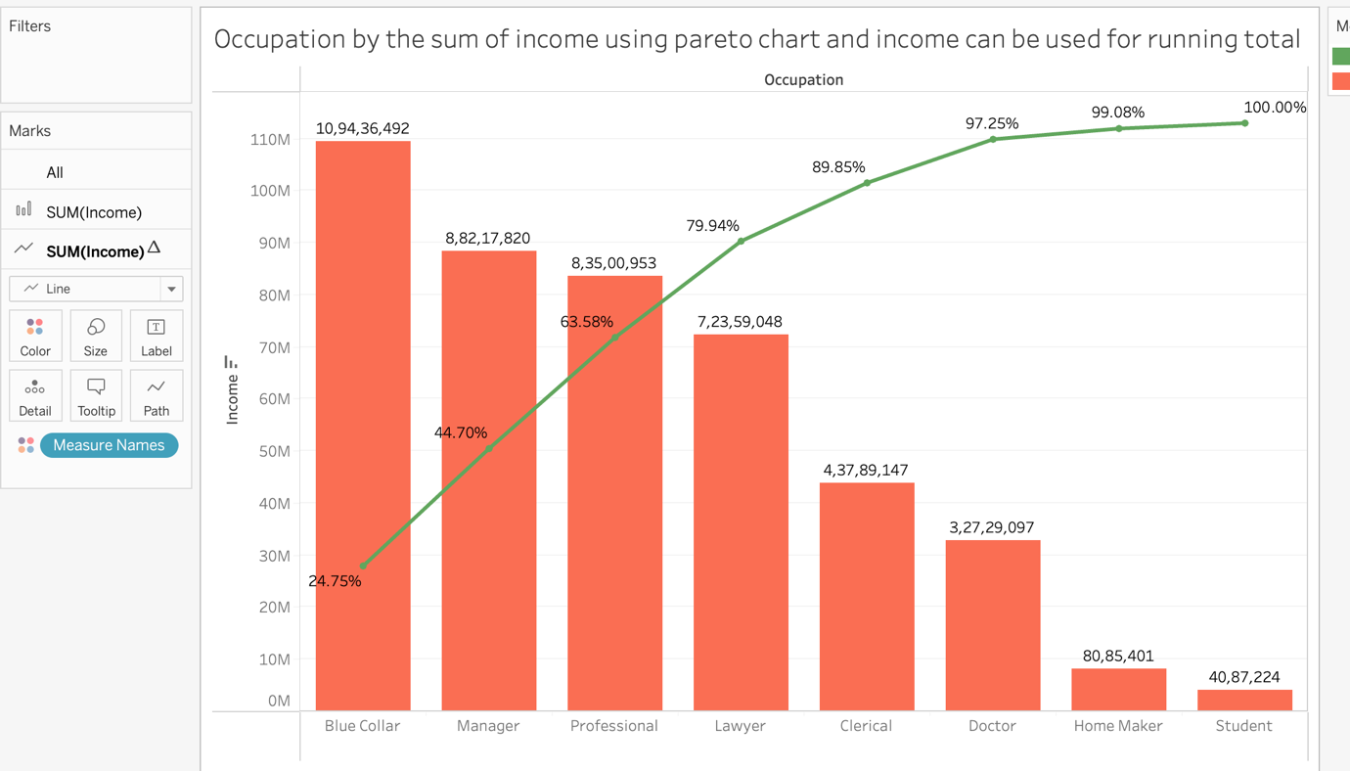

The above pic shows the occupation by the sum of income using the pareto chart and income can be used for running total as measure name in it. Blue collar at 24.75 was the highest income has got here.

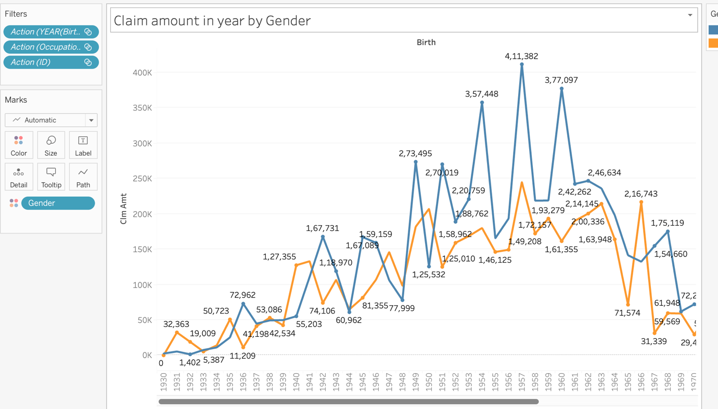

The above pic shows the claim amount in the year by the broke gender male was first member s to claim the amount in 1931.female are 0 to claim amount in 1931.

The above pic shows the Heat map for the occupation and claims amount with different occupation in the data set blue collar got the dark and big box than others.

The above pic shows the Highlight table for education and claim amount freq claim. Highschool was the highest claim to receive the claim amount phd was last to receive the claim amount with less members.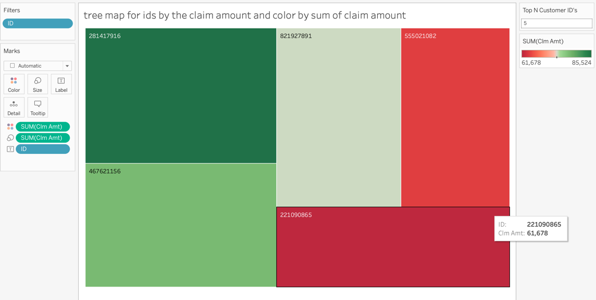

The above pic shows the tree map for id by sum of claim amount and color by sum of claim amount in this pic. By using parameters we can change or add more customers we required for it .

The above pic shows the scatter plot for the claim amount by blue book color by car types. Claim amount was Hight for Minivan as 34M.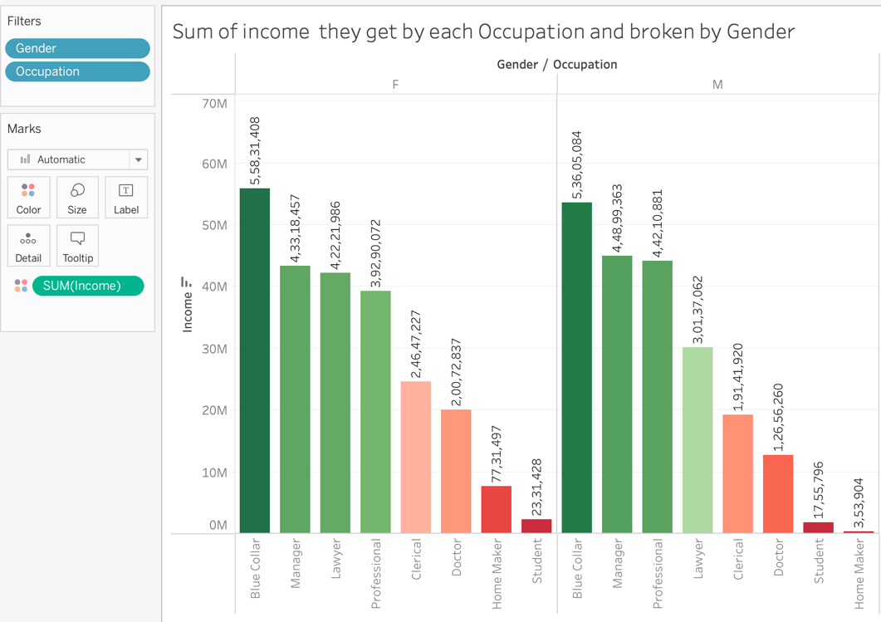

The above pic shows the Sum of income they get by each occupations and broken by Gender blue collar was highest from both male and female of data used.

DASHBOARDS:

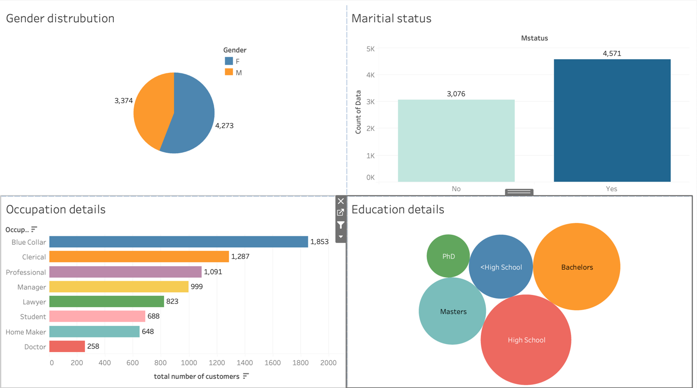

The above pic shows the customer details and used the filters to all the data can be used for particular data sets we need to use the data will get change.

The above pic shoes the preferred car by customer by different types of car using in total customers.

Count of data with preferred cars, car use Gender Parent1 Home kids, kids drive the cars . cars who drive by different types with the color has make in it.

The above pic show the Year claim according to birth yeas in 1931 male are highest to claim the amount female are 0 has claimed the amount. Birth year wise claim old claims and claim amt and the graph shows the old claim and new claim In particular year has increased and particular year decrease and divided by gender male and female. At a particular year from the has got 3350 in the 1931 and female was 0 top id also show with the parameters.

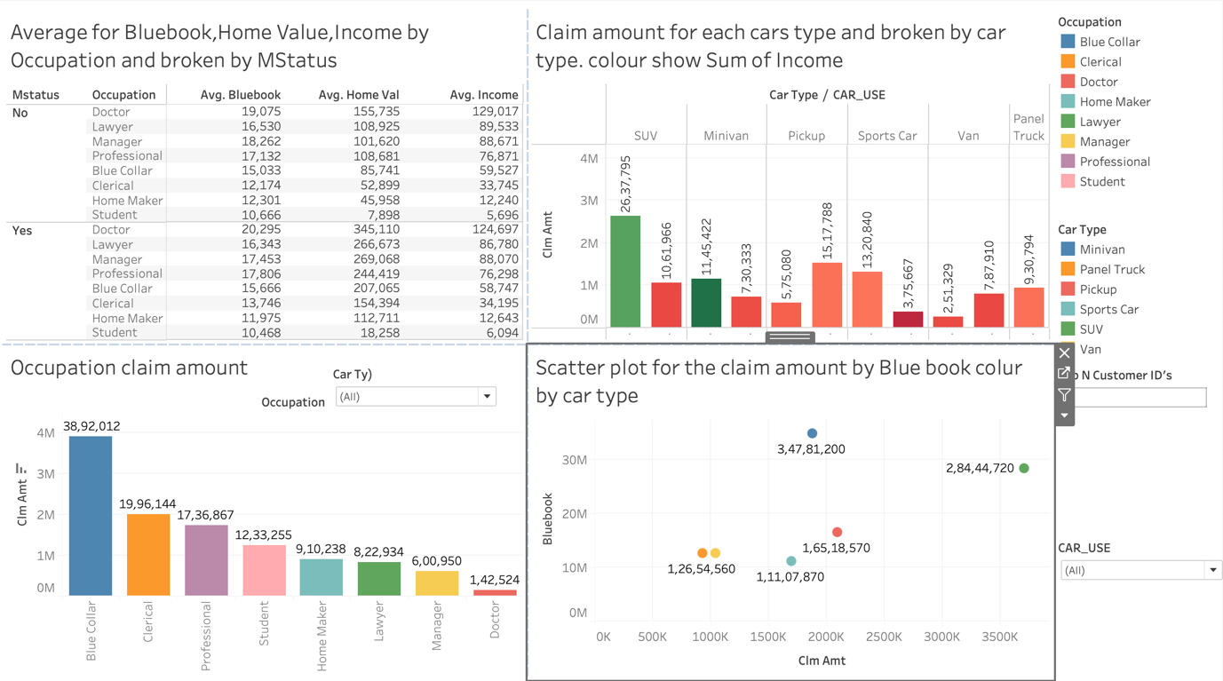

based on the marital status and occupation by Avg(Bluebooks,home amt,income) has given claim amount for each car is broken by the car type and color is shown by income. In the commercial type panel truck is used for this purpose not for the private and some types of cars used for both types

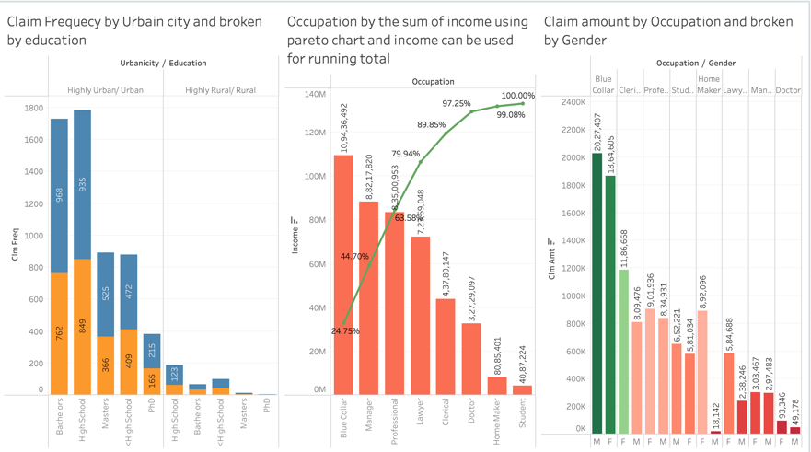

Highly Urban/Urban has more educated than the rular Female are the most educated in all Claim amount by occupation broken by Gender and Blue Collar has highest in all .thyan others.

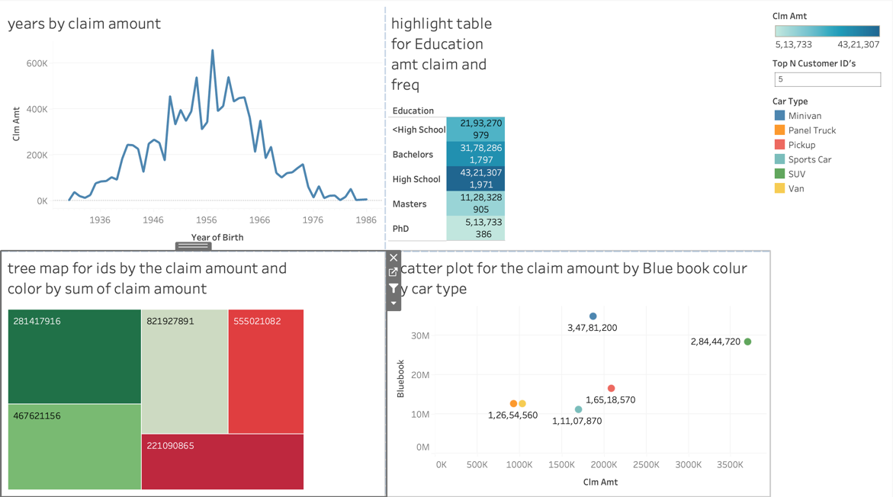

Years by the claim amt education freq amt by using scatter plot using claim amount by colors and car types in it.tree map is used to get the top n data

CONCLUSION:-

In over all data female are most educated and claim more amount in all types. Males are less claim the amount data has given.we need to give the female some rule to stop accidents to get perfect drive in the car to avoid the car accident and other damages on the car

SUMMARY:-

1.females are the most educated members in the data shows than the male members.

2. in customers married are more members.

3. Highest level education is high school followed by degree. The last was PHD.

4. majority of customers use blue collar job and less in doctors jobs

5. SUV car are most preferred cars than panel truck.

6. Cars are mostly private.

Business Recommendations:-

1. Increase the premium as level of education decreases.
2. Increase the premium for expensive cars
3. Repeatedly claims must increase the premium.
4. Insurance premium must be linked to the driving experience.
5. Vehicle inception after 5 must be required to buy premium.
6. Targeting the high school students to buy premium with the offer for the limited period
7. Setting up new ads for the premium with more offers and more advantages for the premium.
8. Devalue the cars every years according to the market to avoid the risk managements.

Link for the DVT project:-

<https://public.tableau.com/app/profile/tejesh.kandikunta/viz/Carinsurancetype/customeruseofcartypeineducation>