Unit testing

1. Using Maven
2. Using Postman
3. Using Eclipse
4. Using Swagger in browser
5. *Using maven to validate the test cases*

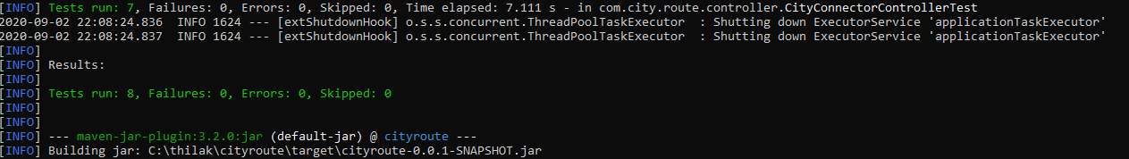

1. *Using Postman:*

http://localhost:8080/connected?origin=Boston&destination=newark

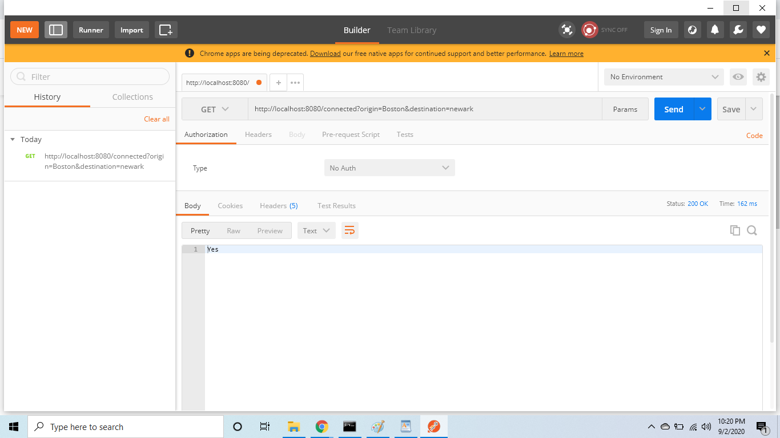

http://localhost:8080/connected?origin=New York&destination=Philadelphia

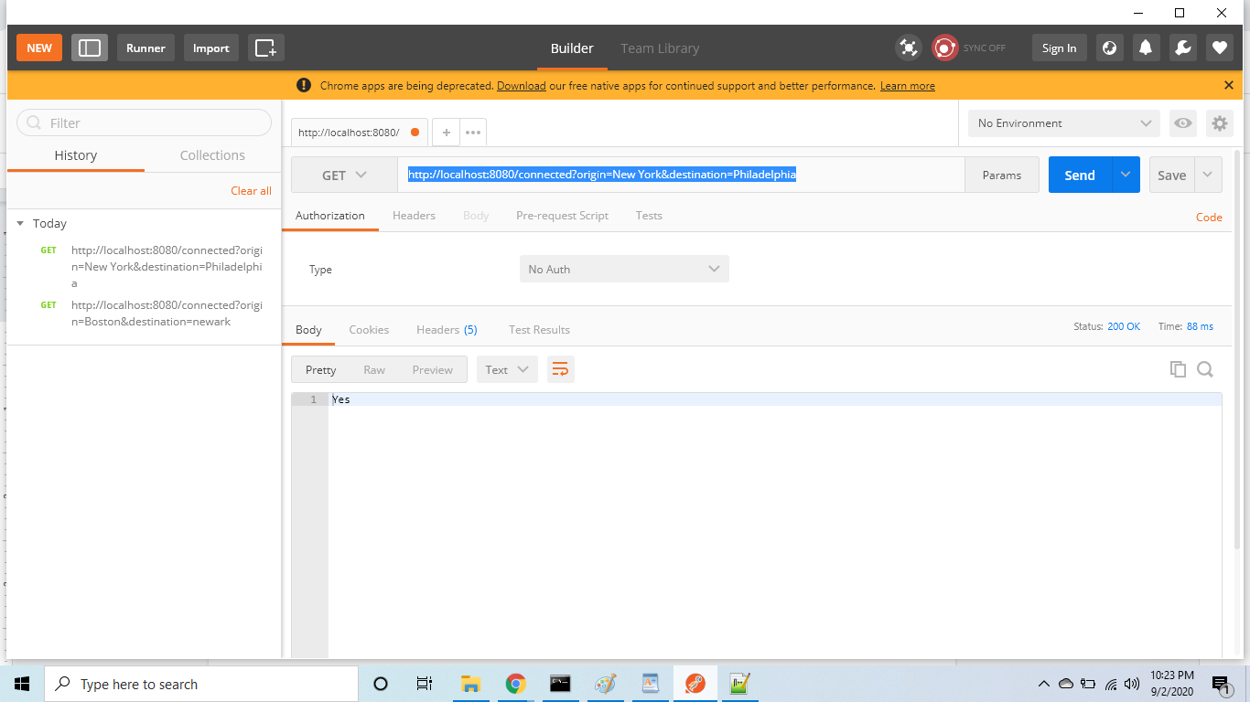

http://localhost:8080/connected?origin=Philadelphia&destination=Boston

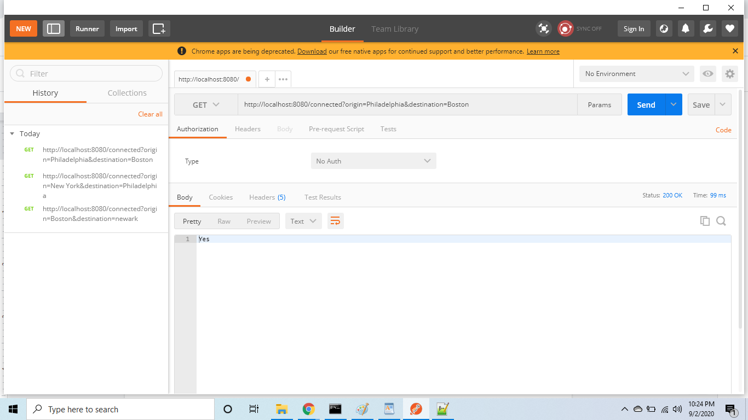

http://localhost:8080/connected?origin=Trenton&destination=Albany

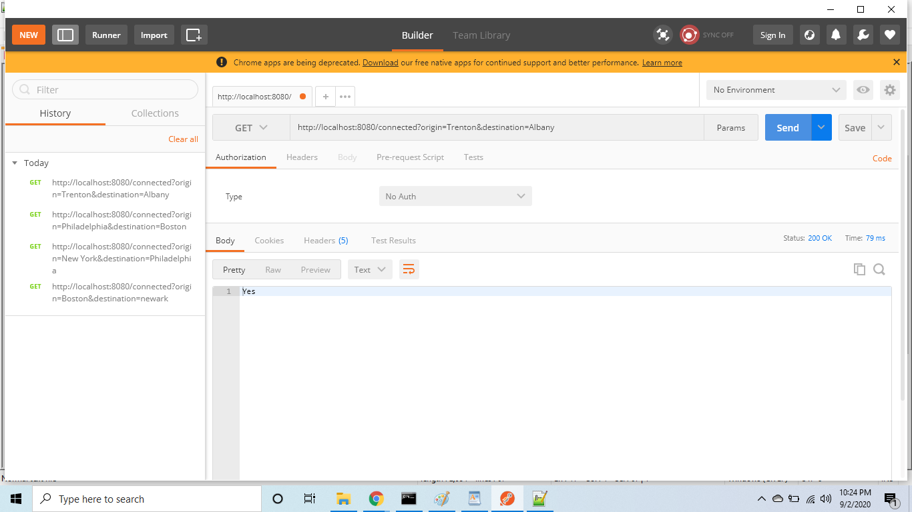

<http://localhost:8080/connected?origin=BOSTON&destination=Albany>

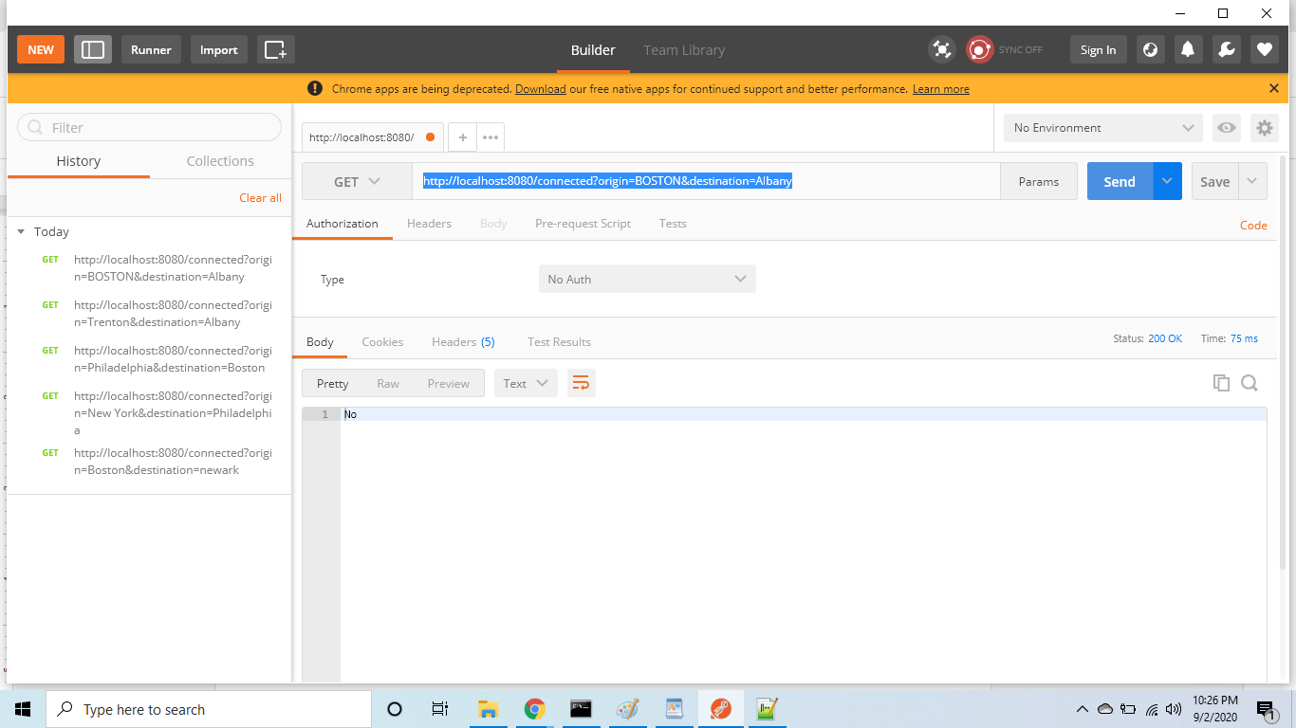

<http://localhost:8080/connected?origin=&destination=Albany>

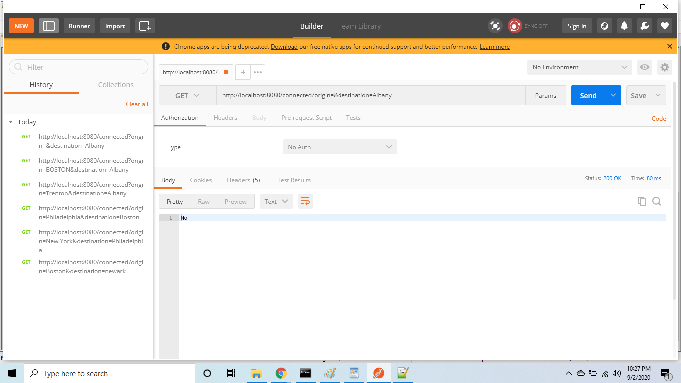

<http://localhost:8080/connected?origin=Boston&destination=>

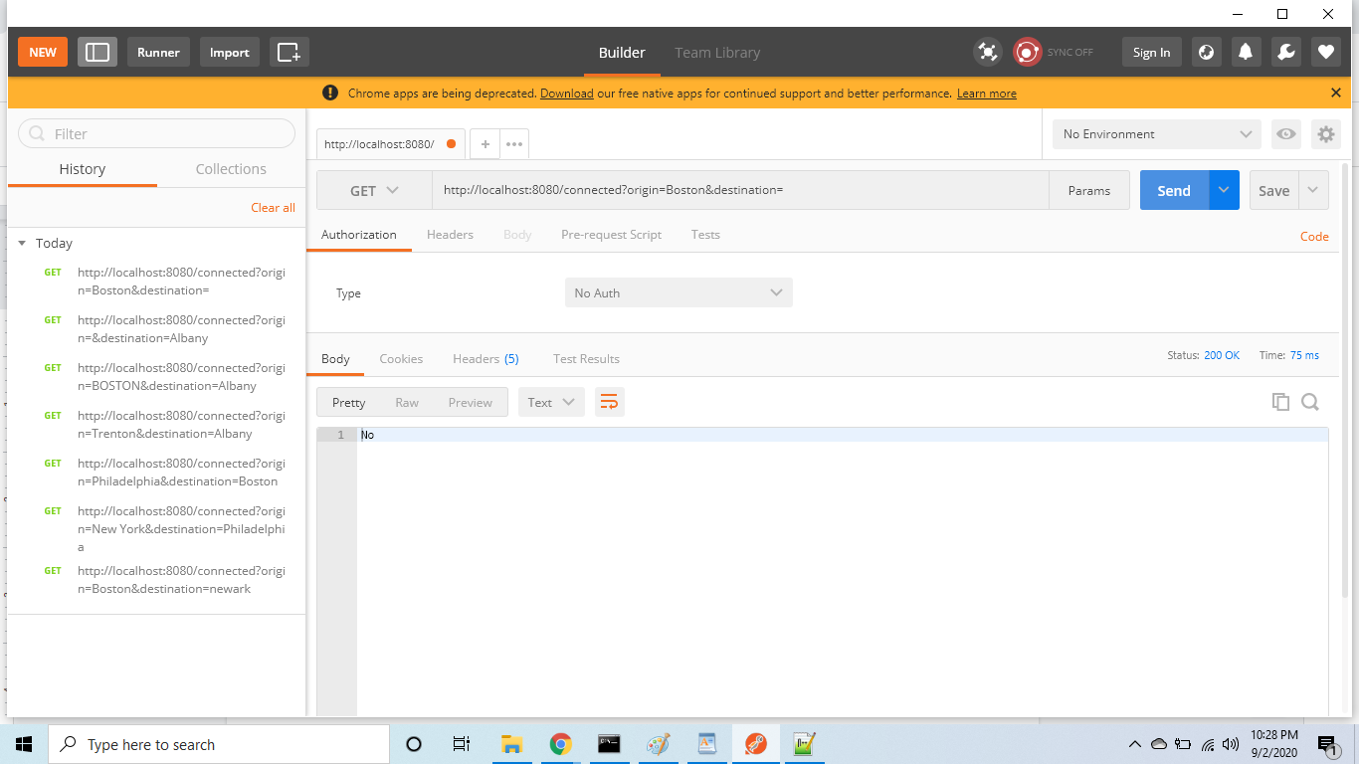

City names in uppercase

<http://localhost:8080/connected?origin=Boston&destination=NEWARK>

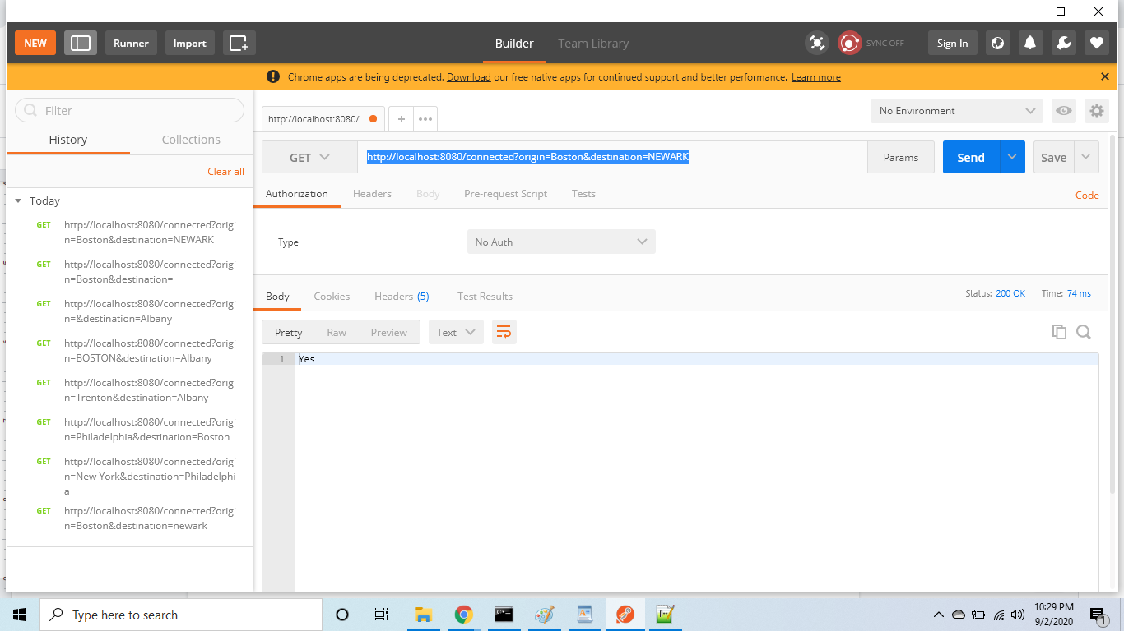

3. Using Eclipse:

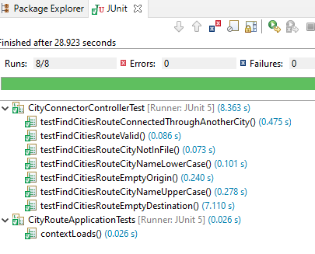

4. Using Swagger

<http://localhost:8080/swagger-ui.html>

