# **Price elasticity of demand with meaning, equation, and its types with the help of diagrams**

## Definition:

Price elasticity of demand is the responsiveness of the quantity of the product demanded when there is a change in its price. This helps in decision making process to understand how the price change affect the demand of product.

## Equation:

Ep = ((change in Demand) ∆D / (change in price) ∆P) * ((original price) P / (original demand) D)

Original demand = 40

New demand = 80

units’ original price = 4

units’ new price = 2

Ep = 40 / -2 * 4 / 40 = -2

In Above price elasticity is -2. So, every change in price there will be change in demand 2 times inversely.

## Types of Price Elasticity of Demand

* Perfectly elastic demand
  + Quantity demanded changes infinitely with any price change. A very small change in price leads to an infinite change in demand. The demand curve is a horizontal line and parallel to the X axis. The numerical co-efficient of perfectly elastic demand is infinity (ED= ∞).
  + 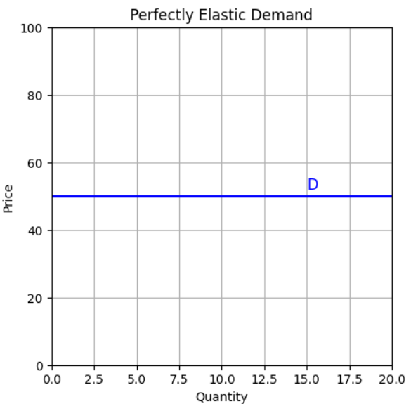Horizontal demand curve.
* Perfectly inelastic demand
  + Quantity demanded does not change regardless of price changes. In case of any change in price, the quantity demanded will be perfectly constant. The demand curve is a vertical straight line and parallel to the Y axis. The quantity demanded would be 10 units, irrespective of price changes from Rs. 10.00 to Rs. 2.00. Hence, the numerical co-efficient of perfectly inelastic demand is zero. (ED = 0).
  + 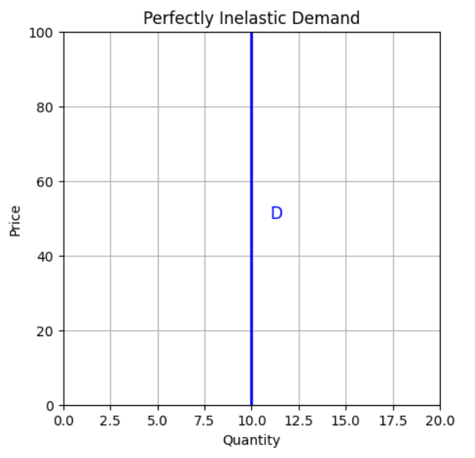Vertical demand curve.
* Relatively elastic demand
  + Quantity demanded changes by a greater percentage than the price change. If there is a small change in price, then it leads to a proportional change in demand. In figure you can see that change in demand is more than that of change in price. Hence, the elasticity is greater than one. For E.g., demand rises by 9 % and price falls by 3%. Hence, the numerical co-efficient of demand is greater than one. (ED > 1)
  + 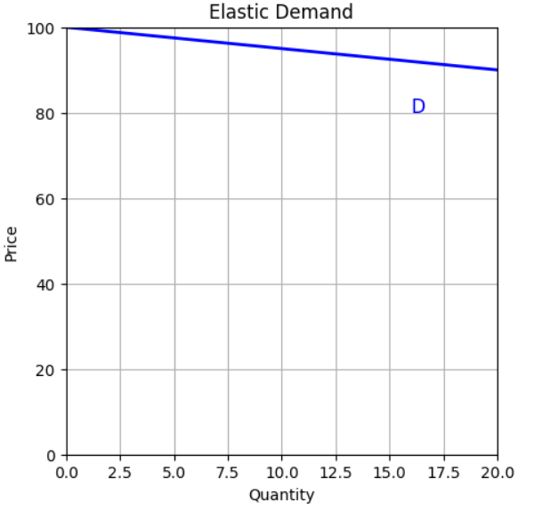Flat downward-sloping demand curve
* Relatively inelastic demand
  + Quantity demanded changes by a smaller percentage than the price change. Here a huge change in price, say 8 % fall price, leads to less than proportional change in demand, say 4 % rise in demand. One can notice here that the change in demand is less than that of change in price. This can be represented by a steeper demand curve. Hence, elasticity is less than one. (0 < ED < 1)
  + 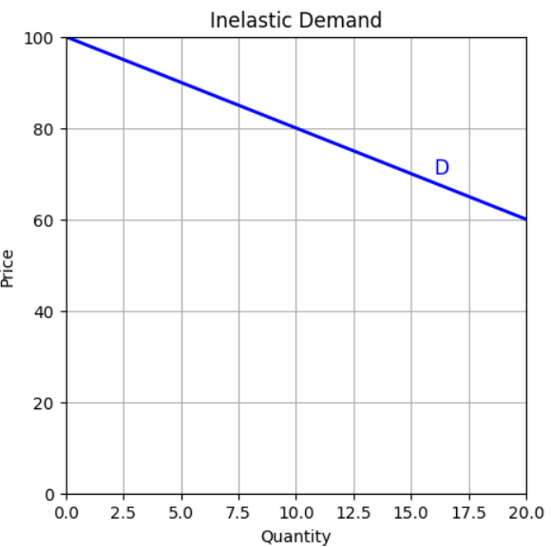Steep downward-sloping demand curve.
* Unitary elastic demand
  + Quantity demanded changes by the same percentage as the price change. Proportionate change in price which leads to an equal proportional change in demand. For E.g., an 8 % fall in price leads to an exactly 8 % increase in demand. Hence, elasticity is equal to unity. It is possible to come across unitary elastic demand, but it is a rare phenomenon. (ED = 1)
  + 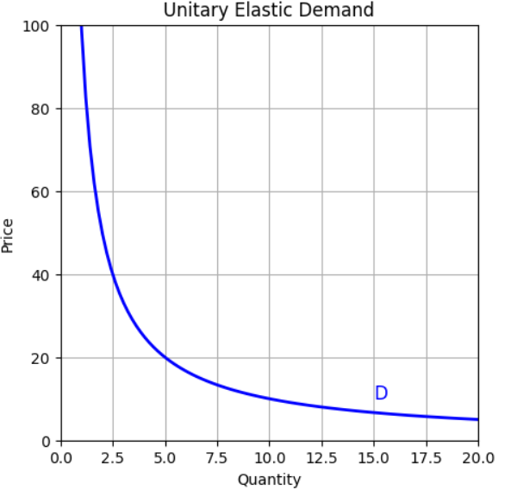Rectangular hyperbola demand curve.

# **Income elasticity of demand with meaning and equation**

## Definition:

Income elasticity of demand defined as the ratio or percentage change in the quantity demanded of a commodity to a given percentage change in the income. In short, it indicates the extent to which demand changes with a variation in consumer’s income.

## Equation:

Ey = % change in demand / % change in income

Ey = ∆D / ∆Y * Y / D

## Example:

Original Demand = 400 units

New Demands = 700 units

Original Income = 4000

New Income = 6000

Ey = 300 / 2000 * 4000/400 = 1.5

Ey is generally positive, because there is a direct relationship between income and demand, i.e. higher the income; higher would be the demand and vice-versa

# **Cross elasticity of demand with meaning and equation**

## Definition:

Cross elasticity is the percentage change in quantity demanded in one commodity because of change in price of another commodity.

## Equation:

Ec = % change in quantity demanded of commodity X / % change in commodity Y

Ec = ∆Dx / ∆Py * Py / Dx

## Example:

Price of tea rises from Rs. 4.00 to 6.00 per cup

Demand for coffee rises from 50 cups to 90 cups.

Ec = 40 / 2 * 4 / 50 = 1.6

# **Advertisement/promotional elasticity of demand with meaning and equation**

## Definition:

Advertising elasticity refers to the responsiveness of demand or sales to change in advertising or other promotional expenses

## Equation:

Ea = Percentage change in demand or sales / Percentage change in Advertisement expenditure

Ea = ∆D / ∆A * A / D

## Example:

Original sales = 10,000 units

Original advertisement expenditure = 800.00

New sales = 50,000 units

New advertisement expenditure = 2000.00

Ea = 40,000 / 1200 * 800 / 10,000 = 2.67