In this module, you will learn the ins and outs of the AWS Solutions Architect exam, where you will have the opportunity to practice with 6 different practice exams. The information in this module relates to the latest SAA-C02 version of the exam blueprint that was released on March 23, 2020, and replaces the previous SAA-C01 exam as of June 30, 2020. In the exam, you will cover a broad set of AWS services, including Amazon FSx, High-Performance Computing, Amazon Aurora, AWS Global Accelerator, AWS Organizations, AWS Resource Access Manager, AWS Database Migration Service, and AWS DataSync. The benefit of putting all of the exam-specific information into one module is providing a centralized, detailed list of the facts you need to know before you take the exam. This will shortcut your study time and maximize your chance of passing the AWS Certified Solutions Architect exam the first time. We hope you get great value from this popular resource that 50,000+ students have well received.

**About this Module**

Learn about the necessary prerequisites for this module.

**We'll cover the following**

* [Who Is This Module For?](https://www.educative.io/module/page/zmG3AWTwgPEZBK6Al/10370001/6546899368148992/5820663037689856#Who-Is-This-Module-For)
* [Module Structure](https://www.educative.io/module/page/zmG3AWTwgPEZBK6Al/10370001/6546899368148992/5820663037689856#Module-Structure)

**Who Is This Module For?**

This module is for those who have basic knowledge of **Access Management(IAM)** and want to master it. The module will offer an overview of different Amazon services, such **as elastic computing, storage, relational database, data migration, and Amazon routing, networking, and workspaces.**

**Module Structure**

This module contains thirteen chapters, and six assessment exams. They are as follows:

1. **Introduction**

This chapter will give us a brief introduction, and explain the exam patterns and domains.

1. **Getting Started**

Learn how to set up an AWS free tier account, its authentication methods, and the activation of MFA on the root account.

1. **Compute**

This chapter teaches us about Amazon web service **“Elastic Compute Cloud Service(EC2)”**. It will highlight different features of this service, such as monitoring, migration, load balancing, etcetera.

1. **Storage**

Learn about Amazon storage objects (S3). Learn what store objects are made of, and find out about their capabilities and use cases.

1. **AWS Database**

Learn about AWS relational databases, their support to database engines, and DB instances. We will also learn about DB migrations and their compatibility with Aurora.

1. **Migration**

Learn about AWS Snowball services, AWS DMS, and AWS DataSync.Test your learning with a quiz at the end of the chapter.

1. **Networking and Content Delivery**

Learn about Amazon VPC, routing, and subnets. The chapter will also cover Amazon CloudFront and Amazon API Gateway features.

1. **Management Tools**

Learn about different management tools like CloudWatch, OpsWorks, CloudFormation, Config, and System Manager. Test your learning with a quiz at the end of the chapter.

1. **Media Services**

This chapter will teach us about Amazon Elastic Transcoder and its supportable media.

1. **Analytics**

This chapter will deal with different services that can boost up business like Amazon EMR, Amazon Anthena, etcetera.

1. **AWS Security, Identity, & Compliance**

This chapter will throw some light on security token service and access management(IAM) for security purposes. This chapter will also teach us about AWS resource groups and AWS resource group managers.

1. **Application Integration**

This chapter will talk about Amazon Simple Notification Service(SNS), Simple Queue Service(SQS), Simple Workflow Service(SWS), their features, and pricing in detail.

1. **AWS Desktop & App Streaming**

This chapter will learn about Amazon workspaces that should be opted for and their compatibility with different OS.

**Practice Exams**

PThe practice exams will test your mastery of AWS services, deployment, AWS cloud, and database AWS services.

**Exam Breakdown - Part 1**

Learn about the exam and its contents.

**We'll cover the following**

* [Test domain 1: Design Resilient Architectures](https://www.educative.io/module/page/zmG3AWTwgPEZBK6Al/10370001/6546899368148992/5827364000366592#Test-domain-1-Design-Resilient-Architectures)
  + [What you need to know](https://www.educative.io/module/page/zmG3AWTwgPEZBK6Al/10370001/6546899368148992/5827364000366592#What-you-need-to-know)
* [Test domain 2: Design High-Performing Architectures](https://www.educative.io/module/page/zmG3AWTwgPEZBK6Al/10370001/6546899368148992/5827364000366592#Test-domain-2-Design-High-Performing-Architectures)
  + [What you need to know](https://www.educative.io/module/page/zmG3AWTwgPEZBK6Al/10370001/6546899368148992/5827364000366592#What-you-need-to-know)

The knowledge required is organized into four test “domains”. Within each test domain, several objectives broadly describe the knowledge and experience required to pass the exam. Here is a breakdown of the four domains:

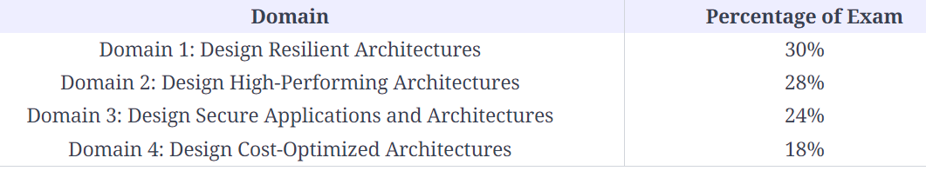

## Test domain 1: Design Resilient Architectures

This domain makes up 30% of the exam and includes the following four objectives:

1. Design a multi-tier architecture solution.
2. Design highly available and/or fault-tolerant architectures.
3. Design decoupling mechanisms using AWS services.
4. Choose appropriate resilient storage.

### What you need to know

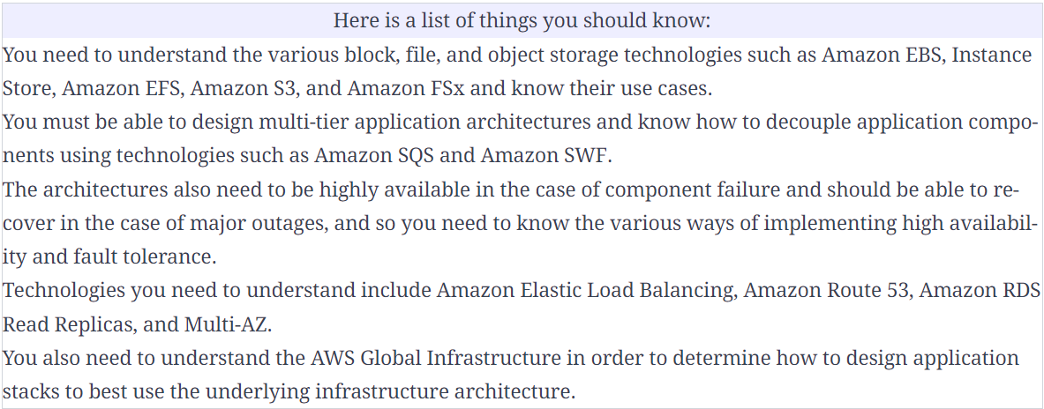

A new Big Data application you are developing will use hundreds of EC2 instances to write data to a shared file system. The file system must be stored redundantly across multiple AZs within a region and must also allow the EC2 instances to access the file system concurrently. The required throughput is multiple GBs per second.

From the options presented, which storage solution can deliver these requirements?

1. Amazon EFS. (Amazon EFS is the best solution as it is the only solution that is a file-level storage solution (not block/object-based), stores data redundantly across multiple AZs within a region, and you can concurrently connect up to thousands of EC2 instances to a single filesystem.)

You are a solutions architect at a media company, and you need to build an application stack that can receive customer comments from sporting events. The application is expected to receive a significant load that could scale to millions of messages within a short space of time following high-profile matches.

As you are unsure of the load required for the database layer, what is the most cost-effective way to ensure that the messages are not dropped?

Ans: Create an SQS queue and modify the application to write to the SQS queue. Launch another application instance that polls the queue and writes messages to the database. (Amazon Simple Queue Service (Amazon SQS) offers a reliable, highly scalable, hosted queue for storing messages in transit between computers and is used for distributed/decoupled applications. This is a great use case for SQS as you don’t have to over-provision the database layer or worry about messages being dropped.)

## Test domain 2: Design High-Performing Architectures

This domain makes up 28% of the exam and includes the following objectives:

1. Identify elastic and scalable compute solutions for a workload.
2. Select high-performing and scalable storage solutions for a workload.
3. Select high-performing networking solutions for a workload.
4. Choose high-performing database solutions for a workload.

### What you need to know[**#**](https://www.educative.io/module/page/zmG3AWTwgPEZBK6Al/10370001/6546899368148992/5827364000366592#What-you-need-to-know)

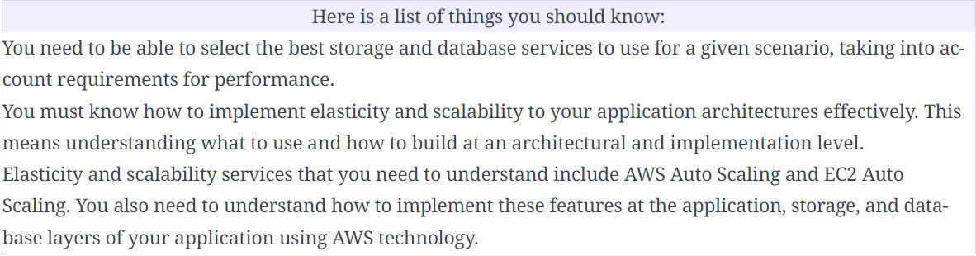

A solutions architect is designing a workload that requires a high-performance object-based storage system that must be shared with multiple Amazon EC2 instances.

Which AWS service delivers these requirements?

Ans. => Amazon S3 (Amazon S3 is an object-based storage system. Though object storage systems aren’t mounted and shared like filesystems or block-based storage systems, they can be shared by multiple instances as they allow concurrent access.)

A developer is creating a solution for a real-time bidding application for a large retail company that allows users to bid on end-of-season clothing items. The application is expected to be extremely popular, and the backend DynamoDB database may not perform as required.

How can the solutions architect enable in-memory read performance with microsecond response times for the DynamoDB database?

Ans: => Configure Amazon DAX.( Amazon DynamoDB Accelerator (DAX) is a fully managed, highly available, in-memory cache for DynamoDB that delivers up to a 10x performance improvement – from milliseconds to microseconds – even at millions of requests per second. You can enable DAX for a DynamoDB database with a few clicks.)