**Getting Started with Ingress**

Learn what is ingress and why it should be used.

**We'll cover the following**

* [Why Use Ingress Objects?](https://www.educative.io/module/lesson/a-practical-guide-to-kubernetes/N732V7qGWo2#Why-Use-Ingress-Objects?)

**Why Use Ingress Objects?**

Applications that are not accessible to users are useless. Kubernetes Services provide accessibility with a usability cost. Each application can be reached through a different port. We **cannot** expect users to know the port of each service in our cluster.

Ingress objects manage external access to the applications running inside a Kubernetes cluster.

While, at first glance, it might seem that we already accomplished that through Kubernetes Services, they do not make the applications truly accessible. We still need forwarding rules based on paths and domains, SSL termination and a number of other features.

In a more traditional setup, we’d probably use an external proxy and a load balancer. Ingress provides an API that allows us to accomplish these things, in addition to a few other features we expect from a dynamic cluster.

**Why Services Are Not the Best Fit for External Access?**

In this lesson, we will discover why services are not the best fit for enabling external access to the applications.

**We'll cover the following**

* [Only services won’t suffice](https://www.educative.io/module/lesson/a-practical-guide-to-kubernetes/qAG2NkOLjPG#Only-services-won%E2%80%99t-suffice)
* [Access through services](https://www.educative.io/module/lesson/a-practical-guide-to-kubernetes/qAG2NkOLjPG#Access-through-services)
* [Understanding the process](https://www.educative.io/module/lesson/a-practical-guide-to-kubernetes/qAG2NkOLjPG#Understanding-the-process)
* [The solution](https://www.educative.io/module/lesson/a-practical-guide-to-kubernetes/qAG2NkOLjPG#The-solution)
* [SSL certificates](https://www.educative.io/module/lesson/a-practical-guide-to-kubernetes/qAG2NkOLjPG#SSL-certificates)
* [Try it yourself](https://www.educative.io/module/lesson/a-practical-guide-to-kubernetes/qAG2NkOLjPG#Try-it-yourself)
* [Troubleshooting with minikube](https://www.educative.io/module/lesson/a-practical-guide-to-kubernetes/qAG2NkOLjPG#Troubleshooting-with-minikube)

**Only services won’t suffice**

We cannot explore solutions before we know what the problems are. Therefore, we’ll re-create a few objects using the knowledge we already gained. That will let us see whether Kubernetes Services satisfy all the needs users of our applications might have. Or, to be more explicit, we’ll explore which features we’re missing when making our applications accessible to users.

We already discussed that it is a bad practice to publish fixed ports through Services. That method is likely to result in conflicts or, at the very least, create the additional burden of carefully keeping track of which port belongs to which Service. We already discarded that option before, and we won’t change our minds now.

kubectl create -f go-demo-2-deploy.yml

kubectl get -f go-demo-2-deploy.yml

The **output** of the get command is as follows.

NAME READY UP-TO-DATE AVAILABLE AGE

deployment.apps/go-demo-2-db 0/1 1 0 2m15s

NAME TYPE CLUSTER-IP EXTERNAL-IP PORT(S) AGE

service/go-demo-2-db ClusterIP 10.111.211.179 <none> 27017/TCP 2m15s

NAME READY UP-TO-DATE AVAILABLE AGE

deployment.apps/go-demo-2-api 0/3 3 0 2m15s

NAME TYPE CLUSTER-IP EXTERNAL-IP PORT(S) AGE

service/go-demo-2-api NodePort 10.103.180.226 <none> 8080:30753/TCP 2m15s

As you can see, these are the same Services and Deployments we previously created.

Before we move on, we should wait until all the Pods are up and running.

kubectl get pods

The **output** is as follows.

NAME READY STATUS RESTARTS AGE

go-demo-2-api-68df567fb5-8qcmv 1/1 Running 0 3m

go-demo-2-api-68df567fb5-k55d4 1/1 Running 0 3m

go-demo-2-api-68df567fb5-ws9cj 1/1 Running 0 3m

go-demo-2-db-dd48b7dfc-hdxbz 1/1 Running 0 3m

If, in your case, some of the Pods are not yet running, please wait a few moments and re-execute the kubectl get pods command. We’ll continue once they’re ready.

## Access through services

One obvious way to access the applications is through Services. Since the service go-demo-2-api in go-demo-2-deploy.yml is listening on port 8080 while the platform is listening on port 3000 thus we are binding the port while calling the service. We used that information to send a request.

kubectl port-forward service/go-demo-2-api 3000:8080 --address 0.0.0.0

#Now open a new terminal and run the following command

curl -i "0.0.0.0:3000/demo/hello"

#close the new terminal after running and observing the output of curl

The **output** of the curl command is as follows.

HTTP/1.1 200 OK

Date: Sun, 24 Dec 2017 13:35:26 GMT

Content-Length: 14

Content-Type: text/plain; charset=utf-8

hello, world!

The application responded with the status code "200" thus confirming that the Service indeed forwards the requests.

While publishing a random, or even a hard-coded port of a single application might not be so bad, if we’d apply the same principle to more applications, the user experience would be horrible. To make the point a bit clearer, we’ll deploy another application.

kubectl create -f devops-toolkit-dep.yml --record --save-config

kubectl get -f devops-toolkit-dep.yml

This application follows similar logic to the first. From the latter command, we can see that it contains a Deployment and a Service. The details are of no importance since the YAML definition is very similar to those we used before. What matters is that now we have two applications running inside the cluster.

## Understanding the process

Let’s check whether the new application is indeed reachable.

kubectl port-forward service/devops-toolkit 3000:80 --address 0.0.0.0

#Now open a new terminal and run the following command

curl -i "0.0.0.0:3000"

#close the new terminal after running and observing the output of curl

We retrieved the port of the new Service and opened the application in a browser. If you get a page not found error, you might want to wait a bit longer until the containers are pulled, and try again

A simplified flow of requests is depicted in the below-given illustration.

A user sends a request to one of the nodes of the cluster. That request is received by a Service and load balanced to one of the associated Pods. It’s a bit more complicated than that, with iptables, kube DNS, kube proxy, and a few other things involved in the process. We explored them in more detail in the Using Services To Enable Communication Between Pods chapter, and there’s probably no need to go through them all again. For the sake of brevity, the simplified diagram should do.

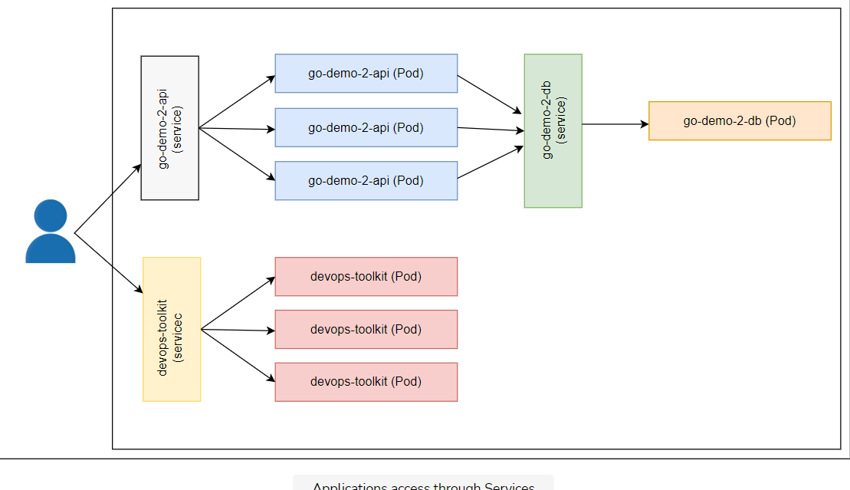

We cannot expect our users to know specific ports behind each of those applications. Even with only two, that would not be very user-friendly. If that number would rise to tens or even hundreds of applications, our business would be very short-lived.

What we need is a way to make all services accessible through standard HTTP (80) or HTTPS (443) ports. Kubernetes Services alone cannot get us there. We need more.

## The solution

What we need is to grant access to our services on predefined paths and domains. Our go-demo-2 service could be distinguished from others through the base path /demo. Similarly, the books application could be reachable through the devopstoolkitseries.com domain. If we could accomplish that, we could access them with the commands as follows.

curl -i "0.0.0.0:80/demo/hello"

The request received the “default backend - 404” response. There is no process listening on port 80, so this outcome is not a surprise. We could have changed one of the Services to publish the fixed port 80 instead assigning a random one. Still, that would provide access only to one of the two applications.

We often want to associate each application with a different domain or sub-domain. Outside the examples we’re running, the books application is accessible through the [devopstoolkitseries.com](http://www.devopstoolkitseries.com/) domain. Since access to the domain is not feasible, we’ll simulate it by adding the domain to the Host header.

The command that should verify whether the application running inside our cluster is accessible through the devopstoolkitseries.com domain is as follows.

curl -i \

-H "Host: devopstoolkitseries.com" \

<http://0.0.0.0:80>

As expected, the request is still refused.

## SSL certificates

Last, but not the least, we should be able to make some, if not all, applications (partly) secure by enabling HTTPS access. That means that we should have a place to store our SSL certificates. We could put them inside our applications, but that would only increase the operational complexity. Instead, we should aim towards SSL offloading somewhere between clients and the applications, and it should come as no surprise that Kubernetes has a solution for all these.

## Try it yourself

A list of all the commands used in the lesson is given below.

kubectl create -f go-demo-2-deploy.yml

kubectl get -f go-demo-2-deploy.yml

kubectl get pods

kubectl port-forward service/go-demo-2-api 3000:8080 --address 0.0.0.0

#Now open a new terminal and run the following command

curl -i "0.0.0.0:3000/demo/hello"

#close the new terminal after running and observing the output of curl

kubectl create -f devops-toolkit-dep.yml --record --save-config

kubectl get -f devops-toolkit-dep.yml

kubectl port-forward service/devops-toolkit 3000:80 --address 0.0.0.0

#Now open a new terminal and run the following commands

curl -i "0.0.0.0:3000"

curl -i "0.0.0.0:80/demo/hello"

curl -i \

-H "Host: devopstoolkitseries.com" \

<http://0.0.0.0:80>

## Troubleshooting with minikube

For deploying the services and running API on a local machine using minikube, use the following code. Here IP will retrieve the IP of the minikube virtual machine while PORT will get the nodePort from the YAML file. The curl command will send an HTTP request to the service.

IP=$(minikube ip)

PORT=$(kubectl get svc go-demo-2-api \

-o jsonpath="{.spec.ports[0].nodePort}")

curl -i "http://$IP:$PORT/demo/hello"

**Enabling Ingress Controllers**

Learn how to enable the Ingress controller and play around with it.

**We'll cover the following**

* [Why ingress controllers are required?](https://www.educative.io/module/lesson/a-practical-guide-to-kubernetes/YMm9noR2nVM#Why-ingress-controllers-are-required?)
* [Enabling ingress on k3d](https://www.educative.io/module/lesson/a-practical-guide-to-kubernetes/YMm9noR2nVM#Enabling-ingress-on-k3d)
* [Playing Around with the Controller](https://www.educative.io/module/lesson/a-practical-guide-to-kubernetes/YMm9noR2nVM#Playing-Around-with-the-Controller)
* [Try it yourself](https://www.educative.io/module/lesson/a-practical-guide-to-kubernetes/YMm9noR2nVM#Try-it-yourself)

**Why ingress controllers are required?**

We need a mechanism that will accept requests on pre-defined ports (e.g., 80 and 443) and forward them to Kubernetes Services. It should be able to distinguish requests based on paths and domains as well as to be able to perform SSL offloading.

Kubernetes itself does not have a ready-to-go solution for this. Unlike other types of Controllers that are typically part of the kube-controller-manager binary, Ingress Controller needs to be installed separately. Instead of a Controller, kube-controller-manager offers *Ingress resource* that other third-party solutions can utilize to provide requests forwarding and SSL features. In other words, Kubernetes only provides an *API*, and we need to set up a Controller that will use it.

Fortunately, the community already built a myriad of Ingress Controllers. We won’t evaluate all of the available options since that would require a lot of space, and it would mostly depend on your needs and your hosting vendor.

**Enabling ingress on k3d**

Enable Ingress on k3d using the following command.

kubectl apply -f <https://raw.githubusercontent.com/kubernetes/ingress-nginx/controller-v1.3.0/deploy/static/provider/cloud/deploy.yaml>

The **output** is as follows.

namespace/ingress-nginx created

serviceaccount/ingress-nginx created

serviceaccount/ingress-nginx-admission created

role.rbac.authorization.k8s.io/ingress-nginx created

role.rbac.authorization.k8s.io/ingress-nginx-admission created

clusterrole.rbac.authorization.k8s.io/ingress-nginx created

clusterrole.rbac.authorization.k8s.io/ingress-nginx-admission created

rolebinding.rbac.authorization.k8s.io/ingress-nginx created

rolebinding.rbac.authorization.k8s.io/ingress-nginx-admission created

clusterrolebinding.rbac.authorization.k8s.io/ingress-nginx created

clusterrolebinding.rbac.authorization.k8s.io/ingress-nginx-admission created

configmap/ingress-nginx-controller created

service/ingress-nginx-controller created

service/ingress-nginx-controller-admission created

deployment.apps/ingress-nginx-controller created

job.batch/ingress-nginx-admission-create created

job.batch/ingress-nginx-admission-patch created

ingressclass.networking.k8s.io/nginx created

validatingwebhookconfiguration.admissionregistration.k8s.io/ingress-nginx-admission created

Wait for the ingress controller to run using the following command.

kubectl get pods --namespace=ingress-nginx

ℹ️ In the rest of the lessons of this chapter the code playgrounds are preconfigured with the Ingress controller. However, it is suggested to please verify if the Ingress controller is running before using the service.

## Playing Around with the Controller

Now that the Ingress addon is enabled, we’ll check whether it is running inside our cluster.

kubectl get pods -n ingress-nginx \

| grep ingress

Ignore the -n argument. We did not yet explore Namespaces. For now, please note that the output of the command should show that “nginx-ingress-controller-…” Pod is running.

If the output is empty, you might need to wait for a few moments until the containers are pulled, and re-execute the kubectl get all --namespace ingress-nginx command again.

ℹ️ The ingress image is based on [NGINX Ingress Controller](https://github.com/kubernetes/ingress-nginx/blob/master/README.md). It is one of the only two currently supported and maintained by the Kubernetes community. The other one is [GLBC](https://github.com/kubernetes/ingress-gce/blob/master/README.md) that comes with [Google Compute Engine (GCE)](https://cloud.google.com/compute/) Kubernetes hosted solution.

By default, the Ingress Controller is configured with only two endpoints.

If we’d like to check Controller’s health, we can send a request to /healthz.

nohup kubectl port-forward -n ingress-nginx service/ingress-nginx-controller 3000:80 --address 0.0.0.0 > /dev/null 2>&1 &

# Please wait for a few seconds before running the next command

curl -i "0.0.0.0:3000/healthz"

The **output** is as follows

HTTP/1.1 200 OK

Server: nginx/1.15.9

Date: Mon, 10 Jun 2019 12:02:11 GMT

Content-Type: text/html

Content-Length: 0

Connection: keep-alive

It responded with the status code “200 OK”, thus indicating that it is healthy and ready to serve requests. There’s not much more to it so we’ll move to the second endpoint.

The Ingress Controller has a default catch-all endpoint that is used when a request does not match any of the other criteria. Since we did not yet create any Ingress Resource, this endpoint should provide the same response to all requests except /healthz.

curl -i "0.0.0.0:3000/something"

The **output** is as follows.

HTTP/1.1 404 Not Found

Server: nginx/1.13.5

Date: Sun, 24 Dec 2017 15:36:23 GMT

Content-Type: text/plain; charset=utf-8

Content-Length: 21

Connection: keep-alive

default backend – 404

We got the response indicating that the requested resource could not be found.

## Try it yourself

A list of all the commands used in the lesson is given below.

kubectl apply -f https://raw.githubusercontent.com/kubernetes/ingress-nginx/controller-v1.3.0/deploy/static/provider/cloud/deploy.yaml

kubectl get pods --namespace=ingress-nginx

kubectl get pods -n ingress-nginx \

| grep ingress

nohup kubectl port-forward -n ingress-nginx service/ingress-nginx-controller 3000:80 --address 0.0.0.0 > /dev/null 2>&1 &

# Please wait for a few seconds before running the next commands

curl -i "0.0.0.0:3000/healthz"

curl -i "0.0.0.0:3000/something"