**What is Python?**

In this introductory section, we'll understand what Python is and how we can set it up.

**We'll cover the following**

* + [The nature of the language](https://www.educative.io/module/lesson/python-fundamentals-for-programmers/Y5wJrN9Pn2K#The-nature-of-the-language)
    - [A High-Level Language](https://www.educative.io/module/lesson/python-fundamentals-for-programmers/Y5wJrN9Pn2K#A-High-Level-Language-)
    - [Readability](https://www.educative.io/module/lesson/python-fundamentals-for-programmers/Y5wJrN9Pn2K#Readability-)
  + [Applications](https://www.educative.io/module/lesson/python-fundamentals-for-programmers/Y5wJrN9Pn2K#Applications-)
  + [Version History](https://www.educative.io/module/lesson/python-fundamentals-for-programmers/Y5wJrN9Pn2K#Version-History)

Welcome to this module! We’re glad to have you with us on this journey through the realm of **Python**.

Since we’ll be starting from scratch, there’s no need to worry if you have no prior experience with Python or coding in general.

So, without further ado, let’s get started by learning what Python is.

**The nature of the language**[#](https://www.educative.io/module/lesson/python-fundamentals-for-programmers/Y5wJrN9Pn2K#The-nature-of-the-language)

Developed in 1990, Python is one of the most popular *general-purpose* programming languages in modern times.

The term “general-purpose” simply means that Python can be used for a variety of applications and does not focus on any one aspect of programming.

**A High-Level Language**[#](https://www.educative.io/module/lesson/python-fundamentals-for-programmers/Y5wJrN9Pn2K#A-High-Level-Language-)

Python falls under the category of **high-level, interpreted** languages. A high-level language is one which cannot be understood directly by our machine. There is a certain degree of *abstraction* in its syntax. Machines are generally designed to read **machine code**, but high-level syntax cannot be directly converted to machine code.

As a result, it must first be converted to **bytecode** which is then converted to machine code before the program can be executed.

Python is an interpreted language because, during execution, each line is interpreted to the machine language on-the-go.

However, if we take the example of C++, the code needs to be compiled into an executable first, and then it can be executed. In Python, we can skip this compilation step (Python does it for us behind the scenes) and directly run the code.

**Readability**[#](https://www.educative.io/module/lesson/python-fundamentals-for-programmers/Y5wJrN9Pn2K#Readability-)

One of the biggest reasons for Python’s rapid growth is the simplicity of its syntax. The language reads almost like plain English, making it easy to write complex programs.

Since it doesn’t have much of a learning curve, Python is a very good entry point into the world of programming for beginners.

**Applications**[#](https://www.educative.io/module/lesson/python-fundamentals-for-programmers/Y5wJrN9Pn2K#Applications-)

Apart from the ease of learning, Python is a very efficient language which is used in almost every sphere of modern computing.

This makes a strong case for learning Python, even for non-programmers.

Some of Python’s main applications are highlighted below:

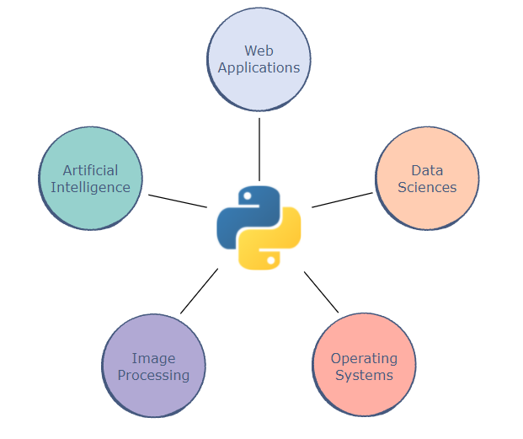

**Version History**[#](https://www.educative.io/module/lesson/python-fundamentals-for-programmers/Y5wJrN9Pn2K#Version-History)

Python has had several major updates in the past. **Python 2.7** was widely used for a very long time, even after the release of newer versions.

However, Python 2.7 has been deprecated as of January 01 2020, and replaced completely by 3.xx versions, known as **Python 3**. The differences between Python 2.7 and Python 3 are minute, but important nonetheless.

To keep up with the latest technologies, we’ll be dealing with Python 3 for the entirety of this module.

Throughout this module, we will be able to write and execute Python code right here 🎉.

**Writing Our First Code**

In this lesson, we'll examine one of the simplest codes in Python syntax.

**We'll cover the following**

* + [The print Statement](https://www.educative.io/module/lesson/python-fundamentals-for-programmers/R8myL3DYY9R#The-print-Statement-)
    - [Printing Multiple Pieces of Data](https://www.educative.io/module/lesson/python-fundamentals-for-programmers/R8myL3DYY9R#Printing-Multiple-Pieces-of-Data-)
  + [Comments](https://www.educative.io/module/lesson/python-fundamentals-for-programmers/R8myL3DYY9R#Comments-)

By now, we’ve learned what kind of language Python is. We are finally ready to start writing code! So, let’s move on to the fun stuff.

**The print Statement**[#](https://www.educative.io/module/lesson/python-fundamentals-for-programmers/R8myL3DYY9R#The-print-Statement-)

Whenever we learn a new language, it is an age-old tradition to start by displaying the text “**Hello World**” on the screen. For the remainder of this course, the terminal will act as our screen.

Every language has a different syntax for displaying or *printing* something on the screen.

Since Python is one of the most readable languages out there, we can print data on the terminal by simply using the print statement.

Here’s what the statement looks like:

print (data)

Whatever we need to print is encapsulated in the parentheses following the print keyword. Let’s try printing “Hello World” on the terminal:

print(50)

print(1000)

print(3.142)

1

2

print("Hello World")

The text Hello World is bounded by quotation marks because it is a *string* or a group of characters, more on this later.

Next, we’ll print a few numbers. Each call to print moves the output to a new line:

print(50)

print(1000)

print(3.142)

**Printing Multiple Pieces of Data**[#](https://www.educative.io/module/lesson/python-fundamentals-for-programmers/R8myL3DYY9R#Printing-Multiple-Pieces-of-Data-)

We can even print multiple things in a single print command; we just have to separate them using **commas**.

By default, each print statement prints text in a new line. If we want multiple print statements to print in the same line, we can use the following code:

print("Hello", end="")

print("World")

print("Hello",·end="·")

print("World")

Output

2.55s

HelloWorld

Hello World

The value of end is appended to the output and the next print will continue from here.

**Comments**[#](https://www.educative.io/module/lesson/python-fundamentals-for-programmers/R8myL3DYY9R#Comments-)

**Comments** are pieces of text used to describe what is happening in the code. They have no effect on the code whatsoever.

A comment can be written using the # character:

print(50)  # This line prints 50

print("Hello World")  # This line prints Hello World

# This is just a comment hanging out on its own!

# For multi-line comments, we must

# add the hashtag symbol

# each time

An alternative to these multi-line comments (line 4 - 8) are **docstrings**. They are encased in triple quotes, """, and can be used to replace multi-line comments:

""" Docstrings are pretty cool

for writing longer comments

or notes about the code"""

That brings us to the end of this section. Be sure to check out the quiz in order to test what you have learned so far.

In the next section, we will learn about the different data types and operators in Python.

**What are Data Types and Variables?**

In this section, we'll learn about the different data types in Python.

**We'll cover the following**

* + [Definition](https://www.educative.io/module/lesson/python-fundamentals-for-programmers/xlwqJM9l8mB#Definition)
  + [Python’s Data Types](https://www.educative.io/module/lesson/python-fundamentals-for-programmers/xlwqJM9l8mB#Python%E2%80%99s-Data-Types)
  + [Variables](https://www.educative.io/module/lesson/python-fundamentals-for-programmers/xlwqJM9l8mB#Variables)
  + [Naming Convention](https://www.educative.io/module/lesson/python-fundamentals-for-programmers/xlwqJM9l8mB#Naming-Convention)

**Definition**[#](https://www.educative.io/module/lesson/python-fundamentals-for-programmers/xlwqJM9l8mB#Definition)

The **data type** of an item defines the type and range of values that item can have.

The concept of data types can be found in the real world. There are numbers, alphabets, characters, etc., that all have unique properties due to their classification.

Such a classification is also made in many programming languages, including Python.

**Python’s Data Types**[#](https://www.educative.io/module/lesson/python-fundamentals-for-programmers/xlwqJM9l8mB#Python%E2%80%99s-Data-Types)

Unlike many other languages, Python does not place a strong emphasis on defining the data type of an object, which makes coding much simpler. The language provides three main data types:

* **Numbers**
* **Strings**
* **Booleans**

**Variables**[#](https://www.educative.io/module/lesson/python-fundamentals-for-programmers/xlwqJM9l8mB#Variables)

A variable is simply a name to which a value can be *assigned*.

Variables allow us to give meaningful names to data.

The simplest way to assign a value to a variable is through the = operator.

A big advantage of variables is that they allow us to store data so that we can use it later to perform operations in the code.

Variables are **mutable**. Hence, the value of a variable can always be updated or replaced.

**Naming Convention**[#](https://www.educative.io/module/lesson/python-fundamentals-for-programmers/xlwqJM9l8mB#Naming-Convention)

There are certain rules we have to follow when picking the name for a variable:

* The name can start with an upper or lower case alphabet.

For example, you can define your income variable as Income or income, both are valid.

* All the names are case sensitive.

For example, Income and income are two different variables and not one.

* A number can appear in the name, but not at the beginning.

For example, 12income is not a valid name but income12 or in12come are valid.

* The \_ character can appear anywhere in the name.

For example, \_income or income\_ are valid names.

* Spaces are not allowed. Instead, we must use [snake\_case](https://en.wikipedia.org/wiki/Snake_case" \t "_blank) to make variable names readable.

For example, monthly\_income is a valid name.

* The name of the variable should be something meaningful that describes the value it holds, instead of being random characters.

For example, inc or even income would not give any useful information but names like weekly\_income, monthly\_income, or annual\_income explain the purpose of our defined variable

# Numbers

This lesson provides an in-depth discussion about numbers in Python.

Python is one of the most powerful languages when it comes to manipulating numerical data.

It is equipped with support for several types of numbers, along with utilities for performing computations on them.

There are three main types of numbers in Python:

**Integers**

The integer data type is comprised of all the positive and negative whole numbers.

The amount of memory an integer occupies depends on its value. For example, 0 will take up 24 [*bytes*](https://en.wikipedia.org/wiki/Byte) whereas 1 would occupy 28 bytes.

Here are some examples of integers:

8

print(10)  # A positive integer

print(-3000)  # A negative integer

num = 123456789  # Assigning an integer to a variable

print(num)

num = -16000  # Assigning a new integer

print(num)

Output

1.82s

10

-3000

123456789

-16000

**Note**: In Python, all negative numbers start with the - symbol.

Floating-point numbers in Python.

**Floating Point Numbers**

Floating-point numbers, or **floats**, refer to positive and negative decimal numbers.

Python allows us to create decimals up to a very high decimal place.

This ensures accurate computations for precise values.

A float occupies 24 bytes of memory.

Below, we can find some examples of floats:

print(1.00000000005)  # A positive float

print(-85.6701)  # A negative float

flt\_pt = 1.23456789

print(flt\_pt)

In Python, 5 is considered to be an integer while 5.0 is a float.

**Complex Numbers**

Python also supports complex numbers, or numbers made up of a real and an imaginary part.

Just like the print() statement is used to print values, complex() is used to create complex numbers.

It requires two values. The first one will be the real part of the complex number, while the second value will be the imaginary part.

Here’s the template for making a complex number:

complex(real, imaginary)

Let’s see a few examples:

Complex numbers in Python.

print(complex(10, 20))  # Represents the complex number (10 + 20j)

print(complex(2.5, -18.2))  # Represents the complex number (2.5 - 18.2j)

complex\_1 = complex(0, 2)

complex\_2 = complex(2, 0)

print(complex\_1)

print(complex\_2)

Output

1.02s

(10+20j)

(2.5-18.2j)

2j

(2+0j)

**Note**: In normal mathematics, the imaginary part of a complex number is denoted by i. However, in the code above, it is denoted by j. This is because Python follows the electrical engineering convention which uses j instead of i. Don’t let that confuse you.

Complex numbers are useful for modelling physics and electrical engineering models in Python. While they may not seem very relevant right now, it never hurts to know!

A complex number usually takes up 32 bytes of memory.

# Booleans

This lesson highlights the key features of the Boolean data type.

The **Boolean** (also known as **bool**) data type allows us to choose between two values: true and false.

In Python, we can simply use True or False to represent a bool:

print(True)

f\_bool = False

print(f\_bool)

Output

0.96s

True

False

**Note**: The first letter of a bool needs to be capitalized in Python.

A Boolean is used to determine whether the logic of an expression or a comparison is correct. It plays a huge role in data comparisons.

**String Slicing**

In this lesson, we'll understand what slicing is and how it can be applied to strings.

**We'll cover the following**

* + [Definition](https://www.educative.io/module/lesson/python-fundamentals-for-programmers/JYJMP8Y2WlK#Definition-)
  + [Slicing with a Step](https://www.educative.io/module/lesson/python-fundamentals-for-programmers/JYJMP8Y2WlK#Slicing-with-a-Step)
  + [Reverse Slicing](https://www.educative.io/module/lesson/python-fundamentals-for-programmers/JYJMP8Y2WlK#Reverse-Slicing-)
  + [Partial Slicing](https://www.educative.io/module/lesson/python-fundamentals-for-programmers/JYJMP8Y2WlK#Partial-Slicing-)

**Definition**[#](https://www.educative.io/module/lesson/python-fundamentals-for-programmers/JYJMP8Y2WlK#Definition-)

**Slicing** is the process of obtaining a portion (substring) of a string by using its indices.

Given a string, we can use the following template to slice it and obtain a substring:

string[start:end]

* start is the index from where we want the substring to start.
* end is the index where we want our substring to end.

The character at the end index in the string, will not be included in the substring obtained through this method.

Let’s look at a few examples:

my\_string = "This is MY string!"

print(my\_string[0:4]) # From the start till before the 4th index

print(my\_string[1:7])

print(my\_string[8:len(my\_string)]) # From the 8th index till the end

Output

1.24s

This

his is

MY string!

**Slicing with a Step**[#](https://www.educative.io/module/lesson/python-fundamentals-for-programmers/JYJMP8Y2WlK#Slicing-with-a-Step)

Python 3 also allows us to slice a string by defining a **step** through which we can skip characters in the string. The default step is 1, so we iterate through the string one character at a time.

The step is defined after the end index:

string[start:end:step]

Let’s see how this works:

my\_string = "This is MY string!"

print(my\_string[0:7])  # A step of 1

print(my\_string[0:7:2])  # A step of 2

print(my\_string[0:7:5])  # A step of 5

Output

1.22s

This is

Ti s

Ti

**7** of 7

**Reverse Slicing**[#](https://www.educative.io/module/lesson/python-fundamentals-for-programmers/JYJMP8Y2WlK#Reverse-Slicing-)

Strings can also be sliced to return a reversed substring. In this case, we would need to switch the order of the start and end indices.

A negative step must also be provided:

my\_string = "This is MY string!"

print(my\_string[13:2:-1]) # Take 1 step back each time

print(my\_string[17:0:2]) # Take 2 steps back. The opposite of what happens in the slide above

Output

1.71s

rts YM si s

!nrsY ish

**Partial Slicing**[#](https://www.educative.io/module/lesson/python-fundamentals-for-programmers/JYJMP8Y2WlK#Partial-Slicing-)

One thing to note is that specifying the start and end indices is **optional**.

If start is not provided, the substring will have all the characters until the end index.

If end is not provided, the substring will begin from the start index and go all the way to the end.

Let’s see this in action:

my\_string = "This is MY string!"

print(my\_string[:8])  # All the characters before 'M'

print(my\_string[8:])  # All the characters starting from 'M'

print(my\_string[:])  # The whole string

print(my\_string[::-1])  # The whole string in reverse (step is -1)

Output

20.78s

This is

MY string!

This is MY string!

!gnirts YM si sihT

That’s pretty much all we need to know about string slicing. Play around with the strings above to get a better understanding of how slicing works.

**Operators**

This lesson highlights the different types of operators in Python.

**Operators** are used to perform *arithmetic* and *logical* operations on data. They enable us to manipulate and interpret data to produce useful outputs.

Operators are represented by characters or special keywords.

In general, Python’s operators follow the **in-fix** or **prefix** notations.

**In-fix** operators appear between two **operands** (values on which the operator acts) and hence, are usually known as **binary** operators:

A **prefix** operator usually works on one operand and appears before it. Hence, prefix operators are known as **unary** operators:

The 5 main operator types in Python are:

* arithmetic operators
* comparison operators
* assignment operators
* logical operators
* bitwise operators

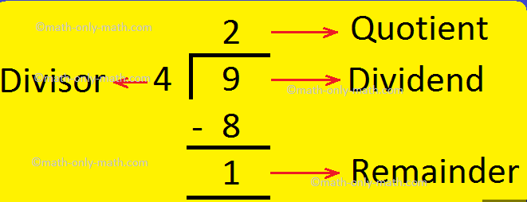

# Arithmetic Operators

In this lesson, we'll learn how to perform calculations using arithmetic operators.

**We'll cover the following**

* [Addition](https://www.educative.io/module/lesson/python-fundamentals-for-programmers/gxxLA4WEoD3#Addition)
* [Subtraction](https://www.educative.io/module/lesson/python-fundamentals-for-programmers/gxxLA4WEoD3#Subtraction)
* [Multiplication](https://www.educative.io/module/lesson/python-fundamentals-for-programmers/gxxLA4WEoD3#Multiplication)
* [Division](https://www.educative.io/module/lesson/python-fundamentals-for-programmers/gxxLA4WEoD3#Division)
  + [Floor Division](https://www.educative.io/module/lesson/python-fundamentals-for-programmers/gxxLA4WEoD3#Floor-Division)
* [Modulo](https://www.educative.io/module/lesson/python-fundamentals-for-programmers/gxxLA4WEoD3#Modulo)
* [Precedence](https://www.educative.io/module/lesson/python-fundamentals-for-programmers/gxxLA4WEoD3#Precedence)
* [Parentheses](https://www.educative.io/module/lesson/python-fundamentals-for-programmers/gxxLA4WEoD3#Parentheses)

Below, we can find the basic arithmetic operators in order of **precedence**. The operator listed higher will be computed first.

These operators allow us to perform arithmetic operations in Python.

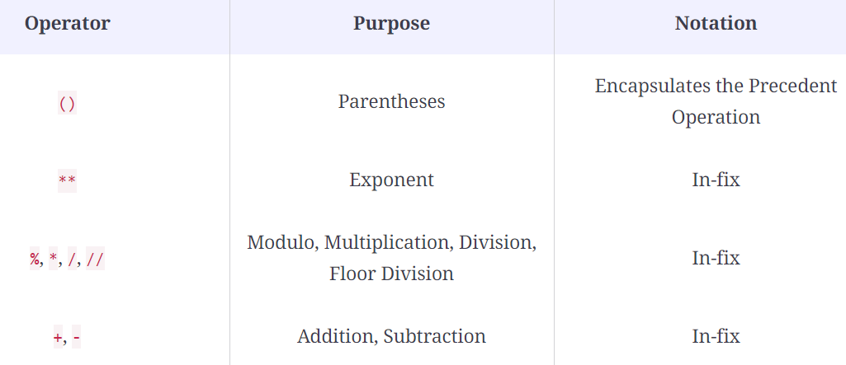

## Addition

We can add two numbers using the + operator:

print(10 + 5)

float1 = 13.65

float2 = 3.40

print(float1 + float2)

num = 20

flt = 10.5

print(num + flt)

As we can see in **line 9**, summing an integer and floating-point number gives us a floating-point number.

Python automatically converts the integer to a floating-point number. This applies to all arithmetic operations.

## Subtraction

We can subtract one number from the other using the - operator:

print(10 - 5)

float1 = -18.678

float2 = 3.55

print(float1 - float2)

num = 20

flt = 10.5

print(num - flt)

## Multiplication

We can multiply two numbers using the \* operator:

print(40 \* 10)

float1 = 5.5

float2 = 4.5

print(float1 \* float2)

print(10.2 \* 3)

## Division

We can divide one number by another using the / operator:

print(40 / 10)

float1 = 5.5

float2 = 4.5

print(float1 / float2)

print(12.4 / 2)

A division operation always results in a floating-point number.

### Floor Division

In floor division, the result is floored to the nearest smaller integer. It is also known as **integer division**.

For floor division, we must use the // operator:

print(43 // 10)

float1 = 5.5

float2 = 4.5

print(5.5 // 4.5)

print(12.4 // 2)

Unlike normal division, floor division between two integers results in an integer.

## Modulo

A number’s [modulo](https://en.wikipedia.org/wiki/Modulo_operation) with another number can be found using the % operator:

print(10 % 2)

twenty\_eight = 28

print(twenty\_eight % 10)

print(-28 % 10) # The remainder is positive if the right-hand operand is positive

print(28 % -10) # The remainder is negative if the right-hand operand is negative

print(34.4 % 2.5) # The remainder can be a float

## Precedence

An arithmetic [expression](https://en.wikipedia.org/wiki/Expression_(computer_science)) containing different operators will be computed on the basis of **operator precedence**.

Whenever operators have equal precedence, the expression is computed from the left side:

# Different precedence

print(10 - 3 \* 2) # Multiplication computed first, followed by subtraction

# Same precedence

print(3 \* 20 / 5) # Multiplication computed first, followed by division

print(3 / 20 \* 5) # Division computed first, followed by multiplication

## Parentheses

An expression which is enclosed inside parentheses will be computed first, regardless of operator precedence:

print((10 - 3) \* 2) # Subtraction occurs first

print((18 + 2) / (10 % 8))

Using all the operations above, we can compute complex mathematical expressions in Python!

Keep in mind that we are never restricted to these operators only, there are countless more arithmetic utilities at our disposal.

# Comparison Operators

In this lesson, we'll learn how to perform comparisons in Python using comparison operators.

**We'll cover the following**

* [Comparisons](https://www.educative.io/module/lesson/python-fundamentals-for-programmers/gx9GPY2Bk4Z#Comparisons)

Comparison operators can be used to compare values in mathematical terms.

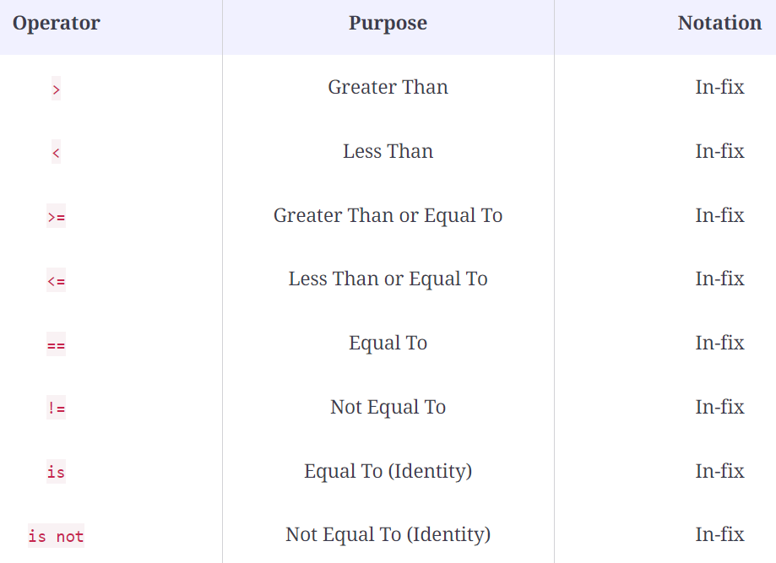

## Comparisons

The result of a comparison is always a bool.

If the comparison is correct, the value of the bool will be True. Otherwise, its value will be False.

The == and != operators compare the **values** of both operands. However, the identity operators, is and is not, check whether the two operands are the **exact same object**.

Let’s look at a few examples:

num1 = 5

num2 = 10

num3 = 10

list1 = [6,7,8]

list2 = [6,7,8]

print(num2 > num1) # 10 is greater than 5

print(num1 > num2) # 5 is not greater than 10

print(num2 == num3) # Both have the same value

print(num3 != num1) # Both have different values

print(3 + 10 == 5 + 5) # Both are not equal

print(3 <= 2) # 3 is not less than or equal to 2

print(num2 is not num3) # Both have the same object

print(list1 is list2) # Both have the different objects

As we can see in **line 7**, num2 is indeed greater than num1. Hence, the result is True. On the other hand, **line 8** contains an incorrect comparison, which results in False.

# Assignment Operators

This lesson showcases Python's various assignment operators and their purpose.

**We'll cover the following**

* [Assigning Values](https://www.educative.io/module/lesson/python-fundamentals-for-programmers/gxKAg37px63#Assigning-Values)
* [The Other Operators](https://www.educative.io/module/lesson/python-fundamentals-for-programmers/gxKAg37px63#The-Other-Operators)

This is a category of operators which is used to assign values to a variable. The = operator is an assignment operator, but not the only one.

Here’s a list of all the assignment operators supported in Python:

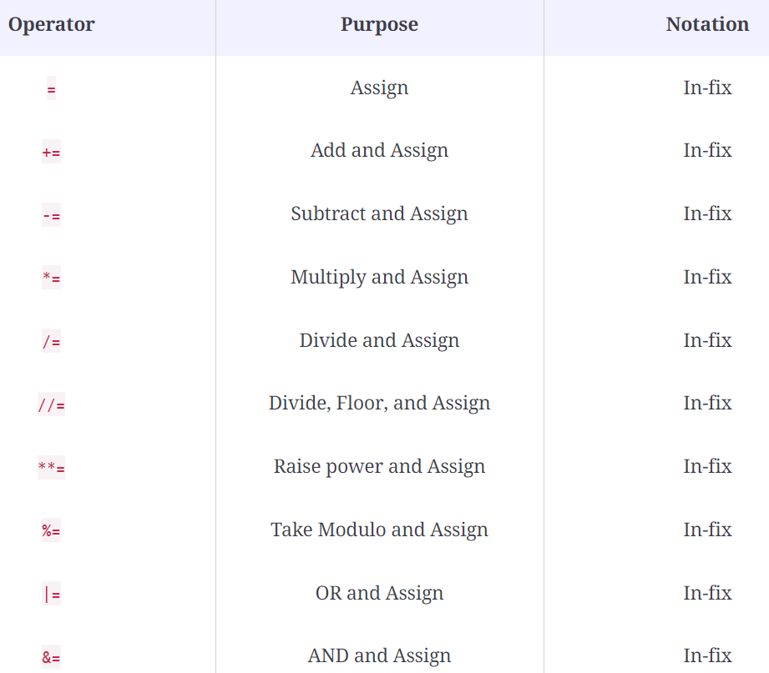

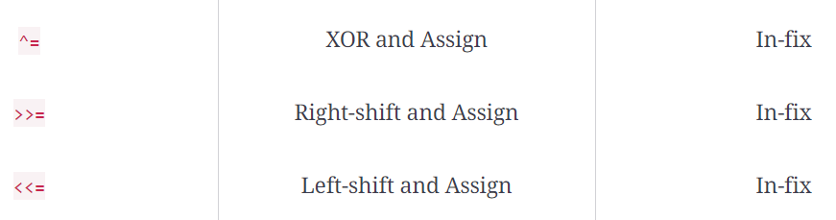

## Assigning Values

Let’s go through a few examples to see how values are assigned to variables.

Variables are **mutable**, so we can change their values whenever we want!

year = 2019

print(year)

year = 2020

print(year)

year = year + 1 # Using the existing value to create a new one

print(year)

One thing to note is that when a variable, first, is assigned to another variable, second, its value is **copied** into second. Hence, if we later change the value of first, second will remain unaffected:

first = 20

second = first

first = 35 # Updating 'first'

print(first, second) # 'second' remains unchanged

## The Other Operators

Below, we can see some of the assignment operators we talked about in action:

num = 10

print(num)

num += 5

print(num)

num -= 5

print(num)

num \*= 2

print(num)

num /= 2

print(num)

num \*\*= 2

print(num)

# Try all the others here!

# Logical Operators

Let's understand the purpose of logical operators!

**We'll cover the following**

* [Logical Expressions](https://www.educative.io/module/lesson/python-fundamentals-for-programmers/g2BV7nQ3o6D#Logical-Expressions)
* [Bit Value](https://www.educative.io/module/lesson/python-fundamentals-for-programmers/g2BV7nQ3o6D#Bit-Value)

Logical operators are used to manipulate the logic of Boolean expressions.

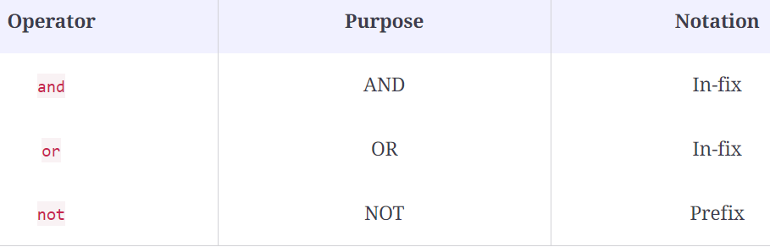

## Logical Expressions

Logical expressions are formed using Booleans and logical operators.

Below, we can find some examples:

# OR Expression

my\_bool = True or False

print(my\_bool)

# AND Expression

my\_bool = True and False

print(my\_bool)

# NOT expression

my\_bool = False

print(not my\_bool)

## Bit Value

All the code we see around us in today’s world is actually made up of bits. Combinations of 1s and 0s form the foundation of programming.

In bit terms, the value of True is 1. False corresponds to 0:

print(10 \* True)

print(10 \* False)

The Python interpreter can automatically convert the bool to its numerical form when needed.

# Bitwise Operators

This lesson showcases all the different bitwise operators available in Python.

**We'll cover the following**

* [Examples](https://www.educative.io/module/lesson/python-fundamentals-for-programmers/JYQZjDAgoJo#Examples)
* [Explanation](https://www.educative.io/module/lesson/python-fundamentals-for-programmers/JYQZjDAgoJo#Explanation)

In programming, all data is actually made up of 0s and 1s known as bits. Bitwise operators allow us to perform bit-related operations on values.

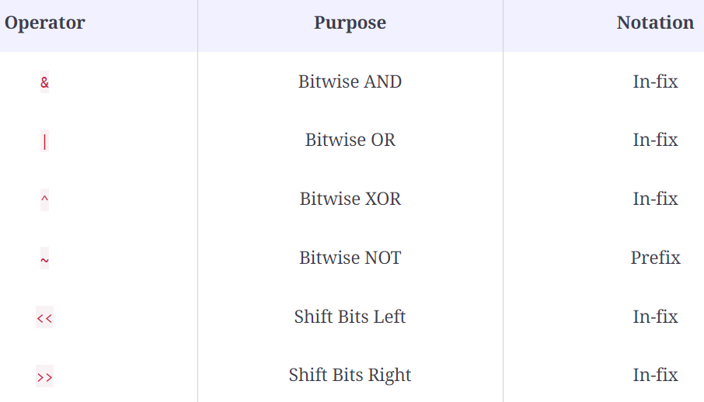

num1 = 10 # Binary value = 01010

num2 = 20 # Binary Value = 10100

print(num1 & num2) # 0 -> Binary value = 00000

print(num1 | num2) # 30 -> Binary value = 11110

print(num1 ^ num2) # 30 -> Binary value = 11110

print(~num1) # -11 -> Binary value = -(1011)

print(num1 << 3) # 80 -> Binary value = 0101 0000

print(num2 >> 3) # 2 -> Binary value = 0010

**Explanation**

In **line 4**, we perform the bitwise AND. This operation takes a bit from num1 and the corresponding bit from num2 and performs an AND between them.

In simple terms, AND can be thought of as a multiplication between the two operands.

Now, let’s visualize this example:

* num1 is 01010 in binary and num2 is 10100.
* At the first step, the first binary digits of both numbers are taken:
  + **0**1010
  + **1**0100
* 0 & 1 would give 0 (again, think of it as multiplication).
* Next, we take the second digits:
  + 0**1**010
  + 1**0**100
* These two will once again give us 0.
* Doing this for all pairs, we can see that the answer is 0 each time.
* Hence, the output is 00000.

The OR operation in **line 5** will work in the same principle except that instead of multiplication, we will perform addition between the two binary numbers.

0 OR 1 gives us 1. 1 OR 1 also produces 1 (binary numbers do not go beyond 1). However, 0 OR 0 will give us 0 (0 + 0 is still 0).

Bitwise XOR and NOT will work on each bit as well. You can play with the code to get a better idea.

The bitshift operations (>> and <<) simply move the bits to either the right or the left. When a binary number is shifted, a 0 also enters at the opposite end to keep the number of the same size.

Let’s suppose we have a binary number 0110 (6 in decimal). The operation we perform is 0110 >> 2:

* 0**11**0 >> 2
* 00**11** (move one step to the right)
* 000**1** (move one more step to the right)
* Operation complete

Similarly, we can move 0110 twice to the left with the following operation 0110 << 2:

* 0**11**0 << 2
* 0**11**00 (move one step to the left)
* 0**11**000 (move one more step to the left)
* Operation complete

Note: In Python, leading zeroes are truncated. For example, the number **0011** will be the same as **11**. Similarly, the number **0001011** will be the same as **1011**.

# String Operations

This lesson showcases some of the most commonly used string operations.

**We'll cover the following**

* [Comparison Operators](https://www.educative.io/module/lesson/python-fundamentals-for-programmers/gkjp699GqWG#Comparison-Operators)
* [Concatenation](https://www.educative.io/module/lesson/python-fundamentals-for-programmers/gkjp699GqWG#Concatenation)
* [Search](https://www.educative.io/module/lesson/python-fundamentals-for-programmers/gkjp699GqWG#Search)

The string data type has numerous utilities that make string computations much easier. Let’s get down to the basics.

## Comparison Operators

Strings are compatible with the comparison operators. Each character has a [Unicode](https://en.wikipedia.org/wiki/Unicode) value.

This allows strings to be compared on the basis of their Unicode values.

When two strings have different lengths, the string which comes first in the dictionary is said to have the smaller value.

Let’s look at a few examples:

print('a' < 'b') # 'a' has a smaller Unicode value

house = "Gryffindor"

house\_copy = "Gryffindor"

print(house == house\_copy)

new\_house = "Slytherin"

print(house == new\_house)

print(new\_house <= house)

print(new\_house >= house)

## Concatenation

The + operator can be used to merge two strings together:

first\_half = "Bat"

second\_half = "man"

full\_name = first\_half + second\_half

print(full\_name)

The \* operator allows us to multiply a string, resulting in a repeating pattern:

print("ha" \* 3)

## Search

The in keyword can be used to check if a particular substring exists in another string. If the substring is found, the operation returns true.

Here’s how it works:

random\_string = "This is a random string"

print('of' in random\_string) # Check whether 'of' exists in randomString

print('random' in random\_string) # 'random' exists!

# Grouping Values

Now, we'll learn how to store multiple values together.

**We'll cover the following**

* [Making a List](https://www.educative.io/module/lesson/python-fundamentals-for-programmers/YVGEZBBxRw0#Making-a-List)

In Python, we can store multiple values together in a single variable. While there are many ways of doing so, the most popular is the **list**.

It is very similar to a string since a string is a collection of characters. A list is also just a collection of values. However, the values can be of any type.

All we have to do is enclose all the elements in square brackets, [], and separate them with commas.

## Making a List [#](https://www.educative.io/module/lesson/python-fundamentals-for-programmers/YVGEZBBxRw0#Making-a-List)

my\_list = [1, 2.5, "A string", True]

print(my\_list)

It’s as simple as that! Lists can be indexed and sliced just like strings. The len command works with them too:

my\_list = [1, 2.5, "A string", True]

print(my\_list[2])

print(len(my\_list))

We’ll explore lists further as the course goes along. For now, we’re good to go ahead.

That brings us to the end of this section. By now, we should be familiar with the various data types, variables, and operators in Python.

In the next section, we’ll be introduced to **conditional statements**. Before that, be sure to check out our fun quiz and coding challenges on all the concepts we’ve learned so far!

What is the value of result at the end of the following code?

x = 20  
y = 5  
result = (x + True) / (4 - y \* False)

###### D)

5.25

What will be the output of the following piece of code?

my\_string = "0123456789"  
print(my\_string[-2: -6: -2])

86

# Exercise: Gravitational Force

Let's calculate the gravitational force between two masses!

**We'll cover the following**

* [Problem Statement](https://www.educative.io/module/lesson/python-fundamentals-for-programmers/qALDB0zQYg2#Problem-Statement)
  + [Sample Input](https://www.educative.io/module/lesson/python-fundamentals-for-programmers/qALDB0zQYg2#Sample-Input)
  + [Sample Output](https://www.educative.io/module/lesson/python-fundamentals-for-programmers/qALDB0zQYg2#Sample-Output)
* [Coding Challenge](https://www.educative.io/module/lesson/python-fundamentals-for-programmers/qALDB0zQYg2#Coding-Challenge)

## Problem Statement

Gravitational force is the attractive force that exists between two masses. It can be calculated by using the following formula:

����2*r*2*GMm*​

where G is the gravitational constant, M and m are the two masses, and r is the distance between them.

You must implement this equation in Python to calculate the gravitational force between Earth and the moon.

### Sample Input

G = 6.67 \* 10-11

MEarth = 6.0 \* 1024

mMoon = 7.34 \* 1022

r = 3.84 \* 108

### Sample Output

FG = 1.99 \* 1020

## Coding Challenge

All the values have already been given to you. You must write the formula in Pythonic syntax and store the answer in the grav\_force variable.

If you feel stuck, refer to the solution review in the next lesson.

Good luck!

G = 6.67 \* (10 \*\* -11)

M = 6.0 \* (10 \*\* 24) # Mass of Earth

m = 7.34 \* (10 \*\* 22) # Mass of the moon

r = 3.84 \* (10 \*\* 8)

# Write your code here

grav\_force = (G\*M\*m)/(r \*\* 2)

# The if Statement

This lesson showcases the functionality of the 'if' statement.

**We'll cover the following**

* [The Structure](https://www.educative.io/module/lesson/python-fundamentals-for-programmers/3YqV6xlwMq9#The-Structure)
  + [Indentation](https://www.educative.io/module/lesson/python-fundamentals-for-programmers/3YqV6xlwMq9#Indentation)
  + [The Flow of an if Statement](https://www.educative.io/module/lesson/python-fundamentals-for-programmers/3YqV6xlwMq9#The-Flow-of-an-if-Statement)
* [Conditions with Logical Operators](https://www.educative.io/module/lesson/python-fundamentals-for-programmers/3YqV6xlwMq9#Conditions-with-Logical-Operators)
* [Nested if Statements](https://www.educative.io/module/lesson/python-fundamentals-for-programmers/3YqV6xlwMq9#Nested-if-Statements)
* [Creating and Editing Values](https://www.educative.io/module/lesson/python-fundamentals-for-programmers/3YqV6xlwMq9#Creating-and-Editing-Values)

## The Structure

The simplest conditional statement that we can write is the if statement. It comprises of two parts:

1. The **condition**
2. The **code to be executed**
3. The : in the illustration above is necessary to specify the beginning of the if statement’s code to be executed. However, the parentheses, (), around the condition are optional. The code to be executed is indented at least one tab to the right.

### Indentation

1. Indentation plays an essential role in Python. Statements with the same level of indentation belong to the same block of code. The code of an if statement is indented a space further than the code outside it in order to indicate that this is an inner and inter-related block.
2. The convention of our indents must also be consistent throughout a block. If we have used two spaces to make an indent, we must use two spaces for an indent in the same block. Hence, always keep indentation in mind when writing code.
3. Indents are important in other aspects of Python, too.

### The Flow of an if Statement

1. An if statement runs like this:
2. **if** the **condition** holds True, execute the **code to be executed**. Otherwise, **skip** it and move on.
3. Let’s write a simple if statement that verifies the value of an integer:
4. num = 5
5. if (num == 5): # The condition is true
6. print("The number is equal to 5") # The code is executed
7. if num > 5: # The condtion is false
8. print("The number is greater than 5") # The code is not executed
9. Our first condition simply checks whether the value of num is 5. Since this Boolean expression returns True, the compiler goes ahead and executes the print statement on **line 4**.
10. As we can see, the print command inside the body of the if statement is indented to the right. If it wasn’t, there would be an error. Python puts a lot of emphasis on proper indentation.

## Conditions with Logical Operators

1. We can use logical operators to create more complex conditions in the if statement. For example, we may want to satisfy multiple clauses for the expression to be True.
2. num = 12
3. if num % 2 == 0 and num % 3 == 0 and num % 4 == 0:
4. # Only works when num is a multiple of 2, 3, and 4
5. print("The number is a multiple of 2, 3, and 4")
6. if (num % 5 == 0 or num % 6 == 0):
7. # Only works when num is either a multiple of 5 or 6
8. print("The number is a multiple of 5 and/or 6")
9. In the first if statement, all the conditions have to be fulfilled since we’re using the and operator.
10. In the second if statement, the Boolean expression would be true if either or both of the clauses are satisfied because we are using the or operator.

## Nested if Statements

1. A cool feature of conditional statements is that we can nest them. This means that there could be an if statement inside another!
2. Hence, we can use nesting to make complex conditions in our program:
3. num = 63
4. if num >= 0 and num <= 100:
5. if num >= 50 and num <= 75:
6. if num >= 60 and num <= 70:
7. print("The number is in the 60-70 range")

## Creating and Editing Values

In a conditional statement, we can edit the values of our variables.

Furthermore, we can create new variables.

num = 10

if num > 5:

num = 20 # Assigning a new value to num

new\_num = num \* 5 # Creating a new value called newNum

# The if condition ends, but the changes made inside it remain

print(num)

print(new\_num)

The if statement is the foundation of conditional programming in Python.

# The if-else Statement

This lesson showcases the main properties of an 'if-else' statement.

**We'll cover the following**

* [Structure](https://www.educative.io/module/lesson/python-fundamentals-for-programmers/xV9Ey1xEx9q#Structure)
* [Benefits of if-else](https://www.educative.io/module/lesson/python-fundamentals-for-programmers/xV9Ey1xEx9q#Benefits-of-if-else)
* [Conditional Expressions](https://www.educative.io/module/lesson/python-fundamentals-for-programmers/xV9Ey1xEx9q#Conditional-Expressions)

What if we want to execute a different set of operations in case an if condition turns out to be False?

That is where the if-else statement comes into the picture.

## Structure

The if-else statement looks something like this:

There’s nothing too tricky going on here. If the **condition** turns out to be False, the code after the else: keyword is executed.

Hence, we can now perform two different actions based on the condition’s value.

The else keyword will be on the same indentation level as the if keyword. Its body will be indented one tab to the right just like the if statement.

Here’s the if-else statement in action:

num = 60

if num <= 50:

print("The number is less than or equal to 50")

else:

print("The number is greater than 50")

## Benefits of if-else

The example above could also be written with two if conditions:

num = 60

if num <= 50:

print("The number is less than or equal to 50")

if num > 50:

print("The number is greater than 50")

However, for the second if, we have to specify the condition again. This can be tricky when dealing with complex conditions. The else statement automatically handles all the situations when the if fails.

Do keep in mind that the else statement cannot exist on its own. It is merely a counterpart of the if statement. It can still contain its own nested if or if-else statements. We’ll leave that as an exercise for you to try on your own.

## Conditional Expressions

Conditional expressions use the functionality of an if-else statement in a different way.

The expression returns an output based on the condition we provide. This output can be stored in a variable.

A conditional expression can be written in the following way:

output\_value1 if condition else output\_value2

If the if condition is fulfilled, the output would be output\_value1. Otherwise, it would be output\_value2.

Let’s refactor the previous if-else statement into a conditional expression:

num = 60

output = "The number is less than or equal to 50" \

if num <= 50 else "The number is greater than 50"

print(output)

Please note that the backslash \ in the above code is only a line continuation character that can be used to split a single line into multiple lines.

# The if-elif-else Statement

This lesson highlights the main properties of the `if-elif-else` statement.

**We'll cover the following**

* [Structure](https://www.educative.io/module/lesson/python-fundamentals-for-programmers/JPqPZJEJ06y#Structure)
* [Multiple elif Statements](https://www.educative.io/module/lesson/python-fundamentals-for-programmers/JPqPZJEJ06y#Multiple-elif-Statements)

The if-else statement handles two sides of the same condition: True and False. This works very well if we’re working with a problem that only has two outcomes.

However, in programming, it isn’t always a True or False scenario, and a problem can have multiple outcomes.

This is where the if-elif-else statement shines. It is the most comprehensive conditional statement because it allows us to create multiple conditions easily.

The elif stands for **else if**, indicating that if the previous condition fails, try this one.

## Structure

The if and else blocks will remain the same. The elif statement comes in between the two.

Let’s write an if-elif-else statement which checks the state of a traffic signal and generates the appropriate response:

light = "Red"

if light == "Green":

print("Go")

elif light == "Yellow":

print("Caution")

elif light == "Red":

print("Stop")

else:

print("Incorrect light signal")

Now, our conditional statement caters to **all** possible values of light.

Try changing the value and see how the response changes.

## Multiple elif Statements

This is the beauty of the if-elif-else statement. We can have as many elifs as we require, as long as they come between if and else.

**Note**: An if-elif statement can exist on its own without an else block at the end. However, an elif cannot exist without an if statement preceding it (which naturally makes sense).

Let’s write a piece of code that checks whether the value of an integer is in the range of 0-9 and prints the word in English:

num = 5

if num == 0:

print("Zero")

elif num == 1:

print("One")

elif num == 2:

print("Two")

elif num == 3:

print("Three")

elif num == 4:

print("Four")

elif num == 5:

print("Five")

elif num == 6:

print("Six")

elif num == 7:

print("Seven")

elif num == 8:

print("Eight")

elif num == 9:

print("Nine")

An important thing to keep in mind is that an if-elif-else or if-elif statement is not the same as multiple if statements. if statements act **independently**.

If the conditions of two successive ifs are True, both statements will be executed.

On the other hand, in if-elif-else, when a condition evaluates to True, the rest of the statement’s conditions are not evaluated.

We’ll understand this better through an example:

num = 10

if num > 5:

print("The number is greater than 5")

if num % 2 == 0:

print("The number is even")

if not num % 2 == 0:

print("The number is odd")

As we can see, in the if tab, all the statements are computed one by one. Hence, we get multiple outputs.

In the if-elif-else tab, since the first condition holds true, all the others are discarded. This proves to be more efficient in terms of code performance.