**Google File System: Introduction**

Let’s explore Google File System and its use cases.

**We'll cover the following**

* [Goal](https://www.educative.io/module/lesson/grokking-system-design-interview/7ApYYXjR3pj#Goal)
* [What is Google File System (GFS)?](https://www.educative.io/module/lesson/grokking-system-design-interview/7ApYYXjR3pj#What-is-Google-File-System-(GFS)?)
* [Background](https://www.educative.io/module/lesson/grokking-system-design-interview/7ApYYXjR3pj#Background)
* [GFS use cases](https://www.educative.io/module/lesson/grokking-system-design-interview/7ApYYXjR3pj#GFS-use-cases)
* [APIs](https://www.educative.io/module/lesson/grokking-system-design-interview/7ApYYXjR3pj#APIs)

**Goal**

Design a distributed file system to store huge files (terabyte and larger). The system should be scalable, reliable, and highly available.

**What is Google File System (GFS)?**

GFS is a scalable distributed file system developed by Google for its large data-intensive applications.

**Background**

GFS was built for handling batch processing on large data sets and is designed for system-to-system interaction, not user-to-system interaction.

Google built GFS keeping the following goals in mind:

* **Scalable**: GFS should run reliably on a very large system built from commodity hardware.
* **Fault-tolerant**: The design must be sufficiently tolerant of hardware and software failures to enable application-level services to continue their operation in the face of any likely combination of failure conditions.
* **Large files**: Files stored in GFS will be huge. Multi-GB files are common.
* **Large sequential and small random reads**: The workloads primarily consist of two kinds of reads: large, streaming reads and small, random reads.
* **Sequential writes**: The workloads also have many large, sequential writes that append data to files. Typical operation sizes are similar to those for reads. Once written, files are seldom modified again.
* **Not optimized for small data**: Small, random reads and writes do occur and are supported, but the system is not optimized for such cases.
* **Concurrent access**: The level of concurrent access will also be high, with large numbers of concurrent appends being particularly prevalent, often accompanied by concurrent reads.
* **High throughput**: GFS should be optimized for high and sustained throughput in reading the data, and this is prioritized over latency. This is not to say that latency is unimportant; rather, GFS needs to be optimized for high-performance reading and appending large volumes of data for the correct operation of the system.

**GFS use cases**

* GFS is a distributed file system built for large, distributed data-intensive applications like **Gmail** or **YouTube**.
* Originally, it was built to store data generated by Google’s large **crawling and indexing system**.
* Google’s **BigTable** uses the distributed Google File System to store log and data files.

**APIs**

GFS does not provide standard POSIX-like APIs; instead, user-level APIs are provided. In GFS, files are organized hierarchically in directories and identified by their pathnames. GFS supports the usual file system operations:

create – To create a new instance of a file.  
delete – To delete an instance of a file.  
open – To open a named file and return a handle.  
close – To close a given file specified by a handle.  
read – To read data from a specified file and offset.  
write – To write data to a specified file and offset.

In addition, GFS supports two special operations:

* **Snapshot**: A snapshot is an efficient way of creating a copy of the current instance of a file or directory tree.
* **Append**: An append operation allows multiple clients to append data to the same file concurrently while guaranteeing atomicity. It is useful for implementing multi-way merge results and producer-consumer queues that many clients can simultaneously append to without additional locking.

**High-level Architecture**

This lesson gives a brief overview of GFS’s architecture.

**We'll cover the following**

* [Chunks](https://www.educative.io/module/lesson/grokking-system-design-interview/qV3pQJ6JKWy#Chunks)
* [Chunk handle](https://www.educative.io/module/lesson/grokking-system-design-interview/qV3pQJ6JKWy#Chunk-handle)
* [Cluster](https://www.educative.io/module/lesson/grokking-system-design-interview/qV3pQJ6JKWy#Cluster)
* [ChunkServer](https://www.educative.io/module/lesson/grokking-system-design-interview/qV3pQJ6JKWy#ChunkServer)
* [Master](https://www.educative.io/module/lesson/grokking-system-design-interview/qV3pQJ6JKWy#Master)
* [Client](https://www.educative.io/module/lesson/grokking-system-design-interview/qV3pQJ6JKWy#Client)

A GFS cluster consists of a single master and multiple ChunkServers and is accessed by multiple clients.

**Chunks**

As files stored in GFS tend to be very large, GFS breaks files into multiple fixed-size chunks where each chunk is 64 megabytes in size.

**Chunk handle**

Each chunk is identified by an immutable and globally unique 64-bit ID number called chunk handle. This allows for 2^{64}264 unique chunks. If each chunk is 64 MB, total storage space would be more than 10^9109 exa-bytes.

As files are split into chunks, therefore, the job of GFS is to provide a mapping from files to chunks, and then to support standard operations on files, mapping down to operations on individual chunks.

**Cluster**

GFS is organized into a simple network of computers called a cluster. All GFS clusters contain three kinds of entities:

1. A single master server
2. Multiple ChunkServers
3. Many clients

The master stores all metadata about the system, while the ChunkServers store the real file data.

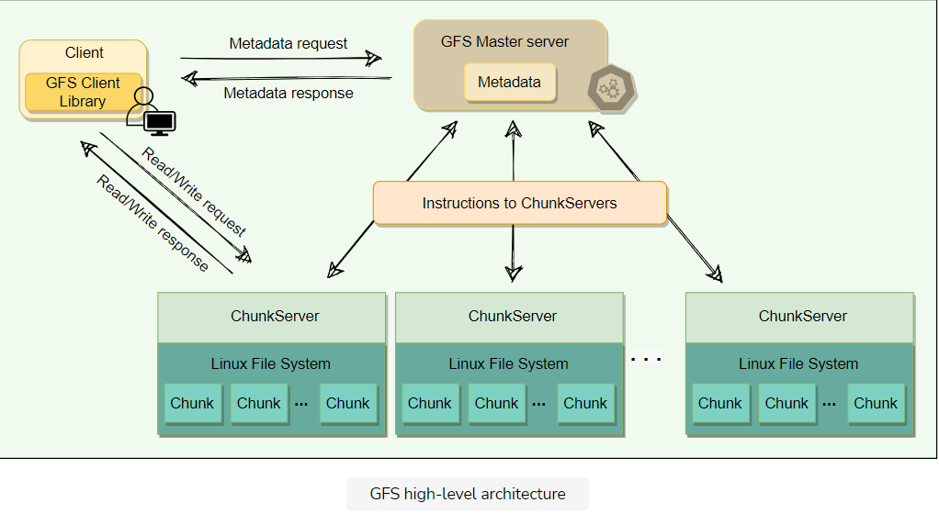

## ChunkServer

ChunkServers store chunks on local disks as regular Linux files and read or write chunk data specified by a chunk handle and byte-range.

For reliability, each chunk is replicated to multiple ChunkServers. By default, GFS stores three replicas, though different replication factors can be specified on a per-file basis.

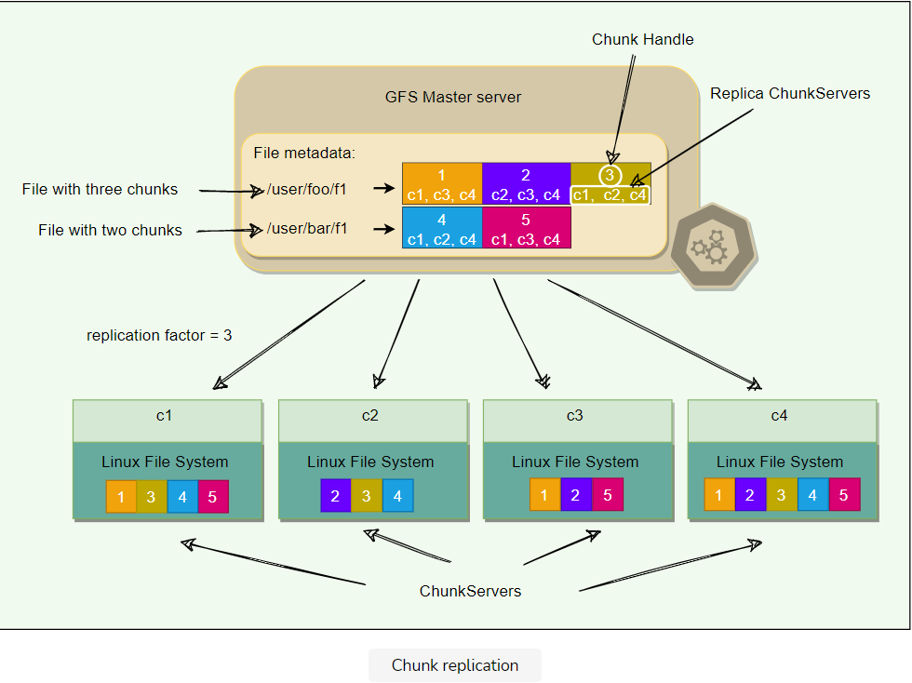

**Master**

Master server is the coordinator of a GFS cluster and is responsible for keeping track of filesystem metadata:

1. The metadata stored at the master includes:
   * Name and directory of each file
   * Mapping of each file to its chunks
   * Current locations of chunks
   * Access control information
2. The master also controls system-wide activities such as chunk lease management (locks on chunks with expiration), garbage collection of orphaned chunks, and chunk migration between ChunkServers. Master assigns chunk-handle to chunks at the time of chunk creation.
3. The master periodically communicates with each ChunkServer in HeartBeat messages to give it instructions and collect its state.
4. For performance and fast random access, all metadata is stored in the master’s main memory. This includes the entire filesystem namespace as well as all the name-to-chunk mappings.
5. For fault tolerance and to handle a master crash, all metadata changes are written to the disk onto an operation log. This operation log is also replicated onto remote machines. The operation log is similar to a journal. Every operation to the file system is logged into this file.
6. The master is a single point of failure, hence, it replicates its data onto several remote machines so that the master can be readily restored on failure.
7. The benefit of having a single, centralized master is that it has a global view of the file system, and hence, it can make optimum management decisions, for example, related to chunk placement.

**Client**

Client is an entity that makes a read or write request to GFS. GFS client library is linked into each application that uses GFS. This library communicates with the master for all metadata-related operations like creating or deleting files, looking up files, etc. To read or write data, the client interacts directly with the ChunkServers that hold the data.

Neither the client nor the ChunkServer caches file data. Client caches offer little benefit because most applications stream through huge files or have working sets too large to be cached. ChunkServers rely on the buffer cache in Linux to maintain frequently accessed data in memory.

**Single Master and Large Chunk Size**

This lesson will explain why GFS has a single master and a large chunk size.

**We'll cover the following**

* [Single master](https://www.educative.io/module/lesson/grokking-system-design-interview/N7B9r7xmlE2#Single-master)
* [Chunk size](https://www.educative.io/module/lesson/grokking-system-design-interview/N7B9r7xmlE2#Chunk-size)
  + [Lazy space allocation](https://www.educative.io/module/lesson/grokking-system-design-interview/N7B9r7xmlE2#Lazy-space-allocation)

**Single master**

Having a single master vastly simplifies GFS design and enables the master to make sophisticated chunk placement and replication decisions using global knowledge. However, GFS minimizes the master’s involvement in reads and writes so that it does not become a bottleneck. Clients never read or write file data through the master. Instead, a client asks the master which ChunkServers it should contact. The client caches this information for a limited time and interacts with the ChunkServers directly for many subsequent operations.

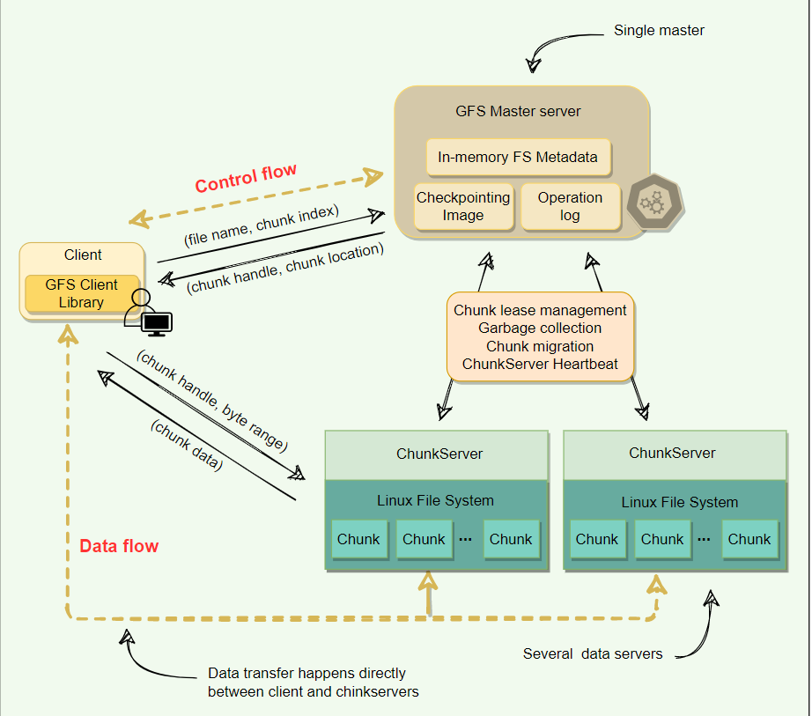

## Chunk size

Chunk size is one of the key design parameters. GFS has chosen 64 MB, which is much larger than typical filesystem block sizes (which are often around 4KB). Here are the advantages of using a large chunk size:

1. Since GFS was designed to handle huge files, small chunk sizes would not make much sense, as each file would have a map of a huge number of chunks.
2. As the master holds the metadata and manages file distribution, it is involved whenever chunks are read, modified, or deleted. This also means that a small chunk size would significantly increase the amount of data a master would need to manage and increase the amount of data that would need to be communicated to a client, resulting in extra network traffic.
3. A large chunk size reduces the size of the metadata stored on the master, which enables the master to keep all the metadata in memory, thus significantly decreasing the latency for control operations.
4. By using a large chunk size, GFS reduces the need for frequent communication with the master to get chunk location information. It becomes feasible for a client to cache all information related to chunk locations of a large file. Client metadata caches have timeouts to reduce the risk of caching stale data.
5. A large chunk size also makes it possible to keep a TCP connection open to a ChunkServer for an extended time, amortizing the time of setting up a TCP connection.
6. A large chunk size simplifies ChunkServer management, i.e., to check which ChunkServers are near capacity or which are overloaded.
7. Large chunk size provides highly efficient sequential reads and appends of large amounts of data.

### Lazy space allocation

Each chunk replica is stored as a plain Linux file on a ChunkServer. GFS does not allocate the whole 64MB of disk space when creating a chunk. Instead, as the client appends data, the ChunkServer lazily extends the chunk. This lazy space allocation avoids wasting space due to internal fragmentation. Internal fragmentation refers to having unused portions of the 64 MB chunk. For example, if we allocate a 64 MB chunk and only fill up 20MB, the remaining space is unused.

One disadvantage of having a large chunk size is the handling of small files. Since a small file will have one or a few chunks, the ChunkServers storing those chunks can become hotspots if a lot of clients access the same file. To handle this scenario, GFS stores such files with a higher replication factor and also adds a random delay in the start times of the applications accessing these files.

# Metadata

Let's explore how GFS manages the filesystem metadata.

**We'll cover the following**

* [Storing metadata in memory](https://www.educative.io/module/lesson/grokking-system-design-interview/gxJADPoLkKr#Storing-metadata-in-memory)
* [Chunk location](https://www.educative.io/module/lesson/grokking-system-design-interview/gxJADPoLkKr#Chunk-location)
* [Operation log](https://www.educative.io/module/lesson/grokking-system-design-interview/gxJADPoLkKr#Operation-log)
  + [Checkpointing](https://www.educative.io/module/lesson/grokking-system-design-interview/gxJADPoLkKr#Checkpointing)

The master stores three types of metadata:

1. The file and chunk namespaces (i.e., directory hierarchy).
2. The mapping from files to chunks.
3. The locations of each chunk’s replicas.

There are three aspects of how master manages the metadata:

1. Master keeps all this metadata in memory.
2. The first two types (i.e., namespaces and file-to-chunk mapping) are also persisted on the master’s local disk.
3. The third (i.e., chunk replicas’ locations) is not persisted.

Let’s discuss these aspects one by one.

## Storing metadata in memory

Since metadata is stored in memory, the master operates very quickly. Additionally, it is easy and efficient for the master to periodically scan through its entire state in the background. This periodic scanning is used to implement three functions:

1. Chunk garbage collection
2. Re-replication in the case of ChunkServer failures
3. Chunk migration to balance load and disk-space usage across ChunkServers

As discussed above, one potential concern for this memory-only approach is that the number of chunks, and hence the capacity of the whole system, is limited by how much memory the master has. This is not a serious problem in practice. The master maintains less than 64 bytes of metadata for each 64 MB chunk. Most chunks are full because most files contain many chunks, only the last of which may be partially filled. Similarly, the file namespace data typically requires less than 64 bytes per file because the master stores file names compactly using **prefix compression**.

If the need for supporting an even larger file system arises, the cost of adding extra memory to the master is a small price to pay for the simplicity, reliability, performance, and flexibility gained by storing the metadata in memory.

## Chunk location

The master does not keep a persistent record of which ChunkServers have a replica of a given chunk; instead, the master asks each chunk server about its chunks at master startup, and whenever a ChunkServer joins the cluster. The master can keep itself up-to-date after that because it controls all chunk placements and monitors ChunkServer status with regular HeartBeat messages.

By having the ChunkServer as the ultimate source of truth of each chunk’s location, GFS eliminates the problem of keeping the master and ChunkServers in sync. It is not beneficial to maintain a consistent view of chunk locations on the master, because errors on a ChunkServer may cause chunks to vanish spontaneously (e.g., a disk may go bad and be disabled, or ChunkServer is renamed or failed, etc.) In a cluster with hundreds of servers, these events happen all too often.

## Operation log

The master maintains an operation log that contains the namespace and file-to-chunk mappings and stores it on the local disk. Specifically, this log stores a historical record of all the metadata changes. Operation log is very important to GFS. It contains the persistent record of metadata and serves as a logical timeline that defines the order of concurrent operations.

For fault tolerance and reliability, this operation log is replicated on multiple remote machines, and changes to the metadata are not made visible to clients until they have been persisted on all replicas. The master batches several log records together before flushing, thereby reducing the impact of flushing and replicating on overall system throughput.

Upon restart, the master can restore its file-system state by replaying the operation log. This log must be kept small to minimize the startup time, and that is achieved by periodically checkpointing it.

### Checkpointing

Master’s state is periodically serialized to disk and then replicated, so that on recovery, a master may load the checkpoint into memory, replay any subsequent operations from the operation log, and be available again very quickly. To further speed up the recovery and improve availability, GFS stores the checkpoint in a compact B-tree like format that can be directly mapped into memory and used for namespace lookup without extra parsing.

The checkpoint process can take time, therefore, to avoid delaying incoming mutations, the master switches to a new log file and creates the new checkpoint in a separate thread. The new checkpoint includes all mutations before the switch.

# Master Operations

Let's learn the different operations performed by the master.

**We'll cover the following**

* [Namespace management and locking](https://www.educative.io/module/lesson/grokking-system-design-interview/gkNW04j7vMk#Namespace-management-and-locking)
* [Replica placement](https://www.educative.io/module/lesson/grokking-system-design-interview/gkNW04j7vMk#Replica-placement)
  + [Replica creation and re-replication](https://www.educative.io/module/lesson/grokking-system-design-interview/gkNW04j7vMk#Replica-creation-and-re-replication)
  + [Replica rebalancing](https://www.educative.io/module/lesson/grokking-system-design-interview/gkNW04j7vMk#Replica-rebalancing)
* [Stale replica detection](https://www.educative.io/module/lesson/grokking-system-design-interview/gkNW04j7vMk#Stale-replica-detection)

The master executes all namespace operations. Furthermore, it manages chunk replicas throughout the system. It is responsible for:

* Making replica placement decisions
* Creating new chunks and hence replicas
* Making sure that chunks are fully replicated according to the replication factor
* Balancing the load across all the ChunkServers
* Reclaim unused storage

## Namespace management and locking

The master acquires locks over a namespace region to ensure proper serialization and to allow multiple operations at the master. GFS does not have an i-node like tree structure for directories and files. Instead, it has a hash-map that maps a filename to its metadata, and reader-writer locks are applied on each node of the hash table for synchronization.

* Each absolute file name or absolute directory name has an associated read-write lock.
* Each master operation acquires a set of locks before it runs.
* To make operation on /dir1/dir2/leaf, it first needs the following locks:
  + Reader lock on /dir1
  + Reader lock on /dir1/dir2
  + Reader or Writer lock on /dir1/dir2/leaf
* Following this scheme, concurrent writes on the same leaf are prevented right away. However, at the same time, concurrent modifications in the same directory are allowed.
* File creation does not require write-lock on the parent directory; a read-lock on its name is sufficient to protect the parent directory from deletion, rename, or snapshot.
* Write-lock on a file name stops attempts to create multiple files with the same name.
* Locks are acquired in a consistent order to prevent deadlock:
  + First ordered by level in the namespace tree
  + Lexicographically ordered within the same level

## Replica placement

To ensure maximum data availability and integrity, the master distributes replicas on different racks, so that clients can still read or write in case of a rack failure. As the in and out bandwidth of a rack may be less than the sum of the bandwidths of individual machines, placing the data in various racks can help clients exploit reads from multiple racks. For ‘write’ operations, multiple racks are actually disadvantageous as data has to travel longer distances. It is an intentional tradeoff that GFS made.

### Replica creation and re-replication

The goals of a master are to place replicas on servers with less-than-average disk utilization, spread replicas across racks, and reduce the number of ‘recent’ creations on each ChunkServer (even though writes are cheap, they are followed by heavy write traffic) which might create additional load.

Chunks need to be re-replicated as soon as the number of available replicas falls (due to data corruption on a server or a replica being unavailable) below the user-specified replication factor. Instead of re-replicating all of such chunks at once, the master prioritizes re-replication to prevent these cloning operations from becoming bottlenecks. Restrictions are placed on the bandwidth of each server for re-replication so that client requests are not compromised.

**How are chunks prioritized for re-replication?**

* A chunk is prioritized based on how far it is from its replication goal. For example, a chunk that has lost two replicas will be given priority on a chuck that has lost only one replica.
* GFS prioritizes chunks of live files as opposed to chunks that belong to recently deleted files (more on this when we discuss [Garbage Collection](https://www.educative.io/collection/page/5668639101419520/5559029852536832/5335676130689024)). Deleted files are not removed immediately; instead, they are renamed temporarily and garbage-collected after a few days. Replicas of deleted files can exist for a few days as well.

### Replica rebalancing

Master rebalances replicas regularly to achieve load balancing and better disk space usage. It may move replicas from one ChunkServer to another to bring disk usage in a server closer to the average. Any new ChunkServer added to the cluster is filled up gradually by the master rather than flooding it with a heavy traffic of write operations.

## Stale replica detection

Chunk replicas may become stale if a ChunkServer fails and misses mutations to the chunk while it is down. For each chunk, the master maintains a chunk Version Number to distinguish between up-to-date and stale replicas. The master increments the chunk version every time it grants a lease (more on this later) and informs all up-to-date replicas. The master and these replicas all record the new version number in their persistent state. If the ChunkServer hosting a chunk replica is down during a mutation, the chunk replica will become stale and will have an older version number. The master will detect this when the ChunkServer restarts and reports its set of chunks and their associated version numbers. Master removes stale replicas during regular garbage collection.

Stale replicas are not given to clients when they ask the master for a chunk location, and they are not involved in mutations either. However, because a client caches a chunk’s location, it may read from a stale replica before the data is resynced. The impact of this is low due to the fact that most operations to a chunk are append-only. This means that a stale replica usually returns a premature end of a chunk rather than outdated data for a value.

**Anatomy of a Read Operation**

Let’s learn how GFS handles a read operation.

A typical read interaction with a GFS cluster by a client application goes like this:

1. First, the client translates the file name and byte offset specified by the application into a chunk index within the file. Given the fixed chunk size, this can be computed easily.
2. The client then sends the master an RPC request containing the file name and chunk index.
3. The master replies with the chunk handle and the location of replicas holding the chunk. The client caches this metadata using the file name and chunk-index as the key. This information is subsequently used to access the data.
4. The client then sends a request to one of the replicas (the closest one). The request specifies the chunk handle and a byte range within that chunk.
   * Further reads of the same chunk require no more client-master interaction until the cached information expires or the file is reopened.
   * In fact, the client typically asks for multiple chunks in the same request, and the master can also include the information for chunks immediately following those requested.
5. The replica ChunkServer replies with the requested data.
6. As evident from the above workflow, the master is involved at the start and is then completely out of the loop, implementing a separation of control and data flows – a separation that is crucial for maintaining high performance of file accesses.

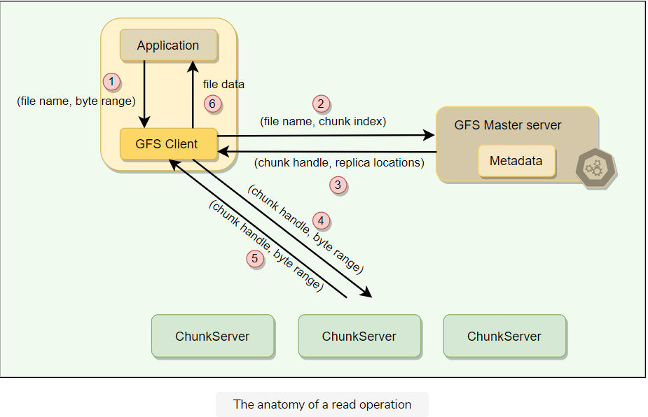

**Anatomy of a Write Operation**

Let’s learn how GFS handles a write operation.

**We'll cover the following**

* [What is a chunk lease?](https://www.educative.io/module/lesson/grokking-system-design-interview/gkN5W5Z523D#What-is-a-chunk-lease?)
* [Data writing](https://www.educative.io/module/lesson/grokking-system-design-interview/gkN5W5Z523D#Data-writing)

**What is a chunk lease?**

To safeguard against concurrent writes at two different replicas of a chunk, GFS makes use of chunk lease. When a mutation (i.e., a write, append or delete operation) is requested for a chunk, the master finds the ChunkServers which hold that chunk and grants a chunk lease (for 60 seconds) to one of them. The server with the lease is called the primary and is responsible for providing a serial order for all the currently pending concurrent mutations to that chunk. There is only one lease per chunk at any time, so that if two write requests go to the master, both see the same lease denoting the same primary.

Thus, a global ordering is provided by the ordering of the chunk leases combined with the order determined by that primary. The primary can request lease extensions if needed. When the master grants the lease, it increments the chunk version number and informs all replicas containing that chunk of the new version number.

**Data writing**

The actual writing of data is split into two phases:

* **Sending**: First, the client is given a list of replicas that identifies the primary ChunkServer and secondaries. The client sends the data to the closest replica. Then replicas send the data in chain to all other replicas to maximize bandwidth and throughput. Eventually, all the replicas get the data, which is not yet written to a file but sits in a cache.
* **Writing**: When the client gets an acknowledgment from all replicas that the data has been received, it then sends a write request to the primary, identifying the data that was sent in the previous phase. The primary is responsible for the serialization of writes. It assigns consecutive serial numbers to all write requests that it has received, applies the writes to the file in serial-number order, and forwards the write requests in that order to the secondaries. Once the primary gets acknowledgments from all the secondaries, the primary responds back to the client, and the write operation is complete. Any errors at any stage in this process are met with retries and eventual failure. On failure, an error is returned to the client.

Following is the stepwise breakdown of the data transfer:

1. Client asks master which chunk server holds the current lease of chunk and locations of other replicas.
2. Master replies with the identity of primary and locations of the secondary replicas.
3. Client pushes data to the closest replica. Then replicas send the data in chain to all other replicas.
4. Once all replicas have acknowledged receiving the data, the client sends the write request to the primary. The primary assigns consecutive serial numbers to all the mutations it receives, providing serialization. It applies mutations in serial number order.
5. Primary forwards the write request to all secondary replicas. They apply mutations in the same serial number order.
6. Secondary replicas reply to primary indicating they have completed operation.
7. Primary replies to the client with success or error message

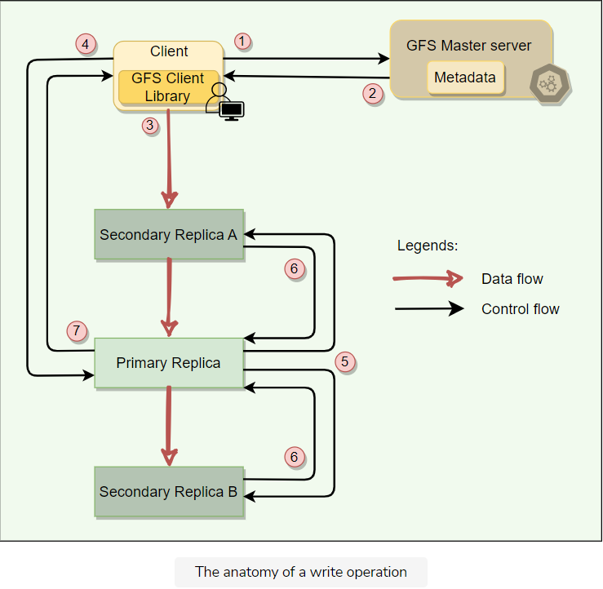

The key point to note is that the data flow is different from the control flow. The data flows from the client to a ChunkServer and then from that ChunkServer to another ChunkServer, until all ChunkServers that store replicas for that chunk have received the data. The control (the write request) flow goes from the client to the primary ChunkServer for that chunk. The primary then forwards the request to all the secondaries. This ensures that the primary controls the order of writes even if it receives multiple concurrent write requests. All replicas will have data written in the same sequence. Chunk version numbers are used to detect if any replica has stale data which has not been updated because that ChunkServer was down during some update

# Anatomy of an Append Operation

Let’s learn how GFS handles an append operation.

Record append operation is optimized in a unique way that distinguishes GFS from other distributed file systems. In a normal write, the client specifies the offset at which data is to be written. Concurrent writes to the same region can experience race conditions, and the region may end up containing data fragments from multiple clients. In a record append, however, the client specifies only the data. GFS appends it to the file at least once atomically (i.e., as one continuous sequence of bytes) at an offset of GFS’s choosing and returns that offset to the client. This process is similar to the append operation on a file opened with [O_APPEND](https://man7.org/linux/man-pages/man2/open.2.html) mode on a POSIX-compliant file system but without the race conditions when multiple writers do so concurrently.

Record Append is a kind of mutation that changes the contents of the metadata of a chunk. When an application tries to append data on a chunk by sending a request to the client, the client pushes the data to all replicas of the last chunk of the file just like the write operation. When the client forwards the request to the primary, the primary checks whether appending the record to the existing chunk will increase the chunk’s size more than its limit (maximum size of a chunk is 64MB). If this happens, it pads the chunk to the maximum limit, commands the secondary to do the same, and requests the clients to try to append to the next chunk. If the record fits within the maximum size, the primary appends the data to its replica, tells the secondary to write the data at the exact offset where it has, and finally replies success to the client.

If an append operation fails at any replica, the client retries the operation. Due to this reason, replicas of the same chunk may contain different data, possibly including duplicates of the same record in whole or in part. Hence, GFS does not guarantee that all replicas are byte-wise identical; instead, it only ensures that the data is written at-least-once as an atomic unit.

**GFS Consistency Model and Snapshotting**

This lesson will explain how GFS handles the consistency of its operations and data. Additionally, we will look into how GFS implements a snapshotting operation.

**We'll cover the following**

* [GFS consistency model](https://www.educative.io/module/lesson/grokking-system-design-interview/7Aw2AZ7n8Y1#GFS-consistency-model)
* [Snapshotting](https://www.educative.io/module/lesson/grokking-system-design-interview/7Aw2AZ7n8Y1#Snapshotting)

**GFS consistency model**

To keep things simple and efficient, GFS has a relaxed consistency model.

Metadata operations (e.g., file creation) are atomic. They are handled exclusively by the master. Namespace locking guarantees atomicity and correctness, whereas the master’s operation log defines a global total order of these operations.

In data mutations, there is an important distinction between write and append operations. Write operations specify an offset at which mutations should occur, whereas appends are always applied at the end of the file. This means that for the write operation, the offset in the chunk is predetermined, whereas for append, the system decides. Concurrent writes to the same location are not serializable and may result in corrupted regions of the file. With append operations, GFS guarantees the append will happen at-least-once and atomically (that is, as a contiguous sequence of bytes). The system does not guarantee that all copies of the chunk will be identical (some may have duplicate data).

**Snapshotting**

A snapshot is a copy of some subtree of the global namespace as it exists at a given point in time. GFS clients use snapshotting to efficiently branch two versions of the same data. Snapshots in GFS are initially **zero-copy**. This means that data copies are made only when clients make a request to modify the chunks. This scheme is known as **copy-on-write**.

When the master receives a snapshot request, it first revokes any outstanding leases on the chunks in the files to snapshot. It waits for leases to be revoked or expired and logs the snapshot operation to the operation log. The snapshot is then made by duplicating the metadata for the source directory tree. Newly created snapshot files still point to the original chunks.

When a client makes a request to write to one of these chunks, the master detects that it is a copy-on-write chunk by examining its reference count (which will be more than one). At this point, the master asks each ChunkServer holding the replica to make a copy of the chunk and store it locally. These local copies are made to avoid copying the chunk over the network. Once the copy is complete, the master issues a lease for the new copy, and the write proceeds.

**Fault Tolerance, High Availability, and Data Integrity**

Let's learn how GFS implements fault tolerance, high availability, and data integrity.

**We'll cover the following**

* [Fault tolerance](https://www.educative.io/module/lesson/grokking-system-design-interview/RMDNx166vPR#Fault-tolerance)
* [High availability through Chunk replication](https://www.educative.io/module/lesson/grokking-system-design-interview/RMDNx166vPR#High-availability-through-Chunk-replication)
* [Data integrity through checksum](https://www.educative.io/module/lesson/grokking-system-design-interview/RMDNx166vPR#Data-integrity-through-checksum)

**Fault tolerance**

To make the system fault-tolerant and available, GFS makes use of two simple strategies:

1. **Fast recovery** in case of component failures.
2. **Replication** for high availability.

Let’s first see how GFS recovers from master or replica failure:

* **On master failure**: The Master being a single point of failure, can make the entire system unavailable in a short time. To handle this, all operations applied on master are saved in an **operation log**. This log is checkpointed and replicated on multiple remote machines, so that on recovery, a master may load the checkpoint into memory, replay any subsequent operations from the operation log, and be available again in a short amount of time. GFS relies on an external monitoring infrastructure to detect the master failure and switch the traffic to the backup master server.
  + **Shadow masters** are replicas of master and provide read-only access to the file system even when the primary is down. All shadow masters keep themselves updated by applying the same sequence of updates exactly as the primary master does by reading its operation log. Shadow masters may lag the primary slightly, but they enhance read availability for files that are not being actively changed or applications that do not mind getting slightly stale metadata. Since file contents are read from the ChunkServers, applications do not observe stale file contents.
* **On primary replica failure**: If an active primary replica fails (or there is a network partition), the master detects this failure (as there will be no heartbeat), and waits for the current lease to expire (in case the primary replica is still serving traffic from clients directly), and then assigns the lease to a new node. When the old primary replica recovers, the master will detect it as ‘stale’ by checking the version number of the chunks. The master node will pick new nodes to replace the stale node and garbage-collect it before it can join the group again.
* **On secondary replica failure**: If there is a replica failure, all client operations will start failing on it. When this happens, the client retries a few times; if all of the retries fail, it reports failure to the master. This can leave the secondary replica inconsistent because it misses some mutations. As described above, stale nodes will be replaced by new nodes picked by the master, and eventually garbage-collected.

📝 **Note:** Stale replicas might be exposed to clients. It depends on the application programmer to deal with these stale reads. GFS does not guarantee strong consistency on chunk reads.

**High availability through Chunk replication**

As discussed earlier, each chunk is replicated on multiple ChunkServers on different racks. Users can specify different replication levels for different parts of the file namespace. The default is three. The master clones the existing replicas to keep each chunk fully replicated as ChunkServers go offline or when the master detects corrupted replicas through checksum verification.

A chunk is lost irreversibly only if all its replicas are lost before GFS can react. Even in this case, the data becomes unavailable, not corrupted, which means applications receive clear errors rather than corrupt data.

**Data integrity through checksum**

Checksumming is used by each ChunkServer to detect the corruption of stored data. The chunk is broken down into 64 KB blocks. Each has a corresponding 32-bit checksum. Like other metadata, checksums are kept in memory and stored persistently with logging, separate from user data.

1. **For reads**, the ChunkServer verifies the checksum of data blocks that overlap the read range before returning any data to the requester, whether a client or another ChunkServer. Therefore, ChunkServers will not propagate corruptions to other machines. If a block does not match the recorded checksum, the ChunkServer returns an error to the requestor and reports the mismatch to the master. In response, the requestor will read from other replicas, and the master will clone the chunk from another replica. After a valid new replica is in place, the master instructs the ChunkServer that reported the mismatch to delete its replica.
2. **For writes**, ChunkServer verifies the checksum of first and last data blocks that overlap the write range before performing the write. Then, it computes and records the new checksums. For a corrupted block, the ChunkServer returns an error to the requestor and reports the mismatch to the master.
3. **For appends**, checksum computation is optimized as there is no checksum verification on the last block; instead, just incrementally update the checksum for the last partial block and compute new checksums for any brand-new blocks filed by the append. This way, if the last partial block is already corrupted (and GFS fails to detect it now), the new checksum value will not match the stored data, and the corruption will be detected as usual when the block is next read.

During idle periods, ChunkServers can scan and verify the contents of inactive chunks (prevents an inactive but corrupted chunk replica from fooling the master into thinking that it has enough valid replicas of a chunk).

Checksumming has little effect on read performance for the following reasons:

* Since most of the reads span at least a few blocks, GFS needs to read and checksum only a relatively small amount of extra data for verification. GFS client code further reduces this overhead by trying to align reads at checksum block boundaries.
* Checksum lookups and comparisons on the ChunkServer are done without any I/O.
* Checksum calculation can often be overlapped with I/Os.

**Garbage Collection**

Let's learn how GFS implements garbage collection.

**We'll cover the following**

* [Garbage collection through lazy deletion](https://www.educative.io/module/lesson/grokking-system-design-interview/NE5XZlrNRYN#Garbage-collection-through-lazy-deletion)
* [Advantages of lazy deletion](https://www.educative.io/module/lesson/grokking-system-design-interview/NE5XZlrNRYN#Advantages-of-lazy-deletion)
* [Disadvantages of lazy deletion](https://www.educative.io/module/lesson/grokking-system-design-interview/NE5XZlrNRYN#Disadvantages-of-lazy-deletion)

**Garbage collection through lazy deletion**

When a file is deleted, GFS does not immediately reclaim the physical space used by that file. Instead, it **follows a lazy garbage collection strategy**. When the client issues a delete file operation, GFS does two things:

1. The master logs the deletion operation just like other changes.
2. The deleted file is renamed to a hidden name that also includes a deletion timestamp.

The file can still be read under the new, special name and can also be undeleted by renaming it back to normal. To reclaim the physical storage, the master, while performing regular scans of the file system, removes any such hidden files if they have existed for more than three days (this interval is configurable) and also deletes its in-memory metadata. This lazy deletion scheme provides a window of opportunity to a user who deleted a file by mistake to recover the file.

The master, while performing regular scans of chunk namespace, deletes the metadata of all chunks that are not part of any file. Also, during the exchange of regular HeartBeat messages with the master, each ChunkServer reports a subset of the chunks it has, and the master replies with a list of chunks from that subset that are no longer present in the master’s database; such chunks are then deleted from the ChunkServer.

**Advantages of lazy deletion**

Here are the advantages of lazy deletion.

* Simple and reliable. If the chunk deletion message is lost, the master does not have to retry. The ChunkServer can perform the garbage collection with the subsequent heartbeat messages.
* GFS merges storage reclamation into regular background activities of the master, such as the regular scans of the filesystem or the exchange of HeartBeat messages. Thus, it is done in batches, and the cost is amortized.
* Garbage collection takes place when the master is relatively free.
* Lazy deletion provides safety against accidental, irreversible deletions.

**Disadvantages of lazy deletion**

As we know, after deletion, storage space does not become available immediately. Applications that frequently create and delete files may not be able to reuse the storage right away. To overcome this, GFS provides following options:

* If a client deletes a deleted file again, GFS expedites the storage reclamation.
* Users can specify directories that are to be stored without replication.
* Users can also specify directories where deletion takes place immediately.

**Criticism on GFS**

Here is the summary of criticism on GFS's architecture.

**We'll cover the following**

* [Problems associated with single master](https://www.educative.io/module/lesson/grokking-system-design-interview/3jRoG7lMwOR#Problems-associated-with-single-master)
* [Problems associated with large chunk size](https://www.educative.io/module/lesson/grokking-system-design-interview/3jRoG7lMwOR#Problems-associated-with-large-chunk-size)

**Problems associated with single master**

As GFS has grown in usage, Google has started to see the following problems with the centralized master scheme:

* Despite the separation of control flow (i.e., metadata operations) and data flow, the master is emerging as a bottleneck in the design. As the number of clients grows, a single master could not serve them because it does not have enough CPU power.
* Despite the reduced amount of metadata (because of the large chunk size), the amount of metadata stored by the master is increasing to a level where it is getting difficult to keep all the metadata in the main memory.

**Problems associated with large chunk size**

Large chunk size (64MB) in GFS has its disadvantages while reading. Since a small file will have one or a few chunks, the ChunkServers storing those chunks can become hotspots if a lot of clients are accessing the same file. As a workaround for this problem, GFS stores extra copies of small files for distributing the load to multiple ChunkServers. Furthermore, GFS adds a random delay in the start times of the applications accessing such files.

**Summary: GFS**

Here is a quick summary of Google File System for you!

**We'll cover the following**

* [Summary](https://www.educative.io/module/lesson/grokking-system-design-interview/NEnrmGwBJzv#Summary)
* [System design patterns](https://www.educative.io/module/lesson/grokking-system-design-interview/NEnrmGwBJzv#System-design-patterns)
* [References and further reading](https://www.educative.io/module/lesson/grokking-system-design-interview/NEnrmGwBJzv#References-and-further-reading)

**Summary**

* GFS is a scalable distributed file storage system for large data-intensive applications.
* GFS uses commodity hardware to reduce infrastructure costs.
* GFS was designed with the understanding that system/hardware failures can and do occur.
* Reading workload consists of large streaming reads and small random reads. Writing workloads consists of many large, sequential writes that append data to files.
* GFS provides APIs for usual file operations like create, delete, open, close, read, and write. Additionally, GFS supports snapshot and record append operations. Snapshot creates a copy of the file or directory tree. Record append allows multiple clients to append data to the same file concurrently while guaranteeing atomicity.
* A GFS cluster consists of a **single master** and **multiple ChunkServers** and is accessed by multiple clients.
* **Chunk**: Files are broken into fixed-size chunks where each chunk is 64 megabytes in size. Each chunk is identified by an immutable and globally unique **64-bit chunk handle** assigned by the master at the time of chunk creation.
* ChunkServers store chunks on the local disk as Linux files.
* For reliability, each chunk is replicated on multiple ChunkServers.
* Master server is the coordinator of a GFS cluster and is responsible for keeping track of all the filesystem metadata. This includes namespace, authorization, mapping of files to chunks, and the current location of chunks.
* Master keeps all metadata in memory for faster operations. For fault tolerance and to handle a master crash, all metadata changes are written to the disk onto an **operation log**. This operation log is also replicated onto remote machines.
* The master does not keep a persistent record of which ChunkServers have a replica of a given chunk. Instead, the master asks each ChunkServer about what chunks it holds at master startup or whenever a ChunkServer joins the cluster.
* **Checkpointing**: The master’s state is periodically serialized to disk and then replicated so that on recovery, a master may load the checkpoint into memory, replay any subsequent operations from the operation log, and be available again very quickly.
* **HeartBeat**: The master communicates with each ChunkServer through Heartbeat messages to pass instructions to it and collects its state.
* **Client**: GFS client code which is linked into each application, implements filesystem APIs, and communicates with the cluster. Clients interact with the master for metadata, but all data transfers happen directly between the client and ChunkServers.
* **Data Integrity**: Each ChunkServer uses checksumming to detect the corruption of stored data.
* **Garbage Collection**: After a file is deleted, GFS does not immediately reclaim the available physical storage. It does so only lazily during regular garbage collection at both the file and chunk levels.
* **Consistency**: Master guarantees data consistency by ensuring the order of mutations on all replicas and using **chunk version numbers**. If a replica has an incorrect version, it is garbage collected.
* GFS guarantees **at-least-once writes** for writers. This means that records could be written more than once as well (although rarely). It is the responsibility of the readers to deal with these duplicate chunks. This is achieved by having checksums and serial numbers in the chunks, which help readers to filter and discard duplicate data.
* **Cache**: Neither the client nor the ChunkServer caches file data. Client caches offer little benefit because most applications stream through huge files or have working sets too large to be cached. However, clients do cache metadata.

**System design patterns**

Here is a summary of system design patterns used in GFS.

* **Write-Ahead Log**: For fault-tolerance and in the event of a master crash, all metadata changes are written to the disk onto an operation log which is a write-ahead log.
* **HeartBeat**: The GFS master periodically communicates with each ChunkServer in HeartBeat messages to give it instructions and collect its state.
* **Checksum:** Each ChunkServer uses checksumming to detect the corruption of stored data.

**References and further reading**

* [GFS paper](https://research.google/pubs/pub51/)
* [Bigtable](https://research.google/pubs/pub27898/)
* [GFS: Evolution on Fast-forward](https://queue.acm.org/detail.cfm?id=1594206)

# Quiz: GFS

Test your knowledge of the Google File System by completing this quiz.

In GFS, files are divided into ------- chunks.

###### B)Fixed size

To detect data corruption, GFS compares the contents of chunks on multiple ChunkServers.

###### B)False

**Explanation**

Instead, GFS uses checksum.

File naming (or renaming) operation is atomic.

###### A)True

**Explanation**

All metadata operations are atomic.

To collect ChunkServer’s state, GFS master sends regular ------ messages to each ChunkServer.

###### D)HeartBeat

Does GFS use time-bound leases to reduce the network traffic?

**Your Answer**

###### A)

True

**Explanation**

For write operations, the primary replica, after getting the lease from master, becomes responsible for maintaining a consistent mutation across replicas until the lease expires. This reduces the network traffic as the lease is valid for a specific time.

Which two strategies are used to keep GFS highly available?

###### D)Fast Recovery and Chunk Replication

Random writes into files in GFS are:

###### C) Less Frequent

Distributing replicas onto different racks causes following side effect:

###### B)Slow writes

Distributing replicas onto different racks has following benefits (select all that apply):

###### B)Faster reads

###### C)Better reliability

What does a ChunkServer store? Select all that apply.

###### A)Chunk data (one file per chunk)

###### C)Chunk metadata (version number, checksum)

# Mock Interview: GFS

Test your knowledge of GFS's architecture by answering these questions.

###### Question 1

How does GFS scale?

Hide Answer

GFS scales by adding ChunkServers to the cluster. The master gradually moves data from existing ChunkServers to the newly added servers.

Since the master stores all metadata in memory (for faster operations), GFS is limited by how much memory the master has. At Google, this is not a serious problem in practice as the master maintains less than 64 bytes of metadata for each 64 MB chunk, but as the system has grown in usage, problems have emerged with the centralized master scheme:

* Despite the separation of control and data flow and the performance optimization of the master, it is emerging as a bottleneck in the design.
* Despite the reduced amount of metadata (because of the large chunk size), the amount of metadata stored by the master is increasing to a level where it is getting difficult to keep all the metadata in main memory.

###### Question 2

How does GFS ensure fault-tolerance and reliability of data?

Hide Answer

Fault tolerance in GFS is achieved through data replication and maintaining a metadata transactions log for the master.

**Replication**: GFS replicates data to multiple nodes for reliability and fault tolerance. By default, each chunk has three replicas stored on three different ChunkServers on possibly three different racks.

**Operation log**: For fault tolerance and to handle a master crash, all metadata changes are written to the disk onto an operation log. This operation log is also replicated onto remote machines.

**Checkpointing**: Master’s state is periodically serialized to disk and then replicated, so that on recovery, a master may load the checkpoint into memory, replay any subsequent operations from the operation log, and be available again very quickly.

###### Question 3

How does GFS manage high availability?

Hide Answer

Each chunk is replicated onto multiple ChunkServers to ensure high availability. By default, GFS stores three replicas of each chunk.

To ensure maximum data availability, master distributed replicas on different racks, so that clients can still read or write in case of a rack failure.

To handle master server crash, GFS stores the checkpoint in a compact B-tree-like form that can be directly mapped into memory and used for namespace lookup without extra parsing. This speeds up the recovery and improves availability

###### Question 4

How does GFS perform master failover?

Hide Answer

GFS relies on an external monitoring infrastructure to detect the master failure and switch the traffic to a backup master server.

###### Question 5

What benefits does GFS get from a single master?

Hide Answer

The benefit of having a single, centralized master is that it has a global view of the file-system, and hence, it can make optimum management decisions, for example, related to chunk placement and replication.

###### Question 6

What problems does GFS face by having a single master?

Hide Answer

As the number of files grows, it becomes impossible to store all files’ metadata in a single master’s RAM. Secondly, as the number of clients grows, the single master becomes a performance bottleneck as it does not have enough CPU power to serve them.

###### Question 7

How does GFS ensure file data integrity?

Hide Answer

GFS uses checksumming to detect the corruption of stored data. Each chunk is broken down into 64 KB blocks, and each block has a corresponding 32-bit checksum. Like other metadata, checksums are kept in memory and stored persistently with logging, separate from file data. ChunkServers verifies the checksum of data blocks that overlap the read/write range before performing the operation.

###### Question 8

How does GFS decouple control flow from data flow, and what benefits does it provide?

Hide Answer

Client communicates with the master for all metadata-related operations like creating or deleting files, looking up files, etc., but all data transfers happen directly between the client and ChunkServers. This decoupling of control flow from data flow minimizes the master’s involvement in reads and writes, so that it does not become a bottleneck. Clients never read or write file data through the master. Instead, a client asks the master which ChunkServers it should contact. The client caches this information for a limited time and interacts with the ChunkServers directly for many subsequent operations.

Furthermore, while performing a write operation, GFS separates control flow from data flow to ensure data consistency. In a write operation, the data flows from the client to the nearest ChunkServer, which then forwards it to other replicas until all ChunkServers that store replicas for that chunk have received the data. The control (the write request) flow goes from the client to the primary ChunkServer for that chunk. The primary then forwards the request to all the secondaries. This ensures that the primary is in control of the order of writes even if it receives multiple concurrent write requests. All replicas will have data written in the same sequence.

###### Question 9

How does lazy space allocation help GFS?

Hide Answer

Each chunk replica is stored as a plain Linux file on a ChunkServer. GFS does not allocate the whole 64MB of disk space when creating a chunk. Instead, as the client appends data, the ChunkServer, lazily extends the chunk. This lazy space allocation avoids wasting space due to internal fragmentation. Internal fragmentation refers to having unused portions of the 64 MB chunk. For example, if we allocate a 64 MB chunk and only fill up 20 MB, the remaining space is unused.

###### Question 10

Can GFS handle small files efficiently?

Hide Answer

GFS can store small files efficiently as it lazily extends the chunks based on the data size. This lazy space allocation scheme avoids wasting storage space due to internal fragmentation.

Having said that, GFS has a large chunk size (64MB), which can have its disadvantages while reading. Since a small file will have one or a few chunks, the ChunkServers storing those chunks can become hotspots if a lot of clients are accessing the same file. To handle this scenario, GFS stores such files with a higher replication factor and also adds a random delay in the start times of the applications accessing these files.

###### Question 11

What are reference counts in context of snapshotting?

Hide Answer

Reference counts are part of the implementation of copy-on-write for snapshots. Snapshots in GFS are initially zero-copy. This means that when GFS creates a snapshot, it does not copy the chunks’ data. Instead, it increases the reference counter of each chunk. Later, when a client makes a request to write to one of these chunks, the master notices its reference count is greater than one. At this point, the master asks each ChunkServer holding the replica to make a copy of the chunk so that the client can update the copy. Snapshotting with reference counts provide following benefits:

1. It makes creating a snapshot inexpensive, as GFS is not making the copy of the data.
2. It delays the copy until it is absolutely required, hoping that not all chunks will be modified, and hence, GFS can avoid making some copies.

###### Question 12

Let’s assume C1 is the primary replica ChunkServer of a chunk, and there is a network partition between the master and C1. When the master notices this, it will designate some other ChunkServer as primary, say C2. Since C1 did not actually fail, are there now two primaries for the same chunk?

Hide Answer

If we have two primaries, both might apply different updates to the same chunk – making the chunk inconsistent. To prevent this, GFS uses leases. In the aforementioned scenario, the master grants C1 a 60-second lease to be primary. C1 knows to stop being primary when its lease expires. The master will not grant a lease to C2 until the previous lease to C1 expires. Hence, C2 will not start acting as primary until after C1 stops.

###### Question 13

How does GFS handle data consistency?

Hide Answer

Master guarantees data consistency by ensuring the order of mutations on all replicas and using chunk version numbers. If a replica has an incorrect version, it is garbage collected.

GFS guarantees at-least-once write for writers. This means that records could be written more than once (although rarely). It is the responsibility of the readers to deal with these duplicate chunks. This is achieved by having checksums and serial numbers in the chunks, which help readers to filter and discard duplicate data.

GFS does not guarantee strong consistency. As described above, there can be duplicate data. In other words, GFS preferred performance and simplicity of design over data correctness.

###### Question 14

As GFS preferred performance and simplicity over correctness, how did it work for GFS?

Hide Answer

For distributed systems, providing strong data consistency usually results in a complex architecture where different components need to communicate with each other to develop consensus. By relaxing consistency requirements, the design can be simple, providing good performance. For example, GFS optimizes for MapReduce applications, which need high read performance for large files and are fine to deal with duplicate records or inconsistent reads. On the other hand, GFS would not be a good fit for systems requiring consistent data, for example, stockbroker or bank transactions.