MATLAB ASSIGNMENT

Newton-Raphson methods, Secant and Runge-Kutta methods: FOR and WHILE loop solutions,flowcharts and pseudocode

NEWTON-RAPHSON METHOD
Formula: x(n+1) = x(n) - f(x(n)) / f'(x(n))

Flowchart

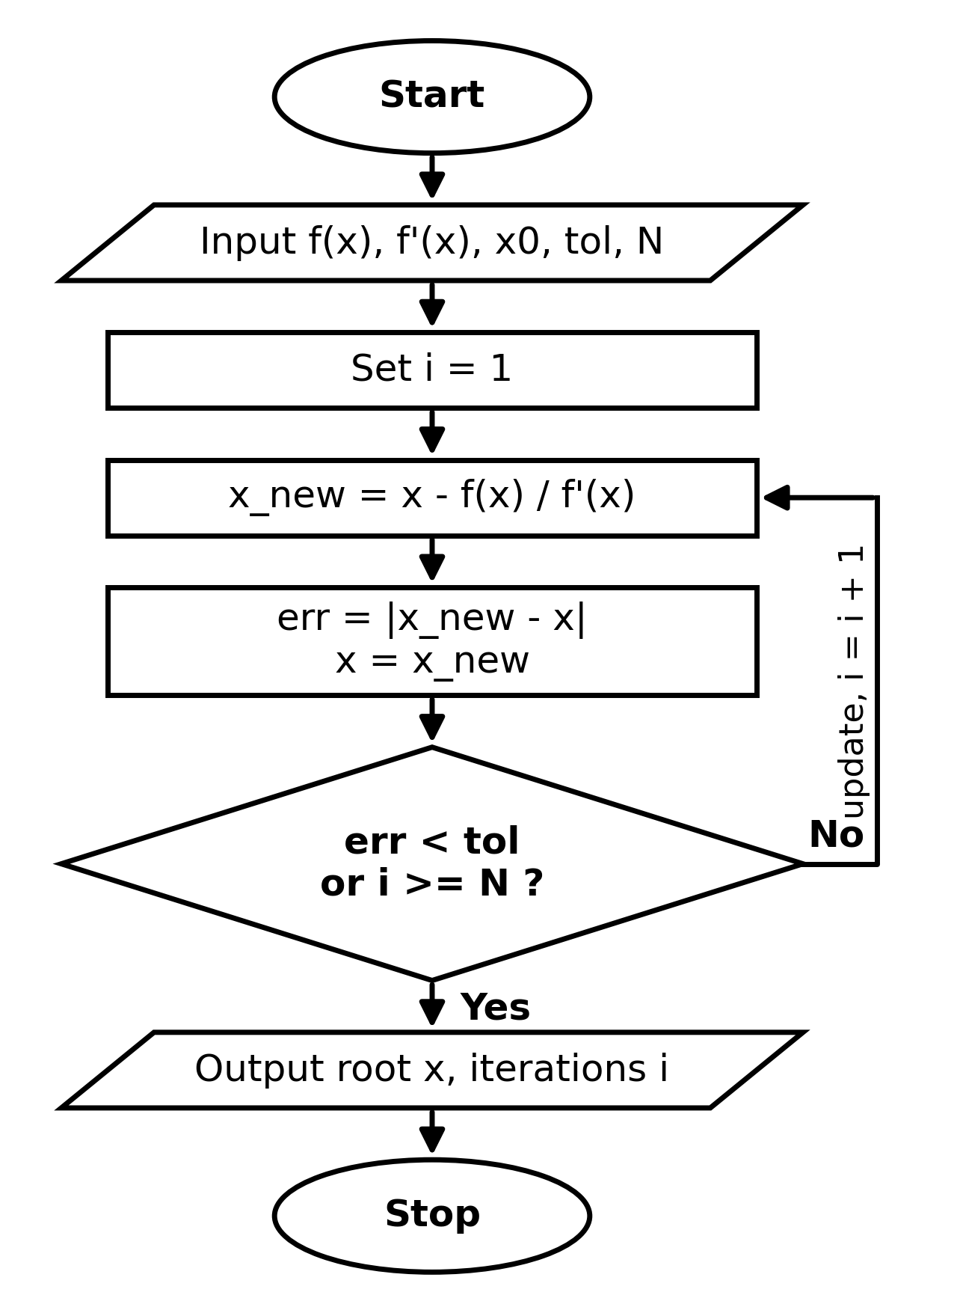
%% SECTION 1: NEWTON-RAPHSON METHOD
% Example function: f(x) = x^2 - 4, f'(x) = 2x
f_nr = @(x) x^2 - 4;
df_nr = @(x) 2*x;
x0 = 3; tol = 1e-5; max_iter = 20;

% Newton-Raphson using FOR loop
x_for = x0;
for i = 1:max_iter
x_for = x_for - f_nr(x_for)/df_nr(x_for);
end
fprintf('NR (for loop) Root: %.5f\n', x_for);
PSEUDOCODE:

INPUT: initial_guess x0=3, max_iterations N=20, tol=1e-5
FOR i FROM 1 TO N DO:
fx = f(x0) // x^2 - 4
dfx = f'(x0) // 2x
IF dfx == 0 THEN:
PRINT "Error: Derivative is zero"
STOP
END IF
x1 = x0 - (fx / dfx)
PRINT "Iteration", i, ": x =", x1
IF ABS(x1 - x0) < tol THEN BREAK
x0 = x1
END FOR
OUTPUT: x1 A// 2.00000

dfx = f'(x0) // 2x
IF dfx == 0 THEN:
PRINT "Error: Derivative is zero"
STOP
END IF
x1 = x0 - (fx / dfx)
PRINT "Iteration", i, ": x =", x1
IF ABS(x1 - x0) < tol THEN BREAK
x0 = x1
END FOR
OUTPUT: x1 // 2.00000

NR (for loop) Root: 2.00000
% Newton-Raphson using WHILE loop
x_while = x0; err = 1; count = 0;
while err > tol && count < max_iter
x_new = x_while - f_nr(x_while)/df_nr(x_while);
err = abs(x_new - x_while);
x_while = x_new;
count = count + 1;
end
fprintf('NR (while loop) Root: %.5f in %d iterations\n\n', x_while, count);
PSEUDOCODE:

INPUT: initial_guess x0=3, tol=1e-5, max_iter=20
SET err = 1, count = 0, x_while = x0
WHILE err > tol AND count < max_iter DO:
fx = f(x_while)
dfx = f'(x_while)
IF dfx == 0 THEN STOP
x1 = x_while - fx/dfx
err = ABS(x1 - x_while)
PRINT "Iteration", count, ": x =", x1
x_while = x1
count = count + 1
END WHILE
OUTPUT: x_while

NR (while loop) Root: 2.00000 in 5 iterations
Iteration table for both loops
Count | X₁ | F(x₁) | F’(x₁) | X₂ | Error|x₂-x₁|
0 | 3.000000 | 5.000000 | 6.000000 | 2.166667 | 0.833333
1 | 2.166667 | 0.694444 | 4.333333 | 2.006410 | 0.160256
2 | 2.006410 | 0.025682 | 4.012821 | 2.000010 | 0.006400
3 | 2.000010 | 0.000041 | 4.000020 | 2.000000 | 0.000010
4 | 2.000000 | 0.000000 | 4.000000 | 2.000000 | 0.000000

SECANT METHOD
Formula: x(n+1) = x(n) - f(x(n)) [x(n) - x(n-1)] / [f(x(n)) - f(x(n-1))]

Flowchart

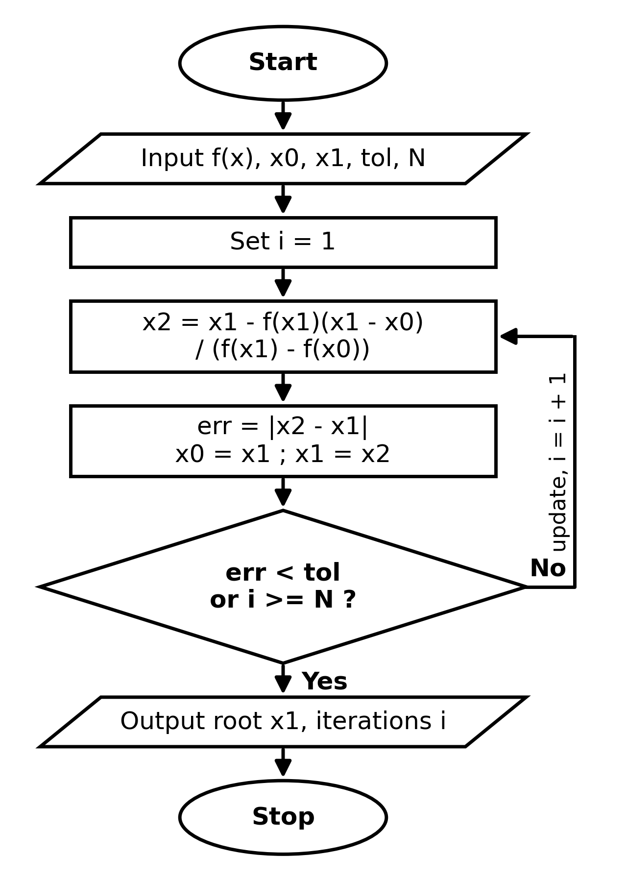
%% SECTION 2: SECANT METHOD
% Example function: f(x) = x^2 - 4
f_sec = @(x) x^2 - 4;
x0 = 1; x1 = 3;

% Secant using FOR loop
x_old0 = x0; x_old1 = x1;
for i = 1:max_iter
x2 = x_old1 - f_sec(x_old1)*(x_old1 - x_old0)/(f_sec(x_old1) - f_sec(x_old0));
x_old0 = x_old1;
x_old1 = x2;
end
fprintf('Secant (for loop) Root: %.5f\n', x2);

PSEUDOCODE:

INPUT: x0=1, x1=3, max_iterations N=20, tol=1e-5
FOR i FROM 1 TO N DO:
f0 = f(x0)
f1 = f(x1)
IF (f1 - f0) == 0 THEN STOP
x2 = x1 - f1*(x1 - x0)/(f1 - f0)
PRINT "Iteration", i, ": x =", x2
IF ABS(x2 - x1) < tol THEN BREAK
x0 = x1
x1 = x2
END FOR
OUTPUT: x2

Secant (for loop) Root: NaN

% Secant using WHILE loop
x_old0 = x0; x_old1 = x1; err = 1; count = 0;
while err > tol && count < max_iter
x2 = x_old1 - f_sec(x_old1)*(x_old1 - x_old0)/(f_sec(x_old1) - f_sec(x_old0));
err = abs(x2 - x_old1);
x_old0 = x_old1;
x_old1 = x2;
count = count + 1;
end
fprintf('Secant (while loop) Root: %.5f in %d iterations\n\n', x2, count);
PSEUDOCODE:
INPUT: x0=1, x1=3, tol=1e-5, max_iter=20
SET err=1, count=0
WHILE err > tol AND count < max_iter DO:
x2 = x1 - f(x1)*(x1 - x0)/(f(x1) - f(x0))
err = ABS(x2 - x1)
PRINT "Iteration", count, ": x =", x2
x0 = x1
x1 = x2
count = count + 1
END WHILE
OUTPUT: x2

Secant (while loop) Root: 2.00000 in 6 iterations
Example: x0​=1, x1​=3
Iteration for both loops

Iter i | X₀ | X₁ | F(x_{o}) | f(x1​) | x2​=x1​−f1​(x1​−x0​)/(f1​−f0​) | Error
1 | 1.000000 | 3.000000 | -3.000000 | 5.000000 | 1.750000 | 1.250000
2 | 3.000000 | 1.750000 | 5.000000 | -0.937500 | 1.947368 | 0.197368
3 | 1.750000 | 1.947368 | -0.937500 | -0.207756 | 2.003559 | 0.056190
4 | 1.947368 | 2.003559 | -0.207756 | 0.014248 | 1.999953 | 0.003606
5 | 2.003559 | 1.999953 | 0.014248 | -0.000190 | 1.999999 | 0.000047
6 | 1.999953 | 1.999999 | -0.000190 | 0.000000 | 2.00000 | 0.000000

Result: Converged in 6 iterations
RUNGE-KUTTA (4th ORDER) METHOD
Formula: y(i+1) = y(i) + (h/6)(k1 + 2k2 + 2k3 + k4)

Flowchart
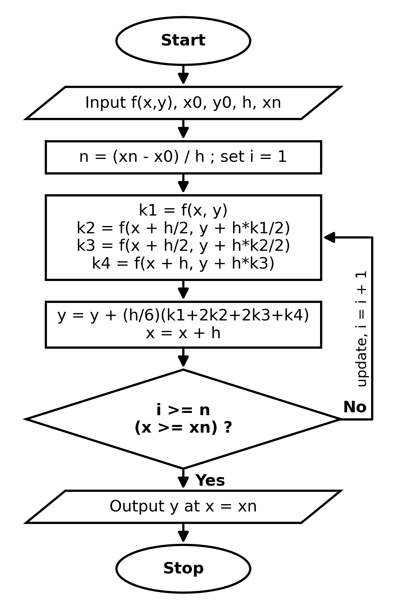

%% SECTION 3: RUNGE-KUTTA 4TH ORDER (RK4)
% Example ODE: dy/dx = x + y, y(0) = 1
f_rk = @(x, y) x + y;
x0 = 0; y0 = 1; x_end = 1; h = 0.1;
N = (x_end - x0)/h;

% RK4 using FOR loop
x_curr = x0; y_curr = y0;
for i = 1:N
k1 = h * f_rk(x_curr, y_curr);
k2 = h * f_rk(x_curr + h/2, y_curr + k1/2);
k3 = h * f_rk(x_curr + h/2, y_curr + k2/2);
k4 = h * f_rk(x_curr + h, y_curr + k3);
y_curr = y_curr + (k1 + 2*k2 + 2*k3 + k4)/6;
x_curr = x_curr + h;
end
fprintf('RK4 (for loop) y(1): %.5f\n', y_curr);
PSEUDOCODE:

INPUT: x0=0, y0=1, h=0.1, xn=0.5, N=5
SET x = x0, y = y0
FOR i FROM 1 TO N DO:
k1 = f(x, y)
k2 = f(x + h/2, y + h*k1/2)
k3 = f(x + h/2, y + h*k2/2)
k4 = f(x + h, y + h*k3)
y = y + (h/6)*(k1 + 2*k2 + 2*k3 + k4)
x = x + h
PRINT x, y
END FOR
OUTPUT: y

RK4 (for loop) y(1): 3.43656

% RK4 using WHILE loop
x_curr = x0; y_curr = y0;
while x_curr < x_end
k1 = h * f_rk(x_curr, y_curr);
k2 = h * f_rk(x_curr + h/2, y_curr + k1/2);
k3 = h * f_rk(x_curr + h/2, y_curr + k2/2);
k4 = h * f_rk(x_curr + h, y_curr + k3);
y_curr = y_curr + (k1 + 2*k2 + 2*k3 + k4)/6;
x_curr = x_curr + h;
PSEUDOCODE:

INPUT: x0=0, y0=1, h=0.1, xn=0.5, N=5
SET x = x0, y = y0
FOR i FROM 1 TO N DO:
k1 = f(x, y)
k2 = f(x + h/2, y + h*k1/2)
k3 = f(x + h/2, y + h*k2/2)
k4 = f(x + h, y + h*k3)
y = y + (h/6)*(k1 + 2*k2 + 2*k3 + k4)
x = x + h
PRINT x, y
END FOR
OUTPUT: y

end
fprintf('RK4 (while loop) y(1): %.5f\n', y_curr);
RK4 (while loop) y (1): 3.90833
Iter i | X | Y | K₁=f (x, y) | k₂​=f (x+$h/2)$ | k₃​=f (x+h/2, y+hk₂​/2) | k_{4​}=f (x+h, y+hk₃​) | y_{next}​=y+h/6(k₁​+2k₂​+2k₃​+k4​)
1 | 0.0 | 1.000000 | 1.000000 | 1.100000 | 1.105000 | 1.210500 | 1.110342
2 | 0.1 | 1.110342 | 1.210342 | 1.320859 | 1.326385 | 1.442980 | 1.242805
3 | 0.2 | 1.242805 | 1.442805 | 1.564945 | 1.571052 | 1.699910 | 1.399717
4 | 0.3 | 1.399717 | 1.699717 | 1.834703 | 1.841452 | 1.983862 | 1.583648
5 | 0.4 | 1.583648 | 1.983648 | 2.132831 | 2.140290 | 2.297677 | 1.797441

Result: At x=0.5, y=1.797441

