Fundamental Decisions in
Tabletop Role-Playing Games

Thomas Karaffa
ISYE 6644 – Simulation and Modeling for Engineering and Science

ABSTRACT

Tabletop Role-Playing Games (TTRPGs) are a collaborative form of storytelling, in which participants, within the boundaries of an established set of formal rules, improvise characterizations, settings, and stories. Typically, a character’s success, failure, and the degrees of each are determined by dice rolls. This work seeks to investigate the optimal answers to several common quandaries for players with regard to the construction of their characters. Although the simulations found hereafter may offer guidance for the TTRPG player, the nature of such games is that, much like real life, the number of decisions is infinite. As such, these simulations are limited in scope, and provide very specific answers to very specific questions.

BACKGROUND

The most famous TTRPG will also be the subject of the investigations in this work. Dungeons and Dragons^{[1]}, originally released in 1974, is currently in its fifth iteration (Dungeons and Dragons Fifth Edition). Only the rules for this most recent version will be considered during the explorations of this work. Typically, any action that a player (the actual person playing the game) chooses for their character (the imagined person in the story) is accompanied by the roll of a d20^{[2]} (a 20-sided die). The result of the roll determines whether the action is successful. Static modifiers^{[2]} may be added to the result under certain conditions – if a character is constructed to be very strong, they may be able to lift something heavy more easily than a weaker character. A character with a higher level^{[2]} (an integer value representing a character’s overall prowess, and corresponding to higher statistics and more powerful abilities available for use) will naturally be stronger in many categories. DnD 5th Edition eschews many (but not all) of these static additions for a simpler system, in which an advantageous situation confers the character Advantage^{[2]}, in which they roll two d20s, and use the higher result. A complementary system exists for disadvantageous situations, aptly named Disadvantage^{[2]}, in which they roll two d20s and use the lower result.
When battling enemies and monsters, characters engage in combat, in which each participant attempts to defeat their opponent by reducing their Hit Points^{[2]} (an integer-valued measurement of how much damage a character can take before being knocked unconscious or dying) to zero. A character rolls a d20 to attempt to hit^{[2]} their opponent with their weapon (a sword, or a bow and arrow) or by some other means (a magical spell). If the roll, plus any static value modifiers (positive or negative) meets or exceeds the target’s Armor Class^{[2]} (abbreviated as AC, an integer-valued measurement of how difficult it is to be hit), the attack is successful. The character then deals damage^{[2]} (the amount to be subtracted from the target’s hit points, which is determined by the roll of one or more dice, depending on the attack). Additionally, on a Natural 20 (when the value rolled on the d20 to-hit is a 20), the attack is always a hit, whether or not its adjusted value (the value of the die roll plus any modifiers) would meet or exceed the target’s AC, and the damage die/dice is/are rolled twice, rather than once. A Natural 1 (when the value rolled on the d20 to-hit is a 1), the attack is always a miss. When a target is reduced to 0 hit points, the battle is ended, and the character with positive hit points is the winner. The following simulations explore various combat situations, comparing different characterizations, to determine which build is superior.

METHODOLOGY

The simulations use a finite-horizon design, with the terminating event as a character being reduced to 0 hit points. Although technically more random values are generated than are required, the simulation effectively ends when the cumulative damage dealt to one character meets or exceeds their hit points.
Each replication is independent, as entirely new characters are generated at the start of the simulation.

1. Shield vs Two-Hand

When building a character, particularly a character focused on melee combat, a weapon and other implements can be used for various purposes. This simulation will explore the effectiveness of using a Longsword^{[2]} (a melee weapon, which has a damage die of a single 8-sided die, or 1d8, and the versatile^{[2]} property, which optionally allows its wielder to hold it with two hands, changing the damage die to 1d10) with or without a Shield^{[2]} (a one-handed piece of equipment that increases its user’s Armor Class by 2). The dichotomy in this simulation is: should a character use a shield to increase their AC by 2, or should they two-hand their weapon to increase their damage die from 1d8 to 1d10? The two characters will henceforth be referred to by their identifying names: Longswordington and Shieldsworth.

1a. Character vs Character

In the first simulation, a head-to-head battle between each character build is simulated. Besides the use of a shield or two-handing the longsword, each character’s statistics and abilities are equal – though through each level up, their hit points may diverge, because the number of hit points added at each level is determined through a die roll. Because each character uses the same 1d10 hit die^{[2]} (the die used to determine how many hit points are added to a character’s total at each level up), on average, it is expected that each character gains 5.5 hit points. It is also randomly determined through a die roll which character will act first, as actions happen in discrete increments. Other statistics (base AC and modifiers) increase in specified increments equally through level ups (e.g., both characters will have a base AC of 17 at level 1, and 21 at level 16). Through levels 1 through 20, both characters are pitted against each other, rolling to hit each other alternately. Intuition informs us that the character with the shield will be hit less frequently, because their AC is higher, and thus higher rolls are required for a successful hit. Conversely, the two-handing character will deal more damage on a successful hit, as their damage die is 1d10, instead of 1d8, increasing the expected value of a successful hit to 5.5 from 4.5.
This simulation measures 10,000 independent replications at each level, for a total of 200,000. The probability of one character winning is observed across levels, to see if there is a (or multiple) break point(s), in which one build starts to outperform the other, or if one consistently performs better. We assume our simulation will follow a binomial distribution, with the probability of one character winning as the value of the unknown parameter p (we will choose a win for Longswordington as the “success” case corresponding to p). Because we have a sufficiently high number of replications, we can assume that the sample mean of p closely matches the actual value of p by the Central Limit Theorem.

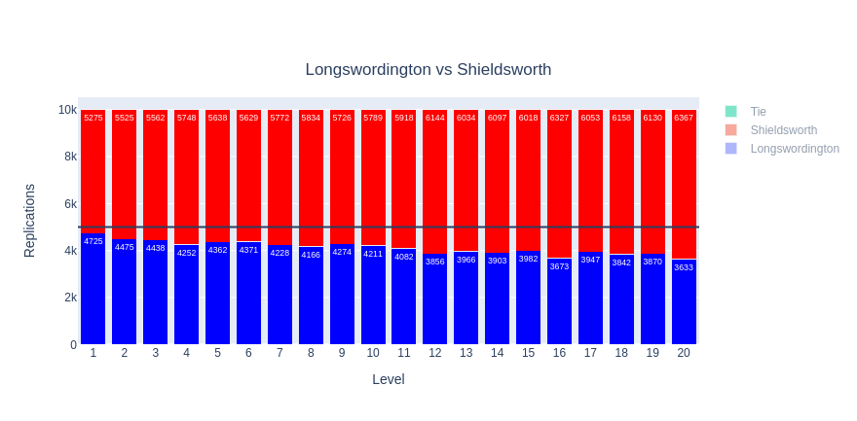
Across all levels, Shieldsworth consistently beats Longswordington, with the disparity slightly increasing at higher levels. At level 1, the sample mean, and the point estimator for p, is .4725 +/- .0049 in a 95% confidence interval, with a sample variance of .2492. Longswordington meets their lowest chance of winning at level 20, with a probability of .3633 +/- .0045 in a 95% confidence interval, and a variance of .2313. This implies that as levels increase, the extra AC provided by a shield offers enough survivability to avoid defeat, or that the extra 1 expected value of damage from two-handing the longsword is not enough to outweigh the decreased probability of actually hitting. However, Player-versus-Player combat is rare, and to answer this question functionally, a deeper investigation into unequal battles should be explored as well.

1b. Character vs Monster

Balancing Monster statistics presented challenges – typically the Challenge Rating^{[2]} (abbreviated CR, the analogous level for a monster) is matched for a party of four characters, e.g., a party of size four with average level 10 would be equipped to fight a single CR 10 monster. Thus, during these simulations, the monsters are reduced in strength befitting a one-on-one combat. True accuracy to the system is less important than for the character creation, as the monsters only serve as a baseline of comparison, and in each replication, the same monster is used in both Longswordington’s and Shieldworth’s fight, to ensure the pair of replications are identically-distributed. Generally, the monster’s statistics follow a triangular distribution adjusted for its CR; a deeper examination of the methods used to randomly generate the monster’s statistics is available in code documentation. With these considerations in mind, this subsequent pair of simulations followed an identical design pattern as the initial.
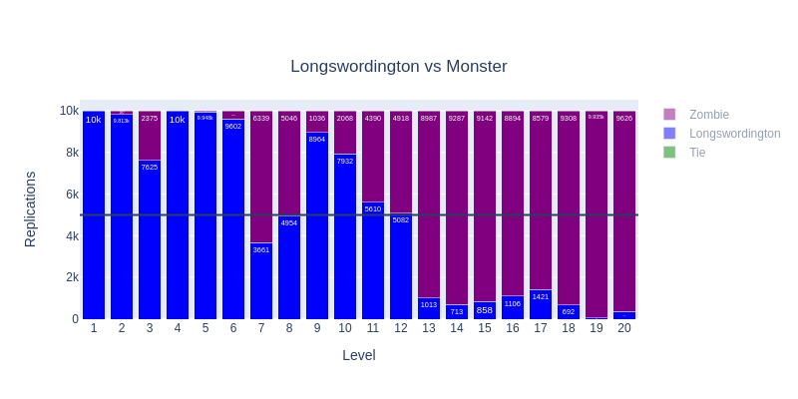
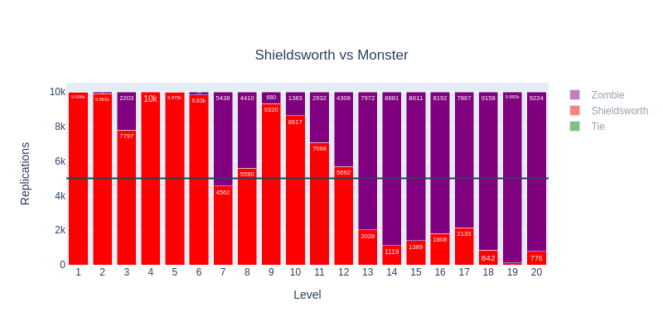
Both characters probabilities of winning follow similar trends: a small dip at level 7, immediately before a significant stat boost from level 8, then an additional +1 bonus in their to-hit, then a plummeting probability at level 13, where the odds of winning remain low through level 20. Shieldsworth is more resilience against the dip at level 7, but still ultimately is overpowered, with a paltry .0776 probability of winning at level 20. However, through all the levels, Sheildsworth’s probability of winning is consistently higher than Longswordington’s. Without diving deeper into simulations (adding party members, adding more items and options during combat, etc.), the conclusion that we can draw from these simulations is this: use a shield.

2. Greatsword vs Greataxe

Another common dichotomy is the choice of which weapon to use. The following simulations will address a classic debate: should a character use a Greatsword^{[2]} (a two-handed weapon with damage dice 2d6) or a Greataxe^{[2]} (a two-handed weapon with damage die 1d12). The greataxe’s damage is a uniformly-distributed random variable with an expected value of 6.5, while the greatsword’s is (discretely) triangularly distributed with an expected value of 7. Though the greatsword appears advantageous, the following simulations will attempt to offer insight into the debate in two specific circumstances. The following simulations are based on 100,000 replications, where the unknown parameter to estimate is the mean damage for each weapon type.

2.a Great Weapon Fighting

Great Weapon Fighting^{[2]} (an ability that allows a character to reroll 1s and 2s on any damage dice once) is a feat that can greatly benefit characters using two-handed melee weapons. Intuitively, having more damage dice means more chances to reroll low values – even before any simulation, we can guess that a greatsword will benefit more from this feat than a greataxe.
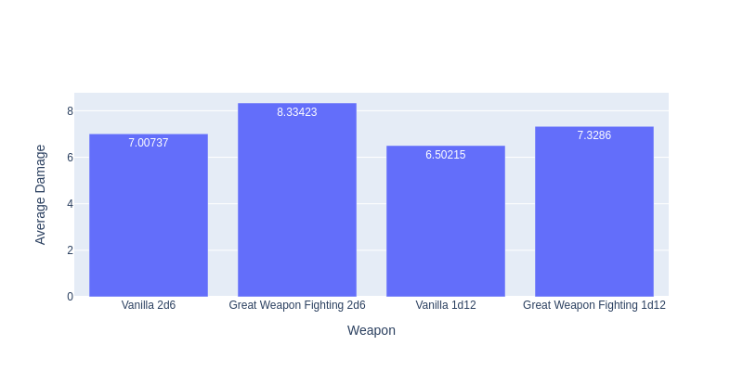
When using Great Weapon Fighting, a greatsword gains, on average, 1.34 points of damage per successful attack, while a greataxe only gains 0.84 points. This follows intuition, as the rerolled values (1 and 2) have a higher probability of being rolled (1/3) than on the greataxe (1/6). Thus, using a greatsword with Great Weapon Fighting is more likely to convert low rolls into higher ones.

This simulation, however, only takes into account the weapon properties themselves, and not any character-specific bonuses or abilities.

2.b A Realistic Pairing

Die rolls do not exist in a vacuum. Their final results are influenced by many factors
beyond the simple static modifiers. Commonly, for the Barbarian class^{[2]} (a class focused on dealing high amounts of damage and taking hits for the party), several feats and abilities combine to make an effective melee character. A Barbarian can choose to roll with advantage on any attack roll (while imposing advantage on all attack rolls against them), so all to-hit rolls used for this simulation are made with advantage. Another abilty used is Brutal Critical (an ability that allows one or more extra damage die to be rolled on a critical hit). As the Barbarian gains levels, Brutal Critical uses more dice and becomes more and more effective. The feature of interest is in the influence this ability, combined with Great Weapon Fighting, should have on a character’s weapon of choice.
Brutal Critical intuitively favors the greataxe over the greatsword, as on a critical hit, the rerolled die is 1d12 instead of 1d6. But when combined with Great Weapon Fighting, which favors the Greatsword, the answer becomes less clear. The following simulations explore several iterations of levels and ACs and compare the damage of each weapon type with both feats.

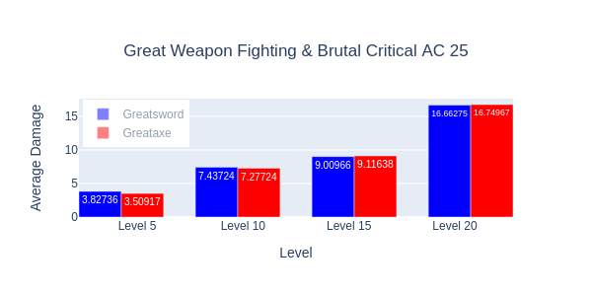
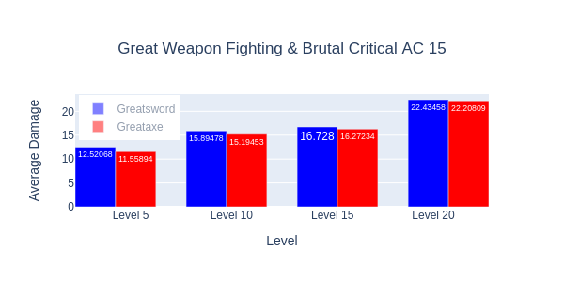
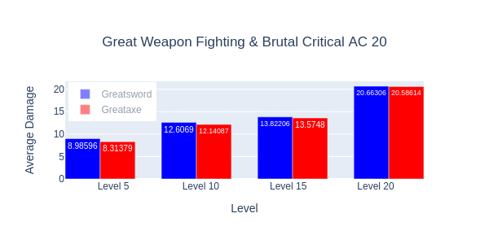
Against a target with AC 15, the greatsword consistently beats out the greataxe in average damage. At level 5, before Brutal Critical is available, the difference is more pronounced, with almost an entire point advantage for the greatsword. As the Barbarian levels up, this effect diminishes, and at level 20, there is only a .21 difference in expected damage.
At AC 20, the gap begins to narrow, as more successful attacks are critical hits, and thus gain the average of 6.5 points of damage per extra die from Brutal Critical when using a greataxe, instead of only 3.5 when using a greatsword. However, at level 20, the greatsword is still slightly preferable, with .08 higher expected damage per attack.
At AC 25, where many attacks are outright misses, critical hits become a relatively more common source of damage; they may represent as much as 25% of all attacks, making Brutal Critical more important. At level 20, the greataxe finally edges out the greatsword, with an expected .13 more damage per roll.
The conclusion from this simulation is this: at higher ACs, a greataxe is preferable for a Barbarian, due to the increased importance of critical hits as a source of damage. At lower ACs, and lower levels, the greatsword is preferable, due to its higher base expected damage, as well as its ability to capitalize on the benefits of Great Weapon Fighting.

CONCLUSION
WORKS CITED

[1] https://en.wikipedia.org/wiki/Dungeons_%26_Dragons

[2] Wizards of the Coast LLC (2014). Dungeons & Dragons Player’s Handbook

