**STEPS TO FOLLOW WHEN CREATING QUOTATION E36**

After You Receive an email from a Respective Engineer follow the following steps

The email looks like the one bellow

**Steps you follow to have information You will use to create The Quotation (e36)**

**Step1**

* Search for the locations of the client Who requires the Services using google Maps or Google Earth

**Step 2**

* Enter the coordinates given in the email of the clients location on Google Maps or Google earth

**Step3**

* Call the BPS responsible to that area ,you can find the contact of the BPS in the Contact Details Document
* When You call the BPS asks for the following information
* The fibre length from the nearest point of present(this is the place where we can connect the clients fibre) to the clients Location
* The types of fibre (ADSS OR DUCTED)

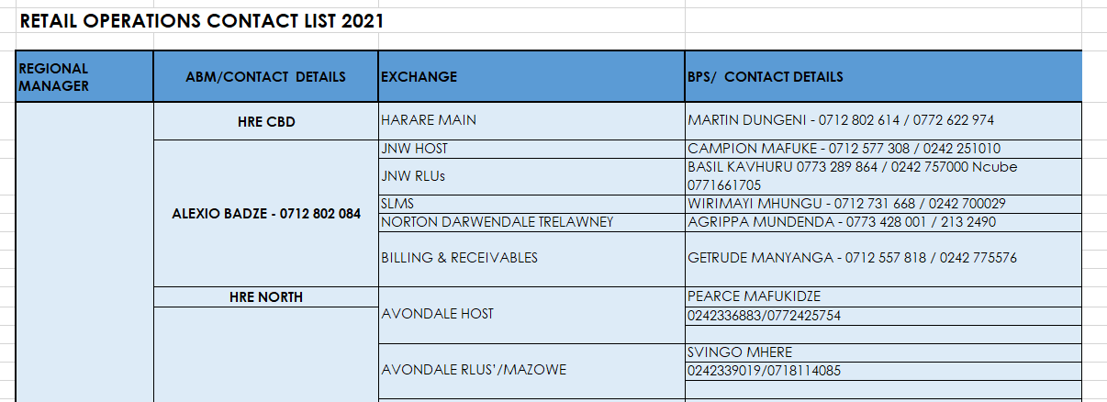

Screenshot of the Contact list

**Step4**

* Find The Distance from the Nearest Telone Exchange to the Clients location using google Maps or Google earth

**Step5**

* Using the information You have create The Quotation(e36)

**How To Create The Quotation**

1. Open The Template for ADSS and for Ducted Respectively according to the fibre Type(The fibre type as stated by the BPS)
2. Edit the Name of the Client Name Where it is Written Client’s Name
3. **Engineering Cost**

Under this heading do not change anything on the template

Unless stated otherwise.

1. **Construction**

**Ducted**

* If it is a new installation charges like trenching, backfilling, HDPE pipe laying and cable laying duct are included.
* If it’s not a new installation charges like duct clearing and cable laying duct are included.
* You add the above charges by adding the fibre length in the quantity column.

Given the given the fibre length is X:

Ducted new installation:

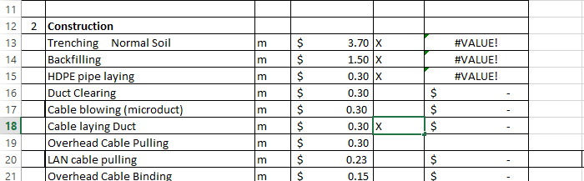

Old installation:

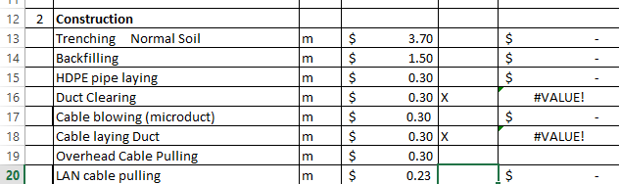

**ADSS**

* If it’s an ADSS installation the following charges are included overhead cable pulling, overhead cable binding, pole fixing, hole digging, pole planting, pole preparation, stay wire preparation.
* How to calculate number of poles: Divide fibre length by 70 for long distances and by 50 for short distances.
* To calculate number of ten meter poles divide the total number of poles by 5.
* The value you get for 10 meter poles is the same value you use for stay wire prep.

Given the fibre length is X, number of poles is Y, number of 10m is Z:

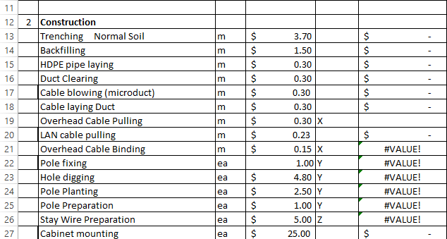

* Under construction in quantity Colum for cabinet mounting, configurations and end to end testing, the value is normally one.
* Also charge for cable splicing and cable termination the value is normally 2.

