INTERNSHIP LOGBOOK & ASSESSMENT FORM

Name of the trainee: Takudzwa Paul Katyora…
Department: National Implementation Corporates Solutions…………………
Student Registration number: NT02022370Y………
Period: from …01/08/2023 to 31/08/2023……………..
Name & address of the company: …TelOne (Pvt) Ltd, Runhare House.
107 Kwame Nkrumah Avenue Harare
Name of the internship supervisor: …………Primus Tsaurai……………………

What does a trainee write in a logbook?
The trainee describes the activities he/she has done during the working hours. He/She can add some personal comment (e.g. if there was a problem). The Logbook is written in ENGLISH.
If absent from work on a particular day state the reason of being absent in the log book.

Importance of a Logbook
The trainee can use these notes to write final report at the end of the internship.
Coordinator at school can use it as a source of information to evaluate the workplace.

How detailed does it have to be?
2 or more sentences per day describing the activities done, how they were done and the new skill gained

Does the supervisor have to sign it?
A logbook contains an assessment that your internship supervisor will have to fill in at the end of every week and at the end of internship period and sign. Don’t forget to show him before you leave!

Advice to the trainee
Don’t postpone filling it in because you will easily forget things; The best is to fill in an internship logbook at the end of every day.

Week 9 [Date :from..25/09/23....to .29/09/23...]
Monday

Received many Quotations from The Engineers which requires to be done. Created some of those ………………………………………………………………………………………………………………… Quotations for clients. Updated the system we used to calculated the financial part so that is can
…………………………………………………………………………………………………………………..
Help us in calculations of the poles and some of the things needed for the creation of Quotations …………………………………………………………………………………………………………………
I have added the picture of the system in use for the help of calculation.
Tuesday

Did not go to work because I was not feeling well. I was given 1 day off from work.
…………………………………………………………………………………………………………………
Wednesday
Went out to Clients Location( Telone Center for Learning) to Troubleshoot some Access Point ………………………………………………………………………………………………………………… which were not working properly and install one Access Point. Learned how to sight a position to ………………………………………………………………………………………………………………… install an Access point so that it can cover a as many people as possible .Also learn some trouble ………………………………………………………………………………………………………………… shooting technique if there is a network problem caused by Access Points, Learned how to ………………………………………………………………………………………………………………… configure an Access Point .Helped in Writing the weekly report with the help of the system we ………………………………………………………………………………………………………………
Developed

Thursday
Updated the jobs of the Engineer I am responsible to updated. Did some Quotations. Went …………………………………………………………………………………………………………………
out to Telone Center for Learning( TCFL) to continue on the trouble shooting. I Learned that a poor ………………………………………………………………………………………………………………… cable termination can caused a network failure. …………………………………………………………………………………………………………………………
Friday
Went out to Clients Locations for training of the system which was developed to be used for
………………………………………………………………………………………………………………… smart Wi-Fi project which was installed. Went back to the office after training and did some. ………………………………………………………………………………………………………………… quotations. Went out to see the data centre. Learned how the core network works, See the IP ………………………………………………………………………………………………………………… MPLS nodes and all the connections …………………………………………………………………………………………………………………
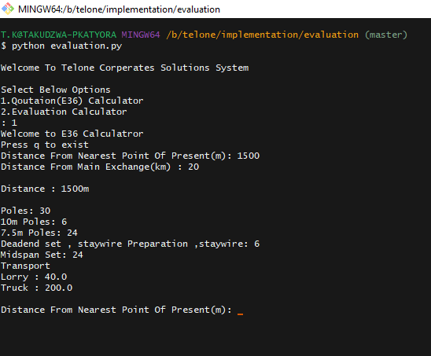
Fig 9.1 Updated Version of the python Script Including calculations for Some of materials for E36

Internship supervisor comment

…………………………………………………………………………………………………………………

…………………………………………………………………………………………………………………

Name: …………………………………… Date: ………… Signature: ………………

Lecturer visit: comment
……………………………………………………………………………………………………………………………………………………………………………………………………………………………………
Name: …………………………………… Date: ………… Signature: ………………

Week 10 [Date:from.02/10/203..to 06/09/2023...]

Monday
Went out for a site survery ,we saw the server room of the client .Learned how to use
...........................................................................................................................................................OTDR(OPTICAL TIME DOMAIN REFLECTOMETER) to check the distance of fibre and also to ............................................................................................................................................................check if there are fibre breaks.

Tuesday

I was involved in a project to connect to a client in South Africa terraco from harare.Went out to the
............................................................................................................................................................data centre in the MDF (main distribution frame) as to see the connections which can be
............................................................................................................................................................don.Drwa the pissibel solutions which can be used.Saw the cable Volt.
………………………………………………………………………………………………………

Wednesday
Helped in Writing the weekly report with and updated Engineers Jobs also do some Quotations ………………………………………………………………………………………………………….

Thursday
We did some quotations for a VPN and leased lines. We went out with an engineer for a site a ………………………………………………………………………………………………………………… survey for the relocation of Shamwa Tollgate. Created a word document of wat we had found from
………………………………………………………………………………………………………………….. the site survey

Friday
Did E36 for clients and finalised in the rotation schedule and also continued developing the system
…………………………………………………………………………………………………………………
for attaches

Week 11 [Date:from.09/10/203..to 13/10/2023...]

Monday
…………………………………………………………………………………………………………… contacted the bidders who did not provide datasheets to provide them.

Tuesday

Wednesday
The Evaluation was sent back to us to make some adjustments and we re-evaluate s ……………………………………………………………………………………………………
Specific SFP, writing the reasons why the bidders did not win. I also do some Quotations ………………………………………………………………………………………………………….

Thursday
We did some quotations for a VPN and leased lines. We went out with an engineer for a site a ………………………………………………………………………………………………………………… survey to hear what the client wanted and to negotiate with them. We saw the client’s server room ………………………………………………………………………………………………………………… booked a day to come and do another site survey. I learned how to do a site survey and how to ………………………………………………………………………………………………………………… negotiate with clients on the technical part.
…………………………………………………………………………………………………………………
Friday …………………………………………………………………………………………………………………
Did some leased line that’s was required .Learned about IP MPLS how it operates in providing …………………………………………………………………………………………………………
internet and VPN Connections to Clients. Draw a diagram in a technical proposal suing lucid ………………………………………………………………………………………………………………… charts .Learned how to draw network diagrams using Lucid Charts …………………………………………………………………………………………………………………

Week 12 [Date:from.16/09/203..to 20/09/2023...]

Monday
I changed department ,and i was assigned to the Interbet and data department.I was told how the …………………………………………………………………………………………………………… department works (orientation).I drew the Internet architecture using lucid chats.

Tuesday

.I drew the Internet architecture using lucid chats.I have included the network diagram below.
………………………………………………………………………………………………………
I learned how to search for free IP A ddress in the sheets which contains IP blocks
…………………………………………………………………………………………………………………
Wednesday
I was taught how to answer call from client s and other telone staff who will be complaining about
……………………………………………………………………………………………………
Internet issues. Learned how to answer calls in a professional way. I learned how to configure a
………………………………………………………………………………………………………….
Router

Thursday
Learned how to configure a DNS server, registering domains for clients. Learning Linux
…………………………………………………………………………………………………………………..commands that a used to restart the server, adding the name server

Friday …………………………………………………………………………………………………………………
Configures the router interfaces assigning IP address to the other department which was
…………………………………………………………………………………………………………………..responsible for pushing data to the clients side. Hosted and Doman for a certain client .learned
…………………………………………………………………………………………………………………..how w to hoist a domain by assigning an IP address to a name server
..…………………………………………………………………………………………………………
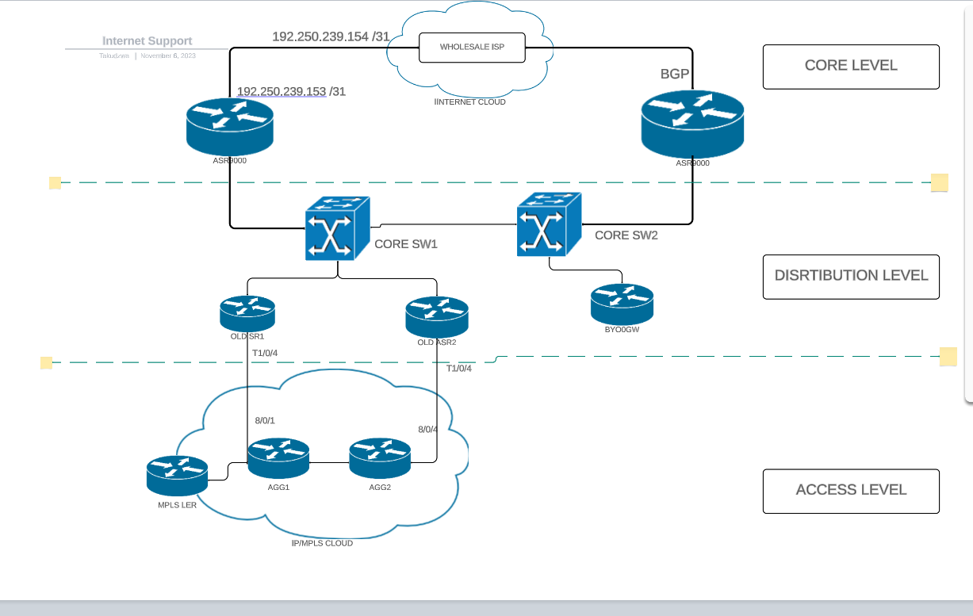
Fig 11.1 Network Diagram of Internet Architecure

Week 13 [Date:from.23/10/203..to 027/10/2023...]

Monday
Learned how to find TheSAP and the interface of a client given the vlanID of theta clinet.Answered
............................................................................................................................................................. call fromm data centre ,and give thenm the IP of a clint connected to the SAP interrface they ……………………………………………………………………………………………………………
provided
Tuesday

We continued with the evaluations on the financial side.We complete this side for all Bidders.
………………………………………………………………………………………………………
We then awarded the winner .We then submitted it to the engineer who was responsible for the ………………………………………………………………………………………………………………… evaluation

Wednesday
The Evaluation was sent back to us to make some adjustments and we re-evaluate s ……………………………………………………………………………………………………
Specific SFP, writing the reasons why the bidders did not win. I also do some Quotations ………………………………………………………………………………………………………….

Thursday
We did some quotations for a VPN and leased lines. We went out with an engineer for a site a ………………………………………………………………………………………………………………… survey to hear what the client wanted and to negotiate with them. We saw the client’s server room ………………………………………………………………………………………………………………… booked a day to come and do another site survey. I learned how to do a site survey and how to ………………………………………………………………………………………………………………… negotiate with clients on the technical part.
…………………………………………………………………………………………………………………
Friday …………………………………………………………………………………………………………………
Did some leased line that’s was required .Learned about IP MPLS how it operates in providing …………………………………………………………………………………………………………
internet and VPN Connections to Clients. Draw a diagram in a technical proposal suing lucid ………………………………………………………………………………………………………………… charts .Learned how to draw network diagrams using Lucid Charts …………………………………………………………………………………………………………………

Week 14 [Date:from.30/10/203..to 03/10/2023...]

Monday
……………………………………………………………………………………………………………

Tuesday
………………………………………………………………………………………………………
…………………………………………………………………………………………………………………

Wednesday
……………………………………………………………………………………………………

Thursday
Changed TXT record for a client who required to add TXT records to her domain ,………………………………………………………………………………………………………………… …………………………………………………………………………………………………………………
…………………………………………………………………………………………………………………

Friday …………………………………………………………………………………………………………………
…………………………………………………………………………………………………………
………………………………………………………………………………………………………………… …………………………………………………………………………………………………………………

Week 15 [Date:from.06/11/203..to 11/10/2023...]

Monday

Did Accepteance testing of a new sysyem which was implemneted.Answered calls and help other telone saff whiich where not accessingb the internet
…………………………………………………………………………………………………………… Tuesday

………………………………………………………………………………………………………
…………………………………………………………………………………………………………………

Wednesday
……………………………………………………………………………………………………
………………………………………………………………………………………………………….

Thursday
………………………………………………………………………………………………………………… ………………………………………………………………………………………………………………… …………………………………………………………………………………………………………………
…………………………………………………………………………………………………………………
Friday …………………………………………………………………………………………………………………
…………………………………………………………………………………………………………
………………………………………………………………………………………………………………… …………………………………………………………………………………………………………………

Week 20 [Date:from.01/01/2024..to 05/01/2024...]

Monday

…………………………………………………………………………………………………………… Tuesday

………………………………………………………………………………………………………
…………………………………………………………………………………………………………………

Wednesday
Started on a Netone metropolitan dark fibre, creating the project file for the network Creating .……………………………………………………………………………………………………
An E36 a client
.………………………………………………………………………………………………………….

Thursday
………………………………………………………………………………………………………………… ………………………………………………………………………………………………………………… …………………………………………………………………………………………………………………
…………………………………………………………………………………………………………………
Friday
Went out for a preinstallation site survey of the Netone metropolitan dark fiber network.Continued …………………………………………………………………………………………………………………
to create the project file for the netone project.Created an E36 for a client.Learned on how to carry …………………………………………………………………………………………………………
out a preinstallation site survey as well as to create a project sign off form . ………………………………………………………………………………………………………………… …………………………………………………………………………………………………………………

Internship supervisor comment
…………………………………………………………………………………………………………………
…………………………………………………………………………………………………………………

Name: …………………………………… Date: ………… Signature: ………………
Lecturer visit: comment
……………………………………………………………………………………………………………………………………………………………………………………………………………………………………
Name: …………………………………… Date: ………… Signature: ………………

FINAL ASSESSMENT

A = excellent (9-10) B = good (8-7) C = sufficient (6-5) D = insufficient (4-0)

Competences OF THE TRAINEE |  |  | Score
Professional knowledge |  | 1. Does the trainee understand the basic techniques? | A – B – C – D
SKILLS | 2. Practical skills: ability to apply the basic techniques on an independent basis |  | A – B – C – D
SKILLS | 3. Technical analysis and problem-solving skills – Critical thinking |  | A – B – C – D
SKILLS | 4. Language skills – Communicative skills |  | A – B – C – D
ATTITUDES | 5. Order, punctuality and work speed |  | A – B – C – D
ATTITUDES | 6. Motivation: attention, interest, independent work, commitment |  | A – B – C – D
ATTITUDES | 7. Finishing off: execute assignments completely and properly, understanding quality |  | A – B – C – D
ATTITUDES | 8. Respect, positive attitude (tolerance, courtesy, decent language, no bullying, acceptance of authority, respect for multiculturalism, care for material) |  | A – B – C – D
ATTITUDES | 9. Social behaviour, working in a group (attitude towards co-workers) |  | A – B – C – D
ATTITUDES | 10. Ability to take initiative, act independently - Flexibility, creativity and inventiveness |  | A – B – C – D
General evaluation: |  |  | A – B – C – D

Remarks: ……………………………………………………………………………………………………………………………
……………………………………………………………………………………………………………………………………………………………………………………………………………………………………………………………………………………………………………………………………………………………………………………………………………………………………………………………………………………………………………………………………………………………………………………………………………………………………………………………..
Name supervisor: …………………………………… Date: ………… Signature: ……………

