Bayes Visualizer

**Introduction**

Bayes visualization application has been developed by collecting information from clinical literature, integrating Bayes’ theorem into the application algorithm and displaying the calculated result using visualization techniques.

The visualized results will help users to compare and decide which diagnostic test is the most appropriate one to order. For the prototype of Bayes visualization application version 1.0, we included related parameters (prevalence of diseases, sensitivity, and specificity of diagnostic tests) of two different diseases - thyroid disease and colorectal cancer.

Web link: <http://bayesvisualizer.comyr.com/BayesVisualizer/index.php>

(Please ignore the ads. We used a free hosting service).

Once users select a disease and enter a prevalence, the application will show post-test probabilities given test results is positive and negative on the right side of a users’ screen.

Users can access the prototype of the application through the following web link (<http://bayesapp-ajonsukdomain.rhcloud.com/>) which works best on Google Chrome web browser.

**Discussion of the prototype**

1. **Result accuracy:**

By calculating post-test probability manually compared to the result from the application, we found that the application is very accurate which indicates that there is no flaw in the calculation algorithm of the application.

1. **Usefulness of the application:**

The application still requires lots of improvement by integrating proposed visualization models into the application. We envisioned our application to take into account age, sex and race and how they affected the post-test probability of having the disease. However, unfortunately the application at this stage does not perform as such. It only utilizes prevalence information in the calculation because we do not have the data to factor in the effects of these parameters into our calculation.

3) **Website Appearance and display**

* The way the additional information (cost, risk) is displayed is not optimal. We sought to display it when the user places the cursor on the specific test but this could not be implemented due to time constraints and issues with the health of the programmer.
* The website still requires lots of improvement on the appearance to make it look more professional.
* The layout of the visualization model need to be refined and improved upon

**Discussion of the visualization models**

1. **Step bar chart**

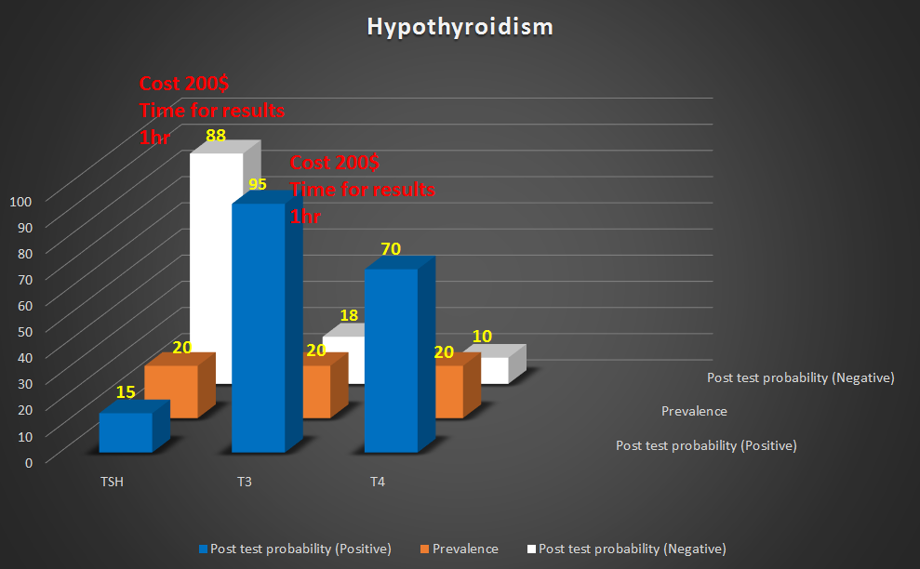

The step bar comes in three distinct colours for post test probability given test is positive, post test probability given test is negative and prevalence. The names of the test are clearly labelled and the percentage figures are shown on each bar.

**Strength:**

1. Simple and conservative way to represent value in different types of categories. Easily understood by the users.
2. The impact of changing prevalence on post-test probabilities can be easily appreciated because the post-test probability is placed closed to each other and clearly organized by a particular type of diagnostic tests.

**Weakness:**

One possible weakness is that it is not a compact model to represent probabilities of different diagnostic tests. Imagine that a disease has more than five related diagnostic tests, this model will contain at least fifteen bars as a result. The users may be overwhelmed by a number of bars and values displayed on their screen.

1. **Stack bar chart model**

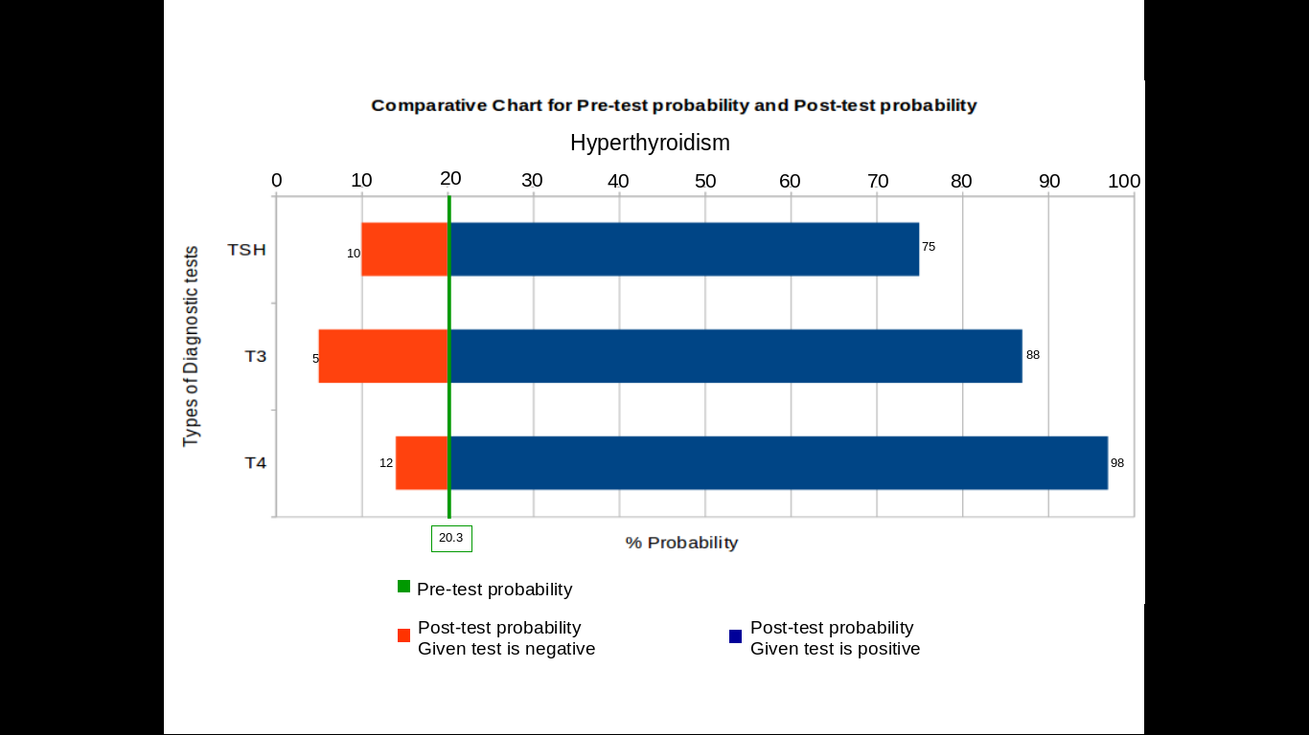

Given different type of the test related to a particular disease on Y-axis and percentage of probability on X-axis, this model is derived from the step bar chart by flattening out values of prevalence into a line which make this model looks more compact than the step bar chart.

* The green line represents the prevalence values.
* The orange bar represents post-test probability given a test result is negative.
* The blue bar indicates post-test probability given a test result is positive.

Users can read values of post-test probabilities from the numbers indicating on the boundary of each bar chart.

**Strength:**

1. The stack bar chart is an efficient way to represent all post-test probabilities of several tests associated to a disease within a limited area of a user’s screen because the bars representing prevalence are reduced into a line.
2. It is also easy to compare the value of probabilities of different tests by looking at the height of the bar chart.

**Weakness:**

This model may not be intuitive at the first time the users see it. It requires effort to understand. Unlike a typical stack bar chart which normally has the origin of all bars starting from zero, the origin of the bars in this model initiate from prevalence which is not located at zero and it can be dynamic according to prevalence adjusted. Therefore, the users need to get use to the concept of the models in order to interpret results.

**3) Gauge model**

The gauge comes in the complete ring form partitioned into post-test probability given a test is positive colored green and post-test probability given test is negative colored yellow. The ring starts from 0-100% for green and again 0-100 for the yellow.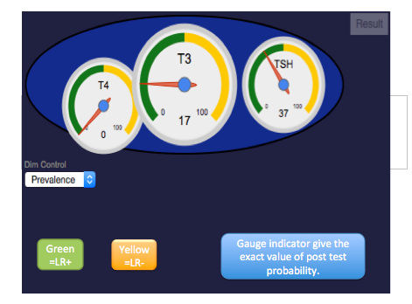

**Strength:**

It is very intuitive, easy to understand and read the result.

**Weakness:**

Users cannot compare post-test probability given test positive and post-test probability given test negative at the same time because a gauge which represents a diagnostic test has only one needle to indicate either post-test probability given test positive or post-test probability given test negative.

**4) Three rings model**

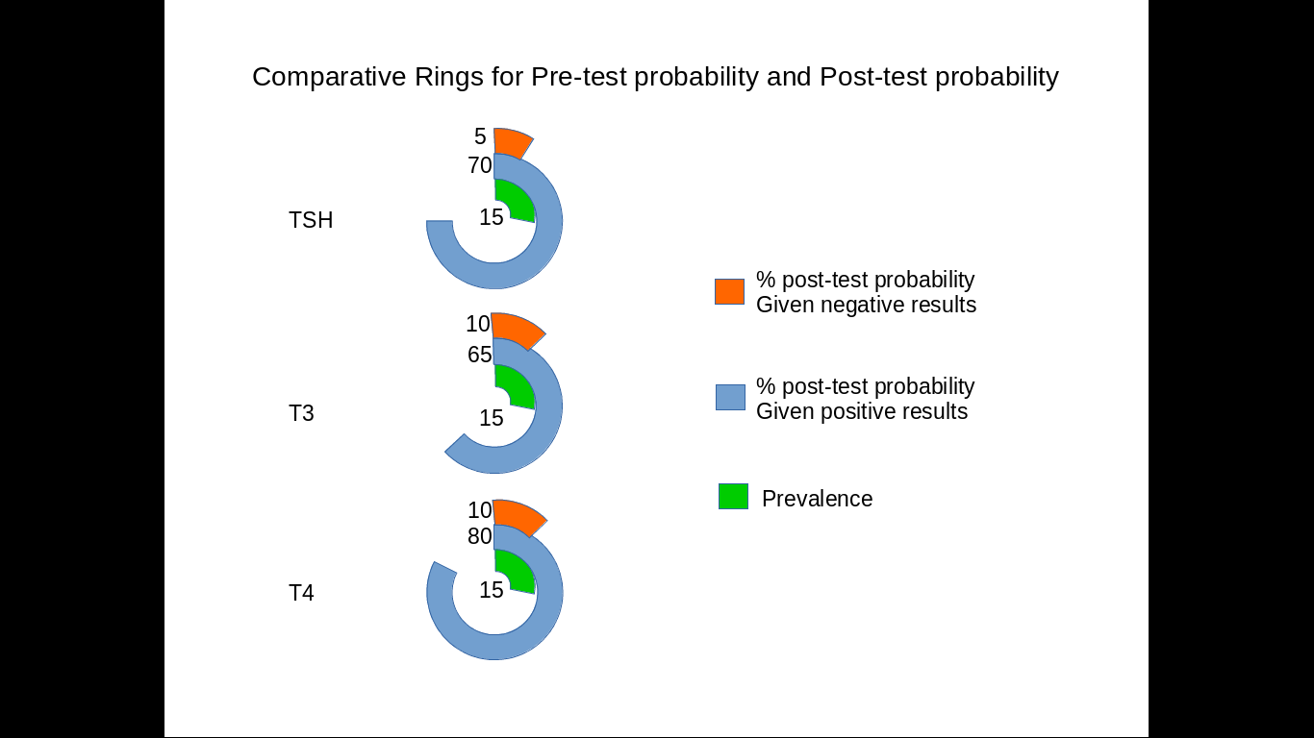

With the same concept as the bar chart described in the first model, however, the three ring model converts straight bars into rings and assembles those three rings to represent three type of probability-- prevalence (green ring), post-test probability given test result positive (blue ring) and post-test probability given test result negative (orange ring). The numbers close to each ring indicate the value of probabilities and a 360-degree ring is equal to 100% probability. Each row shows different diagnostic tests of a specified disease.

**Strength:**

It is a straightforward model to represent probabilities correctively. It can be removed a probability scale out of the model because it is intuitive enough for the user to understand that 360-degree rings means it is 100 % probability.

**Weakness:**

One major weakness of the model is that the area of a ring or the length of a ring is incomparable for different types of probabilities. In this model we use degree of the ring to represent the probabilities which may confuse some users.

**Limitations**

1. Our biggest limitation has been with the development component; we did not have enough members with programming skills to be able to get the application look the way we envisioned it to be.
2. There are functions we could not implement such as determining the false positive rate for a test and making it available to the clinician for assessment.
3. We could not implement all the 4 models. The last model was the most liked based on our user study. We are working on integrating it to the web application.
4. We could not integrate the diseases model from SNOMED or display the risk factors for the diagnostic tests.

**Appendix**

**Below are the screen shots of the questionnaire implemented in Google Forms**

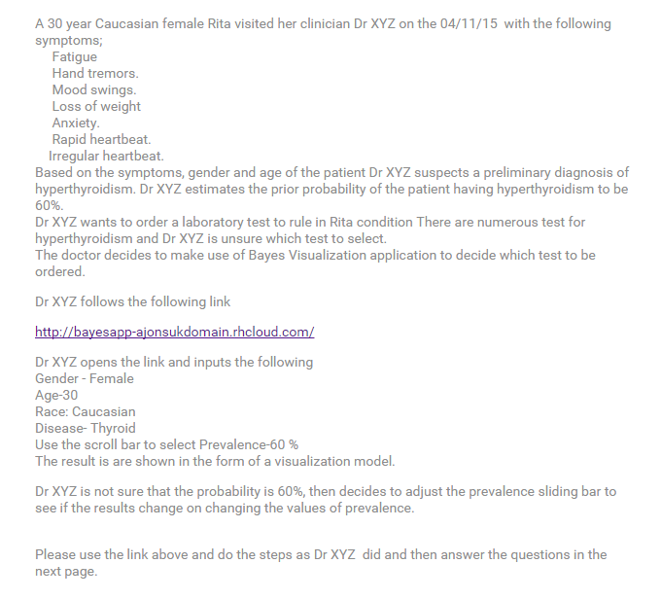

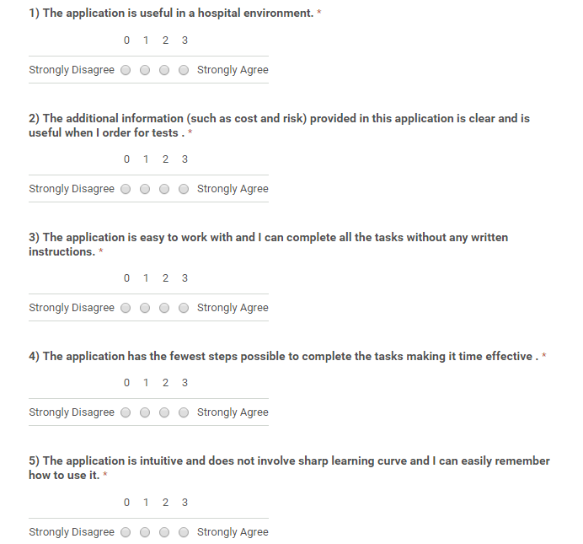

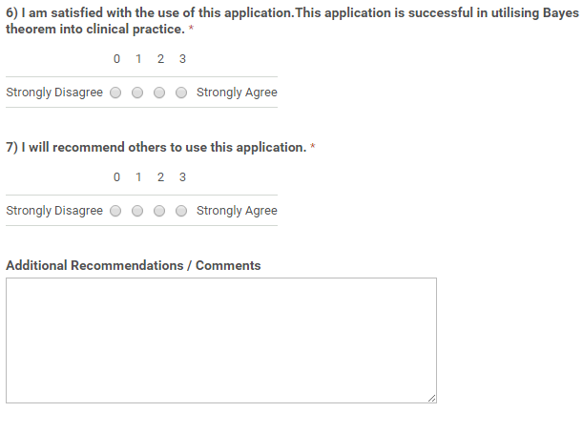

**Model 1**

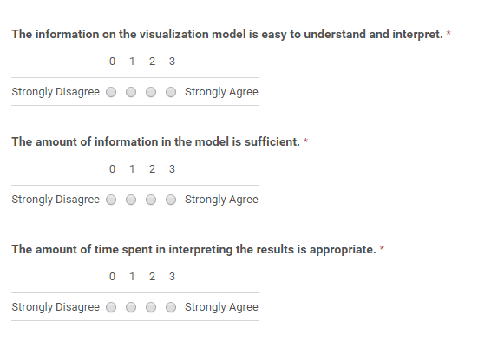

## Model 2



**Model 3**



**Model 4**



