**Butch Cassidy and the Blairlogie Connection**

Butch Cassidy was born in America, but his great-great grandparents and his great grandparents lived in Blairlogie.

Church records do not indicate which house that the **Gillies**’s lived in. Yes this is the name of the family who ultimately spawned **Butch Cassidy**. As you will see later, neither of these names were his given names but ones that he adopted himself.

But back to Blairlogie. Butch’s great-great-great grandfather, **James Gillies** was born in Logie, in Perthshire in 1756 and he married **Marrion Marshall** (born 1760) in Alloa on 8th April 1782 when James was 26 years old and Marrion was 22 years. The couple had at least one child and he was called **John Gillies** and was born in Logie, Perth in 1771 and died in 1857. John married **Christian Gibb** in Blairlogie on 11th November 1818. **Christian Gibb** was born at Bridge of Earn on 3rd January 1796 and died in 1843.

Butch’s great-grand parents **John Gillies** and **Christian Gibb** had a son who they called **Robert Gillies** and he was born in Blairlogie on 8th July 1820 and died in Farmington in Utah on 6th October 1866. **Robert Gillies** married **Jane Sinclair** around 1844. Jane was born in Killin, Perthshire on 5th May 1819 and died on 25th August 1899 in Circleville, Utah, aged 80 years.

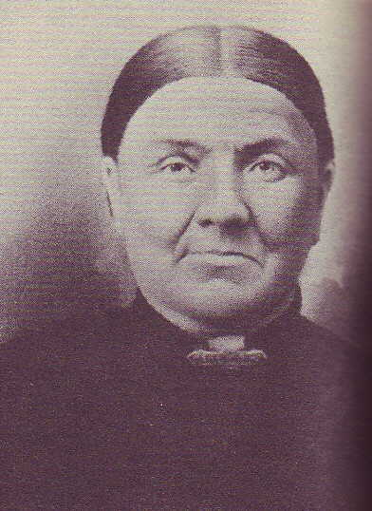**Jane Sinclair**

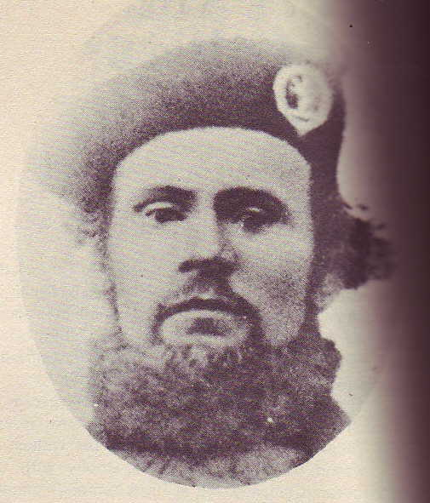**Robert Gillies**

The grand-parents **Robert Gillies** and **Jane Sinclair** had at least four children, but the one of particular interest to Blairlogie is **Ann(ie) Campbell Gillies** who was born on 12 July in Edinburgh and died in Panguitch, Utah on 1st May 1905 aged 59 years. **Ann Campbell Gillies** left Scotland with her parents and on 18th April 1856 sailed on the Samuel Curling to Boston in the U.S.A., arriving on 23rd May 1856. The Gillies family started for Utah in 1856 in the **Hodgetts Company**, but halted somewhere along the way. On 1st June 1857 the family left with the **Jesse B Martin**, **Handcart Company**. Between July 11 and July 17, they decided to stop traveling with the company and turn back. They arrived in Beaver, Utah just over one month later, arriving on 17th July 1857. For details of this harrowing trip, please see the Journal at the end of this story.

The Gillies family eventually made it to Utah by 1859 as they were enumerated in the 1860 census in Beaver in July 1860.

**Ann Campbell Gillies** married **Maximilian Parker** (Born 1844 and died 1938), on 12th July 1865 at Beaver, Utah. They were some of the early Mormons to settle the area. **Ann and Maximilian** had a total of 13 children. The eldest was called **Robert Le Roy Parker** who was born on 13th April 1866 in Beaver, Utah. We will return to this child later as he was to morph into **Butch Cassidy.**

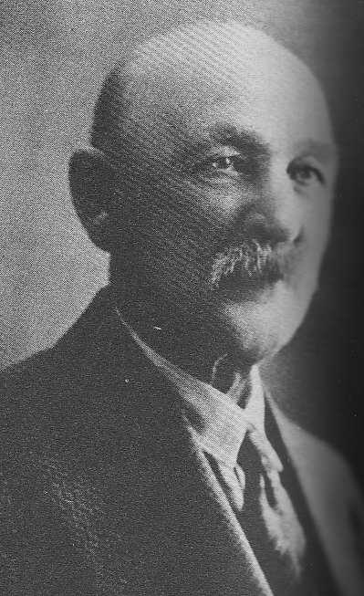**Maximilian Parker**

**Jane Sinclair**

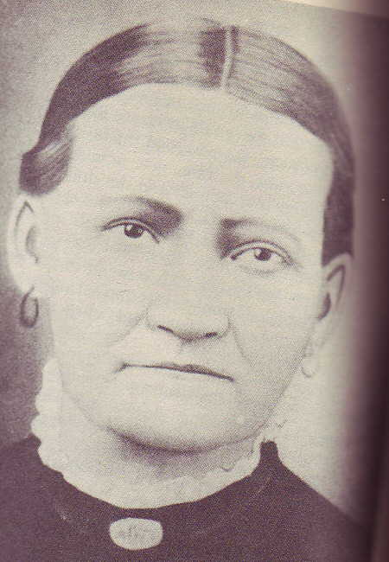**Ann Campbell Gillies**

**Jane Sinclair**

The 12 other children were:

**Daniel Sinclair Parker**, born 21st November 1867 in Washington, Wash, Utah, died 1942.  
**Arthur Parker**, born 6th November 1869, Beaver, Utah, died 1890.  
**Jean Ann Parker**, born 16th October 1871, Beaver, Utah, died 1960.  
**William Moroni Parker**, born 23rd February 1874, Beaver, Utah, died 1952.  
**Sue Knell Parker**, born 24th August 1876, Beaver, Utah, died 1964.  
**Max Ebenezer Parker**, born 19th June 1879, Cleveland, died 1957.  
**Blanch Alice Parker**, born 16th November 1881, Beaver, Utah, died 1967.  
**Lula Parker**, born 5th April 1884, Beaver, Utah, died 1980.  
**Mark D’ Laffiet Parker**, born 4th October 1886, Beaver, Utah, died 1932.  
**Nina Grace Parker**, born 26th January 1889, Beaver, Utah, died 1923.  
**Leona Hartley Parker**, born 19th November 1891, Circleville, Piute, Utah, died 1937.  
**Joseph Rawlins Parker**, born 25th May 1894, Circleville, Piute, Utah, died 1962.

**Robert Le Roy Parker alias Butch Cassidy**Butch was born to a poor Mormon family and his grandparents and parents were Mormons who moved from the United Kingdom in the 1850s. They answered the call of Brigham Young to help to establish Mormon communities in Utah. They settled first in Beaver and then were in Circleville by 1879 where they farmed and raised cattle. In an attempt to improve his lot and make a better living than his parent, Butch left home as a teenager to work in other ranches.

[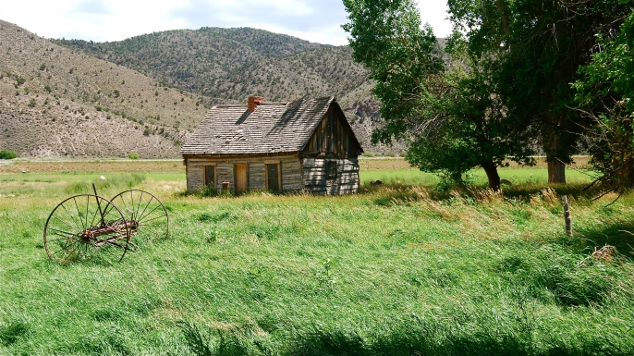](http://cdn.history.com/sites/2/2015/05/list-butch-cassidy-home-522498685.jpg)

**The Parker home**

At the age of 13, whilst working in one of the ranches, Butch was accused of stealing a pair of overalls from a store. The story goes that Butch had made a long ride into town and the shop was shut, so he broke in and took a pair of trousers and left a note stating that he would return with payment. The shop owner decided to have Butch arrested and fortunately he was let off but the experience left him with feelings of resentment towards the legal system and authority. Butch worked on several different ranches and eventually befriended a rancher in the early 1880s named Mike Cassidy. Mike was a cowhand and had a reputation as a cattle and horse thief. Butch admired the older Cassidy and it was he who taught Butch how to train horses and fire a gun. Mike Cassidy eventually ran into trouble with the law and fled the area.

In 1884, at the age of 18 years, Butch left Utah in search of new opportunities. One of the places he landed for a few years was a mining boom town called Telluride, Colorado and he later moved to Wyoming and then Montana.

It was on 24th June 1889 that Butch successfully held up his first bank. He, along with three accomplices, made off with more than $20,000 from the San Miguel Valley Bank in Telluride. In honour of his mentor Mike Cassidy, Butch started to use the name Roy Cassidy. Later on Butch moved to Rock Springs, Wyoming and found employment as a butcher and according to legend this was when he first began to be known as Butcher Cassidy which later became Butch Cassidy. All reports indicate that Butch was a charming thief and never killed anyone.

Around 1889, Butch met William Ellsworth “Elzy” Lay (1868-1934) while working on a ranch at Brown’s Park which is close to the borders of Utah, Colorado, and Wyoming. The ranch was sometimes used as a hideout for outlaws. William Ellsworth “Elzy” Lay would be his best friend and not the Sundance Kid, Harry Alonzo Longabaugh as depicted in the 1969 film “Butch Cassidy and the Sundance Kid”. Lay was convicted in 1899 of killing a sheriff following a train robbery near Folsom, New Mexico and he was sentenced to life imprisonment. Lay was pardoned in 1906 after he helped to stop a prison riot.

In 1890, Butch bought a ranch in Dubois, Wyoming, in 1890 but did not give up his lucrative sideline of rustling cattle and horses.

In 1894, Butch was found guilty of stealing a horse worth £$5 in Wyoming and he was sentenced to 2 years imprisonment in the state penitentiary. Butch believed that he had been set-up by a cattleman who did not want him around. Butch had his sentenced reduced to 18 months due to good behaviour and rumour has it that he also promised the Governor that he would leave the state.

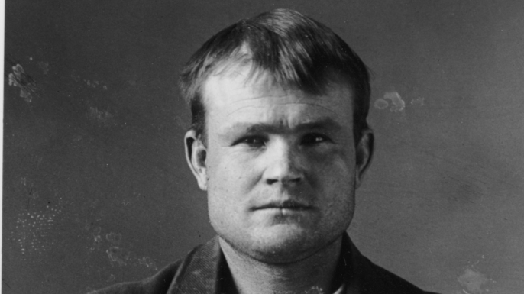

**Butch Cassidy’s mug shot**

After being released from prison in 1896, Butch re-joined the other members of the Wild Bunch. The gang included: Harry Longabaugh (a.k.a. the "Sundance Kid"), William Ellsworth Lay ("Elzy Lay"), Ben Kilpatrick (the "Tall Texan") and Harvey Logan ("Kid Curry")

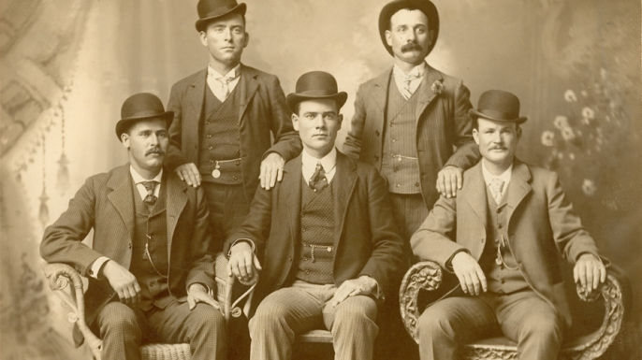

**The Wild Bunch in 1901, with Henry Longabaugh (Sundance Kid) sitting far left and Robert LeRoy Parker (Butch Cassidy) sitting far right. (Credit: The Print Collection/Print Collector/Getty Images)**

This group started out as rustlers and horse thieves before moving on to bank and train robberies. The Wild Bunch developed a system whereby they reconoitered the place to be robbed and leaving food and horses along their escape route. Butch had an awesome reputation for his crimes, he was not known for excessive gun use and was considered by his friends as a good and helpful neighbour. Butch also had a reputation for keeping his word and urban legend has it that before commencing his sentence he asked to be released, promising to return the next day. He was taken at his word and he returned the following morning to commence his sentence.

In August 1896, the wild Bunch robbed a bank in Montpelier, Idaho, where they stole more than $7,000, they then moved on to rob banks and trains in South Dakota, New Mexico, Nevada and Wyoming. The gang returned to their hideout at the Hole-in-the-Wall Pass in Johnson County, Wyoming. This must have been an interesting place as a number of other gangs also holed up here.

Butch and the Wild Bunch’s reputation grew as their crimes continued and became bigger. One of the largest thefts was from a train outside of Folsom, New Mexico where the gang made off with about $70,000. The Union Pacific Railroad became so frustrated at not being able to stop the gang that they proposed to Butch a pardon in exchange for the promise of him ending the robberies and becoming an express guard on the railway. Not surprisingly, Butch declined the offer. The Union Pacific had no option but to turn to the law enforcement agencies to hunt down the Wild Bunch. The company hired the Pinkerton National Detective Agency to hunt down Butch and the gang. In early 1901, with a posse of Pinkerton detectives chasing them, it became prudent for Butch and the Sundance Kid to move to Argentina.

There is some uncertainty if Butch stayed behind to rob a train in July 1901, near Wagner, Montana. At some point in 1902, Butch was with the Sundance Kid, and using aliases, purchased land in Cholila, Argentina where they ran a ranch. By the end of 1904, they sold their property and livestock and moved to Concordia Tin Mines in Bolivia. The reason for the move was that they were concerned that Pinkerton Detectives had discovered their ranch. Whilst living in South America, Butch and the Sundance Kid continued to carry out robberies. The received the credit of not only their own their own thefts, but the thefts of other American outlaws who were operating in the area at the same time.

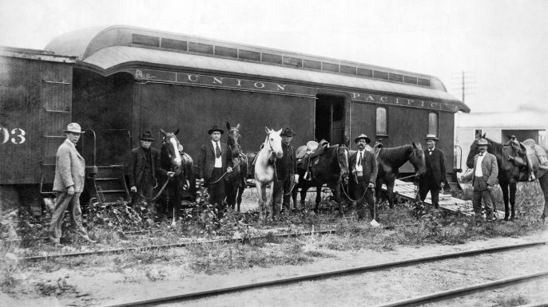

Part of the posse of mounted rangers organized to hunt down the WIld Bunch Gang, including Butch Cassidy and the Sundance Kid. (Credit: Underwood Archives/Getty Images)

The death of Butch Cassidy and the Sundance Kid is a bit of a mystery. Some report that on 4th November 1908, near the town of Tupiza in Southern Boliva, Butch Cassidy and the Sundance Kid held up a payroll as it was being transported to Aramayo mine. The alleged robbers arrived in San Vicente, Bolivia three days later. Villagers were suspicious that these men may have been the bandits who robbed the payroll and Bolivian soldiers were called for and during a shoot-out the Bolivians gunned down the suspects. It is also reported that one of the gunmen may have shot his partner before killing himself. The bodies were buried in unmarked graves in San Vicente cemetery. There has never been any definite proof that Butch Cassidy and the Sundance Kid were involved in the shoot-out or the robbery. The bodies were exhumed in the late 20th century and research proved that the two bodies were not from Butch or Sundance.

There were numerous reports that Butch and Sundance had been seen in the United States after their alleged deaths. Some historical evidence indicates that Butch returned to the United States using the alias William T. Phillips and found employment as a machinist and died in 1937 from cancer.

**Journal of Journey to Beaver in June 1857**  
An account of the journey to Beaver is copied here from: from PioneerSearch, http://www.lds.org/churchhistory/library/pioneercompany/0,15797,4017-1-193,00.html)

The Gillies family originally prepared to travel west with the William B Hodgetts Handcart company, which left Iowa City August 1, 1856.  All the family, except the grandfather John Gillies (age 83 at the time) are on the roster.  However, they decided to stay the winter, possibly to let the grandfather regain his health.

They then came west with the Jesse B Martin handcart company in June 1857. Grandfather John died at the crossing of Elk Horn and was buried July 1, 1857 (from Journal of Jesse Bigler Martin and Robert McQuarry Journal).  The family left the handcart company on July 17 and returned to the Genoa settlement.

Jesse B. **Martin** Company (1857)   **Departure:** 1-3 June 1857

**Arrival in Salt Lake Valley:** 12 September 1857.  
  
**Company Information:**   
192 individuals and 34 wagons were in the company when it began its journey from the outfitting post at Iowa City, Iowa.

Jesse Bigler Martin was an elder of wide experience. He was part of the 1846 exodus from Nauvoo, Illinois, joined the Mormon Battalion, and made the long march to California, where he worked for a while at Sutter's Mill. Later, he travelled to Utah, married, and served as a "Minute Man" in several Indian skirmishes. From 1853 to 1857 he served as a missionary in Great Britain. Now he was returning home. Upon reaching Iowa City he became captain of the emigrant company that bears his name. When it left Iowa City, June 1, the train consisted of 31 wagons. The teamsters were green and had to be trained. The oxen were wild and had to be tamed. In the process an axle broke, one wagon overturned, and another collided with a tree. Days were hot, and fleas plagued the company.

On June 8, heavy showers kept the train in camp longer than usual. At Westfield the party learned, via letter, that members of a handcart company that was ahead of them were all healthy and happy. In Martin's party there was a quarrel between two individuals, probably over another overturned wagon, and the captain admonished everyone against finding fault. The train passed through Newton where Mormon apostates harassed and insulted the emigrants. June 11, a few members of the company became lost temporarily. The train camped on the Des Moines River, two miles from Fort Des Moines. Each wagon then paid 30 cents to be ferried across. The emigrants received a visit from eastward bound Joseph and Brigham Young, sons of President Brigham Young, who brought cheering news from Utah. The train camped outside Adel; rumour had it that smallpox was in the town. The group tried to pass through Adel quickly, but local dogs frightened some of the oxen, causing them to turn suddenly. An occupant of one wagon tumbled out but was not seriously injured. A downpour of rain made crossing the Middle Raccoon difficult and turned the road into a quagmire. One pair of oxen was lost. The ground was so wet on the 17th that the train remained in camp. It was very cold. Canadian bound missionaries brought more news from the Salt Lake Valley.

The emigrants paid 30 cents per wagon to be ferried across the West Nishnabona River. A child died of black canker and was buried near Silver Creek. The emigrants camped near Council Bluffs. A wagon overturned in a creek, nearly drowning a baby, and an ox died from heat exhaustion. But the train successfully crossed the Missouri and reached Florence, Nebraska Territory, June 24. At about this time the emigrants learned of Apostle Parley P. Pratt's death. Over the next two days the travellers acquired supplies, repacked the wagons, and washed clothes, preparing for plains travel. It was hot. Rain and strayed cattle delayed departure until June 28. The train camped on the Little Papillion but stopped short of the Elkhorn because a party of apostates was camped there. While Captain Martin was making arrangements to ferry the wagons across the Elkhorn, apostates visited the train "swearing & raising all manner of threatening," even vowing to kill the captain. A terrible thunderstorm on June 30 scattered the company's cattle; it was two o'clock in the afternoon before they could be gathered and yoked. Apostates claimed that they were responsible for scattering the animals, and they threatened to do so again.

After the train crossed the Elkhorn, about eleven o'clock at night, apostates appeared at the emigrants' camp with a violin, a flute, and a horn, apparently planning to make good on their threats. But Captain Martin, with pistols in hand, quickly aroused several of his men and the intruders left. July 1, while workmen repaired a broken axle, the company buried a man who had died. Mosquitoes were a problem. After passing through Fremont, the party camped on the banks of the Platte River. Here, a government exploring expedition visited them and Apostles John Taylor and Erastus Snow and their escorts caught up with the train. A boy fell under a wagon wheel and was severely bruised; his arm was broken, too. A member of the company set his broken arm.

The train reached Loup Fork on July 4. At the town of Columbus, the emigrants saw men celebrating Independence Day. Near Beaver (Genoa), the company crossed Loup Fork by double-teaming the wagons. In the process, a woman was run over. From here, the Taylor-Snow party pushed on ahead. Later, an overturned wagon had to be righted and the train passed a sign made by members of the handcart company indicating that all was well with them. Martin's people found a stray yoke of oxen. The captain’s wagon tipped over near Wood River, but little damage resulted. There was a severe thunderstorm and another wagon overturned; this one had to be repaired. The train camped at Elm Creek, then Buffalo Creek. Again there were heavy thunderstorms. Now the travellers saw large buffalo herds and the cattle stampeded, trampling a member of the company. After a two-day search for the runaways, all but nine animals were recovered. Again the cattle ran off. Seven of these strays were never recovered. This left the train short on cattle and gave Captain Martin an excuse to send discontented families back east. During a later dispute over animals, teams bolted, breaking several yokes, crashing two wagons, and killing two individuals. Other emigrants were injured. After all this, the captain called upon the travellers to make a covenant with God that they would heed counsel for the remainder of the journey. All agreed, and then they buried the dead and repaired the broken wagons. A different spirit seemed to prevail in the company after this.

The train met more apostates. Three Sioux Indians came into camp wanting to trade a horse for a white woman. Instead, Captain Martin exchanged some sugar for moccasins; other travellers gave the natives food. On July 22 the train crossed Bluff Fork. Flies were troublesome and sandy roads slowed progress. Near Camp Creek the company found another message from the handcart company on a buffalo skull reporting that several handcart women were sick. Again, the wagons had to double-team to get through sand hills. The company met a party returning from California. Opposite Castle Bluff the train left the main road, staying close to the Platte. Unfortunately, 20 or 30 women took the wrong road and lost about two hours travel time. The train passed an Indian camp. On July 28, by climbing a bluff, emigrants caught their first glimpse of Chimney Rock, but rain and sandy hills hindered progress. Another stampede injured three more women. The train camped opposite Scotts Bluff. By crossing the Platte here, a member of the train was able to visit a trading camp and exchange his worn-out oxen for fresh ones on a two-for-one basis. Other party members simply re-shod their tired animals.

On August 4, Captain Martin and others left the train temporarily, riding ahead to Fort Laramie, where the captain had his horse shod and purchased bacon at 25 cents per pound and leather for shoeing cattle at a dollar per pound. The price of flour was $20.00 per 100 lbs. A rough road again required double-teaming. August 9 and 10 herdsmen drove the cattle back and forth across the Platte so they could graze on the south bank. A gun accidentally discharged, narrowly missing several persons. August 11, the handcart train was camped south of the river opposite Martin’s wagons. The carts would cross the river at the upper crossing and there await the wagon train. The two companies would then travel together, or in close proximity, all the way to the Salt Lake Valley. Martin's company had stayed north of the Platte all the way. The wagons camped one mile west of the Platte Bridge, near modern-day Casper, Wyoming, then at Willow Springs, at Greenwood Creek, and at Devil's Gate. From the Mormon outpost at Devil's Gate, the company purchased flour at $12.00 per 100 lbs. About this time the emigrants learned of the military expedition sent out by the United States to "compel the Saints to submit to them and to hang President Young and punish polygamists." The train crossed the Sweetwater and Rocky Ridge.

On August 26, it was at Pacific Springs. Here the emigrants met 70 men from Salt Lake who were headed east to protect later emigrants. The next day 50 men from Provo, on the same mission, passed by. There was more trouble with strayed animals. Martin's company camped at Green River. It also stopped at Black's Fork, at Ham's Fork, and at Fort Bridger. Here the emigrants purchased potatoes, turnips, and beef. On September 6, at Bear River, a quartermaster from the "invading" army overtook the emigrants and camped with them. Later camps were on Echo Creek and at the Weber River. Here the company met 20 yoke of oxen going east to help later emigrants. Camp for September 10 was just east of Big Mountain. Crossing this barrier took all of the following day, but on the 12th the company negotiated Little Mountain, descended Emigration Canyon, and entered Salt Lake City with 192 people, 34 wagons, 130 oxen, 7 cows, and 1 horse. Four people had died during the journey.