**The Robb family in Blairlogie**

The Robb family has been based in Logie parish from the earliest days. Rob is first recorded as a surname in the 1560’s and may originate from a single person called Robert who lived in the last decades of the C15th, whose offspring took the surname Rob. There is some evidence this happened in other parts of the country, but in the absence of any records of such an individual only DNA evidence will pull the strands together. Almost universally the spelling of the surname changed to Robb around 1800.

Logie church records began in the 1680’s, and is difficult to be definite about family relationships before this time. However, in Logie Kirk the Robb family lair remains on the eastern side of the graveyard. The Rob family lair retains four stones in a row recording several generations of the family. The earliest stone is inscribed IR - MD with the date 1690. This is most probably James Rob and his wife Margaret D-, likely Dawson. A James Rob farmed at Blair in the 1660’s and 1670’s and may, in turn have been the son of another James Rob in Blair whose testament dative was recorded in May 1656.

It is placed next to the gravestone FR-MT 1714 for Finlay Rob and Margaret Telfoord, which is in turn next to the stone for IR-JB 1703, for James Rob and Janet Burn. Finlay and James were brothers, and James and Margaret their parents. James Jr, who married Janet Burn in 1697 and died in 1709, was a farmer in Blair, and likely the eldest son inheriting his father’s tenancy in Blair. Finlay and Margaret’s gravestone has his eldest son and his wife’s initials (IR and ER) added later in the corner of their stone.

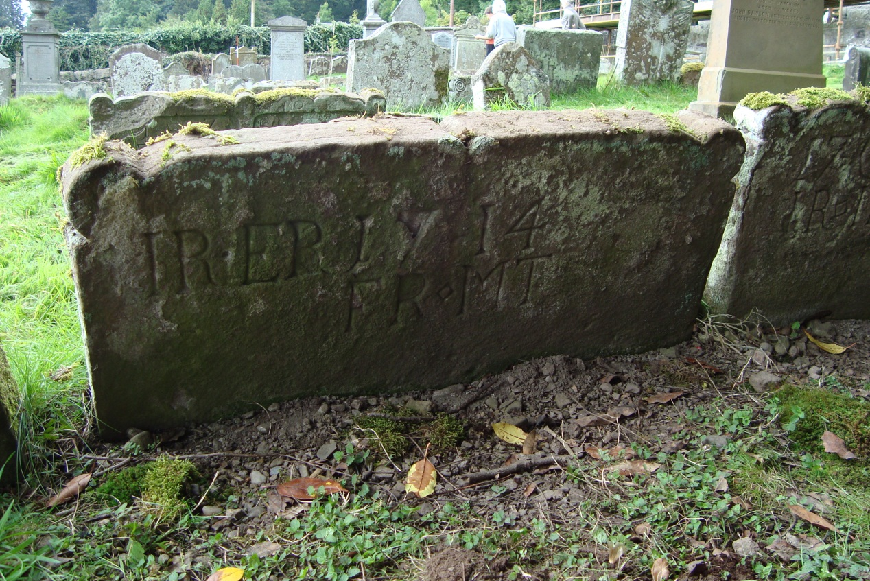

Finlay Rob was born around 1670 and died in late April 1733. By examining the links between families found using the baptismal records, and specifically the witnesses present when children were being baptised, we can confirm that Finlay had at least one brother James Rob, mentioned above, and at least one surviving sister, Janet Rob, who married William Smith in 1695. Smith was Logie’s Session Clerk, Precentor, and the Parish schoolteacher from 1692 until his death in 1744.

Finlay married Margaret Telfoordin Logie Kirk on 14th December 1697. She is probably a sister of John Telfoord, whose family owned property in Blairlogie. Finlay is the first recorded tenant of Long Kerse of Blairlogie, a small but fertile farm holding of 22 acres south east of Blairlogie village, described in some detail in Revd. Menzies Fergusson’s two volume history of Logie parish.

Finlay and Margaret left Long Kerse in 1722 moving to Easter Roughburn of Airthrey where Margaret died later that year. Finlay died in April 1733, his eldest son John taking over his father’s tenancy and later moving to Manor. This family farmed in the area until the early C20th, although many younger sons had emigrated to Canada and the USA in the 1820’s and onwards. One of these was James Robb, owner of the East Point Rice Mills in Charleston, South Carolina. His son William built a substantial house, now known as the William Robb House, in Bee Street, Charleston in 1858. It is now on the US National Register of Historic Places. Another was the Reverend Ralph Robb, first Free Church clergyman to serve in the New World.

Finlay and Margaret’s second son James became a Maltman and Burgess in Stirling, whilst their youngest sons Andrew and Charles Rob (1718-84) both became long-lived shoemakers in Pathfoot, a village of shoemakers based at the foot (of the path) of an old drovers road that came from the Highlands via Sherriffmuir on the way to the Market at Falkirk. In 1769 a detailed map records around a dozen houses. Cattle would arrive at Pathfoot where a Tryst was held around the still extant standing stone. Both Pathfoot and Logie were removed for estate beautification by Sir Robert Abercromby after 1798, the residents being relocated to nearby Causeyhead.

Andrew Rob (1714-84) was born at Long Kerse and married Sophia Ker (1724-92) of St. Ninians in 1744. He lived into his seventieth year and was a witness in the Airthrey Roads case in the 1760’s. For many years he was in receipt of parish aid, so it is likely he was at some point unable to make shoes, perhaps due to old age or injury. Two of his sons became shoemakers in Blairlogie village, another son serving as a soldier in a fencible regiment before settling as a shoemaker in Musselburgh.

His eldest (surviving) son William Rob was born in Pathfoot and christened in 1751 and likely settled in Blairlogie in or before 1786, the year he married Mary Graham. His three children were all born in the village, and his eldest son Andrew (1796-1881) initially worked as a shoemaker in Blairlogie before becoming a Market Gardener in the village. Andrew married Jane Donaldson of Alloa (1797-1884) in 1819 and his large family lived in Blairlogie throughout the nineteenth century, for much of the time in Jessamine Cottage (now called Montana).

William Rob is recorded in the first census in 1841 as a 79 year old shoemaker, when he must have been 89 or 90, a substantial miscalculation. This must be put down to confusion although the first census did tend to mark down ages. In 1841 he was living with Alexander, his grandson, eldest son of the long-lived Andrew Robb and Jane Donaldson and must have died shortly after the census was taken. William’s gravestone (dated 1820) survives in Logie’s new churchyard, with his grandson’s James Robb’s immediately adjacent. An adjacent weathered and illegible gravestone could be John Rob and Mary Baird’s.

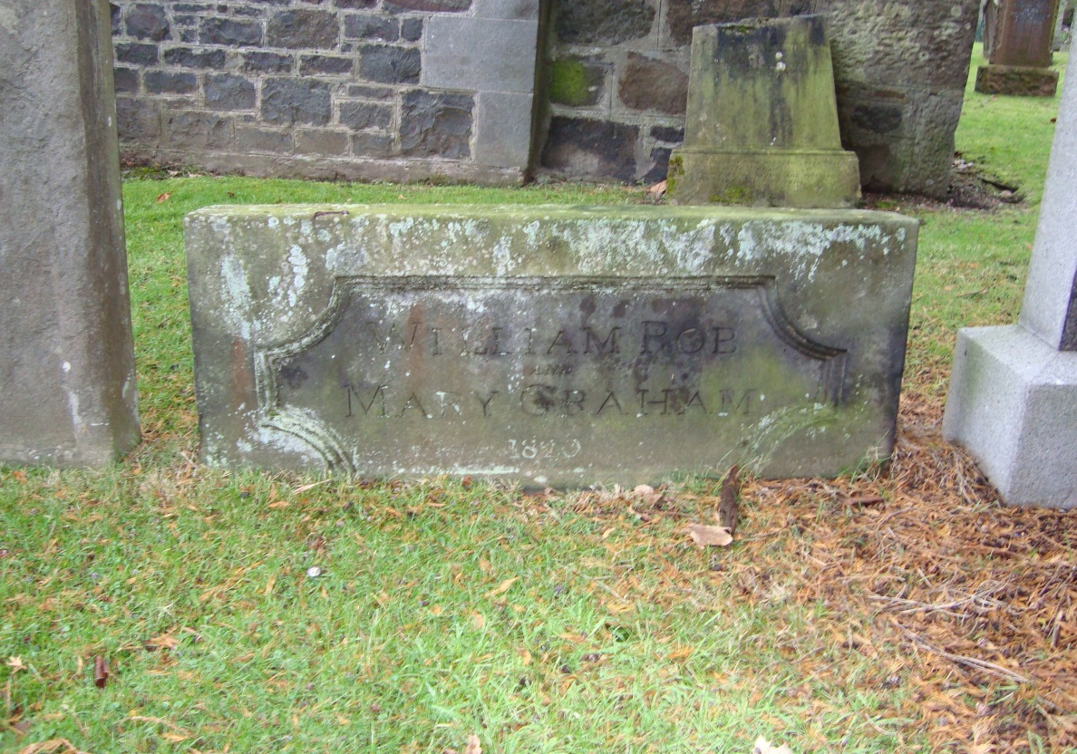

**Gravestone of William Rob and Mary Graham**

John Rob, the fourth (second surviving) son of Andrew and Sophia was born in Pathfoot in 1755. Like his father and elder brother John became a shoemaker and moved to Blairlogie, again likely before his marriage to Mary Baird of Clackmannan on 12 February 1783. They had at least four children born in Blairlogie, three of whose births are recorded in the Logie church records. In 1810 he came under censure from the Incorporation of Shoemakers of Stirling for selling shoes in Stirling without permission, and in 1823 bought three lairs in the new churchyard.

John and Mary’s first son John was born in Blairlogie in 1785. He became a Master Shoemaker and later moved to nearby Menstry where he married Catherine Heggie in 1817. Their second son Andrew Rob was born in 1790. He became a shoemaker in Blairlogie, being recorded as the owner of a property in the village as early as 1834. He may have inherited it from his father as no Sasine records show him purchasing it. This is most likely Crowsteps, an eighteenth century building, rehabilitated in 1974.

In 1829 Andrew is noted as Mrs Spittal of Blairlogie’s Bailie and in the 1841 census he is recorded as being aged 45 (when he would have been 51) and living with his sister Mary Robb who was 40. He likely died unmarried in 1848 when his elder brother John Robb in Menstry is first recorded as the owner of a house and garden in the village. In the 1851 census his sister Mary is recorded as 56 (gaining six years from 1841) and her profession is noted as grocer. She may have run a shop in the village, possibly from the lower part of the cottage, which has an external staircase. Also present in the 1851 census is Mary’s ‘neice’ Jean aged seven, the youngest daughter of Andrew Robb and Jean Donaldson. Mary died between 1851 and 1855, sadly just before the official registration of deaths.

Although still resident in Menstry John Robb owned the house in Blairlogie from 1848 until his death in 1863 when it passed to his wife Catherine Robb nee Heggie. On her death in 1866 the property passed to their eldest son John Robb (1819-1895) a foreman/manager at Keilarsbrae Mill in Alloa. Their younger son Andrew (1825-1900) became Manager of Gaberston Mill, Alloa, and later Tweedside Mill in Peebles.

From 1857 until her death in 1891 the house in Blairlogie was tenanted by Miss Mary Thomson who latterly lived alone with a housekeeper and left £800 in her will.

John Robb married Margaret McKean Mitchell in 1850 and they had three sons and a daughter born in Alva. Margaret’s father and brother ran the Strude Mills in Alva for a spell before a serious fire. John Robb retired to Blairlogie in the early 1890’s and died in Croft House in 1895. His widow Margaret remained in Blairlogie and is recorded in the census of 1901 living in the family property. She died in 1908 and as all three sons had by then died without issue, (in fairly tragic circumstances), the property passed through their daughter Jane Thompson Robb to the Paterson family. Jane had married a local farmer William Paterson (1859-1915) in Alloa in 1884 and had a daughter Helen McQueen Paterson (1885-1960), and a son John Robb Paterson, (1887-1953) before her early death in 1887 aged only 27.

In 1921/2 John Robb Paterson sold the Robb family property in Blairlogie to Ella and Isabella Stevenson.

**Robb in Blairlogie**

James Rob m. Margaret Dawson?

Farmer

Blair

I

Finlay Rob m. Margaret Telfoord James Rob

(d.1733) 1697 (d.1722) (d.1709)

Tenant Farmer

I_______________________________________________________

Andrew Rob m. Sophia Ker Charles Rob

(1714-1784) 1744 (1724-1791) (1718-84)

Shoemaker, Pathfoot Shoemaker, Pathfoot

______________________I______________________________________________________

William Rob m. Mary Graham John Rob m. Mary Baird

(1751-c1843) 1786 (b1755-) 1783

Shoemaker, Blairlogie Shoemaker, Blairlogie

I ____________________________________________I__

Andrew Robb m. Jean Donaldson Andrew Robb Mary Robb John Robb m. Catherine Heggie

(1796-1881) 1819 (1797-1884) (1790-c1845) (1795-c1853) (1785-1863) 1817 (1785-1866)

Shoemaker & Market Shoemaker, Blairlogie Grocer, Blairlogie Shoemaker, Menstrie

Gardener, Blairlogie

I ________________________________________________I

Alexander Robb John Robb m. Margaret Mitchell Andrew Robb m. Mary Swanson

(1823- (1819-95) 1850 (1825-1900) 1861

Schoolteacher, Shetland Manager/Foreman Mill Manager

Keilarsbrae,Alloa Gaberston, Alloa

I I

Jane Robb m William Paterson Andrew Robb