**Philip Dudley Waller**

**Died 14th December 1917**

**Died: 14th December 1917**

**Philip Dudley Waller ~ France**

**Lieutenant Philip Dudley Waller**, 71st Siege Battery, South African Heavy Artillery, born at Bath on 28 January 1889, was the fourth son of Alfred Percy, Inland Revenue, and Emily Elizabeth Waller, of Croft House Blairlogie.

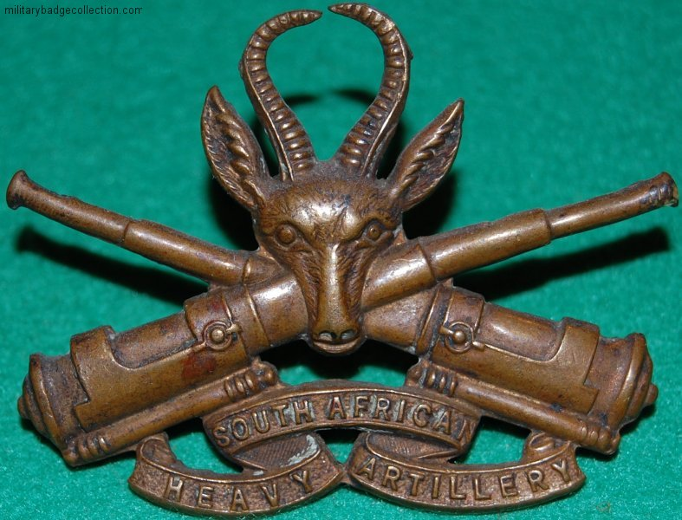

South African Heavy Artillery

Cap Badge

His siblings were Henry, Arthur, Frederick, Norah Beatrice, Dorothy Lilian, Kathleen, John, Olivia, Helen Louise, Charles, Emily, Richard and Elizabeth.

He attended Carmarthen Intermediate School and played as a forward for Newport, making 70 appearances from 1908 to 1910, and played for Somerset and Newport v the 1908-1909 Wallabies. After winning six Welsh caps and three for the 1910 British Lions in South Africa, one of seven Newport men to make the trip, he stayed to play for Johannesburg, and settled there.



He was an Engineer by profession.

Having enlisted in the South African Heavy Artillery Regiment, in March 1916 he played in a South African Heavy Artillery team against a New Zealand Army team at the Queen’s Club London. The SA team won 7-0 thanks to a dropped goal and try by former England International Reginald Hands, their captain.

He was killed by shellfire in Arras on 14 December 1917, age 28, and is buried in Red Cross Corner Cemetery, Beugny, France

It is only thanks to the Commonwealth War Graves Commission that we have any information on Philip as his records appear to have been destroyed in the Blitz.

**Historical Information**

Plot I of the cemetery (except Row K) was made between April 1917 and March 1918 by field ambulances and fighting units. When the cemetery fell into German hands in March 1918, they added the 25 Commonwealth burials that make up Row K (all from 21 March 1918) and began another cemetery alongside (Beugny Military Cemetery No.3). Commonwealth forces retook the cemetery in September 1918 and added Plot II to the original burials. The German graves were removed after the Armistice, and the Commonwealth burials among them were transferred partly to Delsaux Farm Cemetery and partly to Favreuil British Cemetery.  
  
Red Cross Corner Cemetery now contains 219 Commonwealth burials and commemorations of the First World War. 12 of the burials are unidentified and one casualty whose grave was destroyed by shell fire in 1918 is commemorated by a special memorial.  
  
The cemetery was designed by W H Cowlishaw.

[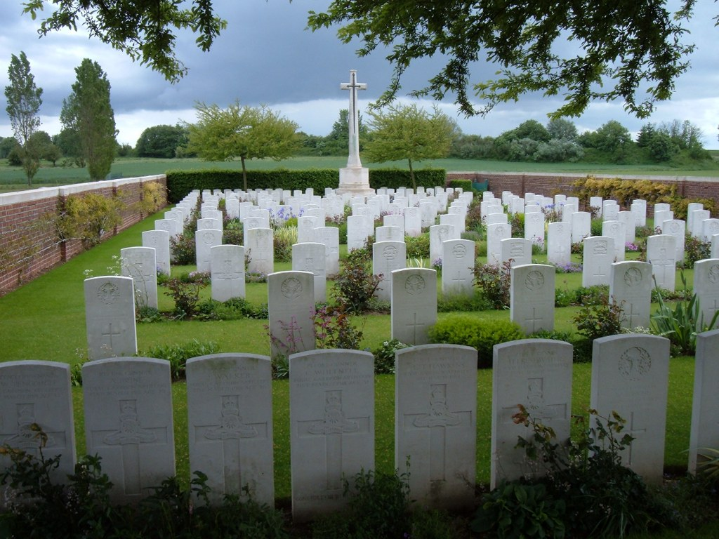](http://www.cwgc.org/dbImage.ashx?id=10973)

**© Commonwealth War Graves Commission**

Red Cross Corner Cemetery, Beugny, France