CellPhenotyper enables auditable analysis of hematoxylin and eosin whole slide images
Martin Ocharo^{1,2}, Moussa Kassim^{1,2}, Dalia Ahmed^{1,3}, Alessia Vignoli^{4,5}, Aashish Kumar⁶, Giulia Canarutto⁷, Brendon Price⁸, Shweta Sbirla⁶, Leonardo Tenori^{4,5}, Silvano Piazza^{7,9}, Dinesh Gupta⁶, Ekene Emmanuel Nweke¹⁰, Stefano Cacciatore^{1,2}
1 Bioinformatics Unit, International Centre for Genetic Engineering and Biotechnology, Cape Town 7925, Western Cape, South Africa.
2 Department of Integrative Biomedical Sciences, Institute of Infectious Disease and Molecular Medicine, University of Cape Town, Cape Town 7925, South Africa.
3 Histopathology and Cytology Department, Faculty of Medical Laboratory Science, Omdurman Ahlia University, Omdurman, Sudan.
4 Department of Chemistry 'Ugo Schiff', University of Florence, Sesto Fiorentino, Italy.
5 Magnetic Resonance Center (CERM), University of Florence, Sesto Fiorentino, Italy.
6 Translational Bioinformatics Group, International Centre for Genetic Engineering and Biotechnology, New Delhi, India.
7 Computational Biology Group, International Centre for Genetic Engineering and Biotechnology, Trieste, Italy.
8 Division of Anatomical Pathology, University of Cape Town and National Health Laboratory Service, Observatory, Cape Town, South Africa.
9 Bioinformatics Facility, Department of Cellular, Computational and Integrative Biology, University of Trento, Trento, Italy.
10 Department of Surgery, School of Clinical Medicine, Faculty of Health Sciences, University of the Witwatersrand, Johannesburg, Gauteng, South Africa.
Correspondence should be addressed to S.C.

Abstract
Reproducible analysis of hematoxylin-and-eosin whole-slide images requires consistent physical scale, coordinates and cell identity. CellPhenotyper is a Nextflow workflow that combines tissue quality control, one selected cell detector, optional virtual-marker analysis and spatial tissue modelling. The current implementation offers mutually exclusive CellViT++ or StarDist segmentation, and uses calibrated Virchow2 tissue features with KODAMA and Bora for tissue-domain analysis. Native image transforms, stable cell identifiers and model provenance link the outputs. Software tests verify detector selection, complete-input checks and registered cell-mask export. An archived 1.90-gigapixel breast-cancer execution preserved 279,899 consensus cells across a previous pipeline version while exposing artifact-model and virtual-marker failure modes. Those historical results do not validate the revised detector or tissue route. CellPhenotyper provides an auditable integration framework for research; expert-referenced, multi-tissue and matched molecular-imaging studies remain necessary.
Hematoxylin-and-eosin (H&E) staining remains the principal morphological reference in histopathology. Whole-slide imaging extends this reference to gigapixel data, but a slide is not a conventional microscopy field: physical scale, file format, tissue artifacts and memory footprint must remain consistent before cell-level measurements can be compared or reconstructed in tissue space [1-4].
Computational pathology tools address distinct tasks. GrandQC assesses tissue and artifacts [5]; StarDist and CellViT++ provide alternative nuclear-instance segmentation approaches [6,9]; GigaTIME predicts virtual multiplex markers [10]; Virchow2 provides histopathology representations for the current tissue route [24]; KODAMA and Leiden organize high-dimensional observations [12,13]; and Bora refines predicted tissue domains and exports their boundaries [25]. HoVer-Net, UNI-2 and MedSAM were components of the archived workflow evaluated below [7,8,11,14]. These tools differ in resolution, coordinate conventions, model assets, data structures and biological scope. A detector label, virtual marker and unsupervised tissue community are therefore retained as different kinds of evidence.
CellPhenotyper addresses the interface between these methods. It defines a physical-coordinate and identity contract, records model provenance, bounds resources, exposes stage-level restart and assigns a stable identifier to each published output. Its contribution is an auditable integration framework rather than a new detector, representation model or clinical predictor.
We distinguish the current software implementation from an archived technical case study on a public high-resolution breast-cancer specimen. The current revision is evaluated here through bounded software and workflow tests. The archived execution tests scale handling, identity continuity, output completeness and resource use for its recorded source version. Its figures and numerical results are retained as version-specific engineering evidence, without transferring them to the revised detector or tissue-analysis methods.

Results

A physical coordinate contract links cell tissue and section outputs
CellPhenotyper uses Nextflow DSL2 [17] to coordinate calibrated image preparation, cell analysis, tissue analysis and optional marker or section-level modules (Fig. 1). Pyramidal image conversion records source MPP and image identity [18]. GrandQC clean-tissue support, optionally intersected with a supplied ROI, defines the analysis area. Stable identifiers and recorded transforms join cell masks, tables and image coordinates; tissue tiles remain separate observations. The current cell selector executes either CellViT++ or StarDist and never substitutes another detector because hardware is unavailable. Source-bound continuation workflows retain the current Bora tissue algorithm and its input lineage.
The numbered stage registry preserves restart compatibility with earlier result directories. Optional virtual-marker and section-level modules are selected separately. PathoFMPred remains a research extension because its fitted registry is private and its outputs lack independent clinical validation; it is excluded from the central reproducibility and biological claims.
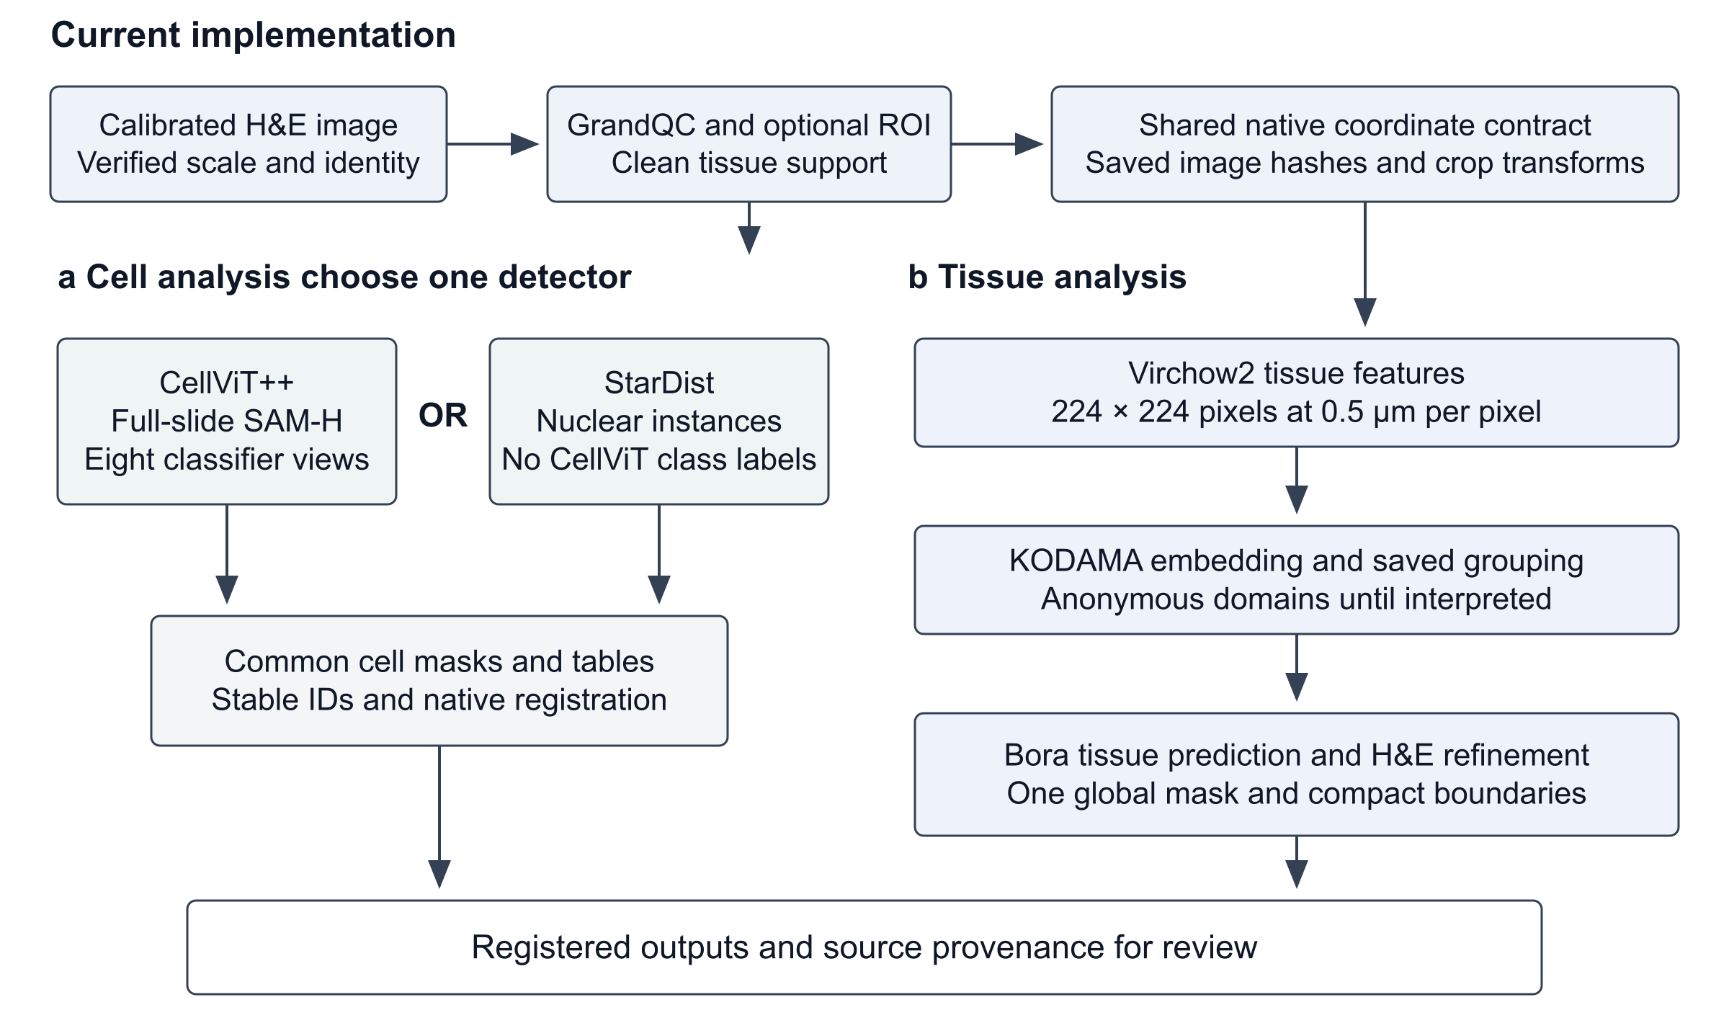
Figure 1 | Current CellPhenotyper analysis routes. A calibrated H&E image and GrandQC support provide a shared coordinate contract. Cell analysis selects exactly one detector: full-slide CellViT++ with its pretrained classifier views, or StarDist nuclear segmentation. The tissue route uses 224 × 224-pixel Virchow2 inputs at 0.5 µm per pixel, KODAMA-derived groups and Bora prediction, refinement and global vectorization. Registered outputs can be opened through CellPhenotyper and wsiTools projects, with route-specific export requirements. Optional GigaTIME and section-level analyses are separate modules and are not depicted as required steps. MPP, micrometres per pixel; ROI, region of interest.

Single detector tests preserve the common cell contract
Local workflow stubs invoked only the selected CellViT++ or StarDist branch and produced the common cell-label interface. Deterministic CPU cases checked source-frame agreement, crop-offset translation, stable identifiers, overlapping-contour raster coverage and rejection of incomplete CellViT input. A StarDist selection did not require unused CellViT model assets or import stale CellViT classifications. These tests assess software routing and conversion; they do not rerun tissue inference or compare segmentation accuracy.

Archived breast cancer execution tests scale and identity continuity
The archived public input measured 45,503 × 41,711 pixels at an effective 0.27377465 µm per pixel. Strict resolution checks passed and recorded that the archived cell-model input at 0.25 µm per pixel required 1.095-fold linear upsampling, which creates no new spatial detail. Its StarDist-derived analysis crop measured 43,520 × 39,678 pixels and retained an explicit transform to the source image.
In that earlier implementation, StarDist, HoVer-Net MoNuSAC and CellViT++ returned 388,525, 75,909 and 376,607 candidate instances, respectively. One-to-one matching within 4 µm retained 279,899 canonical cells supported by at least two detectors. Of these, 234,567 (83.8%) had two-model support and 45,332 (16.2%) had three-model support. Every expected identifier was present in the tiled consensus label image. These archived values establish reconciliation and coverage for the recorded historical source only; the current mutually exclusive detector choice does not use this consensus population.

Archived quality control reveals a GrandQC domain transfer failure
In the archived benchmark execution, GrandQC selected its official 1.5-µm-per-pixel artifact model, processed a 14 × 16 grid using 1,024-pixel tiles with 512-pixel overlap and ran on CUDA. That historical implementation used centre-crop tile merging. The model classified 67.63% of the analysis area as artifact and only 0.0005% as clean tissue, with out-of-focus predictions dominating tissue (Fig. 2a). This result is visually implausible for the specimen. The current software replaces size-dependent merging with disk-backed probability blending for every image size and makes the resulting clean-tissue mask the mandatory crop gate. Because the archived slide has not yet been reprocessed with this revision, its values remain evidence of the earlier failure, not validation of the correction.

Archived virtual markers and paired features retain cell identity
In the archived execution, GigaTIME resampled the crop to exactly 0.25 µm per pixel, producing a 43,452 × 47,659 inference image. Hardware adaptation selected batch size 8 and 1,024-pixel blocks. Of 2,021 candidate blocks, 1,595 were processed and 426 were skipped by the background mask. The model returned 23 channels and quantified all 279,899 canonical cells over nuclei and non-overlapping cell-associated regions. DAPI, PD-1, CD3, CD8 and PD-L1 were retained in the pyramidal quality-control OME-TIFF. Peripheral block boundaries remained visible near tissue-background transitions, so the central field in Fig. 2c is illustrative rather than evidence of marker fidelity. Later seam corrections require their own version-specific evidence and do not retroactively alter these archived outputs.
The archived paired UNI-2-h extraction used token_subset mode. One forward pass produced a 1,536-dimensional tile CLS vector and a 1,536-dimensional inner-square vector by averaging patch tokens with centres inside a fixed 90-pixel square. All 95 checkpoint grids completed; tile and inner-square outputs each contained 279,899 aligned cell identifiers, with no missing rows. These are historical cell-centred representations, not the non-overlapping Virchow2 tissue-tile features used by the current route.
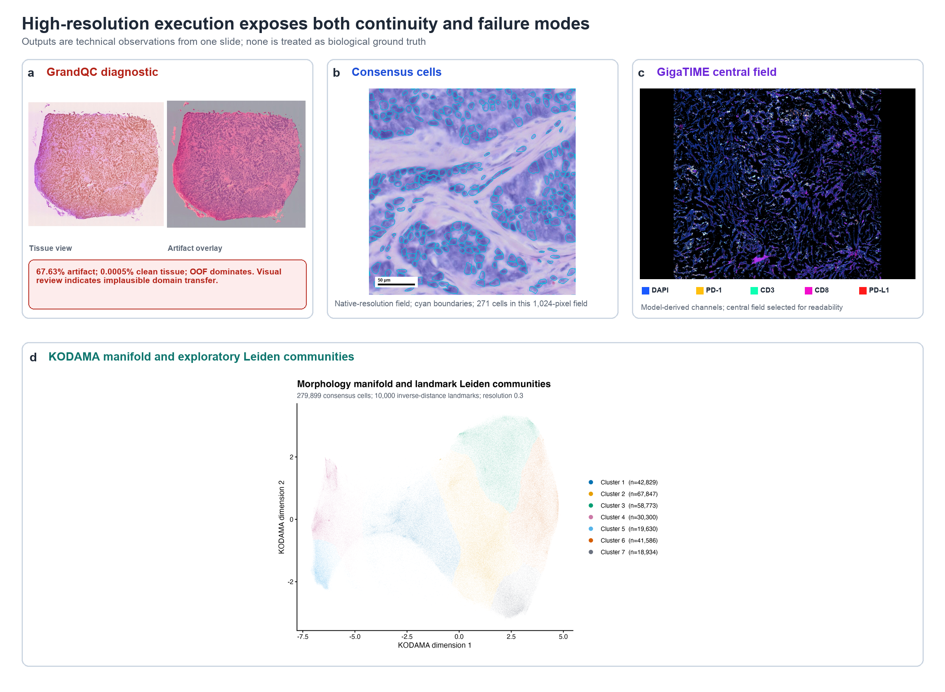
Figure 2 | Archived breast-cancer execution and visible failure modes. a, GrandQC tissue view and artifact overlay; the out-of-focus-dominated output was visually implausible. b, Native-resolution H&E field with historical consensus-cell boundaries and a 50-µm scale bar. c, Central field from the five retained GigaTIME channels; channels are model derived and the archived full-slide output retains peripheral block boundaries. d, KODAMA visualization coloured by seven exploratory Leiden communities. The panels belong to the archived source version and provide no biological ground truth or validation of the current single-detector workflow.

Archived landmark clustering yields an exploratory partition
For the archived UNI-2 analysis, streaming variance estimation retained the 100 highest-variance dimensions from each view. The combined 200-feature matrix was centred, scaled and reduced to 20 principal components before raw matrices were released from memory. KODAMA embedded all 279,899 cells using 1,000 internal landmarks. Clustering used only the two-dimensional visualization: 10,000 landmarks were sampled with probability proportional to the inverse square of mean 50-neighbour distance, Leiden used a 50-neighbour graph at resolution 0.3, and the remaining cells were assigned by 50-nearest-neighbour voting with Rnanoflann. These parameters describe the archived case, not defaults for the revised tissue route.
The procedure produced seven communities containing 42,829, 67,847, 58,773, 30,300, 19,630, 41,586 and 18,934 cells (Fig. 2d). The communities are unnamed exploratory partitions. Their stability and biological meaning cannot be inferred from visual separation and require repeated-seed, representation and annotation experiments.
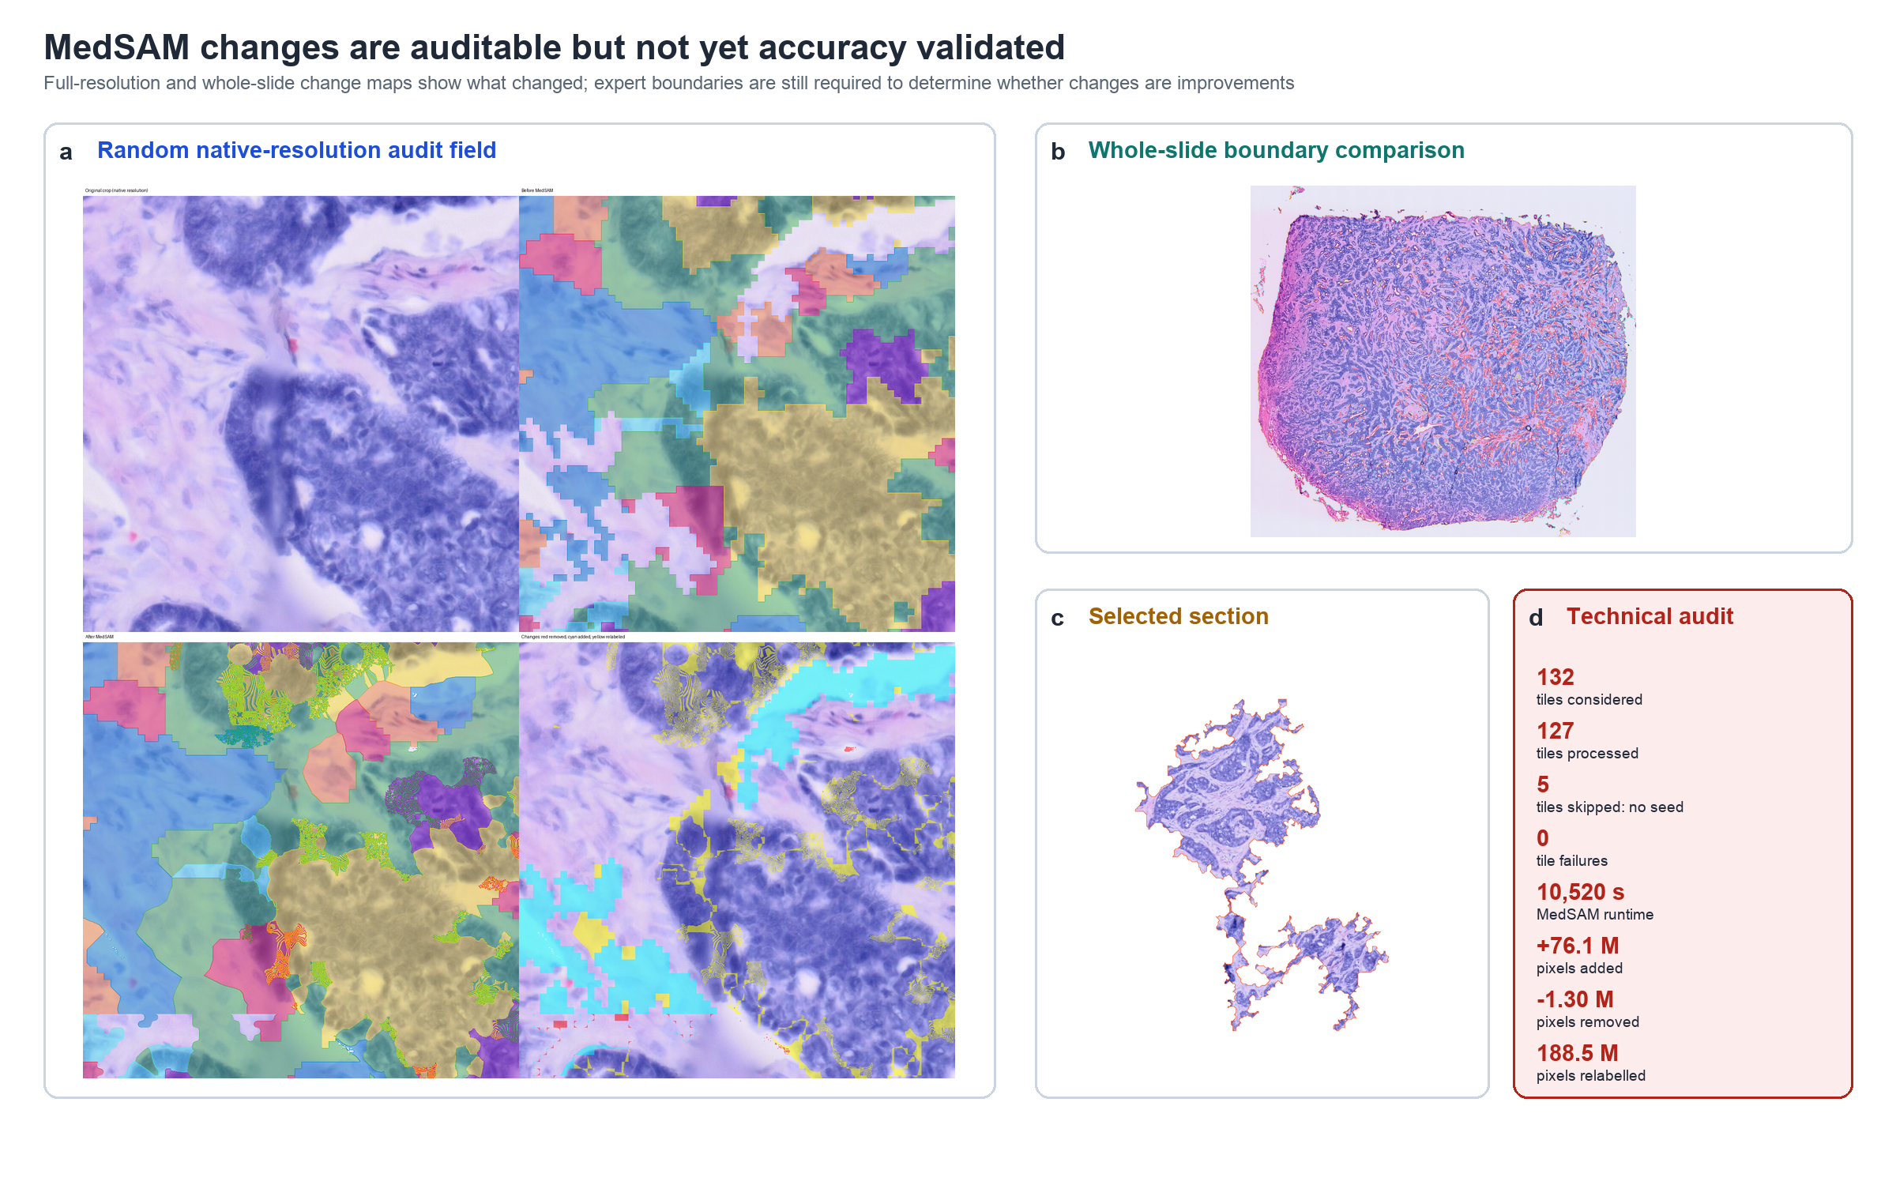
Figure 3 | Archived MedSAM modifications. a, Native-resolution 1,024 × 1,024 field showing H&E, grown mask, refined mask and changes. b, Whole-slide boundary comparison. c, Section selected by historical CellViT++ neoplastic-cell counts. d, Technical change summary. This figure documents the archived algorithm and does not measure the accuracy of current Bora boundaries.

Archived MedSAM output documents boundary modifications
In the archived route, cell communities were projected through the cell-associated mask and grown inside tissue before border-constrained MedSAM refinement. CUDA inference considered 132 overlapping 4,096-pixel tiles: 127 contained eligible seeds, five were skipped and none failed. MedSAM required 10,519.7 s. Relative to the raw grown mask, cleanup recorded 76,092,201 added pixels, 1,303,046 removed pixels and 188,473,375 relabelled pixels.
The archived pipeline produced a native-resolution audit field, whole-slide comparisons and explicit change maps (Fig. 3). These outputs show traceable modifications, not improved accuracy. Subsequent tissue-support clamps were technically exercised in a Visium HD ROI rerun, but that run did not provide an expert boundary comparison. The archived selected section contained 1,545 named neoplastic cells among 1,907 assigned cells; this ranking inherits the unvalidated CellViT++ class label. The current Bora continuation is a distinct tissue-prediction and vectorization route and is not evaluated by these MedSAM figures.

Archived trace profiling identifies computational bottlenecks
The archived final trace contained 24 successful tasks: 17 completed in the final execution window and seven were recovered from cache. Cumulative per-process realtime was 12.45 h; this sum is not wall-clock duration because tasks include cached work from resumed executions. Paired UNI-2 extraction, GigaTIME and MedSAM required 233.9, 225.4 and 176.2 min, respectively, and together accounted for 85.1% of cumulative process realtime. Peak resident memory was highest for HoVer-Net (18.4 GB), CellViT++ (12.9 GB) and MedSAM (11.0 GB) (Fig. 4). These measurements are not performance estimates for the revised single-detector or Virchow2/Bora routes.
The result tree contained 2,128 uniquely catalogued files with 25,997,457,358 bytes of content (26.0 GB; 24.2 GiB). The output catalogue records stable identifiers, paths and stage provenance. Section-level TITAN encoding retained 17 CONCH v1.5 patches and one finite 768-dimensional section vector. PathoFMPred produced 21 BRCA research outputs, but the private fitted registry and absence of external validation exclude these outputs from the core claim.
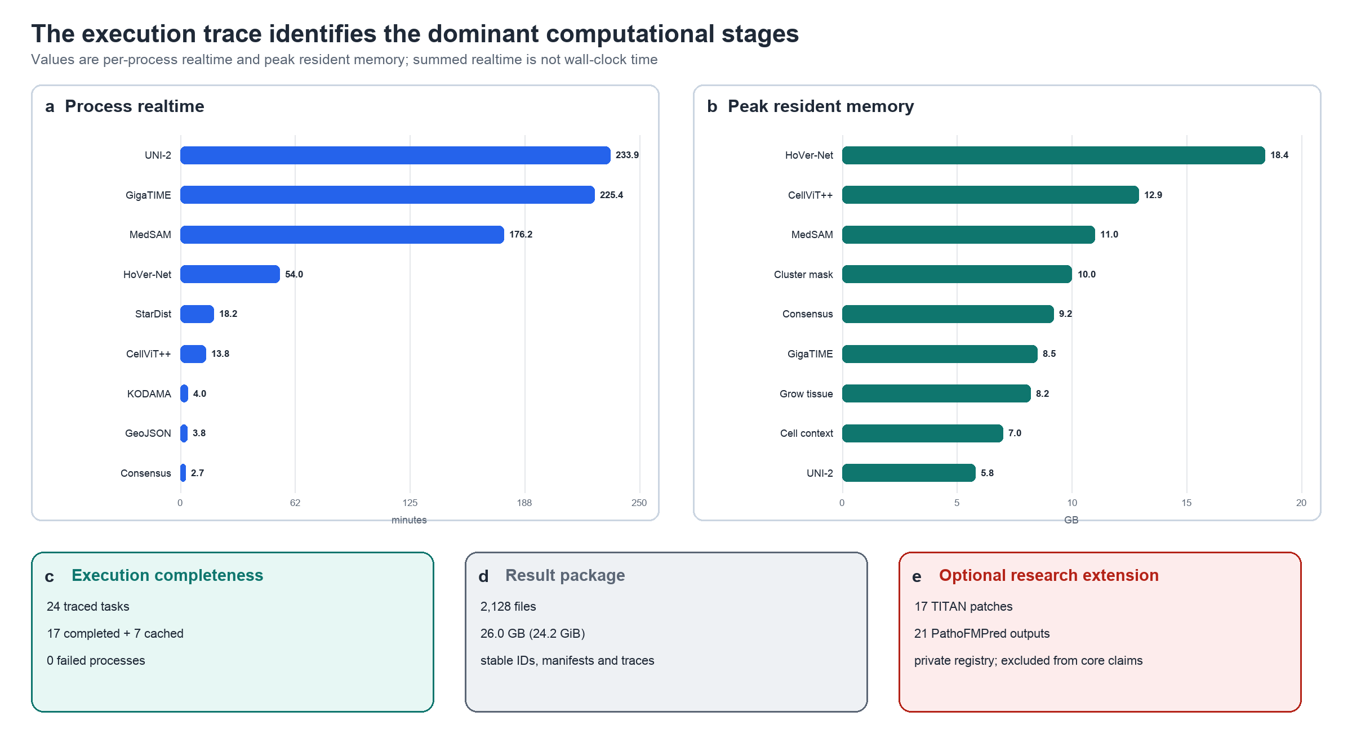
Figure 4 | Archived resource profile and execution completeness. a, Per-process realtime for the longest stages. b, Peak resident memory. c, Successful trace composition. d, Result-package scope. e, Optional section-level extension. Values derive from the archived Nextflow trace; cumulative process realtime is not wall-clock time. Current-route throughput has not been established by this figure.

Discussion
CellPhenotyper provides an executable contract between methods that operate at different physical scales and return incompatible objects. Its principal contribution is the retention of MPP-aware transforms, canonical cell identity, restart state and output provenance across cell, tissue and section representations. This focus complements modular multiplex-imaging workflows such as MCMICRO [19], interoperable image-analysis systems such as LazySlide and spatialproteomics [20,21], and multiscale visualization systems such as Vitessce and Viv [22,23].
The high-resolution case study demonstrates scale handling and also shows why successful process completion is not equivalent to valid scientific output. The implausible GrandQC classification, peripheral GigaTIME blocks and magnitude of MedSAM changes would be obscured by a report limited to exit codes and runtimes. Preserving these observations narrows the present claim: CellPhenotyper is an auditable integration and benchmarking framework, not a validated phenotyping or diagnostic system.
The implementation revision replaces simultaneous detector fusion with an explicit CellViT++ or StarDist choice. It separates shared crop preparation from inference, requires complete full-slide CellViT coverage before primary-cell export, and preserves native-to-crop registration in common cell masks and tables. Tissue analysis now uses calibrated Virchow2 observations with source-bound KODAMA/Bora continuation. Software and dataflow tests verify these interfaces; they do not constitute a new execution of the archived breast-cancer experiment or establish biological accuracy.
Several design choices preserve the meaning of each output. StarDist supplies nuclear instances without invented CellViT++ types; each pretrained classifier retains its own taxonomy; expanded cell-associated regions are not manual cytoplasm; virtual markers remain model-derived values; and unsupervised groups remain anonymous until a separate classifier or expert interpretation is applied. Compact Bora boundaries are checked against their prediction field, which is different from agreement with independent expert annotations. The private PathoFMPred extension remains outside the core reproducibility claim.
The main limitations require new experiments. Each selected detector and classifier needs independent nuclear-instance and cell-type annotations across tissues and scanners. GrandQC needs expert artifact labels, GigaTIME needs matched molecular imaging, and Bora requires held-out tissue identities and boundary annotations. KODAMA representation and clustering settings need repeated-seed and spatial-coherence analysis. Runtime deployment of the revised source, cross-hardware scaling and controlled interruption/resume also require version-specific checks. Visual smoothness or successful process completion cannot substitute for these measurements.
Within this restricted scope, the verified run establishes a reproducible evidence base for those experiments. A submission-ready release will additionally require a persistent data DOI, a digest-pinned container, model checksums, figure-generation code and complete CRediT roles.

Methods

Study design and scope
The technical case study used the public 10x Genomics Visium HD 11-mm human breast-cancer H&E image distributed as Visium_HD_11mm_Human_Breast_Cancer_tissue_image.btf. Its archived source and runtime are recorded below. The current implementation revision is described separately and was checked with deterministic CPU tests and local Nextflow stubs. No new specimens, GPU tissue analysis, expert cell/artifact/boundary reference, matched immunofluorescence or independent clinical outcomes were generated for this revision. Historical benchmark values therefore remain tied to their original source version.

Workflow implementation
CellPhenotyper is implemented in Nextflow DSL2 [17]. The current detector selector accepts cellvitpp or stardist, records that choice in the analysis contract and rejects combined or conflicting requests. Missing hardware or model assets do not cause detector substitution. The full-slide CellViT++ route uses a pinned Singularity runtime and bounded sequential cases, with checkpointed cell identities and a complete-coverage receipt. Source, model and runtime hashes bind the completed project. Shared crop preparation is independent of cell inference. The archived breast-cancer benchmark used source commit c0b94b6e0e3b4ff285647033566d7fbfb34665ed and runtime ghcr.io/tkcaccia/cellphenotyper-runtime:2.7-gpu-amd64; its older inference and fusion choices are stated explicitly.

Image conversion and physical coordinates
Input conversion records dimensions, channel interpretation, source hashes and physical-resolution metadata. The archived 5,739,510,784-byte input measured 45,503 × 41,711 pixels at 0.27377437 µm per pixel in x and 0.27377492 µm per pixel in y. Current wrappers retain native identity and derive model-specific sampling from verified MPP. GrandQC runs on the normalized full image. Clean tissue intersected with the optional ROI defines a level-0 analysis crop, and a shift sidecar records crop origin, dimensions and physical scale. Downstream crop-frame masks and tables share this transform. Full-slide CellViT cells retain their full-image identity and are translated explicitly into the crop frame for those consumers; no full-image label raster is inferred by resizing a crop.

GrandQC artifact analysis
Official GrandQC checkpoints are used [5]. The tissue model operates at 10 µm per pixel and artifact-model selection is MPP aware. Artifact tiles use 50% overlap. For every image size, class probabilities and blending weights are accumulated in disk-backed memory maps and finalized in bounded row blocks; no image-size threshold changes the merge algorithm. Low-confidence artifact calls are suppressed using recorded probability and margin thresholds. Outputs include tissue, clean-tissue and multiclass artifact masks, overlays, GeoJSON, merge metadata and class summaries. The archived benchmark predates this invariant merge contract. A later technical ROI rerun completed the revised implementation but does not replace an expert-labelled artifact benchmark.

One selected cell detector and its classifier views
Cell detection uses exactly one engine per run. CellViT++ is the default and uses the official whole-slide inference route with a pinned SAM-H backbone and calibrated input [9]. Bounded overlapping input regions provide context, but each detected cell belongs to one non-overlapping ownership core, avoiding duplicate halo cells. The standalone CellViT++ full-slide project is available only after all planned cores pass completion checks. Its retained 1,280-dimensional cell vectors support eight named classifier views: PanNuke, CoNSeP, Lizard, NuCLS main, NuCLS super, Ocelot, MIDOG and PanopTILs. Taxonomies and uncalibrated scores are stored separately rather than voted into a composite type. An explicit ROI scope is available without silently replacing the full-slide default. Alternatively, StarDist 2D_versatile_he [6] produces nuclear instances using the shared calibrated crop and blockwise large-image inference. This choice does not load CellViT++ or infer its cell-type labels. HoVer-Net and detector consensus are absent from the current two-choice pipeline.

TMA ROI and cell associated context
The current cell-output adapter converts verified CellViT native contours or complete full-slide index rows to crop-frame labels, object tables and GeoJSON. It checks source identity, full-slide coverage, crop registration and shared tissue support, preserves stable cell IDs separately from raster-label integers, and verifies that every retained cell is represented in the mask. StarDist supplies the same label/table interface. Automatic registration of both detector formats into one final viewer manifest remains a separate integration step; the standalone full-slide CellViT project retains all eight classifier views. TMA assessment and ROI assignment consume these registered outputs. Nuclear labels may be expanded into non-overlapping cell-associated regions without interpreting those regions as manually delineated cytoplasm. When neoplastic-cell section ranking is requested, the CellViT PanNuke view is selected by verified taxonomy and model identity; StarDist alone supplies no neoplastic classification.

GigaTIME inference and quantification
GigaTIME is optional and generates model-derived virtual markers [10]. Its wrapper records physical-scale conversion, channel selection, output storage and nuclear/marker quantification settings. The archived breast-cancer run resampled to 0.25 µm per pixel, used batch size 8 and 1,024-pixel blocks, skipped background blocks and quantified 23 channels over its historical cell population. Those settings and visible seam failures describe that source version. Current source corrections and lossless DAPI quality-control gates require their own recorded runtime and technical validation; matched molecular imaging is still required to establish marker-level fidelity.

Current Virchow2 tissue features and Bora refinement
The current tissue route uses non-overlapping 224 × 224-pixel Virchow2 inputs at 0.5 µm per pixel, covering 112 × 112 µm fields [24]. Tissue-tile vectors and spatial tokens have explicit observation units and feature definitions; they are not substituted for the cell-specific vectors consumed by CellViT++ classifier heads. KODAMA embeds the registered tissue features, and the chosen clustering method assigns anonymous groups using saved parameters. The group-to-image mapping and tile coordinates are retained independently of the visualization.
The accepted Bora continuation constructs a source-bound global tissue-prediction field, refines uncertain boundaries using native H&E evidence and produces one global mask before compact vector export [25]. Shared boundaries are fitted once with straight or diagonal segments and smooth arcs, while recorded raster-agreement and tissue-area guards limit geometric alteration. Physical-area filters control small components and holes. The separately retained exact mask distinguishes prediction changes from display simplification. Displayed Virchow2 RGB colours are feature contrast, not ground truth or the final annotation mask.
Optional tissue names are assigned by a separately frozen Neighbor-context PLS model whose feature definition, training domain and model identity accompany the output. Per-group token means and differences from boundary-weighted neighbouring-group means remain distinct from the unsupervised group labels. A transferred tissue label is exploratory without target-domain validation. The current source exposes this corrected continuation separately from the legacy per-window route; selecting an old route does not reproduce the accepted global boundaries.

Archived paired UNI 2 cell representations
The archived cell-centred route calibrated one tile per consensus cell to 0.25 µm per pixel before the 224 × 224 UNI-2-h transform [11]. In token_subset mode, one forward pass produced a tile CLS vector and an inner-square vector from tokens centred within a fixed 90-pixel square. Both 1,536-dimensional views retained the same cell identifier. These settings are retained to explain the archived benchmark and are not the current tissue-tile route. In particular, the 224-pixel Virchow2 tissue input must not be confused with the larger image regions used by CellViT++ whole-slide segmentation.

Archived KODAMA and Leiden parameterization
In the archived case, streaming variance selection retained 100 dimensions from each UNI-2 view, followed by scaling and 20-component PCA. KODAMA 0.99.7 used 279,899 cells, 1,000 landmarks, ncomp = 2, four CPU cores and seed 543210 [12]. Rnanoflann mean 50-neighbour distances guided sampling of 10,000 clustering landmarks; Leiden used k = 50 and resolution 0.3 [13], and remaining labels were assigned by 50-nearest-neighbour voting. Current Virchow2 tissue experiments record their own observation grid, feature representation, embedding and clustering settings. A chosen number of KODAMA groups is an exploratory modelling parameter, not an independently established tissue taxonomy.

Archived spatial reconstruction and MedSAM
The archived cell-based route joined community labels to canonical cell identifiers, projected them through cell-associated masks and grew seeds inside tissue before border-constrained MedSAM refinement [14]. Subsequent support clamps excluded background from initial masks, seeds, editable tiles, resumed checkpoints and final labels. The corresponding audit outputs include native-resolution before/after fields and change maps. This route is retained to interpret the historical figures; it is distinct from the current global Bora prediction and vectorization continuation.

GeoJSON and optional section outputs
Bora exports registered predicted tissue masks and compact Polygon or MultiPolygon boundaries; small components and holes are controlled by recorded physical-area and geometry settings. In the archived extension, connected sections were ranked by point-in-polygon counts of consensus cells with normalized CellViT++ neoplastic names and cropped with 256-µm padding. TITAN used CONCH v1.5 patches at 0.5 µm per pixel to produce 768-dimensional representations [15,16]. Optional PathoFMPred 0.2.0 checked titan_000 to titan_767 features and generated 21 BRCA research outputs from a private fitted registry. These uncalibrated research outputs remain outside the core reproducibility and clinical claims.

Technical metrics
Historical counts, timing, memory and file sizes were taken from the archived published summaries and final Nextflow trace. Cumulative process realtime was not interpreted as wall-clock duration. Current software checks exercise mutually exclusive Nextflow routes, unavailable-asset rejection, native-to-crop translation, overlapping-contour label coverage, empty results and incomplete full-slide input rejection. Small deterministic inputs establish interface behavior, not nuclear detection, cell-type or tissue-boundary accuracy. The historical experiment had no independent reference annotations, and no hypothesis tests or updated throughput claims are attached to the current implementation.

Use of generative artificial intelligence
OpenAI Codex assisted software development, language editing, manuscript-software consistency checks and assembly of figures from recorded outputs. It did not generate experimental tissue measurements for this revision. The archived numerical results were retained from their version-specific summaries and trace. The authors remain responsible for the implementation, interpretation, verification and final scientific content.

Data availability
The input H&E image is publicly available from the 10x Genomics Visium HD 11-mm human breast-cancer dataset. The derived result tree contained 2,128 files and 25,997,457,358 bytes of content; a checksum-verified 512-MB publication subset was used for manuscript auditing. A persistent repository DOI, complete result archive, output catalogue and figure source data must be deposited before submission. No TCGA cohort was analysed for this manuscript.

Code availability
CellPhenotyper source and documentation are available at https://github.com/tkcaccia/CellPhenotyper. This manuscript describes the development revision dated 27 October 2026, including the single-detector selector and registered cell-output adapter. The archived breast-cancer results remain bound to commit c0b94b6e0e3b4ff285647033566d7fbfb34665ed and runtime ghcr.io/tkcaccia/cellphenotyper-runtime:2.7-gpu-amd64. The current source requires a separately validated, immutable runtime before a new full analysis; a source update does not replace an active container. Bora source is available at https://github.com/tkcaccia/Bora [25]. A tagged release or immutable commit, model checksums, complete parameters, figure sources and deposited data must accompany submission. PathoFMPred is maintained at https://github.com/tkcaccia/PathoFMPred; its private fitted registry remains outside the core reproducibility claim.

Acknowledgements
We thank contributors and early users who tested CellPhenotyper during development. This work was supported by the International Centre for Genetic Engineering and Biotechnology (ICGEB). Additional award identifiers should be confirmed before submission.

Author contributions
S.C. conceived and supervised the project. All authors contributed to method development, software evaluation, interpretation or manuscript preparation and approved the manuscript. Complete author-specific CRediT roles require confirmation by all authors before submission.

Competing interests
The authors declare no competing interests.

Ethics statement
This technical study used publicly released, de-identified data and involved no new specimen collection or interaction with human participants.

References
1. de Haan, K., Zhang, Y. & Zuckerman, J. E. Deep learning-based transformation of H&E stained tissues into special stains. Nat. Commun. 12, 4884 (2021).
2. Komura, D. & Ishikawa, S. Machine learning methods for histopathological image analysis. Comput. Struct. Biotechnol. J. 16, 34-42 (2018).
3. Campanella, G. et al. Clinical-grade computational pathology using weakly supervised deep learning on whole slide images. Nat. Med. 25, 1301-1309 (2019).
4. Lu, M. Y. et al. Data-efficient and weakly supervised computational pathology on whole-slide images. Nat. Biomed. Eng. 5, 555-570 (2021).
5. Weng, Z. et al. GrandQC: a comprehensive solution to quality control problem in digital pathology. Nat. Commun. 15, 10685 (2024).
6. Schmidt, U. et al. Cell detection with star-convex polygons. Med. Image Anal. 61, 101664 (2020).
7. Graham, S. et al. HoVer-Net: simultaneous segmentation and classification of nuclei in multi-tissue histology images. Med. Image Anal. 58, 101563 (2019).
8. Verma, R. et al. MoNuSAC2020: a multi-organ nuclei segmentation and classification challenge. IEEE Trans. Med. Imaging 40, 3413-3423 (2021).
9. Hörst, F. et al. CellViT++: energy-efficient and adaptive cell segmentation and classification using foundation models. Comput. Methods Programs Biomed. 277, 109206 (2026).
10. Yang, S.-P. & Yu, D. (Giga)TIME for the era of AI: virtual multiplex immunofluorescence from routine H&E for large populations. Signal Transduct. Target. Ther. 11, 116 (2026).
11. Chen, R. J. et al. Towards a general-purpose foundation model for computational pathology. Nat. Med. 30, 850-862 (2024).
12. Cacciatore, S. et al. KODAMA: an R package for knowledge discovery and data mining. Bioinformatics 33, 621-623 (2017).
13. Traag, V. A., Waltman, L. & van Eck, N. J. From Louvain to Leiden: guaranteeing well-connected communities. Sci. Rep. 9, 5233 (2019).
14. Ma, J. et al. Segment anything in medical images. Nat. Commun. 15, 654 (2024).
15. Ding, T. et al. A multimodal whole-slide foundation model for pathology. Nat. Med. 31, 3749-3761 (2025).
16. Lu, M. Y. et al. A visual-language foundation model for computational pathology. Nat. Med. 30, 863-874 (2024).
17. Di Tommaso, P. et al. Nextflow enables reproducible computational workflows. Nat. Biotechnol. 35, 316-319 (2017).
18. Goldberg, I. G. et al. The Open Microscopy Environment Data Model and XML file: open tools for informatics and quantitative analysis in biological imaging. Genome Biol. 6, R47 (2005).
19. Schapiro, D. et al. MCMICRO: a scalable, modular image-processing pipeline for multiplexed tissue imaging. Nat. Methods 19, 311-315 (2022).
20. Zheng, Y. et al. LazySlide: accessible and interoperable whole-slide image analysis. Nat. Methods 23, 728-731 (2026).
21. Meyer-Bender, M. et al. Spatialproteomics: an interoperable toolbox for analyzing highly multiplexed fluorescence image data. Nat. Methods 23, 1564-1573 (2026).
22. Keller, M. S. et al. Vitessce: integrative visualization of multimodal and spatially resolved single-cell data. Nat. Methods 22, 63-67 (2025).
23. Manz, T. et al. Viv: multiscale visualization of high-resolution multiplexed bioimaging data on the web. Nat. Methods 19, 515-516 (2022).
24. Zimmermann, E. et al. Virchow2: Scaling Self-Supervised Mixed Magnification Models in Pathology. arXiv:2408.00738 (2024). https://doi.org/10.48550/arXiv.2408.00738
25. Bora. Source code and documentation. https://github.com/tkcaccia/Bora (accessed 27 October 2026).

