CellPhenotyper integrates resolution-aware spatial single-cell phenotyping and tissue-scale inference from H&E whole-slide images
Martin Ocharo^{1,2}, Moussa Kassim Mohamed^{1,2}, Dalia Ahmed^{1,3}, Alessia Vignoli^{4,5}, Aashish Kumar⁶, Giulia Canarutto⁷, Brendon Price⁸, Shweta Sbirla⁶, Leonardo Tenori^{4,5}, Silvano Piazza^{7,9}, Dinesh Gupta⁶, Ekene Emmanuel Nweke¹⁰, Stefano Cacciatore^{1,2}
1 Bioinformatics Unit, International Centre for Genetic Engineering and Biotechnology, Cape Town 7925, Western Cape, South Africa.
2 Department of Integrative Biomedical Sciences, Institute of Infectious Disease and Molecular Medicine, University of Cape Town, Cape Town 7925, South Africa.
3 Histopathology and Cytology Department, Faculty of Medical Laboratory Science, Omdurman Ahlia University, Omdurman, Sudan.
4 Department of Chemistry ‘Ugo Schiff’, University of Florence, Sesto Fiorentino, Italy.
5 Magnetic Resonance Center (CERM), University of Florence, Sesto Fiorentino, Italy.
6 Translational Bioinformatics Group, International Centre for Genetic Engineering and Biotechnology, New Delhi, India.
7 Computational Biology Group, International Centre for Genetic Engineering and Biotechnology, Trieste, Italy.
8 Division of Anatomical Pathology, University of Cape Town and National Health Laboratory Service, Observatory, Cape Town, South Africa.
9 Bioinformatics Facility, Department of Cellular, Computational and Integrative Biology (CIBIO), University of Trento, Trento, Italy.
10 Department of Surgery, School of Clinical Medicine, Faculty of Health Sciences, University of the Witwatersrand, Johannesburg, Gauteng, South Africa.
Correspondence should be addressed to S.C.

Abstract
Hematoxylin-and-eosin whole-slide images contain cellular and tissue structure but are difficult to transform reproducibly into spatial single-cell data. We developed CellPhenotyper, a Nextflow workflow that combines resolution-aware artifact quality control, three-model cell consensus, virtual multiplex-marker inference, paired UNI-2 morphology embeddings, scalable KODAMA–Leiden phenotyping, MedSAM tissue-boundary refinement and section-level TITAN representation. In a public breast-cancer specimen, StarDist, HoVer-Net and CellViT++ detected 22,663, 25,639 and 91,104 candidates; two-of-three alignment retained 23,226 consensus cells. GigaTIME quantified 23 markers for 23,223 cells, paired UNI-2 extraction produced complete features for 23,206 cells, and landmark clustering resolved four spatial phenotypes. Conversion through TITAN completed in 69.5 min on a 16-GB NVIDIA GPU and generated traceable masks, tables, OME-TIFF images, GeoJSON annotations, embeddings and research-only PathoFMPred outputs. CellPhenotyper provides a restartable framework that preserves physical coordinates and model provenance across cellular, tissue and section-scale analyses.
Hematoxylin-and-eosin (H&E) staining remains the principal morphological reference in diagnostic histopathology. Whole-slide imaging extends this reference to gigapixel data that can support quantitative analysis of nuclei, cellular neighbourhoods and tissue architecture [1–4]. Yet a slide is not a conventional microscopy field: its physical scale, file format, artifacts and memory footprint must be handled consistently before cell-level measurements can be compared or reconstructed in tissue space.
Existing computational pathology tools address individual parts of this problem. GrandQC detects tissue and acquisition or preparation artifacts [5]; StarDist, HoVer-Net and CellViT++ segment or classify nuclei using different geometric and representational assumptions [6–9]; GigaTIME infers virtual multiplex markers [10]; UNI-2 provides general-purpose histopathology representations [11]; KODAMA supports knowledge discovery in high-dimensional data [12]; Leiden clustering identifies graph communities [13]; and MedSAM refines image masks from prompts [14]. However, combining these tools into one reproducible analysis remains difficult because they expect different pixel resolutions, coordinate systems, data structures, model caches and hardware environments. Their outputs also differ in biological semantics: a segmentation instance is not a consensus cell, a virtual marker is not a measured immunostain, an unsupervised cluster is not automatically a cell type, and a section-level model score is not a clinical prediction.
CellPhenotyper was developed to make those distinctions explicit while retaining end-to-end provenance. The workflow standardizes image ingestion and micrometre-per-pixel (MPP) metadata, performs artifact-aware quality control, aligns three independent cell detectors into canonical cells, identifies tissue-microarray (TMA) structure when present, quantifies virtual markers over matched nuclear and cell-associated regions, derives paired cell-centred UNI-2 representations, learns a low-dimensional manifold, clusters a density-aware landmark subset, reconstructs continuous tissue compartments and restricts MedSAM to editable borders. Optional downstream stages rank connected tissue sections by named neoplastic consensus cells, encode the selected section with TITAN and CONCH v1.5 [15,16], and submit the resulting feature vector to cancer-specific PathoFMPred research models.
Here we describe the implemented workflow and report a complete technical execution on one public H&E breast-cancer specimen. This case study evaluates coordinate continuity, output completeness, resource use and execution of all stages; it does not constitute a multi-institutional accuracy benchmark or clinical validation. That distinction is central to the interpretation of the results below.

Results

A physically calibrated workflow links cell, tissue and section scales
CellPhenotyper is organized as 19 restart points and 18 numbered analysis stages plus execution metadata (Fig. 1). Image conversion produces a pyramidal OME-TIFF while preserving physical pixel size. GrandQC precedes cell segmentation so that tissue and artifact masks are available to later stages. StarDist, HoVer-Net MoNuSAC and CellViT++ run in a shared crop coordinate system and are reconciled into canonical cells before TMA detection, ROI assignment, cytoplasm-associated expansion, marker quantification and representation learning. Cluster labels are projected back into the source image, grown only within tissue, refined at their borders and exported as class-aware GeoJSON. Optional stages 16–18 select a neoplastic-cell-rich connected section, compute TITAN features and generate PathoFMPred research reports.
The implementation differs from simply chaining upstream commands. GrandQC uses MPP-selected official checkpoints, overlapping inference and smooth probability blending; the three cell models are normalized to a common physical coordinate frame; GigaTIME uses exact floating-point resampling and integrated single-cell quantification; UNI-2 produces tile and inner-square vectors from one model pass; and MedSAM edits only an explicit border band while preserving cluster seeds. Nextflow DSL2 provides stage-specific restart, process isolation, resource declarations and an output catalogue in which every published file has a stable identifier and address [17].
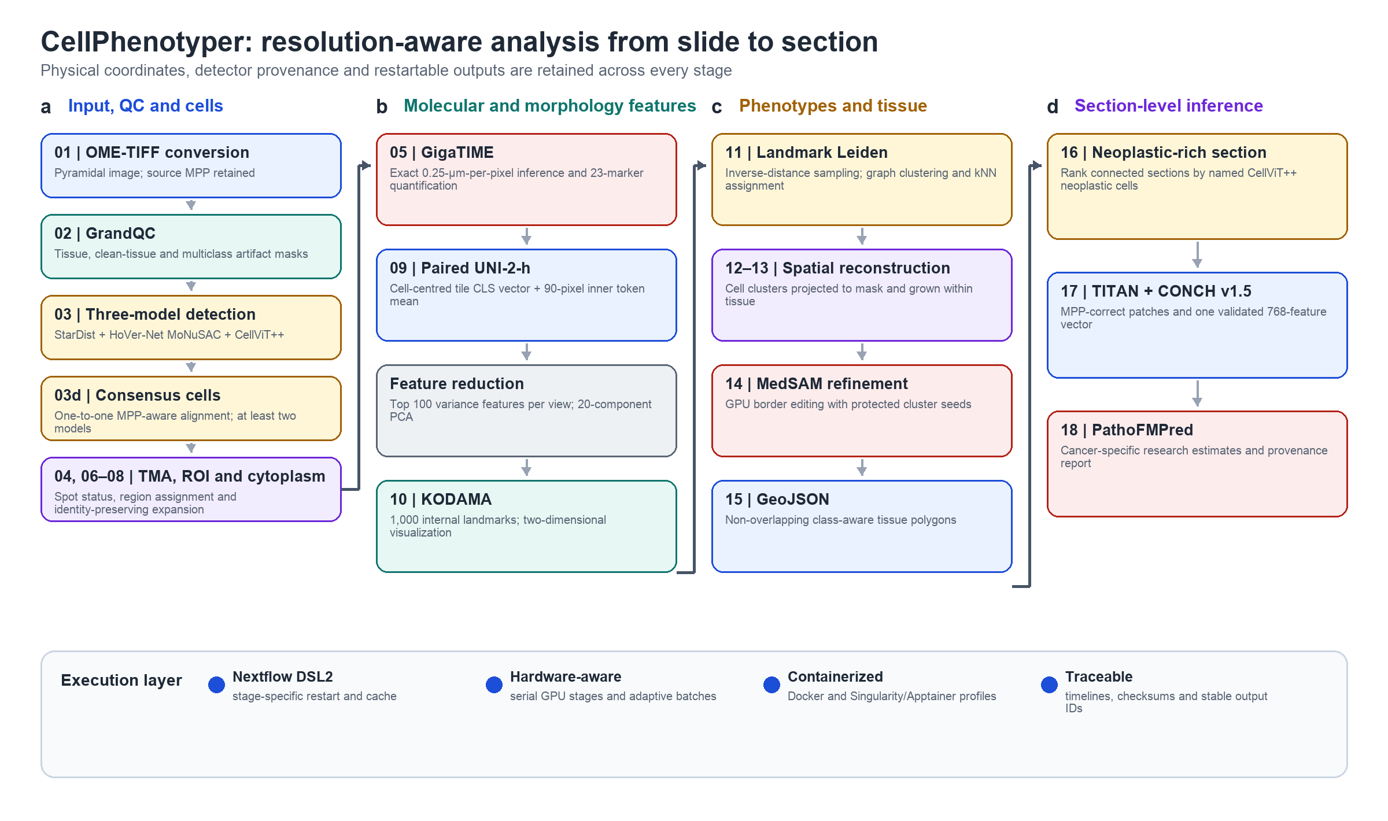
Figure 1 | CellPhenotyper workflow. a, Input conversion, GrandQC and three-model consensus cell identification. b, GigaTIME virtual-marker inference and paired cell-centred UNI-2 representations. c, KODAMA visualization, density-aware landmark Leiden clustering, spatial reconstruction and MedSAM border refinement. d, Selection of the connected section with the largest named neoplastic consensus-cell count, TITAN/CONCH v1.5 representation and cancer-specific PathoFMPred research inference. The execution layer provides MPP-aware coordinates, hardware-adaptive resources, containerized software, restartable checkpoints and project-wide output identifiers. MPP, micrometres per pixel; ROI, region of interest; TMA, tissue microarray.

Three detectors yield a traceable consensus cell set
The public breast specimen measured 16,016 × 14,625 pixels at 0.5473 µm per pixel; the cell-analysis crop measured 11,912 × 13,303 pixels. GrandQC selected its 2.0-µm-per-pixel artifact model, processed a 7 × 8 grid with 1,024-pixel context and 50% overlap, and blended probabilities in slide coordinates. The resulting QC mask contained 6.11% artifact and 66.02% clean tissue (Fig. 2a). These fractions describe model output on the QC grid and were not treated as histopathological ground truth.
StarDist, HoVer-Net MoNuSAC and CellViT++ detected 22,663, 25,639 and 91,104 candidate instances, respectively. The higher CellViT++ count illustrates why detector outputs cannot be concatenated without reconciliation. One-to-one centroid matching at a 4-µm radius and a minimum support of two models retained 23,226 canonical cells (Fig. 2b). Of these, 19,674 (84.7%) were supported by two models and 3,552 (15.3%) by all three. Each output cell retained its canonical identifier, selected contour, coordinates, source-model identifiers and named detector classes. The TMA module correctly emitted an explicit non-TMA status for this specimen, with no spot polygons or spot assignments.

Virtual markers and paired morphology features remain cell aligned
GigaTIME resampled the crop from 0.5473 to exactly 0.25 µm per pixel, yielding a 29,124 × 26,078 inference image. Hardware adaptation selected batch size 2 and 768-pixel blocks. The model produced 23 virtual-marker channels; DAPI, PD-1, CD3, CD8 and PD-L1 were persisted as image channels for quality control, while all 23 markers were quantified over nuclear and non-overlapping cell-associated regions (Fig. 2c). Quantification completed for 23,223 cells (99.99% of the consensus set). These intensities are model-derived virtual measurements and should not be interpreted as measured immunofluorescence without marker-specific validation.
UNI-2-h processing was centred on canonical cells and calibrated to 0.25 µm per pixel before the 224 × 224 model transform. A single forward pass produced a 1,536-dimensional full-tile CLS representation and a 1,536-dimensional inner-square representation obtained by averaging patch tokens whose centres fell within a fixed 90-pixel square. The inner square was therefore neither a cytoplasm mask nor a second masked-image inference. Checkpointed bucket outputs yielded aligned paired embeddings for 23,206 cells (99.91% of the consensus set), while avoiding the storage of per-cell tile images.

Memory-bounded KODAMA and landmark clustering resolve four communities
For the completed run, the loader retained the 100 highest-variance features from each 1,536-dimensional UNI-2 family. This corrects the earlier draft, which described spatial feature selection: because each family was reduced to 100 features before KODAMA, no additional spatial ranking was applied in this run. The 200 retained features were centred, scaled and reduced to exactly 20 principal components; the raw matrices were then removed from memory. KODAMA used all 23,206 aligned cells, 1,000 internal landmarks, two internal components and a 30-neighbour visualization.
Clustering used only the two-dimensional KODAMA visualization (Fig. 2d). Ten thousand landmarks were sampled with probability proportional to the inverse square of the mean distance to each cell's 50 nearest neighbours. Leiden clustering used a 30-neighbour landmark graph; the remaining cells were assigned by 50-nearest-neighbour voting with Rnanoflann. The archived representative run used the earlier silhouette, modularity and complexity score for automatic resolution screening over 0.005-0.05; it selected 0.005 and produced four communities containing 14,654, 5,524, 1,833 and 1,195 cells. The current workflow instead chooses the eligible resolution with the smallest predicted abstained population, as described in Methods. The representative result was not recalculated retrospectively and is therefore not evidence for the revised selector.

MedSAM changes borders without redefining cluster seeds
Cell clusters were mapped through the expanded label image and grown within the tissue mask. MedSAM then processed 16 overlapping 4,096-pixel tiles with 512-pixel overlap on CUDA, completing all tiles without failure in 530.9 s. The refinement summary recorded 1,098,089 removed pixels, 1,456,033 added pixels and 11,155,206 relabelled pixels during cleanup and conflict resolution. Core cluster seeds remained protected, and full-resolution random-region and raw-versus-final panels were produced for quality control (Fig. 2e). The final mask was exported as pyramidal OME-TIFF and non-overlapping class-aware GeoJSON.

Section selection connects tissue phenotypes to research-only molecular estimates
The final vector output contained 395 connected tissue components. Exact point-in-polygon assignment linked 23,169 of 23,226 consensus cells to a component. Ranking by the named CellViT++ neoplastic class selected standard_class_1_component_1, which contained 11,884 neoplastic cells among 18,372 assigned cells (Fig. 2f). A 256-µm padded full-resolution crop and its coordinate transform were retained.
At 0.5 µm per pixel and a minimum tissue coverage of 20%, TITAN encoded 554 CONCH v1.5 patches on an NVIDIA GeForce RTX 5060 Ti and returned finite 768-dimensional patch and section representations. PathoFMPred validated the exact titan_000–titan_767 schema and, using the explicitly configured BRCA model family, generated 21 outputs: 16 continuous estimates and five binary calls. The binary scores are out-of-fold reference ranks rather than calibrated probabilities, and the fitted models have not undergone independent external clinical validation.
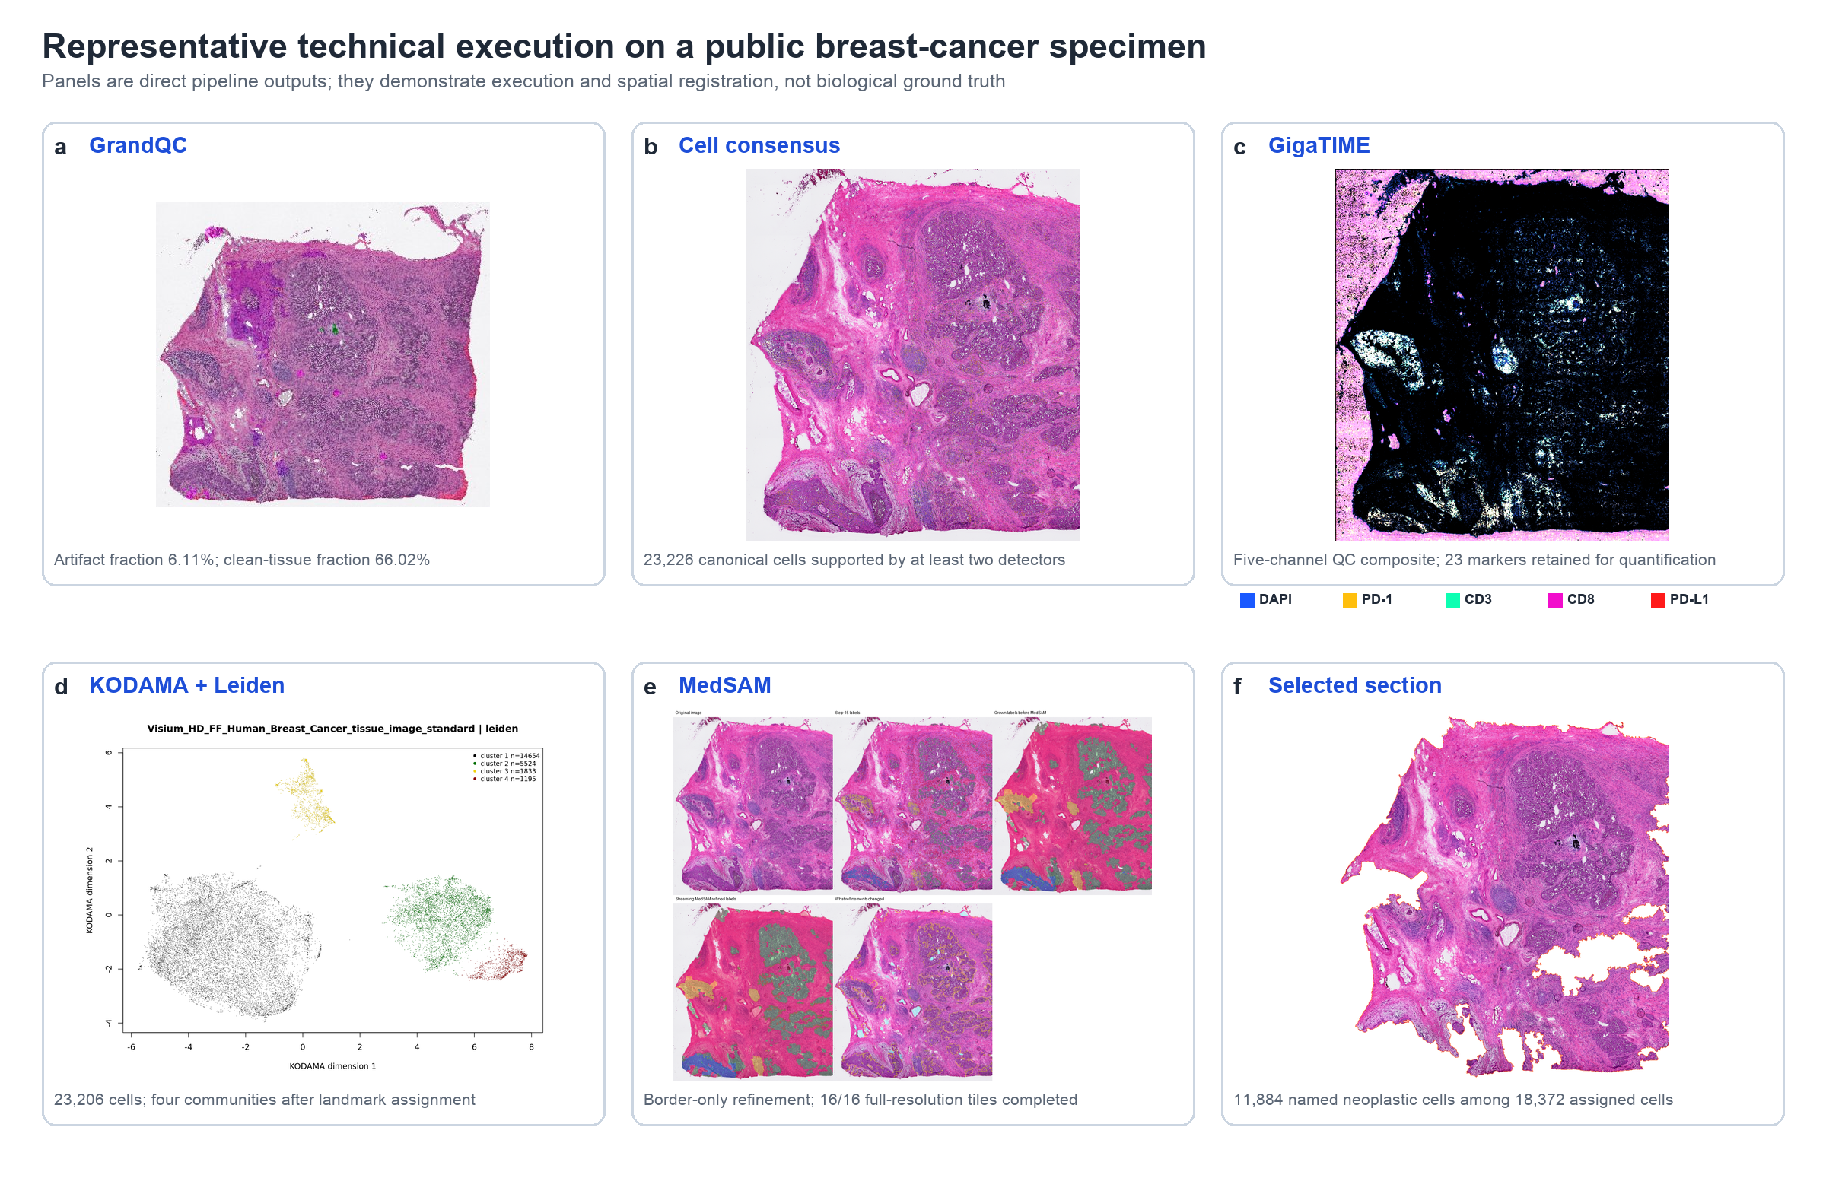
Figure 2 | Representative outputs from the public breast-cancer specimen. a, GrandQC overlay. b, Three-model consensus-cell preview. c, Five-channel GigaTIME quality-control composite (DAPI, PD-1, CD3, CD8 and PD-L1); all 23 model markers were retained for per-cell quantification. d, KODAMA visualization coloured by four Leiden communities. e, MedSAM raw-versus-final quality-control panel. f, Connected tissue section selected by named neoplastic consensus-cell count. Panels demonstrate technical execution and spatial registration; they do not establish biological ground truth or clinical validity.

Development selection of spatial resolution and boundary regularization
A separate development experiment evaluated spatial-grid UNI-2 sampling and final vector regularization on a 43,458 x 39,886-pixel breast-cancer tissue image with a three-class expert annotation. The annotation was withheld from pipeline inference and was used only after candidate generation. With K fixed at three for this comparison, a 28-pixel central token-pooling square and a 56-pixel grid stride produced a mean class intersection over union (IoU) of 0.9454 and mean Dice score of 0.9717 after label matching. The corresponding values were 0.8837 and 0.9383 for a 56-pixel square with the same stride, and 0.6817 and 0.8077 for the historical coupled 90-pixel geometry. Both 56-pixel-stride routes generated 498,992 observations. Summed task runtime was 35,247.2 s for the 28/56 route and 34,925.6 s for the 56/56 route, a difference of 321.6 s (0.92%). These measurements support the 28/56 geometry for grid-based tissue-domain development, but they do not establish performance on independent specimens.
The selected final vector procedure applied one selective shared-boundary Laplacian pass after topology-preserving simplification. It reduced the 95th percentile boundary-turn angle from 121.13 degrees to 116.58 degrees and the density of long sharp turns from 1,355.0 to 1,292.4 per 100,000 ring pixels, without changing the external tissue footprint, feature count or 244,005-segment count. The maximum vertex displacement was 11.856 native pixels, and positive-area overlap between classes remained zero. Mean class IoU changed from 0.94536 to 0.94234 and boundary F1 at 32 pixels from 0.91979 to 0.91938. We therefore treat this as a development-selected geometric regularizer that improves angular plausibility with a small loss of agreement to this reference, rather than as evidence of improved segmentation accuracy.

The complete run is feasible on a single 16-GB GPU workstation
The conversion-to-TITAN workflow completed successfully in 69.5 min. HoVer-Net was the longest process (27.3 min) and had the highest peak resident memory (16.6 GB), followed by paired UNI-2 extraction (19.0 min; 5.8 GB) and MedSAM (9.0 min; 4.2 GB) (Fig. 3a,b). KODAMA required 69 s and 276 MB after variance filtering and PCA. TITAN required 38 s and 3.7 GB. PathoFMPred ran separately from cached TITAN output in 3.5 s with 366.8 MB peak resident memory. The final result mirror contained 1,826 files in 259 directories and 5.02 GB of file content, including the execution report, traces, output manifest and unique output identifiers.
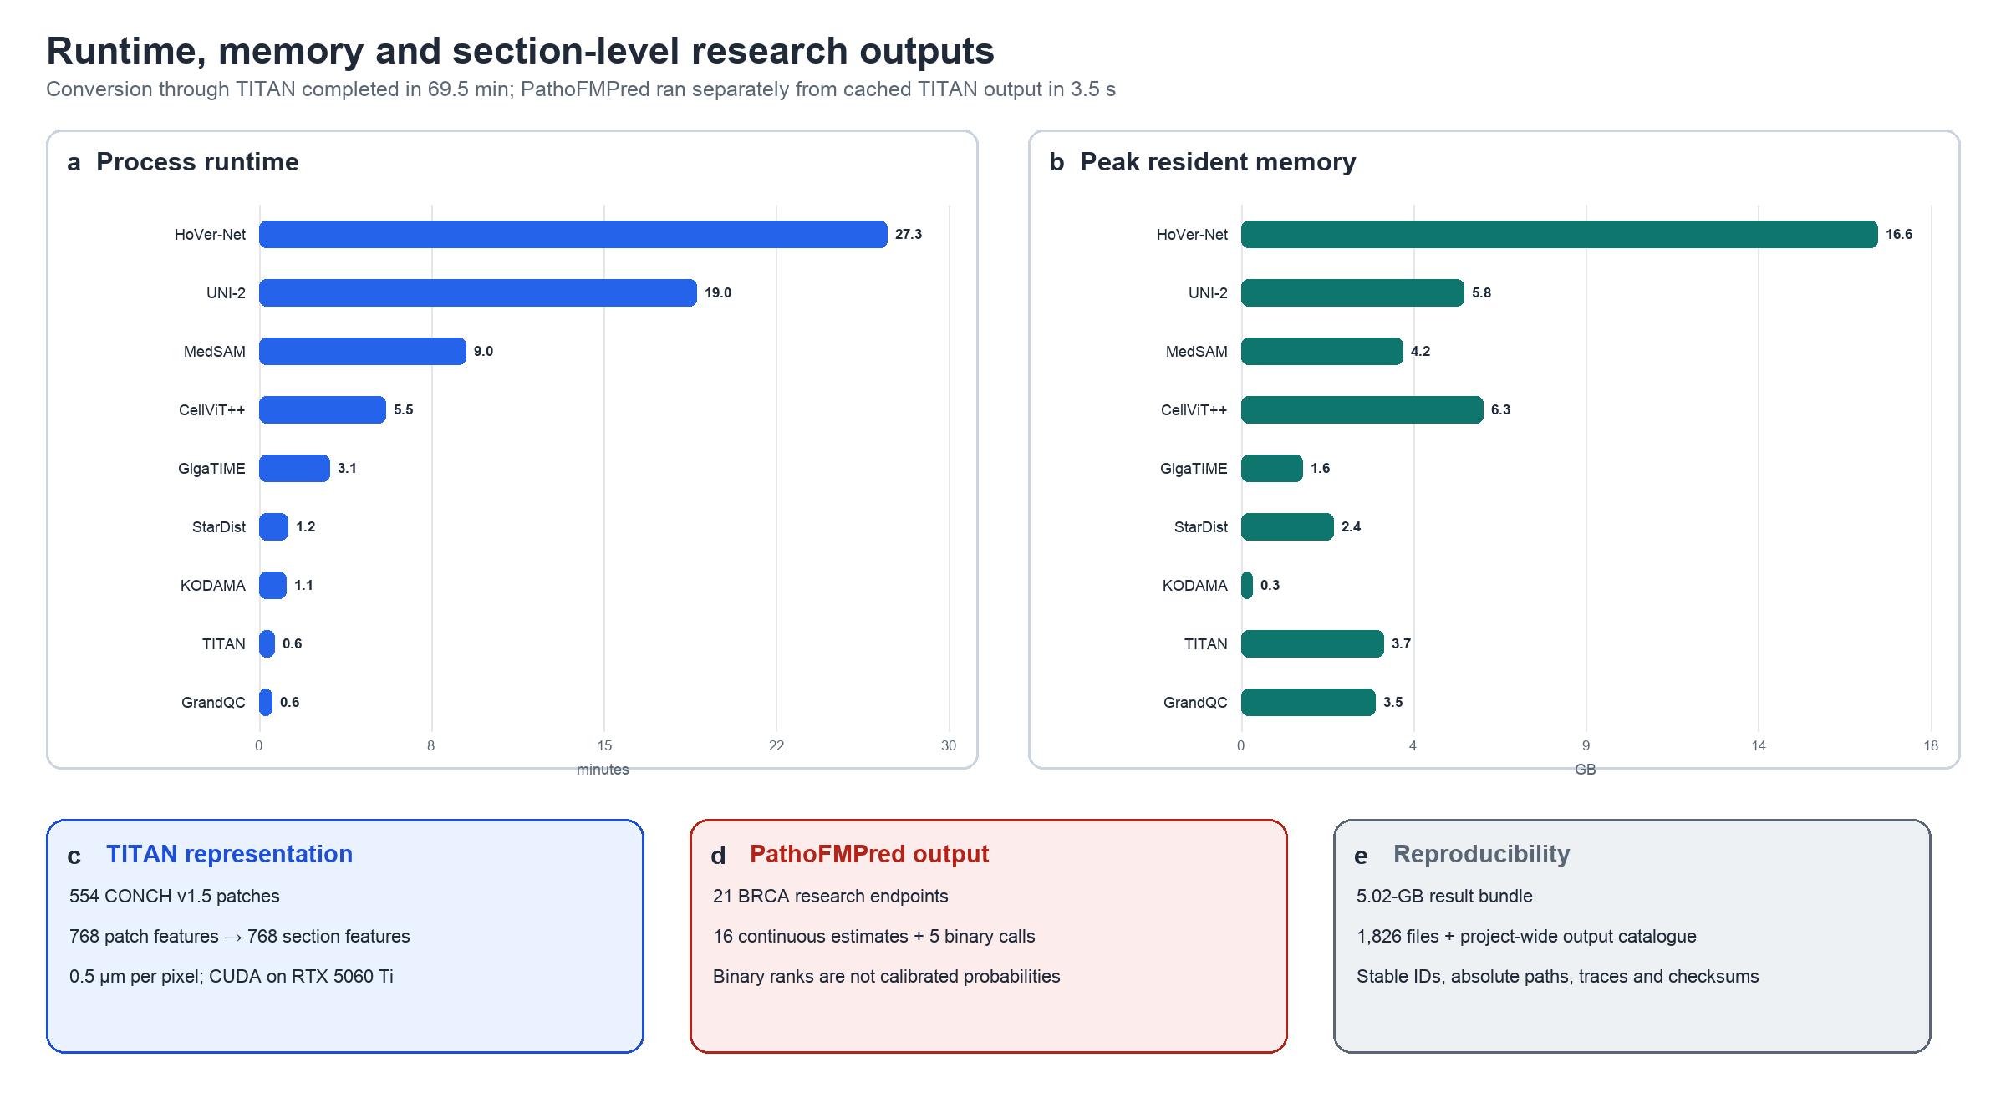
Figure 3 | Resource profile and section-level outputs. a, Per-process runtime for the principal computational stages. b, Peak resident memory from the Nextflow trace. c, TITAN patch and section representations. d, PathoFMPred output scope; all results are research estimates, and binary ranks are not calibrated probabilities. e, Reproducibility artifacts in the checksum-verified 5.02-GB result bundle. Runtime and memory values are for the representative breast specimen on the Chiamaka workstation and should not be generalized to other slide sizes or hardware without benchmarking.

Table 1 | Technical completeness of the representative run
Stage | Observed output | Interpretation
Input | 16,016 × 14,625 pixels; 0.5473 µm per pixel | Physical scale recovered and retained
GrandQC | 6.11% artifact; 66.02% clean tissue | 7 × 8 overlapping QC grid; CUDA
Cell candidates | 22,663 StarDist; 25,639 HoVer-Net; 91,104 CellViT++ | Detector disagreement retained as provenance
Consensus | 23,226 cells | 19,674 two-model; 3,552 three-model support
TMA | Non-TMA; 0 candidate spots | Explicit status; no spot assignment
GigaTIME | 23 markers; 23,223 quantified cells | Five channels persisted in the QC OME-TIFF
UNI-2 | 23,206 paired cell embeddings | 1,536 tile + 1,536 inner-square features
KODAMA/Leiden | 23,206 cells; four communities | 10,000 landmarks; auto resolution 0.005
MedSAM | 16/16 tiles; 530.9 s; no failures | CUDA border-only refinement
Section selection | 395 components; 11,884/18,372 neoplastic/total in selected section | Deterministic named-class ranking
TITAN | 554 patches; 768 section features | CONCH v1.5; 0.5 µm per pixel
PathoFMPred | 21 BRCA research endpoints | 16 continuous; five binary; no clinical calibration
Execution | 69.5 min to TITAN; 5.02-GB result bundle | Traces, manifests, checksums and stable output IDs
Values are direct measurements from the verified result bundle. They quantify technical execution and completeness, not segmentation accuracy or biological validity.

Discussion
CellPhenotyper provides an executable contract between methods that otherwise operate at different physical scales and return incompatible objects. Its main contribution is not a new foundation model, cell detector or segmentation network. Instead, it converts their outputs into a common, restartable analysis with explicit coordinate transforms, canonical cell identifiers, named class provenance and full-resolution spatial reconstruction. The representative run shows that this integration can proceed from H&E input to cell-level marker tables, paired morphology features, tissue compartments and section-level research estimates on a single GPU workstation.
Several design choices are deliberately conservative. Consensus requires support from at least two detectors rather than assuming that the most prolific model is correct. Cytoplasm-associated regions are described as identity-preserving expansions rather than true cell membranes. GigaTIME intensities are labelled virtual measurements. KODAMA–Leiden communities remain unnamed until supported by histology, measured markers or independent annotations. MedSAM cannot create a compartment without a cluster-derived seed, and PathoFMPred outputs are reported as research estimates with explicit calibration and validation warnings. These constraints reduce the risk that technical outputs are presented as biological facts.
The present study has important limitations. It reports one complete public breast-specimen execution and therefore does not estimate segmentation accuracy, cross-scanner robustness, TMA sensitivity, marker fidelity, cluster stability across cohorts or molecular-prediction generalizability. Consensus between models is not equivalent to expert ground truth, and the non-TMA result is only a negative control for the TMA module. Likewise, the reported resource profile depends on slide dimensions, tissue fraction, selected channels and hardware. A Nature Methods-level performance claim will require a preregistered multi-institutional benchmark with expert cell annotations, measured multiplex markers, representative TMA slides, ablation of each integration choice, repeated seeds, comparison with end-to-end alternatives and external evaluation of TITAN/PathoFMPred outputs.
Within that scope, the current implementation establishes a reproducible foundation for such validation. Stable output identifiers, complete run traces, restartable model stages and explicit warnings make it possible to compare future algorithmic changes without silently changing coordinates or feature definitions. CellPhenotyper therefore serves as both an analysis workflow and an auditable test bed for cellular, tissue and section-scale computational pathology.

Methods

Study design and scope
We evaluated technical execution on the public 10x Genomics Visium HD fresh-frozen human breast-cancer H&E image distributed as Visium_HD_FF_Human_Breast_Cancer_tissue_image.ome.tif. No new specimens or participant data were collected. The analysis was designed to verify coordinate continuity, output completeness, restartability and resource use across all enabled stages. No expert cell annotations, matched immunofluorescence or independent molecular outcomes were available; consequently, no accuracy, sensitivity, specificity or clinical-performance claims were made.

Workflow implementation
CellPhenotyper was implemented in Nextflow DSL2 [17] at source commit 30dcdf5fbd595587d0057577257c5afe9a7be390. The verified amd64 GPU runtime was ghcr.io/tkcaccia/cellphenotyper-runtime:2.7-gpu-amd64. Processes declared CPU, RAM, GPU and timeout requirements. GPU-intensive cell models ran serially to limit aggregate video memory; model batch sizes and block sizes were bounded by available GPU and system memory. Nextflow caching enabled stage-specific restart, and UNI-2 added bucket-level checkpoint markers. The execution directory contained the trace, timeline, report, directed acyclic graph, final status report, file manifest and project output catalogue.

Image conversion and physical coordinates
The input was converted to pyramidal OME-TIFF [18] while retaining level-0 dimensions and MPP. The initial image measured 16,016 × 14,625 pixels at 0.547304 µm per pixel. Downstream cell analysis used an automatically prepared crop of 11,912 × 13,303 pixels at 0.547302 µm per pixel, with shift metadata linking crop and source coordinates. The crop was written as a tiled RGB OME-TIFF with SubIFD overviews down to one tile, using the configured input codec; dimensions, physical resolution, compression and pyramid geometry were validated before publication. All MPP-sensitive stages resolved physical scale from OME metadata or the saved coordinate transform; configured fallbacks were used only when metadata could not be recovered.

GrandQC artifact analysis
Official GrandQC tissue and artifact checkpoints were used [5]. The tissue detector used its 10-µm-per-pixel model. Hardware-aware selection chose the 2.0-µm-per-pixel artifact model and 1,024-pixel context tiles on CUDA. Tiles overlapped by 512 pixels, and class probabilities were combined with a smooth blending window before argmax classification. The default analysis-support mask retained all tissue-detector-positive pixels, including artifact candidates, while background was excluded. The cropped artifact mask was propagated separately, and each UNI-2 grid observation recorded its candidate overlap. Candidate observations entered UNI-2 and KODAMA unchanged. After clustering, a candidate was excluded only when its mean 15-nearest-neighbour distance to non-candidate observations in the same cluster exceeded both the 99.5th percentile and median plus six median absolute deviations of the reference-distance distribution. Clusters with fewer than 50 non-candidate references failed open. Outputs retained candidate flags, distances, thresholds, scores, tissue and artifact masks, previews, GeoJSON and model provenance. This gate is an unsupervised engineering policy and not a validated artifact classifier.

StarDist, HoVer-Net and CellViT++
StarDist used the 2D_versatile_he model with tiled inference to produce nuclear instances [6]. HoVer-Net used the official fast MoNuSAC checkpoint [7,8], target MPP 0.25 and batch size 16. Its type mapping was background, epithelial, lymphocyte, macrophage and neutrophil. CellViT++ used the HIPT encoder with PanNuke taxonomy, batch size 2 and one bounded Ray worker [9]. Its named mapping was neoplastic, inflammatory, connective, dead and epithelial. Each wrapper recovered source MPP, transformed detections into the StarDist crop frame and exported centroids, contours, numeric identifiers, readable names and confidence or provenance fields. HoVer-Net and CellViT++ were executed serially.

Consensus cell identification
Predictions were matched by one-to-one centroid distance after converting a 4-µm radius to 7.3086 crop pixels. Components containing support from at least two distinct models were accepted. A component could not contain duplicate predictions from one model. Canonical coordinates were the means of member centroids. Geometry was selected deterministically from CellViT++, then HoVer-Net, then StarDist when available. The stage emitted a tiled label TIFF, object table, alignment table, GeoJSON, preview and support summary.

TMA detection and region assignment
A thumbnail-based custom module segmented separated tissue components and evaluated component count, area coefficient of variation, circularity, solidity, eccentricity and grid-like organization. At least four compact components were required for a TMA call. For positive images, spot polygons and cell-to-spot assignments were exported; negative images retained explicit status metadata. Consensus cells were also assigned to supplied or automatically generated ROI polygons by coordinate containment.

Cytoplasm-associated expansion
Consensus labels were expanded into non-overlapping cell-associated regions with nearest-label/Voronoi constraints. Canonical identity was preserved and nuclear labels were retained separately. These regions approximate per-cell context and were not interpreted as manually delineated cytoplasmic boundaries.

GigaTIME inference and quantification
The source crop was resampled by the exact floating-point ratio required to reach 0.25 µm per pixel before GigaTIME inference [10]. Hardware adaptation selected batch size 2, 768-pixel blocks and a 1.25-GiB output-memory target. Overlapping predictions were blended in slide coordinates and written to a chunked Zarr store before export as a pyramidal multichannel OME-TIFF. The model channels were DAPI, TRITC, Cy5, PD-1, CD14, CD4, T-bet, CD34, CD68, CD16, CD11c, CD138, CD20, CD3, CD8, PD-L1, CK, Ki67, Tryptase, Actin-D, Caspase3-D, PHH3-B and Transgelin. DAPI, PD-1, CD3, CD8 and PD-L1 were persisted in the image; all 23 channels were quantified over nuclei and cell-associated regions as per-cell means, sums and maxima.

Paired UNI-2 embeddings
One tile was centred on each canonical cell. Source crops were calibrated to 0.25 µm per pixel and transformed to the 224 × 224 UNI-2-h input [11]. In token_subset mode, one forward pass generated the full-tile CLS vector and exposed patch tokens. Patch tokens whose centres fell inside a centred 90-pixel square were averaged to form inner_square. Both outputs contained 1,536 features and the same cell identifier. Embeddings were written in bucketed CSV shards with completion markers; per-cell PNG tiles were not saved. Model assets were read from a shared cache.

Feature reduction and KODAMA
The embedding loader computed streaming feature variances and retained the 100 highest-variance dimensions separately from tile and inner_square. Matrices were intersected with canonical annotations by cell identifier and concatenated. KODAMA.pca centred and scaled the 200-feature matrix and returned 20 principal components with seed 543210 [12]. Raw matrices were removed immediately after PCA. KODAMA 0.99.7 used all 23,206 aligned cells, spatial coordinates, 1,000 internal landmarks, ncomp = 2, four CPU cores and seed 543210. KODAMA.visualization used UMAP with 30 neighbours to obtain the two-dimensional visualization.

Landmark Leiden clustering
Clustering used only the two-dimensional KODAMA visualization [13]. For every cell, Rnanoflann computed the mean distance to 50 nearest neighbours. Ten thousand landmarks were sampled without replacement with probability proportional to the inverse square of that distance, and a 30-neighbour shared-nearest-neighbour graph was constructed on the landmarks. When cluster_resolution was auto, candidate Leiden resolutions 0.005, 0.010, 0.020, 0.030, 0.040 and 0.050 were evaluated across the configured random seeds on a common landmark graph and all-cell nearest-neighbour query. For each candidate, a predicted abstention was the union of a landmark-vote margin below the declared assignment threshold and an across-seed agreement fraction below the declared stability threshold. Candidates with fewer than two clusters or more than the adaptive cluster-count cap were excluded. The eligible candidate with the fewest predicted abstentions determined both the resolution and cluster number; ties were resolved by mean and minimum adjusted Rand index, tiny-cluster burden, silhouette, modularity and then the smaller cluster count. The selected resolution was held fixed during a broader stability pass that resampled landmarks. Candidate metrics and the selected row were written to the cluster-resolution candidate table. The former silhouette, modularity and complexity selector remained available as an explicit compatibility option. Clusters smaller than 1% of cells could subsequently be merged. GrandQC artifact candidates were not removed before graph construction. The selected partition was used only afterward to evaluate candidate-specific KODAMA-display outliers within each cluster; confirmed outliers were explicitly marked for downstream exclusion, whereas all other candidates retained their raw cluster assignment.

Spatial reconstruction and MedSAM
Cluster labels were joined to canonical cell identifiers and projected through the cell-associated mask. Seed labels were expanded only inside the tissue mask by nearest-label growth and morphological regularization. MedSAM [14] was used as a refinement model, not as a first-pass cluster detector. It received the H&E crop, protected cluster seeds and grown mask, and was allowed to alter only a configurable border band. GrandQC artifact candidates remained in the baseline unless the post-KODAMA gate confirmed them as outliers; confirmed cores were encoded as uncertainty code 5 and treated as hard exclusions throughout MedSAM. The representative run used CUDA, 4,096-pixel tiles, 512-pixel overlap and 16 tiles. Labels were processed independently, including tiles containing one cluster, followed by deterministic overlap resolution and conservative cleanup. Outputs included refined and intermediate masks, whole-slide previews, change maps, raw-versus-final panels and one random 1,024 × 1,024 full-resolution quality-control region.

GeoJSON and connected-section selection
Refined categorical masks were vectorized from the native-resolution label raster with four-connected rasterio polygonization while retaining interior rings and every positive-area annotated component. Valid polygon parts kept their original class. Shared edges with unequal collinear noding were planarized once and rebuilt as labelled atomic faces. The configured simplification tolerance was treated as an upper search bound: exact categorical symmetric difference against the unsimplified native coverage was measured at each candidate, and the strongest shared-boundary simplification satisfying the declared annotation-error fraction was selected. One dissolved Polygon or MultiPolygon feature was then emitted per positive label; per-class hole filling and buffer smoothing were disabled. Pairwise positive-area intersections were tested before publication, and the stage failed closed if vector geometries were not mutually exclusive. Connected components were ranked by exact point-in-polygon counts of consensus cells carrying a normalized CellViT++ neoplastic, tumor or tumour name. Ties were resolved by total assigned cells, polygon area and stable section identifier. The selected component was exported with ROI and local coordinates, a mask, a 256-µm padded pyramidal OME-TIFF crop, preview, count table and coordinate transform.

TITAN representation
The selected section was sampled at the physical equivalent of 512 pixels at 0.5 µm per pixel [15]. At the source MPP this corresponded to 468-pixel crops, which were resized with the official CONCH v1.5 preprocessing [16]. Patches containing at least 20% selected-section tissue were encoded on CUDA in batches of 12 to 768-dimensional features. Coordinates were regularized to the 20× reference grid and supplied with a leading slide dimension to TITAN encode_slide_from_patch_features. The stage retained 554 patch vectors, coordinates, tissue fractions, model revision and one finite 768-dimensional section vector.

PathoFMPred
The TITAN vector was validated against the exact named schema titan_000 through titan_767 and passed to PathoFMPred 0.2.0 with cancer code BRCA and fastPLS 0.99.20. The fitted model registry was loaded from a protected external R library and was not embedded in the public runtime. The stage exported a 21-row prediction table, continuous radar plot, binary-call plot, HTML report and runtime metadata. Continuous estimates retain source endpoint units; binary calls and reference ranks are uncalibrated research outputs. Neither is intended for diagnosis or treatment decisions.

Technical metrics
Counts and metadata were read from published JSON and CSV summaries. Runtime and peak resident memory were taken from the successful Nextflow trace. Conversion-to-TITAN wall time was measured from the first process submission to completion of TITAN. PathoFMPred timing was taken from its targeted cached restart trace. File count and byte size were measured on the checksum-verified local mirror. No hypothesis tests were performed because the study contained one technical case and no ground-truth labels.

Use of generative artificial intelligence
OpenAI Codex was used for language editing and manuscript–software consistency checks. It did not generate experimental data or alter pipeline analyses. All numerical statements were checked against source code, configuration and published run outputs; responsibility for the final scientific content remains with the authors.

Optional foundation encoders and PathSegmentor evidence
UNI2-h remained the default patch encoder. Experimental Virchow, Virchow2 and Phikon-v2 routes were configured with the same observations, 224-pixel tensor geometry, physical sampling, KODAMA.matrix ncomp=50 and clustering policy. Model-specific adapters fixed the loading backend and pooling rule; Virchow and Virchow2 use the concatenated class token and mean spatial-patch token, with the four Virchow2 register tokens excluded from patch and inner-tile summaries. Whole-context and central inner-square features are derived from one forward pass when supported. Alternative routes are disabled by default and require pre-approved, locally cached weights; no model will be selected from the evaluation annotation.
PathSegmentor was implemented as an optional supervised evidence branch rather than an unsupervised tissue-discovery or cell-instance method. The adapter evaluates overlapping 1,024-pixel fields at 0.25 µm px−1 using a fixed breast prompt panel, blends them into physically calibrated probability maps and clips them to the pre-existing GrandQC tissue support. Prompt scores are summarized for grid observations, canonical cells and fixed KODAMA clusters. A separate sensitivity output is configured to learn semantic prototypes from eroded KODAMA interiors and permit relabelling only within a predefined boundary band; it preserves cluster count and does not replace the primary KODAMA, cluster-mask or MedSAM outputs. This branch remains exploratory pending held-out annotation and runtime validation.

Pre MedSAM boundary competition
Before MedSAM inference, adjacent KODAMA tissue labels compete within a bounded internal-boundary error band. The optimizer uses deterministic mean-field annealing of a multiclass Potts objective comprising robustly scaled Lab and optical-density appearance terms and edge-weighted spatial smoothness. The default eight-neighbour system includes distance-weighted diagonal interactions to reduce grid-aligned staircasing. At each cooling iteration, a pixel can retain its current label or receive only a label present on its local frontier, which prevents non-local label transfer. Temperature decreases geometrically from 2.0 to 0.05 over 16 iterations at fourfold working downsampling and a 64-native-pixel boundary radius. The lowest hard-energy state observed is retained. Confident eroded label cores, foreground/background membership and GrandQC clean-tissue support remain invariant. MedSAM receives this optimized categorical baseline together with the original protected seeds. The operation is unsupervised and does not use the expert development annotation.

Pyramidal ROI crop
The shared full-resolution ROI crop is written automatically as a tiled, losslessly compressed pyramidal BigTIFF. The native RGB level remains pixel exact, and successive twofold SubIFD overview levels are generated until the image fits within one 512-pixel tile. The writer preserves the verified physical calibration, validates the native dimensions, tiling, level count, level geometry and resolution tags before publication, and records the resulting contract in crop_summary.json. Both the primary streaming pyvips path and the bounded-memory TIFF fallback implement the same pyramid contract.

Topology preserving cluster vectors
The final multiclass GeoJSON is derived from the native-resolution MedSAM-refined categorical raster using four-connected rasterio polygon topology. Interior rings and every positive-area annotated component are retained. Shared boundaries with unequal collinear vertices are noded once and polygonized into atomic faces that retain their original raster class. Shared-boundary Visvalingam-Whyatt simplification is optimized up to a configured maximum tolerance subject to an exact categorical symmetric-difference limit against the unsimplified coverage; a zero limit requests exact geometry. Per-class hole filling and buffering remain disabled. After simplification, one endpoint-preserving Laplacian pass selectively moves internal vertices only when the turn is at least 45 degrees and both adjacent segments are at least 16 native pixels. The displacement coefficient is 0.05. The external tissue footprint is fixed, no vertices are added, and the modified linework is polygonized once to reconstruct a mutually exclusive labelled coverage. Every class pair is tested for positive-area intersection, and the stage fails before publication if overlap is detected. The native categorical raster remains authoritative for exact pixel counts. The GeoJSON provenance receipt records source dimensions and hashes, selected pyramid level, level-zero scaling, connectivity, repair diagnostics, requested and selected simplification tolerance, categorical fidelity, segment reduction, selective-smoothing settings, displacement and overlap tests.

Spatial grid resolution development benchmark
For grid-based tissue-domain analysis, the 224 x 224-pixel UNI-2 context field remained physically calibrated to 0.25 micrometres per pixel. Grid-centre stride and the central patch-token pooling square were varied independently. We compared 28/56 and 56/56 inner-square/stride geometries with the historical 90/90 geometry while retaining UNI2-h, GrandQC support, downstream algorithms and KODAMA.matrix ncomp=50. The 28/56 configuration was selected on the three-class development specimen. The supplied expert GeoJSON was rasterized only in the evaluation program after every candidate was complete. Cluster identities were matched to reference identities with a Hungarian assignment. Reported endpoints included class Dice and IoU, tissue-footprint agreement, symmetric internal-boundary distance, boundary F1 at fixed native-pixel tolerances, boundary-length ratio and runtime. Because the reference contained self-intersections and overlapping features, rasterization followed the declared feature order and recorded the overlap count. No reference-derived mask, distance transform, polygon or parameter was passed to UNI-2, KODAMA, clustering, MedSAM or vector generation.

Selective shared-boundary regularization
Selective regularization was applied after fidelity-constrained coverage simplification. Internal shared-boundary vertices were eligible only when their turn was at least 45 degrees and each adjacent edge was at least 16 native pixels. One endpoint-preserving Laplacian pass moved an eligible vertex by 0.05 times its local Laplacian displacement. Vertices on the external tissue boundary were fixed, and the method added no vertices. The complete modified seam network was polygonized once and assigned back to the unique source class, preventing neighbouring classes from being simplified independently. Candidate generation used only the pipeline prediction. The expert annotation was used later to choose among completed development candidates and to quantify the resulting trade-off; the selected constants therefore require confirmation on held-out specimens.

Data availability
The input H&E image is part of the publicly accessible 10x Genomics Visium HD human breast-cancer dataset (https://www.10xgenomics.com/datasets; search ‘Visium HD’ and ‘breast cancer’). The checksum-verified derived result bundle described here contains 1,826 files and 5.02 GB of file content. It is available from the corresponding author during peer review and should be deposited with a persistent DOI before publication. No TCGA cohort was analysed for the results reported in this manuscript.

Code availability
CellPhenotyper source code, parameter documentation, stage outputs and upstream-tool differences are available at https://github.com/tkcaccia/CellPhenotyper; the analysed revision is commit 30dcdf5fbd595587d0057577257c5afe9a7be390. The validated GPU runtime is ghcr.io/tkcaccia/cellphenotyper-runtime:2.7-gpu-amd64. PathoFMPred source is maintained separately at https://github.com/tkcaccia/PathoFMPred. Its fitted registry is access controlled and is not required for stages 01–17; reviewers must be provided appropriate access if stage 18 is part of the submitted reproducibility claim.

Acknowledgements
We thank contributors and early users who tested CellPhenotyper during development. This work was supported by the International Centre for Genetic Engineering and Biotechnology (ICGEB).

Author contributions
S.C. conceived and supervised the project. All authors contributed to method development, software evaluation, interpretation of results or manuscript preparation and approved the manuscript. Detailed CRediT role assignments should be confirmed by all authors in the submission system.

Competing interests
The authors declare no competing interests.

Ethics statement
This methods demonstration used publicly released, de-identified data and involved no new specimen collection or interaction with human participants.

References
- de Haan, K., Zhang, Y. & Zuckerman, J. E. Deep learning-based transformation of H&E stained tissues into special stains. Nat. Commun. 12, 4884 (2021).
- Komura, D. & Ishikawa, S. Machine learning methods for histopathological image analysis. Comput. Struct. Biotechnol. J. 16, 34–42 (2018).
- Campanella, G. et al. Clinical-grade computational pathology using weakly supervised deep learning on whole slide images. Nat. Med. 25, 1301–1309 (2019).
- Lu, M. Y. et al. Data-efficient and weakly supervised computational pathology on whole-slide images. Nat. Biomed. Eng. 5, 555–570 (2021).
- Weng, Z. et al. GrandQC: a comprehensive solution to quality control problem in digital pathology. Nat. Commun. 15, 10685 (2024).
- Schmidt, U. et al. Cell detection with star-convex polygons. Med. Image Anal. 61, 101664 (2020).
- Graham, S. et al. HoVer-Net: simultaneous segmentation and classification of nuclei in multi-tissue histology images. Med. Image Anal. 58, 101563 (2019).
- Verma, R. et al. MoNuSAC2020: a multi-organ nuclei segmentation and classification challenge. IEEE Trans. Med. Imaging 40, 3413–3423 (2021).
- Hörst, F. et al. CellViT++: energy-efficient and adaptive cell segmentation and classification using foundation models. Comput. Methods Programs Biomed. 277, 109206 (2026).
- Yang, S.-P. & Yu, D. (Giga)TIME for the era of AI: virtual multiplex immunofluorescence from routine H&E for large populations. Signal Transduct. Target. Ther. 11, 116 (2026).
- Chen, R. J. et al. Towards a general-purpose foundation model for computational pathology. Nat. Med. 30, 850–862 (2024).
- Cacciatore, S. et al. KODAMA: an R package for knowledge discovery and data mining. Bioinformatics 33, 621–623 (2017).
- Traag, V. A., Waltman, L. & van Eck, N. J. From Louvain to Leiden: guaranteeing well-connected communities. Sci. Rep. 9, 5233 (2019).
- Ma, J. et al. Segment anything in medical images. Nat. Commun. 15, 654 (2024).
- Ding, T. et al. A multimodal whole-slide foundation model for pathology. Nat. Med. 31, 3749–3761 (2025).
- Lu, M. Y. et al. A visual-language foundation model for computational pathology. Nat. Med. 30, 863–874 (2024).
- Di Tommaso, P. et al. Nextflow enables reproducible computational workflows. Nat. Biotechnol. 35, 316–319 (2017).
- Goldberg, I. G. et al. The Open Microscopy Environment (OME) Data Model and XML file: open tools for informatics and quantitative analysis in biological imaging. Genome Biol. 6, R47 (2005).

