fastEmbedR: Multicore and GPU UMAP and Compact-Support t-SNE in R
Moussa Kassim Mohamed^{1,2,*} Martin Ocharo^{1,2,*}
Giulia Canarutto^{3,4} Dalia Ahmed¹ Dupe Ojo¹
Alessia Vignoli^{5,6} Leonardo Tenori^{5,6,†}
Dinesh Gupta⁷ Silvano Piazza^{3,8}
Stefano Cacciatore^{1,2,†}

Abstract
Uniform manifold approximation and projection (UMAP) and t-distributed stochastic neighbor embedding (t-SNE) are widely used for exploratory visualization, but large data sets make neighbor search, initialization, graph construction, and layout optimization expensive. fastEmbedR is an MIT-licensed R package that implements fuzzy UMAP and a compact-support interpolation-based t-SNE variant, with candidate width equal to perplexity, on multicore CPU, Apple Metal, and NVIDIA CUDA. Matrix, float32, and reusable nearest-neighbor inputs share strict backend reporting. The package also provides randomized principal component analysis (PCA), reusable weighted graphs, community detection, optional landmark fitting, and fixed-reference projection. Component tests compare graph weights, affinities, forces, gradients, and trajectories with independent references. The benchmark design evaluates complete public calls separately from direct-Python fits and records runtime, memory, observed neighbor recall, and embedding quality. The available full-data, 11-data-set workflow campaign is diagnostic because its final audit failed. It does not establish release-level speedups. Source, documentation, and reproducible benchmark code are publicly available.

Keywords
dimensionality reduction, GPU computing, Metal, CUDA, PCA, t-SNE, UMAP

Introduction
Uniform manifold approximation and projection (UMAP) and t-distributed stochastic neighbor embedding (t-SNE) are standard tools for inspecting high-dimensional data in genomics, cytometry, image analysis, and machine learning (Maaten and Hinton 2008; McInnes, Healy, and Melville 2018; Kobak and Berens 2019). Their output is a low-dimensional layout that aims to retain local relationships from the original feature space. The computational burden is not limited to the final optimization. A complete workflow also includes preprocessing, $k$-nearest-neighbor (KNN) search, graph or affinity construction, initialization, and data movement between the R process and an accelerator.
Several implementations address individual parts of this problem. Barnes-Hut t-SNE reduces repulsive-force complexity (Maaten 2014); interpolation-based t-SNE uses a regular grid and fast Fourier transform (FFT) convolutions (Linderman et al. 2019); and GPU implementations accelerate both t-SNE and UMAP (Chan et al. 2018; Nolet et al. 2020). In R, Rtsne and uwot provide mature CPU workflows, while FIt-SNE, Python openTSNE, umap-learn, and RAPIDS cuML provide additional CPU or CUDA routes. A user nevertheless often has to combine several packages or language environments, materialize the same neighbor graph repeatedly, and accept different data types and timing boundaries.
fastEmbedR addresses this systems problem with one native R interface for multicore central processing units (CPUs), Apple Metal, and NVIDIA Compute Unified Device Architecture (CUDA). Its principal contributions are software-engineering rather than new UMAP or t-SNE mathematics:
- package-owned float32 fuzzy UMAP and compact-support t-SNE implementations, including interpolation-based repulsion, with strict backend reporting;
- matrix and precomputed-neighbor interfaces that reuse native nearest-neighbor results and avoid unnecessary host-device transfers;
- landmark models and fixed-reference transformation for new samples;
- shared CPU, Metal, and CUDA validation tests for affinities, graph weights, forces, optimization, precision, and difficult inputs; and
- typed results carrying resolved parameters, precision, backend, and timing information.
Supporting utilities provide backend-native randomized PCA for preprocessing and t-SNE initialization and native weighted graph construction with Louvain, Leiden, and Walktrap community detection. These utilities complete common embedding workflows but are not the basis of the principal embedding claims.
The package is intentionally not an API clone of any one reference implementation. It follows the published UMAP objective and the interpolation-based t-SNE optimizer, while its production t-SNE affinity uses compact support with one non-self candidate neighbor per unit of perplexity. This policy differs from conventional sparse t-SNE workflows with wider candidate sets. Fuzzy UMAP is the default. A binary graph mode is retained as a separately labeled adjacency sensitivity analysis that can emphasize cluster boundaries, but it changes the graph objective and is not a replacement for standard fuzzy UMAP.
Table 1 summarizes capabilities of the listed versions. Multicore CPU indicates user-selectable parallel CPU work; KNN input means that an embedding can consume precomputed nearest neighbors. For landmarking, “manual” means fitting a selected reference subset and projecting the remainder through a separate public transform method, whereas “built-in” includes landmark selection and projection.
Core embedding capabilities of related software. Experimental file-backed routes are excluded.
Software | Method | Multi-CPU | CUDA | Metal | Landmarking | KNN input | 3D output
Rtsne 0.17 | t-SNE | Yes | No | No | No | Yes | Yes / –
FIt-SNE 47ff14f | t-SNE | Yes | No | No | No | Limited | Yes / –
openTSNE 1.0.4 | t-SNE | Yes | No | No | Manual | Yes | Yes / –
uwot 0.2.5 | UMAP | Yes | No | No | Manual | Yes | – / Yes
umap 0.2.10.0 | UMAP | No | No | No | Manual | Yes | – / Yes
umap-learn 0.5.12 | UMAP | Yes | No | No | Manual | Yes | – / Yes
RAPIDS cuML 26.06 | UMAP, t-SNE | No | Yes | No | UMAP only | Yes | No / Yes
fastEmbedR | UMAP, t-SNE | Yes | Yes | Yes | Built-in | Yes | Yes / Yes
The 3D column is ordered t-SNE / UMAP; a dash means the method is not implemented. FIt-SNE and openTSNE use a Barnes–Hut route for 3D output rather than FFT interpolation. cuML’s 3D output and reference projection are UMAP-only. fastEmbedR supports three-dimensional t-SNE and UMAP on CPU, CUDA, and Metal for ordinary matrix or precomputed-neighbor fits. Three-dimensional GPU landmark refinement and full-graph CUDA t-SNE are not available.
This article combines the software description, implementation details, usage examples, numerical validation, workflow benchmarks, and limitations. UMAP and t-SNE remain the central embedding contribution; PCA and graph clustering are evaluated as integrated computational stages that let an analysis remain within the same typed, backend-aware workflow.

Software architecture

Execution model and ownership boundary
The principal execution path begins with a matrix that may be centered, scaled, or reduced by randomized PCA. Nearest-neighbor search provides the sparse local relationships required by both methods. UMAP turns these relationships into a weighted graph; t-SNE turns them into sparse probabilities. A backend-specific optimizer then produces the final layout. Precomputed neighbors can enter after the search stage, and landmark models separate reference fitting from projection of omitted or genuinely new rows.
The required R layer is limited to Rcpp, withr, and the methods package distributed with R; only Rcpp is a compiled-code linking dependency. The CPU native core otherwise requires a C++17 toolchain and the Basic Linear Algebra Subprograms (BLAS), Linear Algebra Package (LAPACK), and Fortran runtime already configured for R. Matrix workflows use the package’s native neighbor layer, whereas the precomputed-neighbor interfaces define an explicit boundary at which a caller can supply indices and distances. The selected metric, neighborhood size, search engine, observed recall, and backend are retained for reproducibility. Search time remains part of complete public-workflow timing. A comparative study of nearest-neighbor algorithms is outside the scope of this article, but the accuracy of the search used by each reported workflow is measured because it can affect both runtime and embedding quality. Metal and CUDA builds link optional accelerator libraries; they do not redistribute them. Copyright and third-party notices are retained in the package source.
Explicit backend requests are strict. If backend = "metal" or backend = "cuda" is unavailable, the function raises an error instead of silently reporting CPU work as accelerated work. When backend = NULL, the session option and environment-variable policy are consulted, with CPU as the final default. Successful results record both the requested and observed backend; unavailable accelerator requests fail before a result is returned.

Data representation and memory
The production numerical payload uses float32. Ordinary R matrices require one controlled conversion at the native boundary. Objects from float are read directly. Neighbor distances, affinities, graph weights, layouts, gradients, gains, and update buffers remain float32; indices and compressed sparse row (CSR) offsets use int32. A float32 input returns a float32 layout, whereas an ordinary matrix returns a double matrix only at the final R boundary.
The memory reduction is smaller than 50 percent in a complete process because object headers, labels, int32 graph structure, search indexes, FFT padding, spectra, and allocator workspaces are not double-precision payloads. CUDA keeps eligible neighbor, graph, affinity, layout, and optimizer buffers on-device. Metal uses unified memory, so separate host and device peaks cannot be added meaningfully. The result records persistent and temporary native-buffer estimates when available.

Experimental file-backed workflows
The ordinary matrix interfaces remain the default. For an explicit file-backed analysis, massive_matrix() describes a row-major float32 .f32 or .fbin file without reading all observations into R. The same pca(), umap(), and tsne() entry points accept this descriptor with a selected massive mode and persistent output path. Streamed PCA reads bounded row blocks and writes scores to disk. The landmark embedding mode fits selected reference rows and projects the others; this is an approximation to fitting every row, even though the output contains coordinates for every observation. Neither UMAP nor t-SNE automatically selects this approximation in response to memory pressure.
A separate out_of_core_graph mode consumes a prepared file-backed fuzzy graph for UMAP or affinity graph for t-SNE, together with initial coordinates. Graph construction can use the package’s existing CPU exact/HNSW or CUDA cuVS exact/IVF search routes. Thus, file-backed optimization of all rows is distinct from landmark projection, but it does not imply exact nearest-neighbor search. The full path currently requires explicit preparation of its graph and initialization; a single file-to-layout call is not claimed. CPU and CUDA stages have been exercised experimentally, while Metal file-backed processing is unavailable and raises an error. Selected CUDA PCA, search, and projection stages can partition rows across devices; the complete embedding optimizer is not distributed across GPUs. Memory budgets constrain algorithm buffers, not total process resident memory or disk-cache use.

Public interface
Table 2 maps the stable interface. Generic names are always shown with namespace qualification in mixed-package sessions, for example fastEmbedR::umap() and fastEmbedR::pca().
Canonical public API. CPU, Metal, and CUDA are available where the package was compiled with the corresponding backend.
Function | Purpose
tsne(), umap() | Complete matrix-to-layout workflows.
tsne_knn(), umap_knn() | Layout from reusable neighbor indices and distances.
precompute_knn() | Backend-native non-self neighbor search.
pca() | Randomized PCA and optional t-SNE-scaled initialization.
select_landmarks() | Reusable landmark/reference selection.
project_landmark_model() | Project omitted or new observations into a fixed reference.
transform_tsne() | Fixed-reference t-SNE transformation.
knn_graph(), graph_cluster() | Secondary graph construction and Louvain, Leiden, or Walktrap clustering.
The principal embedding functions return an S3 fastEmbedR_embedding object with coordinates, resolved parameters, requested and observed backend, precision, stage timings, and optional neighbor state. Methods for print() and plot() provide concise summaries. Neighbor, PCA, landmark, graph, and clustering results have dedicated classes. The current source accepts three-dimensional t-SNE and fuzzy UMAP on CPU, CUDA, and Metal for ordinary fits. The evaluated image predates native 3D GPU support, so its benchmarks do not validate those newer routes.

Algorithms and backend implementations

UMAP
UMAP constructs a fuzzy graph from local distances and optimizes a low-dimensional cross-entropy objective (McInnes, Healy, and Melville 2018). For observation $i$, the package estimates local connectivity $ρ_{i}$ and scale $σ_{i}$, forms directed membership strengths, and combines reciprocal memberships as
$$w_{ij}+w_{ji}−w_{ij}w_{ji}.$$
The resulting CSR graph stores the row pointer, column index, weight, and edge sampling schedule once. Fuzzy weighting is the standard default. Binary mode sets unit weight on the symmetric neighbor union; it can make adjacency-defined boundaries visually sharper, but it changes the objective and its quality varies by data set.
The CPU optimizer uses contiguous arrays, thread-local random-number streams, and atomic updates. The Metal implementation retains graph, coordinates, and optimizer state in unified memory. CUDA consumes a resident nearest-neighbor object, constructs the graph on-device, uses pooled memory for temporary storage, and groups rows for coalesced access. Its production row optimizer assigns one warp to a head row, fuses attraction, negative sampling, repulsion, and coordinate updates, and aggregates the head update before issuing tail atomics. Negative samples are generated on-device from the per-edge epoch state. Repeated epoch work is captured as a CUDA Graph while the graph, layout, and optimizer buffers are reused. The package owns the optimizer policy and records the resolved values. The public controls are neighborhood size, metric, fuzzy or binary graph mode, preprocessing, backend, seed, output dimension, and CPU cores. The number of epochs, learning rate, minimum distance, spread, repulsion strength, and negative-sample rate are fixed internally by the recorded release policy.

Compact-support interpolation-based t-SNE
t-SNE converts local high-dimensional distances into probabilities $p_{ij}$ and minimizes Kullback-Leibler (KL) divergence from these probabilities to the low-dimensional Student distribution (Maaten and Hinton 2008). fastEmbedR implements sparse Gaussian affinity construction, early exaggeration, momentum, adaptive gains, gradient clipping, and interpolation-based FFT repulsion for two-dimensional layouts in the evaluated image (Linderman et al. 2019).
The package uses compact affinity support: perplexity $P$ selects $⌈P⌉$ non-self candidate neighbors. This policy is shared by the matrix, precomputed-neighbor, landmark, and transformation interfaces and by the CPU, Metal, and CUDA backends. The candidate width, achieved perplexity, optimizer schedule, learning rate, exaggeration, and repulsion method are returned with the fit. For a conditional probability vector over $k$ candidates, $H\left(p_{i}\right)≤log\left(k\right)$. Consequently, when $k=P$, the target entropy $log\left(P\right)$ lies at the boundary and is attained exactly only by uniform conditional weights. The finite solver tolerance produces nearly uniform, rather than mathematically identical, weights. High-dimensional distances therefore determine candidate membership much more strongly than relative mass within a candidate row; reciprocity during symmetrization can still differentiate the final undirected edge weights. The production API does not expose a wider affinity-support mode; therefore, all cross-backend t-SNE validation in this article evaluates this same compact policy, including the CUDA backend.
The FFT grid is selected by observation count $n$, with each reported size denoting cells per coordinate axis. For two-dimensional layouts, CPU uses 128 cells for $n<40,000$ and 256 otherwise; Metal uses 128 for $n<10,000$ and 256 otherwise; CUDA uses 256 for $n<20,000$, 512 for $20,000≤n<100,000$, and 1024 otherwise. The FASTEMBEDR_TSNE_FFT_GRID environment variable can override the two-dimensional choice: CPU and Metal round a positive request up to a power of two within 32–512, whereas CUDA accepts only powers of two from 32 through 1024. FFT convolution pads each axis to twice the selected grid size. UMAP does not use this repulsion grid. The evaluated container does not provide native three-dimensional accelerator fits; three-dimensional claims require a new image and separate validation.
Grid resolution is not a common tunable parameter across implementations. The tested cuML 26.6.0 t-SNE fixes three interpolation points and 50 intervals per axis in its FFT source; its Python API offers no grid control. FIt-SNE exposes the interpolation order and minimum interval count, but its effective grid can increase with coordinate span. The updated benchmark requests a FIt-SNE lower bound close to the CPU grid and records both policies. Neither setting makes the grids identical, and these changes were not applied to the diagnostic campaign reported below.
CPU execution retains FFT plans, grids, and thread scratch across iterations. Metal uses native grid deposition, FFT, interpolation, and update kernels. CUDA retains cuFFT plans, workspaces, coordinates, gains, updates, and force buffers and uses CUDA Graph execution for repeated iteration groups. Device synchronization occurs before a public function returns, so elapsed time does not omit queued accelerator work. On CUDA, the layout-statistics, grid deposition, batched spectral products, interpolation, attractive-force, and optimizer-update stages are encoded in the captured iteration sequence. The global mean reduction and final centering remain separate kernels because they require completed cross-block reductions; keeping this dependency explicit preserves the objective and update order while avoiding host-side launches.

PCA and initialization
Randomized singular value decomposition approximates a low-rank subspace using random projection and power iterations (Halko, Martinsson, and Tropp 2011). The public fastEmbedR::pca() function returns scores, loadings, singular values, centering and scaling vectors, decomposition metadata, and the observed backend. With tsne_init = TRUE, it also centers the requested low-dimensional scores and rescales them so that the largest component standard deviation is ${10}^{−4}$, which is directly accepted by fastEmbedR::tsne() and fastEmbedR::tsne_knn().
CPU PCA uses a blocked float32 randomized range finder followed by a small dense decomposition. Metal uses a float32 block-subspace randomized decomposition with Metal Performance Shaders. CUDA selects between native float32 randomized SVD and resident RAPIDS RAFT truncated singular value decomposition from matrix shape, requested rank, and estimated arithmetic cost. The typed result includes scores, loadings, singular values, preprocessing vectors, optional test-set projections, and the observed backend. Comparisons with irlba (Baglama, Reichel, and Lewis 2026) assess performance and agreement between two approximate methods rather than treating either as an exact reference. The PCA alignment study evaluates CPU, the tested M3 Metal system, and CUDA. Agreement is measured after Procrustes or subspace alignment because truncated decompositions can return equivalent bases with different signs or rotations. When PCA is requested inside an embedding workflow, its preprocessing and transfer costs belong to the complete-call time; a standalone PCA benchmark is reported separately. The shape-dependent CUDA choice is recorded for each fit, because a faster truncated decomposition on one matrix shape need not remain faster on another.

Landmarks and new observations
Landmarking is explicit. A reference subset is selected by a seeded projection-diversity policy or supplied by the user. The ordinary fastEmbedR::tsne() or fastEmbedR::umap() implementation embeds that subset. Remaining rows query the fixed reference, receive weighted or affine-interpolated coordinates, and can undergo a short row-restricted refinement while reference coordinates are restored after each update.
The package distinguishes reconstruction of omitted rows from prediction of genuinely unseen observations. In held-out transformation, query rows do not participate in landmark selection, reference preprocessing, neighbor search among reference rows, initialization, or stopping. t-SNE query probabilities are optimized with the reference fixed (Poličar, Stražar, and Zupan 2021); UMAP projects queries through reference neighbors and optional fixed-reference refinement. The returned model records landmark indices, preprocessing, neighborhood policy, graph or affinity policy, backend, and stage timings. Landmarking is a scalability approximation, not a guarantee of faster execution or unchanged quality.

Graph construction and community detection
The same sparse-neighbor infrastructure constructs undirected weighted graphs from a feature matrix or reusable KNN object. Edge weights can encode shared-neighbor Jaccard similarity, inverse distance, or binary adjacency; mutual-neighbor filtering and weight pruning alter the resulting graph and must be reported with it. Reusing a graph permits community analyses without another neighbor search, although graph construction remains a distinct timed stage.
Package-native Louvain and Leiden support CPU, Metal, and CUDA local movement, while exact Walktrap is CPU-only (Blondel et al. 2008; Traag, Waltman, and Eck 2019; Pons and Latapy 2006). A clustering fit reports membership, modularity, connectivity diagnostics, backend, and run parameters. Agreement with igraph is assessed on the identical stored weighted graph, with adjusted Rand index (ARI) for membership; stochastic algorithms need not return identical partitions. These utilities support interpretation after embedding but are not evidence for UMAP or t-SNE correctness.

Using fastEmbedR

Installation and backend inspection
A portable CPU installation requires R, Rcpp, withr, a C++17 compiler, and R’s configured linear-algebra libraries. Metal acceleration requires Apple Silicon, macOS 14 or later, Xcode 15 or later, and the Foundation, Accelerate, Metal, Metal Performance Shaders, and Metal Performance Shaders Graph frameworks supplied by the Apple software development kit (SDK); these are not separate R-package dependencies.
CUDA acceleration requires an existing compatible NVIDIA driver and a separately installed CUDA toolkit providing the CUDA runtime, cuFFT, cuBLAS, cuSOLVER, and cuRAND. RAPIDS cuVS is required only when a CUDA workflow must construct nearest neighbors directly from a matrix. CUDA embedding from a precomputed-neighbor object does not require cuVS. RAPIDS RAFT and the RAPIDS Memory Manager (RMM) are optional and are used only by the RAFT truncated singular value decomposition branch of automatic CUDA PCA. The package no longer links or loads FAISS; its retained FAISS notices document provenance of adapted native algorithms rather than a runtime dependency.
The installation guide gives release-tested commands for a portable CPU source build, an Apple Silicon Metal build with an explicit SDK, and a strict CUDA build that fails when any requested CUDA, cuVS, or RAFT component is missing. The suggested R packages are confined to optional float32 input, validation, diagnostics, thread control, tests, and vignette construction; they do not enlarge the minimum CPU runtime. A source install from an immutable release tag is recommended for a publication analysis. The accompanying replication script requests only the CPU backend and runs with one core, so it also exercises the minimum installation.
Session defaults are set with options(backend = "cuda") and options(n.cores = 4L). An explicit function argument takes precedence; the environment variable FASTEMBEDR_BACKEND is consulted only when no explicit argument or session option is present. CPU remains the final default. The requested and observed backends are recorded in each successful result, and an unavailable explicit accelerator request raises an error. Tested examples are maintained in the package vignette and online tutorial.
The benchmark preflight executes this CPU example:
set.seed(4)
x <- matrix(rnorm(128 * 8), 128, 8)
options(backend = "cpu", n.cores = 2L)
fit <- fastEmbedR::umap(x, n_neighbors = 15, seed = 4)
knn <- fastEmbedR::precompute_knn(x, k = 15)
from_knn <- fastEmbedR::umap_knn(
knn$indices, knn$distances, seed = 4)
The matrix fit returns fit$layout; from_knn is a two-column layout computed from the reusable neighbor result. An explicit backend argument can override the session default.

Matrix and precomputed-neighbor workflows
The matrix interfaces tsne() and umap() perform preprocessing, neighbor search, initialization, and optimization. The corresponding tsne_knn() and umap_knn() interfaces consume reusable indices and distances, avoiding repeated search in seed, optimizer, or graph-mode comparisons. The CUDA route can retain the neighbor object on the device and consume it directly during affinity or graph construction.

PCA and landmark models
The pca() interface returns ordinary scores and, with tsne_init = TRUE, a scaled t-SNE initialization. Landmarking is enabled within tsne() or umap() by supplying a fraction, count, or row indices to landmarks; the default FALSE fits all observations. The fitted result contains a reusable model accepted by project_landmark_model() for independently held-out rows. Reference coordinates remain immutable during projection.
With file-backed input, pca() streams scores when massive is out_of_core. Setting massive to landmark in umap() or tsne() fits a chosen reference subset and writes projected coordinates to disk. The prepared-graph modes instead update all observations. The experimental vignette documents file layout, memory controls, checkpointing, and unsupported backend combinations.

Validation

Validation strategy
Final t-SNE coordinates are non-convex and need not be identical across parallel implementations. Correctness was therefore tested below the final layout as well as at the layout level. Tests used exact high-dimensional neighbors and common initial coordinates where the compared APIs permitted them. UMAP validation compared edge sets, fuzzy weights, aligned coordinates, and embedding neighborhoods. t-SNE validation compared conditional and symmetrized affinities, exact attractive and repulsive forces, finite-difference gradients, FFT-grid force convergence, one-step updates, objective trajectories, final KL divergence, aligned coordinates, and embedding neighborhoods.
PCA tests compare aligned scores, principal angles, captured variance, and test-set projection. Graph tests use canonical clique graphs, stochastic block models, isolated vertices, disconnected candidate communities, high-degree vertices, and fixed real-data graphs. Louvain and Leiden are compared with igraph modularity and membership; Walktrap is compared with the igraph Pons–Latapy implementation.
Pathological embedding tests included duplicated observations, zero distances, disconnected graphs, coincident coordinates, extreme finite coordinates, and nonfinite input. CPU float32 forces were also compared with an independent float64 oracle. Fixed seeds make the deterministic one-thread CPU route repeatable, but do not guarantee bitwise Metal or CUDA identity because atomic update order can differ.

Affinity, graph, and force agreement
On a fixed 2,000-point MNIST subset, fuzzy UMAP edge Jaccard agreement with a uwot similarity graph was 1.000000; weight Pearson and Spearman correlations were 0.999990 and 0.999977. On common compact t-SNE support, edge Jaccard and Pearson weight agreement with Python openTSNE were 1.000000. The Spearman value of 0.852 arose from rank changes among numerical near-ties: all matched weights differed by less than ${10}^{−7}$ and the maximum absolute difference was $1.66×{10}^{−8}$. This validates arithmetic on the supplied compact support, rather than equivalence to a conventional wider-support t-SNE affinity model.
The fixed-input affinity characterization confirms the mathematical consequence of this policy. At each tested perplexity, the achieved perplexity equaled the supplied support width, normalized entropy was 1, and the conditional coefficient of variation was numerically zero. Distances therefore select the neighbors, while reciprocity in symmetrization provides most of the remaining edge-weight variation. This is a deliberate compact approximation and is not presented as affinity-equivalent to conventional wider-support t-SNE.
Table 3 reports lower-level t-SNE tests. FFT force error fell from $5.07×{10}^{−4}$ at grid 32 to $7.68×{10}^{−6}$ at grid 256. The CUDA validation exercises the production FFT path; it does not report an unsupported exact-repulsion CUDA route as a passing test.
Component-level t-SNE validation. Relative L2 error is measured against the stated independent reference.
Component | Acceptance threshold | Maximum observed
Float32 affinity versus float64 | $2×{10}^{−6}$ absolute | $2.06×{10}^{−8}$
Exact attractive force | $5×{10}^{−5}$ relative | $4.12×{10}^{−7}$
Exact repulsive force | $5×{10}^{−5}$ relative | $1.68×{10}^{−7}$
Finite-difference gradient | $2×{10}^{−4}$ relative | $1.27×{10}^{−7}$
FFT repulsion, grid 128 | ${10}^{−3}$ relative | $3.37×{10}^{−5}$
CPU-CUDA FFT first step | $2×{10}^{−3}$ relative | $3.80×{10}^{−8}$
Common-affinity KL | $2×{10}^{−5}$ absolute | $1.21×{10}^{−6}$
Pathological inputs | finite result or explicit error | 15 of 15 passed

Final-layout agreement
Compact-support validation used common initialization and affinities for 2,000 observations from Fashion-MNIST, MNIST, MetRef, and USPS. The archived 1,000-normal-iteration outputs used seed 42 and a 256-cell FFT grid in Table 4. Other seed runs stopped at 750 normal iterations; they cannot be counted as 1,000-iteration replications. The corrected benchmark schedules seeds 4, 17, and 42 at 1,000 normal iterations on the same grid. Until that run is complete, the table is a diagnostic single-seed comparison, not evidence of between-seed stability. Metal was not part of this Linux experiment and is not inferred from it.
Fixed-input compact-support t-SNE final-layout validation. Seed-42 diagnostic values at 1,000 normal iterations and a fixed 256-cell FFT grid. Python openTSNE supplies the common reference fit. USPS trustworthiness was present in the saved results.
Data set | Implementation | Common KL | Trustworthiness | Preserve@30
Fashion-MNIST | Python openTSNE | 1.2842 | 0.9819 | 0.5765
 | fastEmbedR CPU | 1.2835 | 0.9818 | 0.5784
 | fastEmbedR CUDA | 1.2829 | 0.9819 | 0.5783
MNIST | Python openTSNE | 1.7367 | 0.9557 | 0.5228
 | fastEmbedR CPU | 1.7403 | 0.9539 | 0.5211
 | fastEmbedR CUDA | 1.7373 | 0.9557 | 0.5210
MetRef | Python openTSNE | 1.8354 | 0.8460 | 0.4352
 | fastEmbedR CPU | 1.8476 | 0.8558 | 0.4427
 | fastEmbedR CUDA | 1.8378 | 0.8528 | 0.4405
USPS | Python openTSNE | 1.6906 | 0.9577 | 0.5203
 | fastEmbedR CPU | 1.6889 | 0.9578 | 0.5229
 | fastEmbedR CUDA | 1.6900 | 0.9580 | 0.5218
Across three FFT grid sizes at seed 42 and 1,000 iterations, median Procrustes correlations with Python openTSNE were 0.998, 0.930, 0.778, and 0.995 for CPU on Fashion-MNIST, MNIST, MetRef, and USPS; the corresponding CUDA values were 0.998, 0.939, 0.764, and 0.992. Neighborhood agreement at 30 ranged from 0.672 to 0.936 for CPU and from 0.650 to 0.935 for CUDA. The lower coordinate agreement on MetRef coexisted with closely matched KL and local-neighborhood quality, illustrating why non-convex t-SNE validation cannot rely on coordinate correlation alone.
With common precomputed neighbors and matched seeds, fixed-input UMAP CPU-CUDA Procrustes correlation had median 0.962 across 33 data-set–seed pairs (range 0.776–0.996). Neighborhood agreement at 30 had median 0.812 (range 0.473–0.900). The lowest agreements occurred for ImageNet and USPS; their data-set medians were 0.904/0.474 and 0.799/0.574 for Procrustes/neighborhood agreement. These results establish behavioral agreement rather than bitwise identity and retain the weaker cases instead of reporting only aggregate medians.

Precision boundary
Using the same exact neighbors, initialization, and seed, ordinary double matrices and direct float inputs produced identical affinity or graph weights, aligned layouts, neighborhood metrics, and t-SNE KL in the focused boundary test. Runtime differences were small and not consistent across objectives. The result supports numerical agreement and copy avoidance, not a universal speedup for the float32 input class.

Benchmark design

Data sets and hardware
The diagnostic workflow campaign covered 11 external data sets (Table 5): image data, metabolomics, cytometry, single-cell RNA sequencing, and foundation-model image features. No benchmark matrix or label vector is distributed with the package. The package vignette uses only datasets::iris.
Benchmark data sets and fitted row counts in workflow campaign 20260930T203319Z. All rows were fitted. ImageNet features are used primarily as a scalability and memory stress test rather than a two-dimensional class-separation task.
Data set | Source rows | Fitted rows | Variables | Domain
COIL20 | 1,440 | 1,440 | 16,384 | Object images
USPS | 11,000 | 11,000 | 256 | Handwritten digits
MNIST | 70,000 | 70,000 | 784 | Handwritten digits
Fashion-MNIST | 70,000 | 70,000 | 784 | Clothing images
MetRef | 873 | 873 | 375 | Metabolomics
mass41 | 965,282 | 965,282 | 14 | Mass cytometry
flow18 | 1,000,021 | 1,000,021 | 11 | Flow cytometry
ImageNet features | 1,281,167 | 1,281,167 | 1,024 | DINOv2 features
FlowRepository | 5,220,347 | 5,220,347 | 32 | Mass cytometry
Tabula Muris | 100,102 | 100,102 | 50 | Single-cell RNA-seq PCs
Macosko retina | 44,808 | 44,808 | 50 | Single-cell RNA-seq PCs
Linux CPU and CUDA jobs ran on the University of Cape Town high-performance computing facility. CPU nodes used Intel Xeon Gold 6442Y processors; the main comparison allocated four cores. CUDA jobs used one NVIDIA L40S with 46,068 MiB memory and compute capability 8.9. The environment contained Debian 13, R 4.6.1, OpenBLAS, uwot 0.2.5, Rtsne 0.17, umap 0.2.10.0, reticulate 1.46.0, and float 0.3.3. Metal tests used an Apple M3 with 8 GB unified memory. Accelerator timing was synchronized before stopping the timer.
The result manifest identifies every comparator independently of its display label. Python comparisons used Python 3.12.13, NumPy 2.2.6, openTSNE 1.0.4, scikit-learn 1.9.0, umap-learn 0.5.12, and RAPIDS cuML 26.6.0. FIt-SNE 1.2.1 was built from commit 47ff14f1defc1ff3a806 5c8b7baaf45c33e7e0b2; its executable has SHA-256 b14ce0ba5310adf0a120 7d2c114f94038812cd20 fb93ccc76efa599528ddaf91. Missing comparator identity is treated as an unavailable benchmark condition and is not eligible for comparative ratios. The publication-data builder also requires a passing campaign audit. That audit checks expected method–data-set combinations, successful statuses, nonempty layout and timing artifacts, finite elapsed times, and agreement between each method’s declared family and its recorded result.

Timing boundaries and metrics
The primary benchmark measures the complete public function: input preparation, transfer, neighbor search and index tuning, initialization, graph or affinity construction, optimization, and returned-layout materialization. These are workflow-level comparisons under each package’s reported configuration, not isolated optimizer comparisons. R-mediated Python total calls, direct-Python fit time, and direct-process wall time remain distinct timing scopes.
Each benchmark runs in an isolated worker. Host peak resident set size (RSS) is obtained from GNU time when available; on heterogeneous Slurm nodes without that utility, the wrapper records elapsed wall time itself and reads the completed batch step’s MaxRSS from sstat. The measurement source is stored with every row, and absence of both measurements is explicit rather than interpreted as zero. CUDA calls synchronize before timing stops; direct-Python calls materialize the returned layout on the host for the same reason. GPU memory is sampled every 0.2 seconds with nvidia-smi on an exclusive device, recording the device-wide baseline before launch, the peak, and the nonnegative peak-minus-baseline value. The baseline includes any initialized runtime or allocator cache. Absolute and baseline-adjusted GPU values are retained because container PID namespaces do not provide reliable per-process device accounting.
Controlled comparisons separately reuse neighbors, support, initial coordinates, metric, seed, and iteration or epoch count wherever the APIs allow. A method that cannot satisfy a control is marked unmatched and is not used for a matched-boundary speed ratio. In each fastEmbedR quality-diagnostic workflow, the neighbor object is retained after timing has stopped. Fixed stratified query rows are compared with exact neighbors computed against the complete benchmark matrix. Mean, median, fifth-percentile, and minimum recall at the fitted neighborhood size are reported with the search engine, exact or approximate status, target recall, and resolved HNSW or IVF parameters. Exact-reference computation and device-to-host materialization are excluded from workflow runtime. The separate cuVS search diagnostic is not divided by a fit time. Stage times in a workflow comparison must come from that same timed call.
Quality metrics include trustworthiness (Venna and Kaski 2001), overlap between high- and low-dimensional neighbor sets, silhouette when labels are available (Rousseeuw 1987), embedding-space label KNN accuracy, t-SNE KL, affinity agreement, fuzzy-graph agreement, and Procrustes-aligned layout similarity. Labels are never used for fitting. Comparator metrics use deterministic, stratified samples of 500–2,000 observations per data set; backend-quality tests may use larger fixed samples. The one-based row identifiers are stored in both RDS and CSV form, and the CSV SHA-256 is copied into every result row. The same observations are therefore reused across methods, backends, timing repetitions, and embedding seeds.
Embedding seeds 4, 17, and 42 quantify seed-associated variation and are not treated as independent timing repetitions. Deterministic initialization and optimization can produce identical layouts across these seeds; such rows do not constitute independent stability observations. The complete-workflow protocol specifies one excluded warm-up and five same-seed repetitions for R and direct-Python calls. The September 30 workflow campaign contains these repetitions for timing-eligible methods. Long jobs completed once under the two-hour method budget are identified separately; the final audit failed. The matched t-SNE embedding-only study used five CPU and Python repetitions and ten CUDA repetitions after warm-up. Timing variation and embedding-seed variation are reported separately.

Principal parameters
All principal workflows used Euclidean distance, perplexity or neighborhood size 30, seeds 4, 17, and 42, and four CPU threads or one GPU. The revised fastEmbedR t-SNE protocol uses compact support ($k=P=30$), 250 exaggerated and 750 normal iterations, learning rate $max\left(n/12,200\right)$, and exaggeration 12. Rtsne uses 1,000 iterations, learning rate 200, PCA layout initialization, and no PCA feature preprocessing before its VP-tree workflow. FIt-SNE uses 1,000 iterations, automatic learning rate, PCA layout initialization, and Annoy. fastEmbedR fuzzy and binary UMAP used 500 epochs below 10,000 rows and 200 otherwise, with a documented 300-epoch high-variability profile; uwot used its default or fast_sgd = TRUE schedule.
Table 6 separates layout initialization from feature preprocessing and records other settings that materially affect runtime and quality. “Policy matched” means that methods use the same class of initialization, such as PCA or spectral initialization, but compute their starting coordinates independently. Exact initial coordinates are shared only in the controlled numerical comparisons described above. They are not shared in complete-workflow timings because doing so would remove each package’s initialization cost from the public call. The complete machine-readable table also records momentum, optimizer, precision, thread control, and the resolved data-set-specific UMAP policy.
Principal settings in the revised complete-workflow protocol. PCA in the preprocessing column reduces input features; PCA in the initialization column supplies starting layout coordinates. Independent PCA or spectral coordinates are policy matched, not numerically identical.
Method | Layout initialization | PCA preprocessing | Optimization budget | Neighborhood or support | Learning-rate policy
fastEmbedR t-SNE | PCA | None | 250 exaggerated + 750 normal | $k=P=30$ | $max\left(n/12,200\right)$
Rtsne | PCA | None | 1,000 total | Internal $3P$ | Fixed 200
FIt-SNE | PCA | None | 1,000 total; 250 exaggerated | Internal $3P$ | Automatic $max\left(n/12,200\right)$
Python openTSNE | PCA | None | 250 exaggerated + 750 normal | Internal $3P$ | Automatic $max\left(n/12,200\right)$
scikit-learn t-SNE | PCA | None | 1,000 total; 250 exaggerated | Internal $3P$ | Automatic, implementation-scaled
RAPIDS cuML t-SNE | PCA | None | 1,000 total; 250 exaggerated | 90 (cuML default; $3P$ here) | Capped $n/48$ (50–200)
fastEmbedR fuzzy UMAP | Spectral | None | 500, 300, or 200 epochs | $k=30$ | Package policy, 1 or 1.25
uwot | Spectral | None | Size-dependent default | $k=30$ | Fixed 1
umap | Spectral | None | 200 epochs | $k=30$ | Fixed 1
umap-learn | Spectral | None | 500 or 200 epochs | $k=30$ | Fixed 1
RAPIDS cuML UMAP | Spectral | None | 500 or 200 epochs | $k=30$ | Fixed 1

Benchmark results

Workflow runtime and quality
Campaign 20260930T203319Z fitted the complete matrix for each of the 11 data sets. On MNIST, median fastEmbedR R public-call times were 1.401 seconds for t-SNE and 1.030 seconds for fuzzy UMAP. Direct-Python cuML fit-only times were 2.394 and 0.867 seconds, respectively. These measurements have different boundaries and do not define a speed ratio. Likewise, t-SNE support and independently computed initial coordinates differ between implementations. Figures 1, 2, and 3 combine the R and Python observations within each method family. Marker shape distinguishes public R calls from direct Python fits and repeated timings from completed single fits. The merged data-set-level times and explicit failure codes are in Supplementary Table S1. Missing points are never filled from another campaign. These displays remain diagnostic because the campaign audit failed.
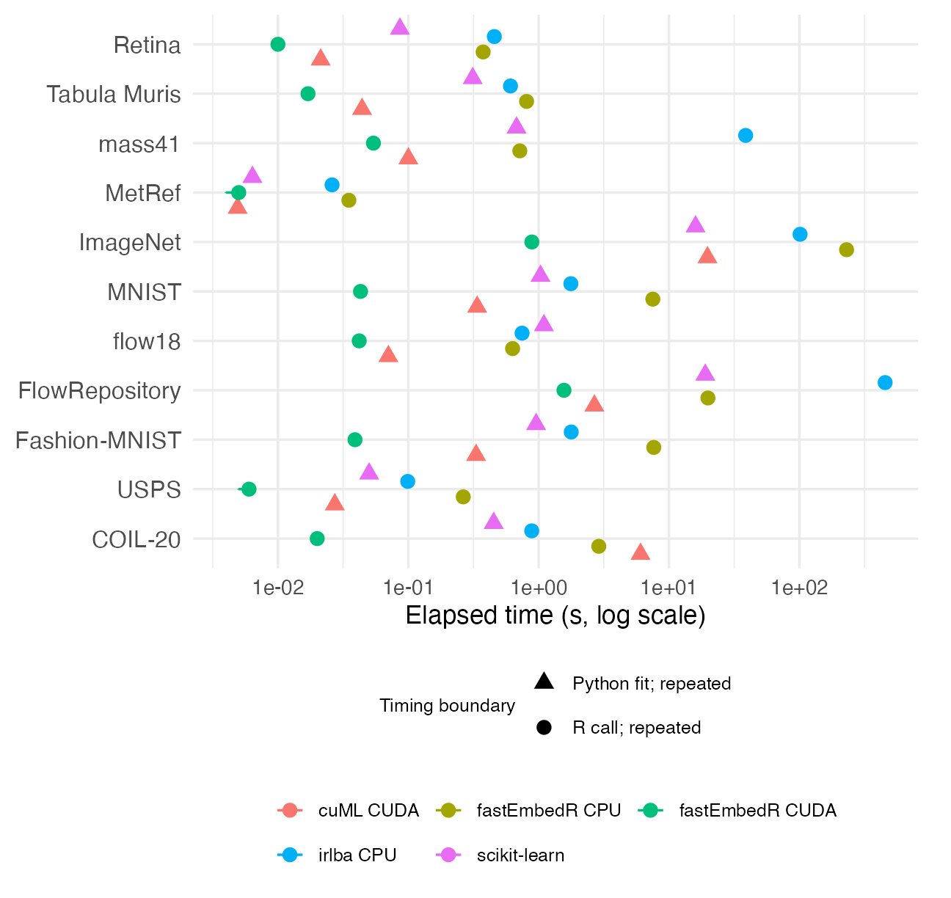
Observed PCA elapsed times in diagnostic campaign 20260930T203319Z. Circles denote complete R public calls and triangles direct Python fits; filled markers have five same-seed repetitions and hollow markers show a completed single fit. Both scopes share an axis for inventory, not for a cross-scope speed ratio. Missing results and failures are identified in Supplementary Table S1.
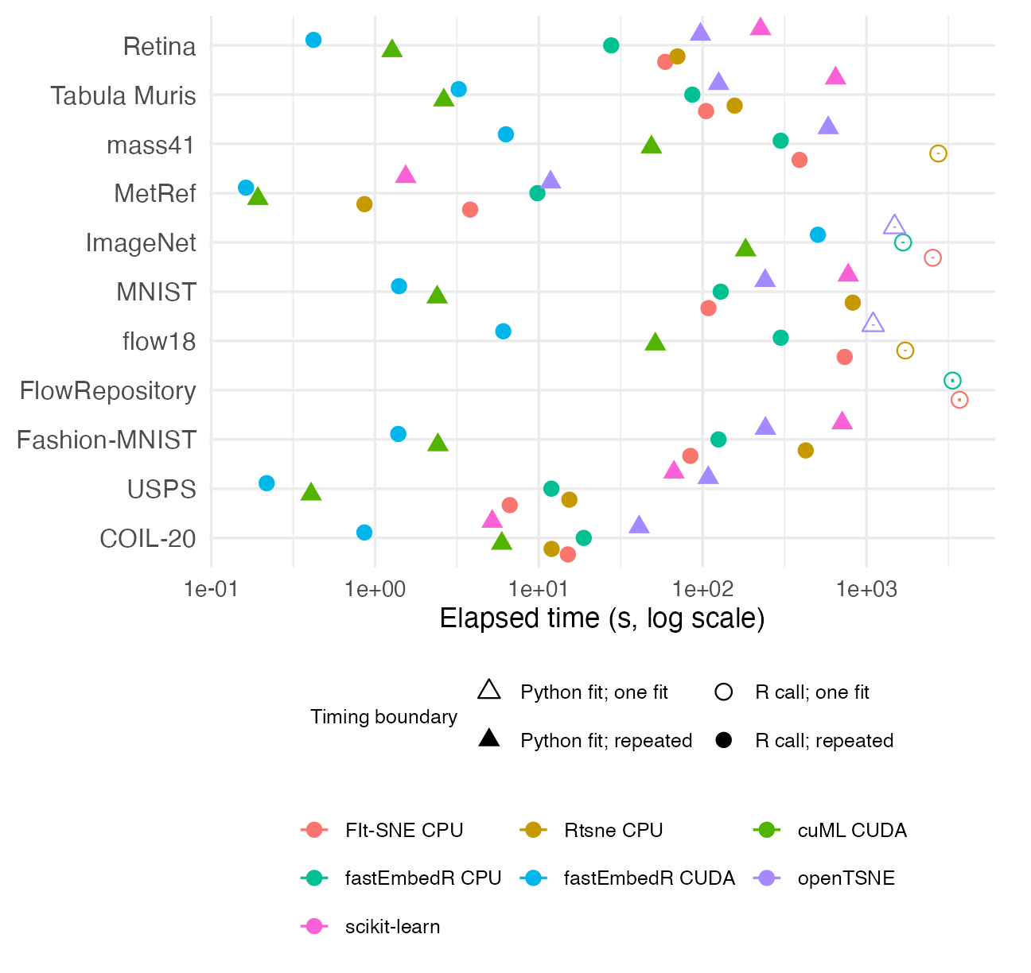
Observed two-dimensional t-SNE elapsed times in the same full-data diagnostic campaign. R public-call and direct-Python fit measurements appear together but have distinct marker shapes and are not directly comparable. Hollow markers indicate completed single fits; missing results are coded in Supplementary Table S1.
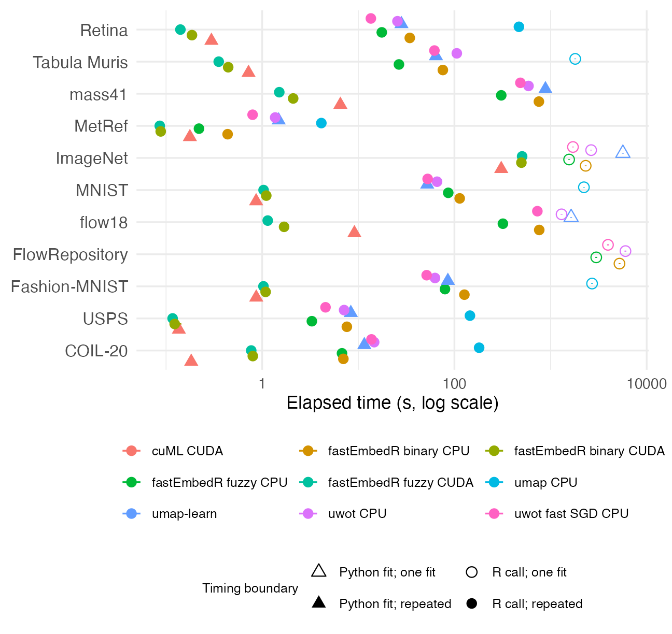
Observed two-dimensional UMAP elapsed times in the same full-data diagnostic campaign. Fuzzy and secondary binary UMAP routes, R and Python methods, and completed single fits are included. Timing boundaries and missing-result codes follow Figure 1 and Supplementary Table S1.
Peak host resident memory and sampled CUDA device-memory increases are reported in Supplementary Table S9. They cover the complete worker, including preparation and quality assessment, rather than the direct-Python fit-only boundary. Short GPU peaks may escape sampling.
The campaign used a 7,200-second per-method limit. Its final audit is FAIL, with 34 failed or timed-out tasks across the campaign and four output-audit failures. Supplementary Table S1 distinguishes timeout, memory limit, other failure, and completed single fit. Some CUDA memory peaks were not sampled adequately; missing values remain missing rather than zero. Publication-level timing claims remain unresolved.
ImageNet is treated primarily as a runtime and memory stress test. Every workflow fit in this campaign used the complete source matrix; source and fitted row counts are displayed in Table 5.
Observed recall@30 was measured against exact full-reference neighbors. The CUDA routes reached at least 0.9982; the CPU ImageNet and retina HNSW routes reached 0.9672 and 0.9831, below the target 0.99. These sampled checks are diagnostic and cannot be attributed to the optimizer.
Diagnostic median host peak RSS across complete CPU comparator workers was 1.53 GiB for fastEmbedR t-SNE and 1.50 GiB for fuzzy UMAP, compared with 1.38 GiB for Rtsne and 5.32 GiB for the R umap package. Device-wide median incremental memory in sampled CUDA workers was 1.03 and 0.78 GiB for fastEmbedR t-SNE and UMAP, versus 1.28 and 0.73 GiB for direct cuML fits. These are whole-worker and sampled-device observations, not fit-only or process-level memory ratios.
Across the ten data sets with successful full-workflow CPU and CUDA fits, median CUDA-minus-CPU trustworthiness differences were +0.0037 for t-SNE and -0.0027 for fuzzy UMAP; Preserve@30 differences were +0.0020 and -0.0058. These are paired quality observations, not proof of identical objectives or trajectories. Dataset-level values and the CUDA/cuML comparison are in Supplementary Tables S3 and S2, respectively.

Compact-support sensitivity
When t-SNE has exactly $P$ candidate neighbors, its requested perplexity equals the maximum possible perplexity on that support. Conditional probabilities therefore approach uniform weights; reducing support changes the affinity objective, not only its computational cost. In an exact-neighbor affinity diagnostic at $P=30$, the median normalized conditional entropy was approximately 1.000 for $k=P$ and 0.761 for $k=3P$.
At $P=10$, 20, and 30, fixed-neighbor sensitivity experiments generally favored compact support for runtime and neighborhood preservation, whereas wider support produced lower sampled KL for its different affinity objective. The paired data-set counts and iteration budget are given in Supplementary Table S4; these calls are not complete workflows.

Multicore scaling
On COIL20, MNIST, flow18, and ImageNet, four CPU threads gave median full-workflow speedups of 2.24 for t-SNE and 2.26 for fuzzy UMAP over one thread. Scaling was not monotonic across 1, 2, 4, 8, and 12 threads; stage times and per-data-set efficiency appear in Supplementary Table S5.

Apple Metal
The Apple M3 study covered MetRef, COIL20, USPS, MNIST, Fashion-MNIST, Macosko retina, and Tabula Muris, spanning 873–100,102 observations and 50–16,384 variables. Median four-thread CPU-to-Metal speedup was 2.63 (IQR 1.62–2.88) for compact-support t-SNE, 1.97 (1.08–3.04) for fuzzy UMAP, and 3.35 (1.63–5.85) for binary UMAP. Median Metal-minus-CPU trustworthiness differences were +0.0006, +0.0027, and +0.0010. These results establish performance on Apple M3 only. Other Apple Silicon systems are compatibility targets unless separately benchmarked; Intel Macs are not supported by the native Metal backend.

Landmarking and held-out transformation
A stratified 80/20 held-out experiment covered all 11 data sets. Median query-to-reference Preserve@30 was 0.371–0.374 for t-SNE and 0.343–0.351 for fuzzy UMAP across CPU and CUDA; the reference did not move. This tests new observations, not reconstruction of omitted fit rows. In the separate 20-percent landmark experiment, median landmark/full runtime ratios were 0.41 and 0.77 for CPU/CUDA t-SNE, and 0.34 and 1.29 for CPU/CUDA UMAP. Median host-RSS ratios were near or above one, so landmarking was not a universal memory saving. Detailed quality and memory results are in Supplementary Tables S6 and S7.

Supporting PCA and graph utilities
On fixed subsets of 11 data sets, CPU and CUDA rank-2 PCA scores had median aligned agreement of 0.999972 and approximately 1.000000 with dense centered singular value decomposition. CPU ImageNet was an outlier (0.783 score correlation). The latest campaign completed the stored-graph clustering comparison on only two data sets, so it does not support a broad clustering-performance claim. PCA accuracy, clustering denominators, and graph-construction scope are documented in Supplementary Tables S10 and S11.

Discussion
fastEmbedR demonstrates that a single R package can expose multicore CPU, Apple Metal, and NVIDIA CUDA implementations of fuzzy UMAP and compact-support interpolation-based t-SNE while maintaining one typed interface. The strongest engineering gains come from reusing sparse structures, using float32 throughout the numerical payload, avoiding repeated R-native copies, retaining accelerator state, pooling temporary memory, and reducing kernel and synchronization overhead. The package does not introduce a new UMAP or t-SNE objective; its contribution is a native, validated, and backend-aware implementation and workflow.
The full-data workflow campaign is insufficient for a release-level speed claim. Its failed final audit, incomplete memory sampling, and mixed R/Python timing boundaries preclude reliable cross-method ratios, despite useful stage and quality observations. A workflow ratio combines implementation, search policy, precision, initialization, and hardware; it does not isolate optimizer speed. Complete R calls and direct-Python fit times answer different questions and are not pooled.
Compact support reduces affinity storage and attractive-force work while making conditional probabilities nearly uniform within each selected row. The t-SNE timing results therefore characterize the stated compact-support method, not an affinity-equivalent replacement for conventional wider-support t-SNE. Practical neighborhood quality and KL are reported with runtime for every valid paired data set.
The production payload uses float32, so trajectories need not reproduce a float64 implementation exactly. Accelerator atomics prevent a fixed seed from guaranteeing bitwise GPU reproducibility. Metal performance evidence is currently limited to one Apple M3 system. Native GPU installation depends on matching SDKs, compilers, drivers, linked libraries, and architecture flags. The UMAP interface exposes scientifically central neighborhood, metric, initialization, graph, backend, and seed controls but keeps several optimizer parameters under a validated release policy. Landmarking can reduce CPU work but is not guaranteed to accelerate a resident GPU pipeline or preserve local quality on every data set. These constraints should guide method selection and reporting.
The file-backed routes are experimental rather than part of the headline workflow comparison. Bounded-memory component tests have processed inputs larger than host RAM, but a converged full-data t-SNE and UMAP comparison on a real beyond-RAM data set is not established here. Multi-GPU row partitioning of PCA, search, or landmark projection does not demonstrate a multi-GPU full embedding. Disk capacity and graph-construction time remain important limits even when the input itself can be streamed.
Observed approximate-neighbor recall is another limitation. The lowest CPU recall@30 was 0.9672 on full-source ImageNet, below the target 0.99. Search recall is consequently reported beside embedding quality, and no claim treats ImageNet CPU results as optimizer-only evidence. Strong CPU scaling was also nonmonotonic: eight threads had higher median total-workflow speedup than twelve across the measured data sets.
Backend-native PCA removes a separate preprocessing boundary and can return a t-SNE-ready initialization. Optional graph clustering reuses a graph already constructed for an embedding workflow, but remains logically separate from evidence for UMAP or t-SNE correctness. Walktrap is most appropriate for smaller graphs because its agglomerative stage is CPU-only and has a denser working set than the multilevel Louvain and Leiden paths.

Reproducibility, availability, and sustainability
The package source is available under the MIT license. An online tutorial and function reference documents installation, backend selection, and principal workflows. Questions and bug reports are handled through the public issue tracker. Benchmark code, preprocessing instructions, environment recipes, parameter manifests, and aggregation scripts are maintained in a separate benchmark repository. Raw benchmark data, credentials, container images, and restricted inputs are not redistributed.
The corrected campaign launcher records the package-source commit, embedded source-tarball and container hashes, and benchmark-suite manifest. It also records any container-build source patch; a Git commit alone is insufficient to identify a patched installation. Campaign evidence includes session information, compiler and linker commands, hardware identity, seeds, parameters, input checksums, status for every requested row, and repetition-level outputs. Public data are reconstructed from their original sources with versioned scripts. Restricted data must be obtained under the provider’s terms; missing data produce an explicit unavailable status rather than substitution.
The diagnostic campaign was 20260930T203319Z, built from source commit 7f22c52b with a recorded container-build patch. Its complete source, archive, library, container, and benchmark-suite SHA-256 identifiers are in Supplementary Table S12; comparator identities and quality-sample row identifiers are in the machine-readable campaign.
Each campaign status inventory records its requested rows. Unsuccessful combinations remain explicit in the machine-readable archives; no speedup ratio is reported as a release-level result from the failed campaign.
The package test suite covers public R behavior and portable native code. Strict hardware jobs verify requested-versus-observed backend identity and run PCA, neighbor search, matrix-input and precomputed-KNN UMAP and t-SNE, held-out landmark projection, graph clustering, and numerical checks on real Metal and CUDA hardware. CPU checks run on macOS, Linux, and Windows. Hardware logs, source packages, binaries, and SHA-256 manifests accompany the benchmark evidence. The replication bundle includes a small deterministic iris script that completes on a standard CPU and separate instructions for the large hardware benchmark.
Host-side line coverage is reported separately for R and portable native code. Metal and CUDA device kernels are not credited by host instrumentation; their current evidence consists of strict real-device execution and numerical tests. Device-aware Metal and CUDA kernel coverage is consequently reported as not measured rather than inferred from host-side bridge execution.

Conclusion
fastEmbedR provides native float32 UMAP and compact-support interpolation-based t-SNE for multicore CPU, Apple Metal, and NVIDIA CUDA execution from R. Its matrix, reusable-neighbor, PCA, landmark, transformation, graph-construction, and community-detection interfaces share strict backend reporting and typed metadata. Metal performance evidence is specific to the tested Apple M3 system and is not generalized to all Apple Silicon hardware. Numerical tests support CPU and CUDA PCA projections, graph construction, clustering, affinities, forces, and backend-specific optimization; a separate M3 study supports the Metal route on that system. The diagnostic campaign does not establish release-level runtime reductions. The CPU ImageNet PCA and HNSW-recall outliers show why data-set-level diagnostics must accompany aggregate summaries.

Acknowledgments
The authors thank the University of Cape Town ICTS High Performance Computing team for providing a high-performance computing facility for this study (https://ucthpc.uct.ac.za/).
Baglama, Jim, Lothar Reichel, and B. W. Lewis. 2026. Irlba: Fast Truncated Singular Value Decomposition and Principal Components Analysis for Large Dense and Sparse Matrices. https://doi.org/10.32614/CRAN.package.irlba.
Blondel, Vincent D., Jean-Loup Guillaume, Renaud Lambiotte, and Etienne Lefebvre. 2008. “Fast Unfolding of Communities in Large Networks.” Journal of Statistical Mechanics: Theory and Experiment 2008 (10): P10008. https://doi.org/10.1088/1742-5468/2008/10/P10008.
Chan, David M., Roshan Rao, Forrest Huang, and John F. Canny. 2018. “T-SNE-CUDA: GPU-Accelerated t-SNE and Its Applications to Modern Data.” arXiv Preprint arXiv:1807.11824. https://doi.org/10.48550/arXiv.1807.11824.
Halko, Nathan, Per-Gunnar Martinsson, and Joel A. Tropp. 2011. “Finding Structure with Randomness: Probabilistic Algorithms for Constructing Approximate Matrix Decompositions.” SIAM Review 53 (2): 217–88. https://doi.org/10.1137/090771806.
Kobak, Dmitry, and Philipp Berens. 2019. “The Art of Using t-SNE for Single-Cell Transcriptomics.” Nature Communications 10: 5416. https://doi.org/10.1038/s41467-019-13056-x.
Linderman, George C., Manas Rachh, Jeremy G. Hoskins, Stefan Steinerberger, and Yuval Kluger. 2019. “Fast Interpolation-Based t-SNE for Improved Visualization of Single-Cell RNA-Seq Data.” Nature Methods 16: 243–45. https://doi.org/10.1038/s41592-018-0308-4.
Maaten, Laurens van der. 2014. “Accelerating t-SNE Using Tree-Based Algorithms.” Journal of Machine Learning Research 15: 3221–45. https://www.jmlr.org/papers/v15/vandermaaten14a.html.
Maaten, Laurens van der, and Geoffrey Hinton. 2008. “Visualizing Data Using t-SNE.” Journal of Machine Learning Research 9: 2579–2605. https://www.jmlr.org/papers/v9/vandermaaten08a.html.
McInnes, Leland, John Healy, and James Melville. 2018. “UMAP: Uniform Manifold Approximation and Projection for Dimension Reduction.” arXiv Preprint arXiv:1802.03426. https://doi.org/10.48550/arXiv.1802.03426.
Nolet, Corey J., Victor Lafargue, Edward Raff, Thejaswi Nanditale, Tim Oates, John Zedlewski, and Joshua Patterson. 2020. “Bringing UMAP Closer to the Speed of Light with GPU Acceleration.” arXiv Preprint arXiv:2008.00325. https://doi.org/10.48550/arXiv.2008.00325.
Poličar, Pavlin G., Martin Stražar, and Blaž Zupan. 2021. “Embedding to Reference t-SNE Space Addresses Batch Effects in Single-Cell Classification.” Machine Learning 110: 1211–31. https://doi.org/10.1007/s10994-021-06043-1.
Pons, Pascal, and Matthieu Latapy. 2006. “Computing Communities in Large Networks Using Random Walks.” Journal of Graph Algorithms and Applications 10 (2): 191–218. https://doi.org/10.7155/jgaa.00124.
Rousseeuw, Peter J. 1987. “Silhouettes: A Graphical Aid to the Interpretation and Validation of Cluster Analysis.” Journal of Computational and Applied Mathematics 20: 53–65. https://doi.org/10.1016/0377-0427(87)90125-7.
Traag, Vincent A., Ludo Waltman, and Nees Jan van Eck. 2019. “From Louvain to Leiden: Guaranteeing Well-Connected Communities.” Scientific Reports 9: 5233. https://doi.org/10.1038/s41598-019-41695-z.
Venna, Jarkko, and Samuel Kaski. 2001. “Neighborhood Preservation in Nonlinear Projection Methods: An Experimental Study.” In Artificial Neural Networks – ICANN 2001, 485–91. Springer. https://doi.org/10.1007/3-540-44668-0_68.

