Supplementary Benchmark Results for fastEmbedR
Moussa Kassim Mohamed^{1,2,*} Martin Ocharo^{1,2,*}
Giulia Canarutto^{3,4} Dalia Ahmed¹ Dupe Ojo¹
Alessia Vignoli^{5,6} Leonardo Tenori^{5,6,†}
Dinesh Gupta⁷ Silvano Piazza^{3,8}
Stefano Cacciatore^{1,2,†}

Abstract
This supplement records the completed observations and explicit failures of diagnostic campaign 20260930T203319Z: workflow timing and memory, embedding quality, neighbor recall, support width, CPU scaling, held-out transformation, landmarking, PCA, and graph clustering. A separate September 29 campaign supplies the illustrative embedding gallery. Neither campaign passed its final audit; results are not release-level speed claims.

Keywords
dimensionality reduction, t-SNE, UMAP, reproducible benchmarks

Workflow elapsed times
Table S1 combines the R and direct-Python results for PCA, t-SNE, and UMAP without treating their timing boundaries as equivalent. It gives every observed completed time, marks single-fit measurements, and identifies failed or missing combinations. The source campaign used full data-set matrices and failed its final audit; the times are descriptive diagnostics, not publication-grade speed ratios. “R call” is the complete public fit; “Py fit” is the direct Python estimator fit, excluding process startup. An asterisk marks a completed single fit without timing repetitions. T denotes a time limit, M a confirmed memory limit, F another failure, K an unclassified kill, U unsupported, C cancelled, I a completed fit without usable time, and – not run or no status.
Table S1. Observed elapsed times (seconds), campaign 20260930T203319Z. R and Python timing scopes differ.
PCA, data sets 1/2
Method | Scope | COIL-20 | USPS | Fashion | FlowRepo. | flow18 | MNIST
fastEmbedR [CPU] | R call | 2.89 | 0.26 | 7.64 | 19.9 | 0.63 | 7.52
irlba [CPU] | R call | 0.89 | 0.099 | 1.78 | 455 | 0.75 | 1.77
fastEmbedR [CUDA] | R call | 0.020 | 0.006 | 0.039 | 1.56 | 0.042 | 0.043
scikit-learn PCA | Py fit | 0.45 | 0.050 | 0.96 | 19.0 | 1.10 | 1.03
cuML PCA [CUDA] | Py fit | 6.05 | 0.027 | 0.33 | 2.68 | 0.070 | 0.34
PCA, data sets 2/2
Method | Scope | ImageNet | MetRef | mass41 | Tabula | Retina
fastEmbedR [CPU] | R call | 230 | 0.035 | 0.72 | 0.81 | 0.38
irlba [CPU] | R call | 101 | 0.026 | 38.7 | 0.61 | 0.46
fastEmbedR [CUDA] | R call | 0.89 | 0.005 | 0.054 | 0.017 | 0.010
scikit-learn PCA | Py fit | 16.0 | 0.006 | 0.68 | 0.31 | 0.086
cuML PCA [CUDA] | Py fit | 19.7 | 0.005 | 0.10 | 0.044 | 0.021
TSNE, data sets 1/2
Method | Scope | COIL-20 | USPS | Fashion | FlowRepo. | flow18 | MNIST
Rtsne [CPU] | R call | 12.0 | 15.4 | 426 | T | 1726* | 825
FIt-SNE [CPU] | R call | 15.0 | 6.64 | 84.1 | 3702* | 736 | 109
fastEmbedR [CPU] | R call | 18.8 | 11.9 | 125 | 3354* | 300 | 129
fastEmbedR [CUDA] | R call | 0.86 | 0.22 | 1.39 | F | 6.07 | 1.40
scikit-learn t-SNE | Py fit | 5.19 | 66.8 | 711 | T | T | 774
openTSNE | Py fit | 40.9 | 108 | 242 | T | 1098* | 241
cuML t-SNE [CUDA] | Py fit | 5.94 | 0.41 | 2.42 | F | 51.4 | 2.39
TSNE, data sets 2/2
Method | Scope | ImageNet | MetRef | mass41 | Tabula | Retina
Rtsne [CPU] | R call | T | 0.86 | 2746* | 157 | 70.1
FIt-SNE [CPU] | R call | 2541* | 3.81 | 390 | 105 | 59.1
fastEmbedR [CPU] | R call | 1672* | 9.80 | 300 | 86.5 | 27.7
fastEmbedR [CUDA] | R call | 505 | 0.16 | 6.29 | 3.24 | 0.42
scikit-learn t-SNE | Py fit | T | 1.54 | T | 648 | 226
openTSNE | Py fit | 1484* | 11.8 | 584 | 125 | 97.0
cuML t-SNE [CUDA] | Py fit | 183 | 0.19 | 48.7 | 2.63 | 1.27
UMAP, data sets 1/2
Method | Scope | COIL-20 | USPS | Fashion | FlowRepo. | flow18 | MNIST
umap [CPU] | R call | 181 | 145 | 2704* | T | T | 2223*
uwot [CPU] | R call | 14.6 | 7.12 | 62.8 | 6016* | 1302* | 65.9
uwot fast SGD [CPU] | R call | 13.7 | 4.56 | 51.4 | 3958* | 729 | 52.6
fastEmbedR fuzzy [CPU] | R call | 6.77 | 3.29 | 79.7 | 2987* | 319 | 86.2
fastEmbedR binary [CPU] | R call | 6.99 | 7.60 | 127 | 5212* | 762 | 113
fastEmbedR fuzzy [CUDA] | R call | 0.77 | 0.12 | 1.03 | F | 1.14 | 1.03
fastEmbedR binary [CUDA] | R call | 0.80 | 0.12 | 1.09 | F | 1.69 | 1.10
umap-learn | Py fit | 11.6 | 8.36 | 85.5 | T | 1636* | 52.1
cuML UMAP [CUDA] | Py fit | 0.18 | 0.14 | 0.87 | F | 9.11 | 0.87
UMAP, data sets 2/2
Method | Scope | ImageNet | MetRef | mass41 | Tabula | Retina
umap [CPU] | R call | T | 4.13 | T | 1806* | 469
uwot [CPU] | R call | 2643* | 1.36 | 590 | 106 | 25.5
uwot fast SGD [CPU] | R call | 1710* | 0.80 | 485 | 61.9 | 13.5
fastEmbedR fuzzy [CPU] | R call | 1559* | 0.22 | 307 | 26.5 | 17.6
fastEmbedR binary [CPU] | R call | 2320* | 0.44 | 756 | 75.8 | 34.3
fastEmbedR fuzzy [CUDA] | R call | 506 | 0.086 | 1.51 | 0.35 | 0.14
fastEmbedR binary [CUDA] | R call | 497 | 0.088 | 2.10 | 0.44 | 0.19
umap-learn | Py fit | 5654* | 1.48 | 885 | 64.3 | 28.1
cuML UMAP [CUDA] | Py fit | 307 | 0.18 | 6.51 | 0.72 | 0.30

Comparator grid and timing boundaries
In the revised two-dimensional t-SNE protocol, fastEmbedR reports its selected grid in each fit. The pinned FIt-SNE wrapper exposes interpolation points, minimum intervals, and intervals per coordinate unit. The benchmark requests three interpolation points and minimum interval counts of 43 below 40,000 rows and 86 otherwise. FIt-SNE rounds these to supported box counts of at least 50 and 90, respectively, corresponding to at least 150 and 270 interpolation nodes per axis. The realized grid can be larger if the current coordinate span requires it; the wrapper does not return that size. These settings approximate rather than exactly match the fastEmbedR CPU 128- and 256-cell policies. FIt-SNE three-dimensional Barnes–Hut runs do not use the interpolation grid.
The tested cuML 26.6.0 implementation fixes three interpolation points and 50 intervals per axis in its two-dimensional FFT source, yielding a 300-cell padded transform axis. Its public Python t-SNE constructor does not expose a grid-resolution parameter, so a matched-grid cuML comparison would require modifying and rebuilding cuML. The benchmark records this fixed source policy, but does not mislabel the runs as grid matched. UMAP methods do not use this t-SNE FFT grid.
The September 30 workflow campaign has five same-seed timing repetitions after warm-up for timing-eligible methods; jobs reaching the long-run budget may have one completed fit. All input matrices were fitted in full. The 7,200-second per-method limit and failed campaign audit are reflected in Table [tab:all-method-performance]. The embedding gallery below comes from a separate, capped September 29 campaign and must not be read as visual evidence for the September 30 timings.

Data-set-level CUDA embedding quality
Table 2 reports trustworthiness, Preserve@30, and sampled t-SNE KL for every CUDA fastEmbedR and cuML pair. The methods use the same fitted row count and evaluation sample within a data set, but differ in affinity support and timing boundary. KL values across those objectives are not directly comparable.
A. Compact-support t-SNE / cuML t-SNE
CUDA embedding quality in diagnostic campaign 20260930T203319Z. Entries are fastEmbedR / cuML on fixed sampled rows; $n$ is the fitted matrix size. Status is fastEmbedR / cuML; – marks unavailable metrics. Different affinity supports make sampled t-SNE KL descriptive, not a matched-objective test.
Data set | Fitted $n$ | Trustworthiness | Preserve@30 | Sampled KL | Status
COIL-20 | 1,440 | 0.939 / 0.934 | 0.627 / 0.623 | 1.480 / 1.317 | success / success
USPS | 11,000 | 0.952 / 0.940 | 0.468 / 0.462 | 2.024 / 2.006 | success / success
Fashion | 70,000 | 0.973 / 0.966 | 0.485 / 0.491 | 1.877 / 1.744 | success / success
FlowRepo. | 5,220,347 | – / – | – / – | – / – | failed / failed
flow18 | 1,000,021 | 0.967 / 0.951 | 0.445 / 0.422 | 2.049 / 1.857 | success / success
MNIST | 70,000 | 0.941 / 0.931 | 0.437 / 0.443 | 2.316 / 2.164 | success / success
ImageNet | 1,281,167 | 0.667 / 0.635 | 0.167 / 0.124 | 3.510 / 3.310 | success / success
MetRef | 873 | 0.848 / 0.797 | 0.442 / 0.358 | 1.846 / 2.153 | success / success
mass41 | 965,282 | 0.968 / 0.949 | 0.407 / 0.396 | 2.128 / 1.960 | success / success
Tabula | 100,102 | 0.962 / 0.940 | 0.632 / 0.592 | 1.736 / 1.596 | success / success
Retina | 44,808 | 0.912 / 0.900 | 0.432 / 0.428 | 1.970 / 1.916 | success / success
B. Fuzzy UMAP / cuML UMAP
CUDA embedding quality in diagnostic campaign 20260930T203319Z. Entries are fastEmbedR / cuML on fixed sampled rows; $n$ is the fitted matrix size. Status is fastEmbedR / cuML; – marks unavailable metrics. Different affinity supports make sampled t-SNE KL descriptive, not a matched-objective test.
Data set | Fitted $n$ | Trustworthiness | Preserve@30 | Status
COIL-20 | 1,440 | 0.908 / 0.920 | 0.613 / 0.620 | success / success
USPS | 11,000 | 0.885 / 0.883 | 0.358 / 0.363 | success / success
Fashion | 70,000 | 0.962 / 0.967 | 0.463 / 0.463 | success / success
FlowRepo. | 5,220,347 | 0.960 / 0.967 | 0.445 / 0.443 | success / success
flow18 | 1,000,021 | 0.962 / 0.961 | 0.435 / 0.432 | success / success
MNIST | 70,000 | 0.939 / 0.935 | 0.452 / 0.444 | success / success
ImageNet | 1,281,167 | 0.585 / 0.647 | 0.104 / 0.161 | success / success
MetRef | 873 | 0.836 / 0.821 | 0.428 / 0.411 | success / success
mass41 | 965,282 | 0.968 / 0.967 | 0.404 / 0.407 | success / success
Tabula | 100,102 | 0.923 / 0.970 | 0.607 / 0.643 | success / success
Retina | 44,808 | 0.900 / 0.904 | 0.406 / 0.411 | success / success

Backend quality and t-SNE support
Table 3 reports full-workflow quality for every completed CPU and CUDA data-set pair. The CPU FlowRepository full-workflow quality run was incomplete; matched-neighbor quality from a different boundary is not substituted. Trustworthiness and Preserve@30 use fixed quality-sample rows. The low ImageNet values reflect this feature matrix’s limited two-dimensional neighborhood preservation; ImageNet is used primarily as a scalability stress test. Final KL was not retained for the CUDA full-workflow diagnostic and is shown as missing, not zero.
File-to-layout quality from campaign 20260930T203319Z. Each entry is CPU / CUDA, over successful full-workflow seeds. A missing CPU FlowRepository result is shown as –. KL is the production t-SNE objective; UMAP has no KL entry. The campaign audit failed.
Data set | Trustworthiness | Preserve@30 | Final KL
Compact-support t-SNE
COIL-20 | 0.938 / 0.940 | 0.630 / 0.627 | 0.794 / –
Fashion-MNIST | 0.972 / 0.973 | 0.483 / 0.484 | 2.697 / –
flow18 | 0.960 / 0.966 | 0.438 / 0.444 | 2.887 / –
ImageNet | 0.646 / 0.658 | 0.155 / 0.158 | 2.287 / –
Retina | 0.906 / 0.912 | 0.424 / 0.431 | 2.941 / –
mass41 | 0.963 / 0.968 | 0.401 / 0.408 | 2.905 / –
MetRef | 0.848 / 0.847 | 0.444 / 0.442 | 1.850 / –
MNIST | 0.939 / 0.941 | 0.436 / 0.437 | 2.903 / –
Tabula Muris | 0.949 / 0.960 | 0.619 / 0.634 | 2.183 / –
USPS | 0.949 / 0.951 | 0.467 / 0.467 | 2.167 / –
FlowRepository | – / 0.964 | – / 0.440 | – / –
Fuzzy UMAP
COIL-20 | 0.915 / 0.908 | 0.612 / 0.612 | – / –
Fashion-MNIST | 0.971 / 0.961 | 0.480 / 0.465 | – / –
flow18 | 0.960 / 0.961 | 0.443 / 0.436 | – / –
ImageNet | 0.582 / 0.589 | 0.105 / 0.107 | – / –
Retina | 0.905 / 0.902 | 0.416 / 0.408 | – / –
mass41 | 0.971 / 0.968 | 0.413 / 0.408 | – / –
MetRef | 0.826 / 0.835 | 0.411 / 0.420 | – / –
MNIST | 0.940 / 0.938 | 0.456 / 0.451 | – / –
Tabula Muris | 0.934 / 0.922 | 0.613 / 0.599 | – / –
USPS | 0.889 / 0.882 | 0.358 / 0.354 | – / –
FlowRepository | – / 0.961 | – / 0.442 | – / –
The $k=P$ affinity support makes the target perplexity the maximum possible entropy of each conditional distribution. At $P=30$, normalized conditional entropy was approximately 1.000 for $k=P$ and 0.761 for $k=3P$ in an exact-neighbor affinity diagnostic. Table 4 gives paired time and quality summaries for $P=10$, 20, and 30. KL values across support widths are objectives with different affinities, not comparable optimization losses for one common objective.
Support-width sensitivity in campaign 20260930T203319Z. Each median uses the same data sets with valid timing and quality at both support widths. Times cover precomputed-neighbor t-SNE calls with 250 exaggerated and 500 normal iterations, not matrix workflows. KL values describe different affinity objectives and are not matched-objective ratios.
Backend | $P$ | $k/P$ | Data sets | Seconds | Trust | Preserve@30 | KL
CPU | 10 | 1 | 4 | 7.76 | 0.914 | 0.424 | 2.194
CPU | 10 | 3 | 4 | 8.27 | 0.897 | 0.410 | 2.046
CUDA | 10 | 1 | 4 | 0.05 | 0.920 | 0.431 | 2.161
CUDA | 10 | 3 | 4 | 0.07 | 0.907 | 0.416 | 2.084
CPU | 20 | 1 | 4 | 7.62 | 0.935 | 0.449 | 2.063
CPU | 20 | 3 | 4 | 8.44 | 0.921 | 0.429 | 1.846
CUDA | 20 | 1 | 4 | 0.06 | 0.935 | 0.449 | 2.038
CUDA | 20 | 3 | 4 | 0.09 | 0.927 | 0.434 | 1.951
CPU | 30 | 1 | 10 | 54.67 | 0.944 | 0.443 | 1.992
CPU | 30 | 3 | 10 | 54.94 | 0.933 | 0.430 | 1.735
CUDA | 30 | 1 | 11 | 0.29 | 0.952 | 0.442 | 1.987
CUDA | 30 | 3 | 11 | 0.69 | 0.940 | 0.433 | 1.727

Scaling, transformation, and landmarks
The strong-scaling experiment used identical inputs at 1, 2, 4, 8, and 12 CPU threads on COIL20, MNIST, flow18, and ImageNet. Times are complete workflows; stage-level values, including search, initialization, graph or affinity construction, and optimization, remain in the machine-readable campaign. The ratios in Table 5 are relative to each data set’s one-thread result.
CPU full-workflow strong scaling in campaign 20260930T203319Z. Speedups at 2–12 threads are relative to the one-thread elapsed time in the same row.
Data set | Method | 1-core s | 2-core | 4-core | 8-core | 12-core
COIL20 | UMAP | 14.5 | 1.90 | 2.19 | 2.02 | 2.13
MNIST | UMAP | 246.6 | 1.44 | 2.64 | 3.65 | 3.40
flow18 | UMAP | 632.8 | 1.10 | 1.87 | 2.03 | 2.37
imagenet | UMAP | 4135.6 | 1.28 | 2.33 | 2.02 | 1.49
COIL20 | t-SNE | 19.0 | 1.88 | 2.16 | 1.95 | 2.05
MNIST | t-SNE | 300.4 | 1.52 | 2.46 | 3.21 | 2.94
flow18 | t-SNE | 553.9 | 1.23 | 1.85 | 2.30 | 2.51
imagenet | t-SNE | 4052.9 | 1.33 | 2.31 | 2.09 | 1.47
Held-out transformation fits a reference on training rows and projects genuinely unseen queries without moving the reference. Table 6 contrasts query-to-reference Preserve@30 with joint embedding of those queries. Times are transform calls, not complete fit-plus-transform workflows.
Held-out transformation in campaign 20260930T203319Z. Each value is the median of data-set medians over successful seeds. Query/reference Preserve@30 is compared with joint embedding of the same queries; the reference is held fixed during transformation.
Method | Backend | Data sets | Transform s | Preserve@30 | Joint | Label KNN | Ref. shift
t-SNE | CPU | 11 | 64.684 | 0.371 | 0.393 | 0.784 | 0
UMAP | CPU | 11 | 65.976 | 0.343 | 0.346 | 0.776 | 0
t-SNE | CUDA | 11 | 0.621 | 0.374 | 0.392 | 0.786 | 0
UMAP | CUDA | 11 | 0.543 | 0.351 | 0.340 | 0.780 | 0
The 20-percent landmark experiment instead reconstructs rows omitted from the fitted subset. It is a different statistical task from held-out prediction. In Table 7, elapsed and host-RSS ratios are landmark/full; ratios below one favor landmarking. The GPU peak ratio is unavailable where device sampling was inadequate. In particular, the CUDA UMAP median runtime and host-RSS ratios exceed one. Procrustes agreement is especially modest for fuzzy UMAP.
Landmark reconstruction over 11 data sets in campaign 20260930T203319Z. Each row is the median of data-set medians for a 20-percent landmark fraction. RSS covers isolated fit workers; – means insufficient device-memory evidence.
Method | Backend | Data sets | Time ratio | Preserve@30 $Δ$ | Procrustes | RSS ratio | GPU ratio
t-SNE | CPU | 11 | 0.41 | -0.006 | 0.86 | 0.98 | –
Fuzzy UMAP | CPU | 11 | 0.34 | -0.011 | 0.52 | 1.01 | –
t-SNE | CUDA | 11 | 0.77 | -0.006 | 0.95 | 1.09 | –
Fuzzy UMAP | CUDA | 11 | 1.29 | -0.006 | 0.47 | 1.07 | –

Secondary analyses and memory
Binary UMAP discards fuzzy edge weights and therefore changes the embedding objective. It is retained as an adjacency sensitivity analysis. Table 8 reports its observed time and Preserve@30 change, without treating it as a faster fuzzy-UMAP setting.
Binary-adjacency versus fuzzy UMAP in campaign 20260930T203319Z. Ratios and quality changes are diagnostic medians over completed data sets; binary UMAP changes the graph objective and is not a drop-in speed substitute.
Workflow | Data sets | Binary/fuzzy time | Preserve@30 change
r_cpu | 9 | 1.986 | 0.003
r_cuda | 11 | 1.053 | 0.008
Table 10 separates complete-worker host RSS from sampled device-wide CUDA memory above the pre-worker allocator baseline. Device sampling may miss short peaks; missing samples remain missing. These memory boundaries are not the direct-Python fit-only timing boundary.
A. Host peak RSS
Observed peak memory in campaign 20260930T203319Z (diagnostic, failed audit). Host RSS covers the complete worker, including data loading and quality assessment; it is not fit-only memory. CUDA values are sampled device-memory increases above the pre-worker baseline (nominal 0.2-s polling plus query time), so short peaks may be underestimated. Values are GiB; – indicates no valid measurement. Counts show valid data sets for each memory metric; missing measurements are archived separately.
Method | Completed | Measured | Median | Maximum
fastEmbedR PCA [CPU] | 11 | 11 | 1.66 | 36.90
irlba [CPU] | 11 | 11 | 1.80 | 33.98
fastEmbedR PCA [CUDA] | 11 | 11 | 1.85 | 37.08
scikit-learn PCA [Python] | 11 | 11 | 0.80 | 11.86
RAPIDS cuML PCA [CUDA] | 11 | 11 | 1.10 | 18.95
Rtsne [CPU] | 9 | 9 | 1.38 | 4.34
FIt-SNE [CPU] | 11 | 11 | 1.75 | 34.53
fastEmbedR t-SNE [CPU] | 11 | 11 | 1.53 | 22.47
fastEmbedR t-SNE [CUDA] | 10 | 10 | 1.51 | 21.20
scikit-learn t-SNE [Python] | 7 | 7 | 0.76 | 1.12
openTSNE [Python] | 10 | 10 | 1.49 | 21.46
RAPIDS cuML t-SNE [CUDA] | 10 | 10 | 1.17 | 18.78
umap [CPU] | 7 | 7 | 5.32 | 9.00
uwot [CPU] | 11 | 11 | 1.68 | 36.66
uwot fast SGD [CPU] | 11 | 11 | 1.70 | 36.66
fastEmbedR fuzzy UMAP [CPU] | 11 | 11 | 1.50 | 25.21
fastEmbedR binary UMAP [CPU] | 11 | 11 | 1.49 | 25.21
fastEmbedR fuzzy UMAP [CUDA] | 10 | 10 | 1.42 | 21.13
fastEmbedR binary UMAP [CUDA] | 10 | 10 | 1.42 | 21.13
umap-learn [Python] | 10 | 10 | 2.09 | 51.67
RAPIDS cuML UMAP [CUDA] | 10 | 10 | 1.47 | 16.00
B. CUDA device-memory increase
Observed peak memory in campaign 20260930T203319Z (diagnostic, failed audit). Host RSS covers the complete worker, including data loading and quality assessment; it is not fit-only memory. CUDA values are sampled device-memory increases above the pre-worker baseline (nominal 0.2-s polling plus query time), so short peaks may be underestimated. Values are GiB; – indicates no valid measurement. Counts show valid data sets for each memory metric; missing measurements are archived separately.
Method | Completed | Measured | Median | Maximum
fastEmbedR PCA [CUDA] | 11 | 0 | – | –
RAPIDS cuML PCA [CUDA] | 11 | 0 | – | –
fastEmbedR t-SNE [CUDA] | 10 | 7 | 1.03 | 17.79
RAPIDS cuML t-SNE [CUDA] | 10 | 7 | 1.28 | 16.97
fastEmbedR fuzzy UMAP [CUDA] | 10 | 7 | 0.78 | 13.57
fastEmbedR binary UMAP [CUDA] | 10 | 7 | 0.76 | 13.57
RAPIDS cuML UMAP [CUDA] | 10 | 7 | 0.73 | 11.96
CPU and CUDA PCA were compared with dense centered singular value decomposition on 11 fixed subsets. Signs and equivalent subspace rotations were aligned before score and loading comparisons. irlba is an approximate performance comparator, not the numerical reference. ImageNet CPU rank-2 score agreement was 0.783, an unresolved outlier for that configuration.
PCA agreement with dense centered SVD on fixed subsets in campaign 20260930T203319Z. The effective rank may be below the requested rank.
Backend | Requested rank | Data sets | Score correlation | Loading cosine
CPU | 2 | 11 | 0.999972 | 0.999998
CPU | 50 | 11 | 0.999292 | 0.998447
CUDA | 2 | 11 | 1.000000 | 1.000000
CUDA | 50 | 11 | 1.000000 | 1.000000
Graph construction was saved separately from clustering. Only COIL20 and MetRef completed the latest same-graph clustering validation; the other nine data-set jobs failed, so Table 12 is restricted to six seed runs per implementation. Native CPU Louvain, Leiden, and Walktrap were compared with igraph; CUDA Louvain and Leiden used the corresponding native CPU memberships as a reference. Label adjusted Rand index compares the recovered communities with the data-set labels; paired adjusted Rand index compares two partitions. These are not end-to-end embedding speedups, and Metal clustering is not represented.
Clustering in campaign 20260930T203319Z. The Runs column counts completed data-set–seed fits; times exclude graph construction. Label ARI uses external data-set labels; paired ARI compares native CPU with igraph or an accelerator with native CPU. Graph sizes identify any fixed Walktrap subset. Missing runs are not zero.
Method | Backend | Implementation | Runs | $n$ range | Median seconds | Label ARI | Paired ARI
louvain | CPU | fastEmbedR | 6 | 873–1440 | 0.006 | 0.496 | 0.838
leiden | CPU | fastEmbedR | 6 | 873–1440 | 0.011 | 0.518 | 0.965
louvain | CPU | igraph | 6 | 873–1440 | 0.017 | 0.512 | 0.838
leiden | CPU | igraph | 6 | 873–1440 | 0.025 | 0.515 | 0.965
louvain | CUDA | fastEmbedR | 6 | 873–1440 | 0.026 | 0.504 | 0.911
leiden | CUDA | fastEmbedR | 6 | 873–1440 | 0.045 | 0.513 | 0.933
louvain | METAL | fastEmbedR | 0 | – | – | – | –
leiden | METAL | fastEmbedR | 0 | – | – | – | –
walktrap | CPU | fastEmbedR | 6 | 873–1440 | 0.320 | 0.424 | 0.922
walktrap | CPU | igraph | 6 | 873–1440 | 0.091 | 0.428 | 0.922

Campaign identity and unresolved gates
The source archive and the installed native library are recorded separately because this image included a container-build patch. Table 13 fixes the exact diagnostic source and benchmark identities. The campaign’s final audit reported 34 failed or timed-out tasks and four output-audit failures. The replication directory retains every unsuccessful method–data-set status.
Immutable identity of diagnostic campaign 20260930T203319Z. The campaign failed its final audit.
Item | Identifier
Package | fastEmbedR 0.1
Source commit | 7f22c52b28400535c2a246de68e7189cd9880ea1
Source archive SHA-256 | a3bc4a09e6f60bb719cf49b5d91af876c084666ff1b390d06ea9c155d2e991b9
Build patch SHA-256 | 8a725d2d2579425ff8d7edd3684f74c3fbb9ec1e5e3624c53e3eb3280b1188c7
Container SHA-256 | 54e9604d951ecb3d80f49671d9db7a35cf19f1342eb3ee7c708cbc0c3a7f0aa8
Installed library SHA-256 | d44f08b574a4932bd36f7afb1d0da0895ccaaa9e1e5ca3f4c040ef2357d649fc
Benchmark manifest SHA-256 | d0dddde1d82fa3faa01a9617db55b4128f8a04de61b8fd4dfb6f117d99e6f44c
The experimental file-backed phase was added after this image and campaign were created. No BigANN 1-billion-row or two-GPU result from that phase appears in these tables. Its six planned analyses are matched correctness, real-data scaling, memory boundary, full versus landmark, multi-GPU, and checkpoint recovery. The phase must be rerun with source and output checksums before any result is included in a release-level comparison.

Embedding gallery
The gallery uses coordinates from campaign 20260929T210526Z, separate from the full-data timing campaign in Table S1. Only seed-4 layouts are shown. Other seeds contribute to numerical summaries but are not illustrated. That campaign also failed its audit; these plots are visual diagnostics, not release-level validation. Missing panels are labelled and are never filled from another campaign.
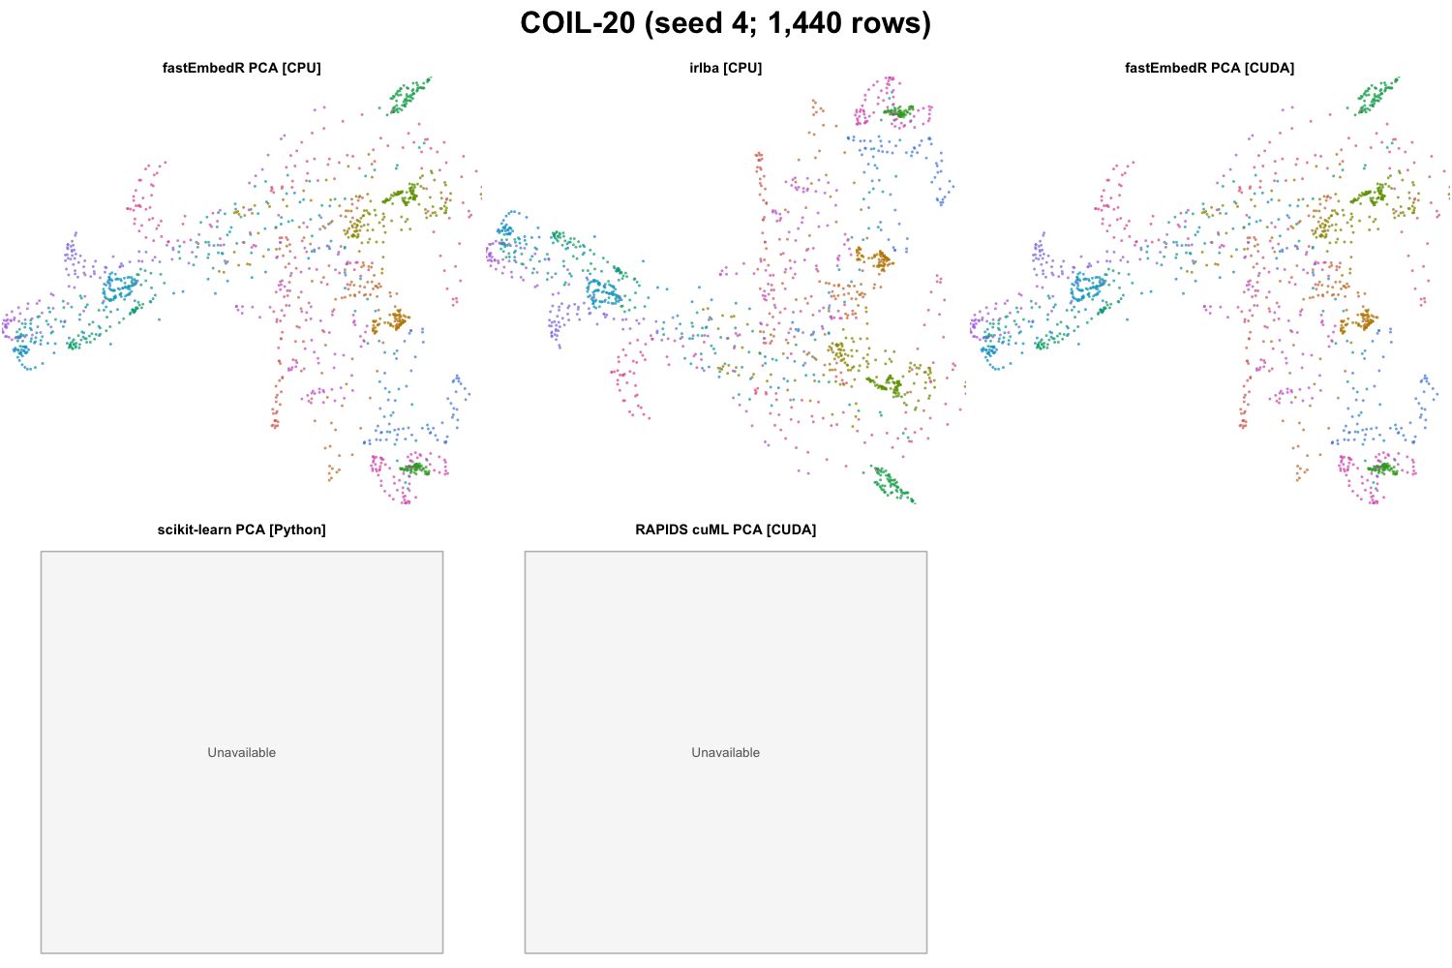
COIL-20 PCA outputs for the tested methods (seed 4; 1,440 rows). Colors encode benchmark labels and were not used for fitting.
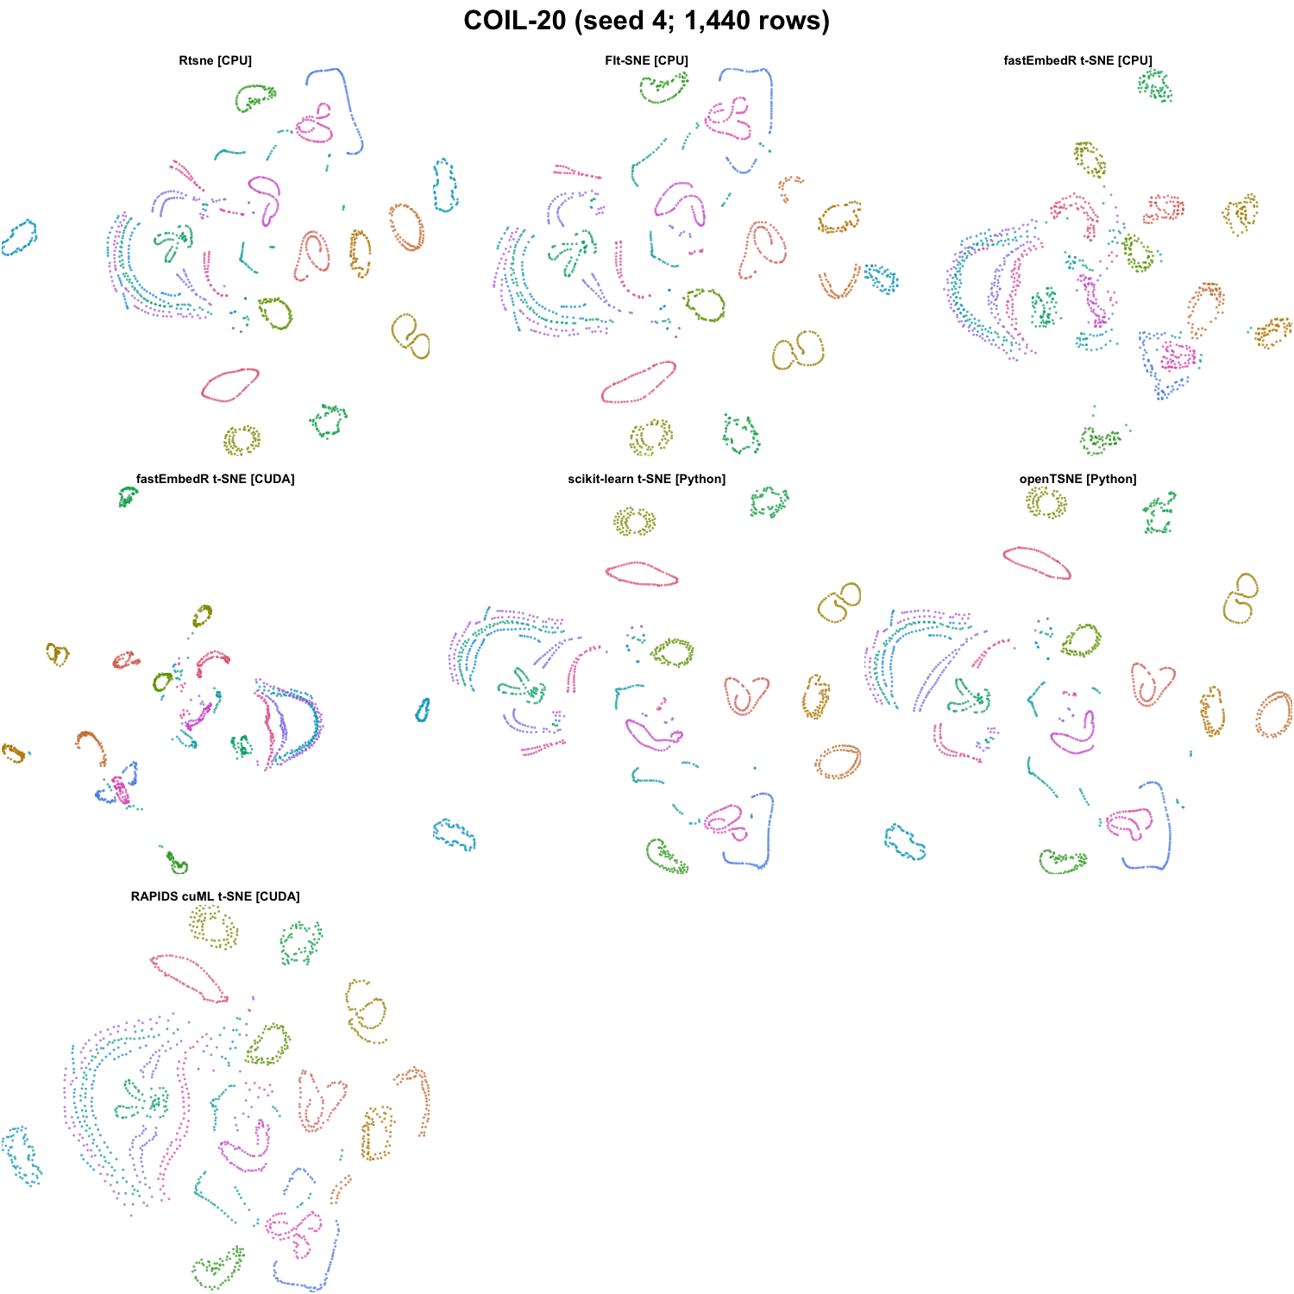
COIL-20 t-SNE outputs for the tested methods (seed 4; 1,440 rows). Colors encode benchmark labels and were not used for fitting.
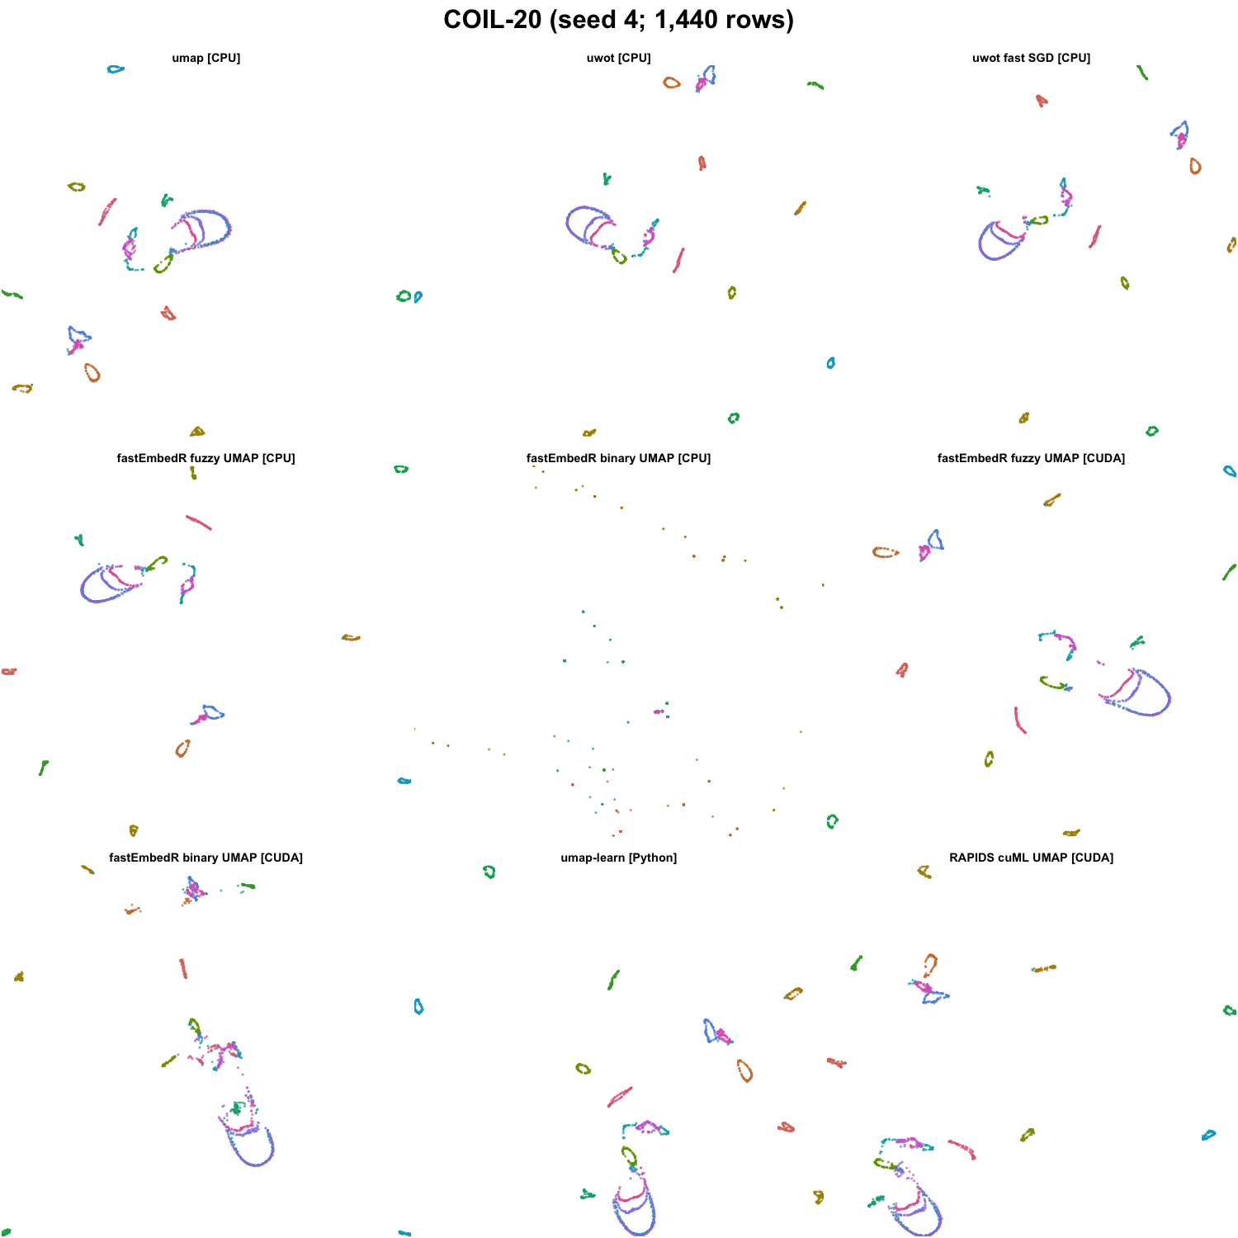
COIL-20 UMAP outputs for the tested methods (seed 4; 1,440 rows). Colors encode benchmark labels and were not used for fitting.
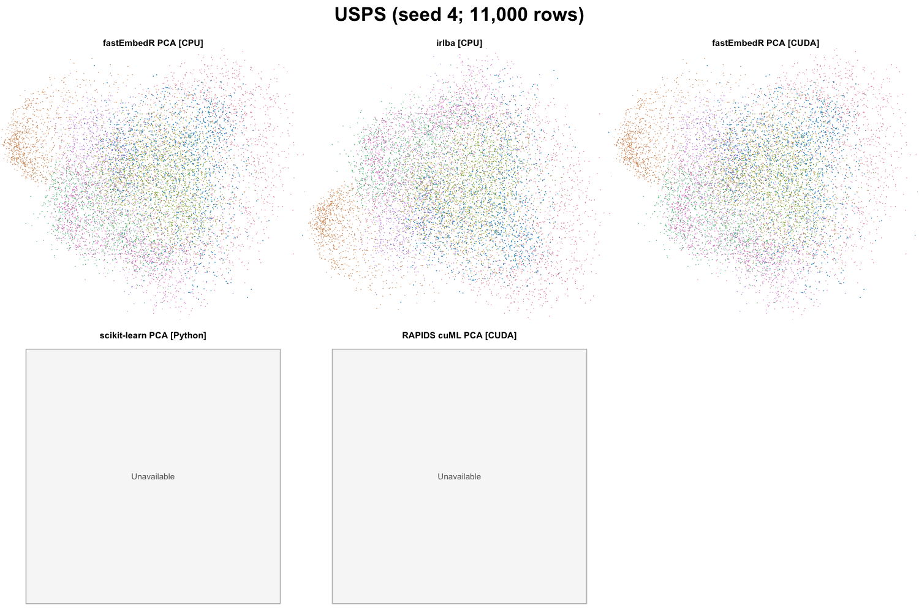
USPS PCA outputs for the tested methods (seed 4; 11,000 rows). Colors encode benchmark labels and were not used for fitting.
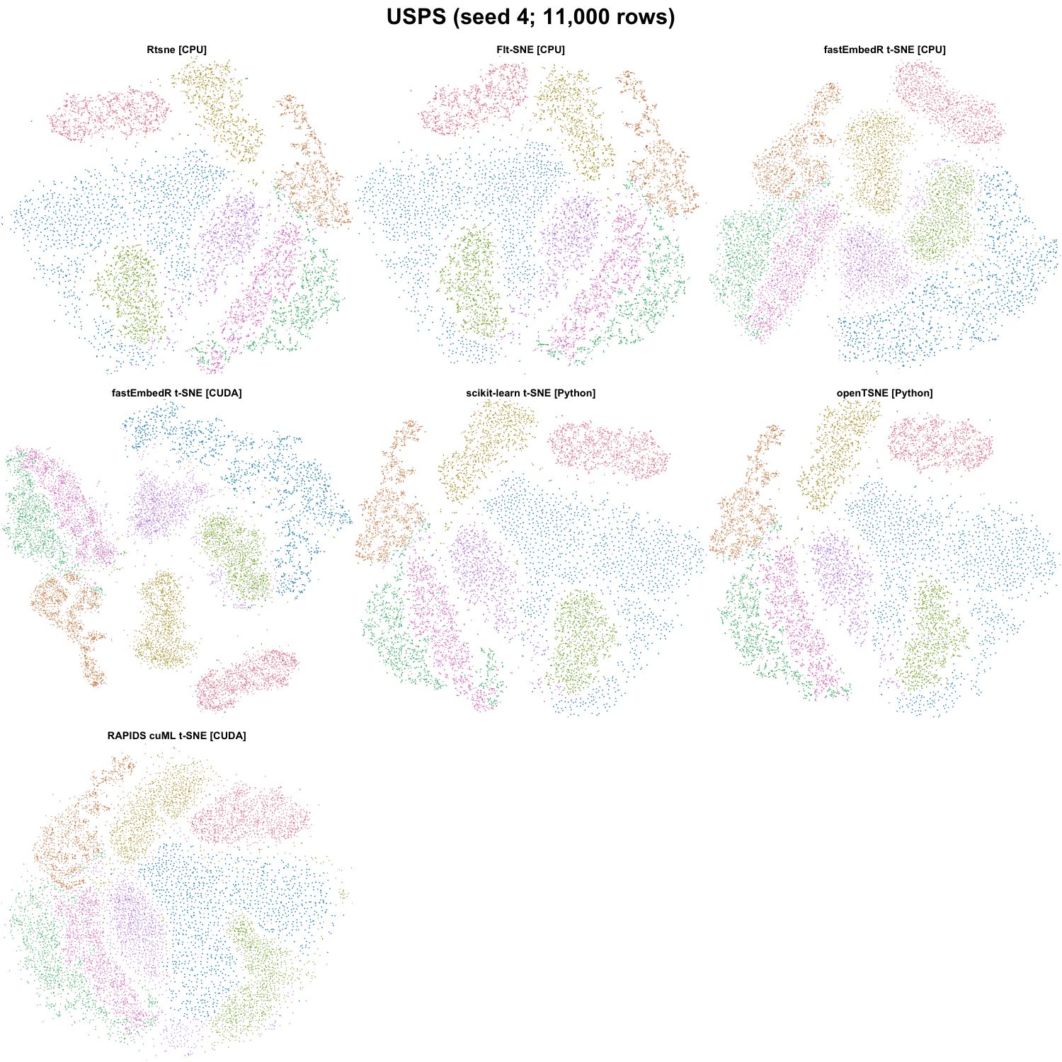
USPS t-SNE outputs for the tested methods (seed 4; 11,000 rows). Colors encode benchmark labels and were not used for fitting.
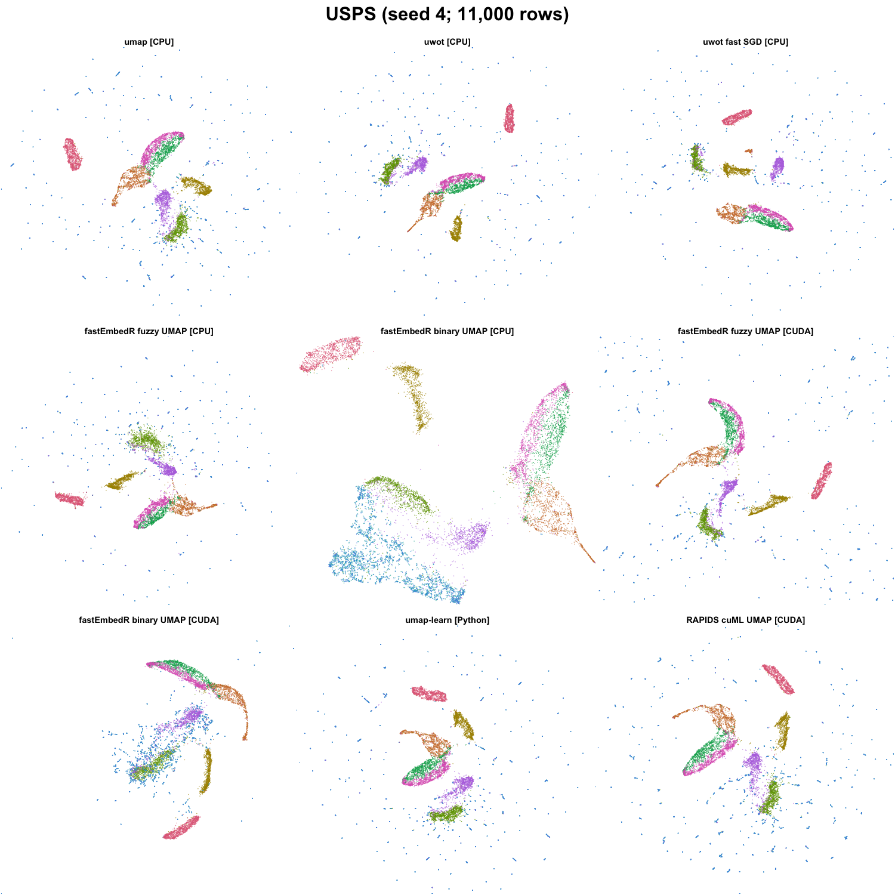
USPS UMAP outputs for the tested methods (seed 4; 11,000 rows). Colors encode benchmark labels and were not used for fitting.
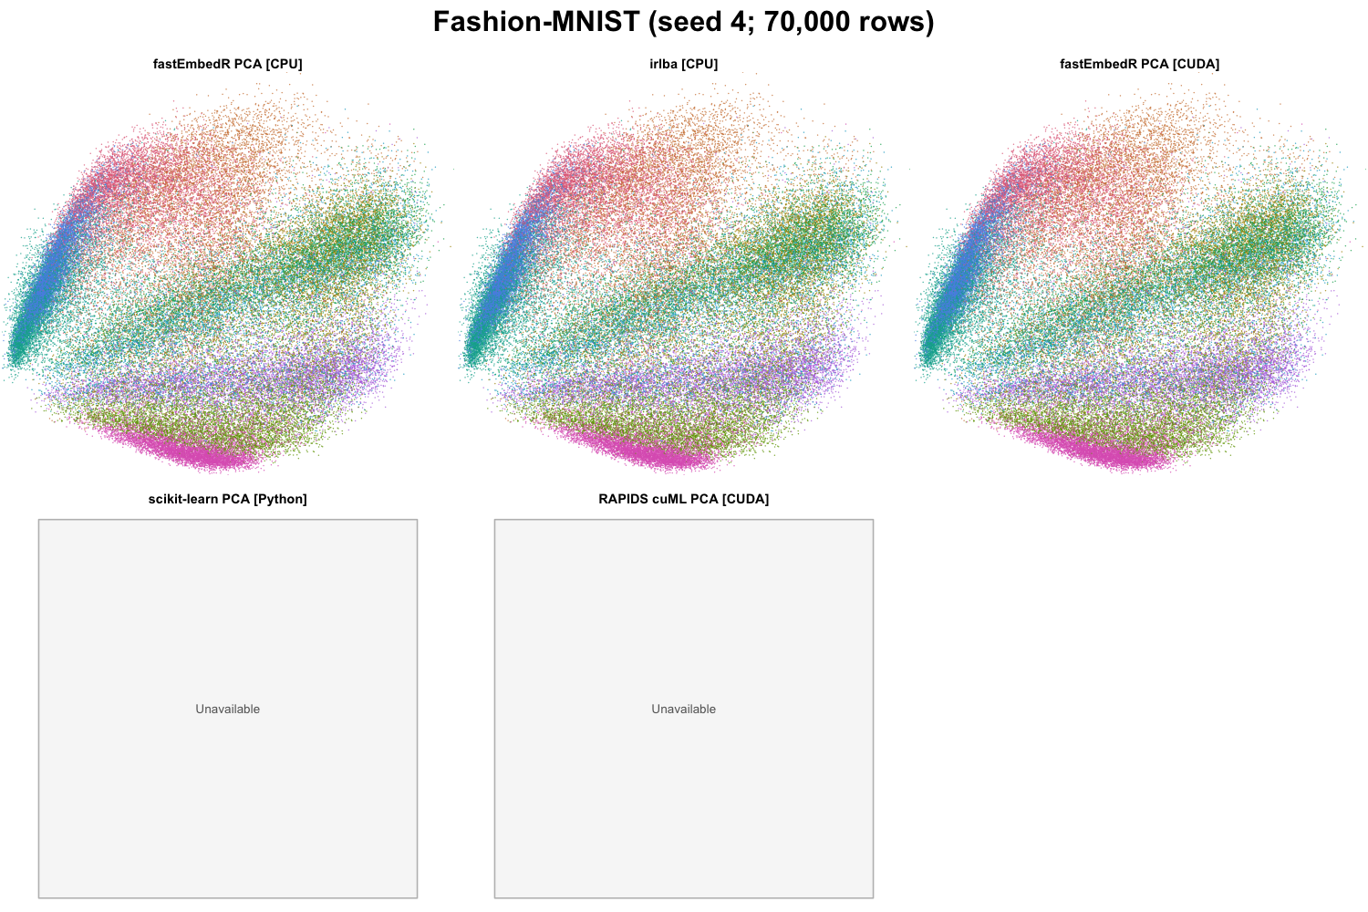
Fashion-MNIST PCA outputs for the tested methods (seed 4; 70,000 rows). Colors encode benchmark labels and were not used for fitting.
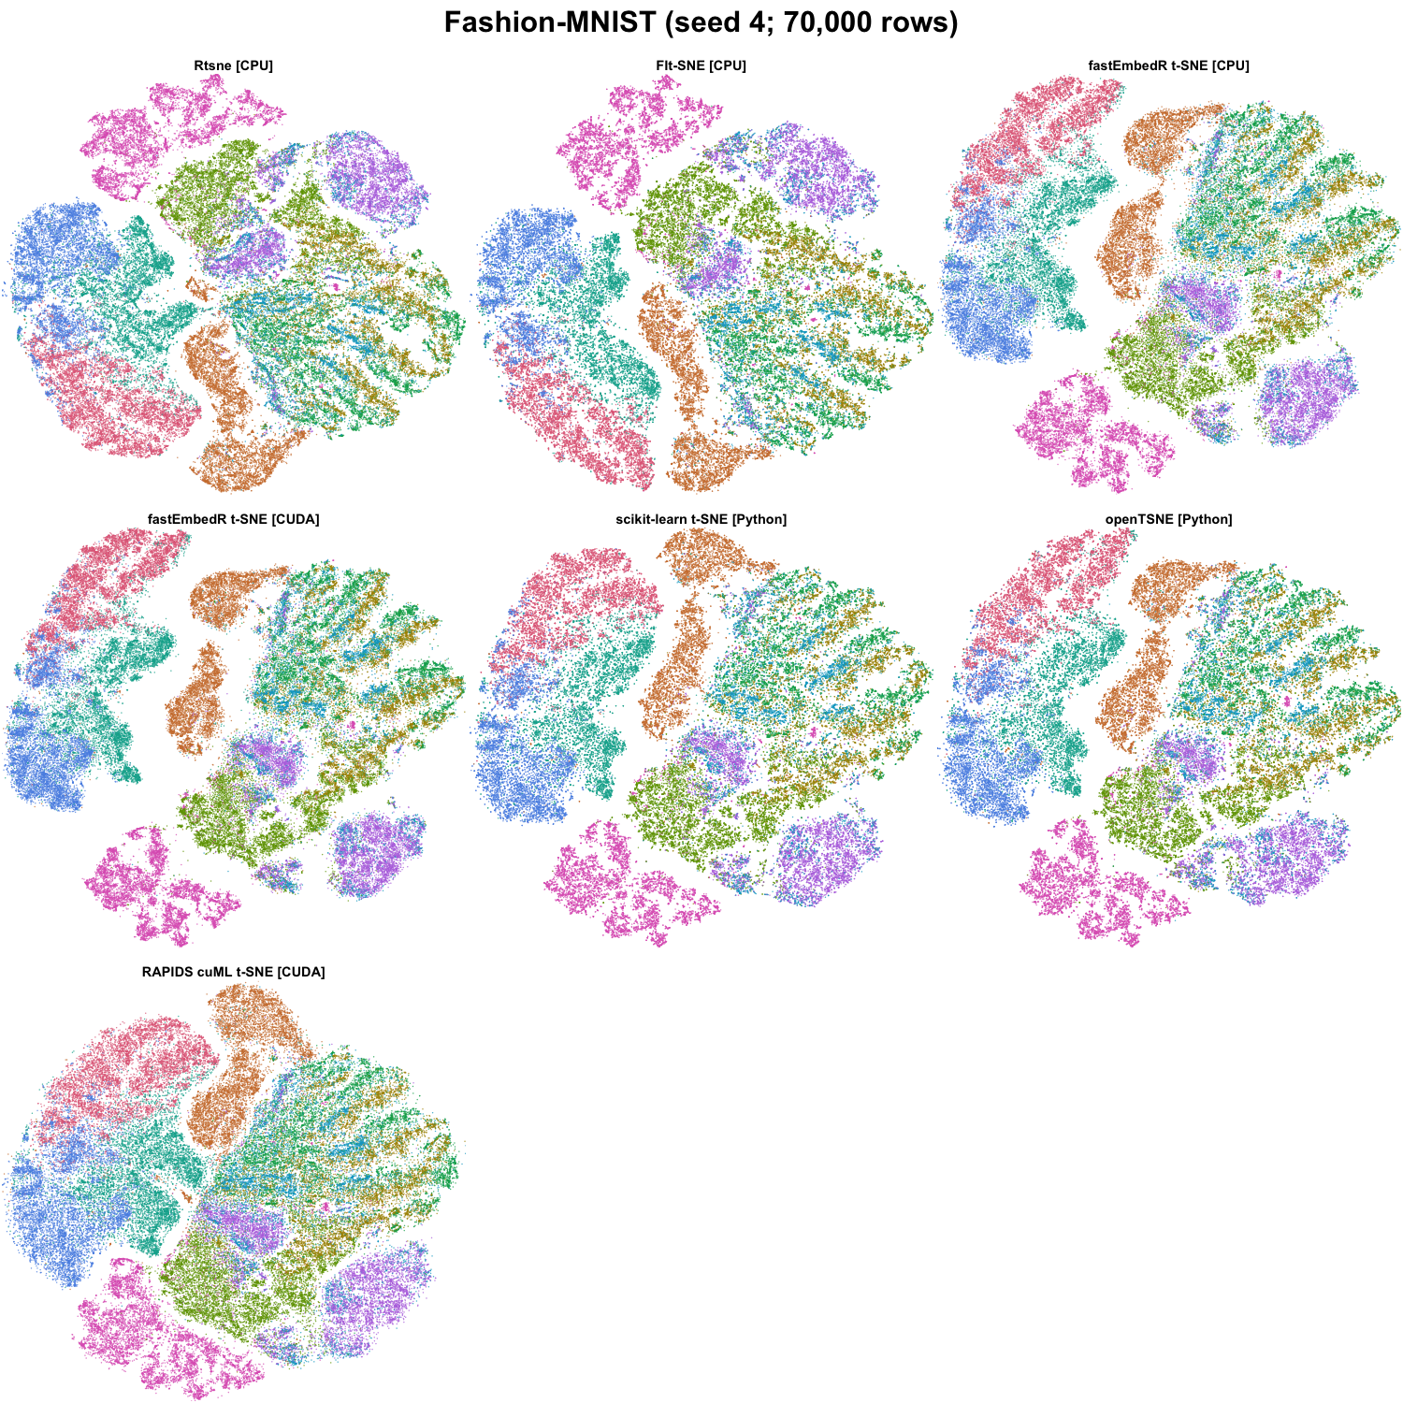
Fashion-MNIST t-SNE outputs for the tested methods (seed 4; 70,000 rows). Colors encode benchmark labels and were not used for fitting.
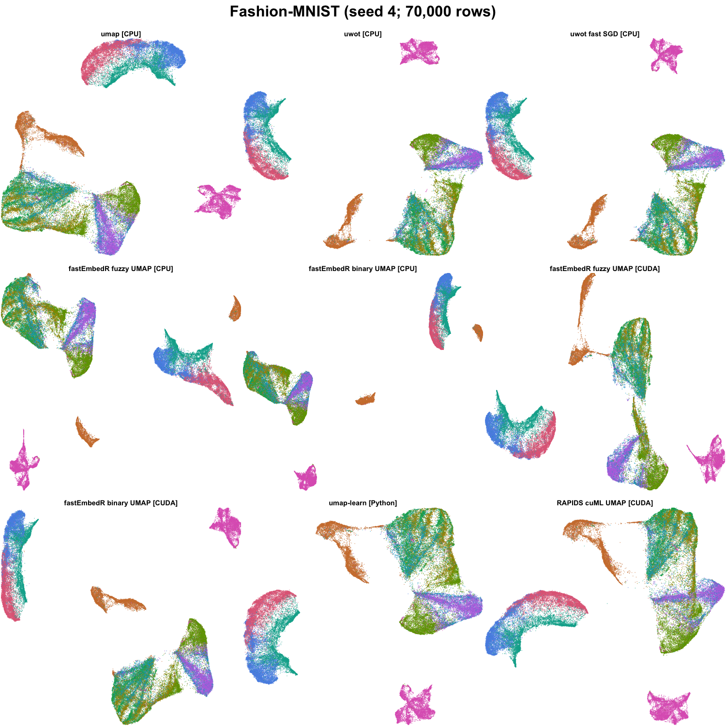
Fashion-MNIST UMAP outputs for the tested methods (seed 4; 70,000 rows). Colors encode benchmark labels and were not used for fitting.
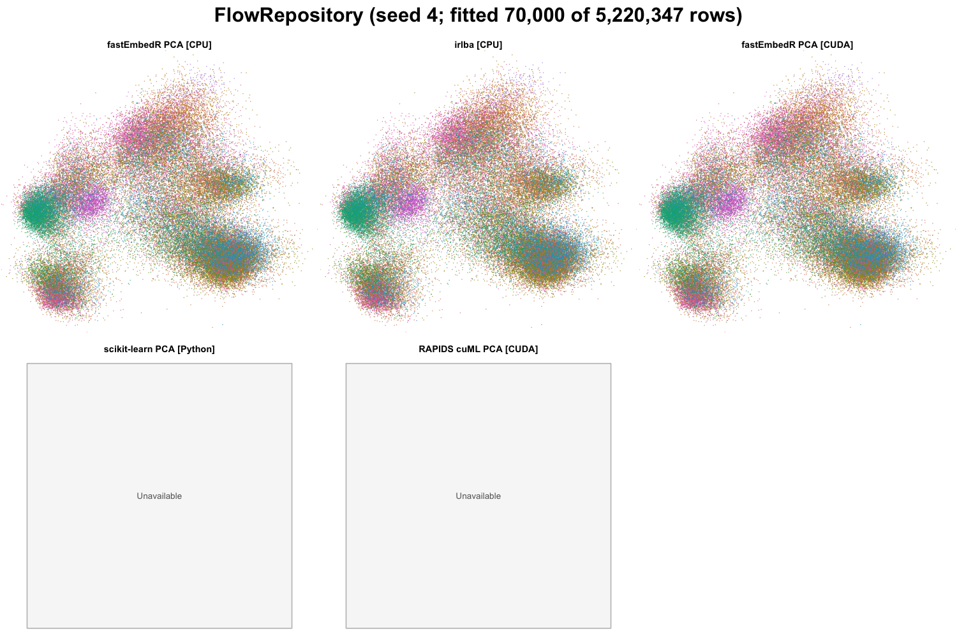
FlowRepository PCA outputs for the tested methods (seed 4; fitted 70,000 of 5,220,347 rows). Colors encode benchmark labels and were not used for fitting.
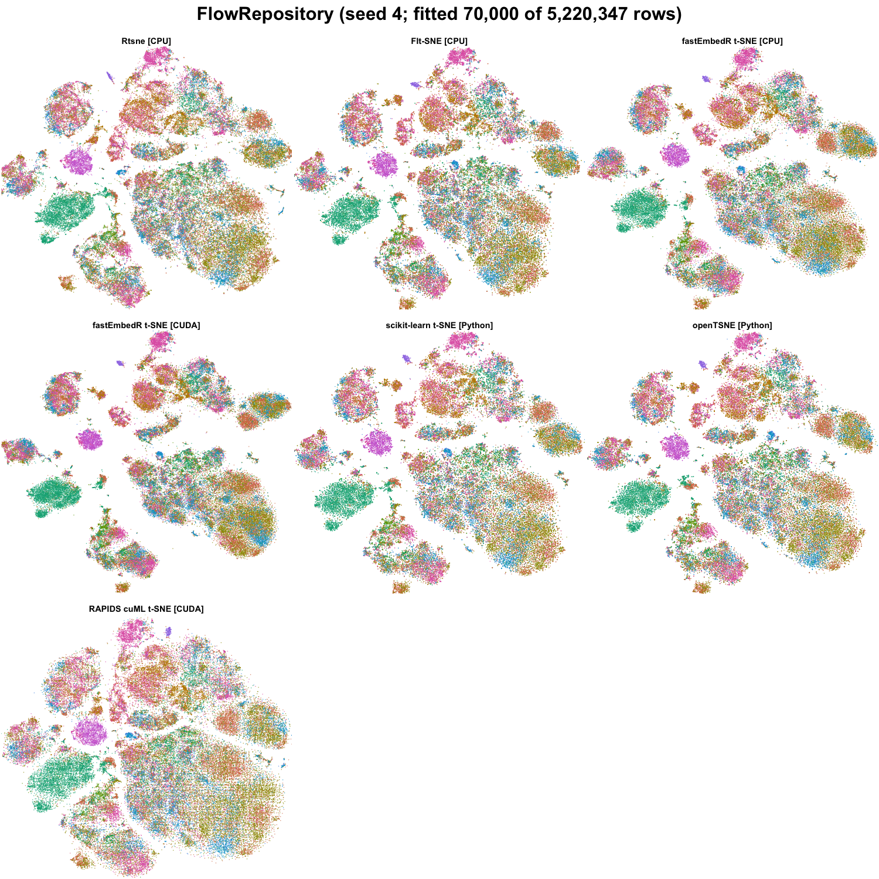
FlowRepository t-SNE outputs for the tested methods (seed 4; fitted 70,000 of 5,220,347 rows). Colors encode benchmark labels and were not used for fitting.
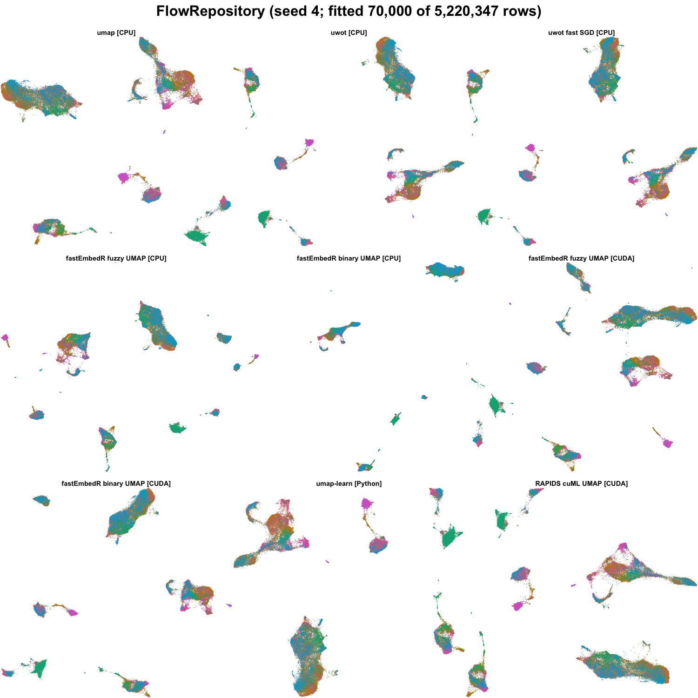
FlowRepository UMAP outputs for the tested methods (seed 4; fitted 70,000 of 5,220,347 rows). Colors encode benchmark labels and were not used for fitting.
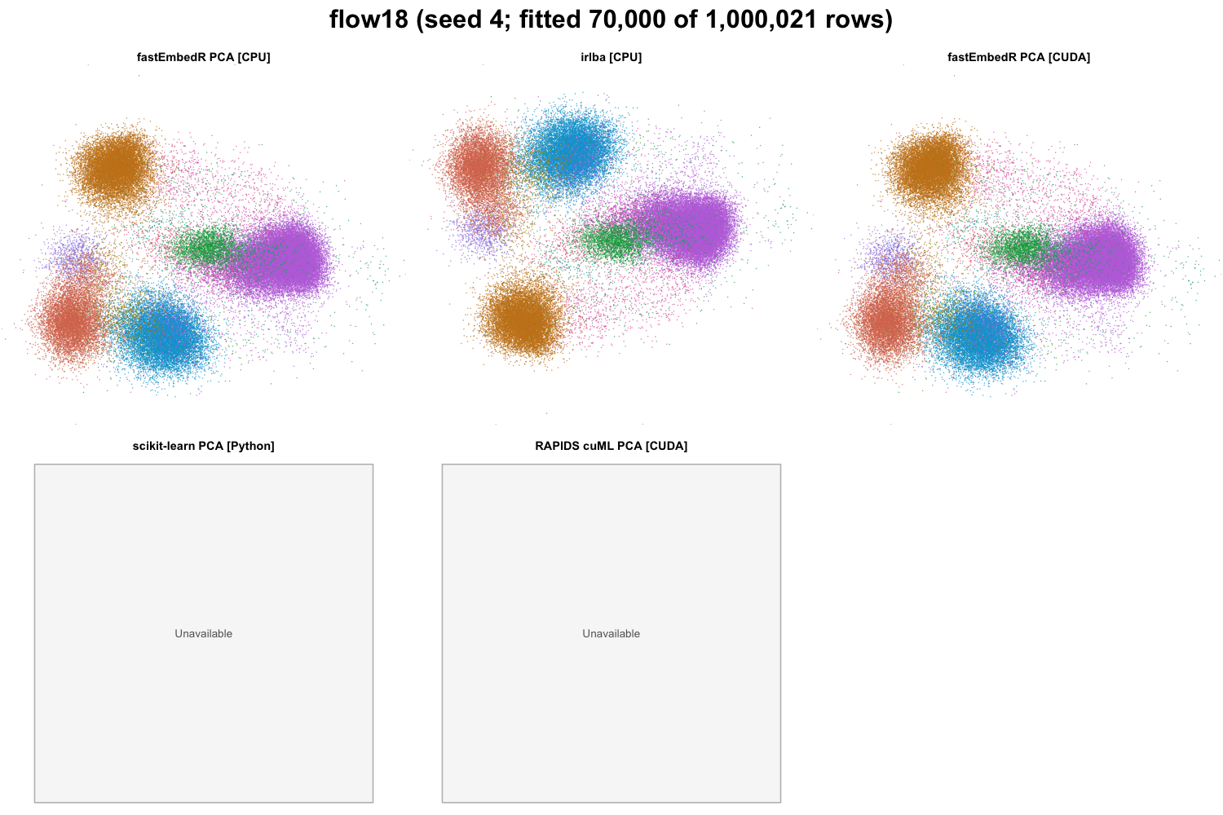
flow18 PCA outputs for the tested methods (seed 4; fitted 70,000 of 1,000,021 rows). Colors encode benchmark labels and were not used for fitting.
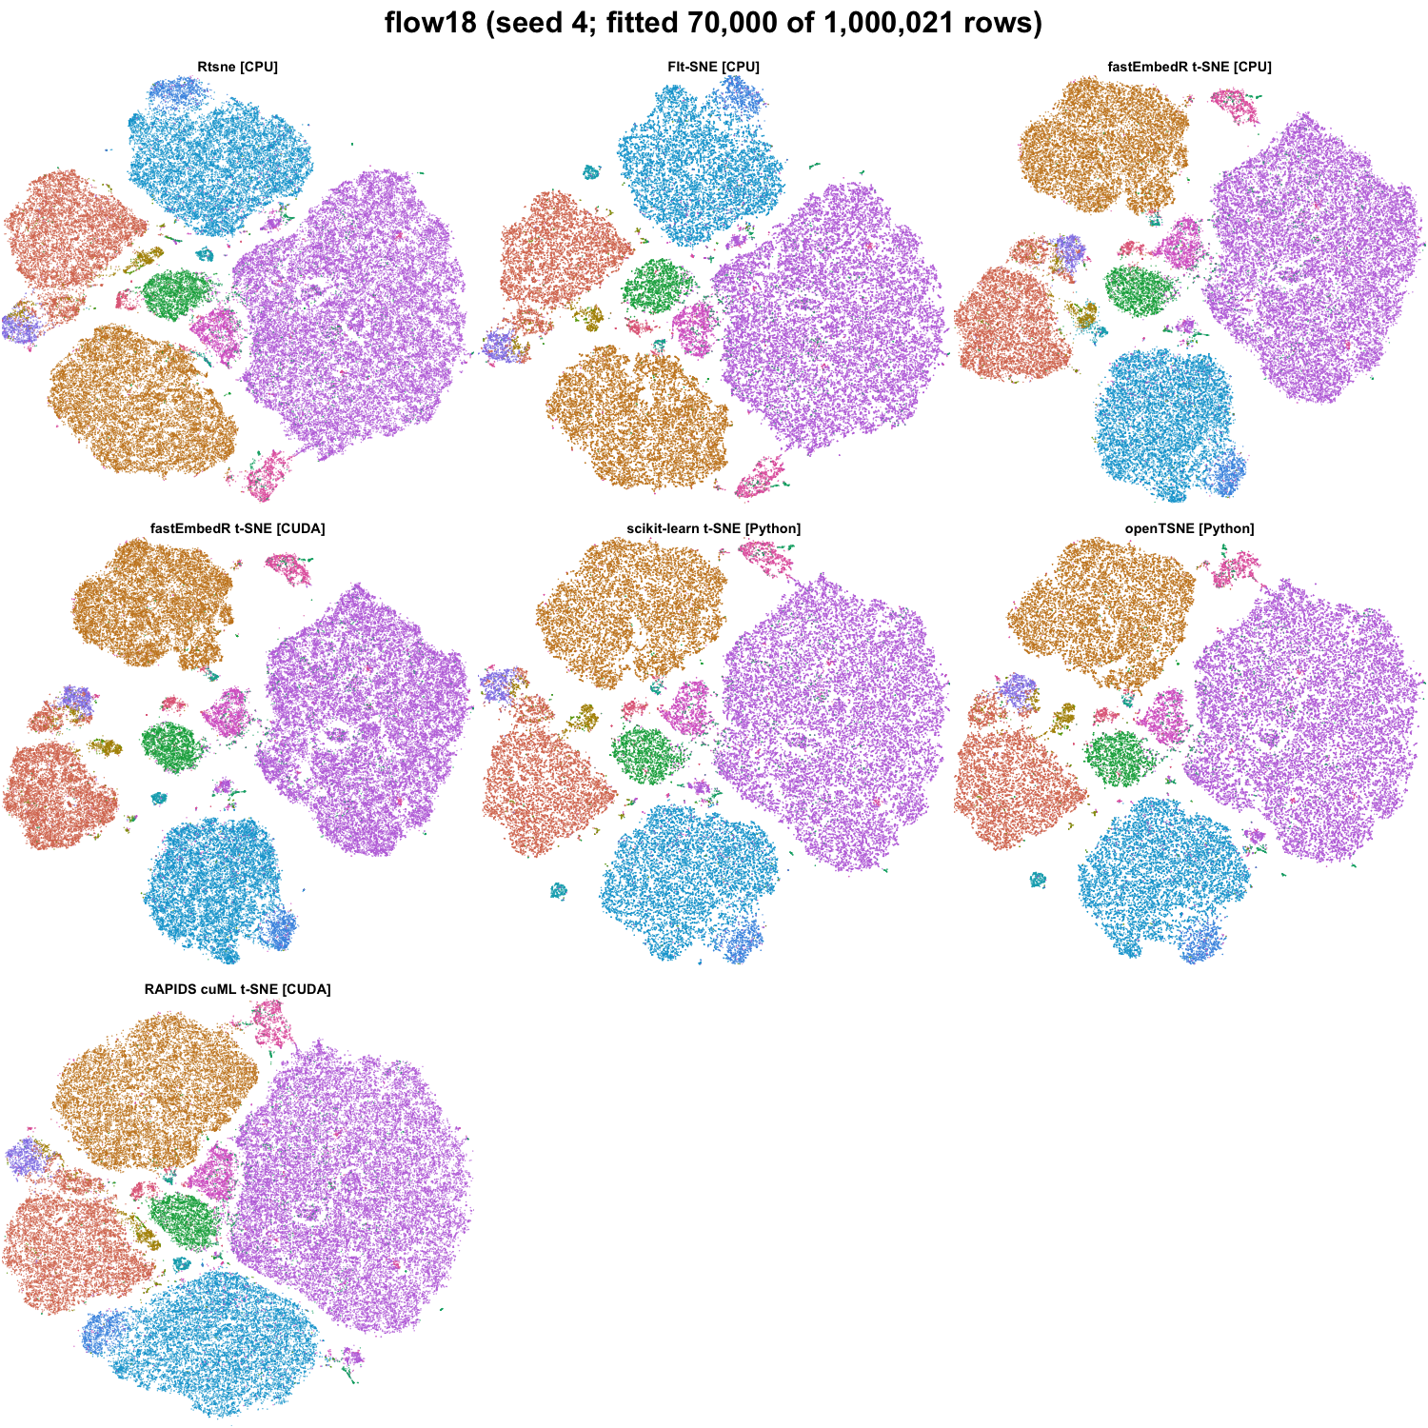
flow18 t-SNE outputs for the tested methods (seed 4; fitted 70,000 of 1,000,021 rows). Colors encode benchmark labels and were not used for fitting.
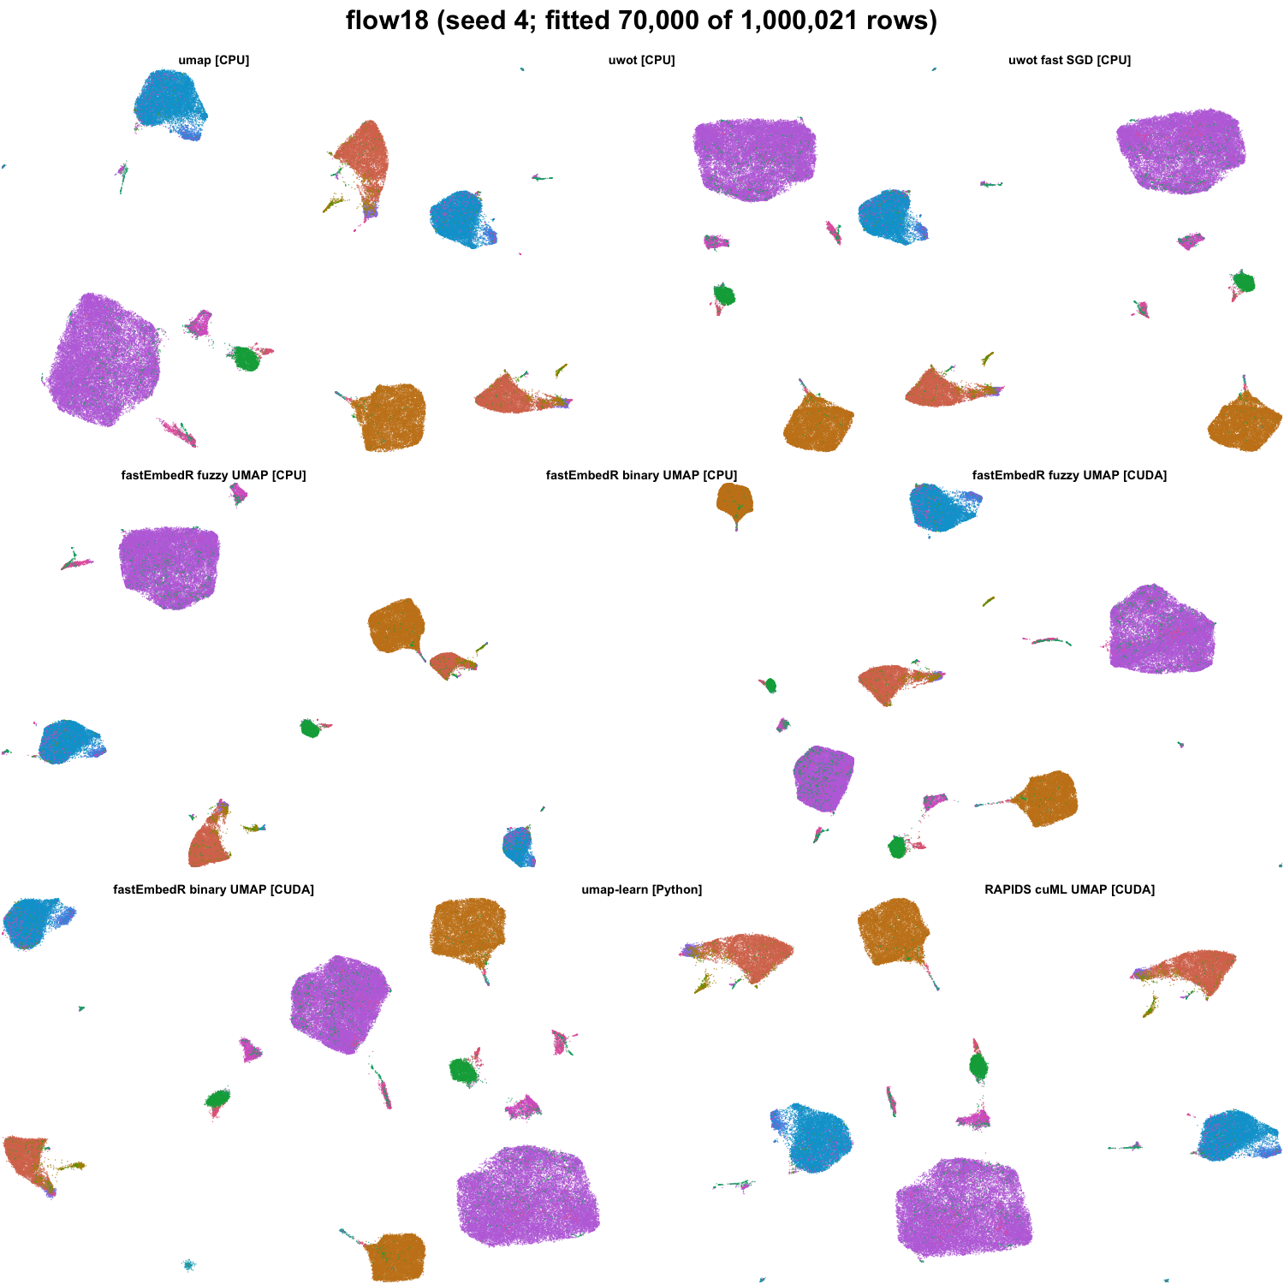
flow18 UMAP outputs for the tested methods (seed 4; fitted 70,000 of 1,000,021 rows). Colors encode benchmark labels and were not used for fitting.
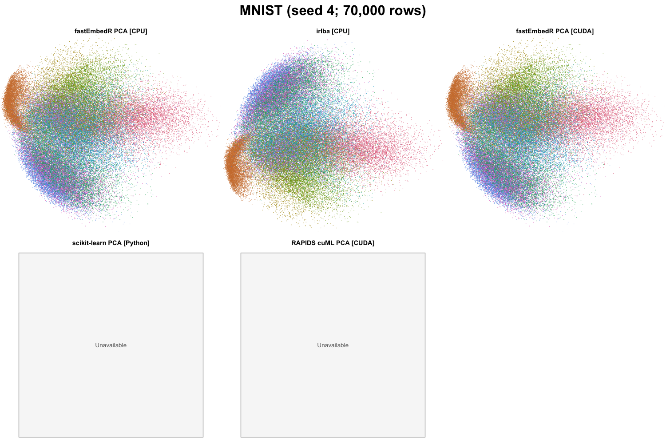
MNIST PCA outputs for the tested methods (seed 4; 70,000 rows). Colors encode benchmark labels and were not used for fitting.
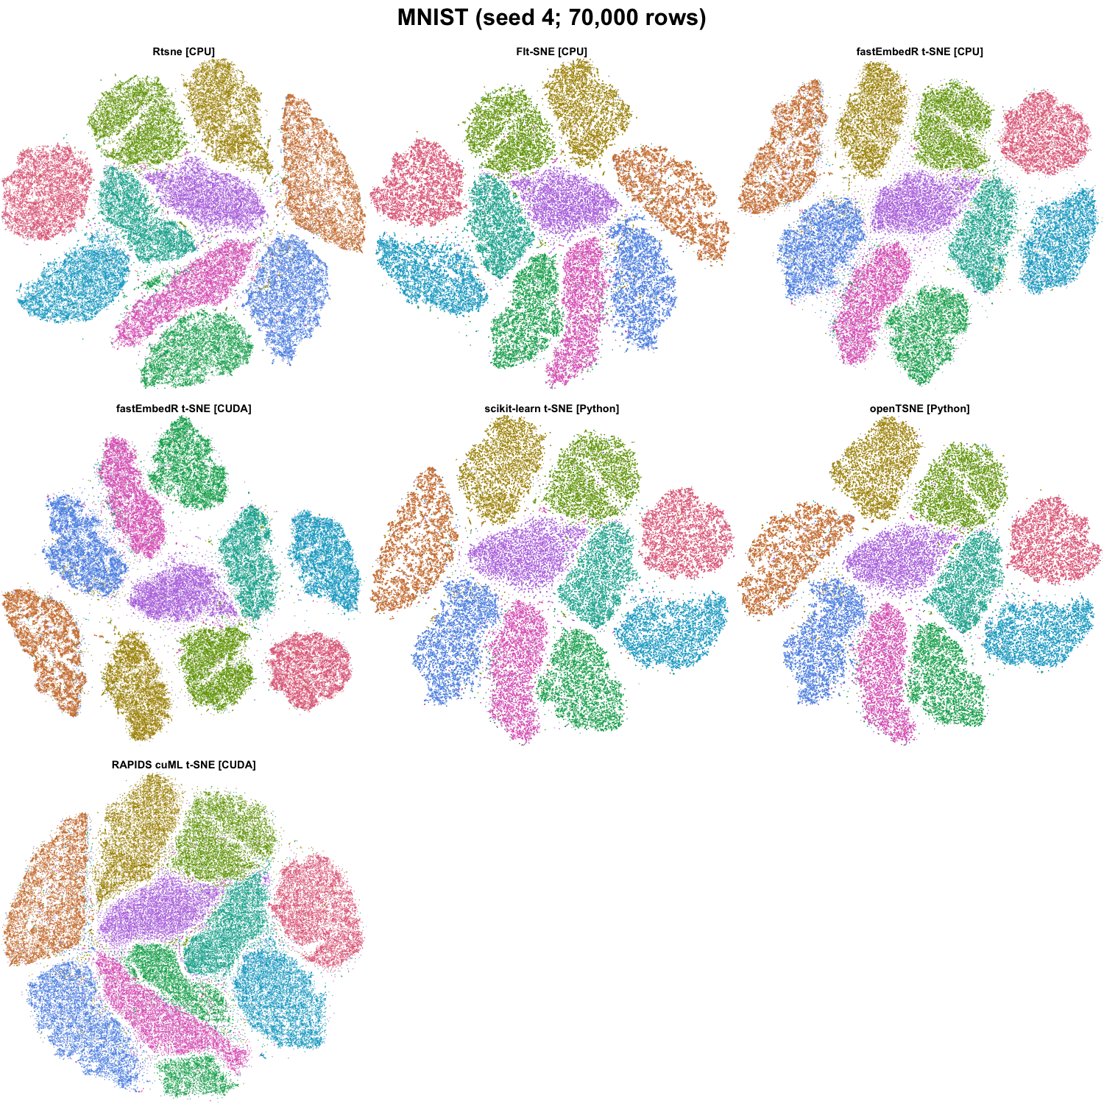
MNIST t-SNE outputs for the tested methods (seed 4; 70,000 rows). Colors encode benchmark labels and were not used for fitting.
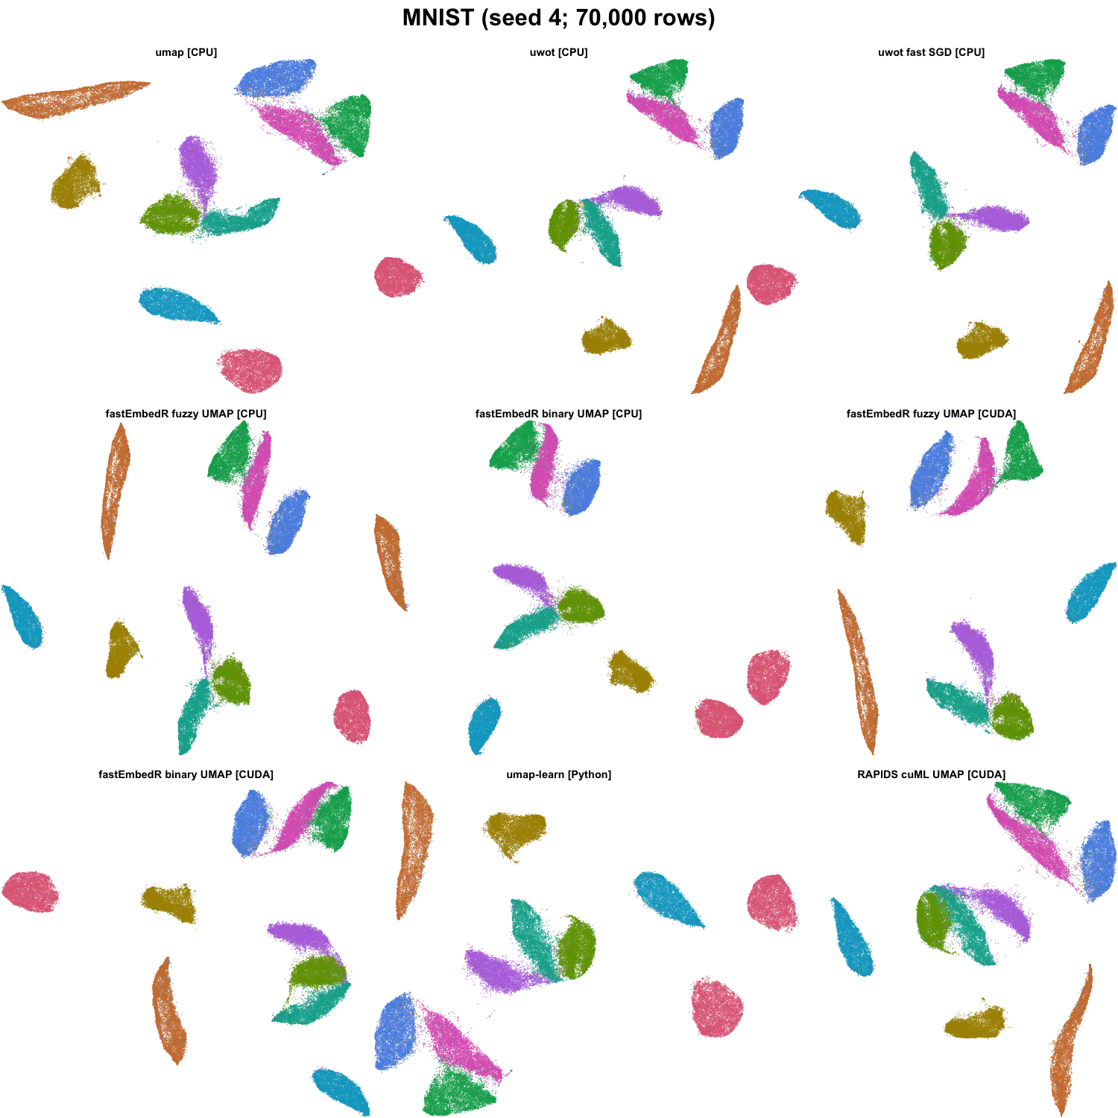
MNIST UMAP outputs for the tested methods (seed 4; 70,000 rows). Colors encode benchmark labels and were not used for fitting.
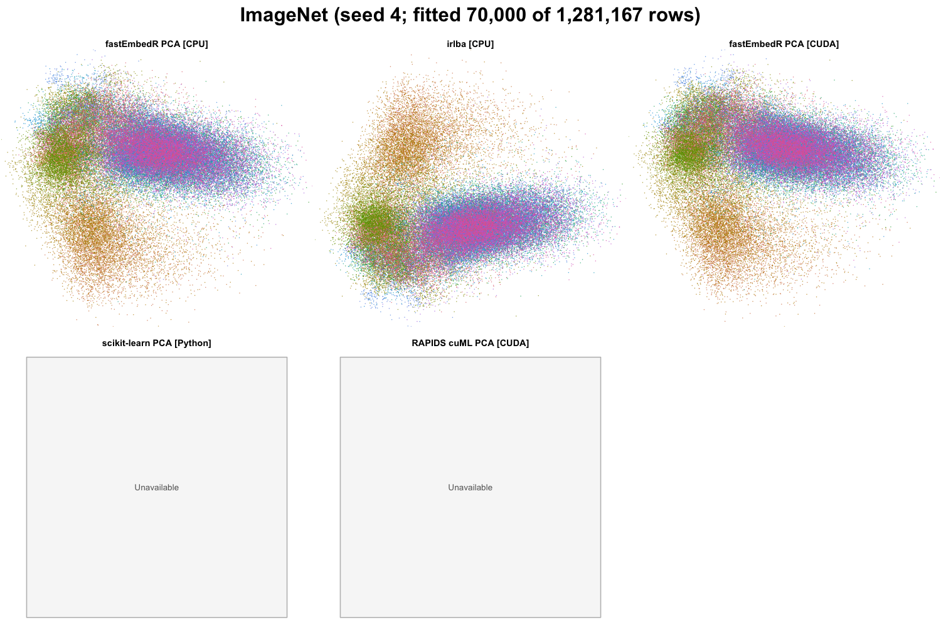
ImageNet PCA outputs for the tested methods (seed 4; fitted 70,000 of 1,281,167 rows). Colors encode benchmark labels and were not used for fitting.
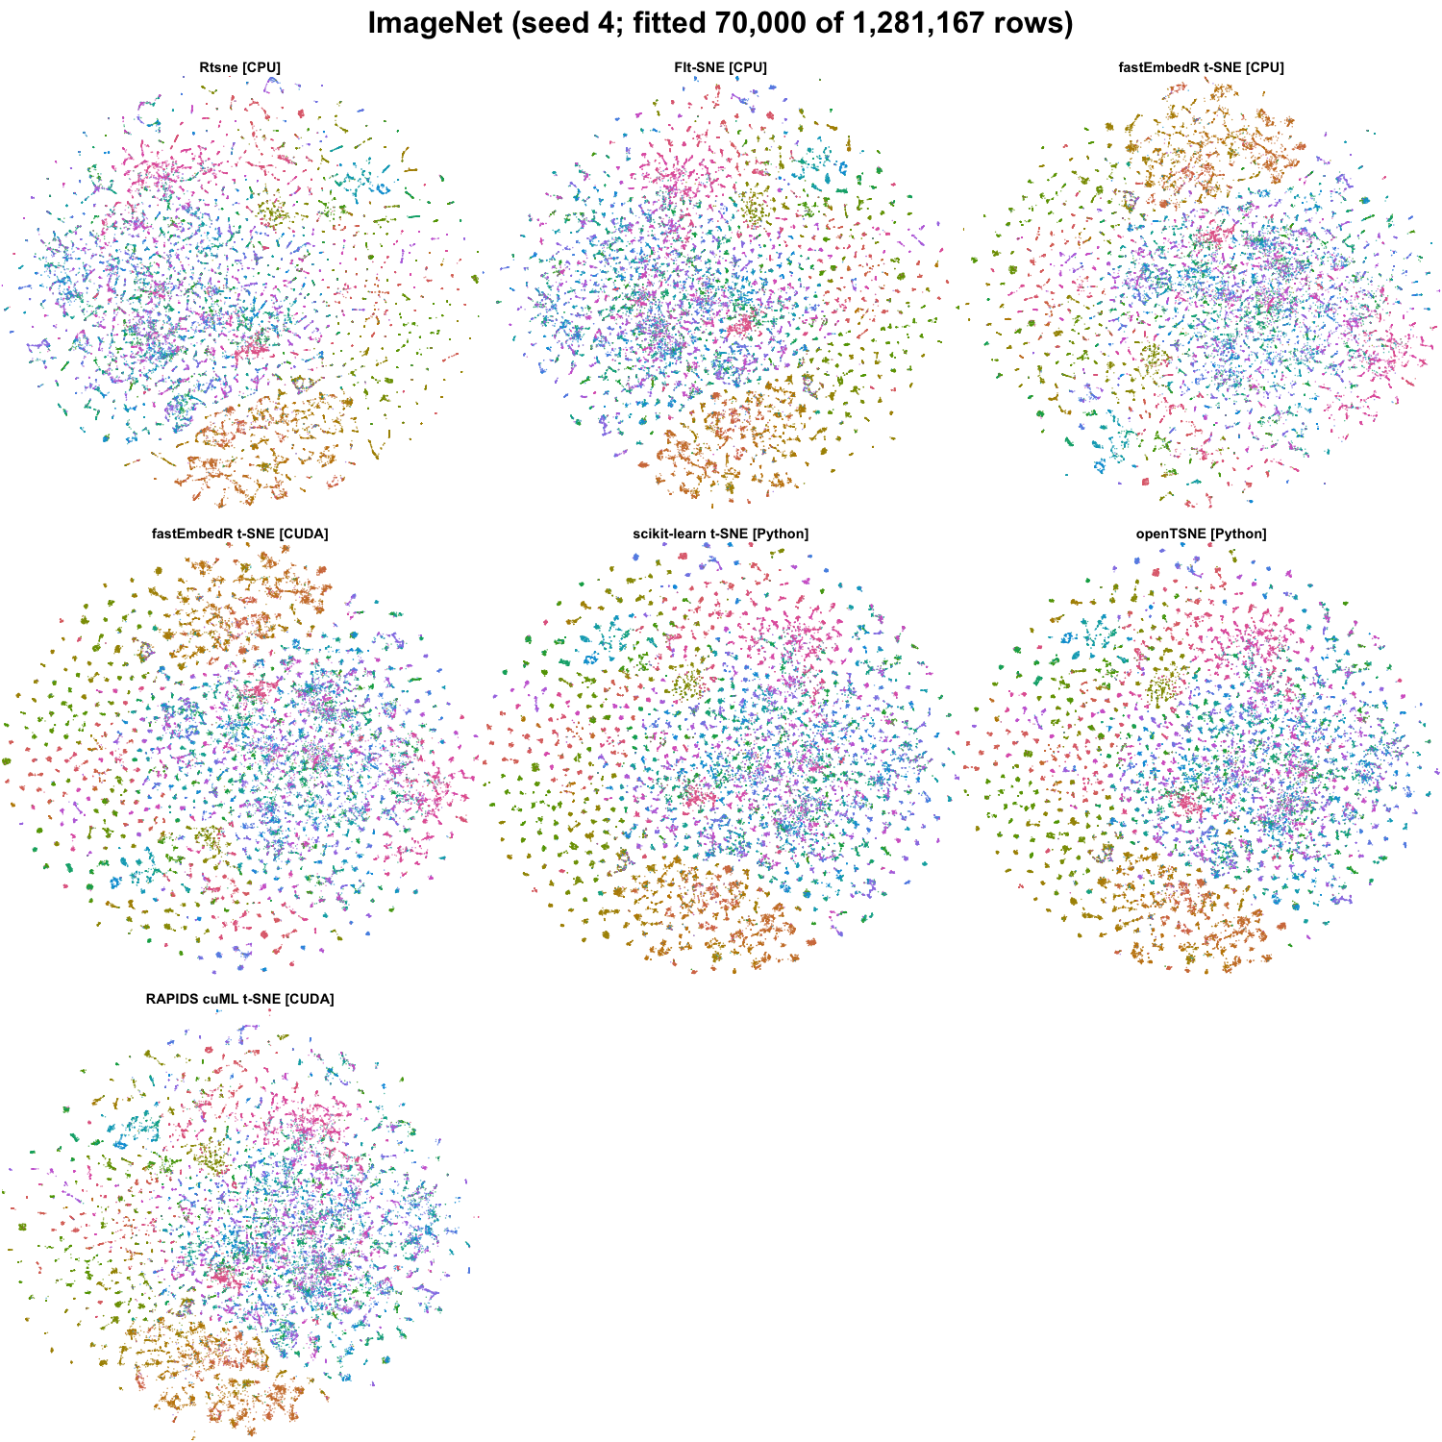
ImageNet t-SNE outputs for the tested methods (seed 4; fitted 70,000 of 1,281,167 rows). Colors encode benchmark labels and were not used for fitting.
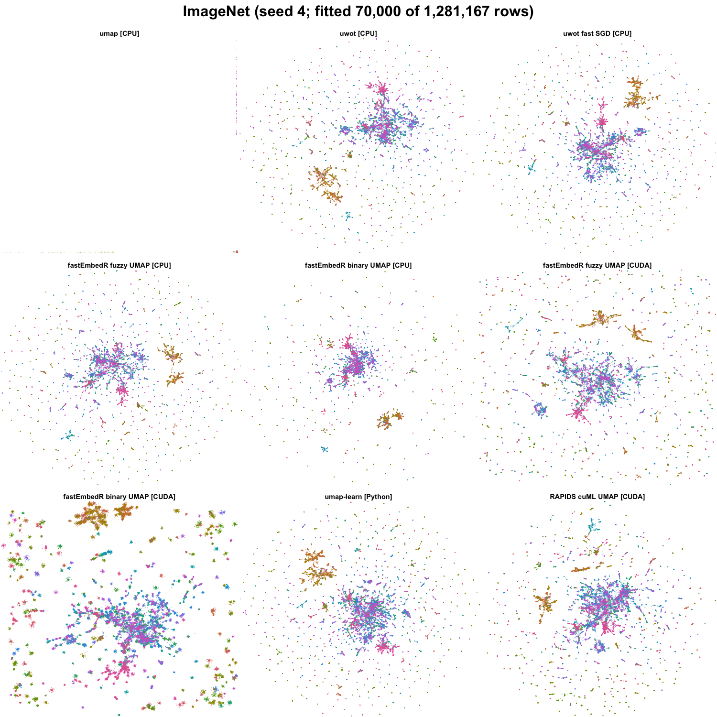
ImageNet UMAP outputs for the tested methods (seed 4; fitted 70,000 of 1,281,167 rows). Colors encode benchmark labels and were not used for fitting.
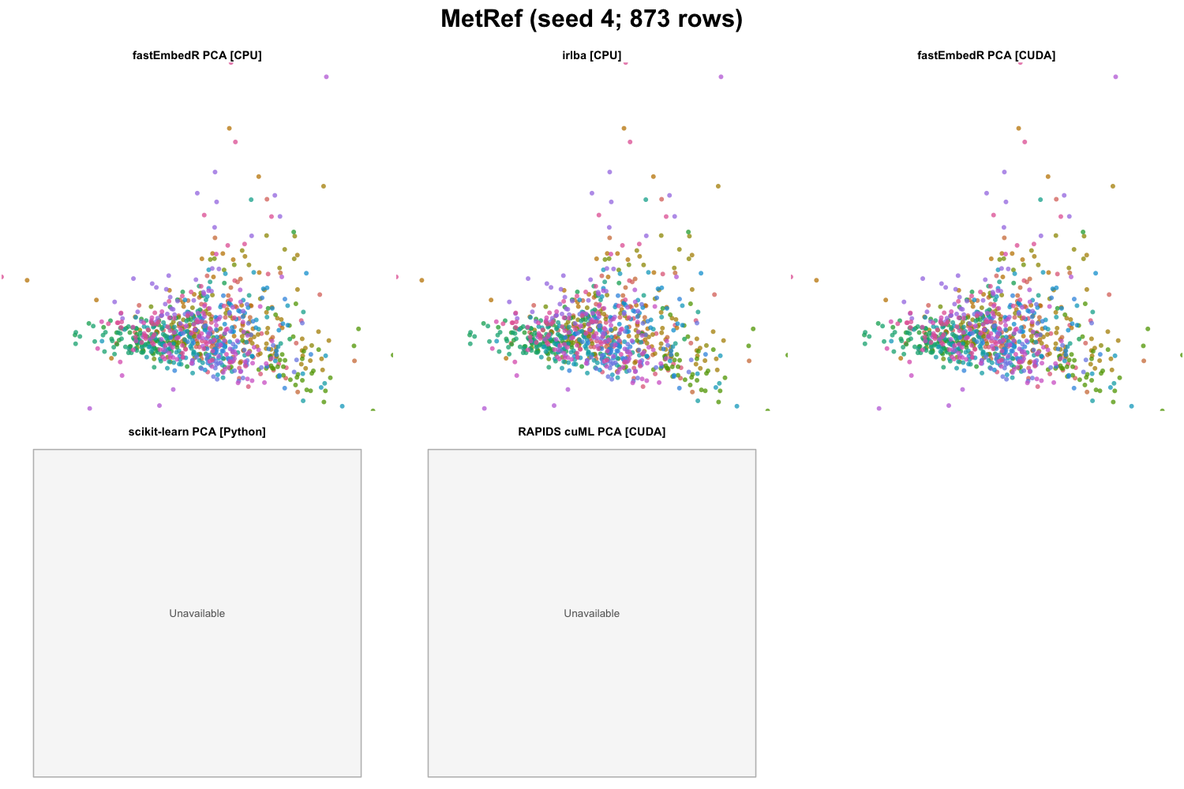
MetRef PCA outputs for the tested methods (seed 4; 873 rows). Colors encode benchmark labels and were not used for fitting.
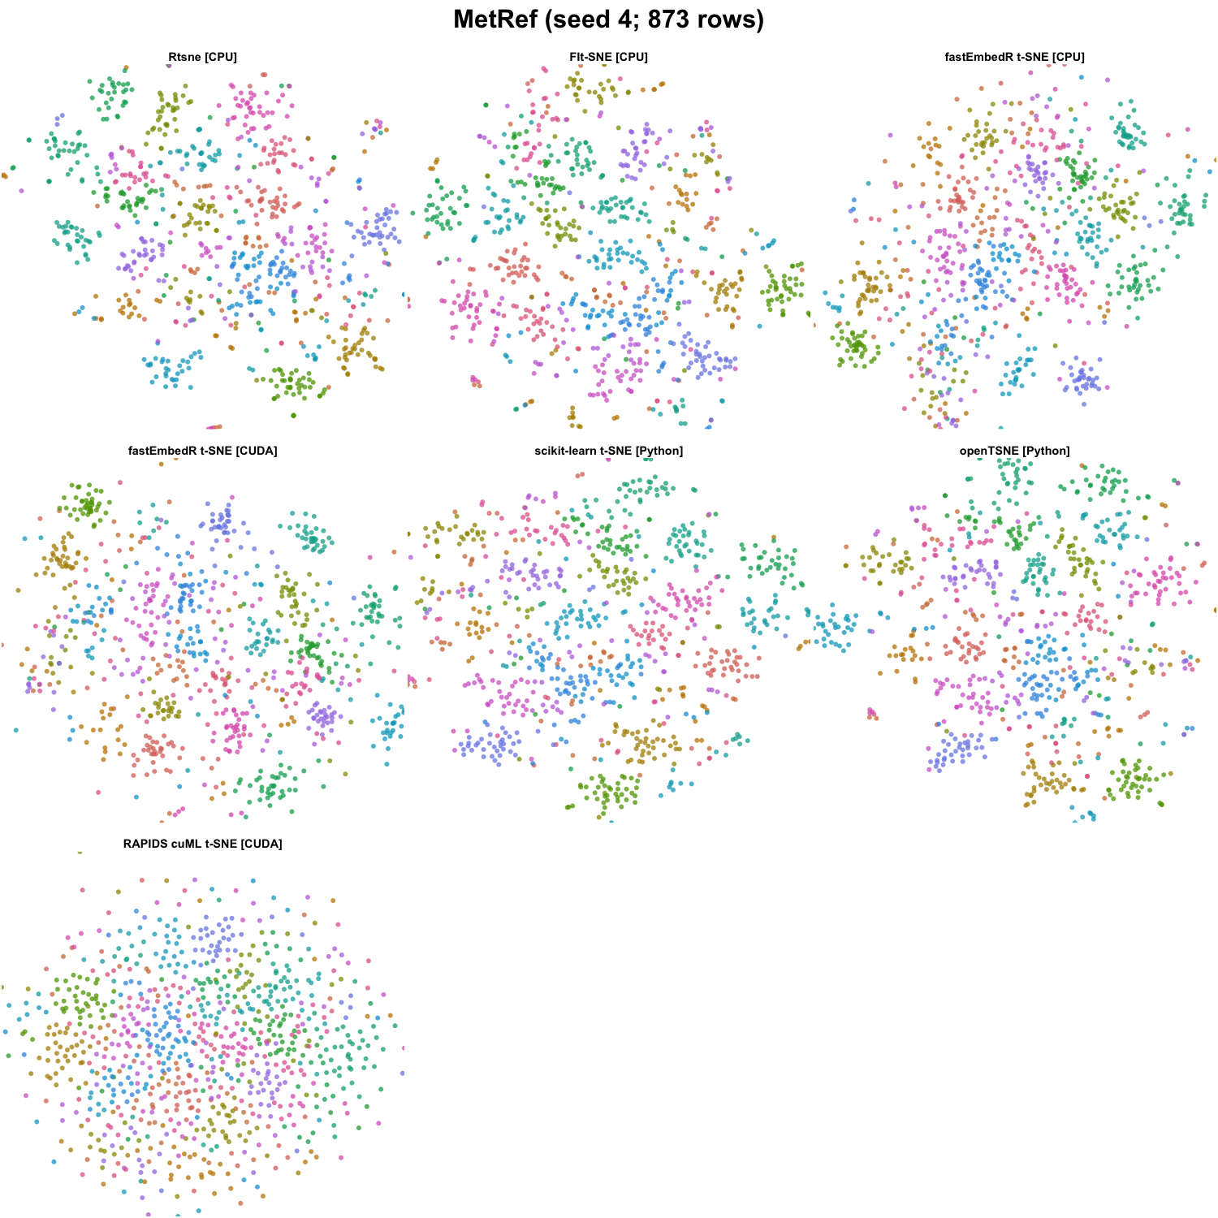
MetRef t-SNE outputs for the tested methods (seed 4; 873 rows). Colors encode benchmark labels and were not used for fitting.
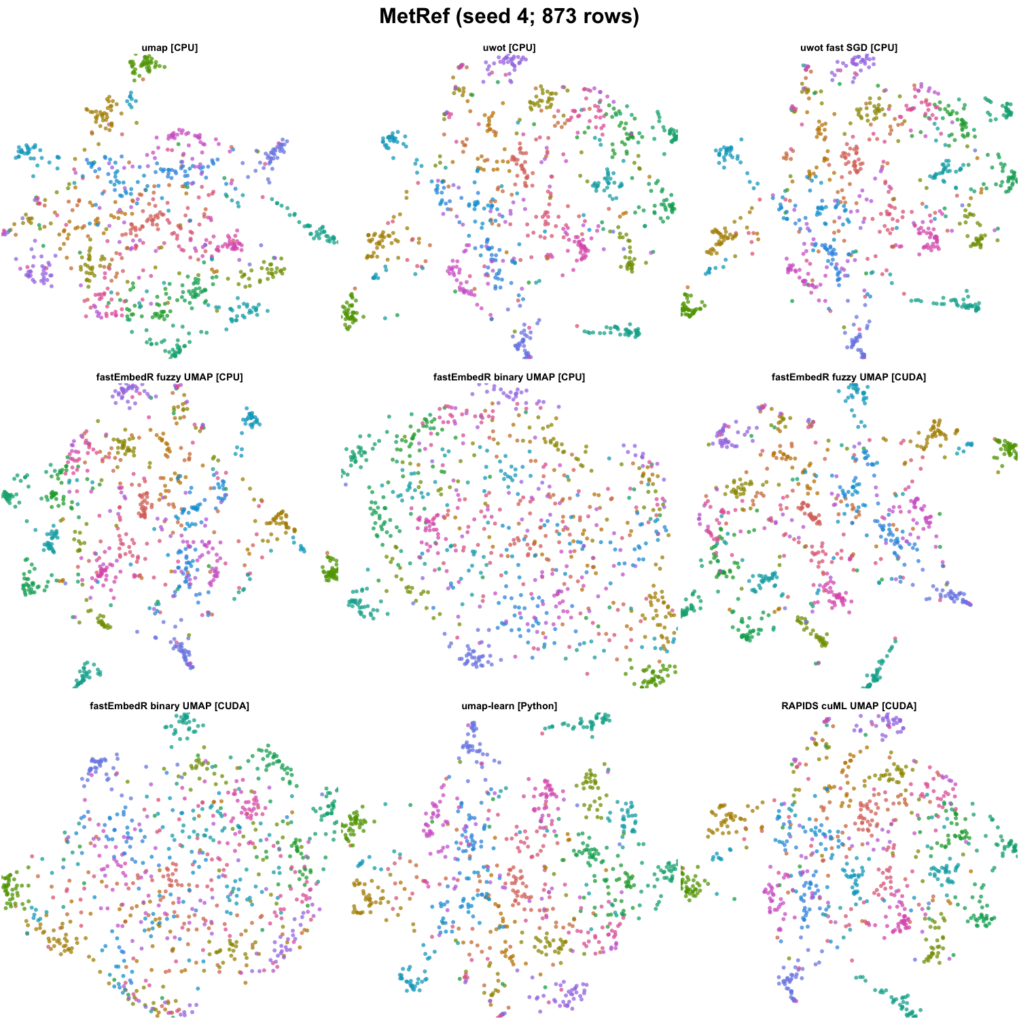
MetRef UMAP outputs for the tested methods (seed 4; 873 rows). Colors encode benchmark labels and were not used for fitting.
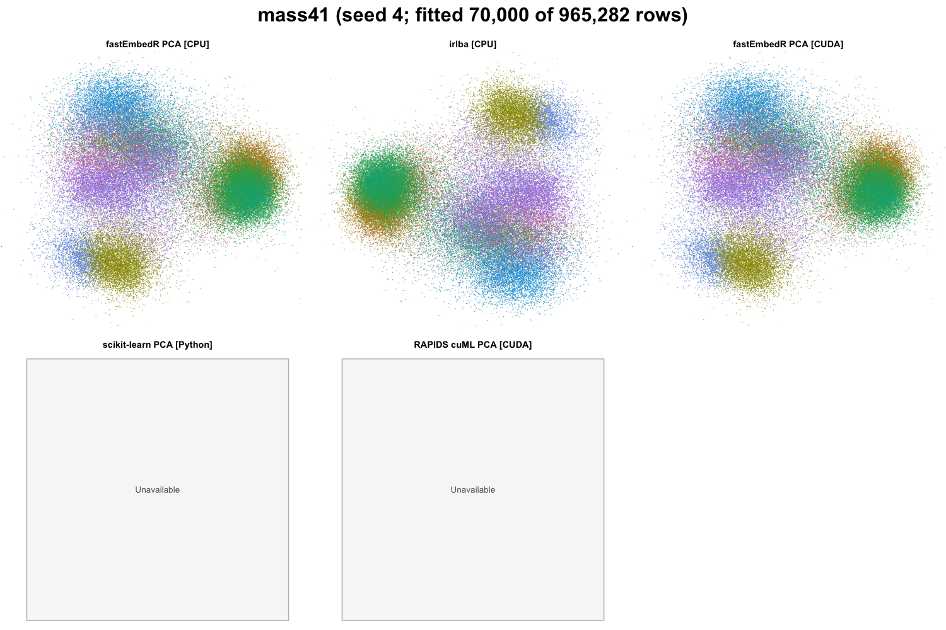
mass41 PCA outputs for the tested methods (seed 4; fitted 70,000 of 965,282 rows). Colors encode benchmark labels and were not used for fitting.
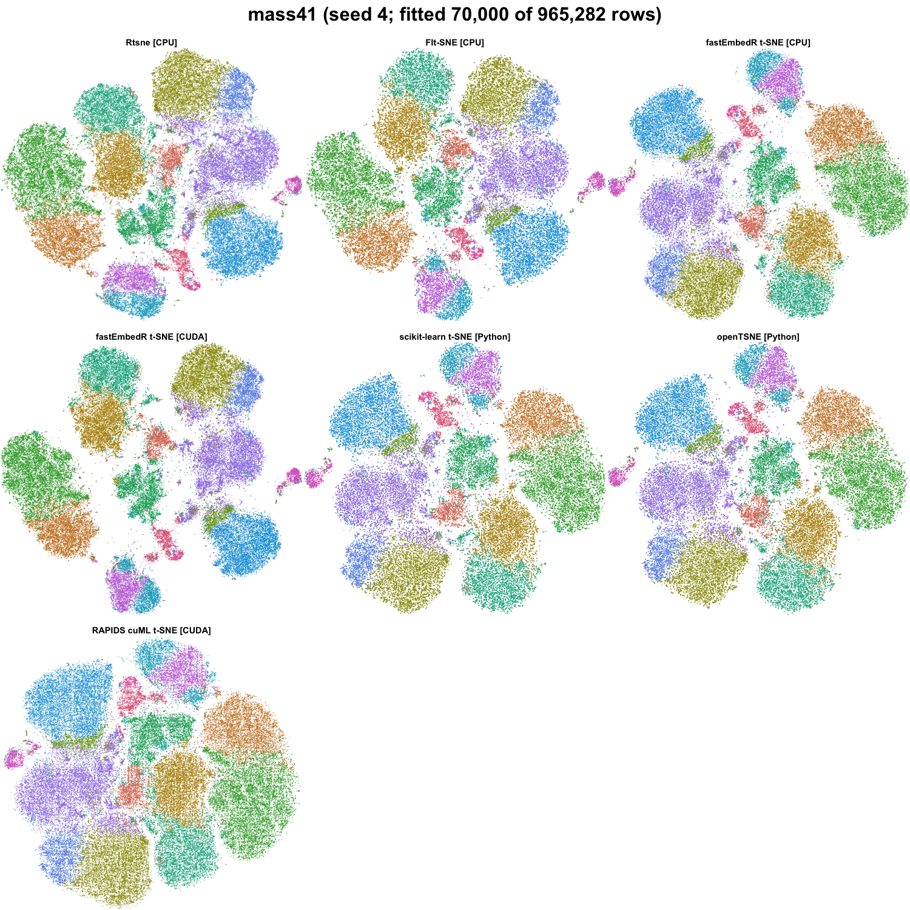
mass41 t-SNE outputs for the tested methods (seed 4; fitted 70,000 of 965,282 rows). Colors encode benchmark labels and were not used for fitting.
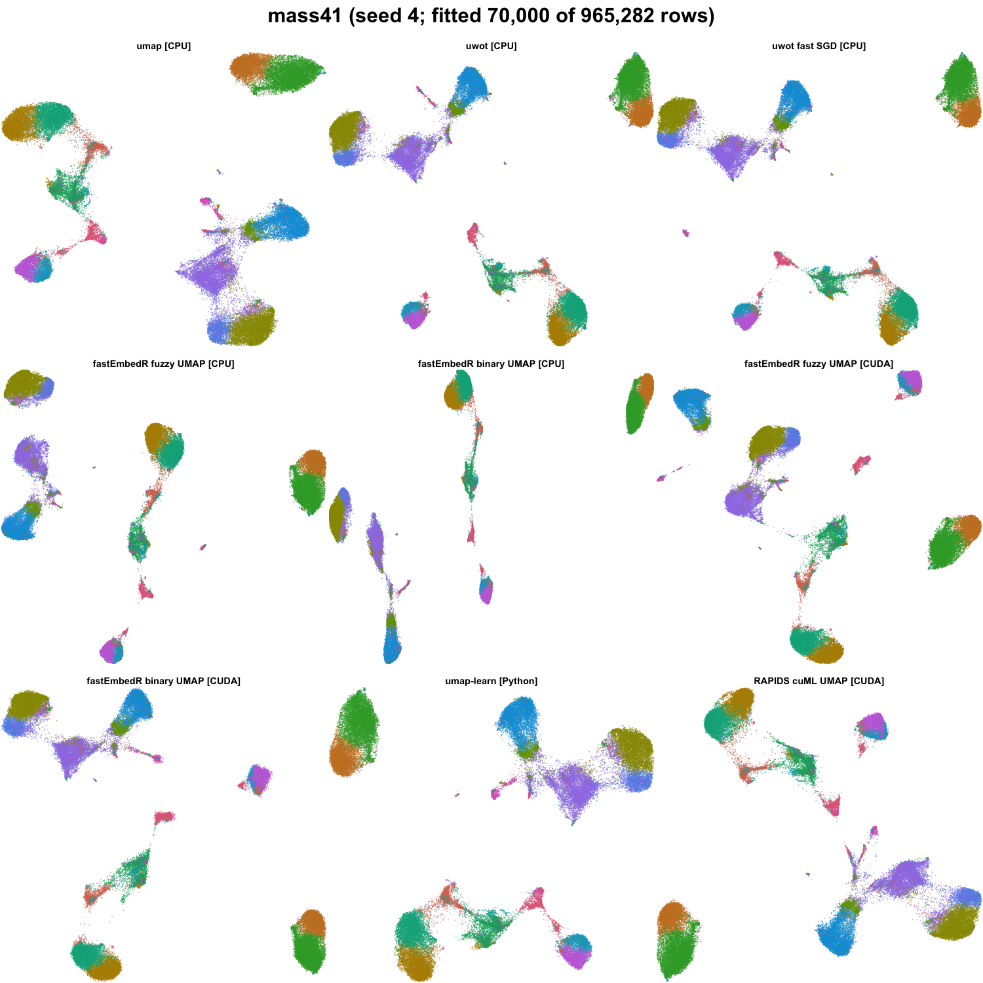
mass41 UMAP outputs for the tested methods (seed 4; fitted 70,000 of 965,282 rows). Colors encode benchmark labels and were not used for fitting.
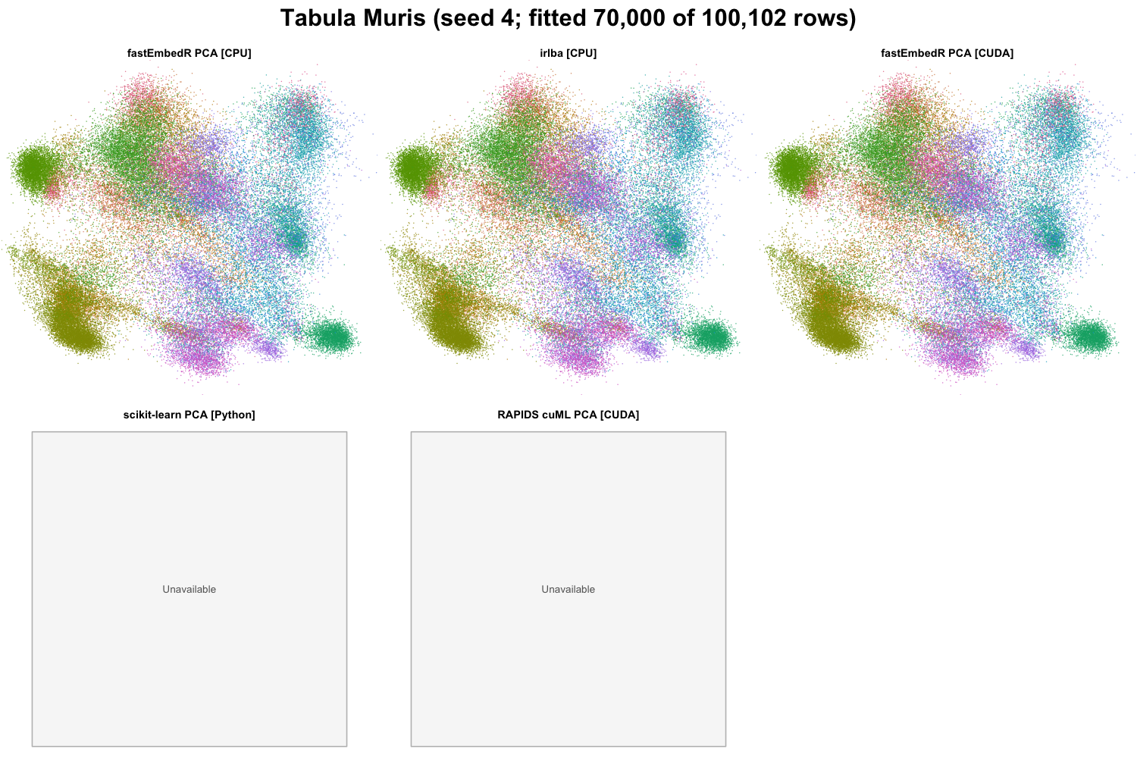
Tabula Muris PCA outputs for the tested methods (seed 4; fitted 70,000 of 100,102 rows). Colors encode benchmark labels and were not used for fitting.
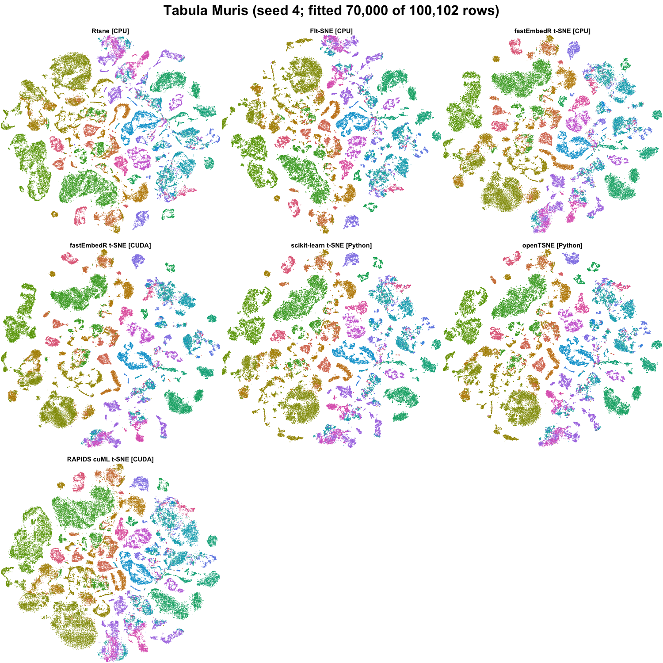
Tabula Muris t-SNE outputs for the tested methods (seed 4; fitted 70,000 of 100,102 rows). Colors encode benchmark labels and were not used for fitting.
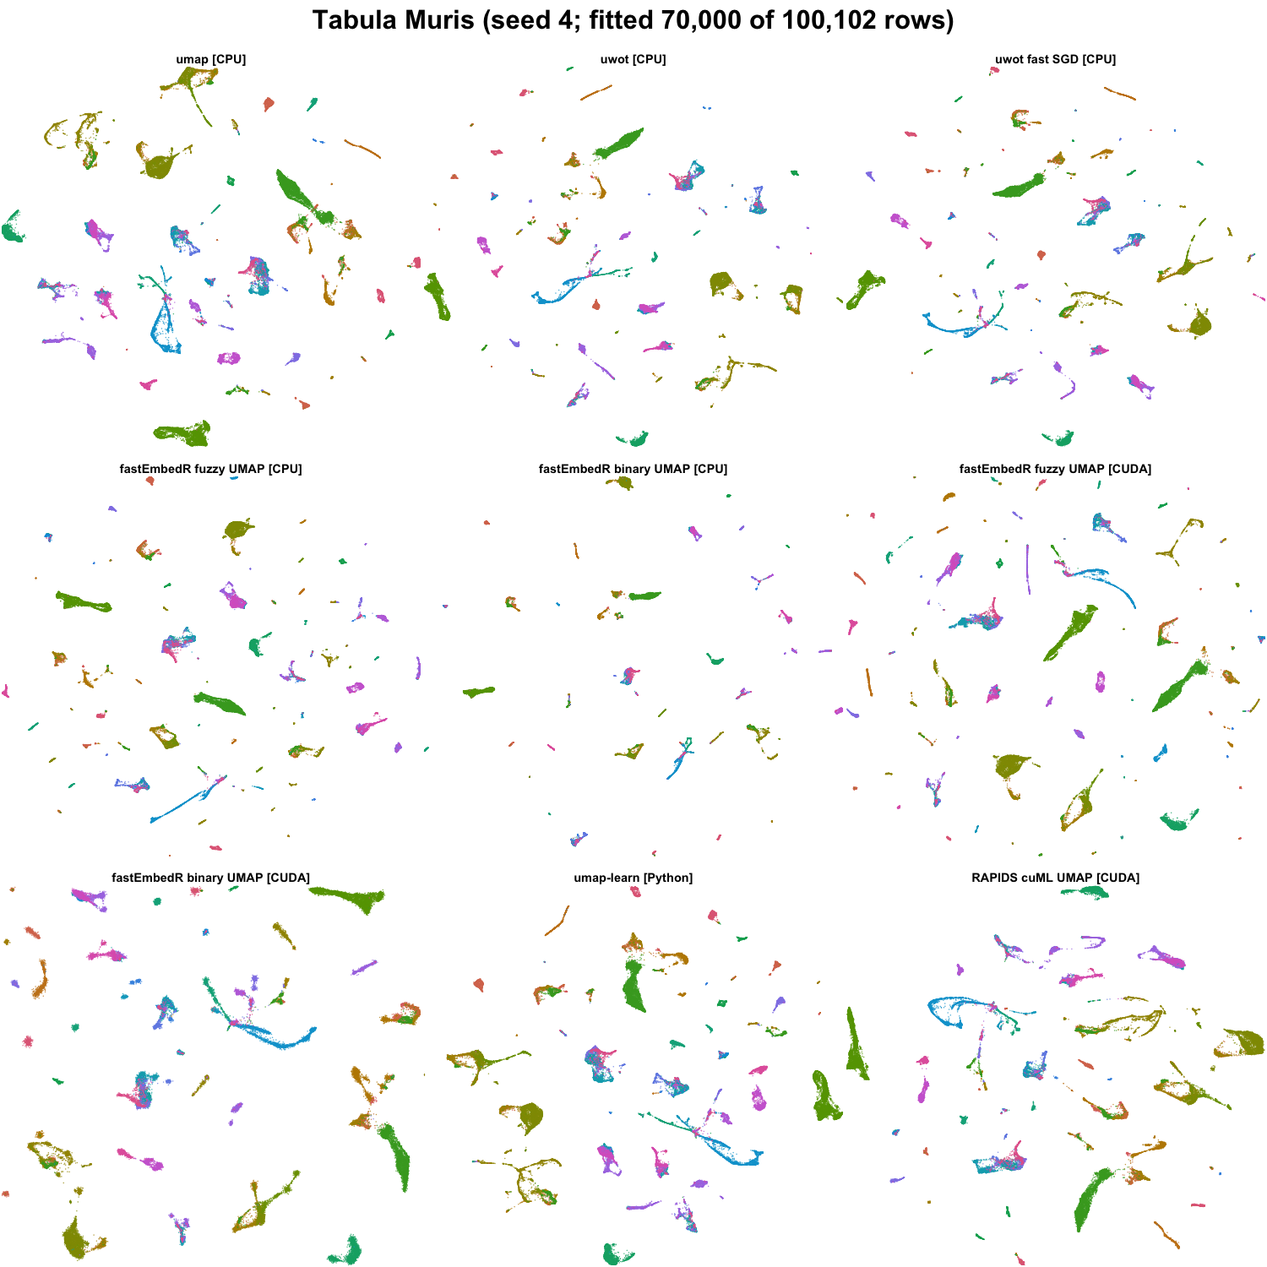
Tabula Muris UMAP outputs for the tested methods (seed 4; fitted 70,000 of 100,102 rows). Colors encode benchmark labels and were not used for fitting.
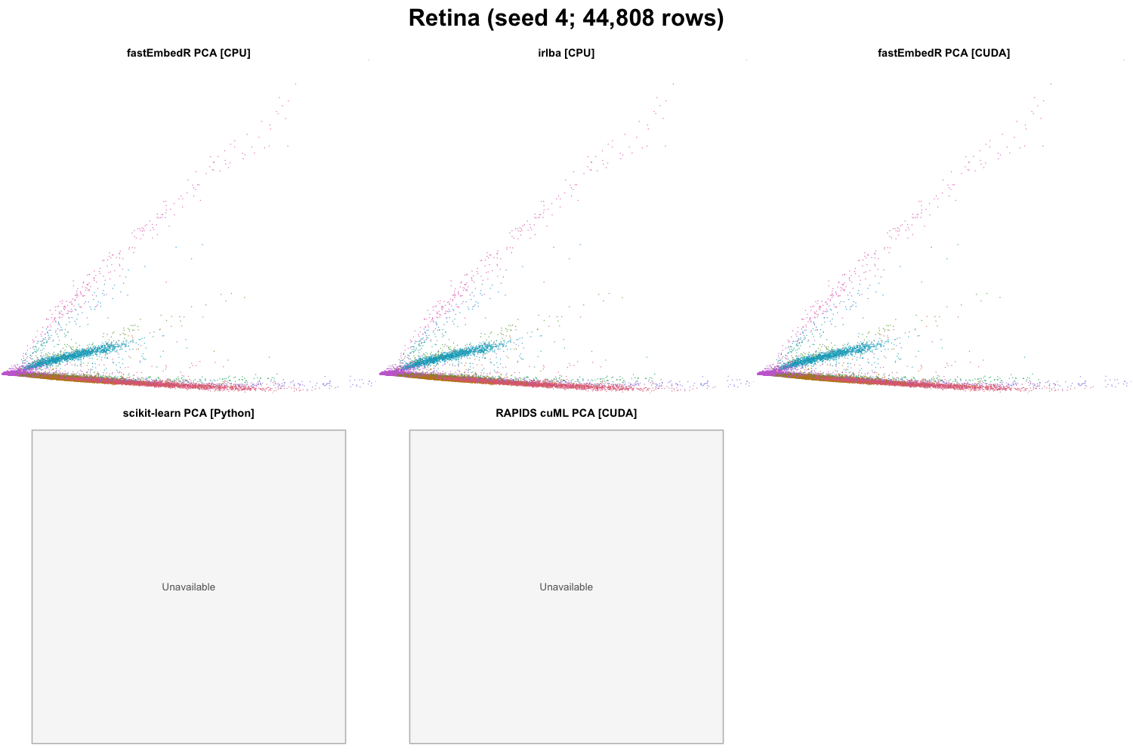
Retina PCA outputs for the tested methods (seed 4; 44,808 rows). Colors encode benchmark labels and were not used for fitting.
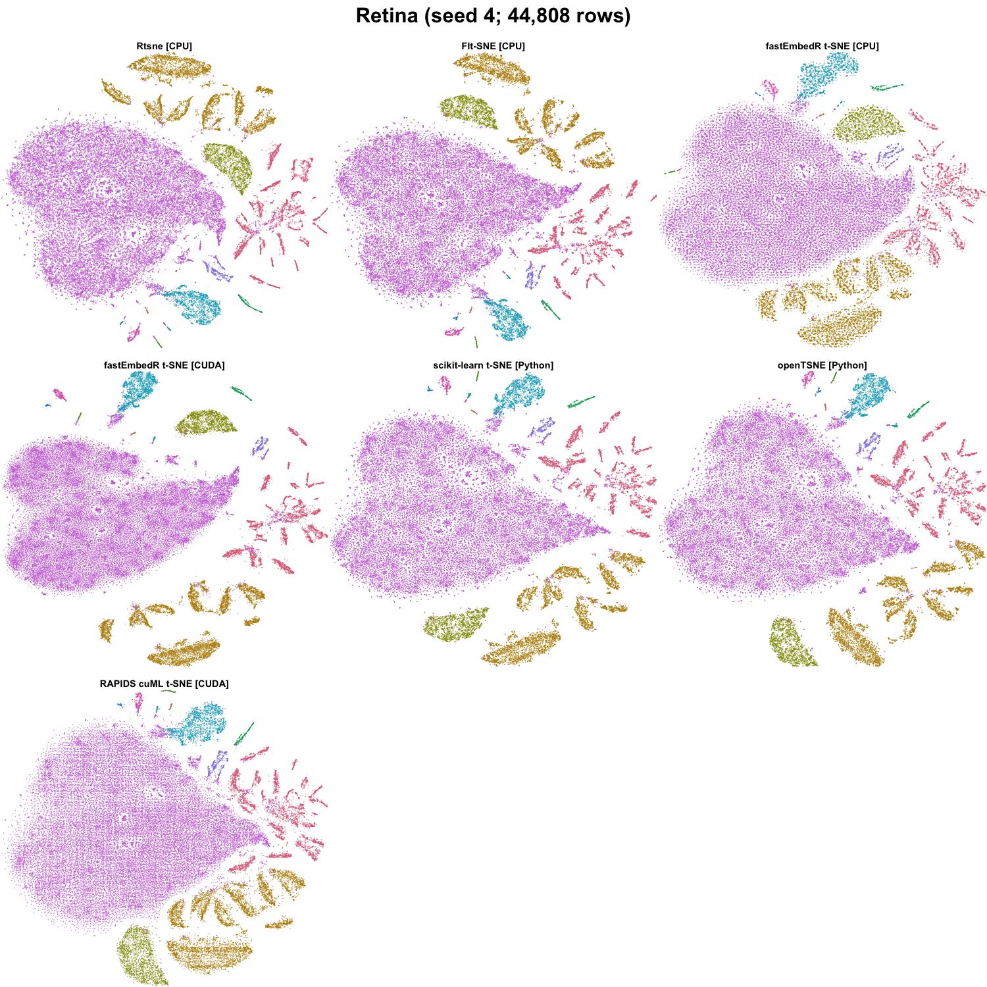
Retina t-SNE outputs for the tested methods (seed 4; 44,808 rows). Colors encode benchmark labels and were not used for fitting.
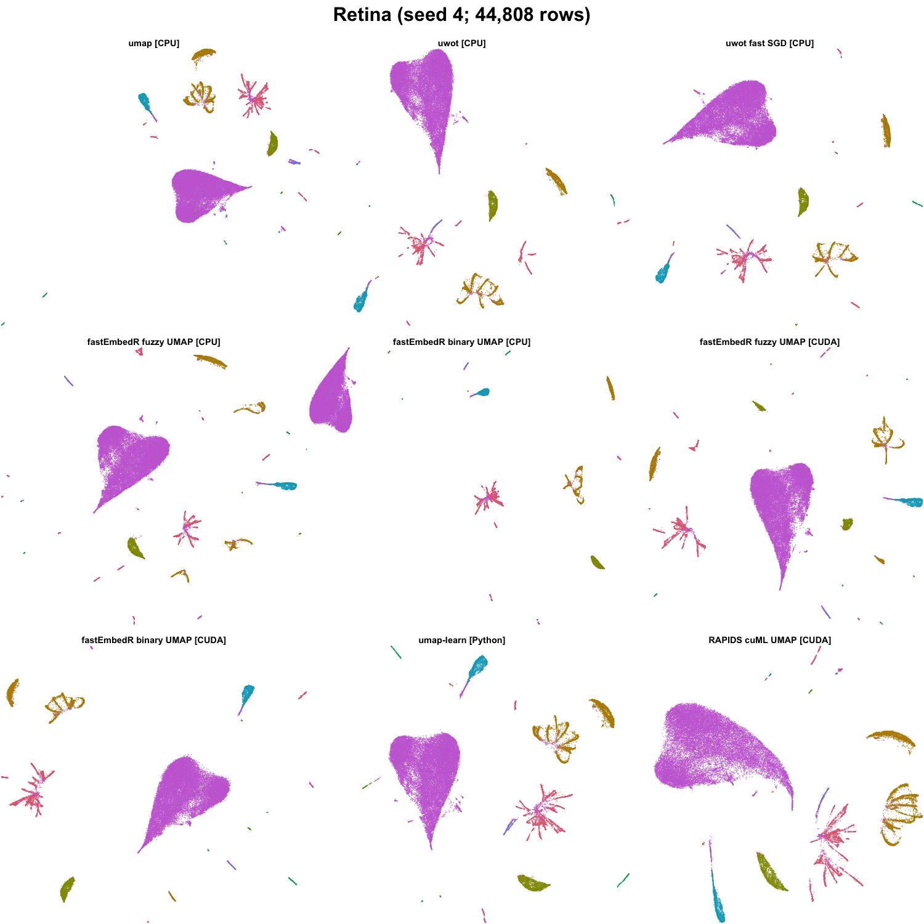
Retina UMAP outputs for the tested methods (seed 4; 44,808 rows). Colors encode benchmark labels and were not used for fitting.

