Supplementary Material: FiberMargin
Moussa Kassim^{1,2} Moussa.Kassim@icgeb.org
Martin Ocharo^{1,2} Martin.Ocharo@icgeb.org
Dalia Ahmed¹ Dalia.Ahmed@icgeb.org
Dupe Ojo¹ dupe.ojo@icgeb.org
Alessia Vignoli^{3,4} vignoli@cerm.unifi.it
Leonardo Tenori^{3,4} tenori@cerm.unifi.it
Dinesh Gupta²⁰ dinesh.gupta@icgeb.org
Silvano Piazza^{21,22} piazza@icgeb.org
Stefano Cacciatore^{1,2} stefano.cacciatore@icgeb.org
¹Bioinformatics Unit, International Centre for Genetic Engineering and Biotechnology (ICGEB), Cape Town 7925, South Africa
²Department of Integrative Biomedical Sciences, Institute of Infectious Disease & Molecular Medicine (IDM), University of Cape Town, Cape Town 7925, South Africa
³Department of Chemistry "Ugo Schiff", University of Florence, Sesto Fiorentino, Italy
⁴Magnetic Resonance Center (CERM), University of Florence, Sesto Fiorentino, Italy
²⁰Translational Bioinformatics Group, International Centre for Genetic Engineering and Biotechnology (ICGEB), New Delhi, India
²¹Computational Biology Group, International Centre for Genetic Engineering and Biotechnology (ICGEB), Trieste, Italy
²²Bioinformatics Facility, Department of Cellular, Computational and Integrative Biology - CIBIO, University of Trento, Trento, Italy

S1 Exact operator specification
This supplement specifies the single production implementation used in the predefined evaluations. The public R function is refine_spatial_labels(xy, labels, samples = NULL, workers = NULL). It accepts two or three coordinates, one observed categorical field, and optional specimen membership. workers is one total native CPU budget and changes execution only; it is not multiplied by the number of specimens.
Every specimen is processed independently, with a local class encoding. The C++ core first chooses the best candidate class from a rival-versus-observed contrast and changes a label only when that contrast clears its candidate-specific barrier. Exact class-evidence ties retain the observed label.
For each specimen, zero-range coordinate axes are removed first. Every remaining axis is mapped from its empirical first and ninety-ninth percentiles to the unit interval and then clipped to $\left[−0.1,1.1\right]$. At least two varying axes must remain. Consequently, constant-$z$ input invokes exactly the 2D operator, whereas genuinely three-dimensional input uses all three coordinates. The multiclass implementation is fixed as follows.
Component | Fixed specification
Path atlas | 9 rotations in 2D; 12 rotations in 3D
Path index | 16-bit Hilbert code after rotation and viewwise unit-box scaling
Reference step | Median positive Euclidean step along a path
Local path gap | Geometric mean of adjacent path steps at an interior location; the available step at an endpoint
Transport action | $h=Δ/r$
Query isolation | $ω=max\{1,q/r\}$; used only in the acceptance barrier
Source evidence | One unit for the observed class at every source location
Transport range | One fixed range, $λ=5$
Path field | $H={\left(\sqrt{L}+\sqrt{R}\right)}^{2}$, normalized over classes within each path
Atlas evidence | Mean rival-versus-observed path contrast
Atlas disagreement | A−1{a​ma−m2}1/2
Class adjustment | $δ_{c}=\sqrt{n_{med}/max\left(n_{c},1\right)}$
Acceptance | A distinct candidate is accepted when its margin is at least its barrier
At an interior path location $i=π_{a}\left(t\right)$, let $q_{ai}=\sqrt{Δ_{a,t−1}Δ_{at}}$; at an endpoint use the available step. The action and isolation are
$$h_{at}=\frac{Δ_{at}}{r_{a}}, ω_{ai}=max\left\{1,\frac{q_{ai}}{r_{a}}\right\}.$$
Define $z_{ajc}=1\{{\tilde{y}}_{j}=c\}$. With $D_{a}^{+}\left(i,j\right)$ and $D_{a}^{−}\left(i,j\right)$ the implemented sums of directed actions, the forward and reverse states are
Laic=j≺ai​e−Da+i,j/5zajc, Raic=j≻ai​e−Da−i,j/5zajc.
The strict path inequalities encode leave-self-out evidence: the observed label at a query is inserted only after its directional state has been read. The two-sided field is
Haic=Laic+Raic2, paic=Haicmax{r​Hair,10−12}.

S1.1 Two-sided amplitude characterization
The square-root exponent is fixed within a deliberately narrow field class. Let $g:[0,∞)→[0,∞)$ with $g\left(0\right)=0$, and suppose a two-sided field is constructed by adding directional amplitudes before squaring:
$$F\left(L,R\right)={\left(g\left(L\right)+g\left(R\right)\right)}^{2}.$$
If the construction must retain one-sided evidence exactly, namely $F\left(L,0\right)=L$ and $F\left(0,R\right)=R$, then necessarily
$$g{\left(u\right)}^{2}=u, g\left(u\right)=\sqrt{u}, F\left(L,R\right)={\left(\sqrt{L}+\sqrt{R}\right)}^{2}.$$
The conclusion follows immediately by setting the other directional state to zero; nonnegativity selects the positive root. Thus the square-root rule is not an arbitrary barrier power within this amplitude-addition construction. This characterization applies to the unnormalized field only. It neither derives nor justifies the separate numerical clipping, per-path normalization, atlas size, rotations, or transport range, which remain fixed implementation choices and are audited separately.
The path contrast is $m_{aic}=p_{aic}−p_{ai,{\tilde{y}}_{i}}$, its atlas mean is mic=A−1a​maic, and the implemented chart-ensemble chart-disagreement scale is
sic=1Aa​maic−mic21/2.
This is the empirical population standard deviation of the deterministic chart contrasts divided by $\sqrt{A}$; it is descriptive and is not interpreted as a calibrated confidence interval.
For observed class count $n_{c}$ and median positive class count $n_{med}$, the acceptance barrier is
$$δ_{c}=\sqrt{\frac{n_{med}}{max\left(n_{c},1\right)}}, B_{ic}=\frac{s_{ic} ω_{i}}{δ_{c}}, ω_{i}={median}_{a}ω_{ai}.$$
Thus transport uses plain geometric path length and unit class evidence. Local isolation protects a query only when its supporting path gaps are larger than typical. Neither term is a probability, confidence score, or learned density model. Returned diagnostics are candidate, margin_score, required, repair_margin, atlas_dispersion, isolation, and changed. The factor also carries per-specimen dimensions_used, labels_changed, changed_fraction, classes_before, classes_after, removed_classes, and sample_sizes, plus the total workers budget. No class-count constraint is applied. A specimen with fewer than two varying axes is rejected because no supported 2D or 3D spatial operator can be constructed.

S1.2 Binary specialization
For two observed classes, a specimen with fewer than 20 locations, or fewer than two observed classes, is retained unchanged. Otherwise the code obtains $k_{d}=min\left(\left|I_{s}\right|−1,2^{d+4}\right)$ nearest other locations and counts their two labels. The strict ballot majority is the candidate; ties retain the observed label. For a distinct candidate, the evidence is its vote count minus the observed vote count and the barrier is one. The binary branch returns isolation = 1 and atlas_dispersion = 0. It is a fixed specialization of the same public candidate-first decision, not a user-selectable second method. Because there is exactly one rival, the signed local count difference exhausts the local candidate comparison; multiclass path normalization is not needed to choose among several rival classes.

S2 Comparator information contract
Every method in the predefined matrices receives coordinates, one observed categorical field, and specimen membership only. No method receives a reference annotation, expression matrix, image, feature vector, confidence map, or trusted seed at repair time.
The primary comparison is Pareto non-domination in the triplet of accuracy, ARI, and correction damage. A method dominates another only if it has at least as high accuracy and ARI and no greater damage, with one strict inequality. This predeclared relation is used to describe operating points rather than to create a post-hoc scalar rank. All other reported scores are retained as diagnostics of the resulting trade-offs.
Method | Fixed benchmark specification
FiberMargin | Multiclass: 9/12 Hilbert charts, range 5, two-sided enclosure; binary: $2^{d+4}$-nearest ballot
Alpha-expansion Potts | 8 neighbours; unary 5; 3 cycles
Coordinate CRF | 16 neighbours; fixed unary and beta; 8 iterations
Harmonic propagation | 24 neighbours; retention 0.20; 12 iterations
Multiscale mode | 6, 14, and 30 neighbours; retention 0.20
Potts ICM | 8 iterations; fixed consensus and preservation
SpaGCN correction | Fixed 6-neighbour post-hoc correction rule
GraphST correction | Fixed 50-neighbour post-hoc correction rule
8-NN modal filter | One-pass 8-neighbour mode
SpaGCN and GraphST are evaluated as fixed post-hoc controls, not as their feature-guided domain-discovery workflows (Hu et al. 2021; Long et al. 2023).
The four configurable controls were calibrated once on 24 non-overlapping 2D/3D development fields. Candidate grids contained 18 alpha-expansion, 27 coordinate-CRF, 18 harmonic, and three multiscale settings. Within each family, the retained setting maximized mean accuracy subject to the same absolute damage cap of 0.05, with ARI breaking ties. The selected settings are exactly those in the table above. The archived calibration summary, all 1,584 case-setting rows, and manifest make the choice auditable; neither FiberMargin’s damage nor any reported evaluation panel defines the cap.

S3 Matched enclosure controls
The enclosure field is the only quantity changed in this audit. All paths, geometric actions, query isolation, class adjustment, and acceptance terms are held fixed. The matched additive control removes only the square-root cross term after the directional recurrences have computed $L$ and $R$:
$$L+R+2\sqrt{LR} \text{versus} L+R.$$
The comparison uses all 60 CRC and 45 MERFISH predefined conditions under the final chart-disagreement admission rule. Repeated corruptions from a common reference annotation are descriptive units, not independent biological specimens. Table S1 records the source-matched retrospective mechanism comparison.
Dataset | Units | Square-root Acc. | Additive Acc. | Square-root ARI | Additive ARI | Square-root damage | Additive damage
CRC | 60 | 0.85890 | 0.85881 | 0.78062 | 0.78054 | 0.04777 | 0.04808
MERFISH | 45 | 0.89053 | 0.88925 | 0.80044 | 0.79873 | 0.03670 | 0.03784
Table S1. Source-matched mechanism comparison of the two-sided enclosure field. Higher is better except for damage. The additive field is near-tied on CRC but has lower primary scores and higher damage on both panels. The complete mechanism and evaluation ledgers record every fixed field replacement and secondary outcome. Both panels are multiclass; the binary specialization is not evaluated.

S4 Fixed atlas-and-range sensitivity audit
A development audit changes one geometric constant at a time while retaining the two-sided field and admission rule. It compares nested 7/9, 9/12, 11/15, and 13/18 path atlases at range 5, a longer range, and a dimension-dependent range. The panel contains 50 predefined real-coordinate corruptions and six geometry-diverse simulations. The 9/12 atlas is the smallest expansion that improves the real-panel accuracy and ARI averages. The 11/15 and 13/18 atlases improve those averages further, but progressively increase damage; on the 20-case CRC development subset they also reduce sparse-region accuracy by 0.0263 and 0.0378 relative to 7/9. Because the 50 real-coordinate fields are subsets of the final study panels, this is a configuration audit rather than an independently held-out comparison.
The 9/12 atlas was then confirmed on all 150 real-coordinate fields, 708 complete simulations, and 108 unseen geometries. It improves accuracy and ARI on every real-coordinate dataset and both broad simulation ledgers. The released setting therefore uses 9/12 paths with range 5. This is a fixed cross-panel operating point, not a theorem-determined optimum.
Panel or dataset | 9/12 accuracy change | 9/12 ARI change | 9/12 damage change
Development real panel, 50 fields | +0.00085 | +0.00154 | +0.00136
DLPFC confirmation, 45 fields | +0.00199 | +0.00294 | +0.00011
CRC confirmation, 60 fields | +0.00015 | +0.00035 | +0.00205
MERFISH confirmation, 45 fields | +0.00061 | +0.00156 | +0.00141
Complete simulation, 708 fields | +0.00095 | +0.00193 | +0.00106
Unseen geometry, 108 fields | +0.00161 | +0.00262 | +0.00063
Table S1A. Source-matched 9/12-atlas changes relative to the 7/9 atlas. Positive accuracy and ARI changes are improvements; positive damage is worse. The full case-level ledgers also report boundary, sparse-region, worst-class, and correction outcomes. This is an audit of the multiclass enclosure atlas; the binary specialization has no path atlas.
The remaining internal quantities have distinct roles. The 16-bit Hilbert code is a numerical representation rather than a fitted statistical parameter: after unit-box scaling, one quantization cell has coordinate width at most $1/\left(2^{16}−1\right)$. Rotations are generated deterministically by the low-discrepancy irrational schedules in the source. The barrier has no fitted multiplier: its units are the chart contrast dispersion times the local-gap factor, divided by the square-root class-amplitude adjustment. Robust 1st–99th percentile normalization, the chart count, and the central range remain pragmatic fixed defaults, with their complete fixed-configuration sensitivity records included here.

S4.1 Chart-interior and limitation-map audit
This independent 48-field audit asks whether the explicit local premise of Theorem S2 is informative in irregular spatial fields and where released FiberMargin gains or loses against its direct controls. It is not a source selection study. The saved panel contains 24 two-dimensional and 24 three-dimensional five-class fields. The 2D fields use tubular-network or braided-channel geometry, uniform or extreme sampling, random, boundary, or patch corruption, and 10% or 30% corruption. The 3D fields use folded layers or branching tubes, uniform or class-imbalanced sampling, random, boundary, or regional corruption, and the same rates. Each 2D field has 3,000 locations and each 3D field 4,000; the 48 seeds, inputs, and design table are saved in the result archive.
A benchmark-only C++ diagnostic reproduces the released robust normalization, rotations, 16-bit Hilbert code, tie order, and 9/12-path atlas. After repair, it uses the reference field only to count consecutive same-reference-class locations immediately on both sides of each query in every chart. The all-chart run length is the minimum of these two-sided runs. Consequently, the exact $q$-chart-interior condition in Theorem S2 holds if and only if that recorded length is at least $q$. No diagnostic quantity enters repair. Table S1B gives the resulting reference-based strata.
$q$ | All-chart prevalence | Accuracy, inside/outside | Correction recall, inside/outside | Damage, inside/outside
1 | 0.5240 | 0.9390 / 0.7992 | 0.5481 / 0.4358 | 0.00078 / 0.06050
2 | 0.4057 | 0.9450 / 0.8223 | 0.6000 / 0.4483 | 0.00044 / 0.04854
3 | 0.3366 | 0.9475 / 0.8335 | 0.5917 / 0.4542 | 0.00044 / 0.04348
4 | 0.2889 | 0.9502 / 0.8398 | 0.6127 / 0.4574 | 0.00035 / 0.04059
Table S1B. Exact reference-based chart-interior strata in the fresh 48-field audit. Values are means over saved fields. The condition has no repair-time use. Locations deeper in all released paths have higher conditional recovery and much lower conditional damage, an empirical association coherent with the theorem’s local premise. It is not a verification of its independent-noise assumptions, which do not describe the structured corruption mechanisms in this panel. All fields are multiclass and use the enclosure mechanism.
The same fields compare released FiberMargin with alpha-expansion Potts, coordinate CRF, self-anchored harmonic propagation, and multiscale mode. All five methods receive the same coordinates and observed categorical field. A positive difference favors FiberMargin except for damage, where a negative value is preferable. Table S1C summarizes the paired method comparisons.
Direct control | Accuracy difference | ARI difference | Correction recall difference | Damage difference | Accuracy win fraction
Alpha-expansion Potts | +0.00606 | +0.01140 | +0.07634 | +0.01190 | 0.604
Coordinate CRF | +0.04587 | +0.07206 | +0.28655 | +0.02470 | 0.750
Harmonic propagation | +0.01525 | +0.05078 | +0.05260 | -0.00181 | 0.792
Multiscale mode | +0.00772 | +0.00974 | +0.04237 | +0.00397 | 0.604
Table S1C. Paired mean FiberMargin-minus-control outcomes on the fresh 48-field audit. The win fraction is the fraction of fields with higher FiberMargin accuracy. The CRF comparison illustrates an operating-point tradeoff: FiberMargin gains accuracy and correction recall while causing more damage. All FiberMargin results use the multiclass enclosure mechanism.
Against the post-hoc best of the four direct controls, FiberMargin leads in 18/48 fields (37.5%), with mean accuracy difference $−0.00362$. The factor map therefore reports a limitation as well as positive regimes: the mean difference is $−0.01308$ for 10% 2D patch corruption and +0.00950 for 30% 3D random corruption. The observed agreement and local-density descriptors are recorded for every field, but no threshold, learned selector, pre-repair applicability score, or new package input is introduced.

S4.2 Geometric bridge audit
The same predefined fields support a second benchmark-only diagnostic for Lemma 1. For each query and $q∈\{1,2\}$, it reconstructs the released robust normalization, rotations, code values, stable tie ordering, and chart spans. It then computes the finite Hilbert-block radius $ρ_{iq}$ from the proof and the exact maximum Euclidean distance to every required atlas witness. Reference labels are read only after the released repair call to measure nearest different-class separation. Neither quantity is returned by the package or used to choose a method.
$q$ | Exact interior | Code-gap certificate | Precision | Interior coverage | Direct-witness certificate | Finite queries | Max direct/bound
1 | 0.5518 | 0.0881 | 1.0000 | 0.1421 | 0.4425 | 167254 | 0.8557
2 | 0.4307 | 0.0406 | 1.0000 | 0.0804 | 0.3219 | 166524 | 0.8576
Table S1D. Deterministic Euclidean-to-chart bridge audit. The code-gap certificate requires reference separation greater than the conservative radius in Lemma 1. Precision is the fraction of certificate locations satisfying the exact all-chart predicate; coverage is the fraction of exact interiors carrying the certificate. Max direct/bound is the mean across fields of the within-field maximum exact witness-radius divided by its finite Hilbert-block bound. Every finite bound contains every required witness and every certificate is an exact interior. The certificate is intentionally conservative: it proves a usable sufficient condition, not a complete characterization of chart interior. This audit concerns the multiclass enclosure mechanism, which constructs the chart atlas.
Within the $q=1$ certificate, correction recall is 0.6734 and damage is 0.00042, compared with 0.4550 and 0.03017 outside it. At $q=2$, the corresponding values are 0.7274 and zero, compared with 0.4575 and 0.02883 outside. These reference-only strata show that the geometric sufficient condition is non-vacuous, but they are not a method-selection result.

S5 Fixed-component audit
Each row below removes one protective term, or doubles the chart-disagreement barrier, while holding the path atlas, range, and stored inputs fixed. Deltas are relative to FiberMargin; positive damage is worse. The final operator is a cross-panel compromise: removing class adjustment, query isolation, or the default chart-disagreement admission rule can improve a primary score in one panel, but each removal either damages CRC accuracy or weakens sparse-region protection while raising damage.
Dataset | Operator change | Accuracy change | ARI change | Sparse accuracy change | Damage change
CRC | Class adjustment | -0.0059 | -0.0086 | -0.0712 | +0.0222
CRC | Query isolation | -0.0010 | -0.0009 | -0.0274 | +0.0050
CRC | Doubled admission barrier | +0.0008 | +0.0002 | +0.1269 | -0.0201
MERFISH | Class adjustment | +0.0012 | +0.0014 | -0.0011 | +0.0017
MERFISH | Query isolation | -0.0003 | -0.0004 | -0.0029 | +0.0026
MERFISH | Doubled admission barrier | -0.0029 | -0.0074 | +0.0102 | -0.0130
Table S2. Component ablations across predefined real-coordinate corruptions. The complete case-level ledger records all secondary outcomes and the literal operator changes. Table S2 makes the cross-panel trade-off explicit. CRC and MERFISH are multiclass and therefore use the enclosure mechanism.

S6 Fixed atlas-size audit
The production atlas uses nine 2D and twelve 3D paths. The following audit recompiles only those constants while leaving the field, barrier, stored inputs, and score code unchanged. The 1/1 variant is a simple reference-path control: it retains one Hilbert traversal, two-sided transport, and the same acceptance rule, but removes chart ensembling. Timings are therefore comparable within this literal source-variant harness, but not with times measured by a different benchmark driver. Because it uses the same panels as the reported matrix, it is a sensitivity analysis rather than independent selection evidence. The 9/12 setting is the released operating point: one path has much poorer primary and damage outcomes, 7/9 is close but lower in accuracy and ARI, and the 5/6 atlas trades lower runtime for lower primary scores.
Table S3 reports the fixed atlas-size audit.
Dataset | Atlas | Accuracy | ARI | Damage
CRC | 1/1 path | 0.8242 | 0.7297 | 0.11684
CRC | 9/12 paths | 0.8589 | 0.7806 | 0.04777
CRC | 7/9 paths | 0.8587 | 0.7803 | 0.04573
CRC | 5/6 paths | 0.8582 | 0.7793 | 0.04387
MERFISH | 1/1 path | 0.8517 | 0.7315 | 0.09521
MERFISH | 9/12 paths | 0.8905 | 0.8004 | 0.03670
MERFISH | 7/9 paths | 0.8899 | 0.7989 | 0.03530
MERFISH | 5/6 paths | 0.8872 | 0.7939 | 0.03559
Table S3. Fixed atlas-size audit on the same 60 CRC and 45 MERFISH corruptions per literal variant. The 1/1 row is the simple one-Hilbert-path control. Accuracy and ARI are higher-is-better; damage is lower-is-better. Runtime is reported in the common-harness timing table rather than this parallel source-variant audit. This audit concerns only the multiclass enclosure mechanism; the binary specialization has no atlas-size setting.

S7 Binary interior recovery guarantee
This proof concerns the implemented binary ballot. Work in the robustly normalized coordinate domain. Fix a query $i$ in a specimen of size $m$ whose reference label is $t$, and suppose a Euclidean ball $B\left(x_{i},r\right)$ lies inside the true-$t$ region. If conditional coordinate density in the ball is at least $f_{min}$, let $v_{d}$ be the unit $d$-ball volume, $k=min\left(m−1,2^{d+4}\right)$, and
$$μ=\left(m−1\right)f_{min}v_{d}r^{d}≥2k.$$
Assume conditional independent locations and independent flips of true-$t$ neighbour labels with probability at most $p<1/2$.
Theorem S1 (binary interior recovery). Under these conditions, the binary branch returns $t$ at $i$ with probability at least
$$1−e^{−μ/8}−e^{−2k{\left(1/2−p\right)}^{2}}.$$
Proof. Let $Z$ count the other locations in the ball. Since $EZ≥μ$, a multiplicative Chernoff bound gives $Pr\left(Z<k\right)≤e^{−μ/8}$. On $Z≥k$, all $k$ nearest neighbours lie in the ball and have reference class $t$. Let $W$ count their observed $t$ labels. Hoeffding’s inequality gives $Pr\left(W≤k/2\right)≤e^{−2k{\left(1/2−p\right)}^{2}}$. Outside those events, $t$ has a strict ballot majority. If $i$ already has label $t$, it is retained; otherwise its positive integer vote margin clears the implemented unit barrier. A union bound proves (S7). $▫$
The result is local to a true-region interior. It makes no claim at a boundary, in a density void, or after a class has disappeared from the observed field.

S8 Euclidean-to-chart bridge
The multiclass theorem requires same-reference-class witnesses immediately on both sides of every released path. This section gives a deterministic geometric sufficient condition for that witness event. It uses the same robustly normalized coordinate system as the production implementation, not raw measurement units.
Fix a chart $a$ and write $u_{ai}$ for its rotated, viewwise unit-box-scaled coordinate of query $i$. Let $c_{a1}≤⋯≤c_{am}$ be the 16-bit Hilbert codes in the implementation’s stable sort order, and let $p_{a}\left(i\right)$ be the position of $i$. Let $s_{a}$ be the largest coordinate span before this viewwise rescaling. For a requested run length $q$ with sources on both sides, define
$$g_{aiq}=max\{c_{a,p_{a}\left(i\right)}−c_{a,p_{a}\left(i\right)−q},c_{a,p_{a}\left(i\right)+q}−c_{a,p_{a}\left(i\right)}\}, r_{aiq}=min\{r≥0:2^{dr}≥g_{aiq}+1\},$$
and
$$ρ_{iq}=\max_{a}\left\{s_{a}\sqrt{d+3} \frac{2^{r_{aiq}}}{2^{16}−1}\right\}.$$
If a path lacks $q$ sources in either direction, set $ρ_{iq}=∞$. The code-gap radius depends only on coordinates, chart geometry, and stable input order; it has no reference-label or repair-time role.
Lemma S2A (Euclidean-to-chart bridge). Let the true region for class $t$ contain $B\left(x_{i},ρ_{iq}\right)$ in the robust coordinate system. Then the first $q$ released path sources in each direction of every chart have reference class $t$. Hence $i$ is $q$-chart-interior.
Proof. The finite 16-bit code is the standard recursive Hilbert traversal implemented through the Skilling transform (Skilling 2004). A consecutive code interval of $g_{aiq}+1≤2^{dr_{aiq}}$ cells intersects at most two aligned level-$r_{aiq}$ Hilbert blocks. Consecutive blocks in that traversal share a face. Each block has side at most $2^{r_{aiq}}/\left(2^{16}−1\right)$ in unit-chart coordinates. The union of two face-adjacent $d$-cubes of side $h$ has Euclidean diameter $h\sqrt{d+3}$. Thus every one of the $2q$ required sources in chart $a$ lies within
$$s_{a}\sqrt{d+3} \frac{2^{r_{aiq}}}{2^{16}−1}$$
of $x_{i}$: the inverse rotation preserves Euclidean norm and the inverse coordinate-wise rescaling has operator norm at most $s_{a}$. Taking the maximum over charts gives $ρ_{iq}$. The assumed ball containment therefore gives reference class $t$ to every required source, exactly the chart-interior predicate. $▫$
The lemma removes no other multiclass assumption. In particular, action bounds, independent source-label noise, class balance, and the acceptance inequality remain necessary for Theorem S2. It is a geometric bridge to the witness event, not a claim that a Euclidean ball makes the complete recovery theorem hold.

S9 Multiclass chart-interior recovery guarantee
This result concerns the implemented multiclass recurrence. Work within one specimen and fix a query $i$ with reference class $t$. In chart $a$, enumerate the source locations before and after the query as $j_{aℓ}^{−}$ and $j_{aℓ}^{+}$, with $ℓ=1,2,…$, and write $D_{aℓ}^{−}$ and $D_{aℓ}^{+}$ for their exact accumulated implemented path actions. The query is $q$-chart-interior if
$$y_{j_{aℓ}^{−}}^{*}=y_{j_{aℓ}^{+}}^{*}=t \left(a=1,…,A; ℓ=1,…,q\right).$$
This is an explicit region-and-boundary condition. It requires $q$ sampled same-class witnesses on both sides of every chart, rather than an assumption on the candidate returned by FiberMargin. Assume that, for constants $0<a≤b$, all source actions obey $D_{aℓ}^{±}≥ℓa$, while the chart-interior sources obey $D_{aℓ}^{±}≤ℓb$. The first condition controls the total remote mass; the second is a local sampling-density condition. Conditional on the reference field, assume the observed source labels are independent and, for every chart-interior source and rival $c≠t$,
$$Pr\left(\tilde{y}=t\right)≥1−p, Pr\left(\tilde{y}=c\right)≤p, 0≤p<1/2.$$
Let $λ$ be the fixed central range used by the implementation and define
$$W_{q}\left(b\right)=\sum_{ℓ=1}^{q}{e^{−ℓb/λ}}, V_{q}\left(a\right)=\sum_{ℓ=1}^{q}{e^{−2ℓa/λ}}.$$
$$T_{q}\left(a\right)=\sum_{ℓ=q+1}^{∞}{e^{−ℓa/λ}}, U\left(a\right)=\sum_{ℓ=1}^{∞}{e^{−ℓa/λ}}.$$
$$γ=\left(1−2p\right)W_{q}\left(b\right)−ϵ−T_{q}\left(a\right), Q\left(a\right)=max\{4U\left(a\right),{10}^{−12}\}, m_{0}=4γ/Q\left(a\right).$$
Here $W_{q}$ is guaranteed same-class support, $T_{q}$ is the worst-case remote rival mass, and $U$ bounds either complete directional state. Let $ω_{i}≤Ω$ be the implemented local-gap factor at $i$ and suppose the observed class adjustment of the true candidate obeys $δ_{t}≥δ_{0}>0$. The deterministic acceptance condition is
$$γ>0, m_{0}≥\frac{Ω\left(1−m_{0}\right)}{2δ_{0}\sqrt{A}}.$$
Theorem S2 (multiclass chart-interior recovery). Under (S8)–(S11), the implemented multiclass branch returns $t$ at $i$ with probability at least
$$1−2A\left(C−1\right)exp\left\{−\frac{ϵ^{2}}{2V_{q}\left(a\right)}\right\}.$$
The statement covers both retention of an observed $t$ and correction when the observed query class differs from $t$.
Proof. Fix one chart, one direction, and one rival $c≠t$. For the first $q$ sources, let $w_{ℓ}=e^{−D_{aℓ}^{±}/λ}$ and $Z_{ℓ}=1\{{\tilde{y}}_{j_{aℓ}^{±}}=t\}−1\{{\tilde{y}}_{j_{aℓ}^{±}}=c\}$. By (S8)–(S9), $EZ_{ℓ}≥1−2p$; by the action bounds, $\sum_{ℓ=1}^{q}{w_{ℓ}}≥W_{q}\left(b\right)$ and $\sum_{ℓ=1}^{q}{w_{ℓ}^{2}}≤V_{q}\left(a\right)$. Weighted Hoeffding therefore gives
$$Pr\left\{\sum_{ℓ=1}^{q}{w_{ℓ}}Z_{ℓ}<\left(1−2p\right)W_{q}\left(b\right)−ϵ\right\}≤exp\left\{−\frac{ϵ^{2}}{2V_{q}\left(a\right)}\right\}.$$
The contribution of all remaining sources to the true-minus-rival directional state is at least $−T_{q}\left(a\right)$. Hence outside the event in (S13), each directional state satisfies $L_{t}−L_{c}≥γ$ and $R_{t}−R_{c}≥γ$. Because
$$\sqrt{\left(u+γ\right)\left(v+γ\right)}≥\sqrt{uv}+γ \left(u,v,γ≥0\right),$$
the exact implemented enclosure field obeys $H_{t}−H_{c}≥4γ$. Also $H_{c}≤2\left(L_{c}+R_{c}\right)$ and each directional total is at most $U\left(a\right)$, so its normalizer is at most $Q\left(a\right)$. Thus every chart has $p_{t}−p_{c}≥4γ/Q\left(a\right)=m_{0}$. A union bound over two directions, $A$ charts, and $C−1$ rivals gives (S12).
If the observed query class is $t$, it is already the unique candidate and is retained. Otherwise, every chart contrast for candidate $t$ lies in $\left[m_{0},1\right]$. Popoviciu’s variance bound and the exact definition in Equation (7) give $s_{it}≤\left(1−m_{0}\right)/\left(2\sqrt{A}\right)$. Therefore the implemented barrier satisfies
$$B_{it}=\frac{ω_{i}s_{it}}{δ_{t}}≤\frac{Ω\left(1−m_{0}\right)}{2δ_{0}\sqrt{A}}≤m_{0}≤E_{it}.$$
The candidate-first rule in Equation (D) consequently returns $t$. $▫$
The theorem is deliberately local. Chart interior is a testable path-level form of boundary distance and sampling density; it is not claimed to follow automatically from Hilbert ordering on every geometry.

S10 Multiclass enclosure stability
This result concerns two complete observed fields on fixed coordinates and specimen membership. It is a finite-input stability statement, not a consistency result or a latent-label generative model. Let the two fields agree at query $i$, and let $S$ be their changed locations.
For each chart and class, write $ε_{aic}^{+}=\left|L′_{aic}−L_{aic}\right|$ and $ε_{aic}^{−}=\left|R′_{aic}−R_{aic}\right|$. With $M_{aic}$ the maximum of the four directional states, the square-root inequality gives
$$κ_{aic}=ε_{aic}^{+}+ε_{aic}^{−}+2\sqrt{M_{aic}}\left(\sqrt{ε_{aic}^{+}}+\sqrt{ε_{aic}^{−}}\right),$$
and $\left|H′_{aic}−H_{aic}\right|≤κ_{aic}$. The directional differences are bounded directly by the affected sources, for example
εaic+≤j≺aij∈S​e−Da+i,j/5z′ajc−zajc,
with the symmetric reverse bound. Let Tai=max{c​Haic,10−12}, $τ_{ai}=min\left(T_{ai},T′_{ai}\right)$, and $κ_{ai}=\max_{c}κ_{aic}$. Since $\left|T′_{ai}−T_{ai}\right|≤Cκ_{ai}$,
$$\left|p′_{aic}−p_{aic}\right|≤\frac{\left(C+1\right)κ_{ai}}{τ_{ai}}.$$
Consequently, with
$$ρ_{i}=\frac{1}{A}\sum_{a=1}^{A}{\frac{2\left(C+1\right)κ_{ai}}{τ_{ai}}},$$
we have $\max_{c}\left|m′_{ic}−m_{ic}\right|≤ρ_{i}$. The chart dispersion is $s_{ic}=∥P{\left(m_{aic}\right)}_{a=1}^{A}∥_{2}/A$, so the reverse triangle inequality gives
$$\left|s′_{ic}−s_{ic}\right|≤\frac{1}{A}{∥{\left(m′_{aic}−m_{aic}\right)}_{a=1}^{A}∥}_{2}.$$
The isolation $ω_{i}$ is coordinate-derived and unchanged under this comparison. The exact barrier is $B_{ic}=ω_{i}s_{ic}/δ_{c}$, hence
$$\left|B′_{ic}−B_{ic}\right|≤ω_{i}\left[\frac{\left|s′_{ic}−s_{ic}\right|}{δ_{c}}+s′_{ic}\left|\frac{1}{δ′_{c}}−\frac{1}{δ_{c}}\right|\right].$$
Theorem S3 (finite-input enclosure stability). If the unperturbed best candidate has a margin gap greater than $2ρ_{i}$, it is unchanged. If its candidate-versus-barrier clearance exceeds $ρ_{i}+ζ_{i}$, where $ζ_{i}=\max_{c}\left|B′_{ic}−B_{ic}\right|$, the retain/change decision is unchanged.
Proof. Equation (S17) bounds each directional state; (S16) bounds the enclosure field; and (S18) bounds its normalized class fraction. The two contrasts in a rival-versus-observed difference give (S19). Equation (S20) and the exact barrier form give (S21). A margin gap larger than $2ρ_{i}$ preserves the candidate, while a clearance larger than $ρ_{i}+ζ_{i}$ preserves the sign of its acceptance difference. $▫$

S11 Predefined real-coordinate evaluation
DLPFC uses 45 interface-band corruptions across 12 Visium sections from three donors, with 47,329 spots and seven cortical-layer labels. CRC uses five error rates (5%, 10%, 15%, 25%, and 40%), four mechanisms (random, boundary, patch, and regional), and three deterministic replicates, for 60 fields over 194,541 locations. MERFISH uses 45 fixed corruptions across five consecutive hypothalamic planes. Boundary locations have a different reference class among their eight nearest within-specimen neighbours; sparse locations are the least prevalent reference class in an evaluation unit.
Table S4 contains the complete native operating-point matrix on the same stored fields. Accuracy and ARI are primary; correction recall and damage describe the edit trade-off. Common-harness timing is reported separately in Table S8 rather than mixing fresh and retained timing runs.
Dataset | Method | Accuracy | ARI | Correction recall | Damage
DLPFC | Initial | 0.8100 | 0.6956 | 0.0000 | 0.0000
DLPFC | FiberMargin | 0.8942 | 0.8220 | 0.6387 | 0.0386
DLPFC | Alpha-expansion Potts | 0.8709 | 0.7913 | 0.4100 | 0.0099
DLPFC | Coordinate CRF | 0.8272 | 0.7259 | 0.1529 | 0.0001
DLPFC | Harmonic propagation | 0.8689 | 0.7894 | 0.3960 | 0.0049
DLPFC | Multiscale mode | 0.8785 | 0.8029 | 0.4942 | 0.0155
DLPFC | Potts ICM | 0.8842 | 0.8112 | 0.5067 | 0.0164
DLPFC | SpaGCN correction | 0.8569 | 0.7696 | 0.3702 | 0.0126
DLPFC | GraphST correction | 0.8846 | 0.8058 | 0.7316 | 0.0742
DLPFC | 8-NN modal filter | 0.8566 | 0.7650 | 0.6661 | 0.0909
CRC | Initial | 0.8100 | 0.7085 | 0.0000 | 0.0000
CRC | FiberMargin | 0.8589 | 0.7806 | 0.4444 | 0.0478
CRC | Alpha-expansion Potts | 0.8600 | 0.7815 | 0.4049 | 0.0381
CRC | Coordinate CRF | 0.8100 | 0.7085 | 0.0000 | 0.0000
CRC | Harmonic propagation | 0.8497 | 0.7682 | 0.3442 | 0.0324
CRC | Multiscale mode | 0.8604 | 0.7827 | 0.4105 | 0.0336
CRC | Potts ICM | 0.8503 | 0.7690 | 0.4097 | 0.0434
CRC | SpaGCN correction | 0.8490 | 0.7661 | 0.3113 | 0.0175
CRC | GraphST correction | 0.8081 | 0.7141 | 0.5412 | 0.1321
CRC | 8-NN modal filter | 0.8532 | 0.7707 | 0.5895 | 0.0860
MERFISH | Initial | 0.8100 | 0.6502 | 0.0000 | 0.0000
MERFISH | FiberMargin | 0.8905 | 0.8004 | 0.6172 | 0.0367
MERFISH | Alpha-expansion Potts | 0.8843 | 0.7888 | 0.5093 | 0.0188
MERFISH | Coordinate CRF | 0.8263 | 0.6837 | 0.1542 | 0.0002
MERFISH | Harmonic propagation | 0.8817 | 0.7842 | 0.4698 | 0.0105
MERFISH | Multiscale mode | 0.8823 | 0.7856 | 0.5355 | 0.0223
MERFISH | Potts ICM | 0.8742 | 0.7712 | 0.5043 | 0.0232
MERFISH | SpaGCN correction | 0.8634 | 0.7485 | 0.4206 | 0.0155
MERFISH | GraphST correction | 0.8713 | 0.7798 | 0.6821 | 0.0778
MERFISH | 8-NN modal filter | 0.8695 | 0.7596 | 0.6644 | 0.0719
Table S4. Complete DLPFC, CRC, and MERFISH operating-point matrix. Higher is better except for damage. The 45 DLPFC, 60 CRC, and 45 MERFISH corruptions are not independent biological samples.

S12 Broad coordinate-only simulation ledgers
The complete simulation ledger crosses dimensions, geometry families, density profiles, corruption mechanisms, rates, and specimen counts. The unseen- geometry ledger contains six additional families that are absent from the complete panel. Both use prespecified deterministic inputs, and all methods receive the same coordinates and corrupted categorical labels. Table S4A reports the primary aggregate comparison; complete secondary outcomes and per-field rows are retained in the result archive.
Panel | Units | FiberMargin accuracy | Best control accuracy | FiberMargin ARI | Best control ARI
Complete simulation | 708 | 0.8413 | 0.8302 (Harmonic) | 0.6574 | 0.6328 (Multiscale)
Unseen geometry | 108 | 0.8645 | 0.8536 (Harmonic) | 0.7194 | 0.6869 (Multiscale)
Table S4A. Aggregate primary scores on the broad coordinate-only simulation ledgers. Higher is better. Units are generated fields, not independent biological samples.
Main Figure 2 places these two ledgers beside the dedicated variable-density 3D panel and shows the full fixed control roster. Table S4B reports descriptive paired cluster-bootstrap intervals against the strongest aggregate control for each metric and panel. That control is selected after the full roster is displayed, so the intervals are not selection-adjusted. Geometry family is the resampling cluster for the complete and unseen panels; geometry-by-acquisition is the cluster for the variable-density panel. The comparator is the strongest fixed control mean for the stated metric, selected descriptively after the full roster was displayed.
Panel | Accuracy difference (95% interval) | ARI difference (95% interval) | Damage difference (95% interval)
Complete simulation | +0.0112 (+0.0076, +0.0146) | +0.0251 (+0.0135, +0.0360) | +0.0249 (+0.0123, +0.0405)
Unseen geometry | +0.0108 (+0.0078, +0.0147) | +0.0324 (+0.0155, +0.0458) | +0.0218 (+0.0081, +0.0358)
Variable-density 3D | +0.0085 (-0.0066, +0.0188) | -0.0010 (-0.0478, +0.0324) | +0.0323 (+0.0174, +0.0542)
Table S4B. Descriptive FiberMargin-minus-strongest-control paired differences with 10,000 cluster-bootstrap resamples. Harmonic propagation is the accuracy comparator for the complete and unseen panels; multiscale mode is the ARI comparator and both primary-score comparators in the variable-density panel. Coordinate CRF is the lowest-damage comparator. Positive differences favor FiberMargin for Accuracy and ARI but are worse for Damage. The intervals are not adjusted for selecting the strongest displayed control and describe variation across generated geometry clusters, not population-level biological uncertainty.

S13 Procedural categorical-mask evaluation
The following separate simulation matrix evaluates geometric mask repair rather than real-coordinate recovery. It contains 108 deterministic 96 by 96 masks: six families (nested regions, jagged layers, thin networks, disconnected islands, touching regions, and perforated rings), three geometry seeds, three corruption mechanisms (impulse, boundary, and patch), and two corruption rates (15% and 30%). Every method receives only the corrupted categorical mask and its pixel coordinates; reference masks are used only for scoring. Each corruption preserves at least one observed exemplar of every class.
For grid masks, a boundary location has a different reference class in its four-connected neighbourhood. Mean boundary IoU averages, over reference classes, the IoU of the one-pixel inner boundary bands in the reference and repaired masks. Rare-class IoU is the IoU of the least prevalent reference class in the case. The matrix is a controlled geometric stress test, not an independent biological or upstream-prediction study.
Supplementary Figure 1 shows all eleven methods. FiberMargin has the highest accuracy, ARI, mean IoU, boundary IoU, and rare-class IoU. The 8-NN modal filter has higher correction recall, while multiscale mode and alpha-expansion have lower damage. Table S5 gives the complete aggregate matrix, so these distinct operating points are visible rather than collapsed into a single rank.
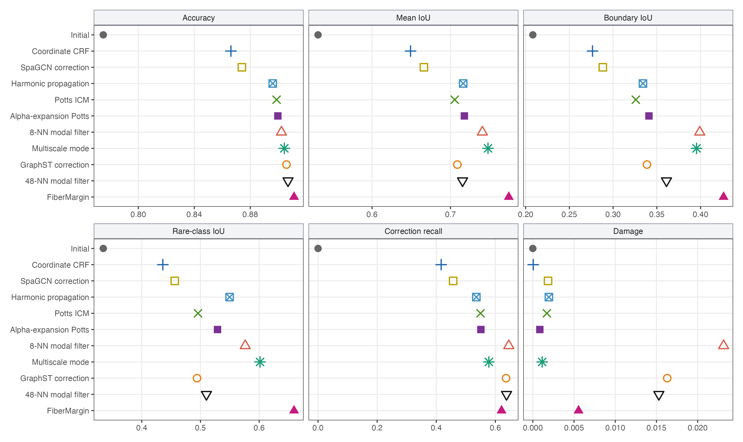
Procedural categorical-mask performance across 108 deterministic cases. Higher is better for accuracy, mean IoU, boundary IoU, rare-class IoU, and correction recall; lower is better for damage. Every point uses only the corrupted categorical field and grid coordinates.
Method | Accuracy | Mean IoU | Boundary IoU | Rare IoU | ARI | Damage
FiberMargin | 0.9113 | 0.7743 | 0.4263 | 0.6594 | 0.7392 | 0.0056
Multiscale mode | 0.9043 | 0.7478 | 0.3954 | 0.6015 | 0.7210 | 0.0011
8-NN modal filter | 0.9023 | 0.7406 | 0.3991 | 0.5763 | 0.7218 | 0.0231
48-NN modal filter | 0.9070 | 0.7153 | 0.3610 | 0.5101 | 0.7012 | 0.0153
GraphST correction | 0.9059 | 0.7087 | 0.3387 | 0.4942 | 0.6964 | 0.0163
Alpha-expansion Potts | 0.8997 | 0.7176 | 0.3410 | 0.5290 | 0.7037 | 0.0009
Potts ICM | 0.8988 | 0.7054 | 0.3260 | 0.4958 | 0.7009 | 0.0017
Harmonic propagation | 0.8961 | 0.7162 | 0.3341 | 0.5496 | 0.6913 | 0.0019
SpaGCN correction | 0.8740 | 0.6661 | 0.2882 | 0.4562 | 0.6335 | 0.0018
Coordinate CRF | 0.8662 | 0.6490 | 0.2764 | 0.4358 | 0.6174 | 0.0001
Initial | 0.7750 | 0.5312 | 0.2082 | 0.3344 | 0.4242 | 0.0000
Table S5. Procedural categorical-mask results across all 108 cases. Higher is better except for damage. The full case-level ledger additionally records macro recall, worst recall, correction recall, changed fraction, and runtime.
Supplementary Figure 2 shows representative 30% boundary-corruption cases so that aggregate scores can be compared with the repaired geometry.
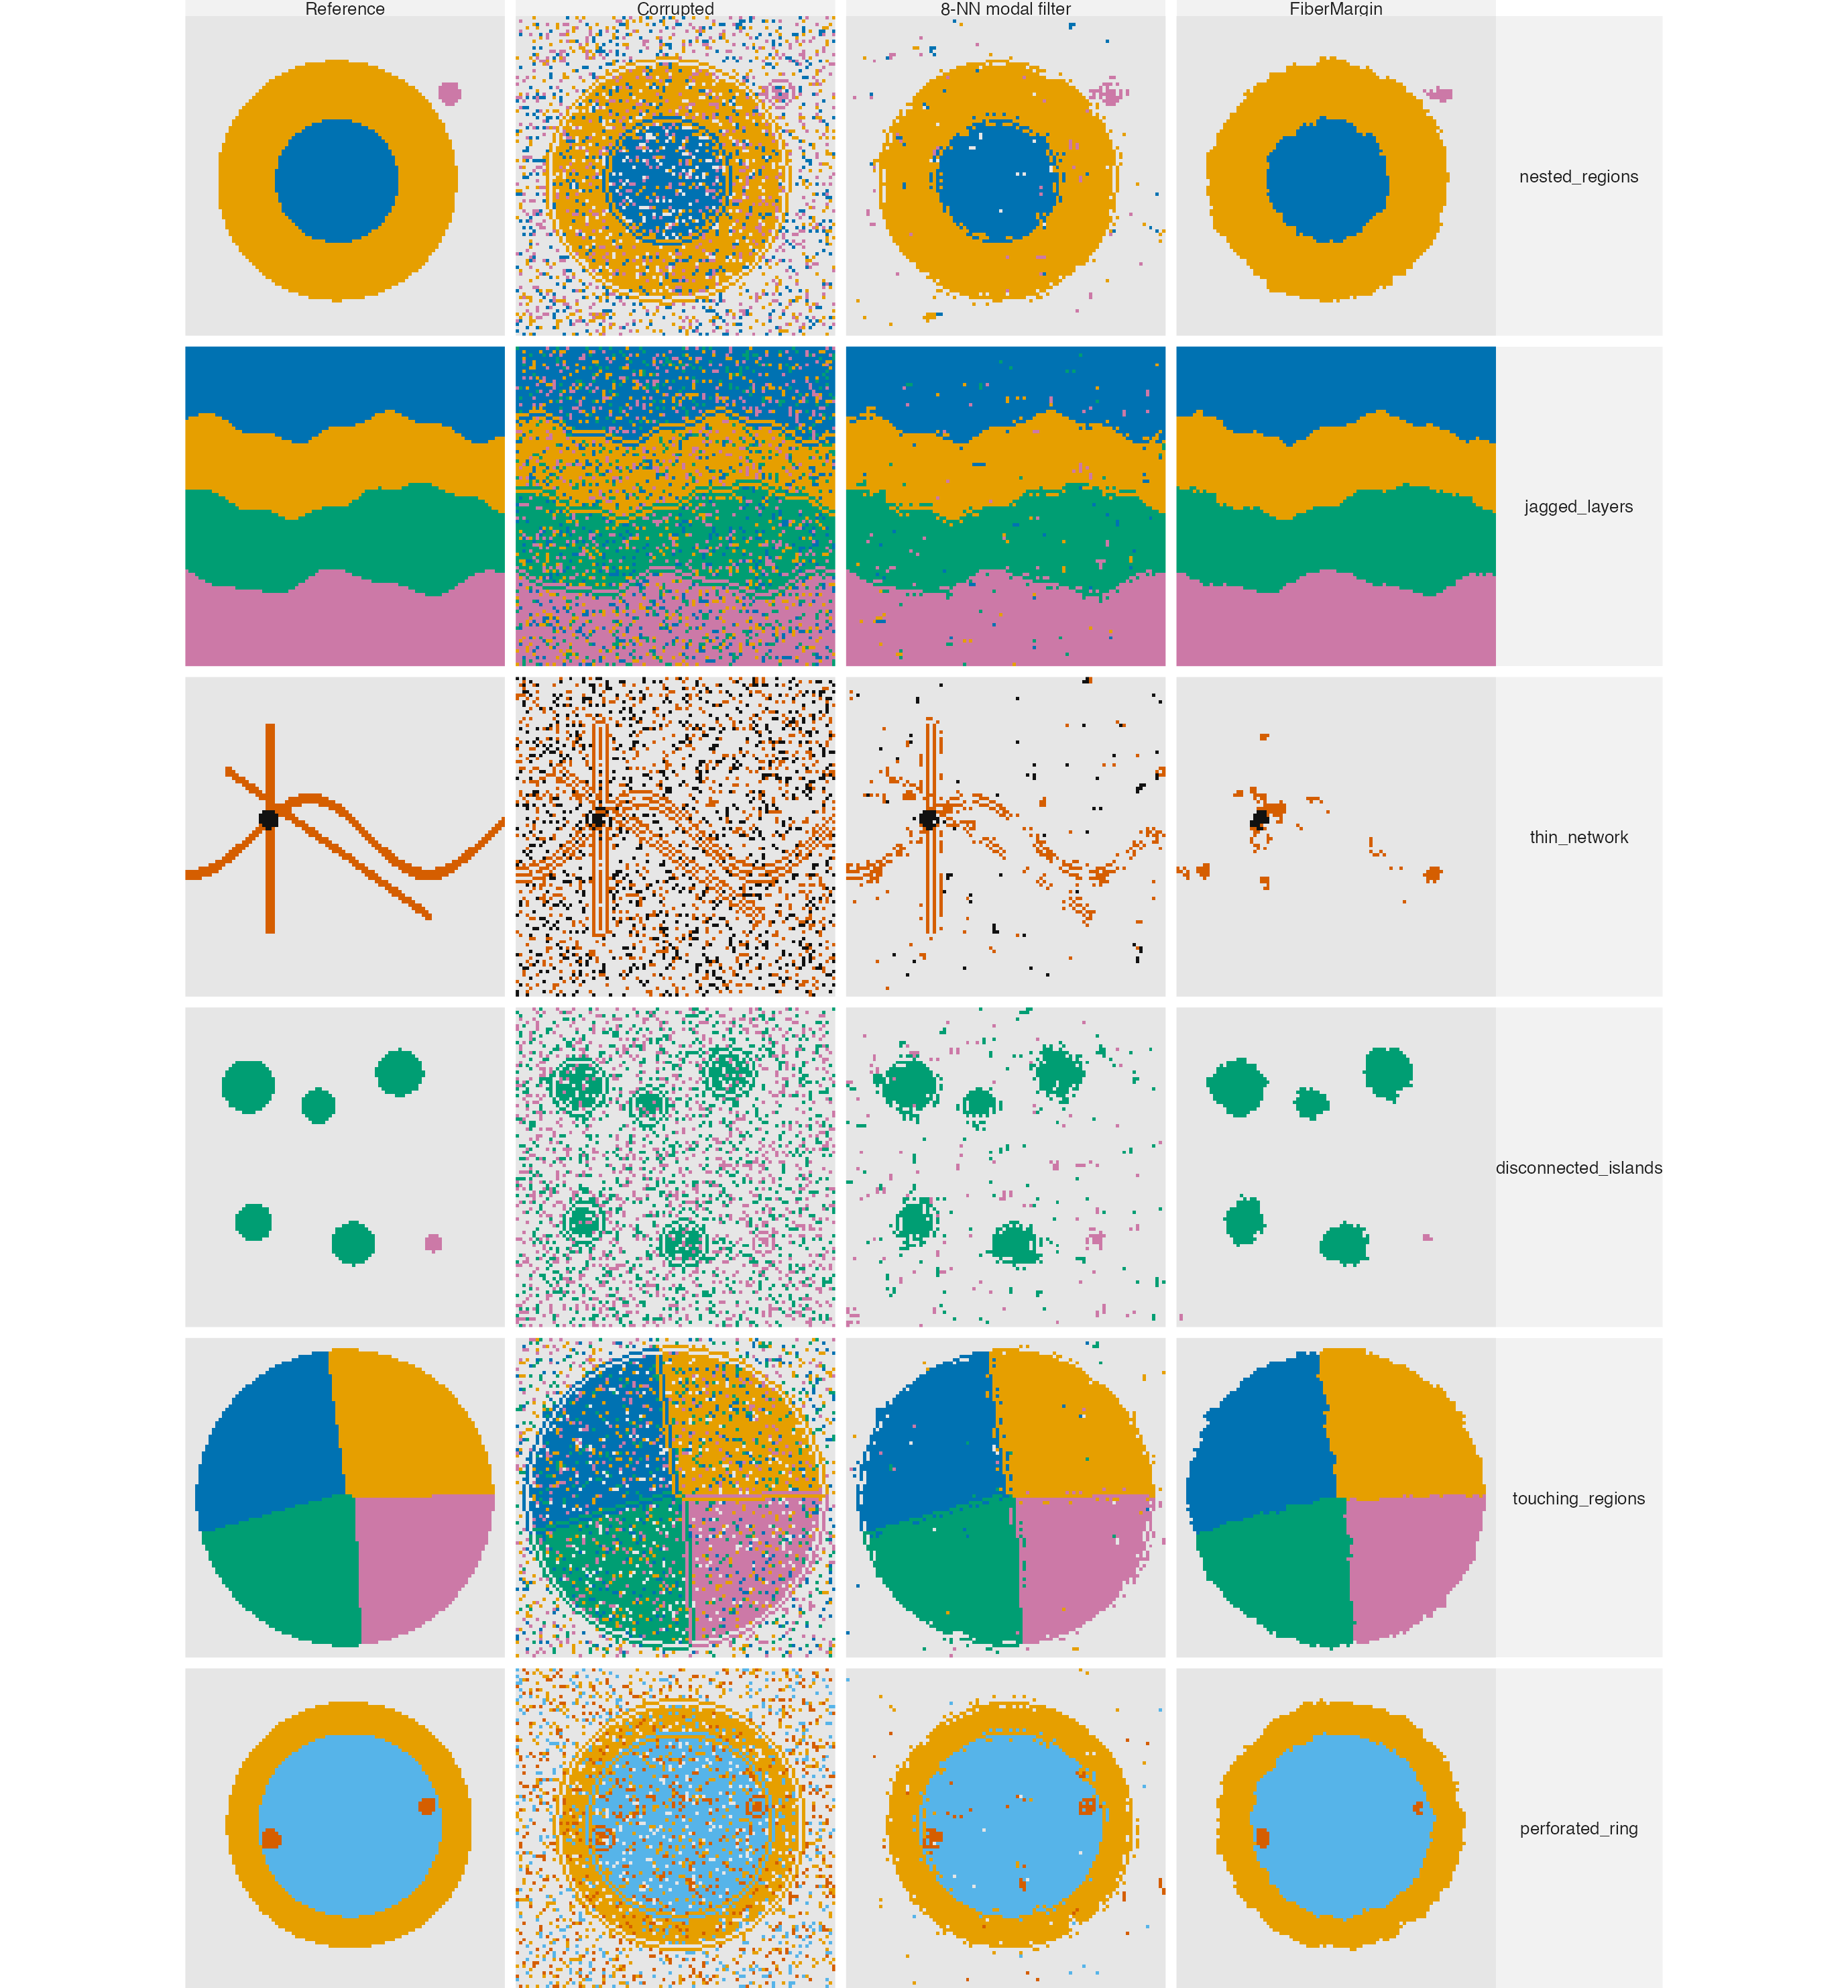
Procedural mask examples at 30% boundary corruption. Each row is a different family; columns show the reference mask, corrupted input, 8-NN modal filter, and FiberMargin.

S14 Three-dimensional variable-density evaluation
This distinct controlled-recovery panel tests the three-dimensional public interface under non-uniform sampling. It contains 36 deterministic five-class fields with 6,000 locations and 25% class-preserving corruption. The full factorial design crosses four geometries (folded layers, thin folded sheets, branching tubes, and disconnected volumes), three acquisition regimes (uniform, class-imbalanced, and irregular depth), and three corruption mechanisms (random, boundary-focused, and patch-like). The class-imbalanced regime uses class-dependent point-sampling weights, so regions have different point concentrations rather than merely different label frequencies. The irregular-depth regime supplies two specimen identifiers, which tests that repair remains within specimen. Every method receives only coordinates, the corrupted field, and specimen membership; reference labels are used only for scoring.
Table S6 contains all fixed coordinate-only controls. FiberMargin has the highest mean accuracy by 0.0085 over multiscale mode, while multiscale mode has a 0.0010 ARI advantage, higher sparse-region accuracy, and lower damage. In the class-imbalanced regime, FiberMargin has accuracy 0.8622 and ARI 0.6198, compared with 0.8444 and 0.5921 for multiscale mode. These means summarize generated fields and are not treated as independent biological replicates. Supplementary Figure 3 gives the full multi-metric operating-point comparison, and Supplementary Figure 4 shows central-depth slices from the class-imbalanced fields. Table S7 reports all three predeclared acquisition regimes for the two leading aggregate methods.
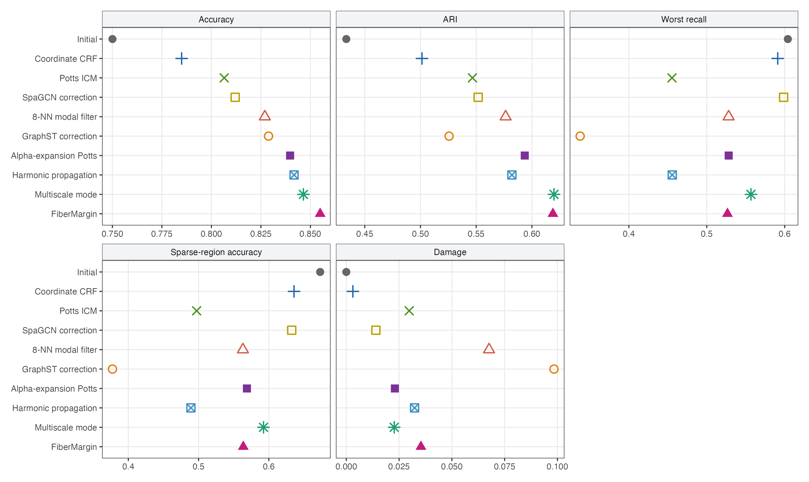
Three-dimensional variable-density performance across 36 deterministic fields. Higher is better for accuracy, ARI, worst recall, and sparse-region accuracy; lower is better for damage. Every method receives the same corrupted categorical field and three-dimensional coordinates.
Method | Accuracy | ARI | Worst recall | Sparse accuracy | Damage | Mean seconds
FiberMargin | 0.8549 | 0.6188 | 0.5266 | 0.5636 | 0.0354 | 0.0374
Multiscale mode | 0.8465 | 0.6198 | 0.5567 | 0.5924 | 0.0227 | 0.0947
Harmonic propagation | 0.8417 | 0.5820 | 0.4557 | 0.4891 | 0.0323 | 0.1003
Alpha-expansion Potts | 0.8397 | 0.5936 | 0.5281 | 0.5688 | 0.0230 | 0.1654
GraphST correction | 0.8288 | 0.5257 | 0.3375 | 0.3774 | 0.0984 | 0.0871
8-NN modal filter | 0.8270 | 0.5764 | 0.5281 | 0.5631 | 0.0676 | 0.0229
SpaGCN correction | 0.8120 | 0.5518 | 0.5986 | 0.6326 | 0.0140 | 0.0193
Potts ICM | 0.8065 | 0.5466 | 0.4553 | 0.4972 | 0.0298 | 0.0464
Coordinate CRF | 0.7850 | 0.5014 | 0.5910 | 0.6359 | 0.0031 | 0.1357
Initial | 0.7501 | 0.4334 | 0.6040 | 0.6730 | 0.0000 | 0.0000
Table S6. Three-dimensional variable-density controlled-recovery results across all 36 fields. Higher is better except for damage and mean seconds. The case-level ledger additionally records macro recall, boundary accuracy, correction recall, geometry, acquisition regime, corruption mechanism, and source identity.
Acquisition regime | Method | Accuracy | ARI | Worst recall | Sparse accuracy | Damage
Class-imbalanced | FiberMargin | 0.8622 | 0.6198 | 0.3638 | 0.3852 | 0.0286
Class-imbalanced | Multiscale mode | 0.8444 | 0.5921 | 0.3594 | 0.3758 | 0.0327
Irregular depth | FiberMargin | 0.8600 | 0.6460 | 0.6337 | 0.6850 | 0.0272
Irregular depth | Multiscale mode | 0.8496 | 0.6399 | 0.6431 | 0.6948 | 0.0173
Uniform | FiberMargin | 0.8426 | 0.5908 | 0.5823 | 0.6206 | 0.0503
Uniform | Multiscale mode | 0.8453 | 0.6275 | 0.6676 | 0.7067 | 0.0181
Table S7. Acquisition-regime summaries for the two leading aggregate methods in the three-dimensional panel, with 12 generated fields per regime. FiberMargin leads accuracy and ARI in the class-imbalanced and irregular-depth regimes; multiscale mode leads both scores under uniform acquisition. Multiscale mode has lower damage in the irregular-depth and uniform regimes. Higher is better except for damage.
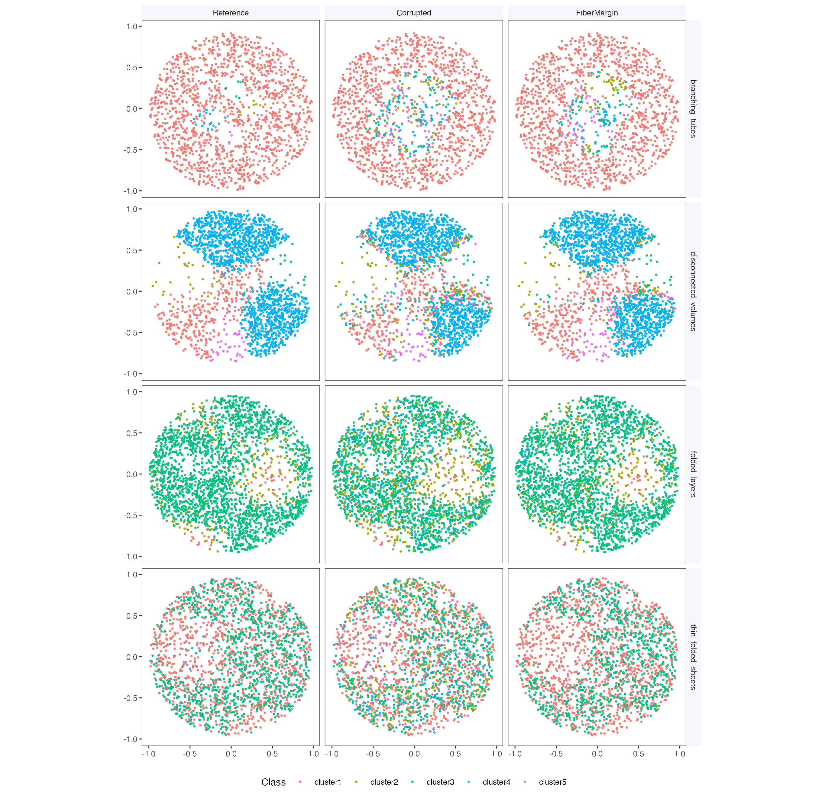
Central-depth slices from four class-imbalanced, boundary-corrupted volumetric fields. Each row is a different geometry; columns show the reference labels, corrupted labels, and FiberMargin repair.

S15 Reproducibility and timing
Table S8 and Supplementary Figure 5 report a fresh common-harness timing study on four predeclared cases each from CRC and MERFISH. The cases span the available error mechanisms and low-to-high error rates. Coordinates, labels, and specimen identifiers were resident in memory before timing; data loading, corruption generation, scoring, and plotting were excluded. Each timed call included input validation, method-specific coordinate preprocessing, inference, and output assembly. In particular, no cached kNN graph was supplied to a direct control. One warm-up call per method and case was excluded, followed by two randomized-order repetitions. Every method returned the same fingerprint across its recorded repetitions.
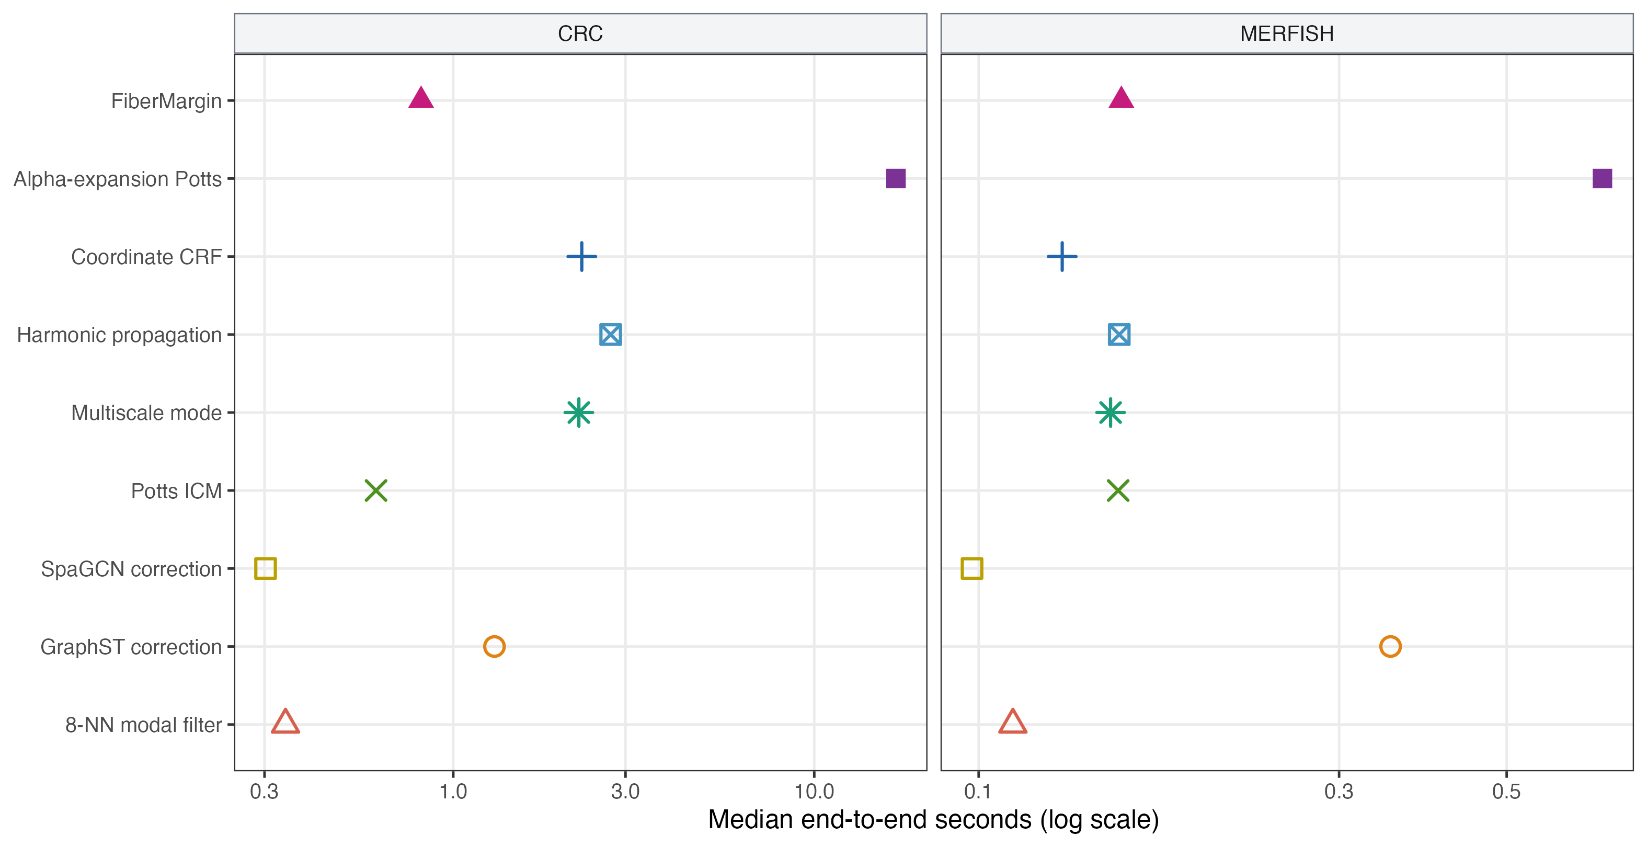
Common end-to-end timing on predeclared CRC and MERFISH cases. Each point is the median across four cases and two repetitions per case; lower is faster. Coordinates, labels, and specimens were already in memory, while each method’s own preprocessing was included.
Method | CRC median seconds | MERFISH median seconds
FiberMargin | 0.815 | 0.154
Alpha-expansion Potts | 16.841 | 0.669
Coordinate CRF | 2.270 | 0.129
Harmonic propagation | 2.729 | 0.154
Multiscale mode | 2.228 | 0.150
Potts ICM | 0.611 | 0.153
SpaGCN correction | 0.302 | 0.098
GraphST correction | 1.300 | 0.351
8-NN modal filter | 0.343 | 0.111
Table S8. Common single-worker end-to-end timing for all nine methods. Each dataset contains four predeclared cases and two recorded repetitions per case (eight calls per method); values are medians over those calls. Lower is faster. This table is intentionally separate from Table S4 because it measures runtime under one freshly executed, explicitly stated scope rather than retaining historical timing records.
The accompanying archive records benchmark-input identities and package-build metadata. Independent benchmark fields were scheduled externally, with one native worker per field, so the experiment-level scheduler controlled the total budget. In the package API, workers is instead the total budget of one call: specimens are processed independently within one native invocation and reuse that budget without nested pools. Labels and diagnostics are invariant to the worker budget.
The authoritative result directory for every central display is enumerated in the publication-provenance CSV under benchmarks/results. Its rows cover the 708 complete simulations, 108 unseen geometries, 36 variable-density 3D fields, three real-coordinate studies, procedural masks, external predictions, and control calibration. Every FiberMargin row identifies the same C++ source fingerprint, e3735422c1ddd6567d42ec603ddf0ca3. The index also records package version, evaluation-unit count, and manuscript consumers; the companion provenance writer under benchmarks checks that each result directory and run manifest exist and that every FiberMargin manifest contains the current source fingerprint before regenerating the index. Each indexed directory contains case-level output or a source-row manifest, aggregate summaries, and run metadata.
Tests ran on macOS 14.5, ARM64 Apple M3, R 4.6.0, and Homebrew clang++ 22.1.1 with C++17 and -arch arm64 -falign-functions=64 -Wall -g -O2. Timings include input validation, coordinate preprocessing, geometry construction, inference, and output assembly, but exclude file I/O, corruption generation, scoring, and plotting. The case-level ledger records the timing scope for every repair call.

S16 Auxiliary binary building-mask diagnostic
This controlled package-scope diagnostic evaluates the fixed local ballot described in Section S1.2, not the multiclass two-sided enclosure developed in the main paper. It uses 55 held-out 256-by-256 binary masks from the HOT Very-High-Resolution Building Segmentation Dataset. Each source mask receives random, boundary-concentrated, and compact-patch corruption at 10% and 25%, producing 330 evaluation units. Only categorical masks and coordinates are supplied to the repair methods; aerial imagery is not read.
GraphST correction had the highest Accuracy (0.8877) and ARI (0.5233). Potts ICM provided a stronger Accuracy–damage operating point than the FiberMargin binary utility: 0.8851 Accuracy with 0.0044 damage versus 0.8822 with 0.0139 damage. The binary result is therefore reported as a boundary of package scope and is not used as evidence for the multiclass enclosure mechanism.
Auxiliary binary-package results over 330 controlled corruptions of 55 held-out building masks. Higher is better except for damage. This table evaluates the package’s local-ballot utility rather than FiberMargin’s multiclass two-sided enclosure mechanism.
Method | Accuracy | ARI | Correction | Damage
Initial | 0.8250 | 0.2934 | 0 | 0
FiberMargin binary utility | 0.8822 | 0.5083 | 0.4076 | 0.0139
Alpha-expansion Potts | 0.8819 | 0.4801 | 0.3852 | 0.0076
Coordinate CRF | 0.8717 | 0.4470 | 0.2877 | 0.0008
Harmonic propagation | 0.8808 | 0.4960 | 0.3441 | 0.0032
Multiscale mode | 0.8776 | 0.4728 | 0.3324 | 0.0034
Potts ICM | 0.8851 | 0.5151 | 0.3787 | 0.0044
SpaGCN correction | 0.8609 | 0.4017 | 0.2432 | 0.0024
GraphST correction | 0.8877 | 0.5233 | 0.4769 | 0.0196
8-NN modal filter | 0.8702 | 0.4375 | 0.4737 | 0.0415

S17 External upstream-prediction validation
This section evaluates the same fixed methods on categorical predictions made by an upstream classifier and saved before repair. It is distinct from the controlled-corruption studies: the repair input is not created by changing a reference annotation. CamVid contributes 233 official test masks (Brostow, Fauqueur, and Cipolla 2009). The saved input is the output of an 80-tree ExtraTrees semantic classifier fitted only to the official CamVid training split from RGB and pixel location. S3DIS contributes one deterministic 4,096-point block from each of 68 Area 5 rooms (Armeni et al. 2016). Its saved input is the output of an 80-tree ExtraTrees semantic point classifier fitted only to Areas 1, 2, 3, 4, and 6 from XYZ and RGB. Both source predictors are deliberately simple; this section is a restricted stored-field stress test rather than an evaluation of contemporary image or point-cloud segmentation architectures.
At repair time, every method receives only the saved categorical prediction and coordinates. It receives no image pixels, RGB values, upstream logits, probabilities, confidence scores, or training annotations. Independent reference annotations are read only for evaluation. No repair-time parameter is fitted from either reference, and no source-specific repair setting is introduced. The evaluation uses the full fixed roster: Initial, FiberMargin, alpha-expansion Potts, coordinate CRF, harmonic propagation, multiscale mode, SpaGCN correction, GraphST correction, 8-NN modal filtering, and Potts ICM.
CamVid averages one score per image. S3DIS averages one score per room block; its archived uncertainty intervals resample room blocks and are descriptive, not evidence of independent scene replication. For both sources, correction damage is the fraction of initially correct categorical predictions changed to an incorrect label. The saved-input manifests, upstream split definitions, package-build metadata, and full case-level ledgers accompany the result archive.
Table S9 reports all CamVid outcomes, and Table S10 reports all S3DIS outcomes. Main Figure 1 displays their shared accuracy–damage view.
Method | Accuracy | Gain | Mean IoU | ARI | Damage
Initial | 0.6096 | 0.0000 | 0.3094 | 0.5103 | 0.0000
FiberMargin | 0.6283 | 0.0186 | 0.3188 | 0.5268 | 0.0444
Alpha-expansion Potts | 0.6180 | 0.0084 | 0.3146 | 0.5182 | 0.0150
Coordinate CRF | 0.6099 | 0.0003 | 0.3096 | 0.5106 | 0.0002
Harmonic propagation | 0.6285 | 0.0189 | 0.3194 | 0.5278 | 0.0215
Multiscale mode | 0.6234 | 0.0137 | 0.3173 | 0.5229 | 0.0266
SpaGCN correction | 0.6168 | 0.0072 | 0.3146 | 0.5169 | 0.0153
GraphST correction | 0.6344 | 0.0248 | 0.3201 | 0.5318 | 0.0651
8-NN modal filter | 0.6220 | 0.0123 | 0.3153 | 0.5214 | 0.0584
Potts ICM | 0.6209 | 0.0113 | 0.3158 | 0.5210 | 0.0182
Table S9. CamVid external upstream-prediction matrix across 233 official test images. Gain is accuracy gain over the saved upstream categorical prediction. Higher is better except for damage.
Table S10. S3DIS external upstream-prediction matrix across 68 held-out Area 5 room blocks. Boundary accuracy uses eight Euclidean nearest neighbours; sparse accuracy is the least frequent reference class within a block. Higher is better except for damage.
Method | Accuracy | Gain | ARI | Boundary | Sparse | Damage
Initial | 0.6006 | 0.0000 | 0.5315 | 0.3992 | 0.5724 | 0.0000
FiberMargin | 0.6211 | 0.0204 | 0.5651 | 0.4177 | 0.6187 | 0.0546
Alpha-expansion Potts | 0.6191 | 0.0185 | 0.5592 | 0.4155 | 0.6163 | 0.0410
Coordinate CRF | 0.6017 | 0.0010 | 0.5327 | 0.3994 | 0.5734 | 0.0006
Harmonic propagation | 0.6268 | 0.0261 | 0.5684 | 0.4286 | 0.6134 | 0.0347
Multiscale mode | 0.6196 | 0.0189 | 0.5583 | 0.4206 | 0.6051 | 0.0401
SpaGCN correction | 0.6113 | 0.0106 | 0.5461 | 0.4081 | 0.5898 | 0.0260
GraphST correction | 0.6322 | 0.0316 | 0.5777 | 0.4367 | 0.6011 | 0.0866
8-NN modal filter | 0.6163 | 0.0156 | 0.5539 | 0.4135 | 0.6003 | 0.0758
Potts ICM | 0.6166 | 0.0160 | 0.5532 | 0.4145 | 0.5924 | 0.0310
Unit-bootstrap intervals were computed from 10,000 resamples. Relative to the saved prediction, FiberMargin’s accuracy difference was +0.0186 (0.0175, 0.0197) for CamVid and +0.0204 (0.0152, 0.0259) for S3DIS. Relative to GraphST correction, the differences were -0.0061 (-0.0066, -0.0057) and -0.0112 (-0.0139, -0.0085), respectively. These are descriptive intervals: CamVid frames retain sequence dependence and S3DIS room blocks retain scene dependence.
FiberMargin improves the saved prediction in both sources, but it is not the primary-score leader in either full matrix. These two studies establish feasibility for the saved-prediction setting and reveal accuracy–damage operating-point trade-offs. They do not establish general superiority. Supplementary Figure 6 shows the predefined CamVid example used for qualitative inspection.
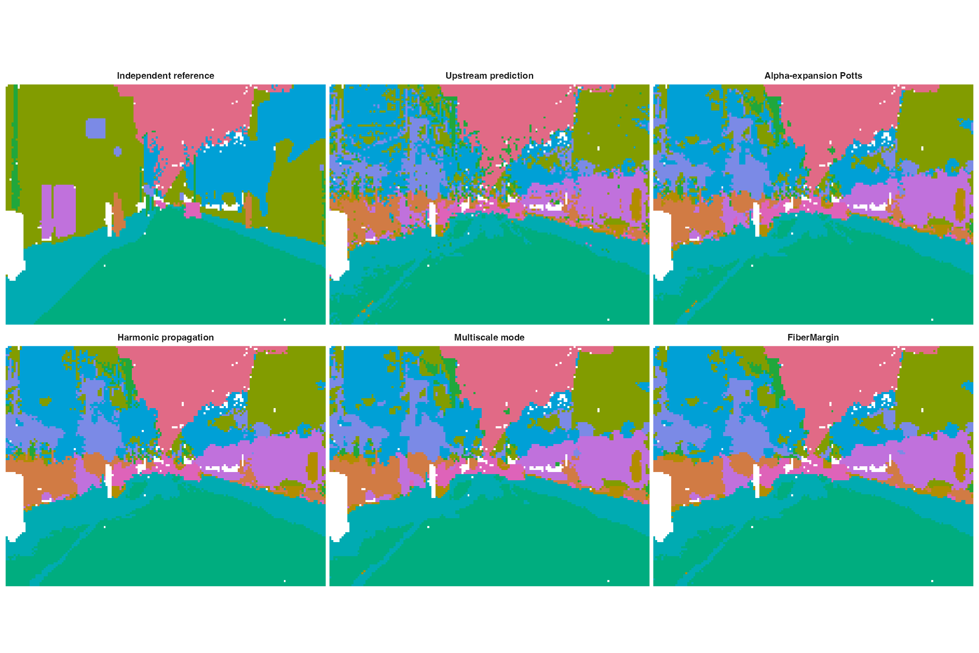
Representative CamVid upstream-mask repair. The displayed frame is the midpoint of the sorted official test collection, independent of outcomes. Panels show the independent reference, the categorical upstream prediction, alpha-expansion Potts, harmonic propagation, multiscale mode, and FiberMargin. The repair stage receives no image values or model scores.

References
Armeni, Iro, Ozan Sener, Amir R. Zamir, Helen Jiang, Ioannis Brilakis, Martin Fischer, and Silvio Savarese. 2016. “3D Semantic Parsing of Large-Scale Indoor Spaces.” In Proceedings of the IEEE Conference on Computer Vision and Pattern Recognition, 1534–43. https://doi.org/10.1109/CVPR.2016.170.
Brostow, Gabriel J., Julien Fauqueur, and Roberto Cipolla. 2009. “Semantic Object Classes in Video: A High-Definition Ground Truth Database.” Pattern Recognition Letters 30 (2): 88–97. https://doi.org/10.1016/j.patrec.2008.04.005.
Hu, Jian et al. 2021. “SpaGCN: Integrating Gene Expression, Spatial Location and Histology to Identify Spatial Domains and Spatially Variable Genes by Graph Convolutional Network.” Nature Methods 18: 1342–51. https://doi.org/10.1038/s41592-021-01255-8.
Long, Yahui et al. 2023. “Spatially Informed Clustering, Integration, and Deconvolution of Spatial Transcriptomics with GraphST.” Nature Communications 14: 1155. https://doi.org/10.1038/s41467-023-36796-3.
Skilling, John. 2004. “Programming the Hilbert Curve.” In Bayesian Inference and Maximum Entropy Methods in Science and Engineering, 707:381–87. AIP Conference Proceedings. https://doi.org/10.1063/1.1751381.

