A patient-level comparison of pathology foundation models for molecular and derived immune-feature prediction across 32 TCGA cancers
Aamilah Ismail^{3,*}, Martin Ocharo^{1,2,*}, Moussa Kassim^{1,2}, Dalia Ahmed¹, Brendon Price⁵, Dupe Ojo¹, Ekene Emmanuel Nweke⁴, Silvano Piazza^{6,8}, Dinesh Gupta⁷, Stefano Cacciatore^{1,2,†}
1 Bioinformatics Unit, International Centre for Genetic Engineering and Biotechnology (ICGEB), Cape Town 7925, South Africa
2 Department of Integrative Biomedical Sciences, Institute of Infectious Disease & Molecular Medicine (IDM), University of Cape Town, Cape Town 7925, South Africa
3 Division of Engineering, New York University Abu Dhabi, Abu Dhabi, United Arab Emirates
4 Department of Surgery, Faculty of Health Sciences, University of the Witwatersrand, Johannesburg, Gauteng, South Africa
5 Division of Anatomical Pathology, University of Cape Town and National Health Laboratory Service, Observatory, Cape Town, South Africa
6 Computational Biology Group, International Centre for Genetic Engineering and Biotechnology (ICGEB), Trieste, Italy
7 Translational Bioinformatics Group, International Centre for Genetic Engineering and Biotechnology (ICGEB), Aruna Asaf Ali Marg, New Delhi 110067, India
8 Bioinformatics Facility, Department of Cellular, Computational and Integrative Biology - CIBIO, University of Trento, Trento, Italy
* These authors contributed equally.
† Corresponding author: Stefano Cacciatore (stefano.cacciatore@icgeb.org).
Author emails: aamilahismail@gmail.com; moussa.kassim@icgeb.org; dalia.ahmed@icgeb.org; dupe.ojo@icgeb.org; stefano.cacciatore@icgeb.org
Research article — Molecular Pathology | Journal of Translational Medicine

Abstract
Background. Whole-slide foundation models can compress histology into reusable representations, but molecular-prediction results may depend on the selected representation. We compared TITAN, Giga-SSL and Prov-GigaPath under one patient-level design rather than claiming unprecedented mutation targets.
Methods. We deterministically mean-pooled primary-tumour diagnostic-slide embeddings before outcome matching and used the patient as the validation unit. The primary TITAN analysis tested 1,614 continuous and 459 binary cancer–endpoint pairs using nested PLS1 or PLS–LDA, complete-process permutation testing and multiplicity control. A locked representation benchmark evaluated all three foundation models on the same 8,241 patients, identical outcome-labelled subsets, folds, seeds and tuning rules across 1,507 continuous and 426 binary tasks.
Results. The primary TITAN screen identified 219 continuous and 104 binary candidates. On the common cohort, TITAN, Prov-GigaPath and Giga-SSL met the screening threshold for 208, 127 and 105 continuous tasks and 93, 82 and 66 binary tasks, respectively. Target-level effects remained correlated with TITAN (Spearman 0.793–0.805 for continuous and 0.628–0.663 for binary tasks), but the representation ranking varied by endpoint. Grouping by TCGA tissue-source-site code reduced 83/323 primary TITAN candidates (25.7%) below threshold.
Conclusions. Foundation-model choice materially changes which molecular and derived immune-feature associations cross an internal screening threshold. TITAN had the broadest coverage in this matched TCGA benchmark, but no representation was uniformly best and none has independent external validation. The accompanying multi-representation R package is a research interface for locked future evaluation, not a clinical prediction system.
Trial registration. Not applicable.
Keywords: computational pathology; whole-slide imaging; foundation model; mutation; inflammation; microsatellite instability; gene fusion; aneuploidy; partial least squares; linear discriminant analysis

Background
Routine haematoxylin-and-eosin sections reflect phenotypic consequences of tumour genotype and the immune microenvironment. Coudray and colleagues established mutation prediction from lung histology [1]. Subsequent work predicted microsatellite instability, including externally validated colorectal models [2,3]; extended mutation and multi-omic screening across TCGA cancers [4,5,8,11,13]; inferred RNA expression [6,12]; identified institution-associated histology bias [7]; detected gene fusions [9,10]; estimated homologous-recombination deficiency [14]; and characterised tumour-microenvironment phenotypes [15]. Collectively, these studies establish biological plausibility while also showing that performance depends on endpoint, disease, cohort and validation design.
Breadth alone is not the gap. Fu et al. analysed 17,355 slides across 28 cancers [4], Kather et al. applied one workflow to more than 5,000 patients across 14 cancers [5], Saldanha et al. externally tested mutation models across seven matched TCGA and CPTAC cancers [11], and Arslan et al. trained 12,093 models for 4,031 genomic, transcriptomic, proteomic and clinical biomarkers in 8,890 TCGA patients across the same 32 cancers [13]. The present study consequently does not claim the first pan-cancer molecular screen, a larger endpoint catalogue, or general mutation-target novelty.
The narrower unresolved gap is a reproducible, endpoint-matched comparison of multiple pathology foundation models that deterministically aggregates slides before outcome matching; performs nested validation with the patient as the unit; preserves tested-negative and sample-size-ineligible results; reports sensitivity to grouping by TCGA tissue-source-site code; models selected derived immune and genomic-context features continuously; and constructs compact fitted predictors with research-use provenance metadata. These design and resource features—not unprecedented endpoint classes—define the contribution of this study.
We evaluated three complementary pretrained representations. TITAN is a multimodal whole-slide model trained with visual self-supervision and vision–language alignment; its published Mass-340K pretraining corpus excluded TCGA, although TCGA was used for downstream evaluation [16]. Giga-SSL is a gigapixel self-supervised whole-slide representation whose official repository distributes 512-dimensional TCGA embeddings [39]. Prov-GigaPath combines a tile encoder with a long-context slide encoder trained on Providence health-system pathology data; we used the final 768-dimensional slide layer from the public TCGA embedding dataset [40]. No weights were fine-tuned. These sources differ in pretraining data, objectives and released TCGA coverage, so the matched comparison estimates representation-associated differences under this pipeline rather than intrinsic superiority in all settings.
A practical feature of the fitted analysis is model portability. PLS, PLS–LDA and ridge predictors can all be represented by compact learned preprocessing and coefficient objects and applied without release of patient-level training embeddings or outcomes. Portability therefore motivates comparison within the linear-model family but is not a unique advantage of PLS. It supports external research testing while minimising distribution of patient-level data, but does not itself establish privacy, licensing compatibility or transportability.
The primary question was cancer-specific: which individual mutations, derived inflammatory features, oncogenic pathways, MSI phenotypes, aneuploidy measures and fusions show held-out cross-validated statistical association with a foundation-model representation within each cancer, and how stable is that conclusion across TITAN, Giga-SSL and Prov-GigaPath? Throughout this article, ‘predictability’ is shorthand only for that operational cross-validated association at the reported performance threshold. It does not denote causal biological information, a morphological mechanism, direct recovery of the source measurement or justification for replacing an assay. Molecular subtype association was not analysed.

Methods

Study design, slides and patient unit
The published TITAN TCGA table contained 11,449 eligible primary-tumour diagnostic slides (TCGA sample type 01 and –DX filename) from 9,404 participants. The 843 participants with multiple eligible slides contributed one patient vector obtained by feature-wise arithmetic mean before outcomes were joined. Patient—not slide—was the independent cross-validation unit. Within a patient, every eligible slide received weight 1/n; after pooling, every participant contributed one row and therefore one observational unit. TITAN's TCGA-Slide-Reports.csv matched 10,106 selected slides exactly by filename; 1,343 slides lacked an exact report row. Report metadata were used only to audit identifiers, project/cancer provenance and anatomical resection/biopsy-site annotations, and no report text entered a model. The two-character tissue-source-site code used for grouped validation was derived directly from the TCGA participant barcode. 9 participants without a resolvable cancer label did not enter cancer-specific modelling. No participant had eligible slides from more than one primary sample barcode.
No structured tumour-content/cellularity percentage, tissue-area measurement, artefact assessment, biopsy-versus-resection indicator or slide/image-quality score was available in the TITAN feature table or TCGA-Slide-Reports.csv; accordingly, none was used for slide exclusion or weighting. The field named site_of_resection_or_biopsy contains an anatomical site, not specimen procedure. Generated slide narratives were audited only for transparency and were not treated as independent pathologist-adjudicated QC labels. Eligibility therefore reflected TCGA sample type and diagnostic-slide filename, not prospective pathology review.
All models were stratified by cancer type. No model learned pan-cancer differences, and no patient could occur in more than one validation fold. The intended use was discovery-stage prioritisation rather than diagnosis, treatment selection or replacement of molecular testing.
All available eligible TCGA participants were used; no formal power calculation was performed. Minimum outcome-specific denominators were prespecified to support nested folds. Treatments were not modelled because the endpoints were contemporaneous molecular or derived immune/genomic features rather than prognosis or treatment response.
Reporting was audited against TRIPOD+AI [28]. Participant characteristics were linked from the TCGA Clinical Data Resource [29] and summarized overall and by cancer. These fields were not supplied to prediction models. In a post hoc denominator-first audit, a cancer–endpoint model was considered high volume at ≥200 outcome-labelled patients. Performance was recalculated within the fixed five-repeat held-out predictions when a continuous subgroup contained ≥50 patients or a binary subgroup contained ≥20 positive and ≥20 negative patients. Recorded sex used the TCGA CDR gender field; broad race retained White, Black or African American, Asian and other recorded categories separately. Continuous subgroup metrics were Q², RMSE and Spearman correlation; binary metrics were sensitivity, specificity, balanced accuracy, AUROC and PR-AUC. No subgroup-specific model was refitted, no formal between-group hypothesis test or multiplicity correction was performed, and the audit was not designed to establish fairness. Exact counts and reasons for non-estimability were retained for every model–subgroup row.
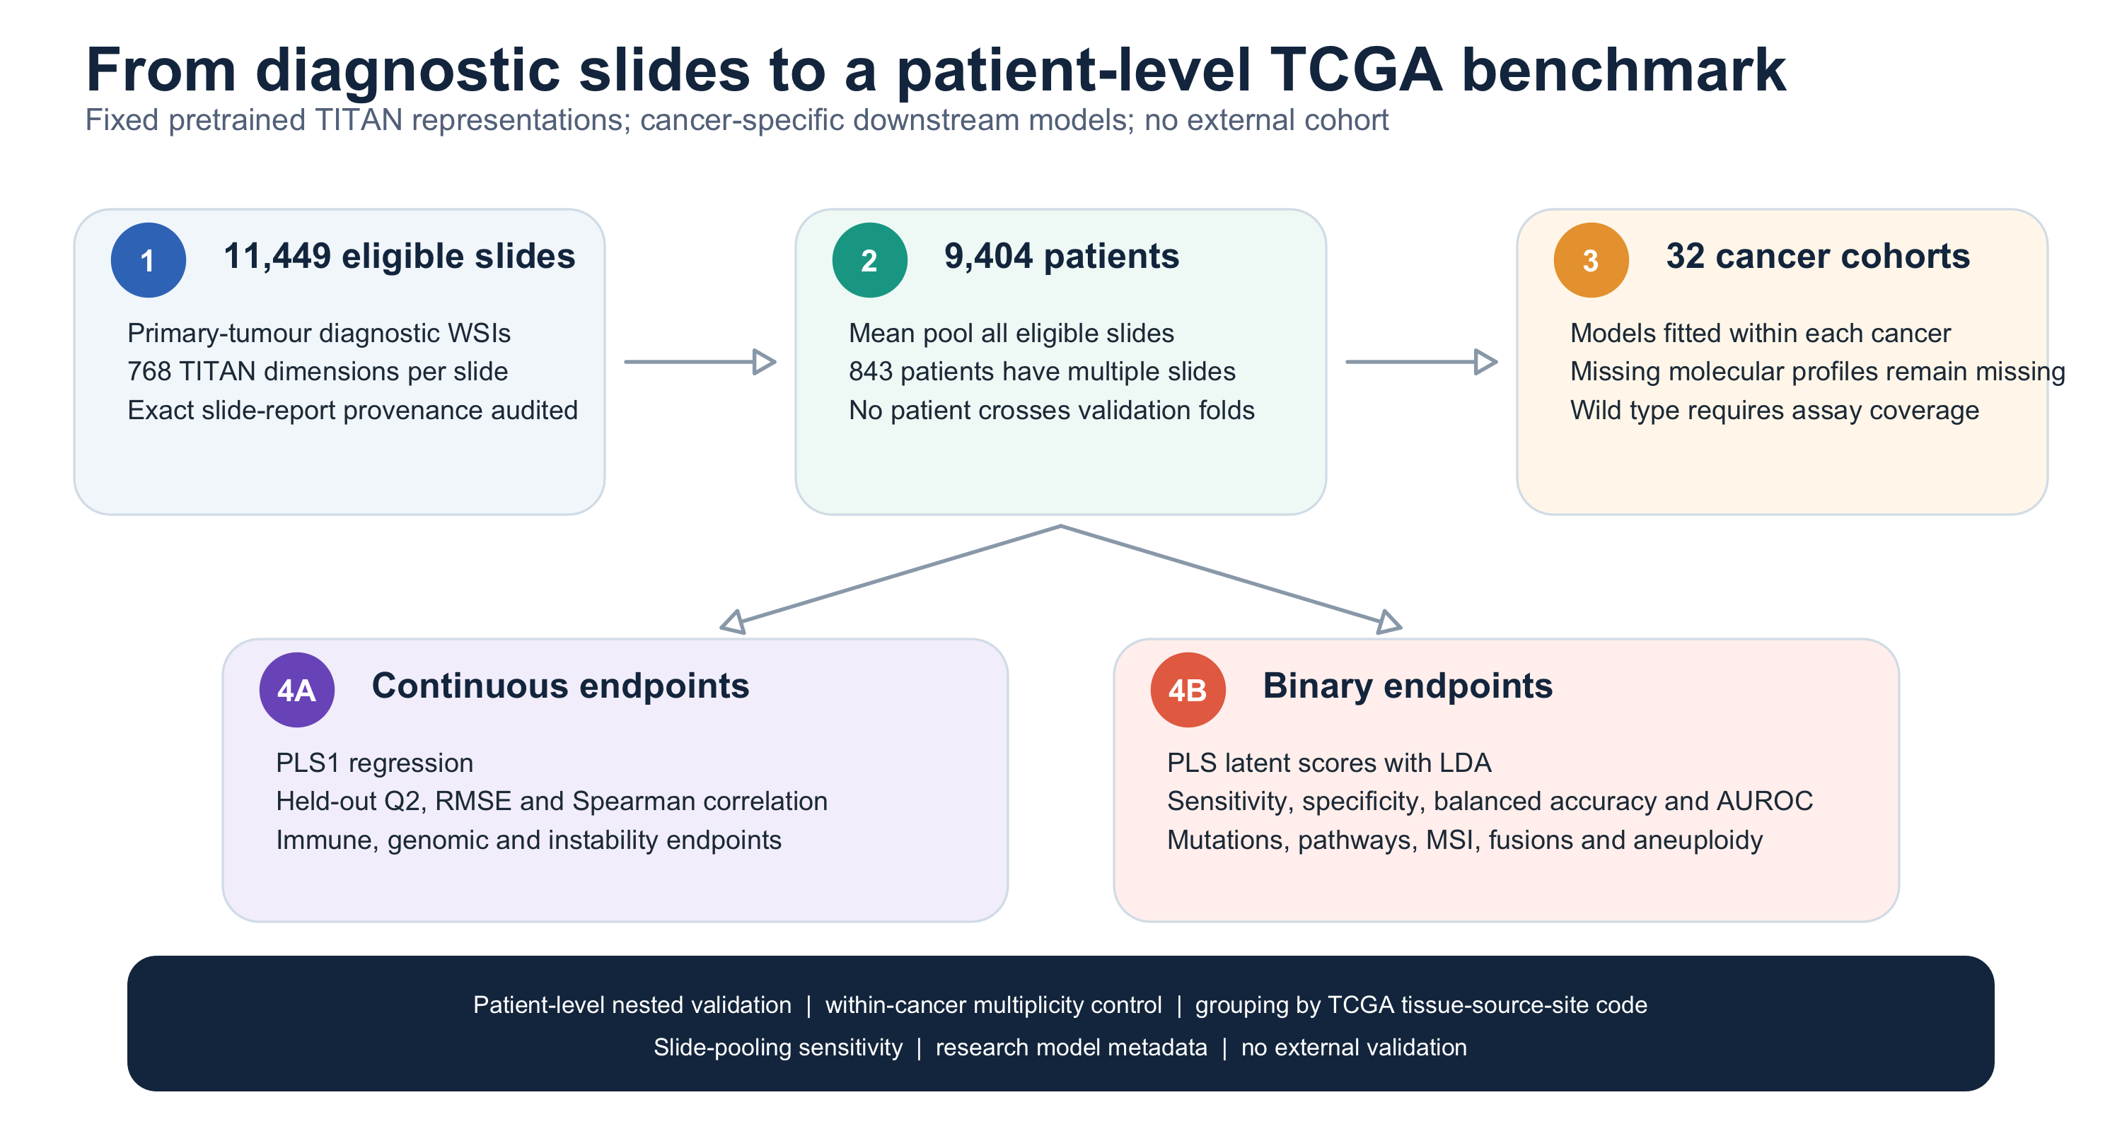
Figure 1. Patient-first study design. Eligible diagnostic slides are mean-pooled before outcome matching; all model selection and evaluation occur at patient level within cancer type.

Predictors and outcomes
Predictors were fixed pretrained whole-slide representations: 768 TITAN dimensions [16], 512 Giga-SSL dimensions [39] and the final 768-dimensional Prov-GigaPath slide layer [40]. The TITAN artifact was obtained from the official gated Hugging Face release; Giga-SSL embeddings were taken from the official GitHub release (commit 605b950); and Prov-GigaPath embeddings were obtained from the public Hugging Face TCGA dataset. Conversion scripts preserve slide identifiers, deterministic feature names and SHA-256 provenance. Exact duplicate Prov-GigaPath slide rows were verified to have identical final-layer vectors and deduplicated deterministically. No slide pixels were downloaded or reprocessed for the added representations and no foundation-model weights were fine-tuned.
Continuous outcomes comprised 39 immune/inflammatory measures and 11 genomic-context scores from Thorsson et al. [19], three aneuploidy burdens from Taylor et al. [20], log-transformed fusion burden from Gao et al. [21], and MANTIS/MSIsensor scores from Bonneville et al. and the cBioPortal TCGA PanCancer Atlas files [22,23]. Binary outcomes comprised qualifying protein-altering PASS mutations in tissue-specific consensus cancer genes from MC3 and Bailey et al. [24,25], ten oncogenic-pathway alteration indicators [26], genome doubling [20], any called fusion and eligible recurrent fusion pairs [21], and MSI-H definitions at MANTIS >0.4 and a strict >0.6 sensitivity threshold [22].
For the representation comparison, each model was independently mean-pooled across eligible primary-tumour diagnostic slides. The intersection contained 8,241 patients. Every cancer–endpoint task used the identical outcome-labelled patients, outer folds, inner folds, seeds, component range and rSVD settings for all three representations. The comparison includes all 1,507 continuous and 426 binary tasks meeting eligibility on this common cohort; neither targets nor examples were selected using a representation's performance. Q², RMSE and Spearman correlation were reported for continuous outcomes, and balanced accuracy, AUROC and PR-AUC for binary outcomes. This is an internal TCGA representation benchmark, not external validation.
The Thorsson Nonsilent Mutation Rate, Silent Mutation Rate, SNV Neoantigens, Indel Neoantigens and Number of Segments variables, and the Gao fusion burden, were analysed as log(1+x); all other continuous endpoints retained their source scale. Reported RMSE values therefore use these analysed units.
The Thorsson umbrella does not denote a single immune assay. Its targets include CIBERSORT relative leukocyte fractions inferred by deconvolving bulk RNA sequencing [37], a leukocyte fraction inferred from DNA methylation, bulk-RNA gene-set signatures, BCR/TCR repertoire quantities reconstructed from RNA sequencing, in-silico neoantigen burdens, purity- and copy-number-derived genomic-context scores, and TIL Regional Fraction inferred from H&E by the Saltz deep-learning workflow [19,38]. The last target is a same-histology-modality concordance task rather than cross-modal molecular prediction. None of these inferred quantities is treated as equivalent to flow cytometry, immunohistochemistry, a directly counted immune-cell assay or a clinically certified biomarker. A 2,073-row endpoint dictionary records source modality, direct/inferred status, derivation, source scale, transformation, outcome-specific missingness, expected measurement error, biological interpretation and an assay-equivalence caveat for every modelled target; its 194 unique definitions are supplied separately.
Molecular missingness was retained rather than converted to a negative label, and no outcome imputation was performed. Mutation status was defined only among 8,476 embedding patients matched to an MC3 primary-tumour profile; 919 embedding patients without such a profile were excluded from mutation denominators. Within this profiled set, wild type meant no qualifying PASS protein-altering variant in the specified gene. Fusion-negative status was assigned only within the Gao study sample list. Multiple primary aliquots, if present, were collapsed at patient level by any alteration for binary mutation/pathway/fusion endpoints and by the prespecified mean or any-positive rule for continuous or binary instability endpoints. The source-level coverage table records covered patients, missing patients, aliquot multiplicity and aggregation for every cancer and source; no source contained multiple primary aliquots among matched embedding patients in this release.
Continuous pairs required at least 50 non-missing patients. Binary screening eligibility required at least 20 positive and 20 negative patients. Eligibility was decided before modelling and every eligible test remained in its endpoint-family multiplicity denominator. Because this lower binary limit can produce sparse nested folds, we additionally repeated the eligibility and candidate-retention summary at 50 patients per class. Screen-positive models below that stricter threshold were retained in the complete atlas as exploratory/limited evidence, but were separated from standard-evidence models and excluded from the default inference interface.

PLS1 regression and PLS–LDA classification
For each cancer–endpoint pair, five outer folds estimated performance and five inner folds selected 1–10 PLS components. Scaling and component selection were learned from training patients only. All primary, permutation, repeated, sensitivity, PLS1–PLS2 and final-model fits used CPU rSVD with 10 oversampling vectors, two power iterations and explicit seeds. Continuous performance was out-of-fold Q², with RMSE and Spearman correlation secondary. Binary models supplied PLS latent scores to ridge-stabilised LDA; balanced accuracy was primary, with AUROC and precision–recall area under the curve (PR-AUC) calculated from continuous LDA scores in repeated validation.
Q² was 1−Σ(y−ŷ)²/Σ(y−ȳ)² over outer-fold predictions, and RMSE was the square root of the mean squared prediction error. For binary outcomes, class 1 denoted altered or positive and class 0 denoted wild type or negative within the outcome-specific covered denominator. Sensitivity was the class-1 true-positive rate, specificity the class-0 true-negative rate, and balanced accuracy their arithmetic mean. AUROC used the continuous class-1-minus-class-0 LDA discriminant score. PR-AUC was non-interpolated average precision, so its no-skill reference equals outcome prevalence. Positive and negative predictive values (PPV and NPV) were calculated from held-out class calls at the observed outcome prevalence in the analysed TCGA cohort; they are cohort-specific descriptive estimates, not calibrated probabilities or transportable operating characteristics. Spearman correlation used observed and held-out continuous predictions.
As a secondary algorithmic benchmark, targets were selected from all 2,073 eligible cancer–endpoint tests without using PLS performance. Continuous and binary sampling frames were divided into empirical sample-size terciles; binary endpoints were additionally divided into empirical terciles of minority-class fraction. Within each non-empty outcome-family × sample-size cell—and binary family × size × imbalance cell—the endpoint with the lowest salted SHA-256 rank was selected. The fixed rule yielded 12 continuous and 35 binary targets, including 14 screen-positive and 33 screen-negative endpoints. The complete sampling frame, salt, hashes and selected jobs are released. This is a representative metadata-stratified comparison, not an atlas-wide fit of ridge to every endpoint.
Each selected target was fitted across five repeated nested partitions using PLS1 or PLS–LDA and ridge-penalised Gaussian or logistic regression. Within every repeat, both methods used identical patients, outer folds and inner folds. For continuous outcomes, both PLS component count and ridge penalty maximised pooled inner out-of-fold Q²; maximising Q² is equivalent to minimising pooled squared error because the validation outcome denominator is fixed. For binary outcomes, each method's operating threshold maximised balanced accuracy on its own inner out-of-fold continuous scores, without access to the outer test fold. Threshold-independent AUROC was the primary binary comparison metric and symmetrically thresholded balanced accuracy was secondary; continuous comparisons used Q² and Spearman correlation. For repeat r, d_r=M_r(ridge)−M_r(PLS) and Δ=(1/5)Σ_r d_r. Two thousand paired patient-resampling replicates sampled patients with replacement, retained both methods and all five matched predictions, and recalculated d_r and Δ; percentile 2.5 and 97.5 formed the interval. The interval does not repeat metadata-stratified target selection, generate new partitions or refit either algorithm. Ridge was chosen as a simple portable linear baseline; portability is not unique to PLS.
No class under-sampling, over-sampling or synthetic augmentation was used. The prespecified atlas—not the secondary method benchmark—retained the fitted LDA class rule with observed training-fold class priors and returned a class plus an uncalibrated discriminant score, not a probability or clinical-risk threshold. The symmetric benchmark applied its nested threshold rule to both PLS–LDA and ridge and did not replace the primary atlas predictions or fitted models. Outcome tables were constructed independently of TITAN feature processing and joined only after patient-level aggregation.
Nested performance was first checkpointed for the complete screen. Only models with Q²≥0.20 or chance-corrected balanced accuracy≥0.20 entered permutation testing. For every permutation, patient labels were reassigned and the complete modelling process was repeated: training-fold centering, five-fold inner selection of 1–10 components, outer-fold refitting and held-out prediction. Thus neither scaling parameters, component counts nor outer predictions were reused from the observed-label fit. A 99-permutation checkpoint was followed by refinement toward 999 permutations. During final refinement, evaluation stopped conservatively after 49 exceedances because raw p<0.05 was then impossible even if every remaining null statistic were less extreme; stopped endpoints were assigned p=1. Early-stopped jobs resumed from the exact number attempted, so no permutation indices were skipped. Regression extremeness used lower RMSE, whereas classification used higher balanced accuracy. Completed finite p values were (b+1)/(B+1), giving minimum resolution 0.001. Exact two-sided 95% Clopper–Pearson intervals for the underlying null exceedance probability quantify Monte Carlo uncertainty; with zero exceedances among 999 permutations this interval is 0–0.003686.
Because each disease defines a separate prediction and intended-use population, Benjamini–Hochberg FDR was controlled separately for continuous and binary screens within cancer and prespecified endpoint family [27]. Two stricter sensitivities were retained: BH across cancers within the same outcome type and family, and a single BH correction across all eligible continuous and binary cancer–endpoint tests in the atlas. Eight models were locked before high-resolution results were generated: four leading continuous immune programmes and four leading binary claims spanning mutation, strict MSI and fusion endpoints. Their saved first 999 permutations were extended without early stopping to 9,999 complete-process permutations. This targeted analysis improves Monte Carlo resolution for leading claims but was not substituted into the prespecified 999-permutation FDR screen. The screening statistic is Q² for continuous outcomes and 2×balanced accuracy−1 for binary outcomes. Screen-positive candidates were assigned to prespecified screening tier A (primary q<0.05 and screening statistic≥0.40) or prespecified screening tier B (primary q<0.05 and screening statistic from 0.20 to <0.40). For binary outcomes these cut-offs correspond to balanced accuracy≥0.70 and 0.60 to <0.70, respectively; for continuous outcomes they correspond to Q²≥0.40 and 0.20 to <0.40. Screen-negative tested pairs and pairs ineligible by sample-size rules were reported separately. Models are ordered by the outcome-appropriate predictive metric, with repeated stability and stability under grouping by TCGA tissue-source-site code reported alongside; tied permutation q-values are not used for ranking. The tiers are prespecified prioritisation rules, not established clinical or statistical effect categories, and their numerical values are not interpreted as directly commensurate across outcome types.

Robustness and saved models
The initial nested-CV estimate used for candidate screening, permutation testing and tier assignment is termed the primary screening estimate. Only endpoints passing that initial atlas screen entered five additional independently seeded nested-CV partitions; their reported repeated-validation estimate is the arithmetic mean of the five repeat-specific metrics. The two estimates answer different questions and need not be numerically identical because they use different fold partitions and rSVD seeds. The primary screening estimate preserves the prespecified selection and multiplicity path, whereas the five-repeat estimate describes post-selection resampling stability; it does not replace or retroactively alter screen membership. For example, THYM–Th17 had primary screening Q²=0.638 and five-repeat mean Q²=0.594. Each repeat seed governed both fold construction and rSVD. Sensitivity, specificity, balanced accuracy and AUROC were calculated within each repeat for binary endpoints; Q², RMSE and Spearman correlation were calculated within each repeat for continuous endpoints. LDA scores from independently fitted repeats were never pooled onto an assumed common scale. For highlighted models, 1,000 patient-cluster bootstrap resamples retained all five existing held-out predictions for each sampled patient, recalculated the metric within repeat and then averaged the five repeat metrics; the 2.5th and 97.5th percentiles formed the reported 95% selection-conditioned patient-resampling interval for repeated out-of-fold predictions. This interval represents patient sampling variability conditional on the five fitted nested-CV prediction sets. It includes neither the initial screen and endpoint highlighting nor new partition generation, scaling or component reselection, model refitting inside bootstrap replicates, winner's-curse correction, or external cohort, institution, scanner and population variation. Validation grouped by TCGA tissue-source-site code assigned all patients sharing the same two-character code to one outer fold. The same constraint on TCGA tissue-source-site code was passed to every inner component-selection split within the outer training set; thus neither outer performance estimation nor inner tuning divided a code across folds. For every model and outer fold, we recorded test and training patients, TCGA tissue-source-site codes, and—where applicable—positive and negative cases. A sensitivity analysis replaced each mean-pooled vector with the lexicographically first eligible diagnostic slide while preserving patients and seeds. Full-data research models were tuned by ten-fold CV and saved with feature order and checksum, training ranges, aggregation rule, endpoint transformation and output units, class coding and priors, decision rule, calibration status, class counts, exact software version and commit, computation backend, rSVD controls, external-validation status and intended-use metadata.
For every screen-positive binary model, we recorded positive and negative counts in all 25 repeated outer test folds and reconstructed the exact five-fold inner component-selection partitions within every outer training set. We summarized the selected-component distribution across the resulting 25 fits. Repeat stability was quantified using pairwise Spearman correlations of patient-level standardized held-out scores and agreement of held-out class calls across repeats. For the limited-evidence subset, learning curves retained each repeat's original outer test fold while fitting on stratified 50%, 75% and 100% subsets of the outer training data; the five repeats were analysed separately. This design isolates training-size sensitivity without moving patients between training and evaluation. These analyses do not convert sparse internal validation into external evidence.
To quantify whether TITAN itself retained information about TCGA tissue-source-site code, we treated that code as a multiclass outcome within each cancer. This dedicated confounding analysis retained codes represented by at least 10 patients, required at least two eligible codes per cancer, and used five independently seeded nested five-fold PLS–LDA validations with the same component range and rSVD controls. The primary metric was multiclass macro balanced accuracy (mean recall across TCGA tissue-source-site codes); chance was 1/k for k analysed codes, and a chance-normalised value, (balanced accuracy − 1/k)/(1 − 1/k), was calculated for cross-cancer description. Patients with rare codes excluded from this code-classification analysis remained in all eligible molecular-endpoint analyses. This analysis tests whether the representation encodes signatures associated with TCGA tissue-source-site code; it does not identify their scanner, laboratory, staining or population causes.
For qualitative morphological context, we selected five representative models spanning an H&E-derived TIL quantity, an RNA-derived CIBERSORT fraction, an RNA-expression signature, a copy-number burden and a sequence-supported mutation. Within each model, high and low anchors were chosen from concordant extremes of mean repeated out-of-fold predictions. The closest within-cancer patient was then retrieved by cosine similarity of patient-level mean TITAN representations. For display only, a report-covered slide closest to each patient mean was selected deterministically, and prespecified morphological terms were extracted from TITAN-generated TCGA-Slide-Reports text. Neither report text nor example selection entered model fitting. Only global 768-dimensional pooled representations were available; no patch embeddings, attention maps or slide pixels were retained. The analysis is therefore descriptive nearest-neighbour context, not patch-level relevance, causal attribution or blinded pathologist review.
PathoFMPred accepts TITAN, Giga-SSL or Prov-GigaPath features through an explicit foundation_model argument and validates the representation-specific feature schema before patient-level pooling. It retains binary LDA scores but does not convert them to probabilities. Research outputs label their TCGA out-of-fold score rank as not a probability and place training denominators and evidence warnings beside each estimate. Representation availability in the package does not imply external validation or clinical suitability.
The fitted PLS and PLS–LDA objects contain the learned transformations and coefficients needed for research inference but no patient-level training rows. They are distributed as prespecified reference models, not as models shown to outperform ridge. The access-controlled inference interface validates the 768-feature order and applies the prespecified patient-level slide aggregation. The secondary PLS1–PLS2 inflammatory comparison, including matched folds and cancer-bootstrap intervals, is described in the Supplementary Methods.

Software, transparency and validation status
Analyses used R 4.6.0 and fastPLS 0.99.20 (Git commit dcf45cc). Version-controlled code, source manifests, target catalogues, matched out-of-fold predictions, figures and model registries are organized in the public companion analysis repository [30]. The renamed access-controlled GPL-3 R package, PathoFMPred, contains representation-specific fitted objects, feature schemas, SHA-256 registries, reference distributions and a research-software output template [32]. It requires an explicit foundation_model selection. The repository is private and no public availability of fitted artifacts is claimed. No independent cohort with compatible representation and endpoint labels was included; every performance estimate is an internally derived TCGA estimate.

Prospectively locked protocol for future independent evaluation
After the internal TCGA screen, but before accessing any external features, outcomes or predictions, we fixed a three-model UCEC subset for future independent evaluation: TP53 mutation, genome doubling and continuous aneuploidy score. The exact fitted-object SHA-256 hashes are c39ba2caeefc148e67412647f3e1835dbcd719088a4d379b53068482ebb2ede0, 8f9fd73578189bab5d5c88bb8005415a07b93a662f2b0adb893f0b04e1cc3604 and 0c520d8a9d57dd5af109416c5b82ffb0f0862e3505cd9888965fdeee4aa60f3b, respectively. Their internal performance is selection-conditioned; locking them now does not convert TCGA estimates into external evidence.
A future evaluation must extract every eligible primary-tumour diagnostic slide with the documented CONCH v1.5–TITAN pipeline, apply the same deterministic patient mean pooling, preserve the 768-feature order and use the hashed artifacts without refitting, recalibration, class-prior changes or threshold adjustment. Outcomes must be constructed independently of image predictions using definitions compatible with the TCGA targets; an irreproducible endpoint must be reported as non-evaluable rather than replaced with an externally optimised surrogate. Binary primary performance is balanced accuracy, with AUROC, sensitivity and specificity secondary; continuous primary performance is Q², with RMSE, Spearman correlation, calibration intercept and calibration slope secondary. Patient/slide flow, molecular missingness, exclusions, denominators, uncertainty and all three outcomes—including failures—must be reported. The executable specification and machine-readable lock file are provided in the companion repository.
OpenAI Codex was used for analysis-code refactoring, document generation and language editing. All statistical choices, source-data mappings, numerical outputs and manuscript interpretations were reviewed by the human authors, who retain responsibility for the work.
Supplementary methods, Tables S1–S15, Figures S1–S4 and the machine-readable-file inventory are provided in Additional file 1. The two post hoc illustrative COAD research-software outputs are supplied separately as Additional files 2 and 3.

Results

Cohort and analysis coverage
The embedding cohort contained 9,404 patients represented by 11,449 slides; 843 patients (9.0%) had more than one eligible diagnostic slide. The maximum was 30 slides for TCGA-DX-AB2L (TCGA-SARC); its 30 slides each received weight 1/30 in the pooled vector, while the resulting patient vector had the same downstream observational weight as every other participant. No patient contributed slides from multiple primary sample barcodes. Exact slide-report coverage was 10,106/11,449 (88.3%). Cancer labels were available for 9,395 patients across 32 cancers. The primary screen evaluated 1,614 continuous and 459 binary cancer–endpoint pairs; full family-level counts are in Supplementary Table S1. Of 537 prespecified cancer–gene mutation pairs with a profiled denominator, 238 met the 20-positive/20-negative rule and 299 were reported as ineligible rather than tested-negative.
The structured pathology-QC audit confirmed that tumour percentage, tissue area, artefact, specimen procedure and slide quality were unavailable. Among the 10,106 matched generated slide narratives, tumour-content, tissue-area, artefact and explicit slide-quality phrases occurred in only 16, 9, 2 and 0 slides, respectively; these unvalidated text mentions did not alter inclusion or weights. All 30 generated narratives for TCGA-DX-AB2L stated that no residual sarcoma/myxofibrosarcoma was seen. This finding exposes a clinically important limitation of barcode-based eligibility and is not reinterpreted as an adjudicated exclusion because the narratives were generated from the same images rather than independently reviewed.
The TCGA Clinical Data Resource [29] matched 9,385/9,404 participants. Age was available for 9,338 participants (median 60.0 years, IQR 50.0–70.0); 4,780/9,385 with recorded gender were female. Race was recorded for 8,262 and broad stage I–IV for 7,505. These fields describe cohort composition and support the post hoc subgroup denominator audit below.

Matched comparison of three foundation-model representations
After identical primary-tumour diagnostic-slide filtering and patient mean pooling, TITAN contained 11,449 slides from 9,404 patients, Giga-SSL 11,427 slides from 9,378 patients, and Prov-GigaPath 10,328 slides from 8,393 patients. Their common cohort comprised 8,241 patients. On this intersection, the three representations were evaluated on exactly the same 1,507 continuous and 426 binary cancer–endpoint tasks. The comparison therefore removes patient and endpoint composition as explanations for between-representation differences, while remaining conditional on TCGA and each public embedding release.
TITAN met the prespecified screening threshold for 208 continuous and 93 binary tasks, compared with 127 and 82 for Prov-GigaPath and 105 and 66 for Giga-SSL, respectively. Across all matched targets, effect statistics from Giga-SSL and Prov-GigaPath correlated with TITAN at Spearman 0.793 and 0.805 for continuous tasks and 0.628 and 0.663 for binary tasks. TITAN had higher target-level effect statistics more often overall, but both alternative representations were superior for substantial subsets. Consequently, the relevant translational result is representation sensitivity at the individual target level, not a universal ranking.
Representation | Dimension | Patients | Continuous ≥ threshold | Binary ≥ threshold | External validation
TITAN | 768 | 9,404 | 208 | 93 | None
GigaSSL | 512 | 9,378 | 105 | 66 | None
ProvGigaPath | 768 | 8,393 | 127 | 82 | None

Sex- and broad race-stratified performance audit
Of 323 screen-positive models, 266 had at least 200 outcome-labelled patients. Using fixed repeated out-of-fold predictions, both recorded-sex groups met the prespecified subgroup denominator in 138 continuous and 56 binary models; at least two broad race groups were estimable in 98 continuous and 32 binary models. The complete audit contains 2,094 model–subgroup rows, including exact subgroup and binary class counts, 864 estimable performance rows and a specific non-estimability reason for every remaining row. Across estimable female–male comparisons, the median absolute difference was 0.099 in Q², 0.026 in AUROC and 0.019 in balanced accuracy. For White versus each estimable non-White category, the corresponding medians were 0.089 in Q², 0.023 in AUROC and 0.034 in balanced accuracy. These are descriptive, post hoc internal TCGA estimates from the same held-out predictions—not independently validated fairness estimates—and small differences should not be interpreted as evidence of demographic equivalence or disparity.

Endpoint provenance and assay equivalence
The target-level audit classified the 2,073 eligible tests as 265 directly observed genomic alteration; 439 sequencing-derived continuous burden; 685 computationally inferred immune-cell fraction; 299 transcriptomic signature; 13 pathology-associated quantity; 372 composite genomic-context score. These categories describe the label-generation modality, not the modality of the TITAN predictor. Only the 13 cancer-specific TIL Regional Fraction tests used an outcome derived from H&E itself. Thus, apparent predictability of CIBERSORT fractions, leukocyte fraction or RNA signatures is agreement with another computational phenotype and cannot be interpreted as recovery of a directly measured immune-cell count. The complete target-level dictionary and the 194-definition dictionary are Supplementary Table S13 machine-readable companions.

Continuous derived immune, genomic-context and instability phenotypes
Among continuous targets, 37 were assigned to prespecified screening tier A and 182 to tier B. The largest primary screening Q² values were TGCT–TGF-beta Response (0.670); THYM–Th17 Cells (0.638); THCA–Lymphocyte Infiltration Signature Score (0.580); BRCA–Wound Healing (0.527); THCA–TGF-beta Response (0.522); SARC–Macrophage Regulation (0.520); KIRP–Proliferation (0.515); LUAD–Proliferation (0.512); BRCA–Proliferation (0.510); THCA–Th1 Cells (0.503). These initial nested-CV values determined screening and tier assignment; five-repeat means are reported separately for stability. These cross-validated statistical associations were cancer specific: the same endpoint could meet the predictability criterion in one tumour type and be screen-negative in another. This contrast is predictive, not evidence of a cancer-specific causal mechanism.
As an explicit example of the two reporting stages, THYM–Th17 had primary screening Q²=0.638 and a five-repeat mean repeated-validation Q²=0.594. This difference reflects independently seeded nested-CV partitions and is not a discrepancy or a change to the primary screen result.
Of 219 within-cancer screen-positive continuous pairs, 219 met q<0.05 under the stricter across-cancer family sensitivity after the 999-permutation refinement. Pairs passing this sensitivity are identified explicitly in the figure and machine-readable table; the remainder are cancer-specific candidates. The 0.001 minimum completed-test p-value should be considered when interpreting large global families.
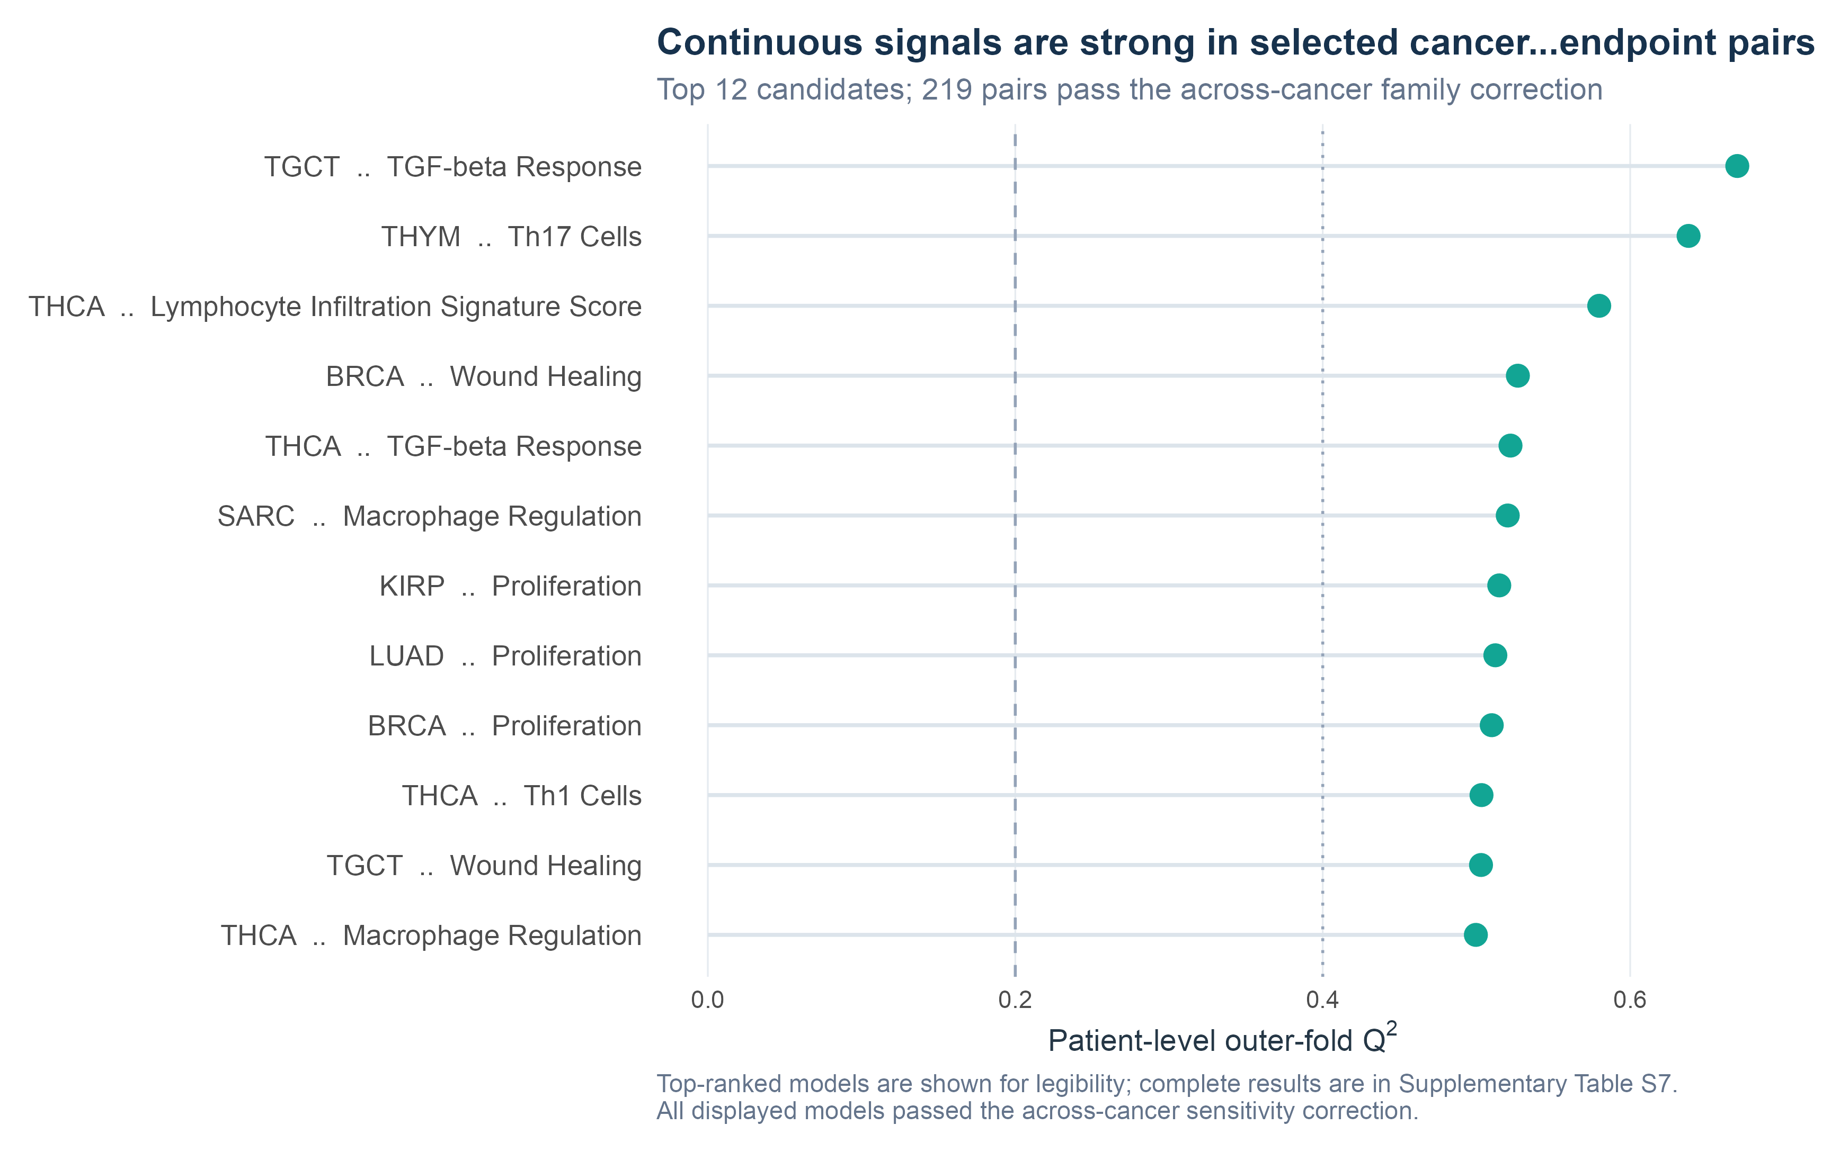
Figure 2. Eighteen strongest within-cancer screen-positive continuous cancer–endpoint results, ranked by primary screening Q². The reduced set and larger typography improve readability; complete results and five-repeat estimates are in Supplementary Table S7 and machine-readable files. All Q² values use genuine patient-level outer-fold predictions.

Binary molecular phenotypes
The binary screen yielded 29 candidates in prespecified screening tier A and 75 in tier B. The largest primary screening balanced accuracies were THYM–GTF2I [mutation] (0.883); READ–APC [mutation] (0.862); READ–TP53 [mutation] (0.861); LGG–TP53 [mutation] (0.846); THCA–BRAF [mutation] (0.830); LGG–TP53 [pathway] (0.822); LGG–HIPPO [pathway] (0.811); COAD–APC [mutation] (0.793); UCEC–Any called fusion [fusion] (0.792); LGG–IDH1 [mutation] (0.786); COAD–MSI-H strict (MANTIS >0.6) [strict MSI] (0.784); COAD–TP53 [mutation] (0.779). These initial nested-CV values determined screening and tier assignment; five-repeat means are reported separately for stability. The complete table distinguishes tested-negative pairs from outcomes that failed prevalence or sample-size eligibility.
Of 104 within-cancer screen-positive binary pairs, 102 also met the stricter across-cancer family q<0.05, including 39 cancer–gene mutation pairs. Mutation pairs passing this stricter sensitivity are distinguished from those supported only within cancer; the 0.001 permutation resolution remains relevant for the full mutation family.

Binary class-size sensitivity and development stability
Of 459 binary pairs eligible at 20 patients per class, 244 (53.2%) also met a 50-per-class rule. Among the 104 screen-positive models, 87 (83.7%) met that stricter standard. The other 17 were designated exploratory/limited evidence; none of the highlighted binary models was in this group. The complete atlas retains these results for transparency, whereas default PathoFMPred's TITAN interface now includes 87 binary and 219 continuous models and omits the limited subset unless explicitly requested.
Across all 104 screen-positive binary models, the smallest repeated outer test fold contained 4 positive and 6 negative patients. Within the limited subset, exact reconstructed inner folds contained as few as 12 positive and 19 negative training patients and 3 positive and 4 negative validation patients. Selected components were therefore reported for every one of the 25 repeated outer fits: 7/17 limited models selected one component in at least one fit, 14/17 reached the ten-component ceiling, and 5 spanned both extremes.
For the 17 limited models, median learning-curve balanced accuracy was 0.603, 0.640 and 0.636 at 50%, 75% and 100% of the outer-training data; median AUROC was 0.679, 0.730 and 0.738, and median PR-AUC was 0.304, 0.381 and 0.389. Median repeat score correlation was 0.674 in the limited subset versus 0.795 in the ≥50-per-class subset. Class-call agreement was also reported, but can appear high under marked imbalance and is not interpreted alone. Endpoint-level PR-AUC, TCGA-prevalence PPV/NPV, fold counts, component distributions, learning curves and stability are provided in Supplementary Table S10g and Figure S3.

Permutation resolution and atlas-wide multiplicity sensitivity
The primary within-cancer/family procedure identified 323 candidates. Of these, 321 passed BH within outcome type and endpoint family across cancers, 321 passed BH across all eligible tests within their outcome type, and 320 passed one BH correction across all 2,073 eligible continuous and binary atlas tests. The three local candidates not retaining atlas-wide q<0.05 were READ genome doubling, OV–TP53 mutation and SKCM–BRAF mutation. The candidate count should therefore be read as a collection of locally controlled cancer-specific questions, with the atlas-wide result as a stricter sensitivity—not as if the primary procedure were one global 5% FDR analysis.
Among completed 999-permutation tests, 308 had zero null statistics at least as extreme as observed. Their finite empirical p-value was 0.001, but the exact two-sided 95% Monte Carlo interval for the underlying exceedance probability was 0–0.003686. The prespecified high-resolution subset extended 8 leading models to 9,999 full nested permutations; 8 had zero exceedances and refined p-values were all 0.0001. The refined values are a targeted precision sensitivity and were not inserted into the primary FDR calculations. Because many primary p- and q-values remain tied at their attainable minimum, figures and tables are ordered by the outcome-appropriate predictive metric, with repeated stability and stability under grouping by TCGA tissue-source-site code reported alongside; q-values are not used for ranking.
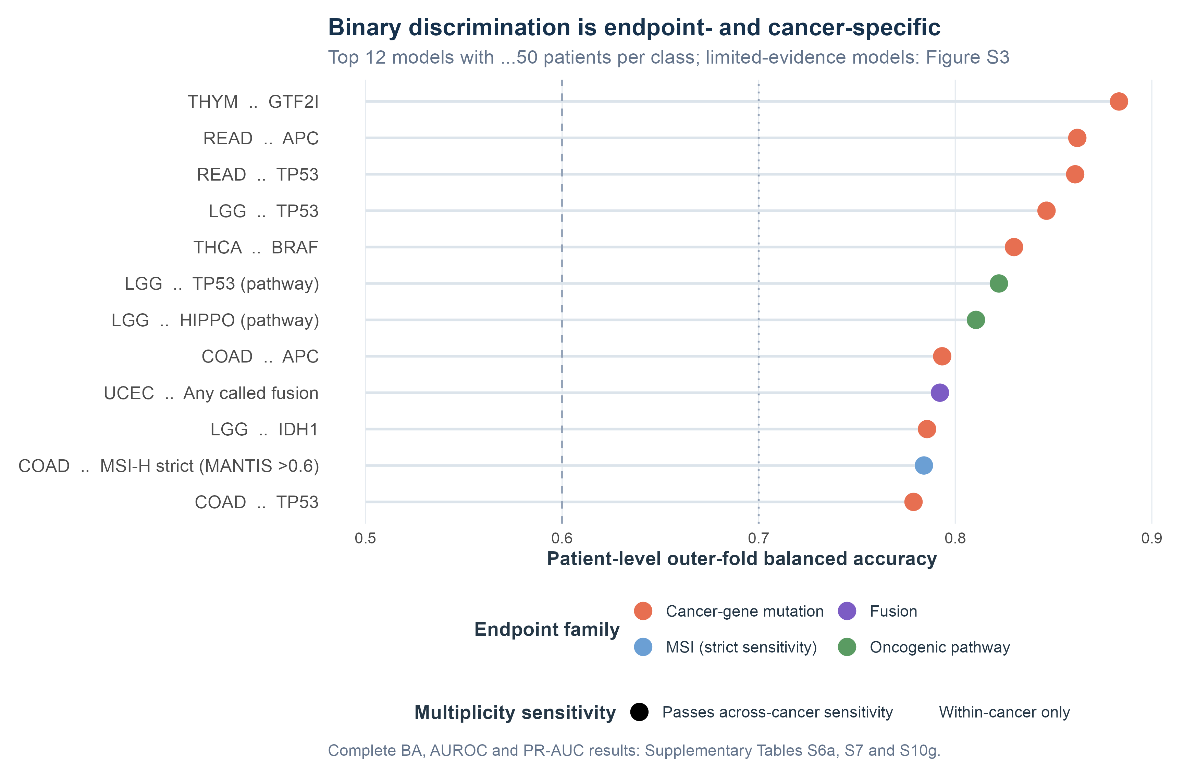
Figure 3. Eighteen strongest within-cancer screen-positive binary molecular predictions among the 87 models with at least 50 patients per class, ranked by primary screening balanced accuracy. Uniform point size and shortened labels reduce visual load; colour indicates endpoint family and symbols indicate across-cancer correction status. Complete BA, AUROC and PR-AUC results are in Supplementary Tables S6a, S7 and S10g. The 17 limited-evidence models appear in Figure S3.
Precision–recall performance was reported for every screen-positive binary endpoint. Across all 104 models, median five-repeat PR-AUC was 0.592; each value should be read against its no-skill reference, the observed TCGA prevalence. The 13 mutation or fusion endpoints with prevalence below 0.20 had median prevalence 0.091, median PR-AUC 0.360 (range 0.196–0.452), despite median AUROC 0.790. This divergence illustrates why AUROC or balanced accuracy alone can overstate positive-class retrieval under low prevalence. Endpoint-level PR-AUC, prevalence, repeat variability and class counts are reported in Supplementary Tables S6a, S7 and S10g and the machine-readable registry.
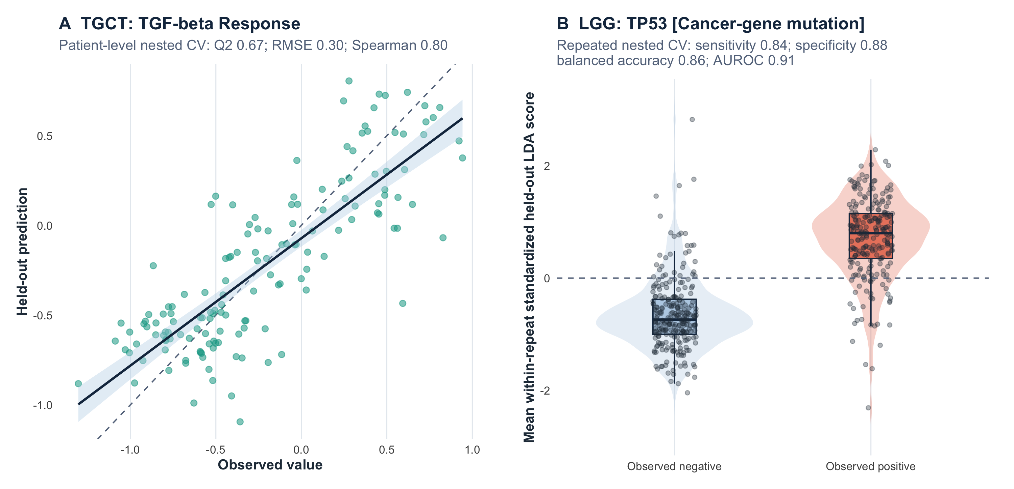
Figure 4. Examples comparing observed outcomes with held-out predictions. Panel A shows the strongest primary screening estimate from the initial patient-level nested-CV continuous screen (TGCT TGF-beta Response); each point is one patient's observed value and genuine held-out prediction. Panel B shows the binary model with the largest five-repeat mean balanced accuracy. Because independently fitted LDA scores need not share a raw scale, held-out scores are standardized within repeat before patient-level averaging for display; repeat-specific AUROCs use untransformed scores. These deliberately strong examples are illustrative, selection-conditioned internal TCGA results rather than external validation or calibration.
Complete highlighted-model performance, uncertainty, class-size metrics and estimates grouped by TCGA tissue-source-site code are reported in Supplementary Table S6a and the machine-readable result files. The main text retains outcome-level summaries and illustrative figures.
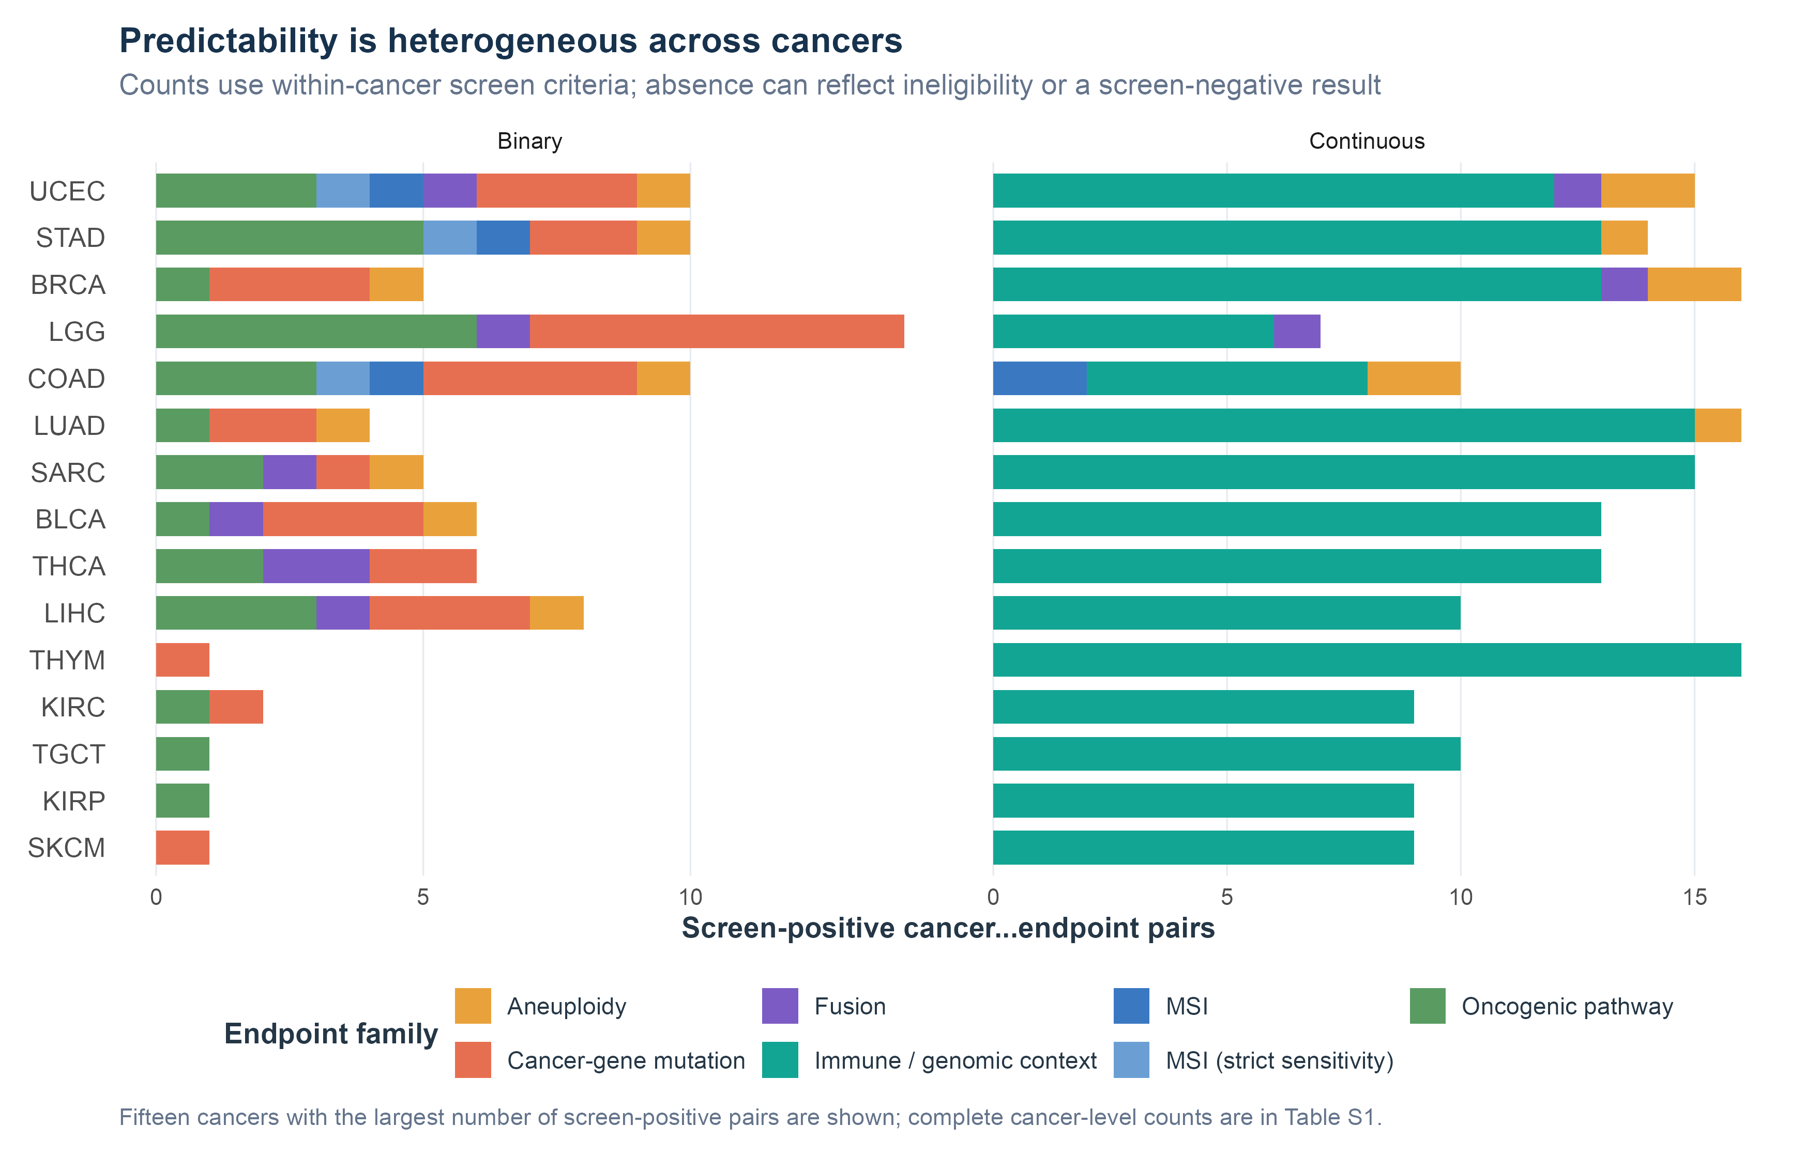
Figure 5. Breadth and family of screen-positive targets in the 15 cancers with the largest candidate counts. Restricting the display improves label size; complete cancer-level counts are in Supplementary Table S1. Absence of a target is distinct from a tested screen-negative result.

Metadata-stratified linear-model comparison
The deterministic representative benchmark contained 35 binary and 12 continuous targets selected from all eligible tests without reference to PLS performance; 14/47 happened to be screen-positive. For binary targets, the median ridge-minus-PLS AUROC difference was 0.008 (IQR -0.002 to 0.027); ridge had a selection-conditioned paired patient-resampling interval above zero for 8 models, PLS for 0, and 27 AUROC differences were uncertain. With the same inner-CV balanced-accuracy threshold rule applied to both methods, the median ridge-minus-PLS balanced-accuracy difference was 0.012 (IQR 0.005 to 0.025); ridge had a selection-conditioned paired patient-resampling interval above zero for 4 models, PLS for 0, and 31 were uncertain. For continuous targets, the median ridge-minus-PLS Q² difference was 0.053 (IQR 0.031 to 0.136); ridge was favoured for 10, PLS for 0, and 2 were uncertain. For continuous Spearman correlation, ridge was favoured for 3, PLS for 2 and 7 were uncertain. Thus the benchmark did not establish PLS superiority and more often favoured ridge, especially for continuous Q². These are representative paired comparisons rather than multiplicity-controlled algorithm discoveries or an atlas-wide ridge screen.

Sensitivity to grouping by TCGA tissue-source-site code
Internal validation grouped by TCGA tissue-source-site code was feasible for 323 screen-positive models. Although the median grouped-minus-random performance change was only -0.026, 83/323 models (25.7%) fell below the original prespecified screening threshold: 58/219 continuous models and 25/104 binary models. Prominent attenuations were READ–APC (balanced accuracy 0.862 to 0.495); COAD–APC (balanced accuracy 0.793 to 0.543); PCPG–Cell Cycle (balanced accuracy 0.686 to 0.476); LIHC–CTNNB1 (balanced accuracy 0.668 to 0.565); OV–TCR Shannon (Q² 0.206 to -0.551); COAD–SNV Neoantigens (Q² 0.239 to -0.013). Folds grouped by TCGA tissue-source-site code contain fewer and less evenly distributed training and test patients, so the decline cannot be attributed solely to confounding by that code; nevertheless, the near-chance colorectal APC results are not adequately summarised by the median and are prominently labelled as sensitive to grouping by TCGA tissue-source-site code in the registry and research-software output.
Across 1,613 outer folds, test partitions contained 1–445 patients and 1–9 TCGA tissue-source-site codes; binary folds contained 0–130 positive and 0–269 negative patients. These imbalances are intrinsic to keeping complete code groups together and are reported model by model and fold by fold. The deterministic fold audit confirmed that no TCGA tissue-source-site code crossed an outer fold and that the same separation was maintained in every inner component-selection split.
The dedicated within-cancer classification of TCGA tissue-source-site code analysis was evaluable in 27/32 cancers and included 7,863 patients from codes represented by at least 10 patients. All 27 observed macro balanced accuracies exceeded their cancer-specific 1/k chance reference; the median was 0.628 (range 0.425–0.966). The strongest chance-normalised code predictability occurred in UVM (macro balanced accuracy 0.966; 3 codes); OV (macro balanced accuracy 0.963; 2 codes); PAAD (macro balanced accuracy 0.911; 5 codes); ESCA (macro balanced accuracy 0.861; 7 codes); READ (macro balanced accuracy 0.862; 5 codes). ACC, CHOL, DLBC, MESO and UCS had fewer than two codes meeting the 10-patient requirement and were reported as ineligible. This result shows a held-out statistical association between the fixed TITAN representation and TCGA tissue-source-site code and strengthens the confounding concern; it does not identify causal scanner, laboratory or staining information.
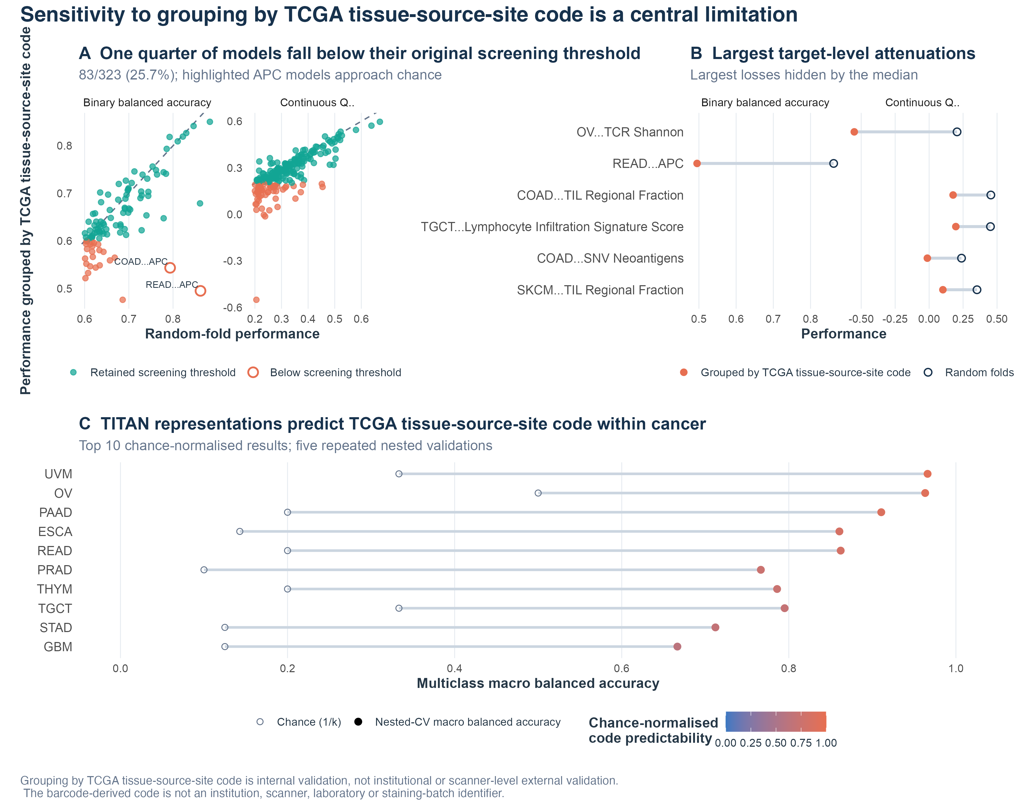
Figure 6. Sensitivity to grouping by TCGA tissue-source-site code as a principal result. Panel A compares all 323 random-fold estimates with estimates grouped by TCGA tissue-source-site code; Panel B shows the six largest attenuations; Panel C shows the 10 strongest chance-normalised within-cancer code-classification results. Larger typography and restricted ranked panels improve readability. This grouping remains internal to TCGA; the code is not an institutional, scanner or laboratory identifier, and the analysis is not external validation.

Multiple-slide sensitivity
Replacing each deterministic patient mean with the lexicographically first eligible diagnostic slide produced a median first-slide-minus-mean-pool performance change of -0.001 across screen-positive models. This patient-level sensitivity is distinct from the analysis grouped by TCGA tissue-source-site code.
Mean pooling limits numerical dominance by heavily sampled participants because each participant remains one validation observation, but it cannot rescue a patient whose eligible slides are uniformly non-representative of the molecularly profiled tumour. The 30-slide SARC example therefore motivates future independent pathology QC and tumour-area-aware aggregation rather than a claim that equal pooling solved tissue adequacy.

Qualitative morphology context
Five representative models were examined using high/low repeated out-of-fold anchors and their nearest within-cancer patient-level TITAN neighbours. The anchors were BLCA–TIL Regional Fraction: high TCGA-FD-A5BS, low TCGA-BL-A0C8; TGCT–Macrophages M2: high TCGA-YU-A94D, low TCGA-2G-AAF6; BRCA–Wound Healing: high TCGA-AR-A1AH, low TCGA-E9-A5UO; UCEC–Aneuploidy score: high TCGA-AJ-A23M, low TCGA-D1-A1NS; THYM–GTF2I: high TCGA-ZB-A96H, low TCGA-4V-A9QS. Exact slide identifiers, observed values, original prediction values, prediction ranks, embedding cosine similarities and generated-report excerpts are reported in Supplementary Table S14 and the machine-readable file; Figure S4 places all held-out patients behind the selected examples. The BLCA TIL Regional Fraction example is explicitly a same-H&E-modality concordance control. The remaining examples provide descriptive embedding context only. No patch-level attribution or blinded pathologist interpretation was possible from the released global embeddings and automated reports.
No non-TCGA patient entered model evaluation, and no external performance result is reported. The prespecified targets and protocol for future independent evaluation are provided in Supplementary Table S6c and the software documentation.

Illustrative COAD profiles
Two COAD participants, TCGA-AA-A01F and TCGA-AA-3972, illustrate contrasting continuous and binary profiles (Figure 7). The pair was chosen post hoc after clinical-text and profile-saturation restrictions and then maximising Euclidean separation across continuous TCGA OOF prediction ranks; the procedure intentionally enhances visual contrast. Nodal status was not matched: TCGA-AA-A01F was reported as pN1, whereas the available slide summary for TCGA-AA-3972 did not state a nodal category. The cases are not presented as a matched clinical comparison, and treatment, response, recurrence, follow-up and survival are neither shown nor interpreted. This is an illustration, not performance, prevalence, prognosis or treatment-response evidence.
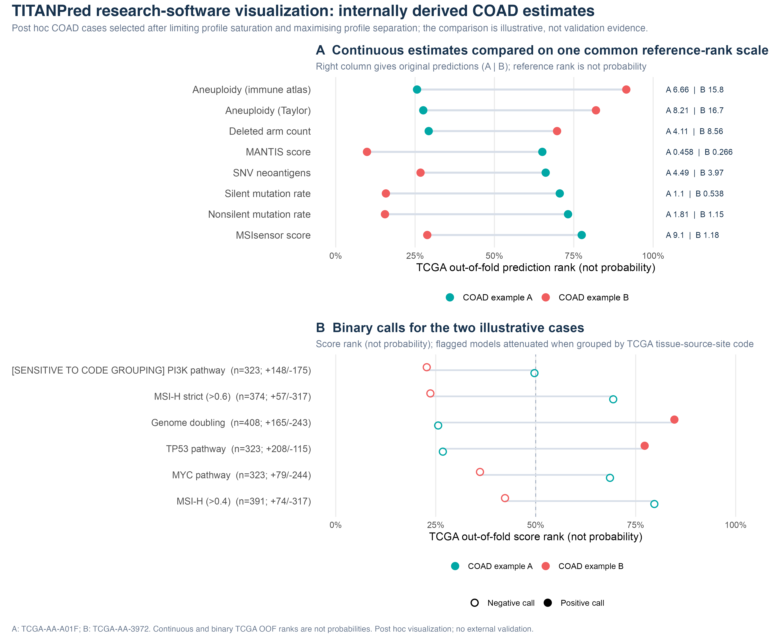
Figure 7. Post hoc PathoFMPred research-software visualization for two COAD participants using TITAN inputs. Panel A uses a common-scale dumbbell comparison of eight continuous TCGA OOF ranks; the right column preserves each original prediction. Panel B compares six binary PLS-LDA score ranks and calls with development class counts. All ranks are explicitly not probabilities. This is an interface illustration, not external validation or representative case sampling.
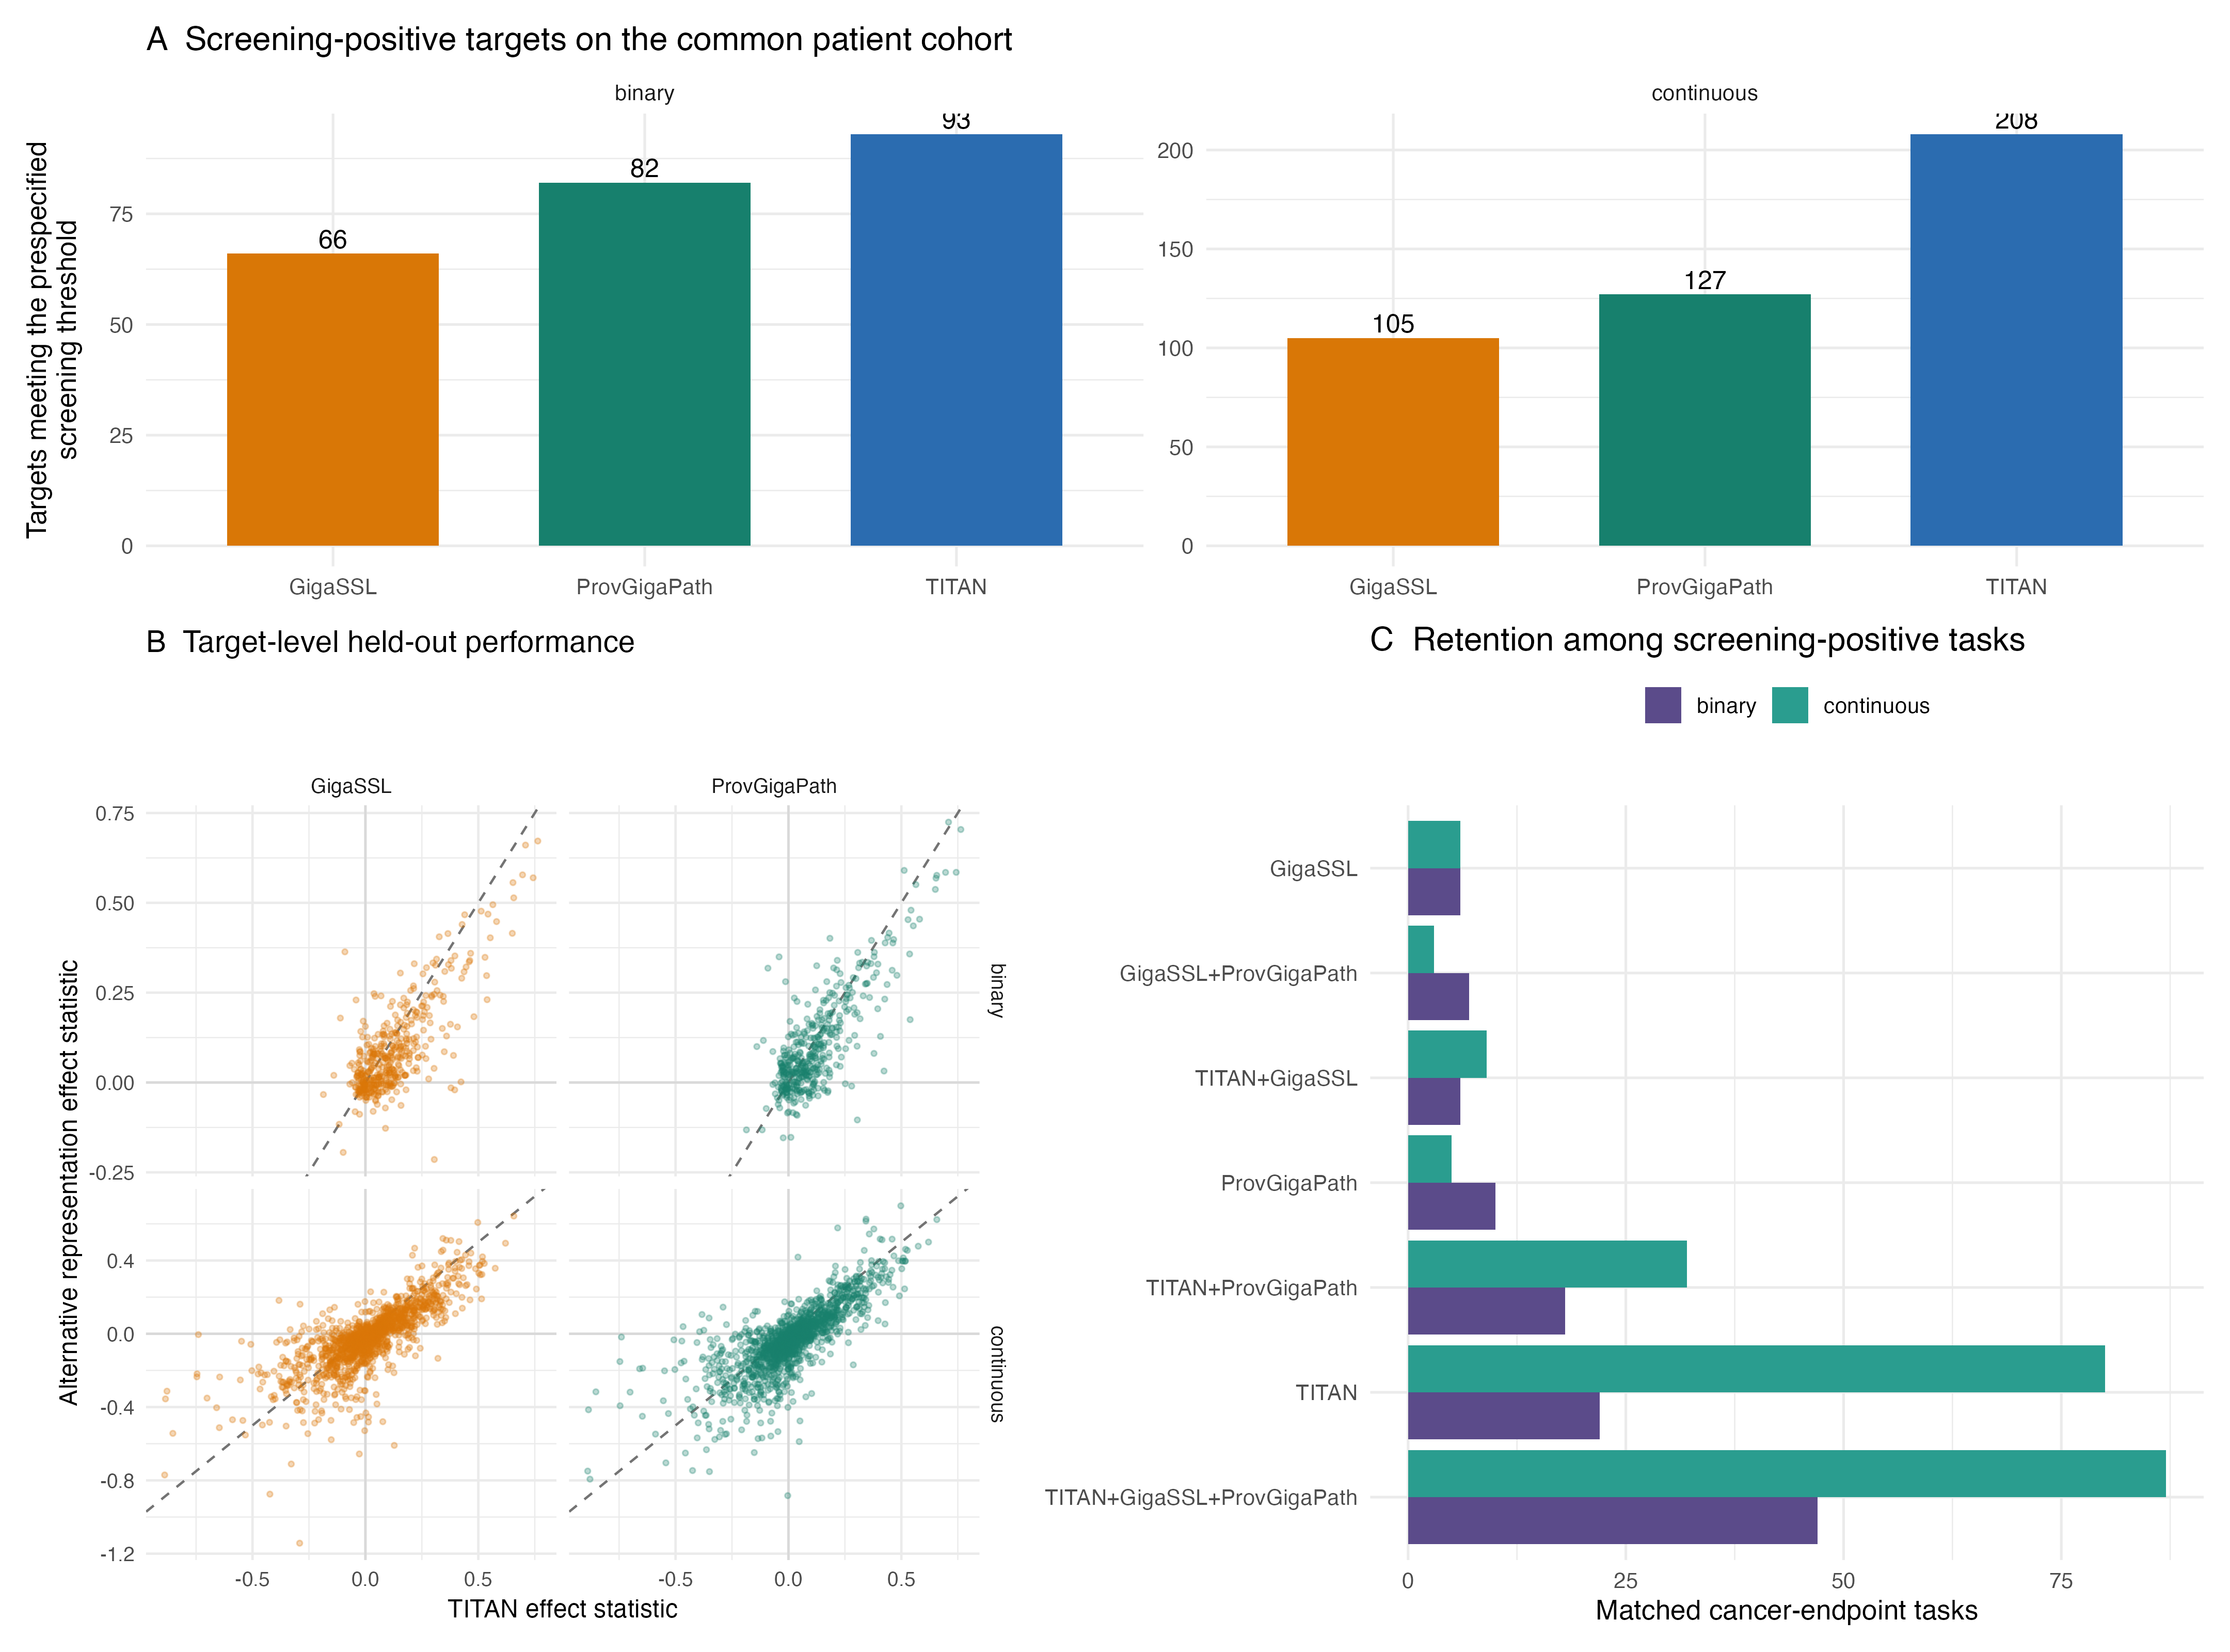
Figure 8. Matched patient-level comparison of TITAN, Giga-SSL and Prov-GigaPath. Panel A reports the number of cancer–endpoint tasks meeting the prespecified internal screening threshold on the common cohort. Panel B compares the target-level effect statistic (Q² for continuous outcomes; 2×balanced accuracy−1 for binary outcomes) against TITAN. Panel C shows which representations retain screening-positive tasks; screen-negative tasks are omitted from this panel for readability. Identical patients, folds, seeds and tuning rules were used within every task. These are internally derived TCGA estimates, not evidence of external transportability.

Discussion
This study is best interpreted as a patient-level pathology foundation-model benchmark and reusable fitted-model resource, not as the first pan-cancer molecular-prediction study or a catalogue of unprecedented mutation targets. Selected immune programmes, mutations and higher-level genomic phenotypes showed held-out cross-validated statistical association, but conclusions were representation-dependent. On a rigorously matched cohort TITAN produced the broadest set of screening-positive tasks, yet Giga-SSL or Prov-GigaPath yielded higher effect statistics for hundreds of individual endpoints. Foundation-model selection should therefore be treated as part of model development and uncertainty, not as a neutral preprocessing choice. Here and throughout, operational ‘predictability’ neither establishes causal biological information nor demonstrates recovery or replacement of the originating assay.
The three-way comparison is translationally relevant because an association that depends strongly on one representation is a weaker candidate for locked evaluation than one retained across distinct pretraining strategies. Cross-representation retention is not independent validation: all embeddings derive from TCGA slides, share the same outcomes and may encode the same cohort-specific artefacts. It nevertheless provides a practical robustness axis and a transparent basis for choosing which representation-specific fitted object to test next. The PathoFMPred interface exposes that choice explicitly rather than silently assuming that one foundation model is universally preferable.
The closest breadth comparator is Arslan et al., who already trained 12,093 target-specific models for 4,031 multi-omic biomarkers in 8,890 TCGA patients across the same 32 cancers [13]. The present study is smaller in endpoint breadth and lacks external validation. Its differentiating elements are the fixed pretrained representation, deterministic pre-outcome patient aggregation, nested patient-level validation, complete tested-negative and ineligible outputs, target-level sensitivity to grouping by TCGA tissue-source-site code, continuous modelling of selected immune and genomic-context measures, and distribution of compact fitted linear predictors. These distinctions—not breadth or endpoint novelty—motivate the study.
The relevant literature spans substantially different validation settings and metrics. For MSI, Kather et al. reported external AUROCs of 0.84 (95% CI 0.72–0.92) in DACHS colorectal cancer and 0.69 (0.52–0.82) in an external gastric cohort, whereas Echle et al. reported an external dMMR AUROC of 0.96 in a 771-case cohort [2,3]. For fusion prediction, Dadhania et al. reported ERG AUROCs of 0.82–0.85, and Mayer et al. reported 100% sensitivity with 100% and 98.6% specificity for ALK and ROS1, respectively, in a small external set [9,10]. Saldanha et al. externally evaluated mutation models in CPTAC, Bergstrom et al. reported external breast HRD AUROC 0.76 (0.71–0.82), and HistoTME reported mean external cell-composition correlation 0.50 and immunotherapy-response AUROC 0.75 (0.61–0.88) [11,14,15]. These externally tested results set a stronger validation standard than the internal TCGA estimates presented here; metric, endpoint and cohort differences preclude claims of direct superiority.
The expanded primary-study audit substantially changes the novelty interpretation. 38/41 screen-positive cancer–gene pairs had already received statistical support in reviewed histology-prediction studies, including pooled colorectal evidence mapped to both COAD and READ where appropriate. Examples include LGG–CIC (prior mean AUROC 0.836, current balanced accuracy 0.779), LGG–ATRX (prior mean AUROC 0.816), THCA–NRAS (0.809), LIHC–BAP1 (0.825), PAAD–TP53 (0.672) and KIRC–VHL (0.631) [13]. Prior studies generally reported AUROC, whereas the present primary metric is balanced accuracy; these values are contextual and are not estimates of improvement or inferiority.
Two current screen-positive pairs had been evaluated but were not statistically supported in the reviewed 2024 study: BLCA–PIK3CA (prior mean AUROC 0.588, corrected p=0.058; current balanced accuracy 0.601) and SKCM–BRAF (prior mean AUROC 0.579, corrected p=0.286; current balanced accuracy 0.626). Only THYM–GTF2I was not identified in the reviewed predictive-model literature; a strong direct GTF2I–thymoma morphology association is already established, so this result is presented as a prediction candidate requiring independent validation rather than a claim of biological novelty. The OV–TP53 entry is supported by a 2025 preprint reporting AUROC 0.82±0.02 and is labelled as preliminary evidence rather than peer-reviewed external validation [34]. The GTF2I morphology association itself was reported by Wells et al. [35]. Supplementary Table S10a and the machine-readable audit give the evidence scope, prior metric, source and note for every screen-positive pair.
External results also caution against equating internal discrimination with transportability. For PAAD–TP53, the current TCGA balanced accuracy was 0.619 and Arslan et al. reported mean internal AUROC 0.672, whereas Saldanha et al. reported internal AUROC 0.554 and external CPTAC AUROC 0.443±0.064 [11,13]. Differences can arise from cohort composition, slide preparation, mutation definition, model class and validation design. The present result therefore supports further locked external testing, not clinical application.
The non-mutation endpoints extend the analysis beyond the exact cancer–gene pairs used for the literature crosswalk, but they must not be collapsed under the phrase 'immune measurements'. Direct sequence-supported alterations, sequencing-derived burdens, inferred immune-cell fractions, transcriptomic signatures, pathology-derived quantities and composite genomic-context scores have different error models and biological meanings. In particular, prediction of a CIBERSORT fraction or RNA signature is agreement with a computational phenotype derived from a bulk specimen; it is not equivalent to flow cytometry, immunohistochemistry, a direct cell count or a clinically certified biomarker. TIL Regional Fraction is an even more specific same-modality case because both predictor and target originate from H&E. Its result is best interpreted as concordance between two image-derived summaries rather than molecular inference.
For continuous outcomes, prior work predicted RNA expression [6], tumour composition [4], continuous HRD and microenvironment features [12], and externally evaluated tumour-microenvironment composition in non-small cell lung cancer [15]. The present study instead screens the prespecified Thorsson-derived panel, genomic-context scores, MSI scores, fusion burden and aneuploidy burdens across eligible TCGA cancers using the same patient-level validation design. Only 219 continuous pairs passed the stricter across-cancer correction; the others should be treated as endpoint- and cancer-specific nominations, not as replications of the external HistoTME results or as evidence of general immune profiling.
The contribution is therefore not that TITAN plus PLS is an optimal algorithmic combination. It is the uniform, auditable patient-level screen over prespecified outcomes using one fixed representation, complete negative reporting and compact fitted reference models. PLS1 and PLS–LDA remain the prespecified reference analysis, but the released PLS objects should not be interpreted as the best available models.
The metadata-stratified benchmark directly weakens any stronger PLS claim. Selection depended only on outcome family, sample size, binary minority-class fraction and a fixed hash, not on PLS performance. Both algorithms used matched outer and inner folds; continuous hyperparameters maximised the same pooled inner Q² and binary thresholds maximised the same inner balanced accuracy. Median ridge-minus-PLS differences were 0.008 AUROC and 0.053 Q². Paired intervals favoured ridge for 8/35 binary and 10/12 continuous targets, PLS for none, and were otherwise uncertain. Portability cannot justify PLS over ridge because both yield compact exportable parameters. We did not replace the locked primary analysis or add post hoc method switching; instead, we report PLS as the prespecified reference and make clear that future model-resource development should compare locked PLS and ridge candidates in independent cohorts.
PLS2 addresses a different question. Its mean cancer-level ΔQ² relative to response-by-response PLS1 was 0.066 for inferred cell fractions, 0.017 for infiltration signatures and 0.056 for immune-repertoire measures, supporting shared inflammatory structure. It remains secondary because each joint fit uses only the complete-case intersection for a coherent continuous response block, shares one latent representation across a fixed ordered panel and cannot replace individual mutation, pathway, MSI, aneuploidy or fusion classifiers. The positive internal averages therefore nominate PLS2 for a future locked multiresponse immune resource; they do not establish a generally preferable main model without external validation and a matched multiresponse baseline.
The prespecified 20-per-class rule supported an inclusive atlas screen, but it was too permissive for presenting every selected binary model as equally mature. Only 87/104 screen-positive binary models met the stricter 50-per-class criterion. The 17 smaller-class models had sparse inner validation folds, frequently selected components across a wide range and showed lower median repeat score correlation than the ≥50-per-class group. Their learning curves showed no uniformly monotonic performance gain, illustrating that the available data cannot establish a stable sample-size plateau. We therefore retain them only as transparently reported exploratory results and exclude them from default inference. PR-AUC adds prevalence-aware discrimination information, whereas PPV and NPV are explicitly conditional on each analysed TCGA prevalence and should not be exported to another population. High call agreement under imbalance can be misleading and does not supersede score stability, sensitivity, PR-AUC or external validation.
Sensitivity to grouping by TCGA tissue-source-site code is a central result rather than a generic robustness footnote. Grouping revealed heterogeneity that the median attenuation concealed: 83/323 screen-positive models (25.7%) fell below their original prespecified screening threshold. READ–APC and COAD–APC declined from balanced accuracies 0.862 and 0.793 to 0.495 and 0.543, respectively. Smaller and less balanced training folds contribute to grouped-validation loss, but performance close to chance requires these models to carry a prominent warning rather than be described as robust biological signals. The model registry and inference output therefore expose the grouped metric, delta, number of TCGA tissue-source-site codes, threshold-retention status and warning for every affected endpoint.
The complementary classification analysis of TCGA tissue-source-site code analysis strengthens this interpretation: the fixed TITAN representation predicted the code within 27/32 evaluable cancers, with median macro balanced accuracy 0.628 despite cancer-specific chance references from 0.053 to 0.500. This demonstrates that information about the TCGA tissue-source-site code is present in the representation and could support confounding. It does not show that each attenuated molecular model is wholly artifactual, because the code correlates with case mix and molecular prevalence as well as technical acquisition. Conversely, successful grouping by TCGA tissue-source-site code cannot prove transportability: the barcode-derived code is not an institution, scanner, staining laboratory or batch identifier.
A further practical feature is data-minimising model portability. Preprocessing values, latent weights and coefficients are sufficient for continuous prediction, with compact LDA parameters added for binary classification. The access-controlled PathoFMPred package applies cancer-matched models to correctly ordered TITAN, Giga-SSL or Prov-GigaPath features without requiring the original patient embeddings or outcomes [32]. The selected representation is explicit in both input validation and output. Its private status is stated explicitly; the manuscript makes no public-artifact availability claim. This design reduces the patient-level data exchanged in authorised research, although it does not itself confer privacy, satisfy local governance requirements or establish transportability.
Strengths include primary-tumour matching across every data source, deterministic mean pooling of multiple slides, nested patient-level validation, FDR control within cancer and endpoint family, exact negative-result reporting, sensitivity analysis grouped by TCGA tissue-source-site code, saved research models and executable inference code. The supplied Bonneville spreadsheets contained only an ACC/CESC/MESO subset; cBioPortal PanCancer Atlas MANTIS fields were therefore used for full coverage and agreed exactly for all 387 overlapping cases.
The principal limitation is absence of independent external validation. TCGA resampling—including the analysis termed 'internal validation grouped by TCGA tissue-source-site code'—cannot establish transportability to another institution, scanner, stain distribution or patient population. The TCGA tissue-source-site code is not an institution, scanner or laboratory identifier. The study is retrospective and exploratory; thresholds are prioritisation rules, not clinical operating points. Although TCGA was excluded from TITAN's Mass-340K pretraining corpus, it was used in the original paper's downstream evaluation; the present cohort is therefore neither a pretraining cohort nor an independent validation cohort. Predictability means cross-validated statistical association only: it does not establish biological causality, reveal a mechanism, reproduce the analytical validity of the source measurement or justify omitting or replacing a molecular or immune assay. The three-model UCEC subset is locked only for future independent evaluation. Until that untouched analysis reports every target, the work should be evaluated as a computational pathology benchmark and research-software resource rather than a translational prediction study.
CPTAC-UCEC illustrates both feasibility and the remaining work: the official collection provides pathology images and links to molecular data, but the approximately 154-GB slide archive requires de novo TITAN extraction and exact outcome harmonisation [36]. Neither the slides nor external labels were inspected here. The locked protocol prohibits model refitting, recalibration and threshold changes; mandates the same patient-level pooling; and requires failure or non-evaluability to be reported. This protocol improves readiness and guards against post hoc target selection, but it is not external validation evidence.
The reported uncertainty is deliberately labelled a 95% selection-conditioned patient-resampling interval for repeated out-of-fold predictions. It represents patient sampling variability conditional on the five fitted nested-CV prediction sets and incorporates the five repeat-specific metrics into each bootstrap calculation. It does not repeat the initial screen or highlighting decision, generate new fold partitions, re-estimate scaling, reselect components, refit a model, correct winner's-curse optimism, or sample a new institution, scanner, staining process or population. It is therefore not a conventional confidence interval for model generalisation or an external-performance interval; locked-model evaluation in an untouched cohort is required for transportability assessment.
Arithmetic mean pooling gives each eligible slide equal within-patient weight and prevents multiple-slide leakage, but it does not model tumour content, variable tissue area, artefact, specimen procedure, slide quality or within-patient morphological heterogeneity. No structured fields for those quantities were available, and no independent pathology review was performed. The maximum-slide participant (TCGA-DX-AB2L, SARC) is particularly cautionary: all 30 generated narratives described no residual sarcoma/myxofibrosarcoma, although those same-image automated narratives cannot serve as adjudicated ground truth. The first-slide sensitivity measures dependence on one deterministic alternative and should not be interpreted as a comparison with pathology-screened, learned or tissue-area-weighted aggregation.
The 768-dimensional TITAN representation is not morphologically self-explanatory. The new high/low anchor and within-cancer nearest-neighbour analysis places representative predictions in the context of globally similar patient embeddings and preserves exact slide/report provenance, but it cannot determine which patch or tissue compartment drove a prediction. The available TCGA-Slide-Reports text was generated by TITAN from the same slides and is neither an independent annotation nor a blinded pathologist review. Consequently, descriptive terms such as lymphoid infiltrate, stromal pattern or necrosis are hypotheses for future review, not validated mechanisms. Tile-level representations or relevance maps retained prospectively, followed by blinded pathologist assessment, are required before morphological explanations can be claimed.
The post hoc subgroup audit partially addresses demographic performance but does not establish algorithmic fairness. Among high-volume models, both recorded-sex groups were estimable for 138 continuous and 56 binary targets, whereas at least two broad race groups were estimable for only 98 continuous and 32 binary targets. Sparse Black or African American, Asian and other recorded-race groups—and, for binary endpoints, sparse positive or negative classes within those groups—were the dominant barriers. Race categories are heterogeneous administrative labels and are not substitutes for ancestry, socioeconomic context or exposure. The estimates condition on the same selected TCGA models and held-out predictions, have no external validation, and were not accompanied by formal between-group tests or multiplicity correction. Apparent similarity therefore cannot be interpreted as demographic equivalence, and apparent differences may reflect sampling error, outcome prevalence, missingness or structure associated with TCGA tissue-source-site code. Any external evaluation should prespecify representative sampling, intersectional subgroups, calibration and failure analysis.

Conclusions
Using patient-level mean-pooled TITAN, Giga-SSL and Prov-GigaPath representations, this study shows that foundation-model choice materially affects internal molecular and derived immune-feature performance. TITAN was strongest in aggregate on the matched TCGA tasks, but no representation was uniformly best. PathoFMPred provides a model-aware research interface for locked follow-up without distributing patient-level training data. All results remain internally derived TCGA estimates; prediction of an inferred target is not evidence that a direct assay has been reproduced. The contribution is a transparent comparative computational-pathology benchmark and research-software framework—not external performance evidence or clinical validation—and independent testing remains essential.

Abbreviations
AUROC, area under the receiver operating characteristic curve; BA, balanced accuracy; CV, cross-validation; FDR, false discovery rate; H&E, haematoxylin and eosin; LDA, linear discriminant analysis; MC3, Multi-Center Mutation Calling in Multiple Cancers; MSI, microsatellite instability; OOF, out-of-fold; PLS, partial least squares; PLS1, single-response PLS; PLS2, multi-response PLS; Q², cross-validated coefficient of determination; RMSE, root-mean-square error; TCGA, The Cancer Genome Atlas.

Declarations

Ethics approval and consent to participate
This secondary analysis used publicly available, de-identified TCGA data. No participants were recruited and no new tissue was collected.

Consent for publication
Not applicable.

Study registration and protocol
This retrospective secondary analysis was not registered. The locked executable analysis plan is available in the companion repository [30].

Patient and public involvement
Patients and members of the public were not involved in the design, conduct, interpretation or reporting of this secondary analysis.

Availability of data and materials
The analysis used the official TITAN TCGA feature artifact, official Giga-SSL TCGA embeddings and the seandavis/tcga_provgigapath_embeddings Hugging Face dataset. Conversion scripts, exact source locations, commits, access conditions and SHA-256 checksums are recorded in the companion repository [30]. Controlled-access whole-slide images are not redistributed. TCGA molecular data remain available from their cited sources. The separate PathoFMPred package and fitted research objects are maintained in a private access-controlled repository [32]; this manuscript does not claim that those artifacts are publicly downloadable.

Competing interests
[Author confirmation required before submission.]

Funding
[Author confirmation required before submission.]

Authors’ contributions
[Author initials and contribution statement required before submission.]

Acknowledgements
OpenAI Codex assisted with code refactoring and language editing. Human authors remain responsible for verification, interpretation and the submitted text.

Additional files
Additional file 1 (.docx): Supplementary material. Contains Supplementary Methods, Tables S1–S15, Figures S1–S4 and an inventory of the companion machine-readable result files.
Additional file 2 (.pdf): COAD example A (TCGA-AA-A01F) PathoFMPred research-software output using TITAN features. Post hoc supplementary interface illustration containing internally derived full-cohort TCGA estimates; not probability-calibrated or externally validated.
Additional file 3 (.pdf): COAD example B (TCGA-AA-3972) PathoFMPred research-software output using TITAN features. Post hoc supplementary interface illustration containing internally derived full-cohort TCGA estimates; not probability-calibrated or externally validated.

References
1. Coudray N, et al. Classification and mutation prediction from non-small cell lung cancer histopathology images using deep learning. Nat Med. 2018;24:1559–1567. doi:10.1038/s41591-018-0177-5.
2. Kather JN, et al. Deep learning can predict microsatellite instability directly from histology in gastrointestinal cancer. Nat Med. 2019;25:1054–1056. doi:10.1038/s41591-019-0462-y.
3. Echle A, et al. Clinical-grade detection of microsatellite instability in colorectal tumors by deep learning. Gastroenterology. 2020;159:1406–1416.e11. doi:10.1053/j.gastro.2020.06.021.
4. Fu Y, et al. Pan-cancer computational histopathology reveals mutations, tumor composition and prognosis. Nat Cancer. 2020;1:800–810. doi:10.1038/s43018-020-0085-8.
5. Kather JN, et al. Pan-cancer image-based detection of clinically actionable genetic alterations. Nat Cancer. 2020;1:789–799. doi:10.1038/s43018-020-0087-6.
6. Schmauch B, et al. A deep learning model to predict RNA-Seq expression of tumours from whole slide images. Nat Commun. 2020;11:3877. doi:10.1038/s41467-020-17678-4.
7. Howard FM, et al. The impact of site-specific digital histology signatures on deep learning model accuracy and bias. Nat Commun. 2021;12:4423. doi:10.1038/s41467-021-24698-1.
8. Loeffler CML, et al. Predicting mutational status of driver and suppressor genes directly from histopathology with deep learning. Front Genet. 2022;12:806386. doi:10.3389/fgene.2021.806386.
9. Dadhania V, et al. Leveraging artificial intelligence to predict ERG gene fusion status in prostate cancer. BMC Cancer. 2022;22:494. doi:10.1186/s12885-022-09559-4.
10. Mayer C, et al. Direct identification of ALK and ROS1 fusions in non-small cell lung cancer from hematoxylin and eosin-stained slides using deep learning algorithms. Mod Pathol. 2022;35:1882–1887. doi:10.1038/s41379-022-01141-4.
11. Saldanha OL, et al. Self-supervised attention-based deep learning for pan-cancer mutation prediction from histopathology. npj Precis Oncol. 2023;7:35. doi:10.1038/s41698-023-00365-0.
12. El Nahhas OSM, et al. Regression-based deep-learning predicts molecular biomarkers from pathology slides. Nat Commun. 2024;15:1253. doi:10.1038/s41467-024-45589-1.
13. Arslan S, et al. A systematic pan-cancer study on deep learning-based prediction of multi-omic biomarkers from routine pathology images. Commun Med. 2024;4:48. doi:10.1038/s43856-024-00471-5.
14. Bergstrom EN, et al. Deep learning artificial intelligence predicts homologous recombination deficiency and platinum response from histologic slides. J Clin Oncol. 2024;42:3550–3560. doi:10.1200/JCO.23.02641.
15. Patkar S, et al. Predicting the tumor microenvironment composition and immunotherapy response in non-small cell lung cancer from digital histopathology images. npj Precis Oncol. 2024;8:280. doi:10.1038/s41698-024-00765-w.
16. Ding T, et al. A multimodal whole-slide foundation model for pathology. Nat Med. 2025;31:3749–3761. doi:10.1038/s41591-025-03982-3.
17. Wold S, Sjöström M, Eriksson L. PLS-regression: a basic tool of chemometrics. Chemometr Intell Lab Syst. 2001;58:109–130. doi:10.1016/S0169-7439(01)00155-1.
18. Szymańska E, et al. Double-check: validation of diagnostic statistics for PLS-DA models. Metabolomics. 2012;8(Suppl 1):3–16. doi:10.1007/s11306-011-0330-3.
19. Thorsson V, et al. The Immune Landscape of Cancer. Immunity. 2018;48:812–830.e14. doi:10.1016/j.immuni.2018.03.023.
20. Taylor AM, et al. Genomic and functional approaches to understanding cancer aneuploidy. Cancer Cell. 2018;33:676–689.e3. doi:10.1016/j.ccell.2018.03.007.
21. Gao Q, et al. Driver fusions and their implications in the development and treatment of human cancers. Cell Rep. 2018;23:227–238.e3. doi:10.1016/j.celrep.2018.03.050.
22. Bonneville R, et al. Landscape of microsatellite instability across 39 cancer types. JCO Precis Oncol. 2017;2017:PO.17.00073. doi:10.1200/PO.17.00073.
23. Cerami E, et al. The cBio cancer genomics portal: an open platform for exploring multidimensional cancer genomics data. Cancer Discov. 2012;2:401–404. doi:10.1158/2159-8290.CD-12-0095.
24. Ellrott K, et al. Scalable open science approach for mutation calling of tumor exomes. Cell Syst. 2018;6:271–281.e7. doi:10.1016/j.cels.2018.03.002.
25. Bailey MH, et al. Comprehensive characterization of cancer driver genes and mutations. Cell. 2018;173:371–385.e18. doi:10.1016/j.cell.2018.02.060.
26. Sanchez-Vega F, et al. Oncogenic signaling pathways in The Cancer Genome Atlas. Cell. 2018;173:321–337.e10. doi:10.1016/j.cell.2018.03.035.
27. Benjamini Y, Hochberg Y. Controlling the false discovery rate: a practical and powerful approach to multiple testing. J R Stat Soc B. 1995;57:289–300. doi:10.1111/j.2517-6161.1995.tb02031.x.
28. Collins GS, et al. TRIPOD+AI statement: updated guidance for reporting clinical prediction models that use regression or machine learning methods. BMJ. 2024;385:e078378. doi:10.1136/bmj-2023-078378.
29. Liu J, et al. An integrated TCGA pan-cancer clinical data resource to drive high-quality survival outcome analytics. Cell. 2018;173:400–416.e11. doi:10.1016/j.cell.2018.02.052.
30. Pathology foundation-model patient-level benchmark repository. GitHub. https://github.com/tkcaccia/titan-prediction. Accessed 24 Aug 2026.
31. International Agency for Research on Cancer. Global Cancer Observatory: GLOBOCAN 2022 world fact sheet. Lyon: IARC; 2024. https://gco.iarc.who.int/media/globocan/factsheets/populations/900-world-fact-sheet.pdf. Accessed 16 Aug 2026.
32. PathoFMPred R package and fitted-model repository. GitHub. https://github.com/tkcaccia/PathoFMPred. Accessed 24 Aug 2026.
33. National Cancer Institute. Genomic Data Commons Cases API. https://api.gdc.cancer.gov/cases. Accessed 16 Aug 2026.
34. Fernandes G. Morpho-genomic deep learning for ovarian cancer subtype and gene mutation prediction from histopathology. arXiv. 2025;arXiv:2511.03365. doi:10.48550/arXiv.2511.03365.
35. Wells K, Lamrca A, Papaxoinis G, et al. Unique correlation between GTF2I mutation and spindle cell morphology in thymomas (type A and AB thymomas). J Clin Pathol. 2023;76:463–466. doi:10.1136/jclinpath-2021-207837.
36. National Cancer Institute Clinical Proteomic Tumor Analysis Consortium. CPTAC-UCEC: The Clinical Proteomic Tumor Analysis Consortium Uterine Corpus Endometrial Carcinoma Collection. The Cancer Imaging Archive. doi:10.7937/K9/TCIA.2018.3R3JUISW. Accessed 24 Aug 2026.
37. Newman AM, et al. Robust enumeration of cell subsets from tissue expression profiles. Nat Methods. 2015;12:453–457. doi:10.1038/nmeth.3337.
38. Saltz J, et al. Spatial organization and molecular correlation of tumor-infiltrating lymphocytes using deep learning on pathology images. Cell Rep. 2018;23:181–193.e7. doi:10.1016/j.celrep.2018.03.086.
39. Lazard T, Lerousseau M, Decencière E, Walter T. Giga-SSL: self-supervised learning for gigapixel images. arXiv. 2022;arXiv:2212.03273. doi:10.48550/arXiv.2212.03273.
40. Xu H, et al. A whole-slide foundation model for digital pathology from real-world data. Nature. 2024;630:181–188. doi:10.1038/s41586-024-07441-w.

