Supplementary material
Patient-level comparison of three released pathology representation pipelines with a common PLS-based probe across TCGA cancers
This document is Additional file 1, supplementary_material_JTM.docx. Additional_file_2_COAD_example_A_PathoFMPred_report.pdf and Additional_file_3_COAD_example_B_PathoFMPred_report.pdf contain the separate COAD research-software examples.

Contents
This shortened Supplement retains interpretation-critical methods, compact three-representation biological summaries and four supporting figures. Complete target-level, fold-level and fitted-model records remain in the synchronized machine-readable companions.
- Supplementary Methods: outcome construction, validation, reliability, literature and endpoint provenance
- Tables S1-S3: cohort, pathology and molecular linkage
- Tables S4-S7: three-representation binary, continuous, family-level and literature summaries
- Tables S8-S13: statistical audits, endpoint provenance, matched benchmark, slide intersection and normalized breadth
- Figures S1-S4: binary reliability, continuous reliability, TCGA tissue-source-site code sensitivity and paired representation effects
- Machine-readable companion inventory by analysis domain

Supplementary Methods
Reference numbers in this Supplement refer to the main-manuscript bibliography. The analysis used the established histology-prediction literature [1-15,17], PLS and discriminant-analysis methodology [33-34], published TCGA phenotype sources [20,25-31], false-discovery-rate and reporting guidance [35-36], the TCGA Clinical Data Resource [37], analysis and software repositories [32,38], global-incidence and GDC resources [39-40], targeted literature and planned external-cohort sources [41-43], immune-deconvolution and H&E TIL methods [21-22], the evaluated representation publications and released artifacts [18-19,44-45], DINOv2 as a general self-supervised vision example [16], UCSC Xena [23] and the MSigDB Hallmark collection [24].
The executable analysis plan, source manifest, eligibility catalogues, checkpoint-capable scripts and released out-of-fold prediction tables are available in the public GPL-3.0-or-later companion analysis repository. PathoFMPred contributor-authored source code and documentation are released under the MIT License. The public package contains a minimal Giga-SSL fixture and explicit, checksum-verified post-install download functions for the permitted Giga-SSL and Prov-GigaPath fitted collections. Those assets carry separate notices and upstream attribution. The TITAN fitted collection is excluded from the public repository because redistribution requires upstream permission; authorized users can construct and apply a local object with the generic builder and object-level prediction function. Large local restart checkpoints and patient-level source data are not redistributed. Tables below are concise views; synchronized machine-readable files provide the complete-resolution companion records.
For the selected cancer and representation, PathoFMPred prediction, plotting and reporting include only fitted objects that met the recorded predictability rule. In the matched atlas this is Q² at least 0.20 for continuous endpoints or AUROC at least 0.60 for binary endpoints. TITAN objects outside the three-representation common cohort retain the supporting permutation/FDR-qualified TITAN status. Smaller-sample crossings require explicit opt-in, while tested-below-threshold objects never enter prediction or reports and remain visible only in the raw audit registry.
Terminology: predictability denotes held-out cross-validated statistical association under the specified model, folds, target definition and performance criterion. It does not denote causal biology, mechanistic interpretation, direct reconstruction of an assay, analytical or clinical equivalence, or permission to replace the originating measurement.
Metric definitions: Q² is the cross-validated coefficient of determination; a q-value is a false-discovery-rate-adjusted empirical p-value; out-of-fold (OOF) denotes predictions generated for patients excluded from model fitting; a selection-conditioned (SC) interval is the patient-resampling interval calculated from the five fixed repeated OOF prediction sets; and TCGA tissue-source-site code is the barcode-derived submitting-centre field used as an internal cohort-structure variable.
Representation-artifact audit: the downloaded Prov-GigaPath Parquet contained 1,406 excess rows across 1,402 duplicated slide identifiers. The repeated final-layer vectors were exactly identical. Conversion retained the first occurrence and removed all 1,406 exact duplicate Prov-GigaPath rows before slide filtering and patient pooling, so repeated source rows could not alter slide or patient weights. The source dataset card does not document why the duplicate rows were present.

Outcome acquisition, participant linkage and label construction
The published supplementary workbooks or public TCGA PanCancer files identified below were downloaded, and values were imported with the source-specific rules implemented in R/02_build_nonmutation_targets.R and R/03_build_mutation_targets.R. Outcomes were joined after slide pooling. A 12-character TCGA participant barcode was used for every analysis row, and 15-character sample barcodes were retained when supplied by the source. Source absence was treated as missing rather than negative. The exception was a documented assayed denominator: MC3-profiled patients without a qualifying mutation and Gao study samples without a fusion call were assigned negative according to the rules below. Filenames, DOI identifiers and SHA-256 digests are recorded in the source manifest; cancer-specific denominators are reported in molecular_source_coverage_audit.csv and mutation_coverage_audit.csv.
Thorsson PanImmune. 22 CIBERSORT LM22 fractions; methylation-derived leukocyte fraction; 10 RNA inflammatory or immune signatures; six BCR/TCR repertoire metrics; two mutation rates; two predicted neoantigen burdens; six genomic-context quantities; H&E-derived TIL Regional Fraction Source: immunology_paper.xlsx; sheet PanImmune_MS (Thorsson et al. 2018; doi:10.1016/j.immuni.2018.03.023). Identifier: 12-character TCGA Participant Barcode only. Processing: Selected 50 non-survival, non-subtype, non-aggregate fields; imported published values rather than recomputing them. Participant rule: One published participant row; endpoint-specific missing values retained. Missing or negative rule: Not applicable to continuous endpoints; absence from the table remained missing. Transformation: Natural log of one plus the source value for silent and nonsilent mutation rates, SNV and indel neoantigens, and number of segments; all other values used as supplied.
MC3 mutations with Bailey driver catalogue. Binary tissue-specific driver-gene mutation status Source: TCGAmutations MC3 objects; Bailey mmc1.xlsx sheet Table S1 (Ellrott et al. 2018 and Bailey et al. 2018; doi:10.1016/j.cels.2018.03.002 and 10.1016/j.cell.2018.02.060). Identifier: 15-character TCGA Tumor Sample Barcode from MC3 clinical metadata. Processing: Retained primary-tumour sample type 01, FILTER=PASS and protein-altering missense, nonsense, nonstop, splice-site, translation-start, frameshift or in-frame variants; COADREAD drivers mapped to COAD and READ. Participant rule: Any qualifying variant in any matched profiled primary sample defined mutated. Missing or negative rule: Wild type assigned only to patients with an MC3-profiled primary tumour and no qualifying variant in that gene; patients without MC3 profiling remained missing. Transformation: None.
Sanchez-Vega oncogenic pathways. Binary alteration status for ten oncogenic signalling pathways Source: oncogenic_mmc4.xlsx; sheet Pathway level (Sanchez-Vega et al. 2018; doi:10.1016/j.cell.2018.03.035). Identifier: 15-character SAMPLE_BARCODE. Processing: Retained primary-tumour sample type 01 and the published pathway-level binary matrix. Participant rule: Any altered primary sample defined the patient-level pathway as altered. Missing or negative rule: Covered primary samples without the pathway alteration were negative; participants absent from the source remained missing. Transformation: None.
Taylor aneuploidy. Aneuploidy score, deleted-arm count, amplified-arm count and genome doubling Source: aneuploidy_mmc2.xlsx; Table S2 (Taylor et al. 2018; doi:10.1016/j.ccell.2018.03.007). Identifier: 15-character Sample barcode. Processing: Retained primary-tumour sample type 01 and the published aneuploidy fields. Participant rule: Continuous values were averaged across primary samples; any positive primary sample defined genome doubling. Missing or negative rule: Participants absent from the source remained missing. Transformation: None.
Gao fusions. Fusion burden, any called fusion and eligible recurrent fusion-pair indicators Source: fusion_mmc2.xlsx; sheets TCGA samples used in this study and Final fusion call set (Gao et al. 2018; doi:10.1016/j.celrep.2018.03.050). Identifier: 15-character Sample barcode. Processing: Retained primary-tumour sample type 01; the study sample sheet defined assay coverage and the final-call sheet defined unique fusions. Participant rule: Unique fusion calls were collapsed by participant. Missing or negative rule: Within the assayed denominator, no fusion call meant zero; participants outside the study sample list remained missing. Transformation: Natural log of one plus the unique fusion count for fusion burden.
cBioPortal TCGA PanCancer MSI. MANTIS score, MSIsensor score and two MANTIS-based MSI-H definitions Source: data_clinical_sample.txt downloaded for 31 TCGA PanCancer Atlas studies (cBioPortal TCGA PanCancer Atlas and Bonneville et al. 2017; doi:10.1200/PO.17.00073). Identifier: 15-character SAMPLE_ID. Processing: Retained primary-tumour sample type 01 and finite MSI_SCORE_MANTIS or MSI_SENSOR_SCORE values. Participant rule: Finite scores were averaged across primary samples. Missing or negative rule: All missing primary-sample scores remained missing; MANTIS greater than 0.4 defined MSI-H in the main binary definition; the strict sensitivity used greater than 0.6 as MSI-H, less than 0.4 as MSS and excluded 0.4 to 0.6. Transformation: None.
UCSC Xena RNA pathway activity. 50 MSigDB Hallmark pathways; Reactome glutathione synthesis and recycling; Gene Ontology vitamin B6 metabolic process Source: data/external/xena/EB++AdjustPANCAN_IlluminaHiSeq_RNASeqV2.geneExp.xena.gz and data/reference/pathway_gene_sets_msigdbr_2026.1.Hs.csv (UCSC Xena TCGA Pan-Cancer RNA-seq and MSigDB 2026.1.Hs). Identifier: 15-character TCGA RNA-seq sample barcode. Processing: Retained primary-tumour sample type 01; standardized each measured gene within cancer; scored each set as mean standardized expression of measured member genes. Participant rule: Expression was averaged across multiple primary-tumour aliquots before pathway scoring. Missing or negative rule: Participants without a matched primary-tumour RNA sample remained missing; a pathway required at least two measured member genes. Transformation: None beyond within-cancer gene standardization.

Binary class-size, fold-composition and stability analyses
The primary screening estimate is the initial nested-CV value used for candidate selection and permutation testing. The repeated-validation estimate is the mean across five additional independently seeded nested-CV partitions and is reported as a post-selection stability estimate. The values need not be identical because the fold partitions and rSVD seeds differ. The supporting screen retained a minimum of 20 positive and 20 negative participants so that rare cancer-specific endpoints were not silently discarded; a separate 50-per-class analysis was used only as a sample-size sensitivity. For all 99 binary candidates, every repeated outer fold and the corresponding inner partitions used to select 1 to 20 components were audited for class counts. Component distributions summarize the 25 outer fits generated by five repeats of five-fold nested validation. PR-AUC is non-interpolated average precision; PPV and NPV use held-out calls and the observed TCGA prevalence and are not calibrated or transportable probabilities.
Prediction stability used standardized held-out LDA scores because independently fitted discriminant scales are not directly comparable. For each pair of repeats, Spearman correlation was calculated over patient scores and agreement over class calls, then averaged. Limited-evidence learning curves used the original outer test fold at every fraction and fitted the model to deterministic stratified 50%, 75% and 100% subsets of that fold's training patients. The full-data point exactly reproduces the original repeated nested-CV result. Small-class screen-positive models remain in the complete analysis registry but are excluded from default PathoFMPred inference; an explicit include_limited_evidence=TRUE opt-in emits a warning.

Continuous sample-size and stability audit
For all 770 continuous TITAN candidates, the outcome-labelled sample size, five-repeat Q² distribution and patient-level prediction stability were summarized. Stability was the mean of all ten pairwise Spearman correlations between the five repeated out-of-fold prediction vectors. The deterministic seed schedule was rerun to persist the component selected in each of 25 outer fits per target. A 20-component selection was recorded as reaching the fixed search ceiling. Ninety-one models had fewer than 100 labelled patients and were assigned to the smaller sample-size maturity stratum; the corresponding binary stratum contained 19 models with fewer than 50 patients in one class. These descriptive cutoffs do not change eligibility, screening, multiplicity or the complete atlas and are not evidence grades.

Targeted narrative literature audit
A targeted narrative audit rather than a systematic review was conducted. PubMed was last searched on 24 August 2026 with: (1) ‘(histology OR H&E OR whole-slide image) AND (mutation OR genomic alteration) AND (prediction OR deep learning) AND cancer’; (2) ‘(computational pathology OR digital pathology) AND molecular biomarker prediction AND cancer’; (3) ‘pan-cancer AND histology AND mutation prediction AND TCGA’; and (4) ‘thymoma AND GTF2I AND (histology OR morphology OR prediction)’. Backward and forward citations of the principal pan-cancer and endpoint-specific reports were checked, and primary-study supplementary tables were inspected when available.
Human tumour studies were included when they predicted a mutation or molecular feature from routine histological whole-slide images and reported a cancer–endpoint result mappable to the present atlas. Morphology-only associations without a predictive model, non-histological predictors, prognosis-only studies, reviews without primary performance estimates and non-mappable targets were excluded. Preprints were retained in a separate preliminary-evidence category. A pooled colorectal/CRC result was mapped to both COAD and READ but retained the scope label ‘pooled colorectal’; exact COAD or READ evidence took precedence. One investigator screened and extracted the study, cancer, endpoint, metric, statistical-support status, cohort scope and source URL. There was no duplicate independent screening, protocol registration or formal risk-of-bias assessment. Accordingly, ‘not identified’ means not found in this targeted cross-check and is not a claim of bibliographic novelty. The machine-readable method and pair-level decisions are literature_crosscheck_method.csv and supported_mutation_literature_audit.csv.

Endpoint provenance and qualitative morphology context
Every eligible cancer-endpoint target was assigned a label-generation class before interpretation: directly observed genomic alteration, sequencing-derived continuous burden, computationally inferred immune-cell fraction, transcriptomic signature, pathology-associated quantity or composite genomic-context score. The machine-readable endpoint_dictionary.csv contains one row for every target, including source modality, direct or inferred status, derivation algorithm, original scale, analysis transformation, missingness, expected measurement error, biological interpretation and an assay-equivalence caveat. endpoint_definition_dictionary.csv collapses these rows to unique endpoint definitions. TIL Regional Fraction alone is flagged as a same-H&E-modality target.
For the morphology-context sensitivity, five models were selected to represent different label modalities rather than to imply exhaustive interpretability. High and low anchors were restricted to report-covered concordant extremes of mean repeated out-of-fold predictions. Their nearest within-cancer neighbours were selected by cosine similarity of patient-level mean TITAN representations within the corresponding high/low prediction stratum. A representative report-covered slide was chosen by minimum squared distance to the patient mean. Exact prediction values and ranks were retained without dichotomising continuous outputs. A fixed term list and excerpts were extracted from TITAN-generated slide reports only for contextual audit. This analysis cannot localise patches or support causal morphology because tile representations, pixels and independent blinded pathology annotations were unavailable.

Secondary comparison of single-outcome and multi-outcome PLS
The documented secondary comparison jointly modelled three inflammatory blocks: infiltration/signatures, immune repertoire and inferred immune-cell fractions. Separate single-outcome PLS models and joint multi-outcome PLS used identical complete-case patients and outer folds, training-fold outcome scaling, separately selected component counts and three independently seeded nested-CV repeats. Changes in Q² were aggregated first within cancer; uncertainty was estimated by resampling cancers. Endpoint win counts were not treated as inferential evidence. Multi-outcome PLS was not substituted into the main resource because it applies only to coherent continuous panels, requires the intersection of patients with every response observed, shares a latent representation across a fixed ordered response set and changes the estimand from one endpoint to a joint panel. It cannot replace the individual binary PLS-LDA models. Its positive average results motivate a future multi-outcome immune resource whose evaluation rules should be committed before outcome inspection, but no external validation or matched multi-outcome ridge baseline was available.

Table S1. Analysis coverage and evidence layers
Layer | Patients | Cancer-endpoint tasks | Representations | Qualification
Matched benchmark | 8,241 | 3,389 | TITAN, Giga-SSL, Prov-GigaPath | Descriptive Q2/AUROC comparison on matched patients and folds
Supporting TITAN screen | 9,404 | 3,633 | TITAN | Effect threshold plus permutation and within-cancer/family FDR
PathoFMPred registry | Not a new cohort | Stored fitted-object subset | Representation-specific | Research interface; no additional validation evidence

The complete family-level eligibility table, candidate counts by cancer and analysis chronology are supplied in machine-readable companions. The TCGA benchmark was retrospective and was not prospectively registered.

Table S2. Participant characteristics of the full TITAN cohort by cancer
This table describes the 9,404-patient TITAN cohort used for the supporting permutation/FDR screen, not the 8,241-patient matched comparison. The complete file retains missingness, CDR matching and every original category. W/B/A/O denote White, Black or African American, Asian and other recorded race.
Cancer | n | Age median (IQR) | Sex F/M | Race W/B/A/O | Stage I/II/III/IV
Overall | 9404 | 60.0 (50.0-70.0) | 4780/4605 | 6771/827/632/32 | 2513/2256/1843/893
ACC | 56 | 49.5 (33.5-61.0) | 31/25 | 42/1/2/0 | 5/29/10/10
BLCA | 386 | 69.0 (60.0-76.0) | 100/286 | 304/21/44/0 | 2/121/133/128
BRCA | 1054 | 59.0 (49.0-68.0) | 1042/12 | 731/167/61/1 | 174/601/237/19
CESC | 269 | 46.0 (38.0-56.0) | 269/0 | 184/27/19/5 | 140/61/42/20
CHOL | 39 | 64.0 (57.5-71.5) | 22/17 | 33/3/3/0 | 19/10/2/8
COAD | 433 | 68.5 (58.0-77.0) | 211/221 | 206/58/11/1 | 73/163/125/60
DLBC | 44 | 57.0 (45.8-67.0) | 26/18 | 29/1/14/0 | 8/16/5/9
ESCA | 156 | 59.5 (53.0-70.0) | 21/135 | 86/5/46/0 | 15/71/53/14
GBM | 384 | 59.0 (49.0-68.0) | 147/237 | 332/30/7/0 | 0/0/0/0
HNSC | 450 | 61.0 (53.0-69.0) | 122/328 | 382/43/9/2 | 22/75/82/271
KICH | 108 | 50.0 (42.0-59.2) | 50/58 | 91/11/4/0 | 50/33/18/7
KIRC | 513 | 61.0 (52.0-70.0) | 182/331 | 444/54/8/0 | 256/57/119/78
KIRP | 273 | 61.0 (54.0-71.0) | 72/201 | 194/58/6/2 | 168/25/49/15
LGG | 490 | 41.0 (32.0-53.0) | 218/271 | 451/20/7/1 | 0/0/0/0
LIHC | 364 | 61.0 (51.0-69.0) | 119/245 | 178/14/161/2 | 167/85/84/5
LUAD | 468 | 66.0 (59.0-73.0) | 253/215 | 353/51/8/1 | 255/114/66/25
LUSC | 477 | 68.0 (62.0-73.2) | 121/356 | 327/30/9/0 | 234/152/81/6
MESO | 75 | 65.0 (57.5-69.5) | 15/60 | 73/1/1/0 | 8/13/39/15
OV | 106 | 61.5 (54.0-70.8) | 106/0 | 87/11/2/3 | 2/4/74/24
PAAD | 183 | 65.0 (57.0-73.0) | 81/102 | 160/7/11/0 | 21/151/4/5
PCPG | 176 | 46.0 (35.0-58.2) | 100/76 | 145/20/6/1 | 0/0/0/0
PRAD | 402 | 61.0 (56.0-66.0) | 0/402 | 137/7/2/0 | 0/0/0/0
READ | 156 | 66.0 (57.0-72.0) | 71/84 | 75/6/1/0 | 28/48/49/22
SARC | 254 | 61.0 (53.0-71.0) | 138/116 | 221/18/6/0 | 0/0/0/0
SKCM | 292 | 58.5 (48.0-71.2) | 111/181 | 276/0/10/0 | 50/94/96/14
STAD | 374 | 67.0 (58.0-72.0) | 128/246 | 234/13/83/1 | 47/115/169/35
TGCT | 149 | 31.0 (26.0-37.0) | 0/133 | 118/6/4/0 | 105/13/14/0
THCA | 505 | 46.0 (35.0-58.0) | 369/136 | 332/27/52/1 | 285/51/112/55
THYM | 121 | 60.5 (49.8-68.2) | 60/61 | 100/6/13/0 | 37/61/14/7
UCEC | 505 | 63.5 (57.0-71.0) | 505/0 | 343/102/19/11 | 319/48/110/28
UCS | 53 | 69.0 (63.0-76.0) | 53/0 | 41/9/3/0 | 21/4/19/9
UVM | 80 | 61.5 (51.0-74.2) | 35/45 | 55/0/0/0 | 0/39/37/4
Unresolved | 9 | 65.0 (60.0-69.2) | 2/7 | 7/0/0/0 | 2/2/0/0

Sex- and broad race-stratified performance counts, metrics and reasons for non-estimability remain in subgroup_performance_audit.csv.

Table S3. Slide multiplicity, pathology quality and molecular-slide linkage
Representation | Released patients | Released slides | Common patients | Multi-slide patients | Heterogeneity summary
TITAN | 9404 | 11449 | 8241 | 843 | median pairwise cosine distance 0.0803; median max leave-one-out change 0.0101
Giga-SSL | 9378 | 11427 | 8241 | 845 | median pairwise cosine distance 0.1027; median max leave-one-out change 0.0118
Prov-GigaPath | 8393 | 10328 | 8241 | 778 | median pairwise cosine distance 0.0517; median max leave-one-out change 0.0058

No structured tumour cellularity, tissue area, artefact, biopsy/resection or independent slide-quality field was available. Generated narratives flagged 6 patients with no-residual-tumour language; these non-adjudicated flags were not used for primary exclusion or weighting.
Molecular source | Identifier resolution | Covered patients | Exact sample match | Multiple primary samples | Residual limitation
Thorsson2018_PanImmune_MS | participant identifier only | 9235 | NA | NA | No sample, portion, analyte or aliquot identifier is supplied; every matched label is participant-level and may refer to a different tumour block.
Taylor2018_TableS2 | TCGA sample barcode available | 8667 | 8667 | 0 | A 15-character TCGA sample match identifies the same primary-tumour specimen, but does not prove that the WSI and molecular assay used the same portion, analyte, aliquot or block.
SanchezVega2018_TableS4 | TCGA sample barcode available | 7789 | 7789 | 0 | Pathway calls can be linked at sample level; portion-, analyte-, aliquot- and block-level identity is unavailable and multiple primary samples are collapsed by patient.
Gao2018_TableS1 | TCGA sample barcode available | 8068 | 8068 | 0 | The assay denominator is sample-indexed, but RNA aliquot/block identity and within-tumour fusion heterogeneity cannot be resolved from the released table.
cBioPortal_TCGA_PanCancer | TCGA sample barcode available | 8964 | 8964 | 0 | MSI scores can be linked at sample level, but the released clinical files do not establish the same molecular aliquot, slide block or tumour region.
TCGA_MC3_Bailey2018 | TCGA sample barcode available | 8482 | 8482 | 0 | MC3 profiling status and mutation calls are sample-indexed; a sample match does not guarantee the same portion, analyte, aliquot, block or subclone as the diagnostic WSI.

Mutation eligibility was documented for 537 cancer-gene pairs. Of these, 238 met the analysis denominator; the remaining pairs lacked sufficient positive or negative cases. Wild type was assigned only inside the MC3-profiled primary-tumour denominator. Cancer-specific coverage, aliquot handling and retained variant classes remain in mutation_coverage_audit.csv, mutation_target_eligibility_audit.csv and mutation_variant_classification_audit.csv.
The outcome-acquisition Methods above report the source, identifier, participant-level aggregation, negative assignment and transformation for the Thorsson, Gao, Sanchez-Vega, Taylor and cBioPortal resources. Complete source-specific coverage, missingness and aliquot counts remain in molecular_source_coverage_audit.csv and outcome_source_acquisition_map.csv.

Table S4. Selected binary tumour-feature predictions across all three representation pipelines
Values are patient-level outer out-of-fold AUROCs in the matched cohort. The examples span mutations, gene fusions, MSI, genome doubling and oncogenic pathways. Support states which pipelines crossed AUROC 0.60; it is a descriptive navigation field, not a multiplicity-controlled discovery label.
Feature class | Cancer and endpoint | n (positive) | TITAN AUROC | Giga-SSL AUROC | Prov-GigaPath AUROC | Pipelines crossing 0.60
Mutation | THYM: GTF2I | 116 (57 positive) | 0.904 | 0.884 | 0.893 | TITAN+Giga-SSL+Prov-GigaPath
Mutation | THCA: BRAF | 480 (286 positive) | 0.886 | 0.862 | 0.857 | TITAN+Giga-SSL+Prov-GigaPath
Mutation | LGG: IDH1 | 485 (375 positive) | 0.837 | 0.782 | 0.840 | TITAN+Giga-SSL+Prov-GigaPath
Mutation | LGG: TP53 | 485 (232 positive) | 0.912 | 0.866 | 0.872 | TITAN+Giga-SSL+Prov-GigaPath
Mutation | BLCA: FGFR3 | 384 (54 positive) | 0.811 | 0.820 | 0.764 | TITAN+Giga-SSL+Prov-GigaPath
Fusion | UCEC: Any called fusion | 152 (80 positive) | 0.859 | 0.661 | 0.705 | TITAN+Giga-SSL+Prov-GigaPath
Fusion | THCA: CCDC6--RET | 492 (20 positive) | 0.806 | 0.627 | 0.567 | TITAN+Giga-SSL
Fusion | PRAD: TMPRSS2--ERG | 369 (154 positive) | 0.653 | 0.606 | 0.632 | TITAN+Giga-SSL+Prov-GigaPath
MSI | COAD: MSI-H strict (MANTIS >0.6) | 373 (56 positive) | 0.940 | 0.851 | 0.857 | TITAN+Giga-SSL+Prov-GigaPath
Genome doubling | UCEC: Genome doubling | 476 (97 positive) | 0.857 | 0.761 | 0.714 | TITAN+Giga-SSL+Prov-GigaPath
Oncogenic pathway | KIRP: Cell Cycle | 243 (31 positive) | 0.874 | 0.754 | 0.857 | TITAN+Giga-SSL+Prov-GigaPath

Fusion findings were substantive. Across 26 eligible binary fusion tasks, TITAN crossed for 12, Giga-SSL for 11 and Prov-GigaPath for 10. UCEC, LGG, THCA and BLCA any-fusion status and PRAD TMPRSS2-ERG crossed with all three pipelines. Complete sensitivity, specificity, PR-AUC, PPV, NPV, prevalence and fold-level results remain in foundation_model_target_comparison.csv and foundation_model_matched_screen.csv.

Table S5. Selected continuous tumour-feature predictions across all three representation pipelines
Values are patient-level outer out-of-fold Q² estimates in the matched cohort. Immune-cell fractions and expression signatures are computational reference phenotypes rather than directly measured cell counts. Support states which pipelines crossed Q² 0.20.
Feature class | Cancer and endpoint | n | TITAN Q2 | Giga-SSL Q2 | Prov-GigaPath Q2 | Pipelines crossing 0.20
RNA pathway activity | TGCT: HALLMARK_GLYCOLYSIS | 149 | 0.723 | 0.623 | 0.667 | TITAN+Giga-SSL+Prov-GigaPath
RNA pathway activity | LIHC: HALLMARK_BILE_ACID_METABOLISM | 354 | 0.545 | 0.226 | 0.418 | TITAN+Giga-SSL+Prov-GigaPath
RNA pathway activity | PAAD: HALLMARK_NOTCH_SIGNALING | 176 | 0.503 | 0.391 | 0.409 | TITAN+Giga-SSL+Prov-GigaPath
RNA inflammatory signature | TGCT: TGF-beta Response | 148 | 0.662 | 0.647 | 0.601 | TITAN+Giga-SSL+Prov-GigaPath
Inferred immune fraction | THYM: Th17 Cells | 113 | 0.617 | 0.522 | 0.425 | TITAN+Giga-SSL+Prov-GigaPath
Methylation-derived fraction | BLCA: Leukocyte Fraction | 386 | 0.364 | 0.404 | 0.379 | TITAN+Giga-SSL+Prov-GigaPath
Methylation-derived fraction | KIRP: Leukocyte Fraction | 268 | 0.368 | 0.401 | 0.407 | TITAN+Giga-SSL+Prov-GigaPath
Immune repertoire | THYM: TCR Shannon | 113 | 0.478 | 0.455 | 0.377 | TITAN+Giga-SSL+Prov-GigaPath
Composite tissue context | TGCT: Stromal Fraction | 148 | 0.473 | 0.427 | 0.437 | TITAN+Giga-SSL+Prov-GigaPath
RNA inflammatory signature | THCA: Lymphocyte Infiltration Signature Score | 488 | 0.565 | 0.348 | 0.487 | TITAN+Giga-SSL+Prov-GigaPath
Fusion burden | UCEC: Fusion burden | 152 | 0.385 | 0.089 | 0.073 | TITAN
Fusion burden | LGG: Fusion burden | 487 | 0.220 | 0.114 | 0.113 | TITAN
Aneuploidy | UCEC: Aneuploidy score | 476 | 0.319 | 0.156 | 0.239 | TITAN+Prov-GigaPath

Continuous fusion burden crossed only with TITAN in UCEC and LGG. This contrasts with the broader binary any-fusion results and shows that detecting the presence of a called fusion is not equivalent to predicting the number of fusion calls.

Table S6. Feature-family predictability across all three representation pipelines
Each cell reports effect-threshold crossings divided by eligible cancer-endpoint pairs. Binary crossings use AUROC at least 0.60 and continuous crossings use Q² at least 0.20. Counts measure task-level breadth within this catalogue, not independent biological discoveries.
Outcome | Tumour-feature family | Eligible tasks | TITAN | Giga-SSL | Prov-GigaPath
Binary | Driver mutations | 217 | 125/217 (57.6%) | 81/217 (37.3%) | 88/217 (40.6%)
Binary | Fusion status and recurrent fusion pairs | 26 | 12/26 (46.2%) | 11/26 (42.3%) | 10/26 (38.5%)
Binary | Genome doubling | 21 | 17/21 (81.0%) | 16/21 (76.2%) | 17/21 (81.0%)
Binary | MSI-H | 3 | 3/3 (100.0%) | 3/3 (100.0%) | 3/3 (100.0%)
Binary | Strict MSI-H sensitivity | 3 | 3/3 (100.0%) | 2/3 (66.7%) | 3/3 (100.0%)
Binary | Oncogenic-pathway status | 156 | 70/156 (44.9%) | 53/156 (34.0%) | 55/156 (35.3%)
Continuous | Thorsson immune, inflammatory and context features | 1339 | 186/1339 (13.9%) | 109/1339 (8.1%) | 128/1339 (9.6%)
Continuous | Aneuploidy burdens | 84 | 6/84 (7.1%) | 3/84 (3.6%) | 5/84 (6.0%)
Continuous | Fusion burden | 28 | 2/28 (7.1%) | 0/28 (0.0%) | 0/28 (0.0%)
Continuous | MSI scores | 56 | 2/56 (3.6%) | 1/56 (1.8%) | 3/56 (5.4%)
Continuous | RNA-derived pathway activities | 1456 | 447/1456 (30.7%) | 249/1456 (17.1%) | 305/1456 (20.9%)

Table S7. Literature context and contribution by tumour-feature class
Feature class | Representative prior H&E evidence | What the present atlas contributes
Driver mutations | Coudray et al.; Fu et al.; Kather et al.; Loeffler et al.; Saldanha et al.; Arslan et al. [1,4-8] | Matched patient-level comparison of three released representation pipelines, negative and ineligible records, and cancer-specific reusable linear heads.
Gene fusions | ERG rearrangement in prostate cancer and ALK/ROS1 fusions in lung cancer were predicted previously, including external testing [12-13]. | Compares any-fusion and eligible recurrent-pair tasks across cancers and representations; identifies UCEC any-fusion as the strongest shared result and separates fusion status from continuous fusion burden.
MSI | CRC, gastric and UCEC MSI models have strong precedent, including independent cohorts [2-3,5]. | Applies common broad and strict MANTIS definitions across the matched pipelines and reports PR-AUC, prevalence and cohort-structure sensitivity.
Aneuploidy and genome doubling | Fu et al. linked H&E features to whole-genome duplication and chromosomal aneuploidies [4]. | Evaluates Taylor arm-level burdens and genome doubling with the same patient-level probe across all three representation pipelines.
Oncogenic pathways | Loeffler et al. compared gene and pathway alterations; HE2RNA linked histology to transcriptomic pathways [6,9]. | Screens the same ten Sanchez-Vega pathway states across eligible cancers and all three representations.
Immune and inflammatory phenotypes | Fu et al., HE2RNA, regression-based biomarker modelling and HistoTME predicted tumour composition, expression or microenvironment phenotypes [4,9-10,15]. | Evaluates one documented panel of inferred fractions, RNA signatures, repertoire measures and composite tissue-context scores across 32 cancers while preserving their reference-label provenance.
Broad multi-omic screening | Arslan et al. trained 12,093 models for 4,031 biomarkers across the same 32 TCGA cancers [8]. | Adds a matched three-representation comparison, deterministic patient-level slide pooling, explicit tested-negative outputs and representation-specific linear model records.

The literature establishes precedent for every broad feature class. The contribution of this study lies primarily in the common three-pipeline, patient-level atlas and its reusable model records. Some exact cancer-feature combinations, including UCEC and LGG fusion burden, appear less commonly studied, but we do not claim endpoint novelty without a dedicated systematic review.

Table S8. Statistical and robustness audit summary
Audit | Scope | Principal result | Complete companion
Permutation and multiplicity | 3,633 eligible TITAN tasks | 864/3633 passed the single atlas-wide BH sensitivity | multiplicity_denominator_audit.csv
Tissue-source-site-code grouping | 869 TITAN candidates | 210 fell below the original effect threshold | site_grouped_models_below_effect_threshold.csv
Binary class size | 99 TITAN candidates | 19 had fewer than 50 patients in one class | binary_class_reliability_summary.csv
Continuous sample size | 770 TITAN candidates | 91 had fewer than 100 labelled patients | continuous_reliability_by_model.csv
PLS versus ridge | 50 metadata-selected targets | Ridge favoured 18, PLS favoured 3, uncertain 29 | pls_vs_ridge_representative_models.csv
Median versus mean pooling | 869 TITAN models | Small median changes with outcome-specific rank concordance reported | median_pooling_sensitivity_summary.csv

The AUROC-centred binary and operating-rule sensitivity is summarised in text rather than a separate small table. TITAN: 230 AUROC crossings, median AUROC 0.615 and median PR-AUC 0.273; Giga-SSL: 166 AUROC crossings, median AUROC 0.576 and median PR-AUC 0.254; Prov-GigaPath: 176 AUROC crossings, median AUROC 0.583 and median PR-AUC 0.260. Complete empirical-prior, equal-prior, training-threshold and fold-level threshold records remain machine readable.

Table S9. Endpoint provenance, derivation and assay equivalence
Measurement class | Cancer-endpoint tests | Unique definitions | Same-H&E tests
directly observed genomic alteration | 265 | 125 | 0
sequencing-derived continuous burden | 439 | 16 | 0
computationally inferred immune-cell fraction | 685 | 23 | 0
transcriptomic signature | 299 | 10 | 0
pathology-associated quantity | 13 | 1 | 13
composite genomic-context score | 372 | 19 | 0

Source | Label domains | Identifier | Processing and participant rule
Thorsson PanImmune | 22 CIBERSORT LM22 fractions; methylation-derived leukocyte fraction; 10 RNA inflammatory or immune signatures; six BCR/TCR repertoire metrics; two mutation rates; two predicted neoantigen burdens; six genomic-context quantities; H&E-derived TIL Regional Fraction | 12-character TCGA Participant Barcode only | Selected 50 non-survival, non-subtype, non-aggregate fields; imported published values rather than recomputing them; One published participant row; endpoint-specific missing values retained; Not applicable to continuous endpoints; absence from the table remained missing
MC3 mutations with Bailey driver catalogue | Binary tissue-specific driver-gene mutation status | 15-character TCGA Tumor Sample Barcode from MC3 clinical metadata | Retained primary-tumour sample type 01, FILTER=PASS and protein-altering missense, nonsense, nonstop, splice-site, translation-start, frameshift or in-frame variants; COADREAD drivers mapped to COAD and READ; Any qualifying variant in any matched profiled primary sample defined mutated; Wild type assigned only to patients with an MC3-profiled primary tumour and no qualifying variant in that gene; patients without MC3 profiling remained missing
Sanchez-Vega oncogenic pathways | Binary alteration status for ten oncogenic signalling pathways | 15-character SAMPLE_BARCODE | Retained primary-tumour sample type 01 and the published pathway-level binary matrix; Any altered primary sample defined the patient-level pathway as altered; Covered primary samples without the pathway alteration were negative; participants absent from the source remained missing
Taylor aneuploidy | Aneuploidy score, deleted-arm count, amplified-arm count and genome doubling | 15-character Sample barcode | Retained primary-tumour sample type 01 and the published aneuploidy fields; Continuous values were averaged across primary samples; any positive primary sample defined genome doubling; Participants absent from the source remained missing
Gao fusions | Fusion burden, any called fusion and eligible recurrent fusion-pair indicators | 15-character Sample barcode | Retained primary-tumour sample type 01; the study sample sheet defined assay coverage and the final-call sheet defined unique fusions; Unique fusion calls were collapsed by participant; Within the assayed denominator, no fusion call meant zero; participants outside the study sample list remained missing
cBioPortal TCGA PanCancer MSI | MANTIS score, MSIsensor score and two MANTIS-based MSI-H definitions | 15-character SAMPLE_ID | Retained primary-tumour sample type 01 and finite MSI_SCORE_MANTIS or MSI_SENSOR_SCORE values; Finite scores were averaged across primary samples; All missing primary-sample scores remained missing; MANTIS greater than 0.4 defined MSI-H in the main binary definition; the strict sensitivity used greater than 0.6 as MSI-H, less than 0.4 as MSS and excluded 0.4 to 0.6
UCSC Xena RNA pathway activity | 50 MSigDB Hallmark pathways; Reactome glutathione synthesis and recycling; Gene Ontology vitamin B6 metabolic process | 15-character TCGA RNA-seq sample barcode | Retained primary-tumour sample type 01; standardized each measured gene within cancer; scored each set as mean standardized expression of measured member genes; Expression was averaged across multiple primary-tumour aliquots before pathway scoring; Participants without a matched primary-tumour RNA sample remained missing; a pathway required at least two measured member genes

endpoint_dictionary.csv supplies the complete target-level dictionary, including modality, direct or inferred status, derivation algorithm, scale, transformation, missingness, expected error, interpretation and assay-equivalence caveat.

Table S10. Matched three-representation benchmark
Representation | Released slides | Released patients | Matched patients | Dimensions | Continuous crossings | Binary crossings
TITAN | 11449 | 9404 | 8241 | 768 | 643 | 230
Giga-SSL | 11427 | 9378 | 8241 | 512 | 362 | 166
Prov-GigaPath | 10328 | 8393 | 8241 | 768 | 441 | 176

Crossings use Q² at least 0.20 or AUROC at least 0.60. They are descriptive and are not representation-specific permutation/FDR discoveries.

Table S10a. Component-ceiling audit
Representation | Outcome | Targets | Median components | Targets with any ceiling | Outer fits at ceiling
Giga-SSL | binary | 426 | 4.0 | 62 | 78/2130
Prov-GigaPath | binary | 426 | 4.0 | 55 | 70/2130
TITAN | binary | 426 | 3.0 | 51 | 63/2130
Giga-SSL | continuous | 2963 | 1.0 | 6 | 6/14815
Prov-GigaPath | continuous | 2963 | 2.0 | 14 | 14/14815
TITAN | continuous | 2963 | 2.0 | 4 | 4/14815

Table S10b. Representation pipelines not included
Model or family | Representation level | Reason not included | Criterion not met
UNI / UNI2-h | tile encoder | Released weights and selected pre-extracted features were available, but this project did not identify a ready-to-use one-vector-per-slide TCGA artifact with deterministic slide identifiers and the complete common-cohort coverage required by the matched patient-level analysis. | compatible released slide-level TCGA artifact
CONCH / CONCH v1.5 | tile vision-language encoder | The released interface produces tile or ROI embeddings and requires slide tiling plus an aggregation pipeline; no compatible complete slide-level TCGA embedding table meeting the benchmark criteria was used. | compatible released slide-level TCGA artifact
Virchow / Virchow2 | tile encoder | The released models are tile encoders; no ready-to-use complete slide-level TCGA embedding artifact with the identifiers and common-cohort coverage required here was identified for the analysis snapshot. | compatible released slide-level TCGA artifact
H-optimus-0 / H-optimus-1 | tile encoder | The released models provide tile-level feature extraction and would require downloading or reprocessing WSI pixels plus a separately chosen slide aggregator. | no-pixel-reprocessing and compatible slide-level artifact
CHIEF | whole-slide model | A published whole-slide framework was available, but no ready-to-use complete slide-level TCGA embedding artifact satisfying the deterministic identifier and common-cohort requirements was identified for this project snapshot. | compatible released slide-level TCGA artifact
PRISM / PRISM2 | whole-slide multimodal model | These slide-level models were relevant, but the project did not have a released complete TCGA slide-embedding artifact meeting the identifier and common-cohort requirements of the matched analysis. | compatible released slide-level TCGA artifact
Threads | whole-slide multimodal model | The slide-level model was relevant, but no ready-to-use complete TCGA slide-embedding artifact meeting all pragmatic inclusion criteria was available in the project snapshot. | compatible released slide-level TCGA artifact

Complete pairwise effects, alternative partitions, threshold curves, grouped-fold adequacy, ridge sensitivity and the 1-20-component audit remain in the foundation_model_* companion files.

Table S11. Exact slide-set intersection sensitivity
Within the matched cohort, exact slide sets agreed for 8,207/8,241 patients. The exact three-way intersection contained 10,165 slides and retained every patient.
Representation | Outcome | Tasks | Primary crossings | Exact-slide crossings | Lost/gained | Median change | Spearman
Giga-SSL | binary | 426 | 166 | 167 | 0/1 | 0.0000 | 1.000
Giga-SSL | continuous | 2963 | 362 | 364 | 1/3 | 0.0000 | 0.994
Prov-GigaPath | binary | 426 | 176 | 176 | 0/0 | 0.0000 | 0.999
Prov-GigaPath | continuous | 2963 | 441 | 444 | 0/3 | 0.0000 | 1.000
TITAN | binary | 426 | 230 | 231 | 0/1 | 0.0000 | 0.999
TITAN | continuous | 2963 | 643 | 648 | 0/5 | 0.0000 | 0.997

Table S12. Catalogue-normalized representation breadth
Representation | Outcome | Task crossings | Unique definitions | Macro family % | Macro cancer % | Largest family share
Giga-SSL | binary | 166/426 (39.0%) | 67/131 (51.1%) | 59.4 | 46.2 | driver_mutation: 48.8%
Giga-SSL | continuous | 362/2963 (12.2%) | 79/108 (73.1%) | 6.1 | 12.1 | rna_pathway_activity: 68.8%
Prov-GigaPath | binary | 176/426 (41.3%) | 75/131 (57.3%) | 65.9 | 46.0 | driver_mutation: 50.0%
Prov-GigaPath | continuous | 441/2963 (14.9%) | 86/108 (79.6%) | 8.4 | 14.8 | rna_pathway_activity: 69.2%
TITAN | binary | 230/426 (54.0%) | 95/131 (72.5%) | 71.6 | 51.1 | driver_mutation: 54.3%
TITAN | continuous | 643/2963 (21.7%) | 91/108 (84.3%) | 12.5 | 21.6 | rna_pathway_activity: 69.5%

Complete family, cancer, endpoint-definition and biological-programme retention tables remain in the normalized-breadth companion files. Counts describe catalogue breadth, not independent biological discoveries.

Table S13. Endpoint-provenance stratification and same-H&E sensitivity
Representation | Outcome | Measurement class | Eligible | Crossings | Crossing %
Giga-SSL | binary | composite genomic-context score | 183 | 74 | 40.4
Prov-GigaPath | binary | composite genomic-context score | 183 | 78 | 42.6
TITAN | binary | composite genomic-context score | 183 | 93 | 50.8
Giga-SSL | binary | directly observed genomic alteration | 243 | 92 | 37.9
Prov-GigaPath | binary | directly observed genomic alteration | 243 | 98 | 40.3
TITAN | binary | directly observed genomic alteration | 243 | 137 | 56.4
Giga-SSL | continuous | composite genomic-context score | 166 | 14 | 8.4
Prov-GigaPath | continuous | composite genomic-context score | 166 | 19 | 11.4
TITAN | continuous | composite genomic-context score | 166 | 34 | 20.5
Giga-SSL | continuous | computationally inferred immune-cell fraction | 638 | 16 | 2.5
Prov-GigaPath | continuous | computationally inferred immune-cell fraction | 638 | 18 | 2.8
TITAN | continuous | computationally inferred immune-cell fraction | 638 | 27 | 4.2
Giga-SSL | continuous | pathology-associated quantity | 11 | 11 | 100.0
Prov-GigaPath | continuous | pathology-associated quantity | 11 | 11 | 100.0
TITAN | continuous | pathology-associated quantity | 11 | 10 | 90.9
Giga-SSL | continuous | sequencing-derived continuous burden | 413 | 14 | 3.4
Prov-GigaPath | continuous | sequencing-derived continuous burden | 413 | 24 | 5.8
TITAN | continuous | sequencing-derived continuous burden | 413 | 33 | 8.0
Giga-SSL | continuous | transcriptomic pathway score | 1456 | 249 | 17.1
Prov-GigaPath | continuous | transcriptomic pathway score | 1456 | 305 | 20.9
TITAN | continuous | transcriptomic pathway score | 1456 | 447 | 30.7
Giga-SSL | continuous | transcriptomic signature | 279 | 58 | 20.8
Prov-GigaPath | continuous | transcriptomic signature | 279 | 64 | 22.9
TITAN | continuous | transcriptomic signature | 279 | 92 | 33.0

Representation | Continuous all | Continuous excluding same-H&E | All matched excluding same-H&E
Giga-SSL | 362/2963 | 351/2952 | 517/3378
Prov-GigaPath | 441/2963 | 430/2952 | 606/3378
TITAN | 643/2963 | 633/2952 | 863/3378

CIBERSORT fractions, methylation-derived leukocyte estimates and RNA signatures measure agreement with computational reference phenotypes. The H&E-derived TIL fraction is same-modality concordance and is excluded from the default cross-modal continuous summary.

Supplementary Figures
Separate single-outcome versus joint multi-outcome PLS: inferred cell fractions: mean cancer-level delta Q2 0.066 (0.041 to 0.096); infiltration signatures: mean cancer-level delta Q2 0.017 (0.007 to 0.031); immune repertoire: mean cancer-level delta Q2 0.062 (0.040 to 0.089). Complete results remain in the synchronized multi-outcome comparison companion.

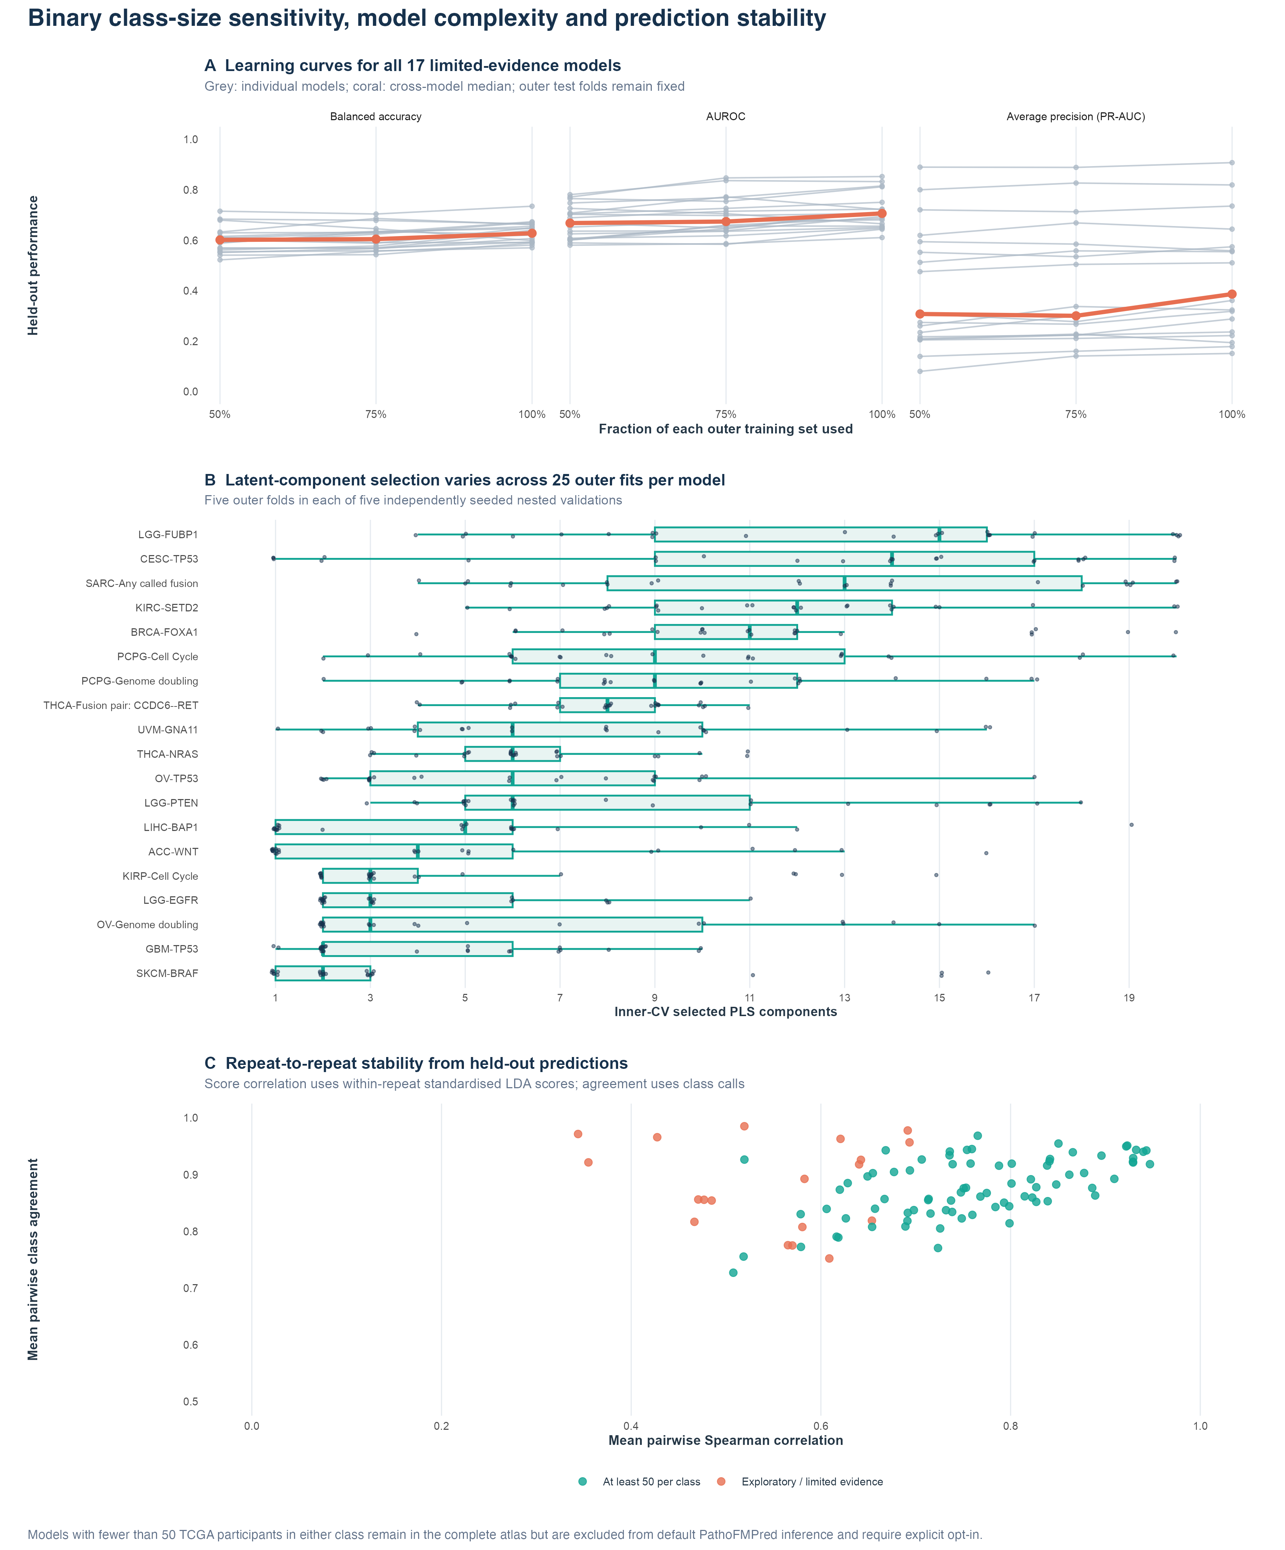
Figure S1. Binary class-size reliability, component selection and repeat-score stability for the smaller-class TITAN models.

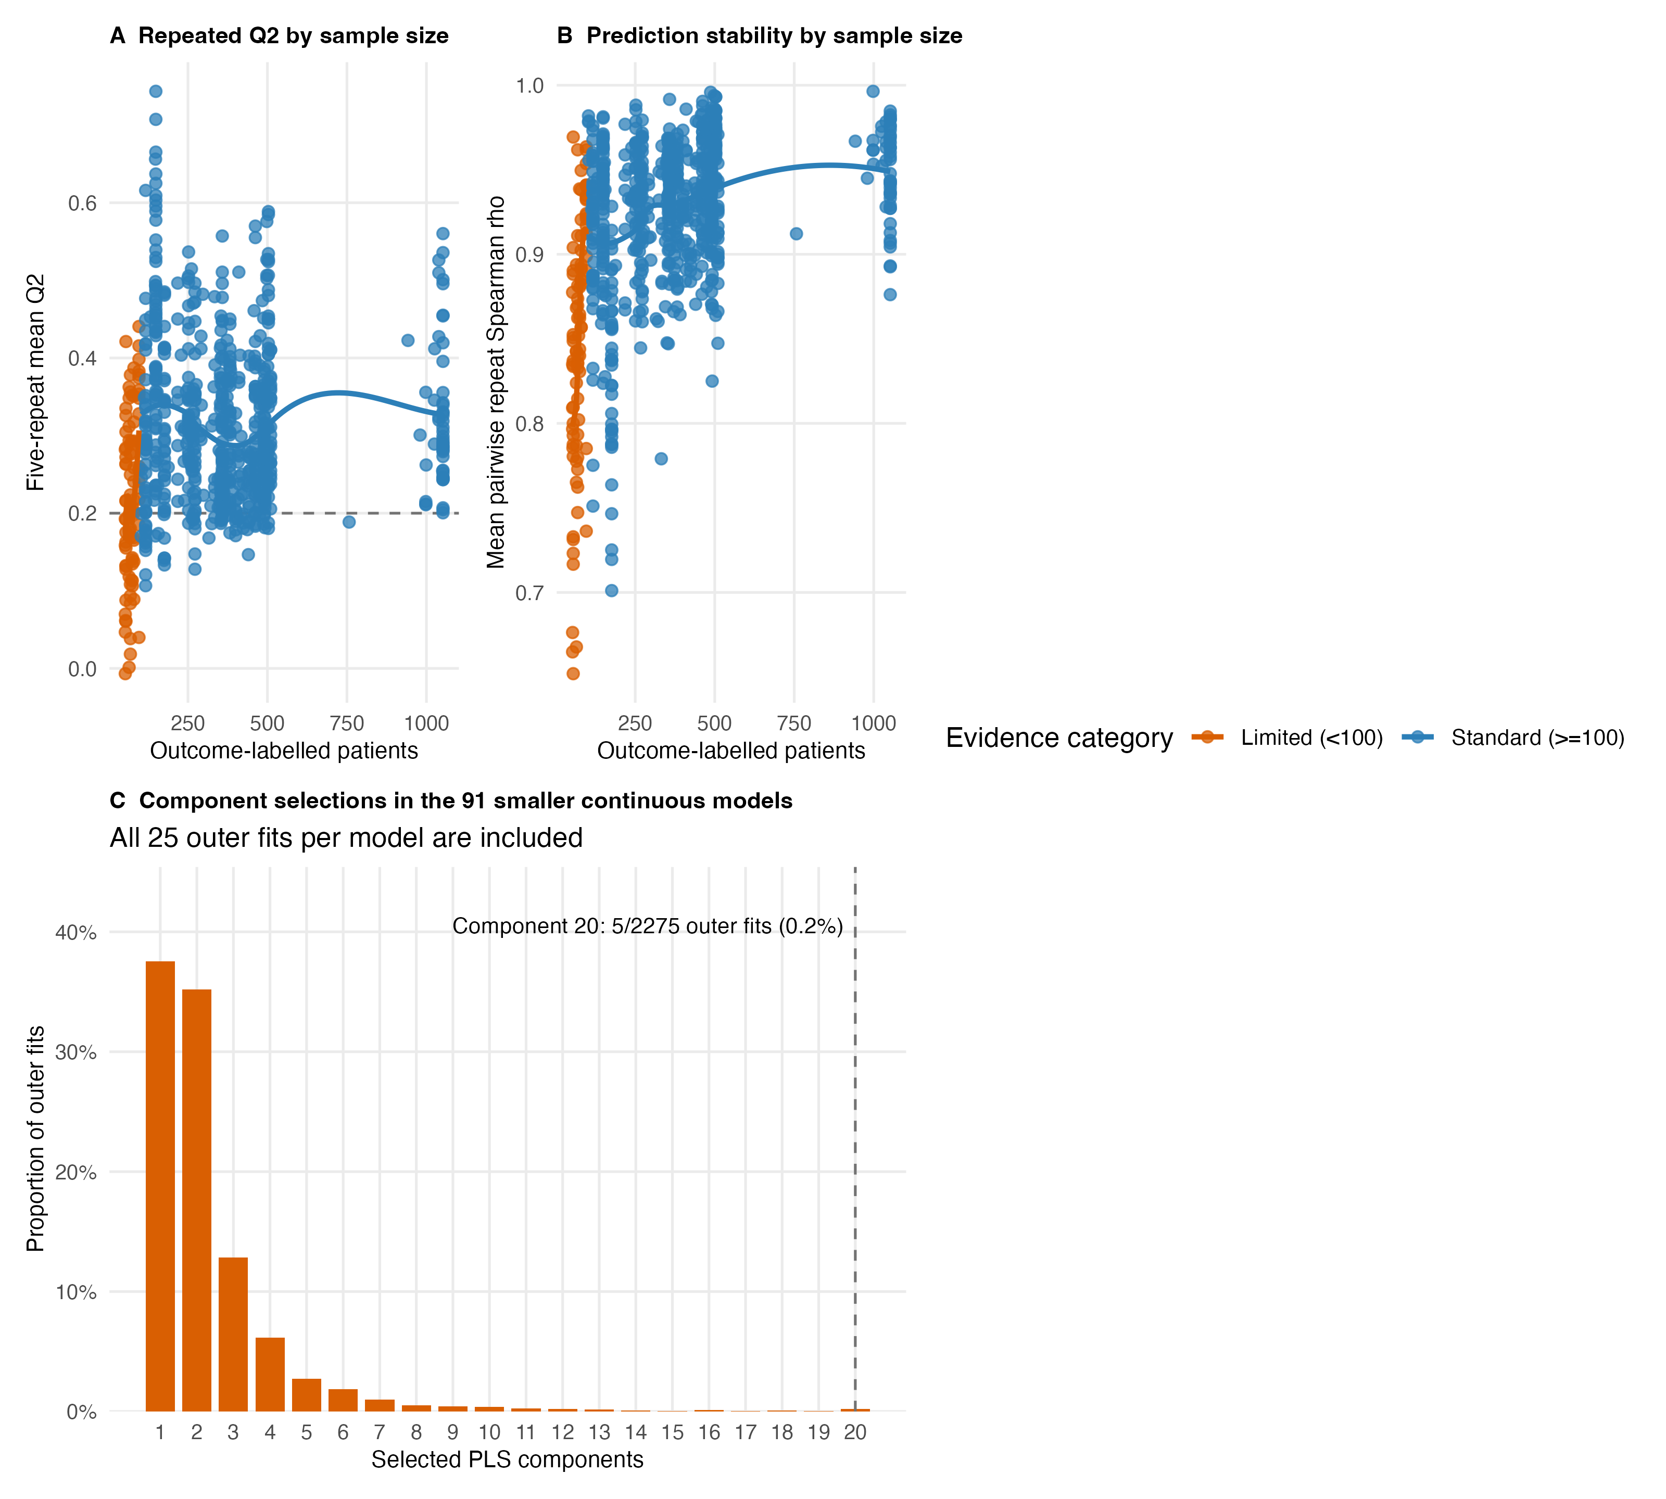
Figure S2. Continuous sample-size, repeated-prediction stability and component selection. The fewer-than-100-patient label is a denominator descriptor, not an evidence grade.

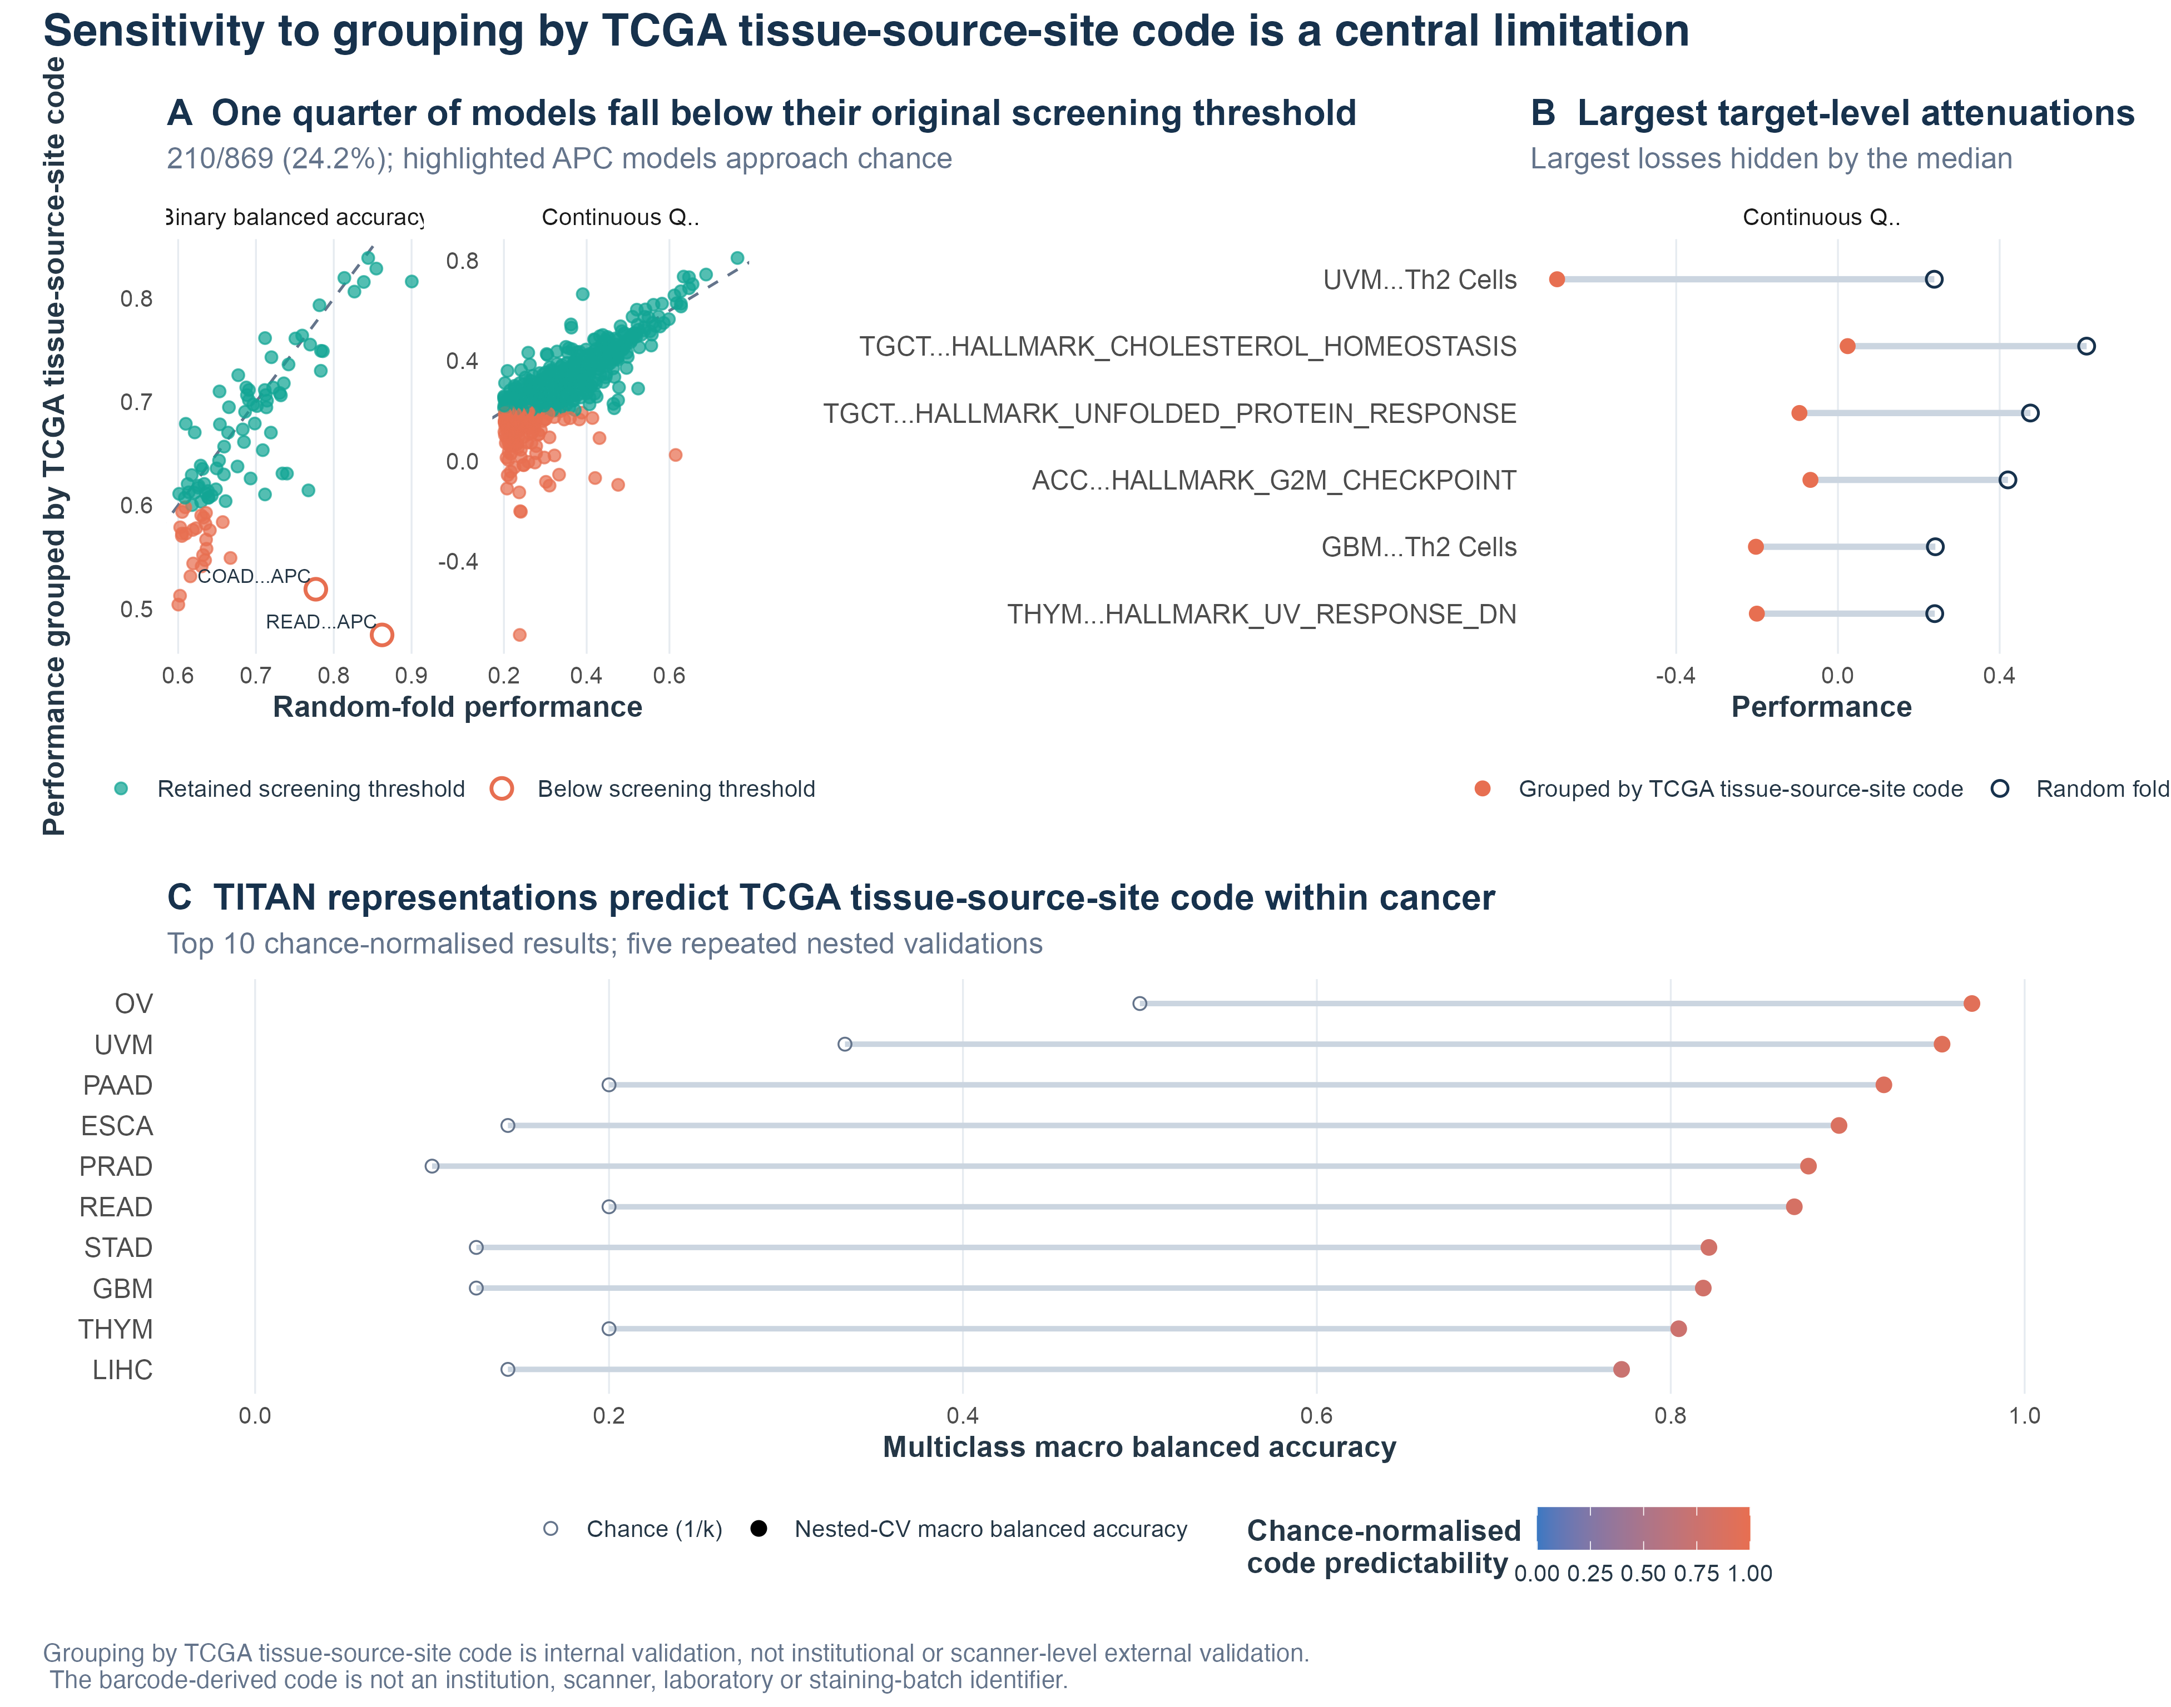
Figure S3. Supporting TITAN sensitivity to grouping by TCGA tissue-source-site code. The code is a barcode-derived cohort variable, not an institution, scanner or laboratory identifier.

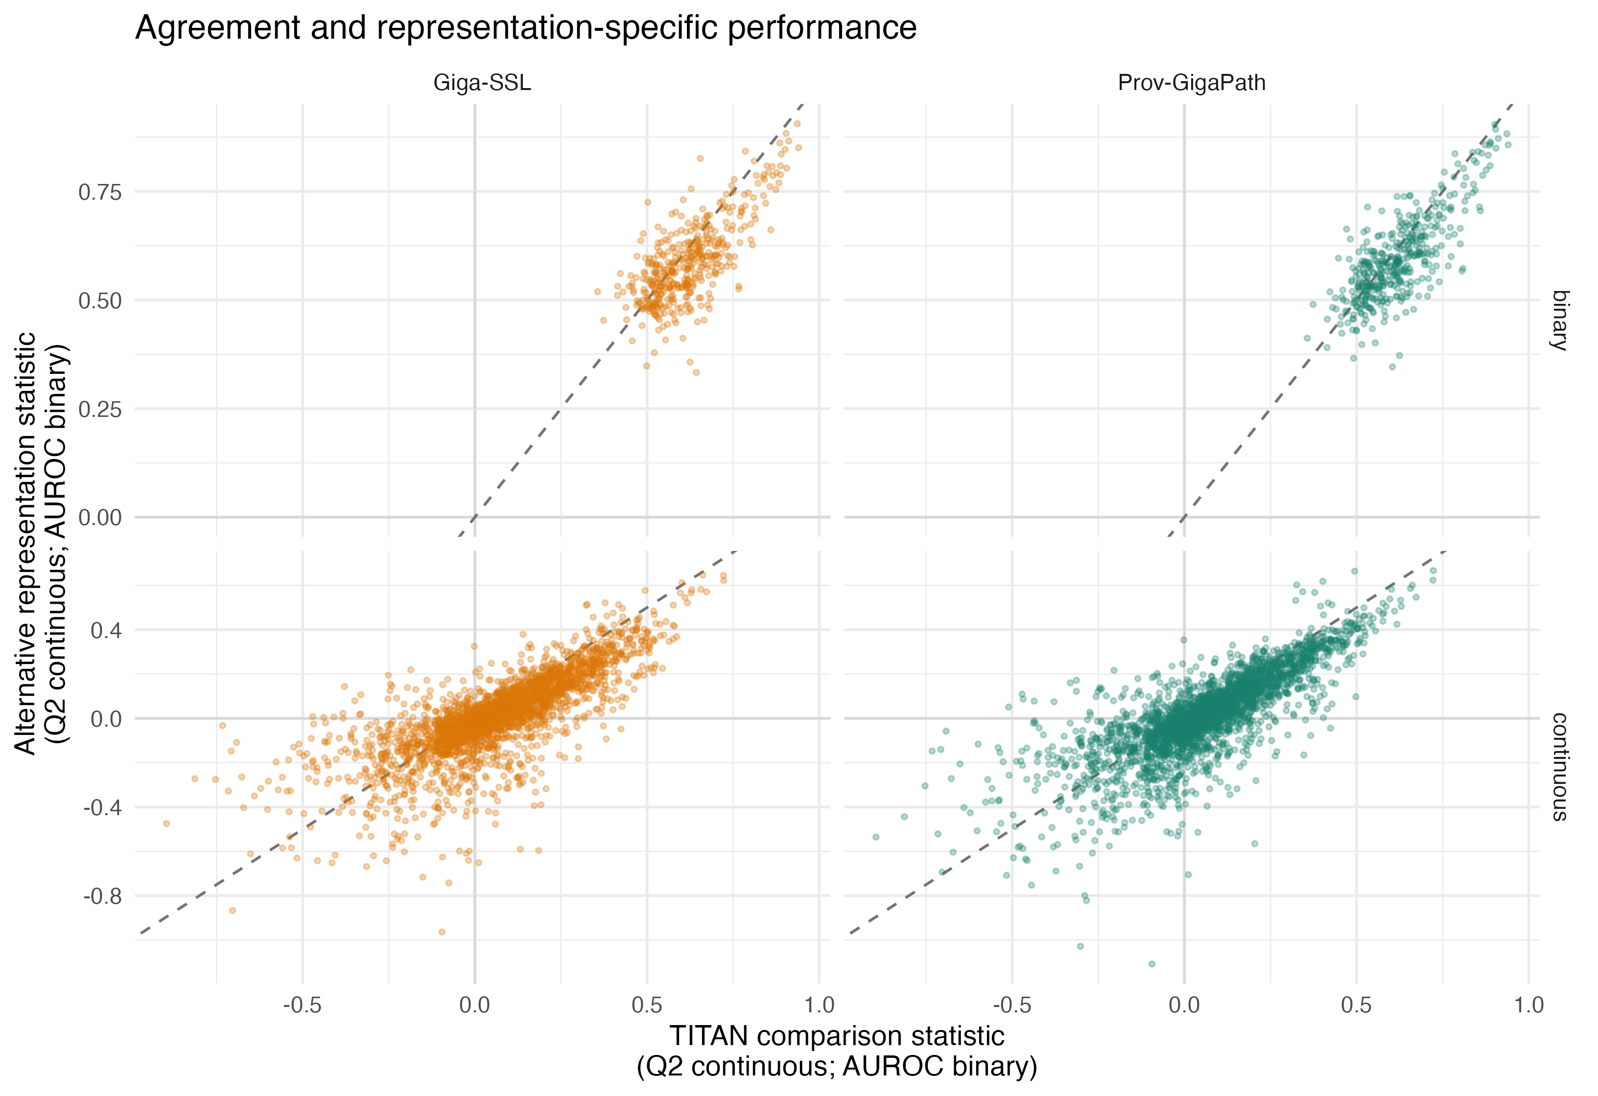
Figure S4. Paired Q2 and AUROC estimates for all 3,389 matched cancer-endpoint tasks. The comparison is conditional on the specified common probe.
The two COAD PathoFMPred examples now appear at readable size in main Figures 5 and 6 and are not duplicated in this shortened Supplement.

Machine-readable additional files
The repository retains complete-resolution records. The groups below replace the former multi-page filename list; source_manifest.csv and software_manifest.csv provide the exact inventory and checksums.
- Matched representation atlas: foundation_model_*.csv and results/predictions/foundation_model_*.rds
- Supporting TITAN screen: continuous_screen.csv, binary_screen.csv and repeated nested-validation files
- Permutation and multiplicity: permutation_*.csv, targeted_permutation_*.csv and multiplicity_*.csv
- Tissue-source-site-code analyses: site_grouped_*.csv, tissue_source_site_*.csv and foundation_model_tss_*.csv
- Reliability and operating rules: binary_*.csv and continuous_reliability_*.csv
- Pathology, pooling and linkage: pathology_qc_*.csv, slide_embedding_*.csv, *_pooling_sensitivity.csv and molecular_slide_linkage_audit.csv
- Endpoint provenance and literature: endpoint_*.csv, outcome_source_acquisition_map.csv and *_literature_*.csv
- Software and fitted-object audits: models/model_registry.csv, fitted_model_*.csv and data/reference/software_access_licensing_matrix.csv
- PathoFMPred COAD examples: coad_pathofmpred_multifoundation_*.csv and Additional files 2-3
- Reproducibility manifests: source_manifest.csv, software_manifest.csv and data/reference/analysis_chronology.csv

