Patient-level comparison of three released pathology representation pipelines with a common PLS-based probe across TCGA cancers
Aamilah Ismail^{3,*}, Martin Ocharo^{1,2,*}, Moussa Kassim^{1,2}, Dalia Ahmed¹, Brendon Price⁵, Dupe Ojo¹, Ekene Emmanuel Nweke⁴, Silvano Piazza^{6,8}, Dinesh Gupta⁷, Alessia Vignoli^{9,10}, Leonardo Tenori^{9,10}, Stefano Cacciatore^{1,2,†}
1 Bioinformatics Unit, International Centre for Genetic Engineering and Biotechnology (ICGEB), Cape Town 7925, South Africa
2 Department of Integrative Biomedical Sciences, Institute of Infectious Disease & Molecular Medicine (IDM), University of Cape Town, Cape Town 7925, South Africa
3 Division of Engineering, New York University Abu Dhabi, Abu Dhabi, United Arab Emirates
4 Department of Surgery, School of Clinical Medicine, Faculty of Health Sciences, University of the Witwatersrand, Johannesburg, Gauteng, South Africa
5 Division of Anatomical Pathology, University of Cape Town and National Health Laboratory Service, Observatory, Cape Town, South Africa
6 Computational Biology Group, International Centre for Genetic Engineering and Biotechnology (ICGEB), Trieste, Italy
7 Translational Bioinformatics Group, International Centre for Genetic Engineering and Biotechnology (ICGEB), Aruna Asaf Ali Marg, New Delhi 110067, India
8 Bioinformatics Facility, Department of Cellular, Computational and Integrative Biology - CIBIO, University of Trento, Trento, Italy
9 Department of Chemistry "Ugo Schiff", University of Florence, Sesto Fiorentino, Italy
10 Magnetic Resonance Center (CERM), University of Florence, Sesto Fiorentino, Italy
* These authors contributed equally.
† Corresponding author: Stefano Cacciatore (stefano.cacciatore@icgeb.org).
Author emails: aamilahismail@gmail.com; moussa.kassim@icgeb.org; dalia.ahmed@icgeb.org; dupe.ojo@icgeb.org; vignoli@cerm.unifi.it; tenori@cerm.unifi.it; stefano.cacciatore@icgeb.org
Research article: Molecular Pathology | Journal of Translational Medicine

Abstract
Background. Routine haematoxylin and eosin (H&E) slides contain morphological correlates of tumour genotype and microenvironment, but which signals persist across pathology foundation-model pipelines remains unclear. We compared three released whole-slide representations to map cancer-specific predictability of mutations, fusions, genomic instability, RNA-derived pathway activity and derived immune phenotypes.
Methods. A total of 8,241 patients across 30 The Cancer Genome Atlas (TCGA) cancer types and 3,389 cancer-endpoint pairs were analysed with TITAN, Giga-SSL and Prov-GigaPath representations. Multiple slides were mean-pooled within patients, and identical outcome subsets and nested patient-level folds were used with a common 1-to-20-component partial least-squares regression and linear discriminant classification pipeline. Cross-validated Q² and area under the receiver operating characteristic curve (AUROC) were used as primary metrics; Q² at least 0.20 and AUROC at least 0.60 summarized catalogue breadth. Stability was assessed with alternative partitions and grouping by TCGA tissue-source-site code. A supporting 9,404-patient TITAN screen across 32 cancers was evaluated with permutation and false-discovery-rate control.
Results. Excluding 11 same-H&E tasks, TITAN, Giga-SSL and Prov-GigaPath crossed the Q² threshold in 633, 351 and 430 of 2,952 cross-modal continuous tasks. They crossed the AUROC threshold in 230, 166 and 176 of 426 binary tasks, including 137, 92 and 98 of 243 directly observed genomic-alteration tasks. Consensus signals included THYM-GTF2I mutation (AUROC 0.904, 0.884 and 0.893), strict COAD microsatellite instability (0.940, 0.851 and 0.857), UCEC fusion status (0.859, 0.661 and 0.705), the published TGCT TGF-beta Response signature (Q² 0.662, 0.647 and 0.601) and TGCT Hallmark TGF-beta signaling (0.519, 0.484 and 0.459), ordered as TITAN, Giga-SSL and Prov-GigaPath. No pipeline led every endpoint. In the supporting TITAN screen, grouping by tissue-source-site code moved 210 of 869 candidates below their original threshold and reduced COAD-APC and READ-APC performance towards chance.
Conclusions. Histology contained reproducible cross-pipeline signals for mutations, fusions, microsatellite instability, genomic context and derived inflammatory phenotypes. TITAN provided the broadest task-level coverage under this probe, while some endpoints favoured another representation. The atlas and PathoFMPred prioritize candidates for independent validation, but internal TCGA estimates and cohort-structure sensitivity preclude clinical use.
Keywords: computational pathology; whole-slide imaging; foundation model; mutation; inflammation; microsatellite instability; gene fusion; aneuploidy; partial least squares; linear discriminant analysis

Background
Digital pathology converts routine haematoxylin-and-eosin whole-slide images into computational data. Pathology foundation models are neural networks pretrained on large and diverse slide collections so that one fixed model can encode each slide as a reusable numerical representation for many downstream tasks. This approach differs from a task-specific convolutional neural network trained separately for one mutation or cancer. The resulting representation can support a compact downstream model even when labelled molecular data are limited. Routine sections also reflect phenotypic consequences of tumour genotype and the immune microenvironment. Coudray and colleagues established mutation prediction from lung histology [1]. Subsequent work predicted microsatellite instability, including externally validated colorectal models [2-3]; extended mutation and multi-omic screening across TCGA cancers [4-8]; inferred RNA expression [9-10]; identified institution-associated histology bias [11]; detected gene fusions [12-13]; estimated homologous-recombination deficiency [14]; and characterised tumour-microenvironment phenotypes [15]. Collectively, these studies establish biological plausibility while also showing that performance depends on endpoint, disease, cohort and validation design.
Prior studies established that H&E images can predict mutations, microsatellite instability and other molecular phenotypes, but they used different cohorts, image encoders, endpoints and validation rules. Fu et al. analysed 17,355 slides across 28 cancers [4], Kather et al. applied one workflow to more than 5,000 patients across 14 cancers [5], Saldanha et al. externally tested mutation models across seven matched TCGA and CPTAC cancers [7], and Arslan et al. trained 12,093 models for 4,031 genomic, transcriptomic, proteomic and clinical biomarkers in 8,890 TCGA patients across 32 cancers [8]. These studies provide the biological and methodological context for our matched comparison of released representation pipelines.
The narrower unresolved gap is a reproducible multi-representation atlas that maps, for the same patients and endpoints, how molecular and derived immune-feature associations compare across released pathology representation pipelines under one transparent downstream analysis. We deterministically aggregated slides before outcome matching, validated models at patient level and preserved tested-negative and sample-size-ineligible results. We also created PathoFMPred as a reproducible analysis interface and model registry. Its controlled internal reference objects cover only a defined subset of atlas tasks, so we do not present it as a complete or publicly functional prediction resource. The matched representation comparison, patient-level analysis and transparent reporting define the study's principal contributions.
Foundation models learn general visual representations from large image collections before a specific downstream task is defined. Vision models such as DINOv2 learn transferable features through self-supervised training [16], and pathology foundation models adapt this principle to tissue tiles or whole-slide images. A pretrained pathology model converts a slide into a fixed numerical vector that can support many cancer-specific analyses without retraining the image encoder. The downstream model still determines how those features are used, so performance reflects the released representation pipeline and the selected prediction method.
We evaluated three released representation pipelines, each comprising its upstream preprocessing, physical-resolution assumptions, encoder architecture, released layer and representation-learning exposure. TITAN is a multimodal whole-slide model trained with visual self-supervision and vision-language alignment; its published Mass-340K pretraining corpus excluded TCGA, although its developers used TCGA for downstream evaluation [17]. Giga-SSL is a gigapixel self-supervised whole-slide representation whose official repository distributes 512-dimensional TCGA embeddings [18]; its developers used TCGA during model development, and we cannot exclude direct overlap between representation-learning images and the slides evaluated here. Prov-GigaPath combines a tile encoder with a long-context slide encoder trained on Providence health-system pathology data; we used the final 768-dimensional slide layer from the public TCGA embedding dataset [19]. We did not fine-tune model weights or use downstream molecular labels during representation learning in this study. Giga-SSL therefore remains label-held-out in downstream cross-validation, although representation learning may have included the evaluation images. We did not harmonise pixel preprocessing or physical input resolution. The matched analysis compares the released representation pipelines under a common 1-to-20-component PLS-based probe rather than isolating intrinsic foundation-model quality.
In this study, a cancer-endpoint pair denotes one TCGA cancer type combined with one outcome, for example COAD with APC mutation or LIHC with the wound-healing score. Each pair defines a cancer-specific prediction task, not a pair of patients. For every eligible pair, we analysed only patients from that cancer who had the required outcome label. We then fitted a separate model for each available representation. In the matched benchmark, we used identical patients and validation folds for TITAN, Giga-SSL and Prov-GigaPath, and we never pooled different cancer types in one prediction model.
We first compared the three representations in the same 8,241 patients, using 3,389 cancer-endpoint tasks and identical validation folds. We then used the larger TITAN cohort for a supporting permutation and multiplicity-controlled screen. Finally, we implemented the fitted research models in PathoFMPred, which selects the appropriate feature schema and cancer-specific model for TITAN, Giga-SSL or Prov-GigaPath input. The package supports reproducible external research testing, but it is not the main scientific result and does not add validation evidence.
Our primary objective was to identify which tumour features routine histology could predict within each cancer and which signals remained visible across TITAN, Giga-SSL and Prov-GigaPath. We evaluated directly observed mutations and fusions, MSI, genome doubling and oncogenic-pathway status, together with sequencing-derived burdens, transcriptomic inflammatory programmes, inferred immune-cell fractions and composite tissue-context phenotypes. We then tested whether the strongest associations persisted across alternative partitions and TCGA tissue-source-site code grouping. Here, predictability means cross-validated agreement with the supplied reference label. It does not imply causality, mechanism, analytical recovery of the originating assay or assay replacement. We did not analyse molecular subtype.

Methods

Study design, slides and patient unit
A total of 11,449 TITAN slides from 9,404 patients, 11,427 Giga-SSL slides from 9,378 patients and 10,328 Prov-GigaPath slides from 8,393 patients were included in the released artifacts. In their union, 9,471 unique patients were identified. Of these, 8,241 (87.0%) were represented in all three datasets and were included in the matched benchmark. Analysis coverage is summarized in Supplementary Table S1, and participant characteristics by cancer are reported in Supplementary Table S2.
Within each representation, eligible primary-tumour diagnostic slides were pooled by arithmetic mean before outcomes were joined. The patient, rather than the slide, was treated as the unit of analysis and cross-validation. Each patient with multiple slides was represented as one observation, and all slides from that patient were kept in the same fold.
No structured field for tumour cellularity, tissue area, artefact, biopsy/resection status or slide quality was provided by the available data. Generated TITAN slide narratives were used only for a non-adjudicated sensitivity audit. In the audit, 35 no-residual-tumour mentions were identified across six patients: TCGA-B6-A0IA and TCGA-B6-A0WV in BRCA, TCGA-55-8203 and TCGA-55-8507 in LUAD, TCGA-22-4596 in LUSC and TCGA-DX-AB2L in SARC. These patients were retained in the primary analysis because the generated narratives were derived from the same slides and did not constitute independent pathology review. In a post hoc sensitivity analysis, all six patients were removed before fold construction, and all 167 screen-positive models in the four affected cancers were refitted using the documented nested-validation rules. A separate maximum-slide-count sensitivity was also conducted for TCGA-DX-AB2L, the participant represented by 30 SARC slides, by removal of this patient before fold construction and refitting of every SARC candidate. Molecular sources were linked at participant or 15-character sample-barcode level; identity of the tissue block, aliquot or tumour region is not proved by either linkage. Complete exclusion results and the full linkage, pathology-quality and pooling audits are reported in Supplementary Table S3.

Predictors and outcomes
Slide vectors of 768 dimensions were supplied by TITAN and Prov-GigaPath, while 512-dimensional vectors were supplied by Giga-SSL. Five pragmatic inclusion criteria were applied. A ready-to-use slide-level TCGA embedding artifact had to be provided without downloading or reprocessing WSI pixels; deterministic slide identifiers linkable to patient and cancer had to be retained; one fixed-length whole-slide vector had to be provided; the 32-cancer frame had to be covered sufficiently for a common-patient analysis; and reproducible release metadata had to be provided for a materially distinct published whole-slide representation strategy. All five criteria were met by TITAN, Giga-SSL and Prov-GigaPath. Representative alternatives excluded because a compatible slide-level TCGA artifact, identifiers or common-cohort coverage were unavailable are listed in the supplementary inclusion audit; exclusion was not treated as a model-quality judgement. Upstream preprocessing, spatial resolution, training exposure and released layers were not harmonised. The estimand was therefore defined as complete released representation-pipeline performance under the common probe rather than intrinsic foundation-model quality. Because TCGA was used during Giga-SSL development, molecular labels were held out downstream although representation learning may have included the evaluated images.
Outcome labels were acquired from published TCGA companion resources and were joined by the 12-character participant barcode after representation-specific patient vectors had been constructed. Where a 15-character TCGA sample barcode was supplied by a source, primary-tumour sample type 01 was first retained and eligible molecular rows were then collapsed to one participant-level outcome. Only a participant identifier was supplied by Thorsson. Source-specific and endpoint-specific missingness was retained. A participant absent from a molecular source was not assigned to the negative class. The same TCGA primary-tumour specimen is indicated by an exact 15-character sample match, but use of the same block, portion, analyte, aliquot, tumour region or subclone by the WSI and molecular assay is not proved. The source file, sheet, identifier, filtering, aggregation, missingness and transformation for every outcome group are reported in the supplementary endpoint dictionary and the machine-readable outcome_source_acquisition_map.csv.
Immune, inflammatory and genomic-context features were obtained from the PanImmune_MS sheet of the Thorsson et al. supplementary workbook [20]. Fifty published non-survival, non-subtype and non-aggregate fields were selected, and their published participant-level values were imported rather than recalculated. These comprised 22 relative immune-cell fractions inferred from bulk RNA sequencing by CIBERSORT with the LM22 reference [21]; one methylation-derived leukocyte fraction; ten bulk-RNA expression signatures, including IFN-gamma response, TGF-beta response, wound healing, macrophage regulation, lymphocyte infiltration and Th1, Th2 and Th17 programmes; six BCR/TCR repertoire metrics; two somatic mutation rates; two in-silico neoantigen burdens; six genomic-context quantities; and the Saltz H&E-derived TIL Regional Fraction [22]. Endpoint-specific missing values were retained. The log1p transformation was applied only to silent and nonsilent mutation rates, SNV and indel neoantigen counts and number of segments; every other Thorsson value was used on its published scale. CIBERSORT fractions and inflammatory signatures were therefore interpreted as agreement with published computational reference phenotypes, not as measurements generated directly from the tissue.
RNA pathway-activity outcomes were constructed from the batch-adjusted TCGA Pan-Cancer RNA-sequencing matrix downloaded from UCSC Xena [23] and the MSigDB 2026.1.Hs gene-set release [24]. Fifty Hallmark gene sets, the Reactome glutathione synthesis and recycling set and the Gene Ontology vitamin B6 metabolic-process set were used. Primary-tumour sample type 01 was retained, expression was averaged across multiple primary-tumour aliquots from the same participant, and genes were standardized within each cancer. Each pathway score was calculated as the mean standardized expression of its measured member genes. The scores are therefore RNA-derived computational reference phenotypes and not direct biochemical measurements of pathway flux, glutathione concentration or pyridoxine metabolism. Source URLs, checksums, gene-set membership and per-cancer measured-gene counts are reported in the supplementary source audit.
Mutation labels were constructed from TCGA MC3 calls [25] accessed through the pinned TCGAmutations package, and tested genes were restricted to the tissue-specific driver catalogue in Bailey et al. Table S1 [26]. Primary-tumour samples, PASS variants and protein-altering missense, nonsense, nonstop, splice-site, translation-start, frameshift and in-frame changes were retained. COADREAD drivers were mapped to both COAD and READ. A participant was classified as mutated when a qualifying variant in the gene was present in any matched profiled primary sample. Wild type was assigned only when profiling of a primary-tumour sample was confirmed by MC3 clinical metadata and no qualifying variant was present; participants without an MC3-profiled primary tumour remained missing.
Pathway status was imported from the Pathway level sheet of Sanchez-Vega et al. Table S4 [27]. Binary alterations in ten oncogenic signalling pathways are reported in the published matrix. Sample type 01 was retained, and a participant was defined as altered when any covered primary sample was altered in that pathway; participants absent from the table remained missing. The Taylor aneuploidy score, deleted-arm count, amplified-arm count and genome-doubling indicator were obtained from Table S2 [28]; continuous values were averaged across primary samples, and genome doubling was assigned when any primary sample was positive. Fusion calls and the assayed denominator were obtained from the two relevant sheets of Gao et al. Table S1 [29]; unique calls were collapsed by participant, zero was assigned only within the study sample list and fusion burden was log1p-transformed. Finally, MANTIS and MSIsensor fields were downloaded from the cBioPortal TCGA PanCancer Atlas clinical-sample files [30-31]; finite primary-sample scores were averaged, and missingness was retained when every primary-sample score was absent. A value greater than 0.4 was used for MSI-H in the main MANTIS definition; in the strict sensitivity, a value greater than 0.6 was used for MSI-H, a value less than 0.4 was used for MSS and intermediate scores were excluded.

PLS regression and PLS-LDA classification
Each eligible cancer-endpoint pair was analysed as a separate cancer-specific task. In the matched benchmark, TITAN, Giga-SSL and Prov-GigaPath models were fitted independently while the same patients and validation folds were used. Features were centred within training folds by nested patient-level five-fold cross-validation, and 1 to 20 latent components were selected from pooled inner held-out predictions, with ties resolved in favour of fewer components. For continuous outcomes, PLS regression was fitted, inner root-mean-square deviation was minimised, and outer-fold Q², the cross-validated coefficient of determination, RMSE and Spearman correlation were evaluated. For binary outcomes, PLS-LDA was fitted, and the component count was selected by pooled inner out-of-fold (OOF) AUROC. The balanced-accuracy-maximising threshold from those inner training predictions was applied unchanged to the outer test fold. Outer OOF AUROC was evaluated as the primary paired statistic; PR-AUC, balanced accuracy, sensitivity, specificity, PPV and NPV were also reported. The observed outcome prevalence was used as the no-skill reference for PR-AUC. The discriminant score was uncalibrated and was not presented as a probability. At least 20 patients per class were required for binary eligibility, and at least 50 labelled patients were required for continuous eligibility.
Seeded rSVD was used for every decomposition with the fastPLS 0.3 defaults. In the matched benchmark, identical outcome-labelled patients, folds, seeds and tuning rules were applied to all three representations. A descriptive effect-threshold crossing was defined as Q²≥0.20 for a continuous task or AUROC≥0.60 for a binary task. No representation-specific permutation or multiplicity procedure was applied in the matched benchmark, so effect-threshold crossings were treated as catalogue-navigation summaries rather than inferential discoveries. For all 426 matched binary pairs, the training-only optimized call was compared with empirical-prior and equal-prior calls on the identical AUROC-selected outer scores. Paired changes in balanced accuracy, sensitivity, specificity, PPV and NPV were reported. Symmetric folds and tuning objectives were used in the fixed 48-target ridge comparison, which was not treated as a second atlas.

Robustness and saved models
Five alternative nested partitions were run for 1334 effect-threshold-crossing or near-threshold pairs. Median effects, interquartile ranges, effect-threshold-crossing proportions, paired effect variability, leading-representation rank stability and threshold-derived support-pattern stability were calculated. All 971 pairs with an effect-threshold crossing in at least one representation were also rerun while complete TCGA tissue-source-site codes were held apart in outer and inner validation. Outer-fold sizes and binary class counts were preserved by matched-random controls. Each task metric was calculated once from all pooled patient-level outer out-of-fold predictions rather than by averaging fold-specific metrics. Predictions from a single-class outer test fold were included in the pooled task metric, but a stand-alone metric for that fold was not interpreted. The number of contributing codes, four- versus five-fold validation, minimum inner and outer training-class counts and single-class outer-test, inner-validation and inner-training indicators are recorded in the task-level audit. Fewer than five outer folds, outer test n below 10, a single-class binary fold or fewer than 20 patients in either binary training class are marked by a machine-readable sparse-fold warning. An unqualified robustness interpretation of a sparse grouped result is prevented by this warning; it is not an exclusion or validity threshold.
For the component-range sensitivity, every selected component across the five outer fits, task-level and outer-fit ceiling frequencies, crossing changes, paired AUROC changes and representation-winner changes were reported. Five constant Giga-SSL dimensions were retained to preserve its released 512-feature schema; each constant column was mapped to zero by training-fold centering. No constant dimensions were present in TITAN or Prov-GigaPath, and no near-constant dimension with a full-cohort standard deviation between zero and 1e-8 was present in any representation. The sensitivity was failed closed on fitting errors, and no fallback estimator was used.
A total of 3,633 eligible pairs, comprising 3,174 continuous and 459 binary pairs, were evaluated in the supporting TITAN-only screen. Models below the effect checkpoint were assigned p=1 without permutation, while tests stopped after significance became impossible were assigned a distinct early-stopped p=1 status. Scaling, inner component selection, refitting and held-out prediction were repeated for every performed permutation. Up to 999 permutations were used in the primary audit, and eight separately locked leading targets were extended to 9,999 complete-process permutations with Monte Carlo intervals. Benjamini-Hochberg correction was applied within cancer and endpoint family; the q-value was defined as the false-discovery-rate-adjusted empirical p-value. Broader multiplicity sensitivities were reported separately. The 869 qualified candidates were subjected to five additional nested partitions and grouping by TCGA tissue-source-site code. For highlighted candidates, patients from five fixed held-out prediction sets were resampled in the 95% selection-conditioned (SC) patient-resampling interval for repeated OOF predictions, and each metric was recalculated without folds being regenerated and without retuning or refitting. Patient sampling variation conditional on those fitted partitions is represented by the interval; it is not a confidence interval for external generalisation, and winner's-curse selection is not corrected. Complete permutation, Monte Carlo, uncertainty, fold-adequacy, class-size, continuous-reliability and multiple-slide details are reported in the Supplementary Methods and machine-readable audit files.
Model coefficients, representation schema, outcome definition and internal-performance metadata are carried by PathoFMPred, but no validation evidence is created. Contributor-authored package source code and documentation are released under the MIT License. Permitted Giga-SSL and Prov-GigaPath fitted collections are provided as explicit, checksum-verified post-install downloads with separate asset notices and upstream attribution. TITAN-derived fitted parameters are excluded from the public repository because the upstream terms require permission for redistribution. Authorized users can construct and apply a local object with generic package functions. No independent cohort was evaluated.

Software, transparency and validation status
The analyses were performed in R 4.6.0 with fastPLS 0.3. Code, manifests, complete-resolution results and registries are contained in the companion repository. Representation sources, checksums, object access terms and the future locked-evaluation protocol are documented in the Supplement and software repository. No independent cohort was included, so every reported performance estimate remains internal to TCGA.

Results

Matched cohort and pipeline scope
We included 8,241 patients and 3,389 cancer–endpoint pairs shared across TITAN, Giga-SSL and Prov-GigaPath in the primary benchmark. These comprised 2,963 continuous and 426 binary pairs across 30 cancers. We used identical patients, outcomes, folds, seeds and tuning rules within each pair. Of the 8,241 patients in this matched cohort, 8,207 (99.6%) had exactly the same TCGA slide identifiers available in all three embedding datasets. At least one dataset lacked one or more otherwise eligible slides for the remaining 34 patients. Restricting every pipeline to the 10,165 slides available in all three datasets left median performance changes near zero. The comparison nevertheless includes each pipeline's upstream preprocessing, resolution, representation-learning exposure and released layer.
We analysed 768-dimensional TITAN, 512-dimensional Giga-SSL and 768-dimensional Prov-GigaPath whole-slide vectors. TITAN combined a CONCH v1.5 tile encoder with its region-of-interest workflow and released slide layer. Giga-SSL combined a ResNet-18 tile encoder with a sparse-convolutional slide encoder, while Prov-GigaPath combined a DINOv2-style tile encoder with its final long-context slide layer. The reported TITAN Mass-340K and Prov-GigaPath Providence pretraining corpora excluded TCGA. Giga-SSL development used TCGA, so direct exposure to evaluated slides cannot be excluded. All three downstream analyses withheld molecular labels. We therefore interpret every comparison as a result for the complete released representation pipeline rather than an image-unseen test of isolated foundation-model quality.
Pathology and molecular linkage limited interpretation. In the pathology-text exclusion sensitivity defined in Methods, the original threshold remained for 157/167 models. All four highlighted affected models retained their thresholds; the largest absolute change was SARC Macrophage Regulation Q² from 0.520 to 0.472. This sensitivity does not replace independent pathology review.
Supplementary Table S3 provides the patient-level generated-text audit, endpoint-level exclusion refits, source-specific linkage denominators and pooling diagnostics.
Pooling sensitivity supported the patient mean as a stable deterministic summary but did not establish tissue adequacy. Coordinate-wise median pooling changed the median Q² and balanced accuracy by 0.000 and 0.000; mean-versus-median ranks correlated 0.992 and 0.978, and 766/770 continuous and 98/99 binary models retained their original thresholds. Among multi-slide patients, median pairwise cosine distances were 0.080, 0.103 and 0.052 for TITAN, Giga-SSL and Prov-GigaPath; their 95th percentiles were 0.324, 0.372 and 0.163. The median maximum leave-one-slide-out centroid changes were 0.010, 0.012 and 0.006. This was an embedding-level stability analysis, not a pathology or endpoint-performance adjudication.
In the maximum-slide-count sensitivity defined in Methods, the original threshold remained for 34/36 continuous and 3/4 binary models. IFN-gamma Response Q² changed from 0.233 to 0.183, Macrophages M0 from 0.211 to 0.163 and TP53 mutation balanced accuracy from 0.617 to 0.589. These threshold changes show why participant weighting and tissue representativeness are distinct problems.
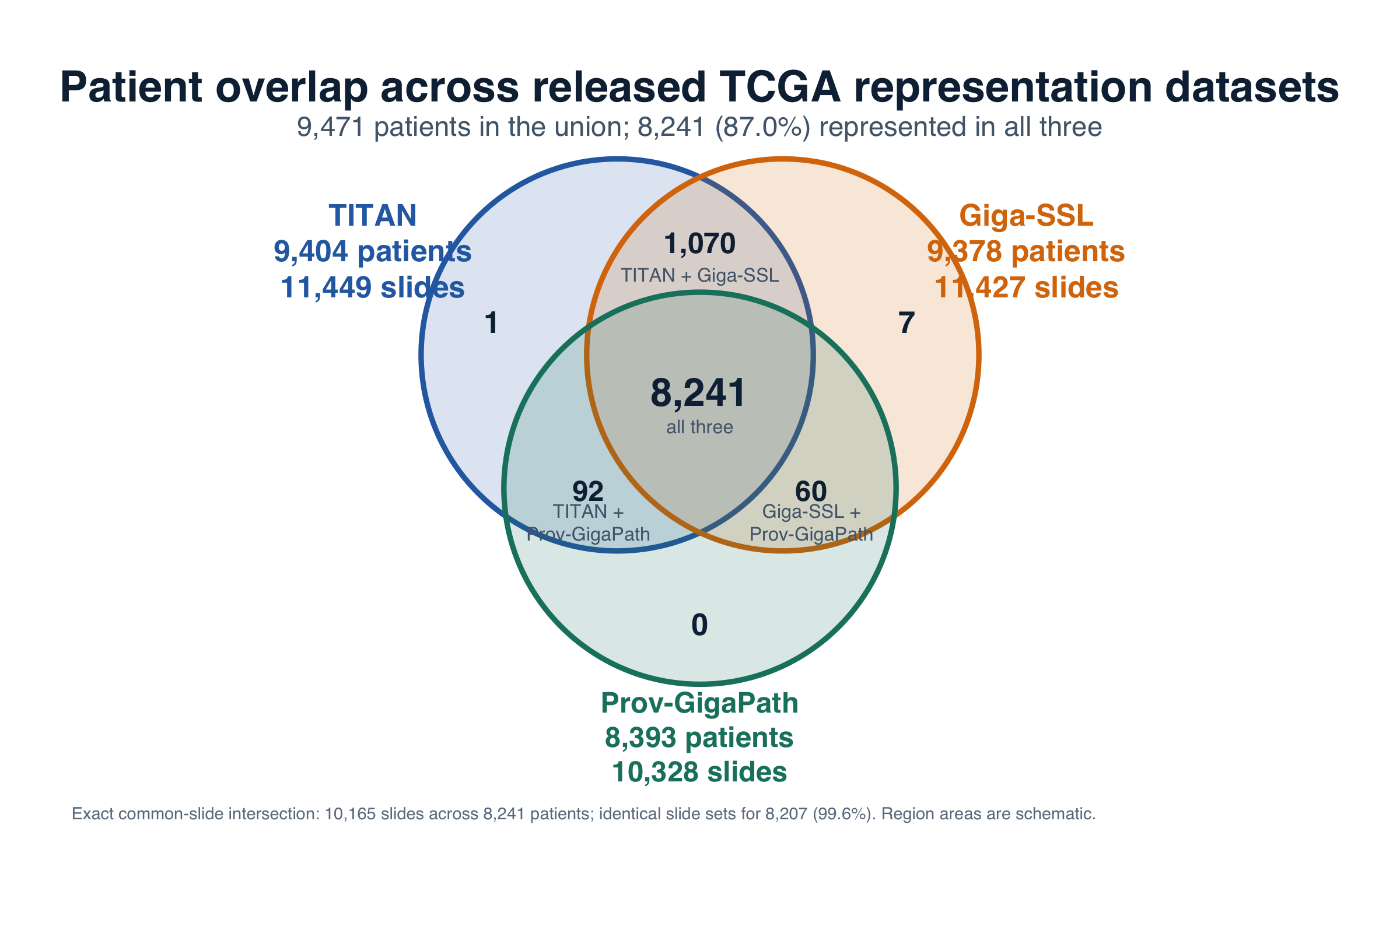
Figure 1. Patient and slide overlap across the three released TCGA representation datasets. TITAN contained 11,449 slides from 9,404 patients, Giga-SSL contained 11,427 slides from 9,378 patients and Prov-GigaPath contained 10,328 slides from 8,393 patients. The matched analysis used 8,241 patients. The exact common-slide intersection contained 10,165 slides, and 8,207 patients had identical slide sets across all three datasets. Region areas are schematic.

Predictable tumour features and biological patterns
The matched benchmark revealed its strongest and broadest biological signal in direct genomic alterations. At least one representation crossed the descriptive AUROC threshold in 160/243 mutation or fusion tasks, and all three crossed in 65/243. Composite genomic-context status, which included MSI, genome doubling and oncogenic-pathway states, crossed in at least one representation for 108/183 tasks and in all three for 57/183. The continuous layer was more selective: at least one representation crossed for 39/413 sequencing-derived burdens, 101/279 transcriptomic signatures, 31/638 computationally inferred immune-cell fractions and 35/166 continuous genomic-context scores. All three crossed for 10, 51, 13 and 11 tasks in these four classes. Figure 2 shows both the class-level breadth and named cancer-specific examples.
We first compared paired Q² and AUROC values without thresholding. Relative to TITAN, Giga-SSL effects had Spearman correlations of 0.804 for continuous tasks and 0.661 for binary tasks; the corresponding Prov-GigaPath correlations were 0.811 and 0.717. Median alternative-minus-TITAN differences were -0.044 Q² and -0.034 AUROC for Giga-SSL, and -0.045 Q² and -0.026 AUROC for Prov-GigaPath. Supplementary Figure S4 reports the complete paired distributions; representation-specific estimates were correlated but not interchangeable.
We also examined TITAN and Prov-GigaPath separately because their reported pretraining corpora excluded TCGA. For continuous tasks, both pipelines crossed Q² 0.20 in 391/2,963 pairs, TITAN alone crossed in 252 and Prov-GigaPath alone in 50. TITAN had the higher Q² in 2,124 pairs and Prov-GigaPath in 839; the median Prov-GigaPath-minus-TITAN difference was -0.045 with a descriptive 95% cancer-cluster interval from -0.054 to -0.035. For binary tasks, both crossed AUROC 0.60 in 152/426 pairs, TITAN alone in 78 and Prov-GigaPath alone in 24. TITAN had the higher AUROC in 288 pairs and Prov-GigaPath in 137; the median difference was -0.026 (-0.034 to -0.018). These cancer-cluster intervals describe paired task effects and are not confidence intervals for external generalisation. This comparison reduces one known difference in reported training exposure but still compares complete pipelines.
Catalogue-normalised summaries gave the same aggregate ordering but substantially different scales across outcomes. For continuous tasks, the task-level effect-threshold-crossing percentage, unique-definition percentage, macro-family percentage and macro-cancer percentage were 21.7/84.3/12.5/21.6% for TITAN, 12.2/73.1/6.1/12.1% for Giga-SSL and 14.9/79.6/8.4/14.8% for Prov-GigaPath. For binary tasks, the corresponding values were 54.0/72.5/71.6/51.1%, 39.0/51.1/59.4/46.2% and 41.3/57.3/65.9/46.0%.
We defined a descriptive effect-threshold crossing as Q² at least 0.20 for a continuous task or AUROC at least 0.60 for a binary task. At least one representation produced an effect-threshold crossing for 971/3,389 cancer-endpoint pairs (28.7%), including 703 continuous and 268 binary pairs and covering 196/238 distinct feature definitions. Two or more representations produced an effect-threshold crossing for 621 pairs. All three did so for 426 pairs, including 304 continuous and 122 binary pairs across 127 distinct feature definitions. These counts depend on the endpoint catalogue, repeat correlated phenotypes across cancers and are not independent biological discoveries. The matched atlas has no representation-specific permutation or multiplicity testing.
The cross-representation genomic core included GTF2I, BRAF, IDH1, TP53, ATRX, CIC, FGFR3, APC and PTEN mutations, any called fusion, MSI status, genome doubling and several oncogenic-pathway states. These associations concentrated in biologically recognisable cancer contexts. The glioma results linked histology to IDH1, TP53, ATRX and CIC alterations and to TP53, HIPPO, WNT and RTK-RAS pathway states. Thyroid carcinoma showed strong BRAF and RTK-RAS signals, thymoma showed a strong GTF2I signal, bladder carcinoma retained FGFR3, and endometrial cancer retained PTEN, TP53, fusion and genome-doubling signals. COAD and STAD retained both strict and broader MSI definitions.
Several direct or sequence-derived examples combined strong discrimination with agreement across representations and retention after TCGA tissue-source-site code grouping. THYM GTF2I mutation reached AUROC 0.904/0.884/0.893 for TITAN/Giga-SSL/Prov-GigaPath. THCA BRAF reached 0.886/0.862/0.857, LGG TP53 reached 0.912/0.866/0.872 and LGG IDH1 reached 0.837/0.782/0.840. COAD strict MSI reached AUROC 0.940/0.851/0.857 and PR-AUC 0.805/0.584/0.620, compared with a prevalence and no-skill PR-AUC reference of 0.150. Supplementary Table S4 reports the selected binary tumour-feature results.
Fusion prediction produced a distinct set of results. Among 26 eligible binary fusion cancer-endpoint pairs, 12 crossed AUROC 0.60 with TITAN, 11 with Giga-SSL and 10 with Prov-GigaPath. Five crossed with all three representations: any called fusion in UCEC, LGG, THCA and BLCA, and TMPRSS2-ERG in PRAD. UCEC any called fusion was the strongest example, with 80 positive cases among 152 patients and AUROCs of 0.859, 0.661 and 0.705 for TITAN, Giga-SSL and Prov-GigaPath. THCA CCDC6-RET, with only 20 positive cases among 492 patients, reached 0.806 with TITAN and 0.627 with Giga-SSL but 0.567 with Prov-GigaPath. Continuous fusion burden crossed Q² 0.20 only for UCEC and LGG with TITAN, at 0.385 and 0.220; neither alternative representation crossed for fusion burden. These internally estimated signals prioritise cancer-specific fusion tasks for external testing rather than support one general fusion detector.
The continuous results linked histology to selected inflammatory and tissue-context programmes rather than to every tested immune feature. All three representations captured TGCT TGF-beta response at Q² 0.662/0.647/0.601, THYM Th17 programme at 0.617/0.522/0.425, BLCA leukocyte fraction at 0.364/0.404/0.379, KIRP leukocyte fraction at 0.368/0.401/0.407 and THYM TCR diversity at 0.478/0.455/0.377 for TITAN/Giga-SSL/Prov-GigaPath. The shared set also included proliferation, macrophage regulation, lymphocyte-infiltration, Th1, TGF-beta and stromal-fraction signals in specific cancers. We treated these as agreement with bulk-transcriptomic, methylation-derived, repertoire or composite reference phenotypes rather than direct recovery of immune-cell abundance. All three representations also crossed all 11 same-H&E TIL Regional Fraction tasks, which we excluded from the default cross-modal summary. Supplementary Table S5 reports selected continuous results, Supplementary Table S6 summarizes predictability by feature family, and Supplementary Table S7 provides the literature context for each tumour-feature class.
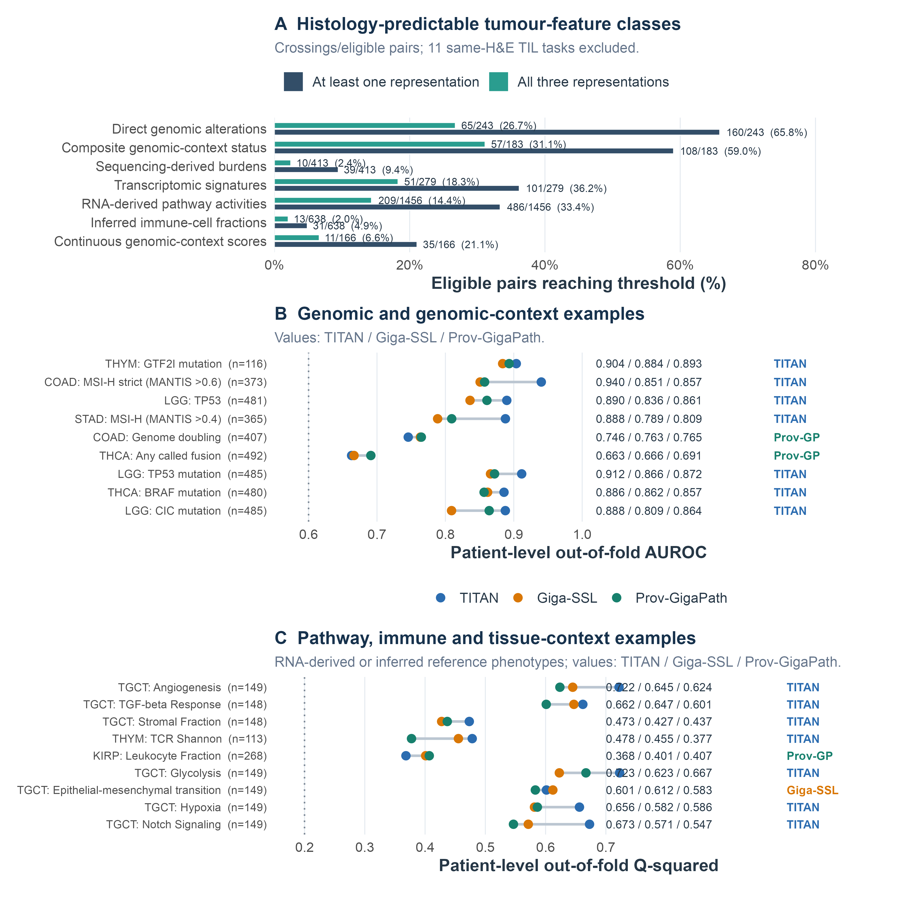
Figure 2. Biological features predictable from the three released pathology representation pipelines. Panel A reports the number of eligible cancer-endpoint pairs reaching Q² at least 0.20 or AUROC at least 0.60 in at least one representation and in all three representations, after excluding the 11 same-H&E TIL-fraction tasks. Panel B shows selected direct genomic and genomic-context examples. Panel C shows selected immune, inflammatory and tissue-context reference phenotypes. Every displayed example crossed in all three representations and retained the threshold after TCGA tissue-source-site code grouping. Points and numerical values follow the order TITAN, Giga-SSL and Prov-GigaPath. The coloured right-hand label identifies the pipeline with the highest observed effect for that pair. The selected examples span outcome classes and cancer contexts; the complete atlas reports every tested pair. Grouped retention is an internal cohort-structure sensitivity, not external validation.
The highest-performing representation differed by feature. TITAN led 14 of the 18 examples in Figure 2, including THYM GTF2I, COAD strict MSI, LGG TP53 mutation and pathway status, THCA BRAF, STAD MSI and several TGCT pathway activities. Prov-GigaPath led COAD genome doubling, THCA any called fusion and KIRP leukocyte fraction. Giga-SSL led the TGCT epithelial-mesenchymal-transition activity. Several margins were small, so we interpret close values as near-ties rather than evidence of a universally superior representation.
The operating-point audit used the same AUROC-selected scores for every rule. Counts with balanced accuracy at least 0.60 under empirical priors, equal priors and a training-only optimized threshold were 88/180/160 for TITAN, 60/107/117 for Giga-SSL and 80/115/116 for Prov-GigaPath. Relative to empirical priors, the training-only threshold changed median balanced accuracy by 0.029/0.020/0.014, sensitivity by 0.378/0.381/0.362, specificity by -0.300/-0.329/-0.329, PPV by -0.020/-0.012/-0.021 and NPV by 0.016/0.012/0.011 for TITAN/Giga-SSL/Prov-GigaPath. Supplementary Table S8 summarizes the statistical and robustness audits, while complete paired changes for all five operating metrics remain machine readable. AUROC and PR-AUC did not change because the component and continuous outer score remained fixed. Table 1 summarizes descriptive predictability by tumour-feature class.
Table 1. Tumour-feature classes with descriptive effect-threshold crossings. Percentages use eligible cancer-endpoint pairs within each class; values in brackets show distinct feature definitions. We evaluated some definitions in several cancers, so task counts are catalogue-dependent and do not represent independent biological discoveries.
Tumour-feature class | Eligible pairs | Effect-threshold crossing in at least 1 representation, n/N (%) [features] | Effect-threshold crossing in all 3 representations, n/N (%) [features] | Examples represented in all 3
Direct genomic alterations | 243 | 160/243 (65.8%) [91] | 65/243 (26.7%) [16] | GTF2I, BRAF, IDH1, TP53, ATRX, CIC, FGFR3, APC, PTEN and called fusions
Composite genomic-context status | 183 | 108/183 (59.0%) [8] | 57/183 (31.1%) [8] | MSI, genome doubling and TP53, RTK-RAS, HIPPO, WNT and NOTCH pathway status
Sequencing-derived burdens | 413 | 39/413 (9.4%) [8] | 10/413 (2.4%) [5] | MANTIS, aneuploidy, TCR diversity and SNV neoantigens
Transcriptomic signatures | 279 | 101/279 (36.2%) [13] | 51/279 (18.3%) [12] | TGF-beta, IFN-gamma, proliferation, wound healing and Th1, Th2 and Th17 programmes
Inferred immune-cell fractions | 638 | 31/638 (4.9%) [7] | 13/638 (2.0%) [5] | leukocyte, naive B-cell, M2-macrophage and regulatory T-cell fractions
Continuous genomic-context scores | 166 | 35/166 (21.1%) [9] | 11/166 (6.6%) [4] | aneuploidy, fraction altered, homologous-recombination defects, segment count and stromal fraction
Same-H&E TIL fraction | 11 | 11/11 (100.0%) [1] | 10/11 (90.9%) [1] | TIL Regional Fraction

Supplementary Table S9 documents endpoint provenance, derivation and assay-equivalence limitations. Table 2 summarizes pathology-quality, pooling and molecular-slide linkage constraints.
Table 2. Pathology-quality, pooling and molecular-slide linkage constraints. Linkage refers to the released identifier resolution. A shared 15-character TCGA sample barcode does not establish identity of the tissue portion, analyte, aliquot, block, tumour region or subclone.
Area or endpoint source | Available linkage or rule | Observed extent | Remaining limitation
Structured pathology quality | Primary-tumour sample type and diagnostic-slide filename | No structured tumour cellularity, tissue area, artefact, biopsy/resection or slide-quality field | Slide eligibility and weighting were not pathology adjudicated
Multiple diagnostic slides | Arithmetic patient mean; slide weight 1/n within patient | 843/9,404 TITAN patients had more than one slide; maximum 30 | Prevents participant over-weighting and leakage but cannot ensure tumour representativeness
Thorsson PanImmune | Participant identifier only | 9,235 participant-linked patients | The WSI and reference phenotype may derive from different tumour specimens
Taylor aneuploidy | 15-character sample barcode | 8,667/8,667 exact sample matches | Portion, analyte, aliquot, block and tumour region remain unresolved
Sanchez-Vega pathways | 15-character sample barcode | 7,789/7,789 exact sample matches | Portion, analyte, aliquot, block and tumour region remain unresolved
Gao fusion calls | 15-character sample barcode | 8,068/8,068 exact sample matches | RNA aliquot, block identity and within-tumour fusion heterogeneity remain unresolved
cBioPortal MSI | 15-character sample barcode | 8,964/8,964 exact sample matches | Molecular aliquot, slide block and tumour region remain unresolved
MC3 mutation calls | 15-character sample barcode | 8,482/8,482 exact sample matches | Portion, analyte, aliquot, block, region and subclone remain unresolved

Across all 960 cross-modal cancer-endpoint pairs reaching the threshold in at least one representation, TITAN produced the highest observed Q² or AUROC for 734 (76.5%), Prov-GigaPath for 139 (14.5%) and Giga-SSL for 87 (9.1%). TITAN led most transcriptomic signatures, direct genomic alterations and both genomic-context classes. Prov-GigaPath contributed its largest relative share among sequencing-derived burdens, where it led 8/38 pairs. Giga-SSL led 22/110 composite binary pairs, including selected RTK-RAS, cell-cycle and genome-doubling tasks. Figure 3 reports every feature-class distribution. These counts identify the highest observed internal estimate under the common PLS-based probe and do not test intrinsic foundation-model superiority.
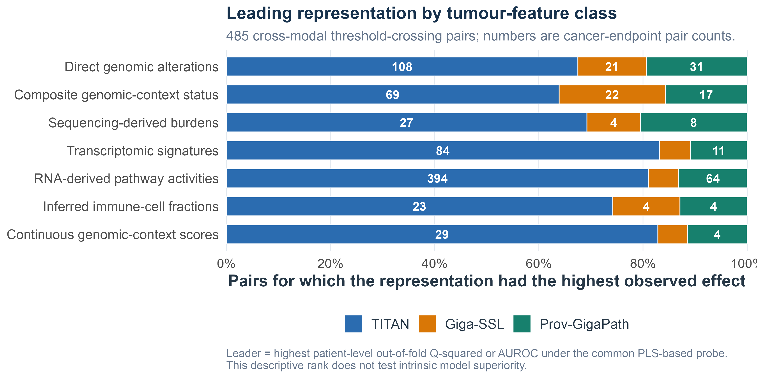
Figure 3. Foundation-model leadership by tumour-feature class. The analysis includes 960 cross-modal cancer-endpoint pairs that reached Q² at least 0.20 or AUROC at least 0.60 in at least one representation. Within each pair, the leading representation had the highest patient-level out-of-fold Q² for a continuous endpoint or AUROC for a binary endpoint under the common PLS-based probe. Numbers inside bars are pair counts. Small paired differences may represent near-ties, and the descriptive rank does not establish intrinsic model superiority or external transportability.

Partition and probe sensitivity
Across five alternative matched partitions, an effect-threshold crossing recurred in all five for 517/978, 265/978 and 330/978 continuous pairs for TITAN, Giga-SSL and Prov-GigaPath, respectively; the corresponding binary counts were 169/356, 96/356 and 120/356. Median between-partition standard deviations were 0.022/0.024/0.026 Q² and 0.026/0.027/0.027 AUROC. The threshold-derived support class agreed with the primary class in at least four of five alternative partitions for 591/978 continuous and 172/356 binary pairs, and in all five for 448/978 and 119/356. The primary leading representation persisted in all five for 600/978 continuous and 132/356 binary pairs. We therefore report support classes only as navigation tags and prioritise continuous effects, paired differences and rank stability.
We applied TCGA tissue-source-site code grouping to all 971 pairs crossing in at least one representation. Of 2,913 representation-task fits, 2,913 were estimable. ACC genome doubling was not estimable for any representation because one inner training partition contained a single class. Among pairs crossing in all three representations, every crossing retained its threshold for 148/304 continuous and 62/122 binary pairs. Median grouped-minus-matched-random effects were -0.027/-0.005 Q²/AUROC for TITAN, -0.043/-0.015 for Giga-SSL and -0.059/-0.011 for Prov-GigaPath. Grouping tests sensitivity to internal cohort structure; it does not provide institutional, scanner-level or external validation.
Grouped-fold adequacy was heterogeneous. Tasks contained 4-35 contributing codes; outer test sets ranged from 1 to 317 patients, and 15 tasks used four rather than five folds. Among 268 binary tasks, 27 had a single-class outer test fold, 114 had a single-class inner validation fold and 2 had a single-class inner training fold. Minimum outer training counts were 1 positive and 5 negative patients; minimum inner training counts were 0 and 1. The sparse-fold warning applied to 153/268 binary and 184/703 continuous tasks. Metrics pooled all outer held-out predictions; we did not calculate or interpret a stand-alone AUROC for a single-class fold.
The separate, larger TITAN permutation/FDR screen showed the same concern under its documented balanced-accuracy rule: 210/869 candidates (24.2%) fell below their original threshold. READ-APC declined from balanced accuracy 0.862 to 0.475, and COAD-APC from 0.777 to 0.519. In the separate matched-partition refits, grouped versus matched-random balanced accuracy was 0.452 versus 0.802 for READ-APC and 0.538 versus 0.751 for COAD-APC. TCGA tissue-source-site code alone achieved AUROC 0.900 and 0.755, respectively. These results support sensitivity to a barcode-derived cohort-structure variable, not proof of technical confounding or transportability.
Representation ordering depended on the downstream analysis. In the symmetric metadata-stratified sensitivity, ridge retained the PLS-leading representation for 25/34 binary and 9/14 continuous targets. The primary atlas therefore compares the released representations under the specified 1-to-20-component PLS-based probe. Selected-component distributions, ceiling selection and feature-variance checks are reported for every representation. The supporting TITAN permutation/FDR screen is reported separately and is not used to rank the three representations.
Figure 4 shows the patient-level predictions behind one of the strongest shared continuous results. The published TGCT TGF-beta Response expression signature had the highest mean Q² among continuous cancer-endpoint pairs that crossed Q² 0.20 with all three representations. We plotted every held-out patient once for each representation, using the same observed reference values and the model-specific outer-fold prediction. This Thorsson signature is distinct from the separately modelled MSigDB Hallmark TGF-beta signaling score.
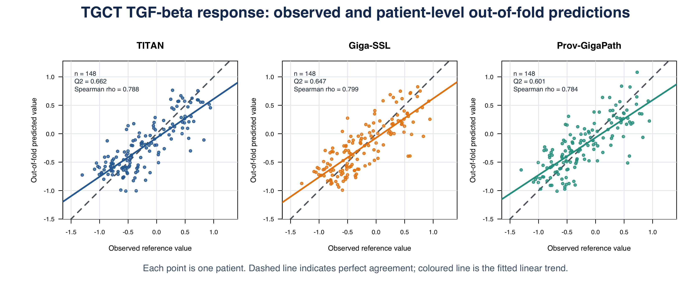
Figure 4. Observed published TGCT TGF-beta Response values and patient-level out-of-fold predictions from TITAN, Giga-SSL and Prov-GigaPath. Each panel contains the same 148 patients. The dashed line marks perfect agreement and the coloured line shows the fitted linear trend. Q² was 0.662 for TITAN, 0.647 for Giga-SSL and 0.601 for Prov-GigaPath; the corresponding Spearman correlations were 0.788, 0.799 and 0.784. TGF-beta Response is a published RNA-expression signature from Thorsson et al., so the figure demonstrates internal agreement with a computational reference phenotype rather than recovery of a direct laboratory measurement or external validation.

PathoFMPred outputs for two illustrative COAD patients
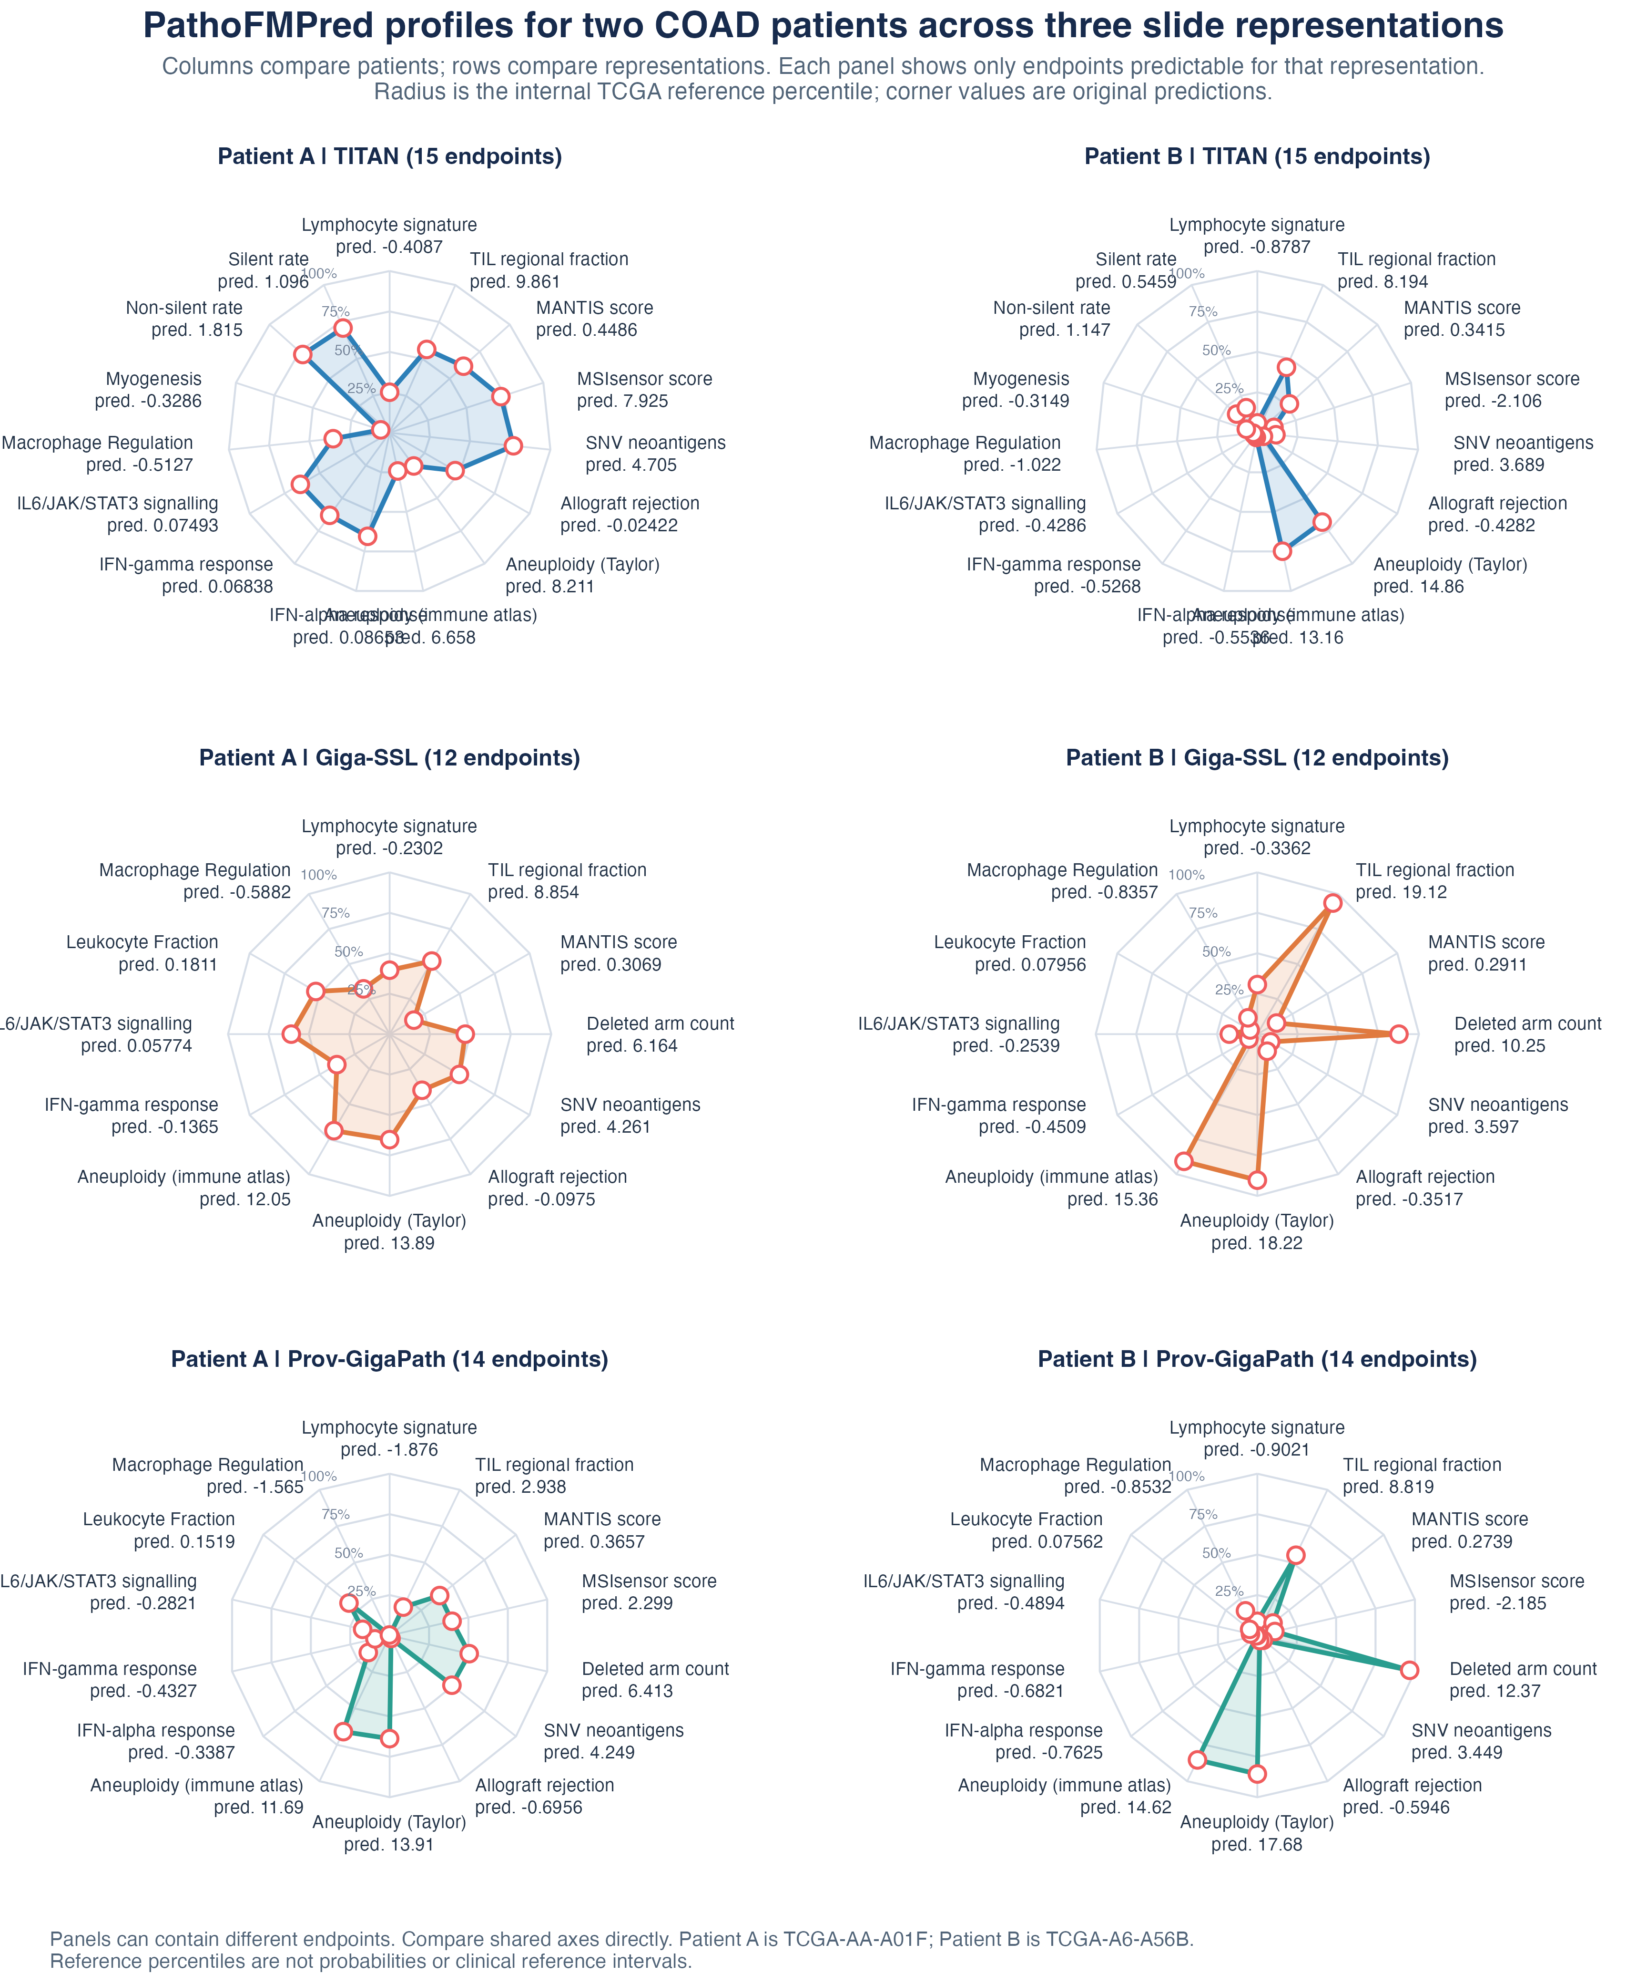
Figure 5. Post hoc PathoFMPred research-software illustration for TCGA-AA-A01F and TCGA-A6-A56B using TITAN, Giga-SSL and Prov-GigaPath inputs. Each panel includes only continuous endpoints predictable for that cancer and representation: 15 for TITAN, 12 for Giga-SSL and 14 for Prov-GigaPath. Corner labels give original predictions in source units. Radius gives the internal TCGA out-of-fold reference percentile, not a probability or clinical reference interval. The examples do not evaluate calibration, treatment response, external validation or clinical utility.
PathoFMPred applies only models that met the recorded predictability rule for the selected cancer and representation. Figure 5 illustrates this behaviour for two post hoc COAD examples. TITAN returned 15 predictable continuous endpoints per patient, Giga-SSL returned 12 and Prov-GigaPath returned 14. The differing radar axes are intentional: an endpoint is absent when the corresponding representation did not cross its threshold or when no eligible fitted object is available. The corners report original predictions in source units, while the radius uses an internal TCGA out-of-fold reference percentile only to place differently scaled outcomes on one display.
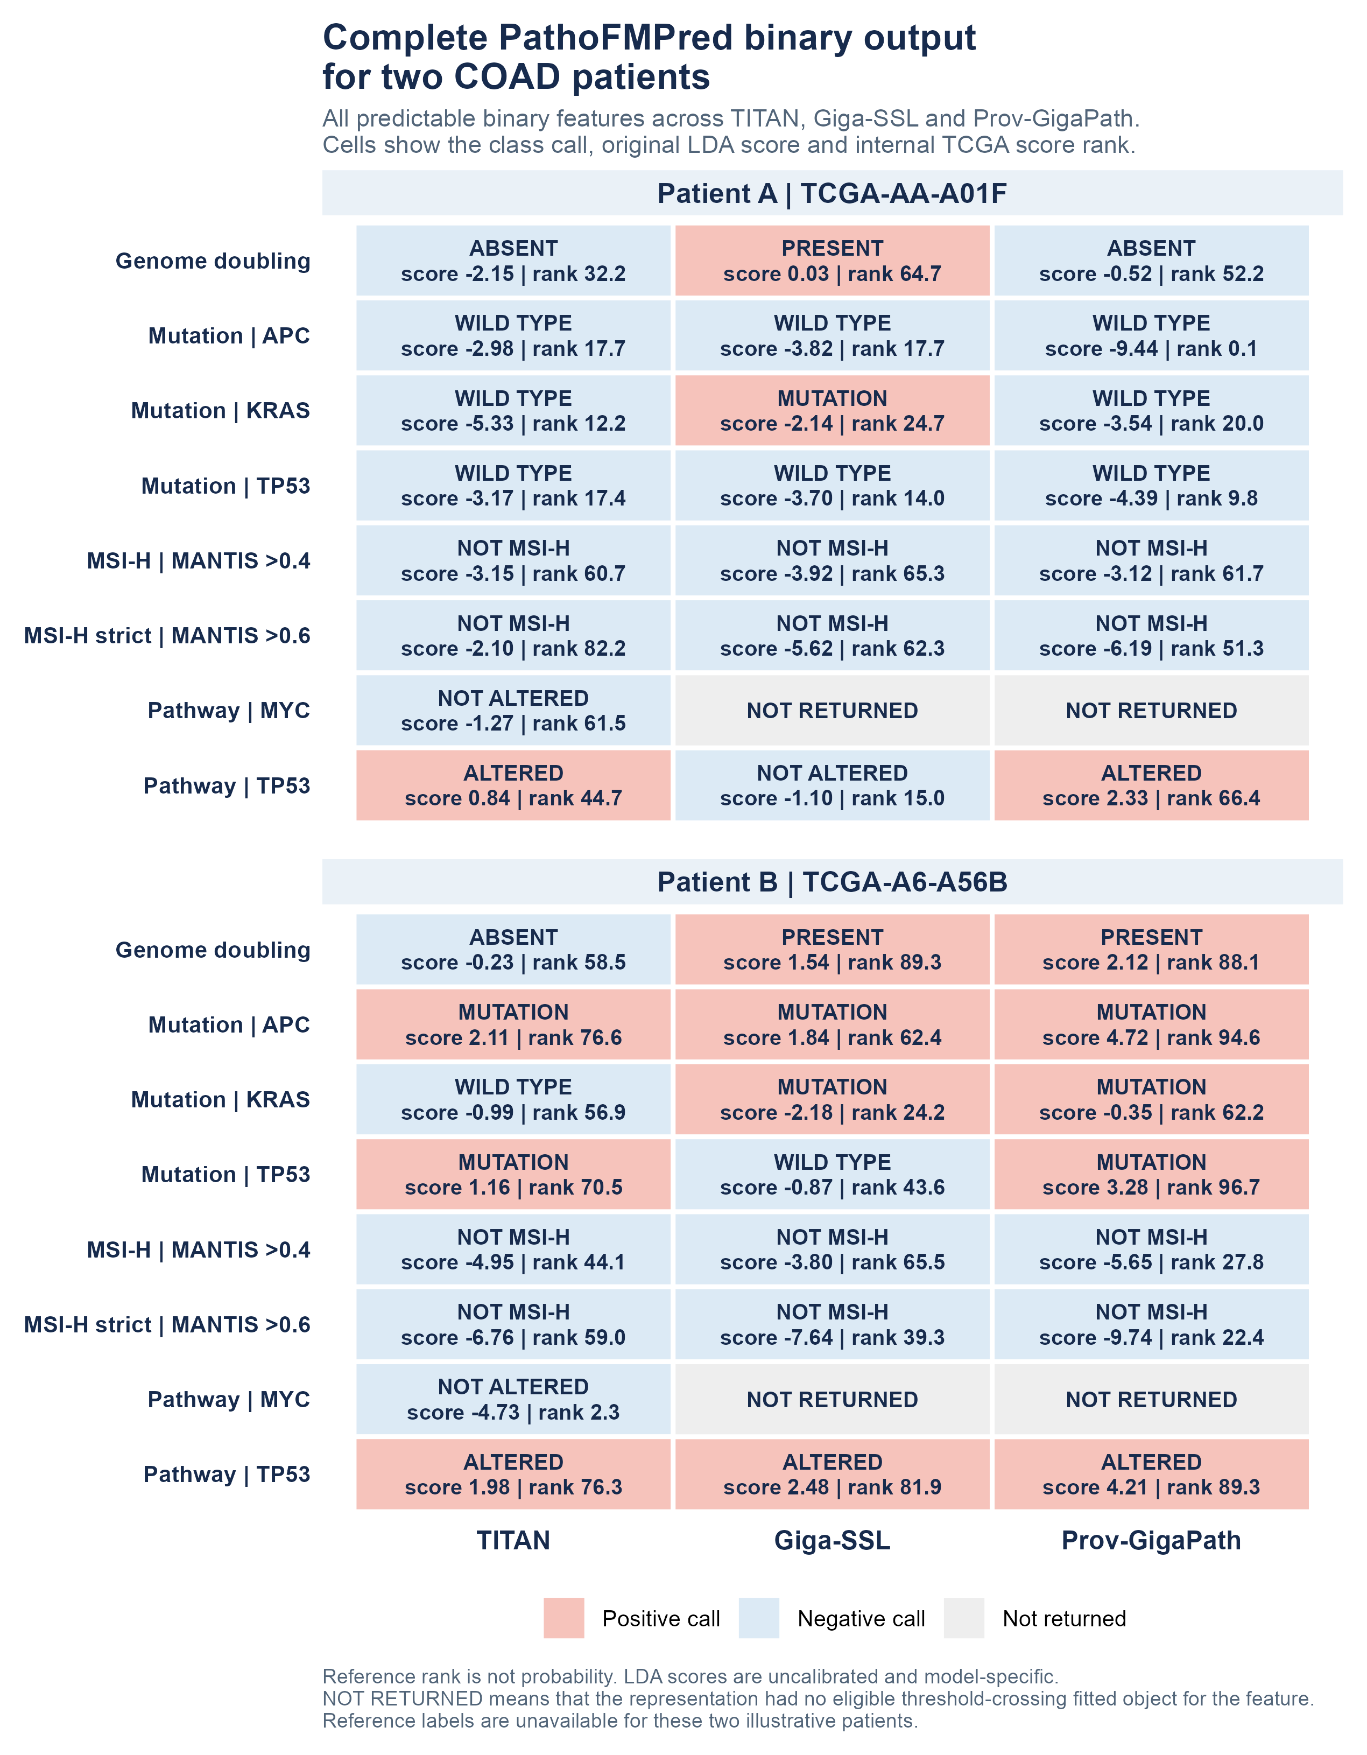
Figure 6. Complete predictable binary PathoFMPred output for the same two COAD examples using TITAN, Giga-SSL and Prov-GigaPath. The figure includes every binary endpoint returned for at least one representation: genome doubling; APC, KRAS and TP53 mutation status; broad and strict MANTIS-based MSI-H status; and MYC and TP53 pathway status. TITAN returned eight endpoints, while Giga-SSL and Prov-GigaPath returned seven each. Grey cells indicate that a representation did not return an eligible threshold-crossing fitted object. Each populated cell reports the direct class call, original uncalibrated LDA score and internal TCGA reference-score rank. Reference rank, not probability: raw LDA scores and ranks cannot be interpreted as calibrated probabilities or compared across models.
Figure 6 shows the complete binary output rather than a three-mutation subset. For TCGA-AA-A01F, all three representations called APC and TP53 mutation wild type; Giga-SSL alone called KRAS mutated and genome doubling present; TITAN and Prov-GigaPath called TP53 pathway status altered, while Giga-SSL called it unaltered. For TCGA-A6-A56B, all three called APC mutated; Giga-SSL and Prov-GigaPath called KRAS mutated; TITAN and Prov-GigaPath called TP53 mutation mutated; and all three called TP53 pathway status altered. Giga-SSL and Prov-GigaPath called genome doubling present in TCGA-A6-A56B, while TITAN called it absent. None of the six patient-representation combinations received an MSI-H call. TITAN alone returned a MYC pathway model and called both patients unaltered. Together, Figures 5 and 6 show every continuous and binary model that PathoFMPred returned for these COAD examples. The examples demonstrate the software interface and do not establish correctness, calibration, treatment response, external validity or clinical utility.

Discussion
The central biological result is a reproducible cross-representation set of cancer-specific histomolecular associations. Direct genomic alterations produced the broadest signal: at least one representation crossed in 160/243 tasks and all three crossed in 65. The strongest shared examples included THYM GTF2I, THCA BRAF, LGG TP53 and IDH1, BLCA FGFR3, UCEC fusion status, strict MSI in COAD and STAD, and genome-doubling or oncogenic-pathway states in several cancers. These results show that the embeddings retained histological information related to tumour lineage, genomic instability and pathway state, although the present analysis cannot identify the specific regions or cell patterns that generated each signal.
The comparison also provides a practical answer about representation choice. TITAN had the highest observed effect for 734/960 cross-modal pairs reaching the threshold in at least one pipeline and led most of the selected high-performing biological examples. Prov-GigaPath nevertheless led 139 pairs, including LGG IDH1, KIRP leukocyte fraction and TGCT stromal fraction, while Giga-SSL led 87, including BLCA FGFR3. Prov-GigaPath supplied its largest relative contribution among sequencing-derived burdens, whereas TITAN dominated the transcriptomic-signature group. These endpoint-specific results support selecting a representation for the intended tumour feature rather than choosing one pipeline for every task. Because small differences, alternative folds and a wider component grid changed some ranks, the atlas reports the full three-model estimates and their stability instead of assigning one universal winner.
The continuous results add a complementary biological layer. Histology predicted selected inflammatory and tissue-context programmes, including TGF-beta response in TGCT and THCA, Th17 in THYM, lymphocyte-infiltration and Th1 signatures in THCA, proliferation in LUAD and THYM, leukocyte fraction in BLCA and KIRP, TCR diversity in THYM, and stromal fraction in TGCT and BLCA. The concentration of signal in particular cancer and feature combinations is more informative than an overall immune count. These models estimate agreement with CIBERSORT fractions, methylation-derived leukocyte estimates, RNA signatures, repertoire metrics or composite purity and stromal quantities. They do not recover a directly measured immune-cell count. We report the same-H&E TIL fraction separately as computational concordance.
Cohort structure and analytical choices materially affected prioritisation. When we held tissue-source-site codes apart, only 148/304 continuous and 62/122 binary pairs with effect-threshold crossings in all three representations retained every threshold. The primary threshold-derived support class agreed in all five alternative partitions for only 448/978 continuous and 119/356 binary pairs. Matched-random controls separate fold size and class balance from the additional grouped change. The expanded 1-20-component analysis retained the primary leader for 323/366 binary pairs and changed it for 43. Continuous effects, paired variability, ranks and grouped-minus-matched-random changes therefore carry more information than a hard threshold class.
The targeted narrative literature audit strengthens the biological credibility of the atlas: 37/42 TITAN screen-positive cancer-gene pairs recovered associations that previous histology-prediction studies had already supported statistically. We did not identify THYM-GTF2I in the reviewed predictive-model literature, which makes it a particularly interesting candidate for independent testing. Relative to earlier pan-cancer resources, including Arslan et al., we add a matched three-representation comparison, patient-first slide aggregation, explicit tested-negative results, and target-level partition and cohort-structure audits. PathoFMPred records compact linear model parameters without redistributing the original patient-level training embeddings, subject to upstream access and redistribution terms.
Previous studies establish that the individual tumour-feature classes are biologically plausible prediction targets. Fu et al. predicted whole-genome duplication, chromosomal aneuploidies, driver alterations and tumour-composition signals [4]. Loeffler et al. compared gene and oncogenic-pathway prediction [6]. Dadhania et al. predicted ERG rearrangement in prostate cancer, and Mayer et al. predicted ALK and ROS1 fusions in lung cancer [12-13]. HE2RNA, regression-based biomarker studies and HistoTME predicted transcriptomic or tumour-microenvironment reference phenotypes [9-10,15], while Arslan et al. screened thousands of multi-omic biomarkers across the same 32 TCGA cancers [8]. Our principal innovation is the unified patient-level comparison of these feature classes across three released representation pipelines, with the same linear probe, explicit negative results and reusable representation-specific model records. The UCEC and LGG fusion-burden results and several cancer-specific any-fusion associations are less commonly reported tasks, but they still require an independent systematic literature review and external validation before any claim of endpoint novelty or clinical use.
Independent validation is the next priority. Tissue-source-site code is a barcode-derived cohort variable rather than a scanner or institution identifier, so grouped retention cannot establish transportability. Our equal-weight pooling could not use tumour-area or independent pathology-quality weights; some molecular labels link only at participant or sample-barcode level; small outcome groups remain unstable; and global embeddings do not localise morphology. PathoFMPred currently supports research application and controlled model comparison. Researchers must test locked models in an independent, pathology-reviewed cohort with compatible endpoints and report all failures before considering clinical use.

Conclusions
Under the common PLS-based probe, TITAN, Giga-SSL and Prov-GigaPath captured specific, cancer-dependent histological associations with mutations, fusions, MSI, genome doubling, oncogenic pathways and selected inflammatory or tissue-context phenotypes. At least one representation crossed the descriptive threshold for 971 cancer-endpoint pairs across 196 feature definitions, and all three crossed for 426 pairs. THYM GTF2I, THCA BRAF, LGG IDH1 and TP53, BLCA FGFR3, COAD strict MSI, TGCT TGF-beta response, THYM Th17 and TCR diversity, and BLCA or KIRP leukocyte fraction provide concrete priorities for independent validation. TITAN produced the highest observed effect for 734/960 cross-modal threshold-crossing pairs, but Giga-SSL and Prov-GigaPath led important feature-specific subsets. Representation, partition and cohort structure still changed some estimates, so the atlas supports endpoint-specific model selection and biological prioritisation rather than one universal model, assay replacement or clinical validity. PathoFMPred provides a secondary route for applying compatible models in locked external research studies.

Abbreviations
AUROC, area under the receiver operating characteristic curve; BA, balanced accuracy; CV, cross-validation; FDR, false discovery rate; H&E, haematoxylin and eosin; LDA, linear discriminant analysis; MC3, Multi-Center Mutation Calling in Multiple Cancers; MSI, microsatellite instability; OOF, out-of-fold; q-value, false-discovery-rate-adjusted p-value; SC interval, selection-conditioned patient-resampling interval for repeated out-of-fold predictions; PLS, partial least squares; Q², cross-validated coefficient of determination; RMSE, root-mean-square error; TCGA, The Cancer Genome Atlas; TCGA tissue-source-site code, barcode-derived submitting-centre field used as an internal cohort-structure variable.

Declarations

Ethics approval and consent to participate
We analysed publicly available, de-identified TCGA data. We recruited no participants and collected no new tissue.

Consent for publication
Not applicable.

Study registration and protocol
We did not prospectively register this retrospective computational benchmark.

Patient and public involvement
We did not involve patients or members of the public in the design, conduct, interpretation or reporting of this secondary analysis.

Availability of data and materials
We used the official TITAN TCGA feature artifact, official Giga-SSL TCGA embeddings and the seandavis/tcga_provgigapath_embeddings Hugging Face dataset. The companion repository records conversion scripts, exact source locations, access conditions and SHA-256 checksums [32]. We do not redistribute controlled-access whole-slide images; the cited sources provide access to TCGA molecular data. We intend to archive the analysis code and synchronized complete-resolution result companions as a versioned release. After the authors approve and archive the exact submission snapshot, they must insert the final release tag, immutable commit and persistent DOI. These items remain blockers before acceptance, and the present working tree does not represent that archive. PathoFMPred source code is released under the MIT licence. The public package contains a minimal Giga-SSL fixture and offers explicit user-invoked downloads of the permitted Giga-SSL and Prov-GigaPath fitted collections, whose asset terms and upstream attribution are stated separately. The TITAN fitted collection is excluded from the public repository and retained only in the private collaboration repository pending written redistribution permission. Users may build a local object from independently obtained compatible representations and outcomes. None of the fitted objects is externally validated or intended for clinical use.

Competing interests
Pending corresponding-author confirmation before submission. The analysis files do not contain a verified competing-interest declaration, so the statement cannot be completed without author input.

Funding
Pending corresponding-author confirmation before submission. The analysis files do not identify verified funders, grant numbers or a no-specific-funding statement.

Authors’ contributions
Pending approval by all authors before submission. A factual CRediT statement requires author confirmation of conceptualization, data curation, formal analysis, investigation, methodology, software, supervision, validation, visualization, writing and project-administration roles.

Acknowledgements
OpenAI Codex assisted with code refactoring and language editing. Human authors remain responsible for verification, interpretation and the submitted text.

Additional files
Additional file 1: supplementary_material_JTM.docx. Contains Supplementary Methods, compact interpretive Tables S1-S13, Figures S1-S4 and an inventory of the synchronized machine-readable result companions.
Additional file 2: Additional_file_2_COAD_example_A_PathoFMPred_report.pdf. COAD example A (TCGA-AA-A01F) complete PathoFMPred research-software output using TITAN, Giga-SSL and Prov-GigaPath features. The report lists every continuous and binary fitted model returned for each representation, with original predictions, class calls, internal TCGA reference ranks and model-performance metadata. It is a post hoc software illustration and is neither probability-calibrated nor externally validated.
Additional file 3: Additional_file_3_COAD_example_B_PathoFMPred_report.pdf. COAD example B (TCGA-A6-A56B) complete PathoFMPred research-software output using TITAN, Giga-SSL and Prov-GigaPath features. The report lists every continuous and binary fitted model returned for each representation, with original predictions, class calls, internal TCGA reference ranks and model-performance metadata. It is a post hoc software illustration and is neither probability-calibrated nor externally validated.

References
1. Coudray N, et al. Classification and mutation prediction from non-small cell lung cancer histopathology images using deep learning. Nat Med. 2018;24:1559–1567. doi:10.1038/s41591-018-0177-5.
2. Kather JN, et al. Deep learning can predict microsatellite instability directly from histology in gastrointestinal cancer. Nat Med. 2019;25:1054–1056. doi:10.1038/s41591-019-0462-y.
3. Echle A, et al. Clinical-grade detection of microsatellite instability in colorectal tumors by deep learning. Gastroenterology. 2020;159:1406–1416.e11. doi:10.1053/j.gastro.2020.06.021.
4. Fu Y, et al. Pan-cancer computational histopathology reveals mutations, tumor composition and prognosis. Nat Cancer. 2020;1:800–810. doi:10.1038/s43018-020-0085-8.
5. Kather JN, et al. Pan-cancer image-based detection of clinically actionable genetic alterations. Nat Cancer. 2020;1:789–799. doi:10.1038/s43018-020-0087-6.
6. Loeffler CML, et al. Predicting mutational status of driver and suppressor genes directly from histopathology with deep learning. Front Genet. 2022;12:806386. doi:10.3389/fgene.2021.806386.
7. Saldanha OL, et al. Self-supervised attention-based deep learning for pan-cancer mutation prediction from histopathology. npj Precis Oncol. 2023;7:35. doi:10.1038/s41698-023-00365-0.
8. Arslan S, et al. A systematic pan-cancer study on deep learning-based prediction of multi-omic biomarkers from routine pathology images. Commun Med. 2024;4:48. doi:10.1038/s43856-024-00471-5.
9. Schmauch B, et al. A deep learning model to predict RNA-Seq expression of tumours from whole slide images. Nat Commun. 2020;11:3877. doi:10.1038/s41467-020-17678-4.
10. El Nahhas OSM, et al. Regression-based deep-learning predicts molecular biomarkers from pathology slides. Nat Commun. 2024;15:1253. doi:10.1038/s41467-024-45589-1.
11. Howard FM, et al. The impact of site-specific digital histology signatures on deep learning model accuracy and bias. Nat Commun. 2021;12:4423. doi:10.1038/s41467-021-24698-1.
12. Dadhania V, et al. Leveraging artificial intelligence to predict ERG gene fusion status in prostate cancer. BMC Cancer. 2022;22:494. doi:10.1186/s12885-022-09559-4.
13. Mayer C, et al. Direct identification of ALK and ROS1 fusions in non-small cell lung cancer from hematoxylin and eosin-stained slides using deep learning algorithms. Mod Pathol. 2022;35:1882–1887. doi:10.1038/s41379-022-01141-4.
14. Bergstrom EN, et al. Deep learning artificial intelligence predicts homologous recombination deficiency and platinum response from histologic slides. J Clin Oncol. 2024;42:3550–3560. doi:10.1200/JCO.23.02641.
15. Patkar S, et al. Predicting the tumor microenvironment composition and immunotherapy response in non-small cell lung cancer from digital histopathology images. npj Precis Oncol. 2024;8:280. doi:10.1038/s41698-024-00765-w.
16. Oquab M, Darcet T, Moutakanni T, et al. DINOv2: learning robust visual features without supervision. Trans Mach Learn Res. 2024. https://openreview.net/forum?id=a68SUt6zFt.
17. Ding T, et al. A multimodal whole-slide foundation model for pathology. Nat Med. 2025;31:3749–3761. doi:10.1038/s41591-025-03982-3.
18. Lazard T, Lerousseau M, Decencière E, Walter T. Giga-SSL: self-supervised learning for gigapixel images. In: Proceedings of the IEEE/CVF Conference on Computer Vision and Pattern Recognition Workshops. 2023. p. 4305–4314.
19. Xu H, et al. A whole-slide foundation model for digital pathology from real-world data. Nature. 2024;630:181–188. doi:10.1038/s41586-024-07441-w.
20. Thorsson V, et al. The Immune Landscape of Cancer. Immunity. 2018;48:812–830.e14. doi:10.1016/j.immuni.2018.03.023.
21. Newman AM, et al. Robust enumeration of cell subsets from tissue expression profiles. Nat Methods. 2015;12:453–457. doi:10.1038/nmeth.3337.
22. Saltz J, et al. Spatial organization and molecular correlation of tumor-infiltrating lymphocytes using deep learning on pathology images. Cell Rep. 2018;23:181–193.e7. doi:10.1016/j.celrep.2018.03.086.
23. Goldman MJ, Craft B, Hastie M, et al. Visualizing and interpreting cancer genomics data via the Xena platform. Nat Biotechnol. 2020;38:675-678. doi:10.1038/s41587-020-0546-8.
24. Liberzon A, Birger C, Thorvaldsdottir H, Ghandi M, Mesirov JP, Tamayo P. The Molecular Signatures Database Hallmark Gene Set Collection. Cell Syst. 2015;1:417-425. doi:10.1016/j.cels.2015.12.004.
25. Ellrott K, et al. Scalable open science approach for mutation calling of tumor exomes. Cell Syst. 2018;6:271–281.e7. doi:10.1016/j.cels.2018.03.002.
26. Bailey MH, et al. Comprehensive characterization of cancer driver genes and mutations. Cell. 2018;173:371–385.e18. doi:10.1016/j.cell.2018.02.060.
27. Sanchez-Vega F, et al. Oncogenic signaling pathways in The Cancer Genome Atlas. Cell. 2018;173:321–337.e10. doi:10.1016/j.cell.2018.03.035.
28. Taylor AM, et al. Genomic and functional approaches to understanding cancer aneuploidy. Cancer Cell. 2018;33:676–689.e3. doi:10.1016/j.ccell.2018.03.007.
29. Gao Q, et al. Driver fusions and their implications in the development and treatment of human cancers. Cell Rep. 2018;23:227–238.e3. doi:10.1016/j.celrep.2018.03.050.
30. Bonneville R, et al. Landscape of microsatellite instability across 39 cancer types. JCO Precis Oncol. 2017;2017:PO.17.00073. doi:10.1200/PO.17.00073.
31. Cerami E, et al. The cBio cancer genomics portal: an open platform for exploring multidimensional cancer genomics data. Cancer Discov. 2012;2:401–404. doi:10.1158/2159-8290.CD-12-0095.
32. Pathology foundation-model patient-level benchmark repository. GitHub. https://github.com/tkcaccia/titan-prediction. Accessed 20 Sep 2026.
33. Wold S, Sjöström M, Eriksson L. PLS-regression: a basic tool of chemometrics. Chemometr Intell Lab Syst. 2001;58:109–130. doi:10.1016/S0169-7439(01)00155-1.
34. Szymańska E, et al. Double-check: validation of diagnostic statistics for PLS-DA models. Metabolomics. 2012;8(Suppl 1):3–16. doi:10.1007/s11306-011-0330-3.
35. Benjamini Y, Hochberg Y. Controlling the false discovery rate: a practical and powerful approach to multiple testing. J R Stat Soc B. 1995;57:289–300. doi:10.1111/j.2517-6161.1995.tb02031.x.
36. Collins GS, et al. TRIPOD+AI statement: updated guidance for reporting clinical prediction models that use regression or machine learning methods. BMJ. 2024;385:e078378. doi:10.1136/bmj-2023-078378.
37. Liu J, et al. An integrated TCGA pan-cancer clinical data resource to drive high-quality survival outcome analytics. Cell. 2018;173:400–416.e11. doi:10.1016/j.cell.2018.02.052.
38. PathoFMPred R package and fitted-model repository. GitHub. https://github.com/tkcaccia/PathoFMPred. Accessed 20 Sep 2026.
39. International Agency for Research on Cancer. Global Cancer Observatory: GLOBOCAN 2022 world fact sheet. Lyon: IARC; 2024. https://gco.iarc.who.int/media/globocan/factsheets/populations/900-world-fact-sheet.pdf. Accessed 16 Aug 2026.
40. National Cancer Institute. Genomic Data Commons Cases API. https://api.gdc.cancer.gov/cases. Accessed 16 Aug 2026.
41. Fernandes G. Morpho-genomic deep learning for ovarian cancer subtype and gene mutation prediction from histopathology. arXiv. 2025;arXiv:2511.03365. doi:10.48550/arXiv.2511.03365.
42. Wells K, Lamrca A, Papaxoinis G, Wallace A, Quinn AM, Summers Y, Nonaka D. Unique correlation between GTF2I mutation and spindle cell morphology in thymomas (type A and AB thymomas). J Clin Pathol. 2023;76:463-466. doi:10.1136/jclinpath-2021-207837.
43. National Cancer Institute Clinical Proteomic Tumor Analysis Consortium. CPTAC-UCEC: The Clinical Proteomic Tumor Analysis Consortium Uterine Corpus Endometrial Carcinoma Collection. The Cancer Imaging Archive. doi:10.7937/K9/TCIA.2018.3R3JUISW. Accessed 20 Sep 2026.
44. Lazard T, et al. Giga-SSL source code and released TCGA_encoded_t5e1000 embeddings. GitHub. https://github.com/trislaz/gigassl. Commit 605b950. Accessed 20 Sep 2026.
45. Davis S. TCGA Prov-GigaPath embeddings. Hugging Face Datasets. https://huggingface.co/datasets/seandavis/tcga_provgigapath_embeddings. Source snapshot commit 073115403c2fc5134ee8d1332c603edba591dddb. Accessed 20 Sep 2026.

