A patient-level atlas of molecular and immune predictability from frozen TITAN whole-slide embeddings across 32 cancers
Authors: Aamilah Ismail [author list to be confirmed]
Division of Engineering, New York University Abu Dhabi, Abu Dhabi, United Arab Emirates
Corresponding author: [to be completed]
Research article — Molecular Pathology | Journal of Translational Medicine

Abstract
Background. Histology can encode molecular and microenvironmental phenotypes, but conventional convolutional-neural-network workflows require repeated task-specific training. We evaluated whether reusable TITAN whole-slide embeddings enable rapid, cancer-specific screening of individual molecular, genomic-instability and immune endpoints.
Methods. We mean-pooled 11,449 primary diagnostic slide embeddings into 9,404 patient vectors across 32 TCGA cancers; 843 patients contributed multiple slides. We tested 1,614 continuous and 459 binary cancer–endpoint pairs. PLS1 regression was used for continuous targets; binary targets used PLS latent scores with LDA. Patient-level nested 5×5 cross-validation selected 1–10 components. Effect-eligible models underwent up to 99 permutations with Benjamini–Hochberg control within cancer and endpoint family; a global-across-cancers q-value was retained as sensitivity. PLS2 was a secondary matched analysis of coherent inflammatory blocks.
Results. Across all families, 152 continuous and 73 binary pairs met Tier A/B criteria. Leading continuous results included TGCT–TGF-beta Response (0.644); THYM–Th17 Cells (0.624); THCA–Lymphocyte Infiltration Signature Score (0.580); TGCT–Macrophage Regulation (0.556). Leading binary results included THYM–GTF2I (0.876); READ–APC (0.860); READ–TP53 (0.847); LGG–TP53 (0.830). Site-grouped and first-slide sensitivity quantified centre and slide-selection dependence. PLS2 effect magnitudes were evaluated at the cancer level rather than by endpoint win counts.
Conclusions. Frozen TITAN features provide a fast hypothesis-generation layer for selected cancer-specific immune and molecular phenotypes, but predictability is heterogeneous and does not replace molecular assays. The internally validated models and negative results require independent external validation before clinical interpretation.
Keywords: computational pathology; whole-slide imaging; foundation model; mutation; inflammation; microsatellite instability; gene fusion; aneuploidy; partial least squares; linear discriminant analysis

Background
Routine haematoxylin-and-eosin sections reflect phenotypic consequences of tumour genotype and the immune microenvironment. Coudray and colleagues trained an Inception-v3 convolutional neural network (CNN) to predict six recurrently mutated genes in lung adenocarcinoma, and subsequent pan-cancer studies expanded image-derived inference to mutations, molecular biomarkers and expression programmes [1–5]. These studies established biological plausibility, but their tile extraction, annotation and target-specific optimization make exhaustive updating expensive.
TITAN is a multimodal whole-slide foundation model pretrained on 335,645 slides using visual self-supervision and vision–language alignment [6]. Its frozen 768-dimensional slide representation can be reused without back-propagation through millions of tiles. PLS is computationally light and well suited to correlated, high-dimensional predictors [7,8]. The advantage tested here is therefore speed and reuse after TITAN extraction—not an assumption that PLS is intrinsically more accurate than a task-optimized CNN.
The primary question was cancer-specific: which individual mutations, inflammatory measurements, oncogenic pathways, MSI phenotypes, aneuploidy measures and fusions are predictable within each cancer? Molecular subtype association was not analysed. PLS1 versus PLS2 was secondary; PLS2 was considered most biologically plausible for correlated inflammatory panels, while PLS–LDA was preferred for individual binary molecular endpoints.

Methods

Study design, slides and patient unit
The published TITAN TCGA table contained 11,449 eligible primary-tumour diagnostic slides (TCGA sample type 01 and –DX filename) from 9,404 participants. The 843 participants with multiple eligible slides contributed one patient vector obtained by feature-wise arithmetic mean before outcomes were joined. Patient—not slide—was the independent cross-validation unit. The slide-report file was used only to audit identifiers, cancer provenance and resection site; no report text entered a model. Nine participants without a resolvable cancer label did not enter cancer-specific modelling. All molecular sources were independently restricted to TCGA sample type 01 before patient aggregation.
All models were stratified by cancer type. No model learned pan-cancer differences, and no patient could occur in more than one validation fold. The intended use was discovery-stage prioritisation rather than diagnosis, treatment selection or replacement of molecular testing.
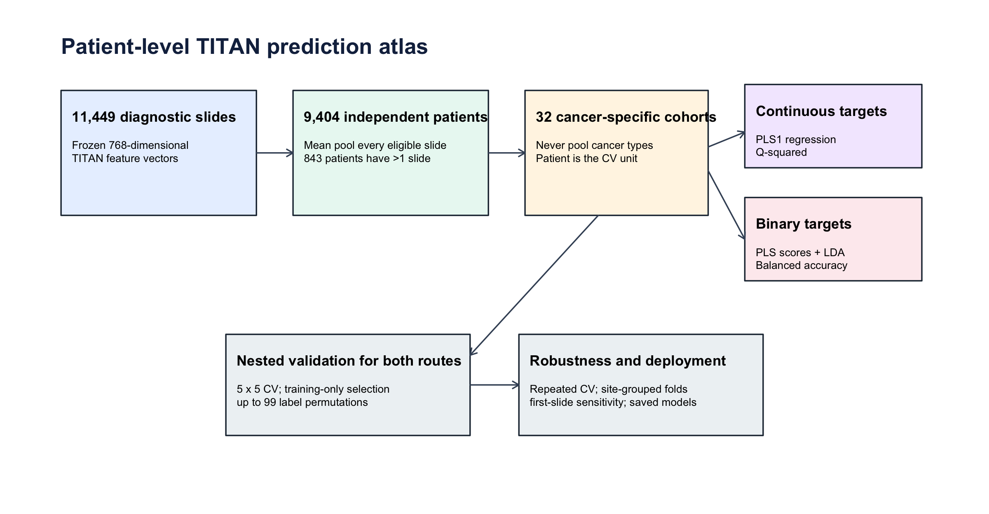
Figure 1. Patient-first study design. Eligible diagnostic slides are mean-pooled before outcome matching; all model selection and evaluation occur at patient level within cancer type.

Predictors and outcomes
Predictors were the 768 frozen TITAN dimensions [6]. Continuous outcomes comprised 39 immune/inflammatory measures and 11 genomic-context scores from Thorsson et al. [9], three aneuploidy burdens from Taylor et al. [10], log-transformed fusion burden from Gao et al. [11], and MANTIS/MSIsensor scores from Bonneville et al. and the cBioPortal TCGA PanCancer Atlas files [12,13]. Binary outcomes comprised qualifying protein-altering PASS mutations in tissue-specific consensus cancer genes from MC3 and Bailey et al. [14,15], ten oncogenic-pathway alteration indicators [16], genome doubling [10], any called fusion and eligible recurrent fusion pairs [11], and MSI-H definitions at MANTIS >0.4 and a strict >0.6 sensitivity threshold [12]. A mutation target denotes a qualifying alteration in a cancer gene; it does not assert that every allele is a functionally validated driver.
Continuous pairs required at least 50 non-missing patients. Binary pairs required at least 20 positive and 20 negative patients. Eligibility was decided before modelling and every eligible test remained in its endpoint-family multiplicity denominator.

PLS1 regression and PLS–LDA classification
For each cancer–endpoint pair, five outer folds estimated performance and five inner folds selected 1–10 PLS components. Scaling and component selection were learned from training patients only. Continuous performance was out-of-fold Q², with RMSE and Spearman correlation secondary. Binary models supplied PLS latent scores to ridge-stabilised LDA; balanced accuracy was primary and AUROC from continuous LDA scores was secondary in repeated validation.
Nested performance was first checkpointed for the complete atlas. Only models capable of Tier B (Q²≥0.20 or chance-corrected balanced accuracy≥0.20) received up to 99 patient-label permutations. Evaluation stopped conservatively after five exceedances because raw p<0.05 was then impossible even if every remaining null statistic were less extreme; stopped endpoints were assigned p=1. Regression extremeness used lower RMSD, whereas classification used higher balanced accuracy. Completed finite p values were (b+1)/(B+1). Because each disease defines a separate prediction and intended-use population, Benjamini–Hochberg FDR was controlled within cancer and prespecified endpoint family; an across-cancer family q-value was retained as a stricter sensitivity. Tier A required primary q<0.05 and effect≥0.40; Tier B required primary q<0.05 and effect 0.20–0.39. An optional 999-permutation extension is implemented in the public code but was not required for primary tiering.

Robustness, saved models and PLS2 sensitivity
Supported models were repeated under five independently seeded nested-CV partitions. Site-grouped folds kept two-character TCGA tissue-source-site codes out of both training and test partitions. A first-slide sensitivity replaced the primary mean-pooled vector while preserving patients and seeds. Full-data research models were tuned by ten-fold CV, saved with feature order, aggregation rule, class counts, software version and intended-use metadata, and tested through a public inference example that mean-pools user slides.
The secondary PLS2 analysis jointly modelled three prespecified inflammatory blocks: infiltration/signatures, immune repertoire and inferred immune-cell fractions. PLS1 and PLS2 used identical complete-case patients and outer folds, training-fold outcome scaling, separately selected component counts and three independent nested-CV repeats. Changes in Q² were aggregated by cancer with cancer-bootstrap intervals; endpoint win counts were not treated as inferential evidence.

Software, transparency and validation status
Analyses used R 4.6 and fastPLS 0.99.20 (Git commit dcf45cc). Complete code, source manifests, target catalogues, checkpoints, out-of-fold predictions, figures, model registry and inference example are organized at [repository URL pending publication]. Fitted TITAN-derived model objects are generated locally; their public redistribution remains subject to TITAN's upstream terms. No external cohort with compatible precomputed TITAN features and the required multi-omic labels was identified, so all performance estimates remain internal to TCGA.
OpenAI Codex was used for analysis-code refactoring, document generation and language editing. All statistical choices, source-data mappings, numerical outputs and manuscript interpretations were reviewed by the human authors, who retain responsibility for the work.

Results

Cohort and analysis coverage
The embedding cohort contained 9,404 patients represented by 11,449 slides; 843 patients (9.0%) had more than one eligible diagnostic slide. Cancer labels were available for 9,395 patients across 32 cancers. The atlas evaluated 1,614 continuous and 459 binary cancer–endpoint pairs (Table 1).
Table 1. Eligible cancer–endpoint models and evidence tiers.
Family | Type | Tests | Cancers | Tier A | Tier B | Tier C
aneuploidy | continuous | 90 | 30 | 0 | 8 | 82
aneuploidy | binary | 22 | 22 | 1 | 12 | 9
cancer-gene mutation | binary | 238 | 25 | 12 | 4 | 222
fusion | continuous | 30 | 30 | 0 | 3 | 27
fusion | binary | 27 | 25 | 1 | 7 | 19
MSI | continuous | 60 | 30 | 0 | 2 | 58
MSI | binary | 3 | 3 | 2 | 1 | 0
strict MSI sensitivity | binary | 3 | 3 | 2 | 1 | 0
oncogenic pathway | binary | 166 | 26 | 6 | 24 | 136
Thorsson immune/genomic-context | continuous | 1434 | 30 | 36 | 103 | 1295

Continuous immune, genomic-context and instability phenotypes
Among continuous targets, 36 were Tier A and 116 Tier B. The strongest effects were TGCT–TGF-beta Response (0.644); THYM–Th17 Cells (0.624); THCA–Lymphocyte Infiltration Signature Score (0.580); TGCT–Macrophage Regulation (0.556); BRCA–Wound Healing (0.528); SARC–Leukocyte Fraction (0.524); THCA–TGF-beta Response (0.524); TGCT–Macrophages M2 (0.517); LUAD–Proliferation (0.513); SARC–Macrophage Regulation (0.509). These results were cancer specific: the same endpoint could be strongly predictable in one tumour type and unsupported in another.
None of the 152 primary continuous Tier-A/B pairs met q<0.05 under the stricter across-cancer family sensitivity at the 99-permutation resolution. Continuous findings should therefore be interpreted as disease-specific screens rather than globally FDR-supported pan-cancer discoveries.
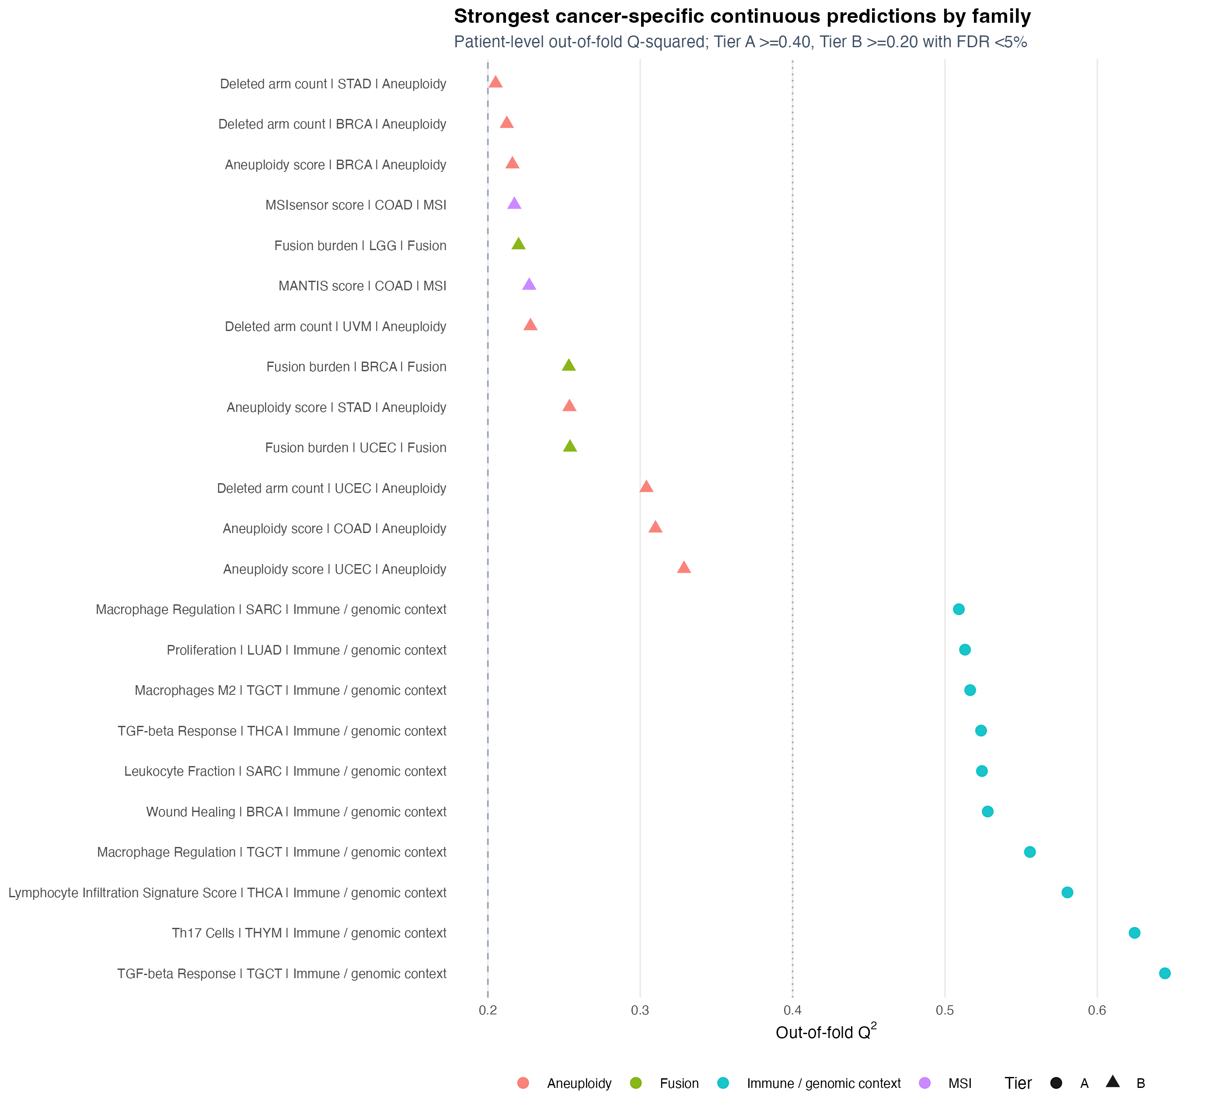
Figure 2. Strongest supported continuous cancer–endpoint results. Q² is calculated from genuine patient-level outer-fold predictions; all tests remain available in the machine-readable atlas.

Binary molecular phenotypes
The binary atlas yielded 24 Tier-A and 49 Tier-B pairs. Leading results were THYM–GTF2I (0.876); READ–APC (0.860); READ–TP53 (0.847); LGG–TP53 (0.830); THCA–BRAF (0.828); LGG–TP53 (0.822); LGG–HIPPO (0.811); COAD–APC (0.792); UCEC–Any called fusion (0.792); COAD–MSI-H strict (MANTIS >0.6) (0.784); LGG–ATRX (0.784); COAD–TP53 (0.777). The complete table includes tested-negative and ineligible distinctions for mutations, pathways, genome doubling, MSI and fusions.
Of 73 primary binary Tier-A/B pairs, 56 also met the stricter across-cancer family q<0.05. No cancer–gene mutation pair passed that global sensitivity, whereas supported pathway, MSI and fusion signals generally did; mutation results are consequently described as cancer-screen-specific findings.
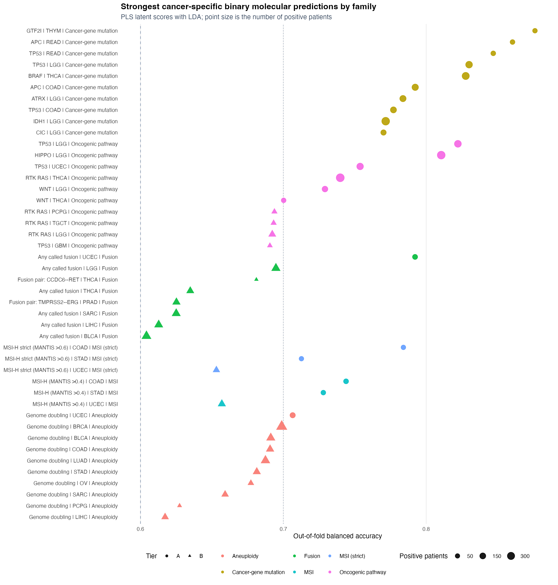
Figure 3. Strongest supported binary molecular predictions using PLS latent scores and LDA. Point size represents the number of positive patients.
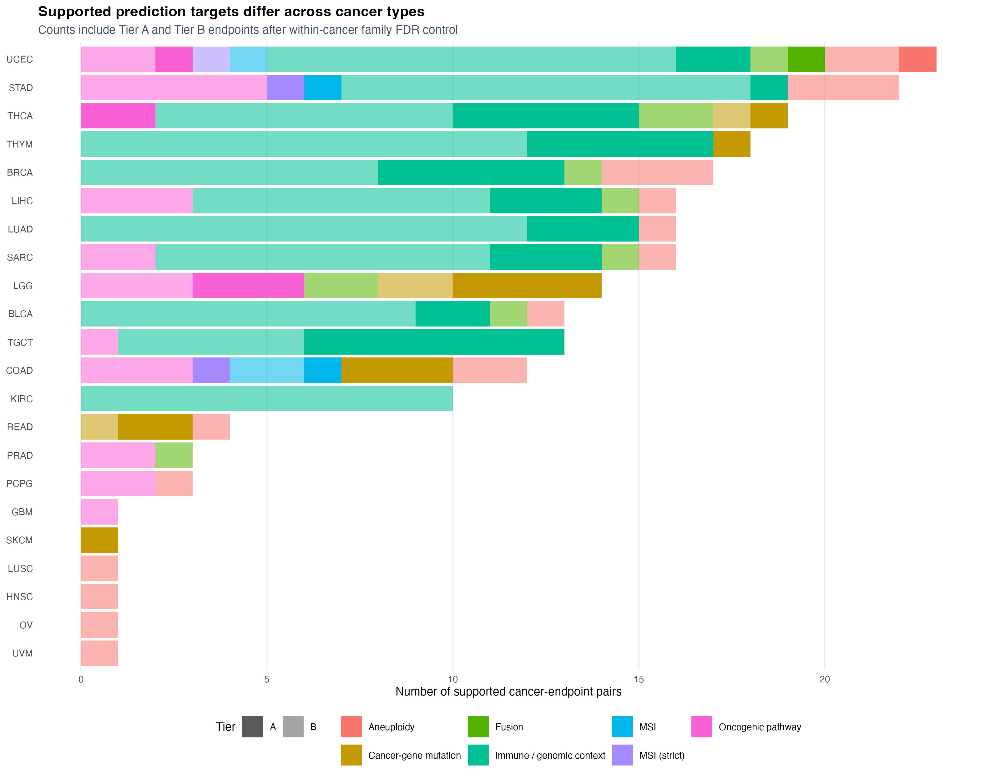
Figure 4. Number and family of Tier-A/B prediction targets within each cancer. Absence of an eligible target is distinct from a tested negative result.

Site and multiple-slide sensitivity
Site-grouped validation was feasible for 225 supported models. The median grouped-minus-random performance change was -0.026. The first-slide-minus-mean-pool median change across supported models was -0.002. Individual attenuations are reported because centre robustness and slide aggregation are target specific.
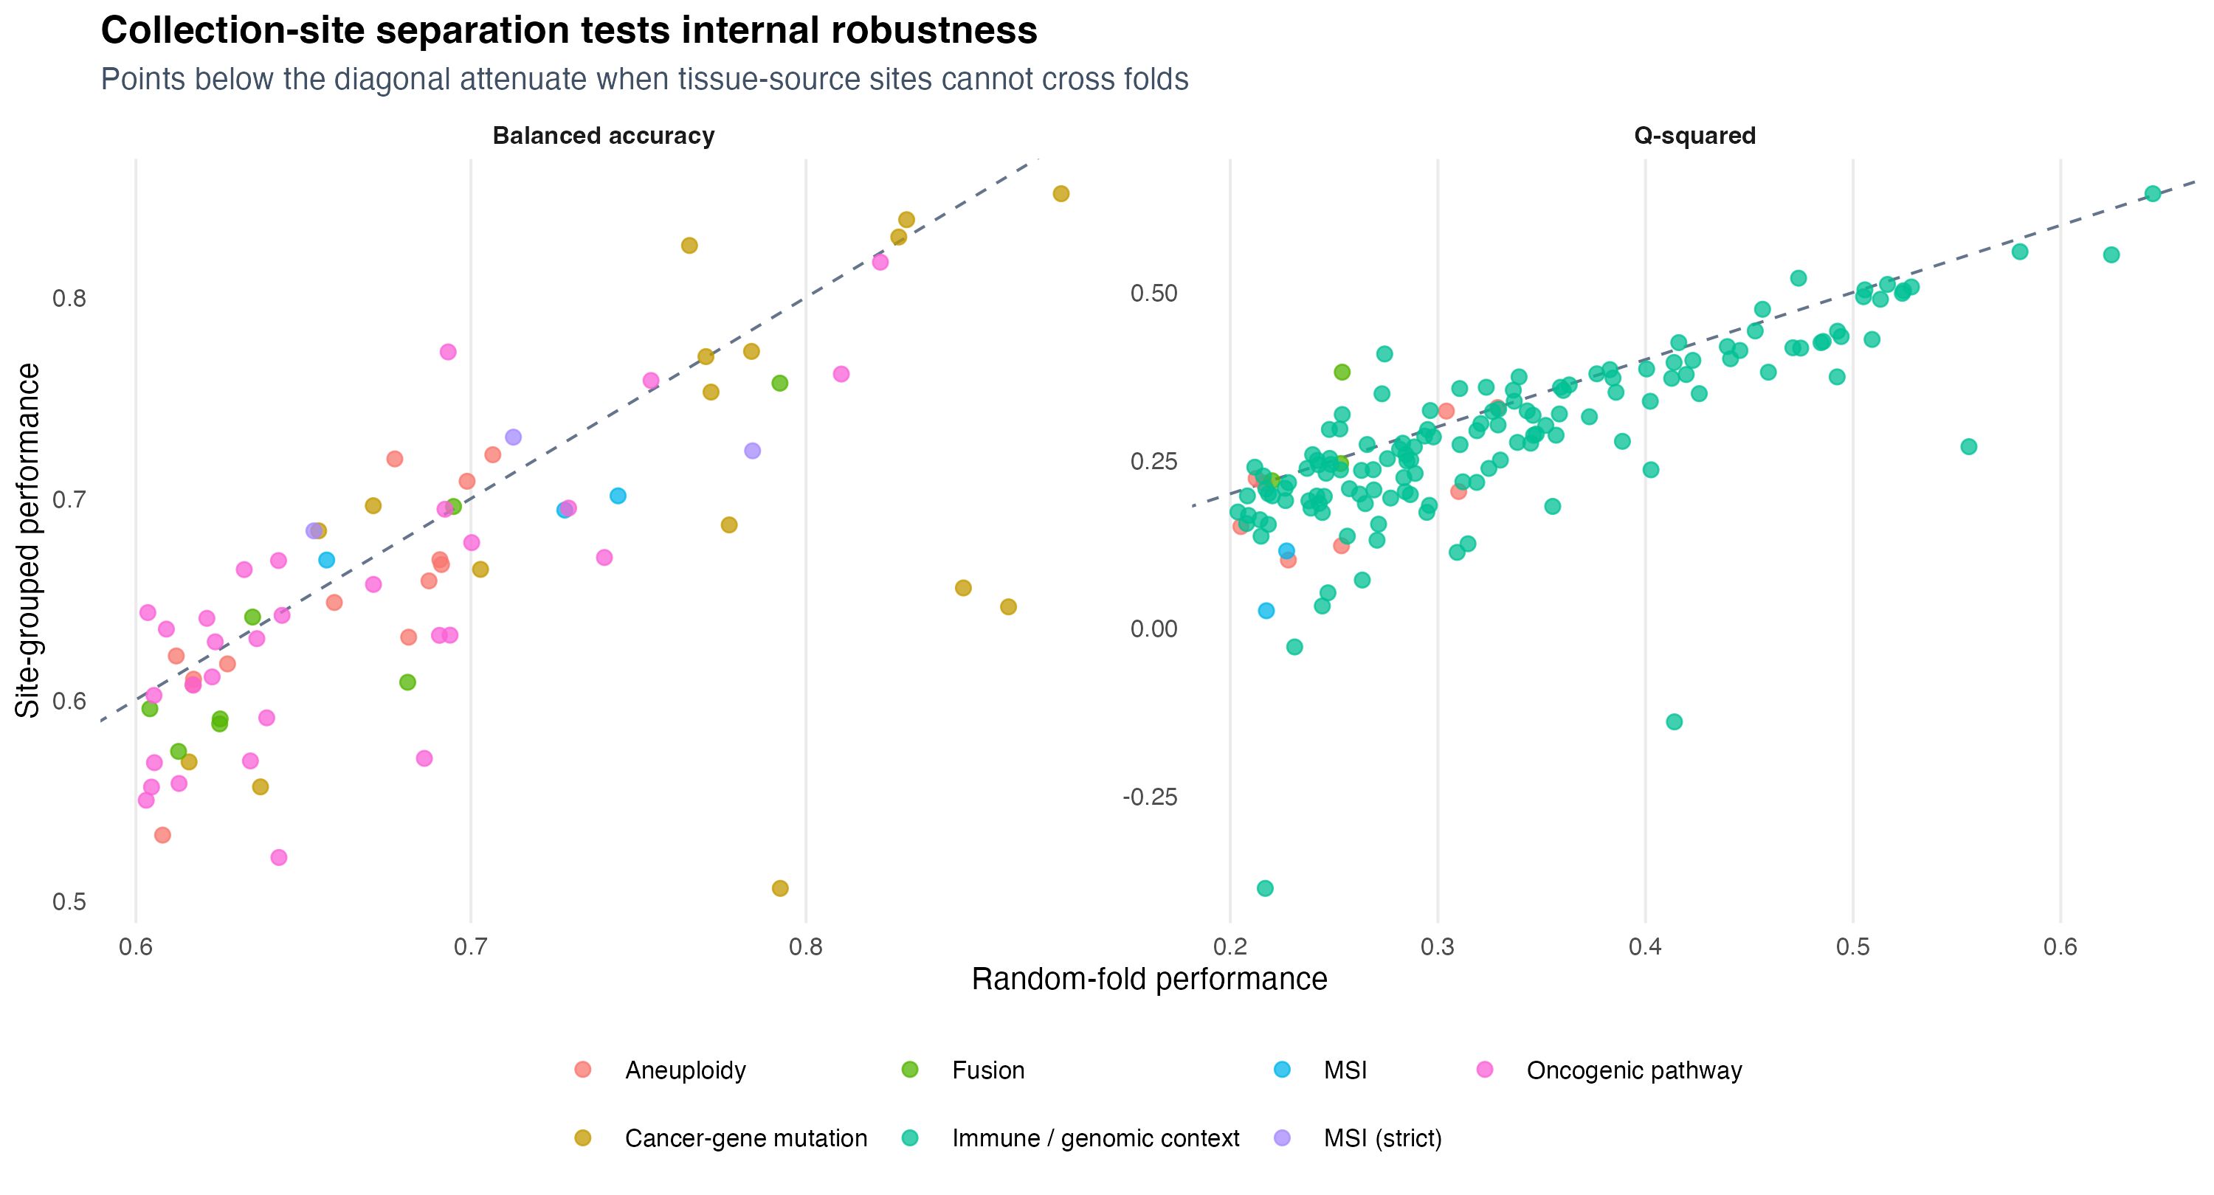
Figure 5. Random-fold versus tissue-source-site-grouped internal validation. Values below the diagonal indicate attenuation when submitting sites are separated.

Secondary PLS1–PLS2 comparison
inferred cell fractions: mean cancer-level ΔQ² 0.067 (95% interval 0.040 to 0.096); infiltration signatures: mean cancer-level ΔQ² 0.018 (95% interval 0.011 to 0.028); immune repertoire: mean cancer-level ΔQ² 0.058 (95% interval 0.040 to 0.079). These effect magnitudes, not the number of endpoints won, determine interpretation.
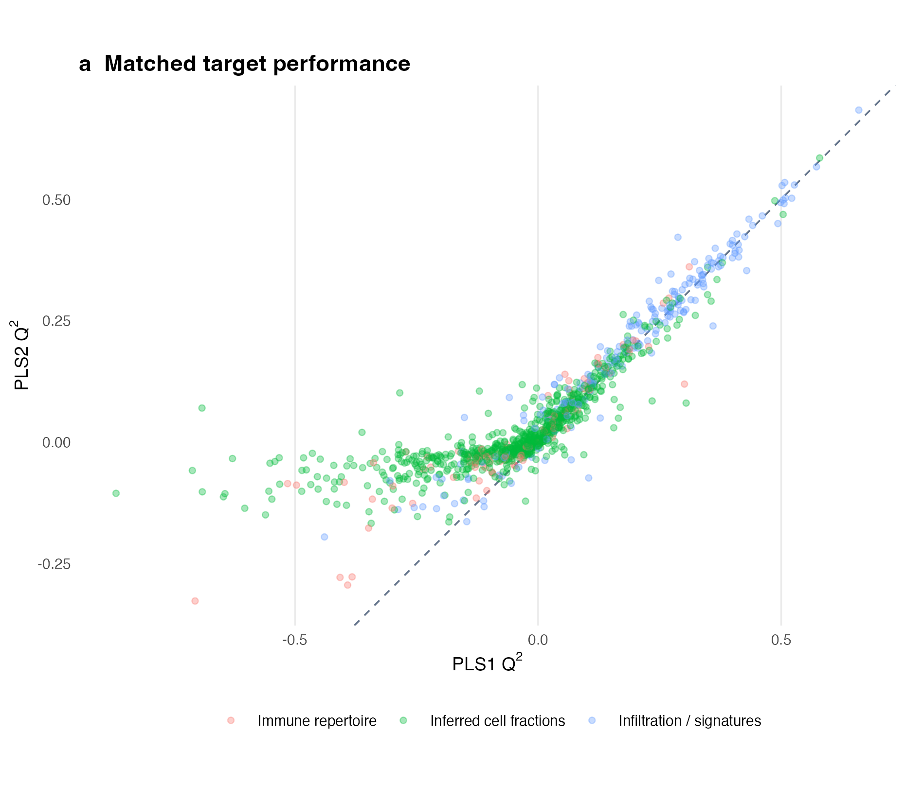
Figure 6a. Matched target-level PLS1 and PLS2 Q² on identical held-out patients.
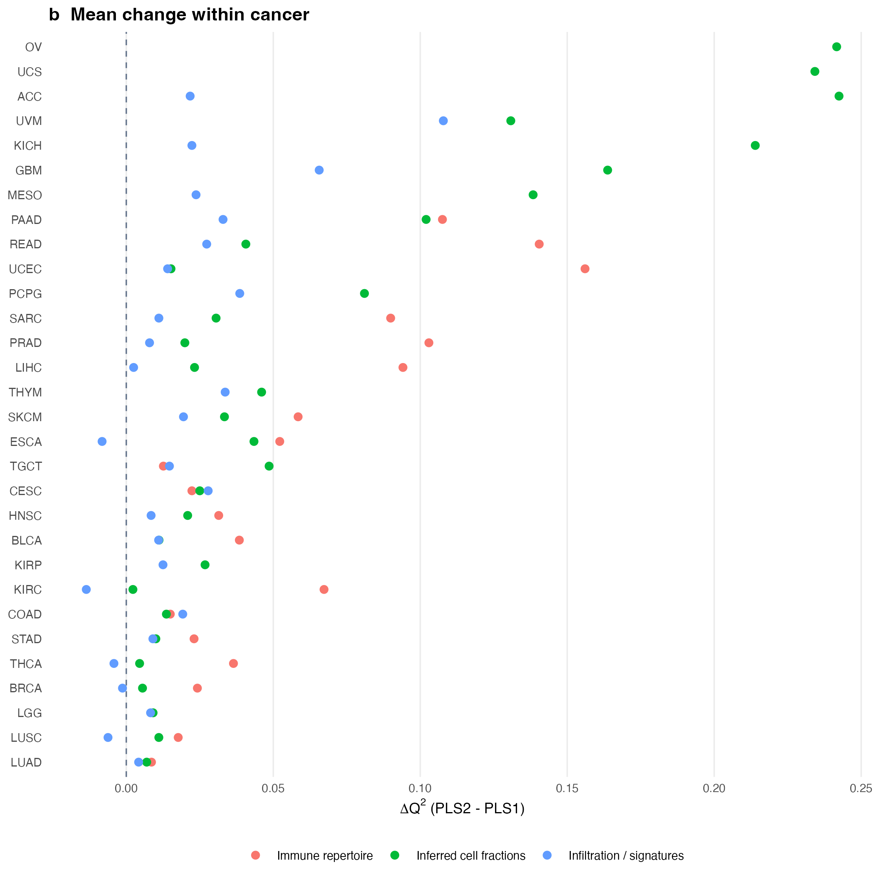
Figure 6b. Cancer-level mean Q² change for joint PLS2 relative to response-by-response PLS1.

Discussion
This study answers a target-by-target, cancer-specific question rather than asking whether molecular subtype and mutation status are associated. Frozen TITAN features contain useful signal for selected immune programmes, mutations and higher-level genomic phenotypes, but most eligible pairs do not satisfy both multiplicity and effect thresholds. That heterogeneity—and transparent negative reporting—is the primary result.
Prior CNN studies recovered histological signal for multiple exact cancer–gene pairs [1–5]. In the prespecified crosswalk, not eligible or not tested: 25, recovered tier A: 3, tested not supported: 32. Recovered and unrecovered pairs are listed in Supplementary Table S4; original study metrics, evidence notes and URLs are retained in the machine-readable crosswalk. Current balanced accuracy cannot be numerically equated to prior AUROC, and disagreement may reflect primary-versus-metastatic sampling, frozen versus FFPE preparation, mutation definition, model class or validation design.
The practical advantage of TITAN plus PLS is rapid reuse. Once slide embeddings exist, hundreds of new outcomes can be screened without retraining a CNN encoder. This is useful for discovery and triage, particularly when new genomic annotations become available. It does not eliminate the one-time TITAN extraction cost and is not a hardware-matched claim of superior accuracy.
Joint PLS2 is most compelling when responses are correlated and measured on the same patients. Its inflammatory benefit must nevertheless be judged by ΔQ² and its cancer-level interval. Binary mutations and fusions are sparse and only partially correlated, so a shared response space can dilute target-specific signal; separate PLS–LDA therefore remains the primary binary strategy.
Strengths include primary-tumour matching across every data source, deterministic mean pooling of multiple slides, nested patient-level validation, family-wise FDR, exact negative-result reporting, site-grouped sensitivity, saved research models and executable inference code. The supplied Bonneville spreadsheets contained only an ACC/CESC/MESO subset; cBioPortal PanCancer Atlas MANTIS fields were therefore used for full coverage and agreed exactly for all 387 overlapping cases.
The principal limitation is absence of independent external validation. TCGA resampling, even with site separation, cannot establish transportability to another institution, scanner, stain distribution or patient population. The study is retrospective and exploratory; thresholds are prioritisation rules, not clinical operating points. TITAN used report alignment during pretraining, predictability does not establish biological causality, and image-derived predictions cannot justify omitting a molecular assay. External feature extraction and prospective evaluation are required before clinical use.

Conclusions
Mean-pooled, frozen TITAN embeddings enable a rapid cancer-specific atlas of selected immune, mutation, pathway, MSI, aneuploidy and fusion phenotypes. PLS2 is a secondary option for correlated inflammatory panels; individual PLS–LDA remains the clearer default for binary molecular targets. The resource prioritises hypotheses and exposes unsupported targets, but remains internally validated and non-clinical.

Declarations

Ethics approval and consent to participate
This secondary analysis used publicly available, de-identified TCGA data. No participants were recruited and no new tissue was collected.

Consent for publication
Not applicable.

Availability of data and materials
Source locations and checksums are recorded in the repository: [repository URL pending publication]. TCGA data are available from the Genomic Data Commons; TITAN resources are available from MahmoodLab. Model-object redistribution is subject to TITAN's upstream terms.

Competing interests
[Author confirmation required before submission.]

Funding
[Author confirmation required before submission.]

Authors’ contributions
[Author initials and contribution statement required before submission.]

Acknowledgements
OpenAI Codex assisted with code refactoring and language editing. Human authors remain responsible for verification, interpretation and the submitted text.

References
1. Coudray N, et al. Classification and mutation prediction from non-small cell lung cancer histopathology images using deep learning. Nat Med. 2018;24:1559–1567. doi:10.1038/s41591-018-0177-5.
2. Fu Y, et al. Pan-cancer computational histopathology reveals mutations, tumor composition and prognosis. Nat Cancer. 2020;1:800–810. doi:10.1038/s43018-020-0085-8.
3. Kather JN, et al. Pan-cancer image-based detection of clinically actionable genetic alterations. Nat Cancer. 2020;1:789–799. doi:10.1038/s43018-020-0087-6.
4. Schmauch B, et al. A deep learning model to predict RNA-Seq expression of tumours from whole slide images. Nat Commun. 2020;11:3877. doi:10.1038/s41467-020-17678-4.
5. Loeffler CML, et al. Predicting mutational status of driver and suppressor genes directly from histopathology with deep learning. Front Genet. 2022;12:806386. doi:10.3389/fgene.2021.806386.
6. Ding T, et al. A multimodal whole-slide foundation model for pathology. Nat Med. 2025;31:3749–3761. doi:10.1038/s41591-025-03982-3.
7. Wold S, Sjöström M, Eriksson L. PLS-regression: a basic tool of chemometrics. Chemometr Intell Lab Syst. 2001;58:109–130. doi:10.1016/S0169-7439(01)00155-1.
8. Szymańska E, et al. Double-check: validation of diagnostic statistics for PLS-DA models. Metabolomics. 2012;8(Suppl 1):3–16. doi:10.1007/s11306-011-0330-3.
9. Thorsson V, et al. The Immune Landscape of Cancer. Immunity. 2018;48:812–830.e14. doi:10.1016/j.immuni.2018.03.023.
10. Taylor AM, et al. Genomic and functional approaches to understanding cancer aneuploidy. Cancer Cell. 2018;33:676–689.e3. doi:10.1016/j.ccell.2018.03.007.
11. Gao Q, et al. Driver fusions and their implications in the development and treatment of human cancers. Cell Rep. 2018;23:227–238.e3. doi:10.1016/j.celrep.2018.03.050.
12. Bonneville R, et al. Landscape of microsatellite instability across 39 cancer types. JCO Precis Oncol. 2017;2017:PO.17.00073. doi:10.1200/PO.17.00073.
13. Cerami E, et al. The cBio cancer genomics portal. Cancer Discov. 2012;2:401–404. doi:10.1158/2159-8290.CD-12-0095.
14. Ellrott K, et al. Scalable open science approach for mutation calling of tumor exomes. Cell Syst. 2018;6:271–281.e7. doi:10.1016/j.cels.2018.03.002.
15. Bailey MH, et al. Comprehensive characterization of cancer driver genes and mutations. Cell. 2018;173:371–385.e18. doi:10.1016/j.cell.2018.02.060.
16. Sanchez-Vega F, et al. Oncogenic signaling pathways in The Cancer Genome Atlas. Cell. 2018;173:321–337.e10. doi:10.1016/j.cell.2018.03.035.
17. Benjamini Y, Hochberg Y. Controlling the false discovery rate. J R Stat Soc B. 1995;57:289–300. doi:10.1111/j.2517-6161.1995.tb02031.x.
18. Collins GS, et al. TRIPOD+AI statement. BMJ. 2024;385:e078378. doi:10.1136/bmj-2023-078378.

