**Computer Lab 4 Homework – AMOVA, FST,**

**Haplotype Networks**

**Conservation Genetics (BIOL 4174 / 5174)**

Due date: 2/19/2018 at Midnight.

Submit this file via Blackboard.

Part I – Haplotype Networks in PopArt

1. **In your Minimum Spanning Tree, did you observe any haplotypes which were shared among two or more populations? What do you think this means in terms of gene flow and connectivity among populations?**
2. **Study your Median Joining Network. Compare the relationship between haplotypes in your network to the physical locations on the map. Do you see a general trend? If so, describe it.**
3. **In your Median Joining Network, did the program infer unobserved haplotypes? What might cause haplotypes to be unsampled?**

Part II – Population genetic statistics in R

1. **Based on the Tajima’s D test, can we assume neutrality? (Null hypothesis for Tajima’s D = markers are neutral). Does Tajima’s D suggest there could have been recent population expansion or reduction?**
2. **What does it mean for a marker to be “selectively neutral” and why are these markers important in conservation genetics?**
3. **In your pairwise FST matrix, did you notice any groups of populations/localities with low FST scores? What does this mean? Do these FST values make sense given the map shown above?**
4. **In general, are your pairwise FST values large or small? How would you interpret this with regards to gene flow?**
5. **Why might sample size influence your FST values?**

Part III – AMOVA in R

1. **Report the percentage of among group, among populations within groups, and within population variance.**

Part IV – More AMOVA in R

1. **Report the groups you defined and the results of the new AMOVA. Were you able to increase the among group variation?**

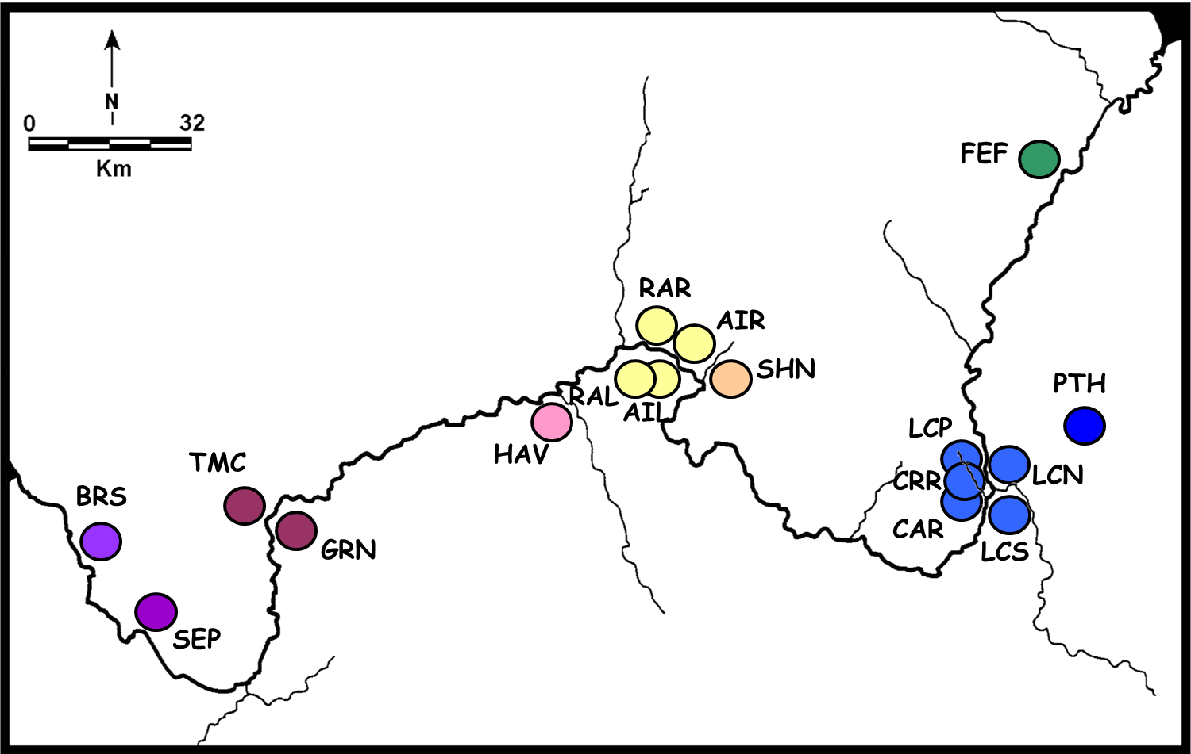

For reference- here is a map of the sampling localities for *Uta stansburiana* (side-blotched lizard)around the Grand Canyon that your data was generated from. The large river is the Colorado River, with several smaller tributaries shown. The data you worked with today was generated from ATPase 8 and ATPase 6, two overlapping mitochondrial genes.